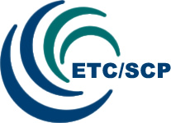



2013 Workshop on Waste Policy Implementation
in the West Balkan countries

EEA, Copenhagen, Denmark
30-31 May 2013

Final Report
15 July 2013

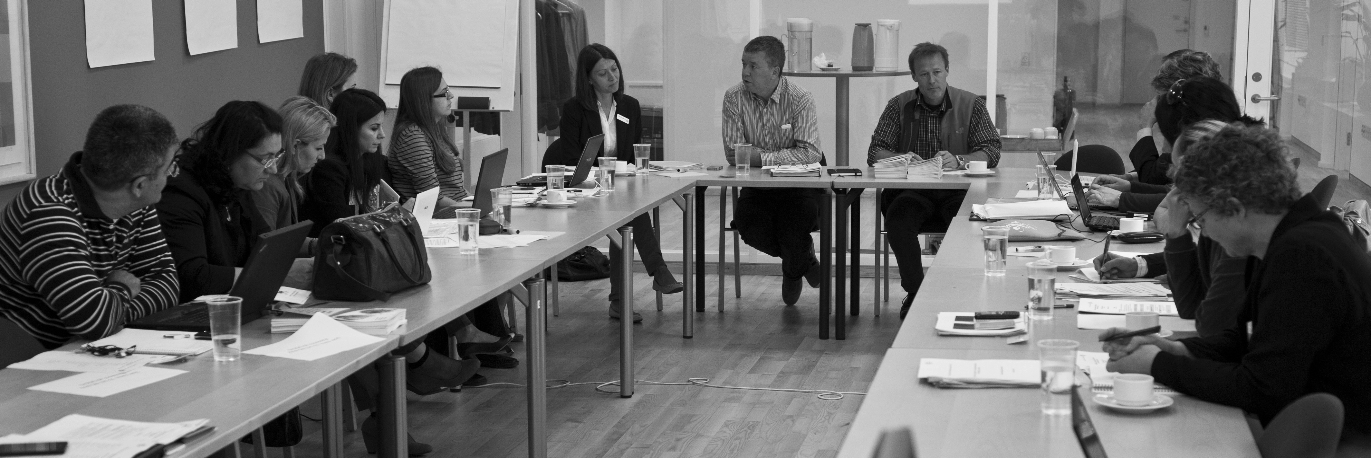

Photo by Packo Sanchez Aguado
Table of contents

Summary 4
1 Introduction 4
2 Structure of the workshop 4
3 First day – 30 May 5
3.1 Session I – Opening of the workshop 5
3.2 Session II - Challenges in implementing Waste Management Plans (WMP) 5
3.3 Session III – Planning waste treatment capacities for biodegradable waste and sewage sludge 9
4 Second day – 31 May 14
4.1 Session IV – Visit to biowaste handling facility Biovækst 14
4.2 Session V – Setting targets and indicators 15
4.3 Session VI: next step 17
Annex I: List of participants 20
Annex II: Workshop agenda 22

Summary
This document contains a brief summary of the workshop and will be sent to all participants.

1 Introduction
The workshop was a part of the project financed by the Multi Beneficiary Instrument for Pre-Accession (IPA) Programme. The project aims to expand the cooperation between the EEA and the West Balkan countries in the field of waste management and SCP. In 2013, it comprises of two activities: a thematic workshop on waste policy implementation and a network facility including a helpdesk.
2013 workshop on waste implementation in the West Balkan countries was held on 30 and 31 May 2013 at the European Environment Agency (EEA) premises in Copenhagen. The overall objectives of the workshop were to facilitate the exchange of experiences on the implementation of waste management plans and to discuss the core elements in waste policy implementation. Further to discuss waste treatment options and methods to plan waste treatment capacities. In addition, workshop was targeting build capacity in use of indicators and target setting for waste management.
In advance of the workshop, the participants received the agenda and a background paper on the status of treatment of biodegradable waste and sewage sludge in the West Balkan countries.

2 Structure of the workshop

The workshop consisted of six sessions:
I Opening of the workshop
II Challenges in implementing Waste Management Plans (WMP)
III Planning waste treatment capacities for biodegradable waste and sewage sludge
IV Visit to bio-waste handling facility
V Setting targets and indicators
VI Next steps
Workshop documentation is available at Eionet forum:
http://forum.eionet.europa.eu/eea-west-balkans-cooperation-interest-group/library/etc-scp-activities-wb/etc-scp-activities-2012-2013/workshop-2013
20 waste experts from seven West Balkan countries participated in the workshop. List of participants and workshop agenda Participants list and agenda attached.

3 First day – 30 May

3.1 Session I – Opening of the workshop
Jock Martin, Head of Programme Integrated Environmental Assessments (IEA), EEA, opened the workshop, welcomed the participants and gave an introduction speech. He highlighted the importance of waste in the resource agenda and drew the attention to the central role of waste and resources in the upcoming SOER 2015.
Peder Jensen, Head of Programme, Governance and Networks (GAN), EEA, also gave an introduction speech. He reflected on the co-operation of the West Balkan countries with the Eionet and the EEA. He circulated the report “West Balkan environmental core set of indicators”.
Tour de table – Participants presented themselves briefly and informed about their expectations of the workshop which were to receive useful information and experiences on waste management from other European countries’ examples. Croatia put forward their specific interest on biodegradable waste management and sewage sludge and said that they expect to receive useful insights during the workshop on this specific issue.
Birgitte Kjær, Senior Consultant, ETC/SCP, gave an introductory presentation to the objectives of the workshop (see presentation).
Jasmina Bogdanovic, Project manager, EEA, explained the different sessions of the workshop and briefly presented the latest EEA/Eurostat/EC waste activities (see presentation).

3.2 Session II - Challenges in implementing Waste Management Plans (WMP)
The invited speaker Jonathan Derham, Resource Use Unit Programme Manager, Irish EPA, gave a presentation about the Irish experience on waste management planning (see presentation). Some extra important information from Jonathan’s presentation included:
- Ireland’s municipal waste include except from household waste, also household like waste from commercial activities, from restaurants, even from canteens from industrial facilities. Per capita MSW as an indicator to compare the performance of different countries is not a good indicator according to Jonathan because the definitions are different from country to country.
- In Ireland 250,000 households are not covered for MSW collection. Due to highly disperse rural population, commercial collection companies don’t see a benefit in collecting that waste. Free market conditions in Ireland. There are only private collectors and treatment operators in Ireland. There could be even 5 different companies collecting waste from the same street.
- 400,000 EUR per year is the costs for gathering and maintaining proper waste statistics, which usually can be as high as 750,000 EUR per year (if we consider additional 350,000 EUR for external consultants). National Waste Reports from Ireland: http://www.epa.ie/pubs/reports/waste/stats/
- Good data essential for waste management planning. Composition is also important. Two composition surveys have been done in Ireland, in 1998 and 2007-08. EPA has a guide for waste characterisation publicly available and free on their website. http://www.epa.ie/pubs/reports/waste/wastecharacterisation/
- National register for waste facilities (electronic) is also very important. Better to start it off from the beginning when implementing waste statistics.
- Additional information on Landfill Design & Operation Guidance
  - Design - http://www.epa.ie/pubs/advice/waste/waste/aguidetolandfillsitedesign.html
  - Groundwater Protection - http://www.epa.ie/pubs/advice/water/ground/groundwaterprotectionresponsesforlandfills.html
  - Monitoring - http://www.epa.ie/pubs/advice/waste/waste/landfillmanual-guidancenoteoflandfillmonitoring.html
  - Restoration - http://www.epa.ie/pubs/advice/licensee/landfillmanual-guidancenoteonlandfillrestoration.html
  - Operational Practices - http://www.epa.ie/pubs/advice/licensee/landfillmanual-guidancenoteonoperationalpractices.html
  - Investigations - http://www.epa.ie/pubs/advice/licensee/landfillmanual-guidancenoteoninvestigationsforlandfills.html

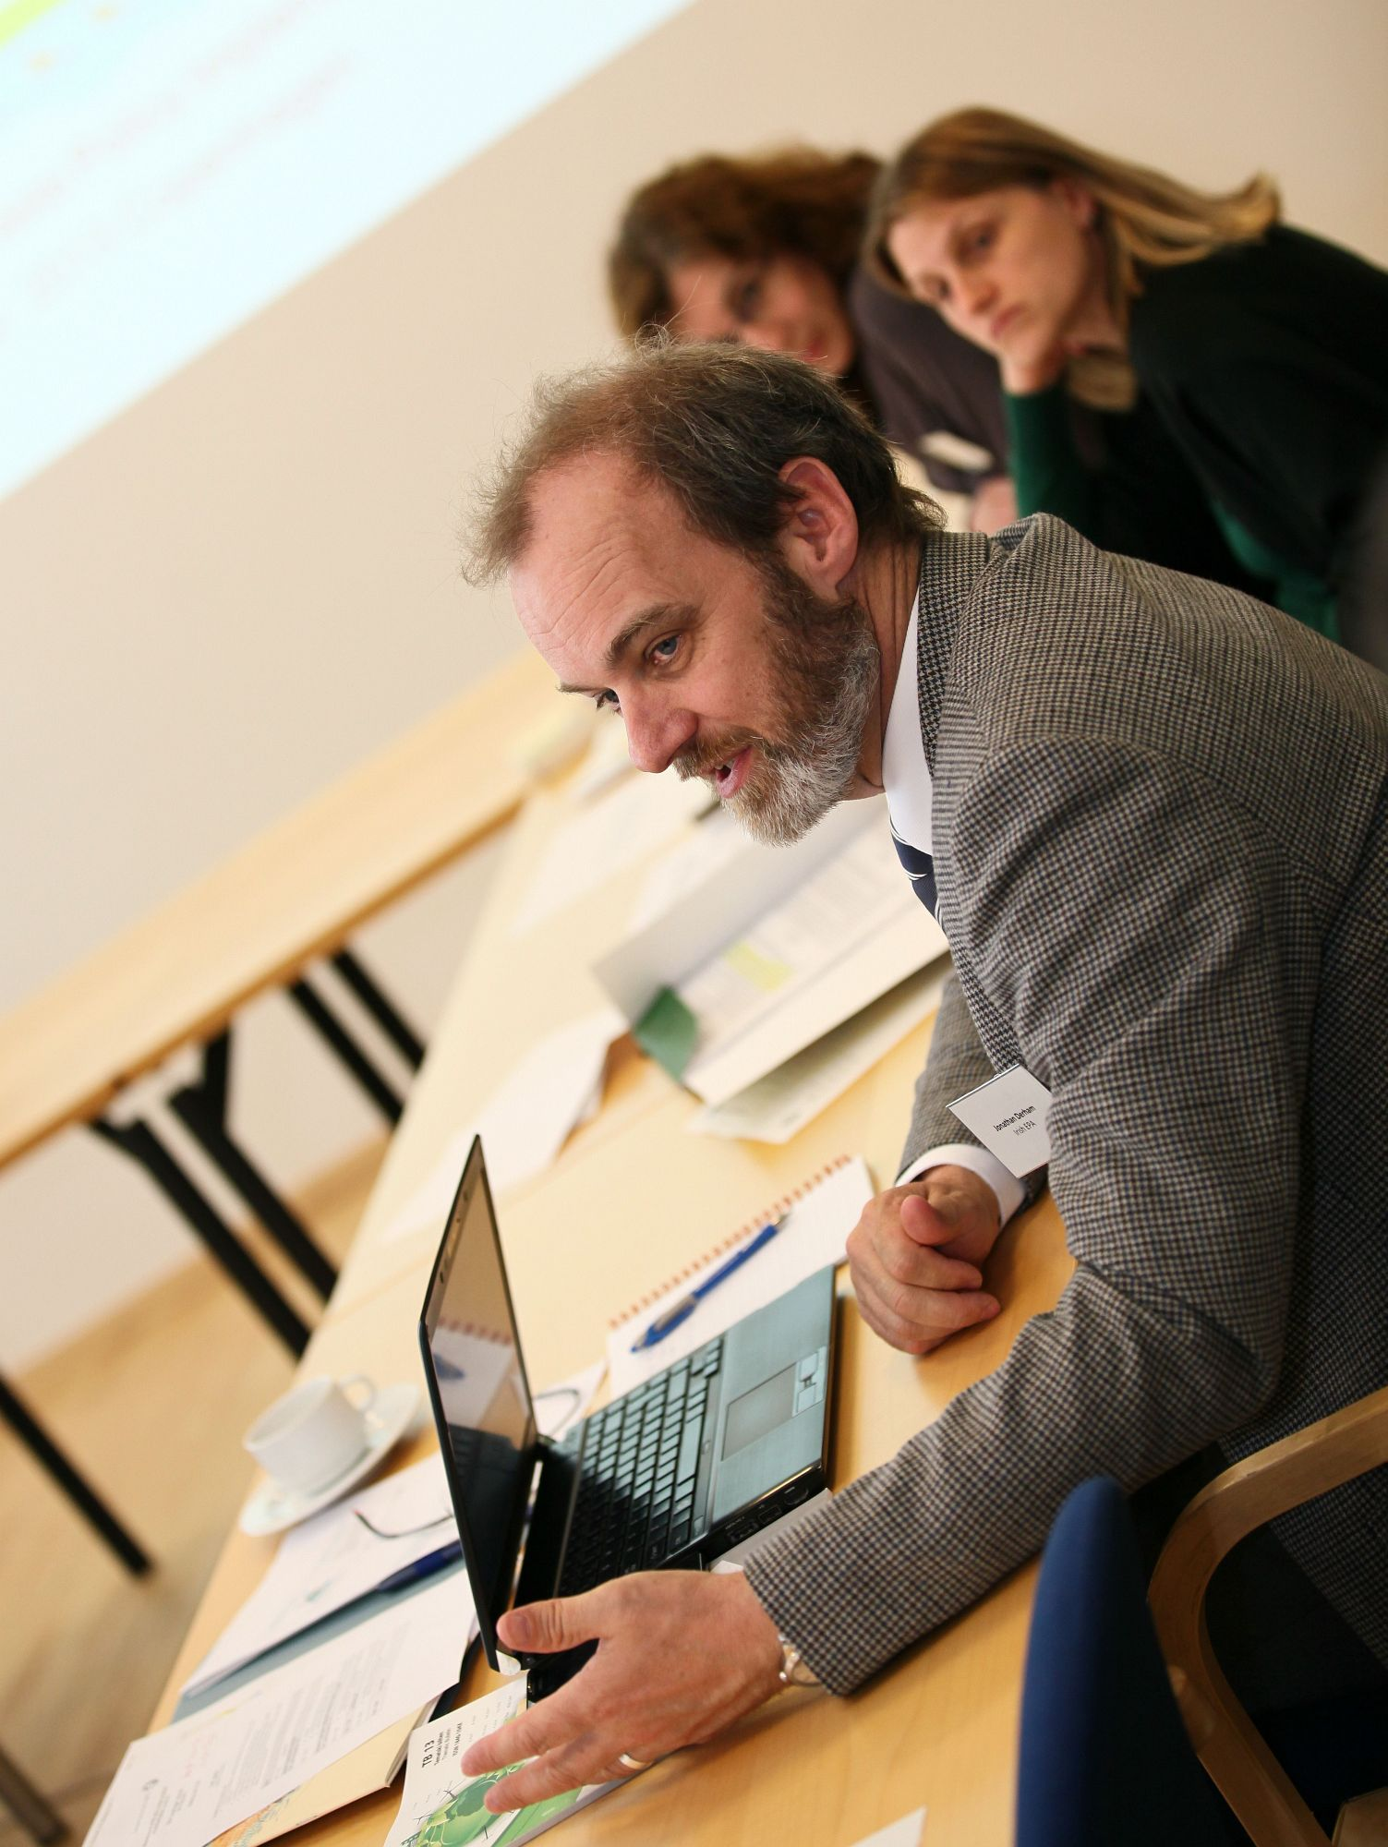
Photo by Pawel Kazmierczyk
Birgitte Kjær presented the questions which the countries were asked to answer for this session about the key challenges they are facing in implementing their Waste Management Plans. List of questions: What are the main challenges in implementing waste management plans? Please identify the main barriers within the challenges. How to overcome the challenges? If you had €10 million for waste management in your country how would you spend the money?
Summary of the country presentations is presented in the following lines.
Albania
Ardita Cakaj presented the situation in Albania. During 2011 Albania adopted the law on Integrated Waste Management. The main challenges are improvement of institutional infrastructure and the cooperation between central and local institutions. There is a huge necessity to set up waste management infrastructure for collection and treatment of waste (see presentation).
Bosnia and Herzegovina
Mirza Agić presented the challenges in the country. A main challenge is the administrative infrastructure (the country is split into two Entities: Republic of Srpska and Federation of Bosnia and Herzegovina, in addition to district Brcko). Bosnia and Herzegovina accounts for 175 municipalities. Federation of Bosnia and Herzegovina has adopted the Waste Management Strategy for a period of ten years (2008-2018). 400 illegal dumps in BiH, only one landfilled certified. There is a strong need to establish a stronger and more effective environment administrative infrastructure in BiH and a realization of the concept of regional waste management (see presentation).
Croatia
Nela Palarić reported that WMP in the country covers the period from 2007 to 2015. The Environmental Protection and Energy Efficiency Fund plays a major role in financing waste management in Croatia. One main challenge in Croatia is the location of waste management centres (see presentation).
The Former Yugoslav Republic of Macedonia
Margareta Cvetkovska presented the main challenges. One challenge is to establish a rationale network of waste treatment and disposal facilities based on the analyses based on market demands for different treatment option of the waste. An incineration plant with heat recovery would be an attractive solution for heating purposes in Skopje. Policy makers need to consider waste management as possibilities for creation of working places (see presentation).
Kosovo under UNSCR 1244/99
Mimoza Hyseni Spahiu explained the situation in Kosovo. The main challenges in waste policy are the lack of law implementation, lack of inter-institutional cooperation and low waste fee payment. No waste management plan is in place. It is expected in 2013. Law on waste was adopted in 2012. About 40% of population pays waste management fees (see presentation).
Montenegro
Vesna Novakovic gave a presentation of the challenges in Montenegro. Preparation of new National WM Plan in line with new WM Law from 2011, is underway. It is expected that the Government of MNE will adopt it no later than the first quarter of 2014. The development of waste infrastructure is hampered by the lack of finances, lack of the system of selective waste collection and lack of urban plans for locations which are needed for building of regional WM centres. Treatment opportunities for hazardous waste are badly needed (see presentation).
Serbia
Ljiljana Djordjevic presented the waste management status of Serbia. A revised National waste strategy of Serbia was adopted in 2010. It is necessary to effectively implement the national program of integrated waste management at all levels, especially at the local level, meaning that recycling processes fully take root at the level of municipalities and cities (especially municipal waste separation processes in households),( see presentation).
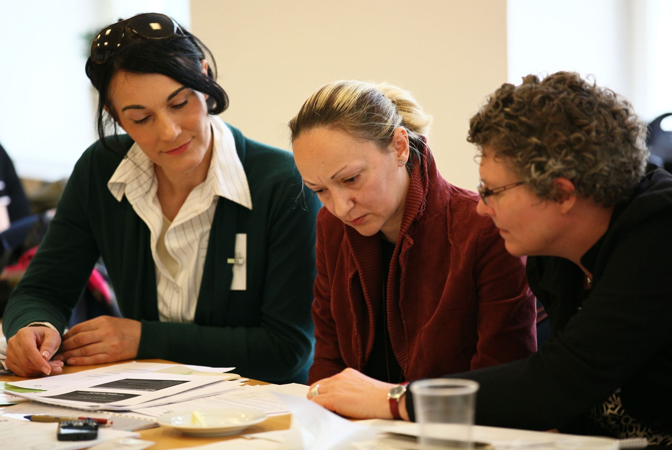Photo by Pawel Kazmierczyk
The presentations pointed at a number of common challenges raised by the countries:
• How to proceed from waste laws/ plans to waste management in practice?
• Improve the infrastructure for collection and waste treatment
• Lack of finances for waste facilities
• Improve monitoring of data
• Lack of public awareness

3.3 Session III – Planning waste treatment capacities for biodegradable waste and sewage sludge
Invited speaker Slavko Dvorsak, Ecologist, Gorenje Surovina,Slovenia, gave a presentation on “Waste treatment of biodegradable waste in Slovenia”. See presentation.
Slovenia has showed progress in the last years in diverting biodegradable waste from landfills. The presentation focused on how to improve the waste management further in Slovenia. In Slovenia it is mandatory to establish separate collection of several materials. Separate collection of kitchen waste (households and also commercial kitchens) door to door has been introduced. The household can chose a bin for separate collection of kitchen waste or to do home composting. Separate collected kitchen waste will be composted or anaerobic digested. Mixed municipal waste will be treated at MBT plants.
Slavko has been a part of the LIFE project BALKWASTE (Waste Network for sustainable solid waste management planning and promotion of integrated decision tools in the Balkan Region) http://www.balkwaste.eu
The project has developed a Decision Support Software Tool in order to support the optimum waste management scenario through the decision making process. The tool focus on Balkan countries with different waste and demographical characteristics and. Guideline can be found here http://www.balkwaste.eu/wp-content/downloads/Manual.pdf
Slavko offered to give more information and guidance on the tool.
The invited speaker Linda Bagge, Senior adviser, Danish EPA gave a presentation about “Waste treatment of sewage sludge in Denmark and other European countries”. See presentation
Linda based her presentation on the implementation of the sewage sludge directive from 1986. There have been several attempts to renew it. However, it has not been successful yet.
Danish limit values are based on the principle that heavy metals and organic pollutants should not accumulate in the soil or effect the environment negative. Therefore, they are a lot stricter than the limit values in the sewage directive. Limit values in other countries can be found in the EC report: Environmental, economic and social impacts of the use of sewage sludge on land http://ec.europa.eu/environment/waste/sludge/pdf/part_iii_report.pdf
New technologies on recycling of phosphorus has been analysed in the Danish Innovation partnership for use of phosphorus from wastewater and sewage sludge. Link to their report with an English summary http://www2.mst.dk/Udgiv/publikationer/2013/01/978-87-92903-82-2.pdf
Link to LCA and cost benefit analysis of sewage sludge
http://www2.mst.dk/Udgiv/publikationer/2013/01/978-87-92903-81-5.pdf
Following Linda Bagge’s presentation there was an active discussion about the problem of using sewage sludge for agricultural purposes, especially in Croatia.
Natalija Golubovac from Croatia EPA gave a presentation on “The challenges of sewage sludge in Croatia”, (see presentation).
In Croatia a large amount of sludge cannot be utilised now because of low interest from the agricultural sector. The current practice in Croatia is the bio-stabilisation of sewage sludge (most commonly with the application of lime) and then storage in temporary disposals.
During the discussion it was said that there are similar problems also in Bosnia and Herzegovina, where there are 27 facilities in total which produce sewage sludge. There is some serious lack of mobile infrastructure resulting in the dumping of most of the sewage sludge because it cannot be transported for further treatment (e.g. lack of trucks). Everybody agreed that certain measures need to be established in order to increase the attractiveness of sewage sludge for agricultural use.
Facilitated discussion with the countries on planning/expanding waste treatment capacities
Delegates were divided in 3 groups, 2 discussing challenges about the treatment of biodegradable waste and 1 group discussing the challenges in the management of sewage sludge.
Results from group 1 on biodegradable waste:
- The responsible authorities must set up regulations for banning biodegradable waste going to landfill.
- Introduce landfill taxes, high enough so no other solutions are cheaper.
- The responsible authorities must set supervision and monitoring mechanisms for the waste that goes to landfill (make sampling analyses etc.).
- Private sector companies should invest in infrastructure (in free markets conditions). Then the municipalities will have 2 possibilities for increasing infrastructure, either employ these private companies or making public-private partnerships. Possibilities for co-financing from EU-funds.
- Household fees for waste management, is the weak point for the West Balkan countries. It is not possible to increase much the waste fees and for this reason funding remains the most critical issue about improving waste infrastructure.
Results from group 2 on biodegradable waste:
- This group started the discussion from the basic challenge the most countries are facing about the definition of biodegradable waste and what is included or not. For example, paper is not included in the definition of biodegradable waste from households in FYR Macedonia. On the other hand, in Ireland, paper, cardboard, timber, food, garden waste, textiles and nappies are all included in the biodegradable waste. See calculations factors in Ireland here:
http://www.epa.ie/pubs/advice/waste/municipalwaste/epaapprovedfactorstocalculatethebmwcontentofmunicipalwastestreams.html and other useful material reporting on biodegradable waste here: http://www.epa.ie/enforcement/lic/bmwreporting/
- Then, talked about how is it possible to motivate the people to pay by weight and not just by using a flat feet as it happens currently in most of the countries.
- They concluded that it is important to introduce a 3 bin collection system. Then the private sector might jump in to take advantage of the already set system of separately recyclable waste and might even further expand it. Still disperse populated and rural areas difficult to include in the collection systems for all the reasons already discussed during Jonathan Derham’s presentation.
- Birgitte Kjær summarised that bring system of separate collection is easier to establish and then in a second stage move on a door-to-door system, but FYR Macedonia commented that there is no motivation for this. Flat fees do not motivate separate collection. Jonathan added that this might start gradually introducing 2 bins first and later go to 3. The separate collection system could have a variation between waste fees, e.g. lower fees for the biodegradable waste bin and higher for the mixed residual waste bin. As it happened in Ireland, collectors (truck drivers) should check themselves the bins while collecting the different bins and if the waste is not satisfactorily separated then they won’t empty it.
- A very serious issue to tackle, common to all countries, is the theft of recyclable materials from recycling centres and bins of dry recyclables.
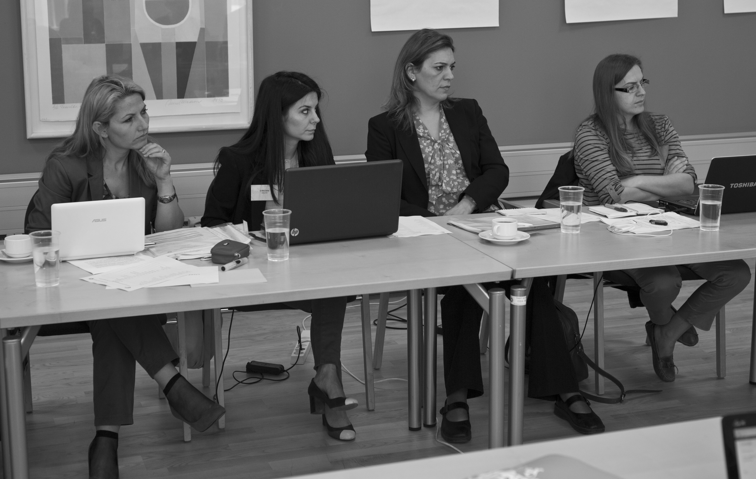Photo by Packo Sanchez Aguado
Results from group 3 on sewage sludge:
- The discussion started concerning issues about the use of the sewage sludge.
- Croatia is not convinced that agricultural application is the best solution, due to strange composition of sewage sludge usually (heavy metals, pharmaceutical, other hormone etc.).
- How to encourage the farmers to use the sewage sludge is another problem discussed. Promoting the use of sludge by paying the farmers is unreasonable. Too expensive, especially when there is so much analysis and testing of sludge and soil in the labs (expensive) before it can be used as a product for agricultural use.
- In Bosnia and Herzegovina there are 27-28 wastewater treatment plants, and the amount of sewage sludge produced is expected to be very high in the future.
- In general there is a need to comply with the directive of sewage sludge and when it concerns drinking water the standards must be even stricter. Jonathan Derham provided the links to Irish guidelines on Organic Waste spreading & Groundwater Protection (incl. Sewage Sludge).
http://www.epa.ie/pubs/advice/water/ground/groundwaterprotectionresponsesforthelandspreadingoforganicwastes.html
http://www.epa.ie/pubs/advice/waste/waste/landspreadingorganicwaste-guidanceongroundwatervulnerabilityassessmento.html
http://www.epa.ie/pubs/advice/waste/waste/epaandapplicationsforlandspreadingbasedongroundwaterprotectioncriteria.html
- Jonathan Derham mentioned about some new technologies which have recently developed for burning sewage sludge for energy recovery. There is a Danish-Irish collaboration technology system that uses sludge for energy recovery when it is too risky to use sewage sludge for food production, application on agricultural land.
Birgitte Kjær wrapped up the workshop’s first day, giving hope to the countries that it is possible to improve and make remarkable improvements in a short-medium term perspective. They could look at the examples of Ireland and Slovenia who have improved very fast over the last 10-15 years.

4 Second day – 31 May

4.1 Session IV – Visit to bio waste handling facility ‘Biovækst’
Visit to Biovækst plant, using dry anaerobic digestion technology for the production of biogas (high methane content) and high quality compost that can be used immediately on agricultural land. More information on the technology can be found here: http://www.aikantechnology.com/
Some highlights from the presentation of the plant:
- Biovækst plant is a public-private partnership owned 50-50 by a private company and 2 inter municipal waste companies. The benefits of public co-ownership are a) the supply of a steady stream of municipal waste and b) the lower interest rates in financing.
- The equipment of the facility is mobile, robust and flexible, so if something is damaged it can be easily and cheaply repaired or replaced.
- The first stage of waste handling at the plant is the opening of the plastic bags and the initial sorting. This is done by a specialised industrial shredder. Around 80% of the impurities are separated in this stage. The rest of the impurities are removed in later stages. The plastic that comes out from this first stage is sent to incineration.
- The waste that comes out from the first stage is mixed with a structural material (could be garden/park waste or wood chips) in a weight proportion 2/3 waste and 1/3 structural material. Sometimes this proportion can be different.
- The mixed waste is then put into a treatment module where the first process is the hydrolysis of the mixture. The mass is sprinkled with digestate liquid which passes through, removing the necessary nutrients and bacteria for digestion, and then it is collected in the biogas tanks, where the actual biogas production takes places.
- After this process, the mix is composted and later put outside in order to mature. Then it is crashed in lesser particles and it’s sold for agricultural use. The compost is a high quality material that has high demand from the local farmers.
- The whole process takes about 5 weeks. Capacity: about 20.000 tonnes per year. Cost: 7 – 9 million EUR. Employment: 3-4 employees (really low), approximately 1 person per 5.000 tonnes of waste.
- Output info (per 1000 tonnes of waste): 80m3 biogas (of which 55m3 methane) which produce 200 kWh of electricity and 200 kWh of heat, in addition to 150 kg compost

4.2 Session V – Setting targets and indicators
Almut Reichel, project manager, EEA, gave a short introduction to the ex-post analysis results and referred to usual common challenges that counties face for collecting data and making indicators.
Birgitte Kjær gave a short presentation “Utilization of waste indicators for planning and monitoring purposes for municipal waste (practical examples)”. Discussion between countries followed.
Croatia is using the indicator generation of MSW per capita. From 2011 Croatia started to include also household like commercial waste in the definition of MSW. Previously, the municipal collection companies didn’t have scale for measuring and therefore the data on waste generated were just estimations. Now they have, so data are more reliable.
Data on packaging waste is confusing because there are several companies operating. The data on packaging waste generation (collection) don’t go to the agency but to the ‘Fund’.
Data on recycling of municipal packaging waste is not included in the data on recycling municipal waste in Croatia. However, Croatia is working on solving this problem.
Jonathan Derham intervened by informing that Ireland has passed a law which obliges all collection schemes (all private companies involved) to report every year about the amounts of waste they have separately collected. They also provide the split between households and industry of packaging waste.
Jasmina Bogdanovic drew attention on the problem of including or not the packaging waste on MSW and urged the countries to include those figures as soon as possible.
Croatia has problem with diverting biodegradable waste from landfills because everything ends up in landfills and as a result, meeting the target of the landfill directive for 2013 would be impossible for Croatia.
Serbia has data for generation of MSW since 2006. Reporting in the beginning consisted only of estimations. From 2008 the reporting of data is better and therefore MSW generation data are more reliable. There was a new by-law about how to measure better MSW about 2 years ago. All MSW goes to landfill, no recycling. There is composition data available. Since 2010 SEPA has been collecting data on WEEE, waste batteries and accumulators, waste tyres and waste oil.
In Montenegro 3 indicators are planned to materialise: generation of MSW, generation of industrial and generation of hazardous. Until now only the indicator on MSW generation is produced. Data which were published in 2011 by the statistical office were very bad. The quality of data for MSW is incompatible between MonStat and the Environment Agency. MonStat receives data from facilities and operators while the agency receives data from municipalities. Monstat figures appear to be much higher, not comparable with agency figures. Currently both authorities have been working together on a project about harmonising their reporting and resolving discrepancies.
In Montenegro there is a new law which obliges all landfill facilities to have measurement instruments for the amounts of waste. There are no recycling facilities in Montenegro, but there have been 3 facilities that do some pre-treatment (plastic, metal, paper/cardboard).Montenegro has no immediate plans to make a C&D indicator.
In Kosovo under UNSCR 1244/99 MSW generation is the only indicator used. They have similar problems as Montenegro. Agency gets data from public companies. The Statistical office shows much higher data but in Kosovo under UNSCR 1244/99 there are more than 400 illegal dumpsites which are probably not included in the data from the public companies.
Albania: There are 2 indicators used, the MSW generation indicator and C&D waste generation. They don’t have separate collection so no recycling indicators can be made easily.
Bosnia and Herzegovina: The Statistical office calculates some indicators which are the MSW generation, industrial waste (hazardous, non-hazardous) generation, and mining waste generation (according to NACE Rev. 1). Data exist from 2003 but before 2008 they are just estimates. This year they will try for the first time to do a C&D waste survey. There are also some pilot surveys from separate collection companies. This year they plan to have the survey for C&D waste again to see the development through the last 2 years.
Jonathan Derham suggested that they could start with estimations (truck size, container) for the C&D waste. Good examples of Irish indicators can be found in the national waste report: http://www.epa.ie/pubs/reports/waste/stats/nationalwastereport2011.html
Bosnia and Herzegovina informed that they have a very good document providing factors for estimations of waste amounts (Tonne) based on the volume of waste (m³). Birgitte Kjær asked if it would be possible for Bosnia and Herzegovina to share the document with the other countries. Bosnia and Herzegovina replied positively.
In FYR Macedonia, the ministry of environment and physical planning monitors all waste streams but currently there are indicators only for the MSW generation, the amount of waste sent to landfill, packaging put on the marked, packaging waste collected, packaging waste recycled, industrial hazardous waste generation.
For MSW it is difficulty to calculate because data come in different values (e.g. tonnes, m³). Challenge is the consistency of information they receive from municipalities. For hazardous waste, the specific definition of waste types is missing.
Jasmina Bogdanovic made clear that the EEA is going to use only Eurostat data for their analysis, so countries should try to come as close as possible to the Eurostat guidelines.

4.3 Session VI: next step
Birgitte Kjær showed the EIONET platform on the internet and asked the participants if they are familiar with it and if they use it. Not many use the Eionet forum and it was agreed that we will provide all participants with username and password in order for them to access all the uploaded material.
Birgitte Kjær asked the participants about what kind of help they would require from the EEA (helpdesk, news mail, thematic fact sheets, webinar etc.) Also, if they have some ideas about what issues and themes they would like to know about or discuss among the countries. FYR Macedonia has asked for help on the preparation of an Ex-post analysis of MSW. If other countries would like the project tem would be happy to support them.
The participants took some minutes to put up their own ideas on the posters and prioritize them.
Ideas for support and networking in 2013
- Integration of waste plans with: spatial plans, waste prevention programs and biodegradable waste management plan – 0 points
- Waste characterisation – webinar and/or methodology papers – 1 point
- Waste oil management – 0 points
- Treatment of waste with asbestos – factsheets - 6 points
- State of the art regarding incineration of hazardous waste in EU – factsheets – 4 points.
- End of waste status – guideline – 0 points
- Support for improving of waste reporting – 2 points
- Waste installation permits in EU, examples - IPPC planning issues – 6 points.
- Data collection and reporting – 1 point.
- More on waste indicators and data – 6 points.
- National register – 0 points.
- Factors for calculating waste volume to weight for different fractions – 1 point.
- Advises for upgrading of waste management information system according to EU legislation – 2013/2014 – 1 point.
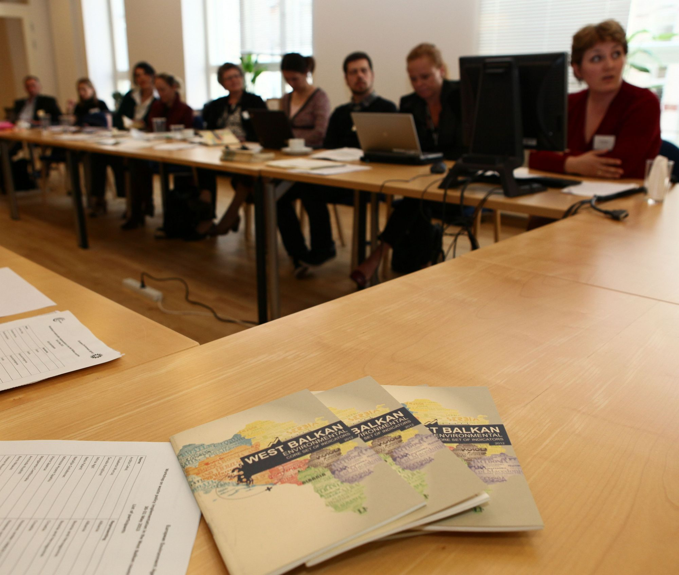Photo by Pawel Kazmierczyk
Ideas for future collaboration in the waste area 2014
- Waste statistical survey – techniques/methods
- Life cycle evaluation methodologies (hierarchy)
- Relationship between animal by-products legislation and biodegradable municipal waste management
- Consistency of definitions
- IT systems to support waste regulation and statistics
- Ground water vulnerability assessments for landspreading of sewage sludge
- Drafting of waste collection permits
Birgitte Kjær thanked for all the ideas and promised come to back to the participants with a proposal for further activities in 2013.
Jasmina Bogdanovic wrapped up the discussions and thanked everyone for their participation and contribution to the workshop.
The workshop ended at 14:30.
Evaluation of the workshop
We would like to thank the participants for their useful comments returned with the evaluation of the workshop. We will take them into account when preparing future workshops. The workshop can be characterised as a great success based on the overall result of the answers of the evaluation. The large majority (12 out of 13) rated the workshop as excellent. The majority of answers is ‘excellent’ for all questions within the different sessions. In general the most appreciated session seems to be the excursion to the bio waste treatment plants and Session II Challenges in implementing Waste management plants.

Annex I: List of participants
Workshop on waste policy implementation in the West Balkan countries
30-31 May 2013
List of participants

Name | Representing | e-mail
Ardita Cakaj | Albanian Agency of Environment, Directory of State of Environment | arditacakaj@gmail.com
Elisabeta Murcaj | Albanian Agency of Environment, Directory of Environmental Monitoring | re2xh@hotmail.com
Ševala Korajčević | Agency for Statistics of Bosnia and Herzegovina, Transport, Environment and Energy Statistics Department | sevala.korajcevic@bhas.ba
Mirza Agić | Agency for Statistics of Bosnia and Herzegovina, Transport, Environment and Energy Statistics Department | mirza.agic@bhas.ba
Nela Palarić | Croatian Ministry of Environmental and Nature protection, Department for waste management licences and transboundary movement of waste | Nela.Palaric@mzoip.hr
Natalija Golubovac | Croatian Environment Agency, Waste Department | Natalija.Golubovac@azo.hr
Mimoza Hyseni Spahiu | Kosovo Environmental Protection Agency, Environment monitoring, reporting and assessment Directory | Mimoza.Hyseni@rks-gov.net
Vlora Spanca | Kosovo Environmental Protection Agency, Environment monitoring, reporting and assessment Directory | Vlora.Spanca@rks-gov.net
Margareta Cvetkovska | Macedonian Ministry of Environment and Physical Planning | M.Cvetkovska@moepp.gov.mk
Arminda Rushiti | Macedonian Ministry of Environment and Physical Planning | A.Rushiti@moepp.gov.mk
Boris Nisavic | Montenegro Environmental Protection Agency, Permitting sector | boris.nisavic@epa.org.me
Vesna Novakovic | Montenegro Environmental Protection Agency, Sector for nature protection, monitoring, analysis and reporting | vesna.novakovic@epa.org.me
Ljiljana Djordjevic | Serbian Environmental Protection Agency (SEPA), Department of National PRTR Register | ljiljana.djordjevic@sepa.gov.rs
Speakers | Representing | e-mail
Jonathan Derham | Irish EPA | j.derham@epa.ie
Slavko Dvorsak | Surovina, Slovenia | slavko.dvorsak@surovina.si
Linda Bagge | Danish EPA | bagge@mst.dk
Facilitators | Representing | e-mail
Jasmina Bogdanovic | European Environment Agency | Jasmina.Bogdanovic@eea.europa.eu
Birgitte J. Kjær | European Topic Centre on SCP | bjk@etc.mim.dk
Leonidas Milios | European Topic Centre on SCP | lemil@etc.mim.dk
Mia Farré Jensen | European Topic Centre on SCP | mifje@etc.mim.dk

Annex II: Workshop agenda
2013 Workshop on waste policy implementation
in the West Balkan countries
EEA, Copenhagen, Denmark
30-31 May 2013
Meeting room 8.2.30
Agenda
The objectives of the workshop are:
- To discuss the core elements in waste policy implementation (waste management plan, waste hierarchy etc.)
- To exchange experiences on the implementation of waste management plans
- To discuss different waste treatment options and methods to plan waste treatment capacities
- To build capacity in use of indicators and target setting for waste management
- To strengthen the Eionet network and cooperation between the waste experts within the West Balkan countries and those of the EEA

Day 1, Thursday, 30 May
9:00 – 9:30 | Registration
Session I: Opening of the workshop
Chair: Jock Martin, Head of Programme, Integrated Environmental Assessments, EEA
9:30 – 10:15 | - Welcome and opening by Jock Martin, Head of Programme Integrated Environmental Assessments (IEA), and Peder Jensen, Head of Programme, Governance and Networks (GAN), EEA  - Introduction to the objectives and structure of workshop by Birgitte Kjær ETC/SCP and Jasmina Bogdanovic, EEA  - Overview on the latest EEA/Eurostat/EC waste activities by Jasmina Bogdanovic, EEA
Session II: Challenges in implementing Waste Management Plans (WMP)
Chair: Jasmina Bogdanovic, EEA
10:15 – 11:00 | - The success of implementing the Waste Management Plan in Ireland by  Dr Jonathan Derham, EPA (presentation and Q&A)
11:00 – 11:30 | Coffee/tea break
11:30 – 13:00 | - Key challenges in implementing Waste Management Plans in the West Balkan countries (10-15 minutes per country)
13:00 – 14:00 | Lunch break

Session III: Planning waste treatment capacities for biodegradable waste and sewage sludge
Chair: Birgitte Kjær, ETC/SCP
14:00 – 15:30 | - Waste treatment of biodegradable waste in Slovenia by Slavko Dvorsak, Surovina d.d (presentation and Q&A)  - Waste treatment of sewage sludge in Denmark and other European countries by Linda Bagge, Danish EPA (presentation and Q&A)
15:30 – 16:00 | Coffee/tea break
16:00 – 17:30 | - Introduction to the discussion: The challenges of sewage sludge in Croatia by Natalija Golubovac, CEA (10 min)  - Facilitated discussion with the countries on planning/expanding waste treatment capacities  - Wrap-up of the first day

From 18:30 Informal workshop dinner at Riz-Raz, Kompagnistræde 20 (10 minutes walking distance from EEA premises)
Day 2, Friday, 31 May
Session IV: Visit to bio-waste handling facility
7:45 – 11:00 | - Excursion to Biovækst - bio-waste handling facility. The plant integrates anaerobic digestion with in-vessel composting  - The bus will leave from the hotel Opera in Tordenskjoldsgade 15 at 7:45  - Please do wear practical shoes (no high heels allowed)
Session V: Setting targets and indicators
Chair: Jasmina Bogdanovic, EEA
11:00 – 12:30 | - Introduction to the discussion: Utilization of waste indicators for planning and monitoring purposes for municipal waste (practical examples) by Birgitte Kjær ETC/SCP (15 min)  - Countries’ feedback on indicators use for monitoring of targets, including future plans/next steps  - Facilitated discussion with countries
12:30 – 13:30 | Lunch break
Session VI: Next steps
Chair: Birgitte Kjær, ETC/SCP
13:30 – 14:15 | - Facilitated discussion on next steps of the EPA project (e.g. other support and helpdesk in 2013) and future cooperation  - Wrap-up of the second day
14:15-14:30 | Closing and evaluation of the workshop

