Eionet webinars on resource efficiency policies
Webinar on Raw Material Consumption and a European target for resource efficiency

Friday, 5 December 2015, 11:30 - 13:00 (CET)

Agenda and background paper

Prepared by:

Arkaitz Usubiaga (Wuppertal Institute)
European Topic Centre on Waste and Materials in a Green Economy

ETC/WMGE 2.1.1.d Task Manager:
Nora Brüggemann (CSCP)

EEA project manager:
Paweł Kaźmierczyk

Documents, presentations and video recordings from earlier webinars on resource efficiency can be found at the Eionet Forum: http://forum.eionet.europa.eu/nrc-scp-waste/library/eionet-webinars/webinars-resource-efficiency

Contents
1 Objectives of the webinar 3
2 Introduction to Raw Material Consumption 4
2.1 Policy context 4
2.2 Measuring resource efficiency 4
2.3 Raw Material Consumption 5
3 Webinar Agenda 8
4 Instructions how to join the webinar 9

Objectives of the webinar

Webinars on resource efficiency policies and instruments are organized by the European Environment Agency for the Eionet network, to support exchange of information and sharing of experience among national institutions which are responsible for practical implementation of resource efficiency policies at the country level.

The main objectives of the webinars are to keep countries informed about upcoming EU policy initiatives, and to provide a forum where countries themselves can present examples of policy initiatives which they adopt under the heading of resource efficiency.

Previous webinars covered such topics as: national strategies for resource efficiency; targets and indicators; industrial symbiosis; and circular economy.

Raw Material Consumption (RMC) was recently identified as a candidate for indicator to measure resource productivity. The European Resource Efficiency Platform called for the adoption of a target based on RMC to encourage further action. In October 2014 the Council of the European Union embraced that recommendation and stressed that such a target “would provide the much needed link between the measures dealing with economic policies and those addressing natural resource challenges.”

Eurostat has developed a model to estimate the raw material equivalents (RME) of imported and exported goods for the aggregated EU-27 economy (i.e. extra-EU trade). For 2012, Eurostat estimated the exports in RME to amount to 4.6 tonnes per capita which is almost four times the simple weight of exported products. The import of goods in RME is estimated at 7.2 tonnes per capita which is over twice as much as the simple weight of imported products. While Eurostat has compiled RMC time series for the EU27, it is currently envisaged that national statistical offices will compile national RME and RMC data (in the interim continuing to use Domestic Material Consumption – DMC – to monitor resource productivity). At present, six countries are working to develop - on a pilot basis – RME and RMC national figures. They are: France, Germany, Italy, Netherlands, Switzerland and United Kingdom.
The webinar will begin with a policy update by Mr. Werner Bosmans from the European Commission, covering recent initiatives and outlook for the theme of resource efficiency and circular economy, and in particular discussions related to resource productivity indicators and a target. This will be followed by a presentation by Mr. Stephan Moll from Eurostat, who will introduce the concept of raw material equivalents and the Raw Material Consumption indicator, discuss its policy significance and reflect on trends that emerge when using RMC and DMC. Finally, Mr. Harry Lehmann from UBA will present experience in Germany with using RMC for guiding resource efficiency policies.

As promised during the last webinar, we will now use an upgraded version of Webex webinar software, which allows up to 100 participants to take part. You will no longer need to use the telephone for audio - everything will be run over the internet (VoIP). To participate in the webinar you need a computer with a fast internet connection, and equipped with a microphone and speakers (or a headset). Detailed joining instructions are provided at the end of this document.

Introduction to Raw Material Consumption

Policy context
The Europe 2020 Strategy defines the milestones for the EU to become a smart, sustainable and inclusive economy (European Commission, 2010). The strategy is built around seven mutually reinforcing flagship initiatives, one of which has resource efficiency at its core (European Commission, 2011a). As a follow up to this flagship initiative, the Commission adopted the Roadmap to a Resource Efficient Europe in order to set a framework for action that would pave the way towards an EU smart, sustainable and inclusive economy that by 2050 has grown in a way “that respects resource constraints and planetary boundaries, thus contributing to global economic transformation” (European Commission, 2011b, p. 3). The 7th Environmental Action Programme also made reference to the role resource efficiency should play in this transformation by including it in one of its thematic priorities, namely to turn the Union into a resource- efficient, green and competitive low-carbon economy (European Commission, 2014a).

More recently, the Commission’s Communication on the Circular Economy acknowledged that moving “towards a more circular economy is essential to deliver the resource efficiency agenda established under the Europe 2020 Strategy for smart, sustainable and inclusive growth. Higher and sustained improvements of resource efficiency performance are within reach and can bring major economic benefits” (European Commission, 2014b, p. 2). A similar message can be extracted from the most recent Council conclusions, which also call for a better integration of resource efficiency in the EU 2020 Strategy (Council of the European Union, 2014).

Measuring resource efficiency
The European Commission arranged the so-called resource efficiency scoreboard in a three-layered pyramid structure (European Commission, 2011c) to monitor progress towards the objectives of the Resource Efficiency Roadmap:

First tier: the lead indicator
The Commission proposed a provisional lead indicator, resource productivity, measured by the ratio of GDP to DMC, (expressed in Euro/tonne) where a higher ratio indicates better performance.

Second tier: a dashboard of macro-indicators on water, land and carbon
As the lead indicator is unable to illustrate the complexity of resource use impacts and their interrelations covering only material resources and has a national production perspective, it is complemented with a dashboard of macro consumption and production indicators on water, land and carbon. This dashboard of indicators focuses on clear changes or flows of main resources.

Third tier: thematic indicators for monitoring policy effectiveness
The main objective of the third tier of the pyramid is to cover the key thematic areas of the Roadmap measuring performance on the related actions and milestones. The Roadmap included almost 40 indicators for the third layer.

Recent policy discussions on the indicator set and targets for resource efficiency explore a possibility for RMC to complement / replace DMC as the denominator in the headline indicator of resource productivity. Although RMC is not yet fully consolidated in the European environmental accounting system, it seems likely that it will gain higher prominence in the near future (European Commission, 2014b). In this context, the European Resource Efficiency Platform (2014) even called for the adoption of a target based on RMC to encourage further action even if it is at EU level and non-binding. More recently the Council of the European Union (2014, p. 4) embraced that recommendation and stressed that such a target “would provide the much needed link between the measures dealing with economic policies and those addressing natural resource challenges.” The possibility of setting a quantitative goal was specifically addressed in other of the annexes of the circular economy communication (European Commission, 2014c).

Raw Material Consumption
As part of the MFA framework, DMC measures the total quantity of materials used within an economic system, excluding indirect flows (Figure 1). DMC is the result of summing the used fraction of domestically extracted materials (Domestic Extraction Used – DEU) and the weight of imports, and extracting the weight of the exported goods.

Thus, DMC is the closest equivalent to aggregate income in the conventional system of national accounts (Lutter and Giljum, 2014) and is often interpreted as an indicator for potential environmental pressures related to domestic material use, as it comprises all materials that are directly used in the domestic economy thereby contributing to a country’s environmental pressures on the material output side in terms of waste and emissions (Femia and Campanale, 2013).

RMC, on the other hand, is equivalent to DMC when the direct and indirect used fraction of material flows of traded goods and services are completely accounted for. This is done by expressing imports and exports in so-called raw material equivalents. RMC is considered a more appropriate indicator to account for the whole production chain of goods and services related to final consumption, since DMC does not properly account for burden shifting between countries.

Figure 1: Material flow indicators
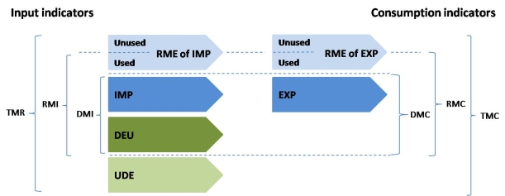
Abbreviations: DEU: Domestic Extraction Used, UDE: Unused Domestic Extraction, IMP: Imports, EXP: Exports, RME: Raw Material Equivalents, DMI: Direct Material Input, DMC: Domestic Material Consumption, RMI: Maw Material Input, RMC: Raw Material Consumption, TMR: Total Material Requirement, TMC: Total Material Consumption
Source: www.materialflows.net

Eurostat has recently implemented a method to estimate the RMC of EU27 (Schoer et al., 2012). Preliminary results show that the main contributor to DMC and RMC is non-metallic minerals (including sand and gravel) (Figure 2). The main differences between both indicators are related to metal ores.

Figure 2: Contribution of different material categories to selected MFA indicators
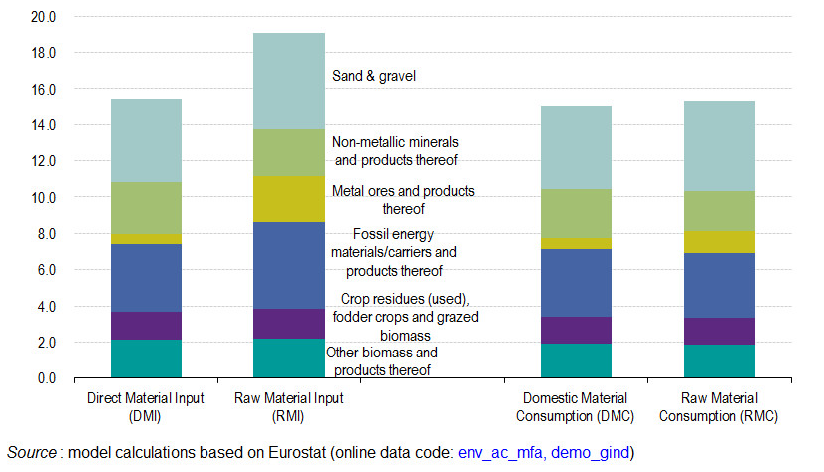

Over time, the ratio RMC/DMC has varied from 1.04 to 1.08 for EU27 (Figure 3). The ratio by material category remains relatively constant except for metal ores (represented in the right-side y axis). In the latter case, the ratio ranges from 2.16 to 4.05.

Figure 3: Ratio between RMC and DMC, including by material category
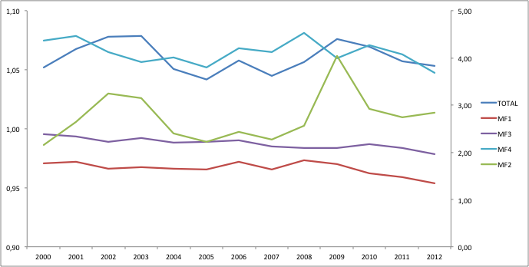
Notes: The material category MF2 is represented in the right side y axis.
Abbreviations: MF1: Biomass, MF2: Metal ores (gross ores), MF3: Non-metallic minerals, MF4: Fossil energy carriers/materials
Source: Based on Eurostat data

Based on the same or similar approaches, several countries (France, Germany, Italy, Netherlands, Switzerland and United Kingdom), have started to make their own estimations. The differences between RMC and DMC trends are more notable than when looking at individual countries than at the EU27 as a whole.

Nevertheless, the calculation of RMC is not limited to national statistical offices. Several researchers are using different tools to do so (see for example (Arto et al., 2012; Tukker et al., 2014; Wiedmann et al., 2013)).

The following links provide more information about Eurostat’s activities on material flow accounting:
http://epp.eurostat.ec.europa.eu/statistics_explained/index.php/Material_flow_accounts
http://epp.eurostat.ec.europa.eu/portal/page/portal/environment/material_flows_and_resource_productivity

References
Arto, I., Genty, A., Rueda Cantuche, J.M., Villanueva, A., Andreoni, V., 2012. Global Resources Use and Pollution, Volume 1 / Production, Consumption and Trade (1995-2008), JRC Scientific and Policy Reports.
Council of the European Union, 2014. Council conclusions on Greening the European semester and the Europe 2020 Strategy - Mid-term review, Environment Council meeting. Luxembourg.
European Commission, 2010. Europe 2020. A strategy for smart, sustainable and inclusive growth. COM(2010) 2020 final.
European Commission, 2011a. A resource-efficient Europe – Flagship initiative under the Europe 2020 Strategy. COM(2011) 21.
European Commission, 2011b. Roadmap to a Resource Efficient Europe. COM(2011) 571 final.
European Commission, 2011c. Analysis associated with the Roadmap to a Resource Efficient Europe Part II. SEC(2011) 1067 final.
European Commission, 2014a. General Union Environment Action Programme to 2020 - Living well, within the limits of our planet.
European Commission, 2014b. Towards a circular economy: A zero waste programme for Europe. COM(2014) 398 final.
European Commission, 2014c. Analysis of an EU target for Resource Productivity. Commission Staff Working Document. SWD(2014) 211.
European Resource Efficiency Platform, 2014. Manifesto & Policy Recommendations.
Femia, A., Campanale, R.M., 2013. On Raw Material Equivalents and their correct use in Resource Productivity (RP) indicators, London Group on Environmental Accounting XVIII meeting, November 2013 MFA/Waste Session. London.
Lutter, S., Giljum, S., 2014. Demand-based measures of material flows: A review and comparative assessment of existing calculation methods and data options. Presented at the OECD international expert workshop on "Demand-based measures of material flows and carbon. 2-3 July 2014, OECD Conference Centre, Paris.
Schoer, K., Glegrich, J., Kovanda, J., Lauwigi, C., Liebich, A., Buyny, S., Matthias, J., 2012. Conversion of European product flows into raw material equivalents. Commissioned by Statistical Office of the European Communities – Eurostat; Directorate E – Agriculture and Environmental Statistics; Statistical Cooperation Unit E3: Environment statistics.
Tukker, A., Bulavskaya, T., Giljum, S., de Koning, A., Lutter, S., Simas, M., Stadler, K., Wood, R., 2014. The Global Resource Footprint of Nations. Carbon, water, land and materials embodied in trade and final consumption calculated with EXIOBASE 2.1. Leiden/Delft/Vienna/Trondheim.
Wiedmann, T.O., Schandl, H., Lenzen, M., Moran, D., Suh, S., West, J., Kanemoto, K., 2013. The material footprint of nations. PNAS 201220362. doi:10.1073/pnas.1220362110

Webinar Agenda

Eionet webinars on resource efficiency policies
Webinar on Raw Material Consumption and a European target for resource efficiency

5 December 2014, 11:30 - 13:00 (CET)
Webinar IT platform will be open for joining at 11:00 (CET) - to log in please follow detailed instructions in the next section
Raw Material Consumption - policy context
11:30 | - Welcome, introduction to the new ETC/WMGS and technical briefing by Paweł Kaźmierczyk (EEA) and Arkaitz Usubiaga (ETC/WMGE)
11:40  –  12:05 | - Policy update from the European Commission: recent initiatives and upcoming work on resource efficiency and circular economy, RMC as a newly proposed indicator to measure resource efficiency by Mr. Werner Bosmans, DG Environment (15 min presentation + 10 min Q&A)  Please use the chat function to send your questions directly to the user ‘EEA Event/ HOST’ who will collect questions and comments during the presentations.
12:05  -  12:30 | - Raw Material Consumption – Eurostat’s work on a new indicator to measure resource productivity: by Mr. Stephan Moll, Eurostat (15 min presentation + 10 min Q&A)  Please use the chat function to send your questions directly to the user ‘EEA Event / HOST’ who will collect questions and comments during the presentations.
Raw Material Consumption in action
12:30  –  12:55 | - National experience with using RME / RMC in Germany by Mr. Harry Lehman, UBA Germany (15 min presentation+ 10 min Q&A)  Please use the chat function to send your questions directly to the user ‘EEA Event / HOST’ who will collect questions and comments during the presentations.
Wrap up and closing
13:00 | Wrap-up by Paweł Kaźmierczyk (EEA)

Instructions how to join the webinar
Thank you for your interest in the upcoming Resource Efficiency Webinar on RMC and European target for resource productivity. The webinar will take place on Friday 5 December from 11.30 – 13.00 (CET). We will open the webinar for login at 11.00. To participate, you will need to:
- Pre-register for the webinar
- Test before the event that your equipment is configured properly
- Log in on the day of the webinar
Below you will find detailed instructions for each of the steps above.
- To register for the webinar:
To register for the Webinar please click the link below and complete the form with the information requested:
http://forum.eionet.europa.eu/nrc-scp-waste/library/eionet-webinars/webinars-resource-efficiency/5th-webinar-rmc-and-target-european-resource-productivity-5-dec-2014/webinar-raw-material-consumption-and-european-target-resource-efficiency/participants/subscriptions/subscribe

When you click on the link, you will find two buttons to sign in: one to use if you have an Eionet account, and another if you don’t. Please choose the one which is appropriate and follow the instructions.

- Technical test of your equipment (ahead of the webinar)
A few days before the event, we kindly ask you to test your equipment (microphone and speakers, or headset etc.) to make sure that everything is in configured properly and in good order.

To do an interactive test with WebEx (which you can do any time), please click on: http://www.webex.com/test-meeting.html

When a welcome screen comes up, we recommend that you don’t install anything but instead click on ‘run a temporary application’ (illustrated with a red arrow on the figure below) and then when another small window pops up, you click on RUN (marked with a green arrow).

The screenshot below shows a dialogue window for Internet Explorer. If you are using a different browser, your window may look different, but there will always be an option to ‘run a temporary application’- click on that, and run the file that pops up / downloads.

NB, please remember to do this test using the very computer / equipment which you will be using on the day of the webinar.

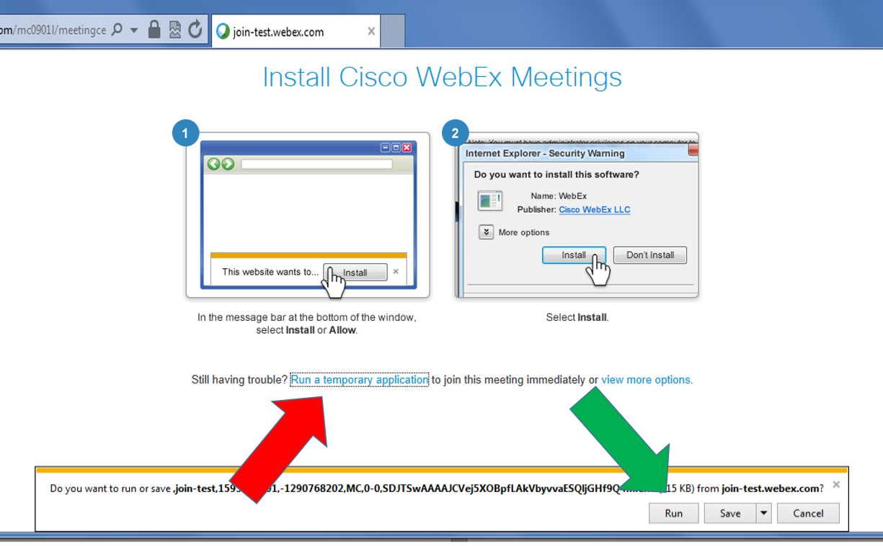

After the computer checks the configuration, you should get a message ‘Congratulations, your system is now set up properly’

If you experience any technical problems, please contact Mr. Orjan Lindberg: Orjan.Lindberg@eea.europa.eu

- To log in (on the day of the Webinar):
A few days before the beginning of the webinar you will receive, at the email address which you registered with, an email message with the link to join the webinar. On the day of the webinar, starting at 11.00 CET, please click on the link and then on "Join Now".
You will be asked to insert your name and email address. Once done, you will be directed to the page where you can choose how to access to the webinar.
When the browser opens, we advise you to select the ‘Run a temporary application’ (identically to the explanation in the previous section). Using this temporary application you should be able to access the webinar within seconds, and this will not attempt to install anything on your computer (you will not be asked for an ADMIN password).
For any further questions, please do not hesitate to contact Marco Veneziani (marco.veneziani@eea.europa.eu) at any time.

