Log-in instructions for participants

EEA/Eionet star resource efficiency webinar –
Mr. Frans Timmermans on the Circular Economy

Tuesday 1 March 2016, 13:00– 14:00 (Central European Time),

Open for login at 12:30

Dear Colleagues,

Thank you for registering for the EEA/Eionet star resource efficiency webinar with First Vice President of the European Commission Mr Frans Timmermans. It will take place on Tuesday, 1 March 2016, between 13:00 and 14:00 CET (=Brussels, Berlin, Paris, Warsaw, etc). You can log in from 12:30 onwards.

Mr Timmermans requested to make tomorrow’s webinar not just an opportunity to present his views and plans of the Commission, but also to be an opportunity to explore with the countries how to develop policies on circular economy, and how to do it in a fast and effective way.

Following a preference of Mr Timmermans to engage in a discussion, we will strengthen the interactive part of tomorrow’s webinar.

The webinar will start with introductory remarks by EEA Executive Director Mr Hans Bruyninckx, followed by a short update by FVP Timmermans in the circular economy package and upcoming initiatives. This will be followed by an extended question and answer and discussion bloc, which will take up bulk of tomorrow’s event. So do have your questions and comments ready.

For the newcomers to EEA resource efficiency webinars, the technical (IT) aspect of webinars is quite straightforward. You will need a computer with a fast and stable internet connection, an external microphone (the one which you plug in) and speakers, or a head set (a microphone and headphones in one).
In this document, we provide detailed instructions how to:
(1) to do a simple self-check to make sure that your equipment is configured properly for running Webex (this is important to do before the webinar, because in case of problems you will have time to request help from your IT team)
(2) to log in on Tuesday 1 March, using the event-specific link provided in this document.

In case of problems, you can reach us by email at Marco.Veneziani@eea.europa.eu

- Technical test of your equipment (self-check)
Please do this test before logging in to the webinar – it takes less than 5 minutes. Remember to do this test using the same computer (with the same equipment/configuration) which you will be using for the webinar.

To do an interactive test with WebEx (self-check which you can do at any time), please click on: http://www.webex.com/test-meeting.html

When a welcome screen comes up, you will be asked to give your name and email address. Then, click on the big green button TEST A MEETING to start the program.

NOW THE IMPORTANT PART: We recommend that you don’t install anything but instead click on ‘run a temporary application’ (illustrated with a red arrow on the figure below) and after another small window pops up, you click on RUN (marked with a green arrow).

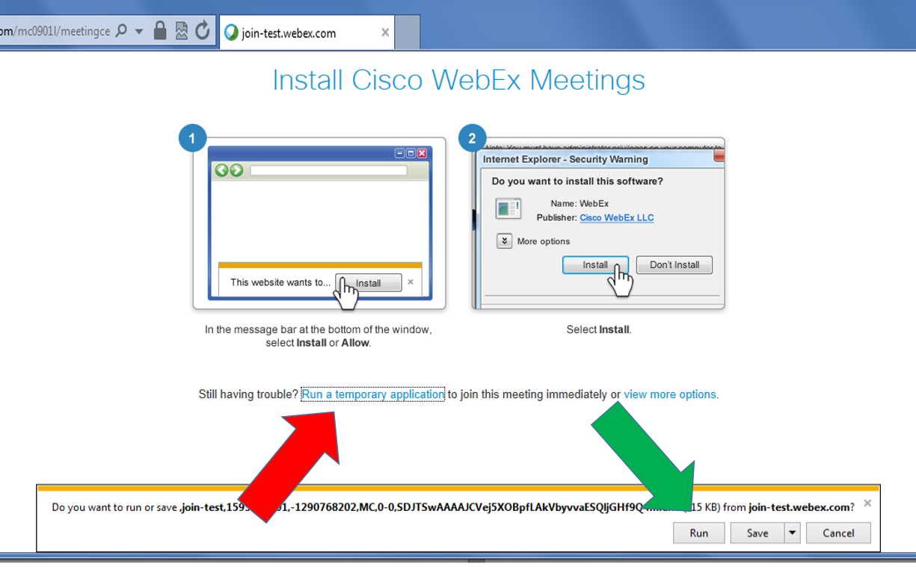

The screenshot above shows a dialogue window for Internet Explorer

In Chrome web browser, you will see the following:

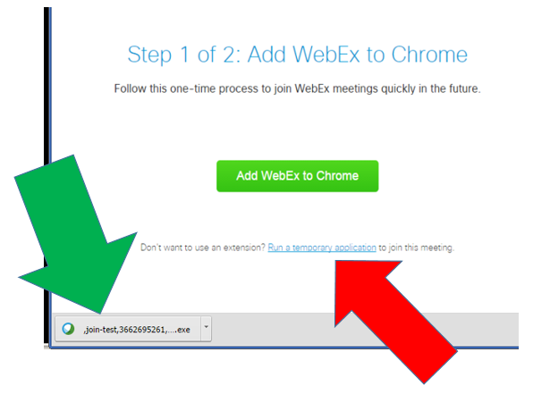

As before, please remember to first run a temporary application (red arrow) and then double-click on the temporary exe file which will download (green arrow).

If you are using a different browser or operating system, your window may look different, but there will always be an option to ‘run a temporary application.’

Opting for the ‘temporary application’ means that nothing will attempt to install itself permanently on your computer, a step which would typically require from you an ADMIN password (i.e., on a computer at work).

FOR MAC USERS ONLY: Using a Mac / iOS based computer, the procedure will be a little different. Most Mac users find their way somehow, but if you prefer we can send you iOS instructions. If you so wish, please send us an email no later than 12noon.

After the computer checks the configuration (it may take a few moments so please wait a little), you should get a message ‘Congratulations, your system is now set up properly’ or something similar (example is shown on the screenshot below).

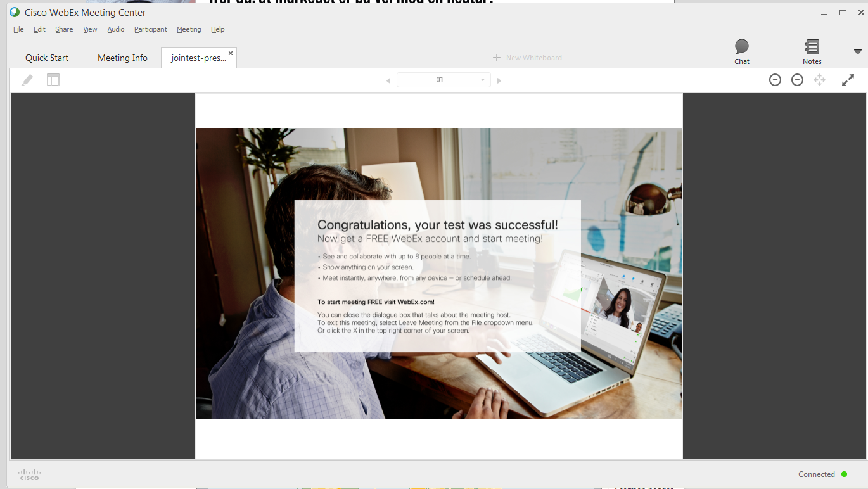

- Log in instructions for the webinar on Tuesday, 1 March 2016 from 13:00 to 14:00 Central European Time

You can log in to the webinar from 12:30 onwards. Please make sure to be logged in and in place before 12:55 – we will start at 13:00 sharp.
To log in, click on the link below:
https://eval-uk.webex.com/eval-uk/onstage/g.php?MTID=e14d84cd6c1548457079789668f858437

You will be asked to provide your name and email address. The name you provide here is how we will see you on the list of logged in participants. To be able to introduce you when asking questions, we suggest that in the box “First name” you enter your name and/or surname, and as “Last name” you give your institution/country. After that please click on “Join Now” button

You will now need to “Run a temporary application” in the same way as is described above for the self-test procedure.

When you successfully log in (Webex will take a moment to load), the window will look something like this:

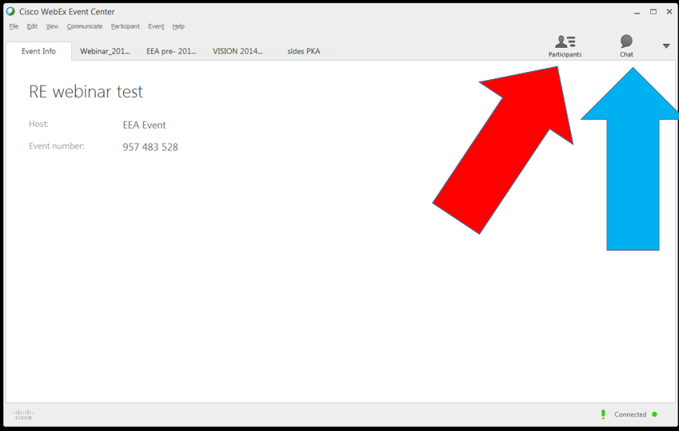

Please click on the grey icons “Participants” (marked with red arrow) and “Chat” (blue arrow) to activate those windows
All the microphones will be muted on entry. We will keep them muted during the event, to avoid cross-talk noise. We will turn on individual microphones when you ask a question during the Q&A session.
To ask your question to Mr Timmermans please send us your question by CHAT to the address _QUESTIONS VIA STUDIO (and not to ALL PARTICIPANTS or other address). Hans will then invite you, and we will activate your microphone so you can ask it in person.
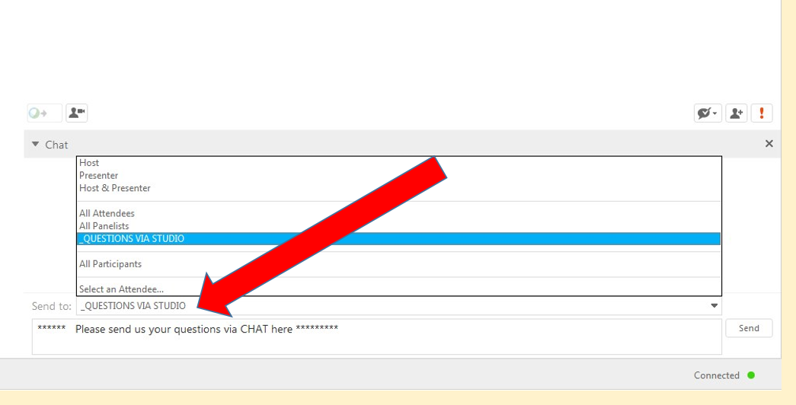

Finally, since we will not be using slides very much tomorrow, you may want to watch the video in full screen. To do it, please click the top right corner of the window with the video, as shown below.
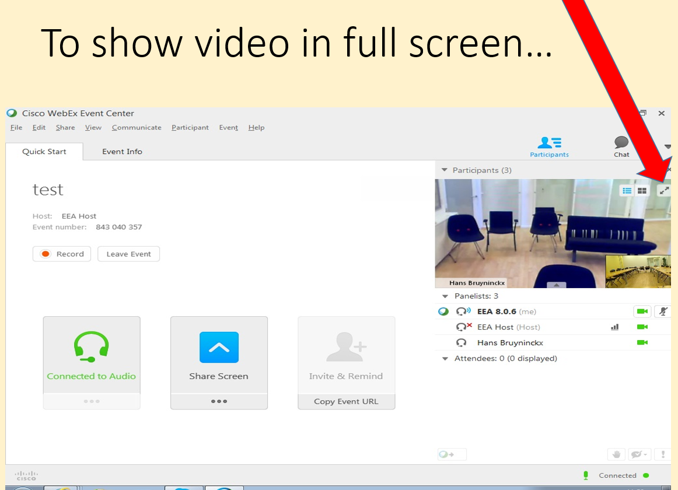
Until tomorrow,
Paweł and Marco

