

Eionet webinars on resource efficiency policies

**Webinar on national targets for resource efficiency**

Thursday, 30 June 2016, 11:30 - 13:00 (Central European Time)

Agenda, background paper and log‑in instructions

Prepared by:

ETC/WMGE 2.1.1.d Task Manager:

**Bettina Bahn-Walkowiak (Wuppertal Institute)**

European Topic Centre on Waste and Materials in a Green Economy

EEA project manager:

**Paweł Kaźmierczyk**

Documents, presentations and video recordings from resource efficiency webinars are available on the Eionet Forum: <http://forum.eionet.europa.eu/nrc-scp-waste/library/eionet-webinars/webinars-resource-efficiency>

Contents

1 Objectives of the webinar 3

2 Targets for Resource Efficiency and A Circular Economy 5

2.1 Policy context 5

2.2 Why focus on targets? 6

2.3 Target types 7

2.4 What’s the situation? 8

3 Short bios of the speakers 11

4 Webinar Agenda 12

5 Instructions how to log in on the 30 June 2016 13

# Objectives of the webinar

Webinars on resource efficiency policies and instruments, initiated in 2012, are organized by the European Environment Agency for the [Eionet network](http://www.eea.europa.eu/about-us/countries-and-eionet). They aim to support exchange of information and sharing of experience among national institutions responsible for practical implementation of resource efficiency policies at the country level.

The main objectives of resource efficiency webinars are to keep countries informed about on-going and upcoming EU policy initiatives, and to provide a forum where countries themselves can present examples of policy initiatives which they adopt and carry out under the heading of resource efficiency.

[Previous webinars](http://forum.eionet.europa.eu/nrc-scp-waste/library/eionet-webinars/webinars-resource-efficiency/organizing-webinars-eea-introduction-and-checklist) covered such topics as: national strategies for resource efficiency; targets and indicators; circular economy; industrial symbiosis; circular economy; RMC and the European target on resource productivity; decoupling; or mixes of policy instruments for resource efficiency.

In an effort to tackle inefficient and wasteful use of natural resources, the European Union has named resource efficiency as one out of seven flagship initiatives under so-called Europe 2020 strategy, which means the EU considers resource efficiency a top policy priority (European Commission, 2010). The "Roadmap to a Resource Efficient Europe" (European Commission, 2011a) describes a vision of an economy in the European Union in 2050, which is competitive and inclusive and has a high standard of living but grows economically in a way that the scarcity of resources and the limits of the planet are respected. In 2015, the European Commission published an Action Plan addressing the transition to a circular economy (European Commission, 2015, p.1)

*"where the value of products, materials and resources is maintained in the economy for as long as possible, and the generation of waste minimised, is an essential contribution to the EU's efforts to develop a sustainable, low carbon, resource efficient and competitive economy."*

However, development and implementation of policies to support resource efficiency and circular economy in a synergistic way are at a fairly early stage. Furthermore, the formulation of appropriate objectives and targets is clearly a challenge, at both the EU and national levels.

The goal of the webinar on 30 June 2016 is to share within the Eionet the information on national targets for resource efficiency collected in the More From Less report, and to invite three countries to present their experience and approach to setting resource efficiency targets.

The webinar will begin with an introduction by **Bettina Bahn-Walkowiak** who will briefly introduce the topic and the objectives of this webinar.

**Paweł Kaźmierczyk** will give an overview of the results of the recently published EEA report [More From Less – material resource efficiency in Europe](http://www.eea.europa.eu/resource-efficiency) which presents a wide variety of topics reported by the [32 participating countries](http://www.eea.europa.eu/publications/more-from-less/). The report examines the approach to targets for resource efficiency at the EU level (Chapter 1, section 5), and then discusses targets reported by countries (Chapter 9). Details of all reported targets are provided in Annex 8.

The three country presentations will be made by:

* Ms. **Sofia Rodrigues**, NFP Portugal and Head of Departament, Environment Agency, Portugal,
* Mr. **Jens Günther**, Federal Environment Agency, Germany,
* Ms. **Erika Lagzdina**, Environmental protection department, Ministry of Environmental Protection and Regional Development, Latvia.

The three presentations were chosen to present a variety of different country approaches to developing and adopting resource efficiency targets, and will address both the targets themselves, and the way the process was organized to agree on those targets. We hope that such information may serve as useful inspiration for other countries working towards targets.

**Technicalities:**

Adobe Connect, the new webinar software which we use, allows up to 100 participants to take part. While priority is given to Eionet participants, non-Eionet participants will also be able to register, so feel free to forward this invitation to other colleagues for whom such information may be of interest. To participate in the webinar, you need a computer with a fast internet connection, and equipped with a microphone and speakers (or a headset).

Prior to the webinar, please run a self-check to verify that your computer is correctly set up to use Adobe Connect: <https://na1cps.adobeconnect.com/common/help/en/support/meeting_test.htm> You can do this check at any time. If you encounter problems, please ask your IT team to help resolve issues – we are not able to help with local computer problems.

On Thursday, 30 June, please log in from 11:00 CET onwards. We will start the webinar at 11:30 sharp. To log in, please click on the link and fill in the information requested:

<http://eu-wacs.adobeconnect.com/targets/>

Detailed instructions explaining how to activate your speakers, microphone, etc., are included at the end of this document.

# Targets for Resource Efficiency and A Circular Economy

## Policy context

The Europe 2020 Strategy defines milestones for the EU to become a smart, sustainable and inclusive economy (European Commission, 2010). The strategy is built around seven mutually reinforcing flagship initiatives, one of which has resource efficiency at its core (European Commission, 2011b). As a follow up to this flagship initiative, the Commission adopted the Roadmap to a Resource Efficient Europe in order to set a framework for action that would pave the way towards an EU smart, sustainable and inclusive economy that by 2050 has grown in a way “that respects resource constraints and planetary boundaries, thus contributing to global economic transformation” (European Commission, 2011a, p.3).

Under the headline “Transforming the economy” the EU Roadmap describes four major guidelines and milestones:

* **Sustainable consumption and production —**By 2020, citizens and public authorities have the right incentives to choose the most resource efficient products and services and market and policy incentives that reward business investments in efficiency are in place.
* **Turning waste into a resource —** By 2020, waste is managed as a resource.
* **Supporting research and innovation —** By 2020, scientific breakthroughs and sustained innovation efforts have dramatically improved how we understand, manage, reduce the use, reuse, recycle, substitute, safeguard and value resources.
* **Environmentally harmful subsidies and getting the prices right** **—** By 2020, Environmentally harmful subsidies will be phased out and a major shift from taxation of labour towards environmental taxation will lead to substantial share of environmental taxes in public revenues(European Commission, 2011a).

The 7th Environment Action Programme also highlighted the role which resource efficiency should play in this transformation by including it in one of its thematic priorities, namely to turn the Union into *“a resource-efficient, green and competitive low-carbon economy.”* The other two key objectives are to protect, conserve and enhance the Union’s natural capital; and to safeguard the Union's citizens from environment-related pressures and risks to health and wellbeing (European Commission, 2014).

Waste management is a longstanding policy field in the EU and goes back to the Packaging and Packaging Waste Directive of 1994, the Landfill Directive of 1999, the Thematic Strategy on the prevention and recycling of waste of 2005 and the Waste Framework Directive of 2008. More recently, the Commission’s Communication on the Circular Economy and closing the loops acknowledged that moving “to a more circular economy, where the value of products, materials and resources is maintained in the economy for as long as possible, and the generation of waste minimised, is an essential contribution to the EU's efforts to develop a sustainable, low carbon, resource efficient and competitive economy” (European Commission, 2015).

## Why focus on targets?

Within the scope of the EEA report covering a wide array of issues reported by countries[1], targets for material resource efficiency are seen as an essential element for creating a strategic framework towards resource efficiency and circular economy.

**Figure 1: Scope of material resources used in the EEA report More from Less**



Source: (EEA, 2016, p. 17), adapted from the 2014 Circular Economy Package

Targets contribute to long-term orientation within complex multi-level political-administrative systems. While goals are set at all governance levels and for all areas of responsibility—global, regional, state, or municipal level, at the company or organization level, for sectors, for specific (environmental) policy areas—, the formulation of targets is challenging and can even be a policy objective itself, for instance, by constituting an element within a policy mix of different measures and initiatives or forming a step of the agenda setting. From an economic perspective, material resource efficiency and circular economy targets serve the society and the economy by overcoming orientation and information deficits. From a consumer and a business perspective, they can initiate or prepare for a change in behaviour and production processes.

While policy objectives set in material resource efficiency policies such as sustainability strategies often tend to be general and descriptive, targets are specific, quantifiable and measurable, and are usually accompanied by a deadline by which they are to be reached. Moreover, targets usually call for regular monitoring of trends or of the distance to a target (EEA 2016).

## Target types[2]

Targets can be considered along different criteria and from different perspectives. National quantitative targets with relevance to resource efficiency may relate to the use of natural resources directly or only indirectly. They can be expressed in **absolute terms** (e.g. intended amount or levels of resource use, stock or savings, etc.), **relative terms** (e.g. intended levels of resource productivity/resource intensity or as percentage values, etc.) and also as a decoupling requirement.

Targets furthermore can be defined at **different levels of aggregation** (e.g. economy-wide targets vs. targets defined at the level of the different sectors, or targets defined for groups of resources vs. a particular resource, etc.) and in many contexts from production or consumption perspectives. In terms of **timing**, quantitative targets may be defined as intended outcome to be achieved per annum or by a given future time.

Relevant economy-wide resource target types as reported in the country profiles are:

* General improvement of resource efficiency and resource productivity implemented in sustainability strategies or programmes
* Quantitative relative improvement of resource efficiency and resource productivity, e.g. by 50% [factor 2] by 2030 compared to base year
* Quantitative relative reduction of resource use, for example, minus 80% by 2020 compared to base year
* General lowering of consumption per capita or economy-wide without further specification
* Extraction or consumption caps, specified in absolute terms
* Strive for a stabilisation of resource consumption

Waste and circular economy related target types as (partly) reported in the country profiles are:

* Waste generation caps and limits
* Waste reduction targets
* Collection targets
* Recycling targets
* Recovery targets
* Landfill targets
* Secondary input targets
* Waste prevention targets (EEA, 2016b)

Another area with many existing targets relates to energy use and energy efficiency, overwhelmingly driven by EU directives. For many countries energy and material resource efficiency are two different policy fields and several countries did not mention energy-related targets at all, despite having them. In addition to the resource productivity, waste and energy-related targets, countries reported more targets in various other areas considered relevant for material resource efficiency (e.g. forestry, land use, green public procurement, greenhouse gas emissions, etc.).These targets shall not be in the focus of this webinar (EEA, 2016a).

## What’s the situation?[3]

Since the implementation of the EU Roadmap to a Resource Efficient Europe in 2011, EU policies and national policies have evolved and advanced. With the recently published Circular Economy Package (European Commission, 2015), efforts on resource efficiency have gained additional traction. The increased focus on closing material loops and waste reduction reflects the notion that incremental resource efficiency gains in a linear economic model may not be sufficient to achieve the 2050 vision.

At the national level, the concepts of resource efficiency and circular economy are increasingly taken up. With the introduction of the Roadmap to a resource efficient Europe (European Commission, 2011a) and the resource efficiency scoreboard with its lead indicator resource productivity, the EU has set a measurable impetus that encouraged many European countries to embed resource objectives in various national programmes, strategies and instruments.

Nine countries have adopted targets for national economy-wide resource productivity to date: Austria, Estonia, France, Germany, Hungary, Latvia, Poland, Portugal and Slovenia. In most cases, these targets are based on gross domestic product relative to domestic material consumption (GDP/DMC), the EU's lead resource productivity indicator. The EU itself does not have a target for material resource efficiency, and the formulation of appropriate objectives and targets is clearly a challenge, at both the EU and national levels.

Economy-wide resource productivity targets adopted by EU Member States include:

* Austria is striving for a 50 % increase in resource efficiency (GDP/DMC) by 2020 relative to 2008, and aspires to a four- to ten-fold improvement by 2050, as presented in its national Resource Efficiency Action Plan (REAP, Box 9.2).
* Estonia reports aiming for a 10 % increase in resource efficiency to EUR 0.46/kg (GDP/DMC) as part of a Coalition Agreement of the Estonian Government for the period 2015–2019.
* France aims for a 30 % increase in resource productivity (GDP/DMC) between 2010 and 2030 as well as a decrease in per person DMC over the same period.
* Germany has a target of doubling abiotic material productivity within the period 1994–2020, included in its 2002 National Sustainable Development Strategy.
* Hungary stipulates reducing its material intensity (DMC/GDP) to 80 % of the 2007 level, by 2020, in the 2011 National Environmental Technology Innovation Strategy (Box 9.3), which is part of the Hungarian National Reform Programme.
* Latvia adopted a target for resource productivity (GDP/DMC) to reach EUR 710/tonne in 2030, with intermediate targets of EUR 540/tonne in 2017 and EUR 600/tonne in 2020 (Box 9.4).
* Poland, in its Strategy for Innovation and Efficiency of the Economy, adopted a target of increasing resource productivity to EUR 0.45/kg by 2015 and EUR 0.5/kg by 2020 (GDP/DMC).
* Portugal stipulates an increase in national resource productivity from EUR 1.14/kg in 2013 to EUR 1.17/kg in 2020 and EUR 1.72/kg in 2030 in its Green Growth Commitment (Box 9.5).
* Slovenia's target for resource productivity anticipates that overall resource productivity by 2023 should increase to EUR 1.5/kg DMC, from 1.07 in 2011.

Targets for reducing the use of primary materials (metals, minerals or biomass), or for specific materials, however, including those on the EU list of critical raw materials have not been reported. In contrast, targets for reducing energy use and improving energy efficiency as well as waste management are fairly common.

This is clearly driven by EU regulations, though some countries have adopted targets that are more ambitious than those required by current EU legislation. Some non-EU participating countries also reported having targets for waste and energy in line with EU directives.

A majority of countries reported having national targets for the recycling of certain waste streams, including organic waste, paper, cardboard, glass, wood, metal, plastic and packaging wastes, electrical or electronic equipment and batteries, mainly to be collected from households, construction and demolition waste, metal wastes, and industrial and hazardous wastes, mainly from the industrial sector.

**Figure 2: Number of countries reporting on targets, by type of targets**



Source: (EEA, 2016a, p. 82)

**Resource use and waste – two sides of the same coin**

The debate under the keyword of circular economy currently partially superposes the resource efficiency debate at least at European level. And, of course, recycling offers significant potentials to reduce resource consumption through an optimized use of recycled and secondary materials. There are many obvious areas where the use of resources and management of waste are linked. They share many of the same driving forces such as economic considerations, affluence, levels of consumption, and the state and pace of technology. In general, the higher the use of resources, the higher the emissions and the more waste generated.

However, a comprehensive understanding of waste and resource management in the sense of an overarching circular economy is not common yet. Currently, both areas are rather separate and the strengthening of links remains a challenge. The basket of targets which most countries report of are not as closely linked and aligned as one could think of for the future.

**References**

EEA, 2016a. More from less — material resource efficiency in Europe : 2015 overview of policies, instruments and targets in 32 countries (EEA Report No. No 10/2016). Copenhagen.

EEA, 2016b. Circular economy in Europe — Developing the knowledge base. European Environment Agency, Copenhagen.

European Commission, 2015. Closing the loop - An EU action plan for the Circular Economy (Communication from the Commission to the European Parliament, the Council, the European Economic and Social Committee and the Committee of the Regions No. COM(2015) 614/2). European Commission, Brussels.

European Commission, 2014. Taking stock of the Europe 2020 strategy for smart, sustainable and inclusive growth (No. COM(2014) 130 final), Commission Staff Working Paper. European Commission, Brussels.

European Commission, 2011a. Roadmap to a Resource Efficient Europe (Communication from the Commission to the European Parliament, the Council, the European Economic and Social Committee and the Committee of the Regions No. COM(2011) 571). European Commission, Brussels.

European Commission, 2011b. A Resource-Efficient Europe - Flagship Initiative under the Europe 2020 Strategy (Communication from the Commission to the European Parliament, the Council, the European Economic and Social Committee and the Committee of the Regions No. COM(2011) 21). European Commission, Brussels.

European Commission, 2010. Europe 2020 Flagship Initiative Innovation Union (Communication from the Commission to the European Parliament, the Council, the European Economic and Social Committee and the Committee of the Regions No. COM(2010) 546 final). European Commission, Brussels.

# About the speakers

**Sofia Rodrigues,** Head of Department, Eionet National Focal Point,Portuguese Environment Agency, Portugal

Sofia Rodrigues, is the head of department at the Portuguese Environment Agency and the Eionet National Focal Point for Portugal. Her department is responsible for the yearly publication of the national State of Environment Report.

E-Mail: [sofia.rodrigues@apambiente.pt](mailto:sofia.rodrigues@apambiente.pt)

**Jens Günther,** German Federal Environment Agency**,** Section I 1.1Fundamental Aspects, Sustainability Strategies and Scenarios**,** Sustainable Resource Use**,** Germany

Jens Günther has worked as scientific officer at the German Environment Agency since 2009, primarily on development of concepts, strategies and policy measures on resource efficiency, improving sustainable use of natural resources and indicator development. Jens graduated in Forest Science, and before joining UBA worked inter alia for the Forest Stewardship Council Working Group Germany and the European Secretariat of ICLEI – Local Governments for Sustainability. He was directly involved in the development of the German Resource Efficiency Programme (ProgRess)

E-Mail: [jens.guenther@uba.de](mailto:jens.guenther@uba.de)

**Erika Lagzdina,** Senior Expert**,** Environmental protection department**,** Ministry of environmental protection and regional development**,** The Republic of Latvia

Erika Lagzdina, MSc. in environmental management, now works as a senior expert at the Ministry of Environmental Protection and Regional Development of Latvia, Department of Enviromental Protection. Former worked as a head o Climate Change and Adaptation Policy Unit at the Climate Change Department. Her main duties are related to environmental policy integration and cross-sectoral cooperation. Her daily work is focused on ensuring of Latvia’s participation in OECD- Organization of Economic Cooperation and Development that includes also such issues as green growth and resources productivity. This is the linkage where her work overlaps with the EU circular policy development.

E-mail: [erika.lagzdina@varam.gov.lv](mailto:erika.lagzdina@varam.gov.lv)

**Bettina Bahn-Walkowiak,** Research fellow at the Wuppertal Institute for Climate, Environment and Energy, Germany, Business Unit Circular Economy, specialises in policy analysis, contributes to research projects on transition processes towards a circular economy, waste prevention and resource efficiency policy mixes.

E-mail: Bettina Bahn-Walkowiak [bettina.bahn-walkowiak@wupperinst.org](mailto:p.ekins@ucl.ac.uk)



# Webinar Agenda

**Webinar on national targets for resource efficiency**

**Thursday 30 June 2015, 11:30 - 13:00 (CET)***Webinar will be open for joining at 11:00 (CET) to ensure prompt start at 11:30 am. To log in please follow the instructions in the last section of this document*

|  |  |
| --- | --- |
| **National targets for resource efficiency - policy context** | |
| **11:30** | **Welcome and introduction to the webinar** by Bettina Bahn-Walkowiak (ETC-WMGE) |
| **11:35**  **–**  **11:55** | **EEA Report "More from less – material resource efficiency in Europe" - An overview**  by Paweł Kaźmierczyk (EEA)  Introductory reflections based on the recently published EEA Report "More from less – material resource efficiency in Europe" and 32 country profiles.  *(15 min presentation+ 5 min Q&A)* |
| **Country presentations: Experiences in target development and implementation** | |
| **11:55**  **–**  **12:10** | **Targets for resource efficiency in Portugal**  Presentation by Sofia Rodrigues, Head of Department, Eionet National Focal Point, Portuguese Environment Agency, Portugal  *(10 min presentation + 5 min Q&A)* |
| **12:10**  **–**  **12:25** | **Economy wide targets on resource use – the continuous development of raw material productivity in Germany**  Presentation by Mr. Jens Günther, Section I 1.1 Fundamental Aspects, Sustainability Strategies and Scenarios of Sustainable Resource Use of German Federal Environment Agency  *(10 min presentation + 5 min Q&A)* |
| **12:25**  **–**  **12:40** | **Targets for resource efficiency in Latvia**  Presentation by Ms Erika Lagzdina, Environmental protection department of Ministry of environmental protection and regional development, Latvia  *(10 min presentation + 5 min Q&A)* |

|  |  |
| --- | --- |
| **General discussion** | |
| **12:45**  **–**  **12:55** | **General discussion and wrap-up** |
| **12:55**  **–**  **13:00** | **Closing** by Bettina Bahn-Walkowiak and Paweł Kaźmierczyk |



# Instructions how to log in on the 30 June 2016

**\*\*\* please log in between 11.00 and 11.25 \*\*\***

*Webinar will take place on Thursday 30 June 2016, 11:30-13:00 (CET)*

Dear Colleagues,

Thank you for signing up for the EEA Resource Efficiency Webinar on national targets for resource efficiency, which will take place on Thursday, 30 June 2016, from 11:30 to 13:00 CET.

Many of you are already familiar with EEA resource efficiency webinars, but for the newcomers, a short note that the technical aspect of webinars is quite straightforward. You will need a computer with a fast and stable internet connection, and an external microphone and speakers (or a head set).

If you will be using a laptop, you would probably want to use an external microphone (or a headset), as the quality of sound from built in microphones is often quite poor. This can be a problem if you would like to ask a question during the webinar.

To log in, we invite you to:

1. **First do a self-check, to make sure that your equipment is configured properly for Adobe Connect**

Prior to the webinar, we kindly ask you to test your software and equipment (microphone and speakers, headset, etc.) to make sure that everything is configured properly and works well. The link to do the test is:

<https://na1cps.adobeconnect.com/common/help/en/support/meeting_test.htm>

If you encounter problems, please ask your in-house IT support to help resolve the issues. This is why it is important to do the self-check well ahead of the webinar, and not in the last minute.

1. **Log in on Thursday 30 June 2016 between 11:00 and 11:25 so that we can start at 11:30 sharp**

To log in, please click on the link:

<http://eu-wacs.adobeconnect.com/targets/>

and fill in the requested info.

**You will not be asked for any password during the log-in.**

Please refer to the quick guide below for further information how to get your speakers, microphone etc. set up.

See you on Thursday!

Adobe Connect: quick guide for participants

Adobe Connect, the new webinar software EEA uses, requires fast internet connection and a lot of free memory and space on the local computer. Therefore, before you log in, please close all the unnecessary applications, including your email browser. Otherwise, the overloaded system may crash.

**To log in to the webinar on 30 June 2016, please click on the link:**

<http://eu-wacs.adobeconnect.com/targets/>

and enter as guest. Please note that the name typed here will be the one visible to the host and other participants. To be able to introduce you if you ask a question to the presenters, the ideal thing would be if you could enter your name and country (eg. “Sofia Rodrigues, Portugal”)

Note: there is no password for this meeting

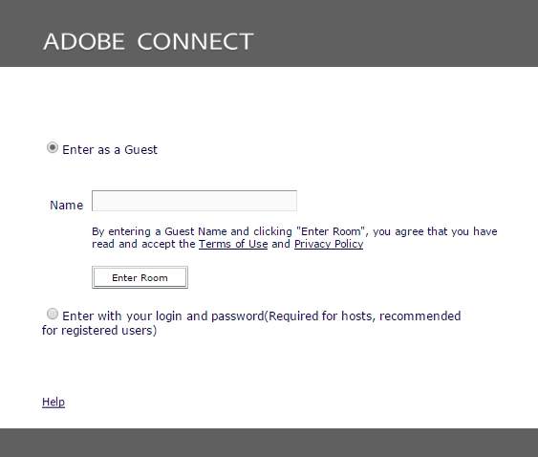

**Activate your speakers to hear the webinar**

Initially, the icons for speakers, microphone and webcam are white, which means they are inactive.

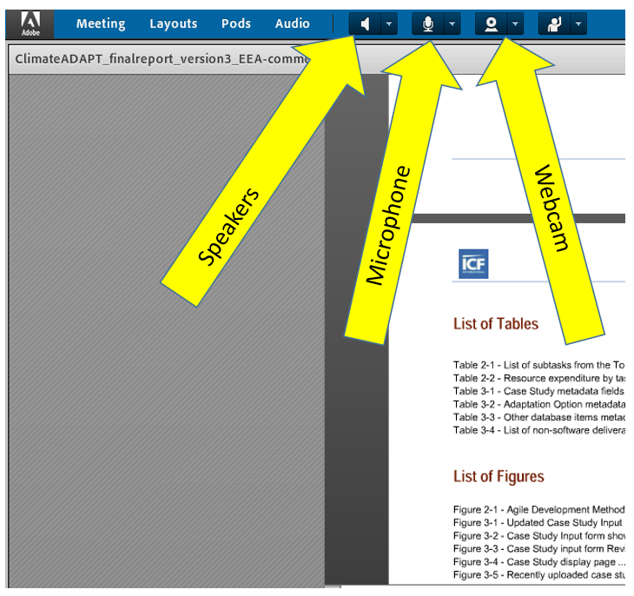

Click on the white speaker icon on the top of the screen. When your speakers are active the icon should become green (illustrated below).

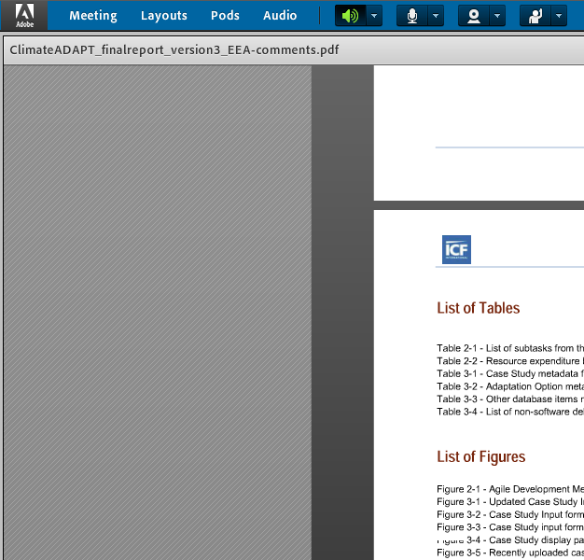

When the speaker icon is green, you will be able to hear audio. If it is not green = active, you will not receive sound. (NB, the microphone and webcam are still white = inactive)

You should now be logged in as a participant, and able to follow the webinar.

**If you want to ask a question…**

If you wish to ask a question to the presenter, or make a remark, please send your question by chat to the **_chair_EEA**, who will then invite you to ask the question yourself.

**Chat function**

The chat window is usually at the bottom right part of your screen.

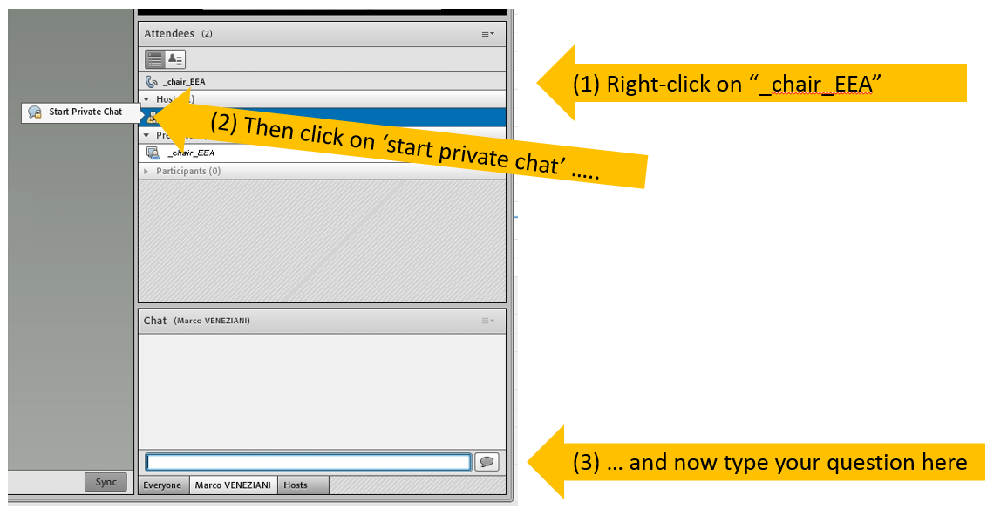

The easiest way to send a chat message to a single person (e.g. “_chair_EEA”) is to (1) right click on the name of that person, then (2) click on ‘start private chat’ pop up icon, and (3) type your message at the bottom box.

**To ask your question/make a comment:**

When your turn comes and you are invited to ask the question, the icon with the microphone will appear in white at the top of the screen (we need to activate this white icon before it appears on your screen).

Prior to asking the question you will need to click on this white microphone icon to make it green = active. This will make the microphone active. NOTE: the microphone is operational only if the colour of the microphone icon changed from white to green.

1. i.e. national strategies or action plans for material resource efficiency and policy objectives, the country’s scope of material resource efficiency, the perceived driving forces of material resource efficiency, country-specific priority material resources, industries and consumption categories, closing material loops in a circular economy, policy instruments and examples of good practice, indicators to monitor material use and resource efficiency, institutional set-up and stakeholder involvement
2. Question 10 of EEA 2016 questionnaire: What targets (measurable and with a timeline) have been set for material resource efficiency?
3. The analysis of targets in the EEA Report 2016 is based on information provided by 32 participating countries on a voluntary basis within the scope of a standardised set of 20 questions.