Log-in instructions for participants
Eionet resource efficiency webinar

Friday 4 December 2015 12:30– 14:00 (Central European Time)

Thank you for registering for the resource efficiency webinar on Friday, 4 December 2015. It will take place between 12:30 and 14:30 CET. You can log in from 12noon onwards.

The webinar will start with a series of short presentations of some country examples highlighted in the draft “More from less” report (the entire 2015 initiative was designed to support the exchange of experience among countries). This will be followed by an opportunity to discuss Eionet member ideas for follow up activities in 2016.

The technical (IT) aspect of webinars is quite straightforward. You will need a computer with a fast and stable internet connection, an external microphone (the one which you plug in) and speakers, or a head set (a microphone and headphones in one).
In this document, we provide instructions how to:
(1) to do a simple self-check that your equipment is configured properly for running Webex
(2) to log in on Friday 4 December, using an event-specific link provided in this document.

Below you will find detailed instructions.

In case of problems, you can reach us by email at Marco.Veneziani@eea.europa.eu

- Technical test of your equipment (self-check)
Please do this test before logging in to the webinar – it takes less than 5 minutes. Remember to do this test using the same computer (with the same equipment/configuration) which you will be using for the webinar.

To do an interactive test with WebEx (self-check which you can do at any time), please click on: http://www.webex.com/test-meeting.html

When a welcome screen comes up, you will be asked to give your name and email address. Then, you will need to start the program - click on the big green button TEST A MEETING.

IMPORTANT: We recommend that you don’t install anything but instead click on ‘run a temporary application’ (illustrated with a red arrow on the figure below) and then when another small window pops up, you click on RUN (marked with a green arrow).

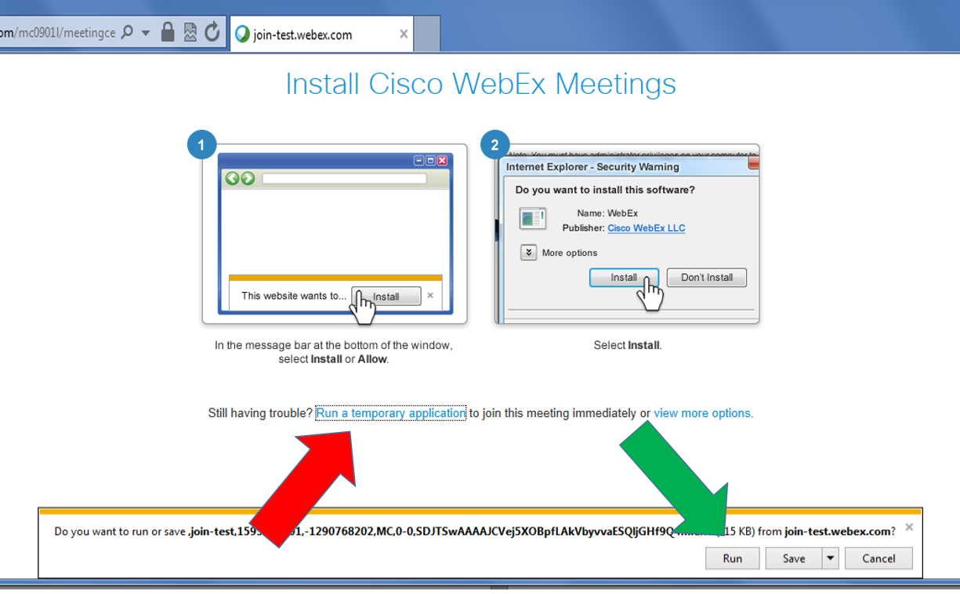

The screenshot above shows a dialogue window for Internet Explorer

In Chrome, you will see the following:

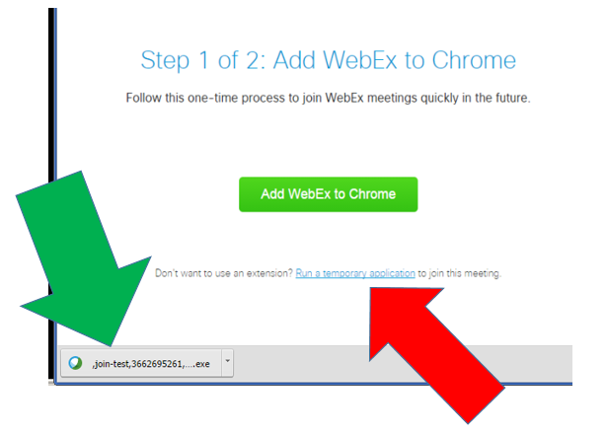

As before, please remember to first run a temporary application (red arrow) and then double-click on the temporary exe file which will download (green arrow).

If you are using a different browser or operating system, your window may look different, but there will always be an option to ‘run a temporary application.’

Opting for the ‘temporary application’ means that nothing will try to install itself permanently on your computer, a step which would typically require an ADMIN password on a computer at work.

After the computer checks the configuration (it may take a few moments so please wait a little), you should get a message ‘Congratulations, your system is now set up properly’ or something similar (example shown on the screenshot below).

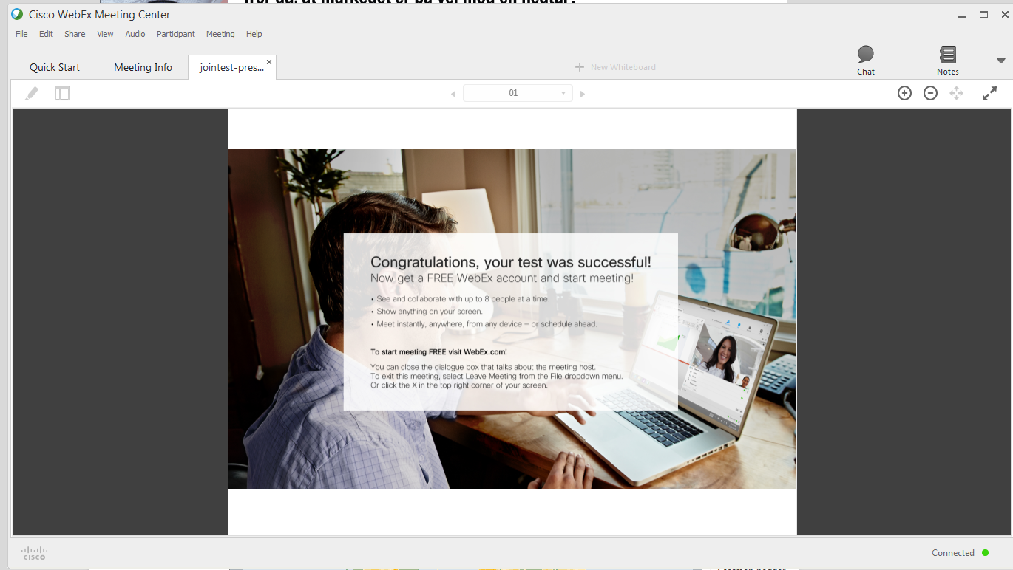

- Log in instructions for the actual webinar on Friday 4 December 2015 from 12:30 to 14:00 CET

You can join the webinar from 12noon onwards. Please make sure to be logged in before 12:30.
To log in, click on the link below:
https://eea-event.webex.com/eea-event/onstage/g.php?MTID=ece1ad7fbeca35e70e0da203c85c5dccf

You will be asked to provide your name and email address. If you are asked for a password, it is eionet

Then you will need to “Run a temporary application” in the same way as described above for the self-test procedure.

When you successfully log in (Webex will take a moment to load), the window will look something like this:

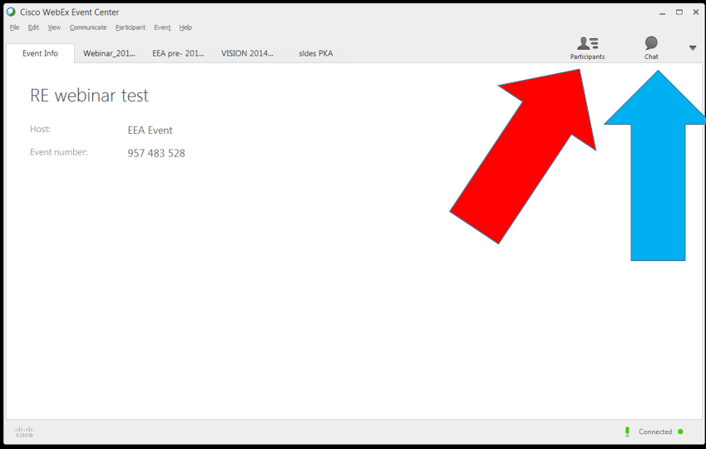

Please click on the grey icons “Participants” (marked with red arrow) and “Chat” (blue arrow) to activate those windows
All the microphones will be muted on entry. We will keep them muted during the event, to avoid cross-noise. We will turn individual microphones when you want to ask a question after the presentations, or to make a comment in the discussion.
Until tomorrow,
Paweł and Marco

