Eionet webinars on resource efficiency
Financing mechanisms for the circular economy

Wednesday, 26 September 2017, 12:30 - 14:00
(Central European Time = Berlin, Brussels, Paris, Warsaw)

Agenda and log-in instructions

Prepared by:

ETC/WMGE 2.1.1.b Task Manager:
Bettina Bahn-Walkowiak (Wuppertal Institute), and Francesca Grossi (Collaborating Centre on Sustainable Consumption and Production - CSCP)
European Topic Centre on Waste and Materials in a Green Economy

EEA project manager:
Paweł Kaźmierczyk

Documents, presentations and video recordings from previous EEA resource efficiency webinars are available on the Eionet Forum: http://forum.eionet.europa.eu/nrc-scp-waste/library/eionet-webinars/webinars-resource-efficiency

Contents

1. Background and objectives of the webinar 3
2. Short bios of the speakers 4
3. Agenda: Webinar on national circular economy policies 6
4. Technical guidance 7
4.1 To register for the webinar 7
4.2 Technical equipment check – simple self-test to do before the webinar 7
4.3 Instructions how to join the webinar on 26 September 2018 9

1. Background and objectives of the webinar

Webinars on policies and instruments for resource efficiency and the circular economy are organized by the European Environment Agency for the Eionet network. They aim to support the exchange of information and sharing of experience among national institutions responsible for development and implementation of policies for the resource-efficient, circular economy at the country level.

The main objectives of resource efficiency webinars are to keep countries informed about on-going and upcoming EU policy initiatives, and to provide a forum where countries themselves can present examples of their national or regional initiatives to support the transition to a resource-efficient circular economy.

Previous webinars covered such topics as: national strategies for resource efficiency; targets and indicators; industrial symbiosis; circular economy – the concept and practice; RMC and the European target on resource productivity; decoupling; policy mixes for resource efficiency; or national action plans for the circular economy.

The latest webinar in this series will be held on 26 September 2018, from 12:30 to 14:00 Central European Time. It will present examples of technical support initiatives and funding mechanisms for the circular economy, with presenters from the European Commission and the European Investment Bank, as well as a national example from Estonia. The topic of this webinar was chosen in light of the increasing number of mechanisms and funding sources for the circular economy policy agenda.

To register for the webinar, please sign up and provide your contact details at:

https://docs.google.com/document/d/1ZZ6xe9ETvoFJWBR-zADdwFoy0jCx8M0YL9wqVqq5wgY/edit

Detailed instructions how to log in to the webinar on 26 September are included in the last section of this document.

2. Short bios of the speakers

Mr. Pavel Misiga, Eco-Innovation Unit, DG RTD, European Commission

Mr. Pavel Misiga is a Head of Unit for Eco-Innovation at DG RTD, and the Coordinator of the CE expert group under the CE Finance Support Platform. He holds degrees from Comenius University, the London School of Economics and Princeton University.

Prior to joining the European Commission, Mr Misiga worked as an environmental expert for numerous private, governmental and non-governmental organisations, and as a senior official at the Ministry of Environment in his home country Slovakia.

Since joining the European Commission, he has led teams working on Sustainable Production and Consumption, Resource Efficiency, Circular Economy and Water policies.

E-mail: Pavel.MISIGA@ec.europa.eu

Mr. Arnold Verbeek, Finance Advisory Division, European Investment Bank

Arnold Verbeek works as a Senior Advisor in the Innovation Finance Advisory division of the European Investment Bank (EIB), where he mainly focuses on access-to-finance challenges and potential new ways of financing highly innovative projects and beneficiaries in RDI intensive sectors. He specialises in Higher Education and RTOs, the digital economy and the agri-food sector, and has been co-leading EIB’s activities in the circular economy.

He has over 15 years of experience in R&D and innovation, including the financing of, and has worked closely with a wide array of national and regional governments, institutions, industry federations and companies in various sectors.

Before joining the EIB, Arnold worked as a manager and senior expert at a Brussels-based advisory firm and as a senior researcher at the University of Leuven (Belgium). He has published several articles on technology development and associated metrics, R&D collaboration and commercialisation.

Arnold holds degrees in Business Administration and Business Sciences.

E-Mail: a.verbeek@eib.org

Mr. Andreas Versmann, TAIEX-EIR, DG Environment, European Commission

Andreas Versmann, Germany, is project manager of the TAIEX-EIR Peer 2 Peer programme at DG Environment, the European Commission, since 2017. He promotes and arranges peer learning between environmental authorities of European Member States. Before, he managed the secretariat of the Sustainable Development Observatory of the European Economic and Social Committee.

From 2007 to 2011 he worked as a policy officer at DG Environment of the European Commission in charge of promoting the circular economy and facilitating the implementation of the Waste Framework Directive from 2008.

In more than 15 years at a ministry for environment in a German region, the Land Brandenburg he gained extensive experience in practical implementation of environmental policies on the ground. He has an academic education in law and political sciences.

E-Mail: Andreas.VERSMANN@ec.europa.eu

Mr. Mihkel Krusberg, Department of Environmental Management, Ministry of Environment, Estonia

Mihkel Krusberg is an adviser in Environmental Management Department at Ministry of the Environment of Estonia. For the last four years, he worked in the areas of resource efficiency and circular economy. Besides implementing initiatives related to the EU (including EU funds), he is also involved in cooperation with the OECD, EEA and the Presidency of UN Environment Assembly.

E-Mail: Mihkel.Krusberg@Envir.ee

3. Webinar Agenda: financing mechanisms for the circular economy

Wednesday 26 September 2018, 12:30 - 14:00 (CET)
Webinar will be open for login at 12:00 (CET) to ensure we start at 12:30 sharp. The log-in link and instructions are in the next section of this document

12:30  -  12:35 | Welcome and introduction  Daniel Montalvo and Pawel Kazmierczyk, EEA
12:35  –  13:00 | Transition to circular economy: how can we accelerate the process through policy and financing?  Mr. Pavel Misiga, DG RTD, European Commission  (20 min presentation + 5 min Q&A)
13:00  –  13:20 | European Investment Bank’s activities to support the Circular Economy transition in member states  Mr. Arnold Verbeek, European Investment Bank  (15 min presentation + 5 min Q&A)
13:20  –  13:35 | Support to Member States’ action on the circular economy through peer learning - TAIEX-EIR PEER 2 PEER  Mr. Andreas Versmann, DG Environment, European Commission  (10 min presentation + 5 min Q&A)
13:35  –  13:50 | Supporting resource efficiency in Estonia  Mr. Mihkel Krusberg, Ministry of Environment, Estonia  (10 min presentation + 5 min Q&A)
13:50  –  14:00 | General questions and answers
14:00 | End of the webinar

4. Technical guidance
Thank you for signing up for the EEA webinar on financing mechanisms for the circular economy. The webinar will take place on 26 September 2018, from 12:30 to 14:00 (CET). You can log in from 12:00 (CET) onwards. In fact, we encourage everyone to login well before the start of the webinar at 12:30 sharp.
To participate, you will need to:
- Register for the webinar (the latest by end of the day on 25 Sept 2018)
- Test your technical equipment before the event to make sure that it is configured properly.
- Log in on the day of the webinar
Below you will find detailed instructions for each of these steps

4.1 To register for the webinar
To register for the webinar, please click on the link below and complete the form with the information requested:

https://docs.google.com/document/d/1ZZ6xe9ETvoFJWBR-zADdwFoy0jCx8M0YL9wqVqq5wgY/edit

While we will do our best to accommodate last-minute registrations, please register by the end of Tuesday, 25 September at the latest, to help us support your participation.

4.2 Technical equipment check – simple self-test to do before the webinar

Before the event, we kindly ask you to test your computer to make sure that everything is configured properly to enable you to log in successfully. We invite you to do this, so that you can identify any problems with your hardware and give yourself time to ask your IT team for help if necessary.

To do an interactive test with WebEx Meeting Center (which you can do at any time), please click on: http://www.WebEx.com/test-meeting.html. After the check of your computer’s compatibility is complete, you should get a message ‘Congratulations, your test was successful!

IMPORTANT: If this is the first time that you are using WebEx Meeting Center program, you will be asked to add WebEx to your computer. The screenshots below illustrate this for Google Chrome

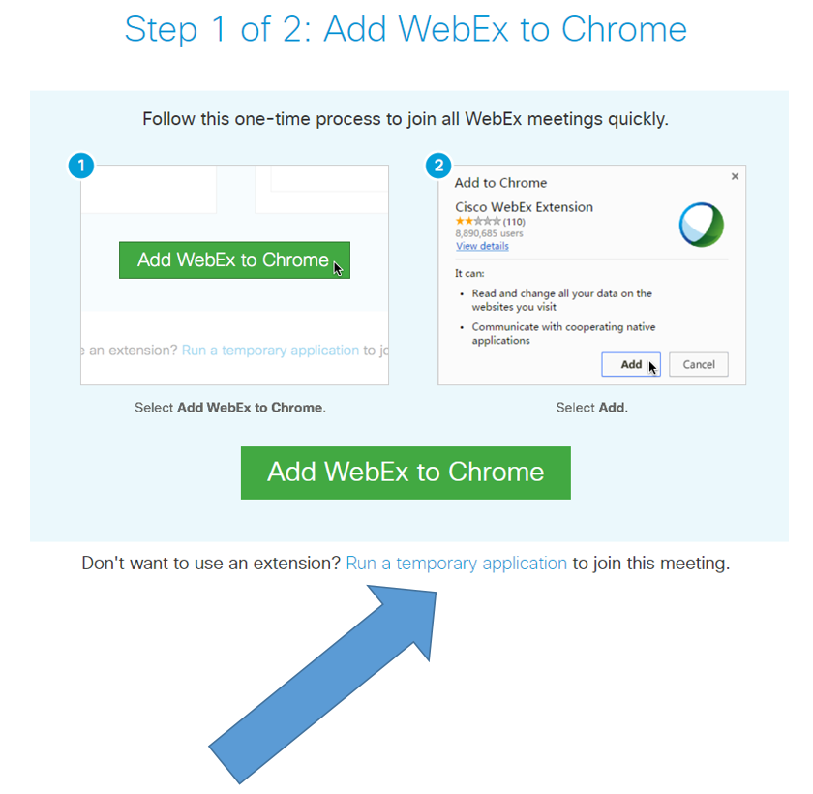

You may choose to add WebEx to Chrome (especially if you are a regular EEA webinar participant), but this requires you to have the administrator password for your computer. Therefore, we recommend that rather than installing the WebEx permanently, you Run a temporary application instead. Using this temporary application will allow you to join the webinar without installing anything on your computer (which most of us cannot do on computers at the office, due to in-house IT policies).

Simply click on the link shown with the blue arrow above to download the file, then double click on the downloaded file, and confirm that you want to run it.

If you are using a different browser and/or a Mac computer, your dialogue windows may look different, but there will always be an option somewhere to ‘run a temporary application.’ Please click on that, and run the file that pops up or downloads. The screenshot below illustrates the dialogue window for the Internet Explorer browser.

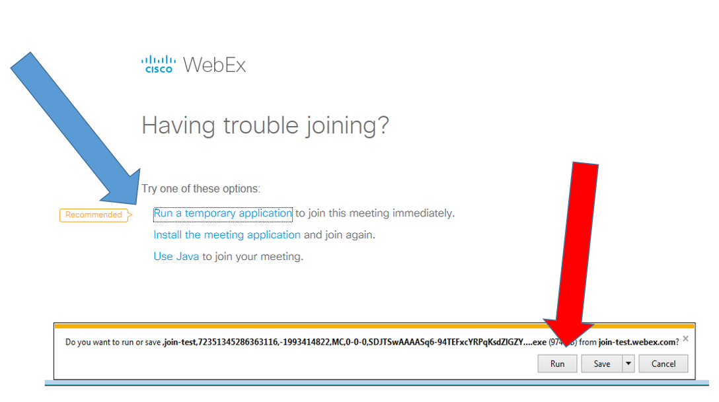

Again, please click first on ‘run a temporary application’ shown with the blue arrow, and then on RUN (red arrow).

If you do not install Webex permanently, the same procedure awaits you when joining the actual webinar on 26 September 2018.

4.3 Instructions how to join the webinar on 26 September 2018
Shortly before the webinar you will receive, at the email address with which you registered, a message with the link to join the webinar and instructions how to do it, as well as the agenda (i.e., this document).
On 26 September, from 12:00 (CET = Brussels, Berlin, Paris time) onwards, please click on the link below and you will be redirected to the starting page of WebEx.
https://eea.webex.com/eea/j.php?MTID=m119bd1de8423d5c1252c80f05c42d7b9
In case you are asked for a password to join the webinar, please enter “5dwhF9p8“ (case sensitive).
Again, please remember to click Run a temporary application, a procedure which you should already know from doing the self-test described in the section 4.2 above.
When logging in, may we ask you to please enter your name and COUNTRY (e.g. Francesca ITALY, Pawel POLAND, etc) so that we can easily identify you if you want to ask questions during the webinar. Then, optionally provide your email address and click on “Join”. (Screenshot below)

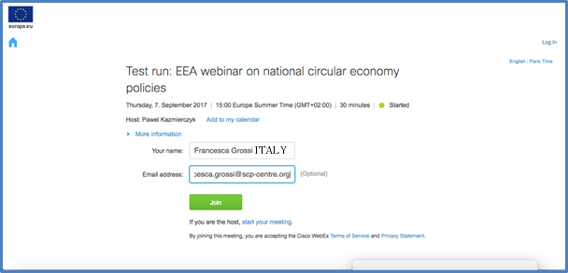

IMPORTANT NOTE - audio is NOT automatically activated when you join the webinar, but you can easily activate it yourself.
Once you have joined the webinar, you will still need to activate your audio (speaker and microphone) in order to be hear the presenters and other participants, and to ask questions during the webinar.
To do that, please click on the Quick Start tab (top left corner). The first circle on the left will then say either ‘Connect to Audio’ or ‘Call Using Computer’ as shown in the screenshot below.

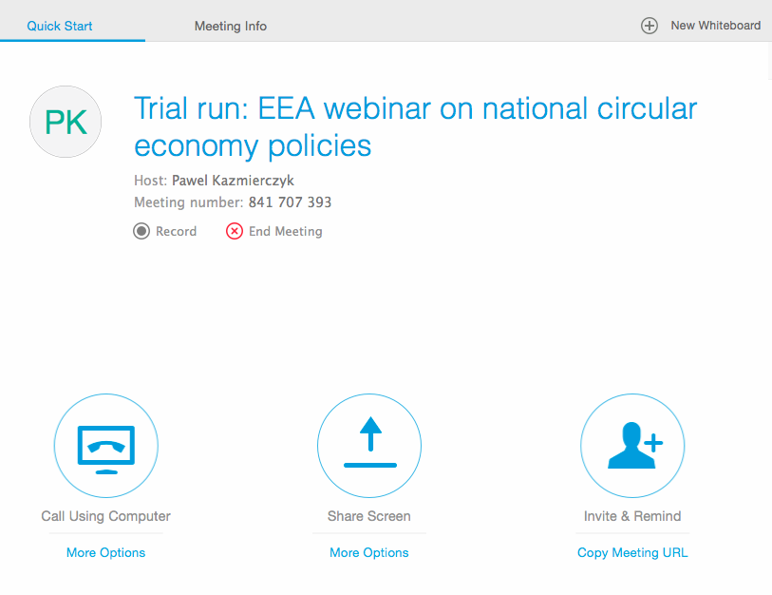

When you see a three-item pop-up menu for Audio Connection (illustrated in the screenshot below), please click on “Call Using Computer” (the other two options are not active, but they may still be displayed, depending on your IT system).

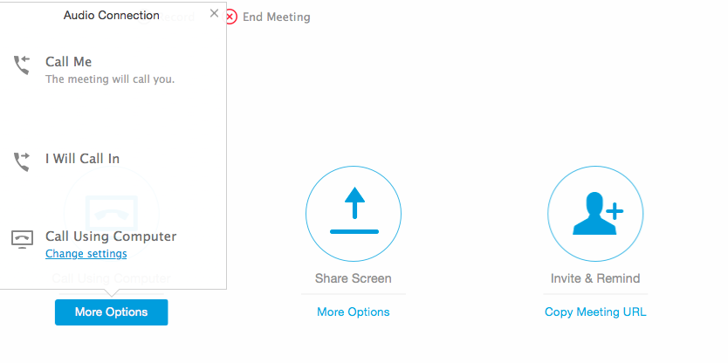

Finally, once you have successfully completed the above steps, please also make sure that the “participant” and “chat” functions are activated. You do that by clicking on the icons in the top right-hand side of the screen, as indicated by the arrows in the screenshot below. Once active, both icons will turn from grey to blue and you will then be able to see the list of other participants/presenters, and use the chat function (which will be needed during the webinar). 