Eionet webinars on resource efficiency
National circular economy policies

Tuesday, 19 September 2017, 11:30 - 13:00 CET

Final report

The full set of materials from the webinar (including the presentations and video recording), is available at the Eionet Forum at:
https://forum.eionet.europa.eu/nrc-scp-waste/library/eionet-webinars/webinars-resource-efficiency/webinar-national-circular-economy-policies-19-sep-2017

Prepared by:

ETC/WMGE 2.1.1.d Task Manager:
Bettina Bahn-Walkowiak (Wuppertal Institute), Francesca Grossi (Collaborating Centre on Sustainable Consumption and Production - CSCP)
European Topic Centre on Waste and Materials in a Green Economy

EEA project manager:
Paweł Kaźmierczyk

Documents, presentations and video recordings from all EEA resource efficiency webinars are available on the Eionet Forum: http://forum.eionet.europa.eu/nrc-scp-waste/library/eionet-webinars/webinars-resource-efficiency

Contents
1. Background and objectives of the webinar 3
2. Policy context and the concept of a Circular Economy 4
3. Agenda: Webinar on national circular economy policies 9
4. Short bios of the speakers 10
5. Presentations 11
Robbert Droop, the Netherlands 11
Kari Herlevi, Finland 13
Iain Gulland, UK/Scotland 17
6. List of participants 21
7. Technical guidance 25
7.1 To register for the webinar 25
7.2 . Technical equipment check – simple self-test to do before the webinar 25
7.3 Instructions how to join the webinar on 19 September 2017 27

1. Background and objectives of the webinar

Webinars on resource efficiency policies and instruments are organized by the European Environment Agency for the Eionet network. They aim to support exchange of information and sharing of experience among national institutions responsible for development and implementation of policies for the resource-efficient circular economy at the country level.

The main objectives of resource efficiency webinars are to keep countries informed about on-going and upcoming EU policy initiatives, and to provide a forum where countries themselves can present examples of policy initiatives, which they adopt to support the transition to a resource-efficient circular economy.

Previous webinars covered topics such as: national strategies; targets and indicators for resource efficiency; industrial symbiosis; circular economy concept and practice; RMC and the European target on resource productivity; decoupling; mixes of policies or national targets for resources efficiency.

The latest webinar in this series will be held on 19 September 2017, from 11:30 to 13:00 Central European Time. It will present national examples of policies adopted to support the circular economy in Finland, the Netherlands and UK/Scotland. The topic of this webinar was chosen in light of the increasing prominence of circular economy on the EU policy agenda.

The three presenters will illustrate different approaches to developing circular economy policies. We hope that such information will serve as useful inspiration for other countries working on their own national initiatives for the circular economy.

To register for the webinar, please sign up and provide your contact details at:

https://docs.google.com/document/d/1FmMGMDNfE8PkdUIYVxEwa9UwkVP3Zcj4o5nz3HnKWtI/edit?usp=sharing

Detailed instructions how to log in to the webinar on 19 September are included in the last section of this document.

2. Policy context and the concept of a Circular Economy

Under the headline ‘Transforming the economy’ the “Roadmap to a Resource Efficient Europe” of 2011 describes as one of four major guidelines that by 2020, waste is managed as a resource. While waste management has been a longstanding policy field in the EU, the “Roadmap to a Resource Efficient Europe” is an important step to set a framework for action paving the way towards a smart, sustainable and inclusive EU economy by 2050 growing in a way “that respects resource constraints and planetary boundaries, thus contributing to global economic transformation” European Commission, 2011a, p.3).

In 2015, the Commission initiated next steps by launching its “Action Plan on a Circular Economy” that acknowledges that moving “to a more circular economy, where the value of products, materials and resources is maintained in the economy for as long as possible, and the generation of waste minimised, is an essential contribution to the EU's efforts to develop a sustainable, low carbon, resource efficient and competitive economy” (European Commission, 2015).

Current modes of production and consumption are overwhelmingly based on a linear principle. Resources are extracted, processed, used, and ultimately discarded as waste. At the end of a typical life cycle, waste is disposed of by incineration or landfill. The Circular Economy model provides an alternative vision of a material economy, one which fundamentally questions the “take, make and dispose” model that requires vast, easily accessible material and energy resources to continuously feed our consumption, and endless sinks to accept the resultant waste and emissions. In such model, energy and resource efficiency can provide environmental and economic benefits, but—unless it strives for radical material input reductions—it does not address the finite nature of the resource base.

At its core, a circular economy aims to ‘design out’ waste. Products in a circular economy are ideally designed for reuse, repair, refurbishment, and remanufacturing—either as a whole, or at a material/component level—whilst being supported by a shift towards ‘sharing’ and ‘leasing’ instead of ‘selling’ products.

Figure 1: The concept – Energy and Materials Flow in a Circular Economy

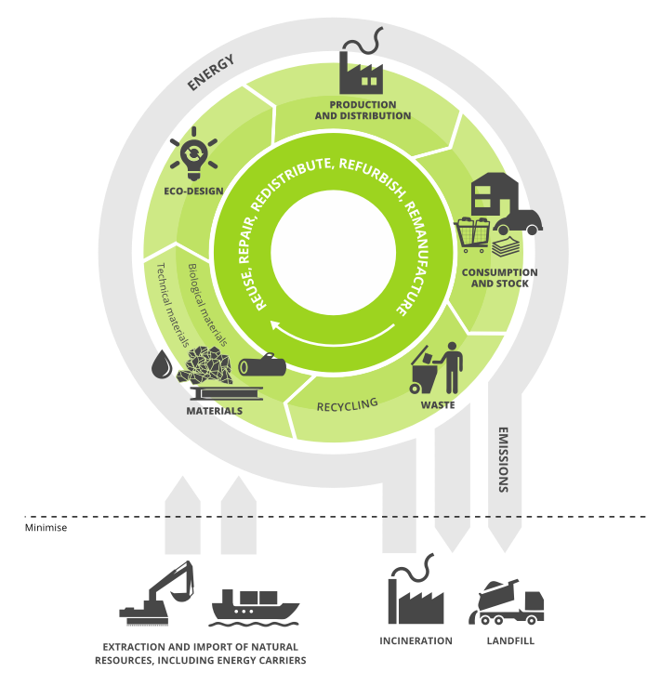
Source: EEA, Circular Economy, 2016b, Circular by Design, 2017

The transition towards a circular economy requires fundamental changes to production and consumption systems, going well beyond resource efficiency and recycling waste. In the concept of the circular economy, preserving the value of products for as long as possible plays a central role, and puts products centre-stage in the transition process. Current actions to stimulate and monitor the transition, however, primarily focus on materials, which is not surprising, as the circular economy vision has evolved as a solution to the waste problem, and current policy and business tools focus on waste or materials. Designing products in a smarter way, extending their useful lives and changing the role of such products within the system will be crucial to the achievement of a circular economy. Reuse, repair, redistribution, remanufacture and refurbishment have so far received less attention than waste-related issues, and related strategies are less mature (EEA 2107).

There is indeed a long way to go from reality to the ideal. As part of the EEA report on material resource efficiency policies “More from Less” published in 2016, a specific section addressed policy approaches countries take towards closing the material loops in the economy. Figure 2 summarises country responses, showing that for the time being the majority still mostly look at waste-related aspects in interventions to close material loops - 53% on waste management and recycling, and a further 17% on waste prevention. (EEA 2016a).

Figure 2: The situation – Policy approaches to closing material loops in the economy/circular economy across different life-cycle stages

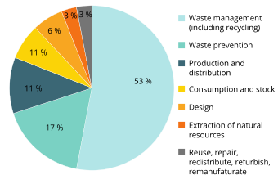
Source: EEA, More from Less, 2016a, p.69

Although the circular economy as a concept goes far beyond waste management, the European Commission acknowledges that efficient waste management infrastructure is a crucial element for reducing linear patterns of production and consumption.

Therefore, the Circular Economy Action Plan comprises various legislative proposals and measures in the areas of production (product design also and production processes), consumption and waste management, as well as concrete targets for creating an ambitious long-term roadmap for waste management and recycling in Europe. As illustrated in Figure 3, the action plan can be divided into two key elements: a communication on how to integrate circular thinking into different stages of the life cycle and a more concrete proposal for changed regulations on waste treatments.

Figure 3: The legislation process - Elements of the Circular Economy Action Plan

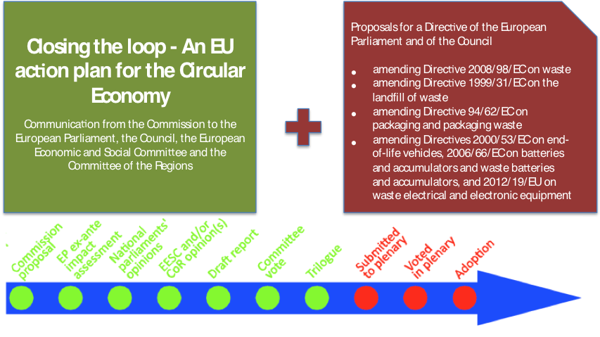
Source: ERPS 2017.

Policies to support the resource efficient use of material resources and the circular economy overlap and in many cases are mutually supportive. The knowledge base on this is expanding, with several countries already having started to develop and implement policies for a circular economy, including Belgium, Finland, the Netherlands, and UK/Scotland.

The goal of the webinar on 19 September 2017 is to share within the Eionet the information on recent national circular economy policies, with speakers from Finland, Netherlands and UK/Scotland presenting their experience and approach in the national context.

References

EEA, 2017. Circular by design — products in the circular economy (EEA Report No 6/2017). European Environment Agency, Copenhagen.
EEA, 2016a. More from less — material resource efficiency in Europe: 2015 overview of policies, instruments and targets in 32 countries (EEA Report No 10/2016). European Environment Agency, Copenhagen.
EEA, 2016b. Circular economy in Europe — Developing the knowledge base (EEA Report No 2/2016). European Environment Agency, Copenhagen.
EPRS, 2017. Circular economy package: Four legislative proposals on waste. Briefing — EU Legislation in Progress - May 2017. EPRS - European Parliament Research Service, Brussels, May 2017. URL: http://www.europarl.europa.eu/RegData/etudes/BRIE/2017/603954/EPRS_BRI(2017)603954_EN.pdf
European Commission, 2015. Closing the loop - An EU action plan for the Circular Economy (Communication from the Commission to the European Parliament, the Council, the European Economic and Social Committee and the Committee of the Regions No. COM(2015) 614/2). European Commission, Brussels.
European Commission, 2011a. Roadmap to a Resource Efficient Europe (Communication from the Commission to the European Parliament, the Council, the European Economic and Social Committee and the Committee of the Regions No. COM(2011) 571). European Commission, Brussels.
European Commission, 2011b. A Resource-Efficient Europe - Flagship Initiative under the Europe 2020 Strategy (Communication from the Commission to the European Parliament, the Council, the European Economic and Social Committee and the Committee of the Regions No. COM(2011) 21). European Commission, Brussels.

3. Agenda: Webinar on national circular economy policies

Tuesday 19 September 2017, 11:30 - 13:00 (CET)
Webinar will be open for login at 11:00 (CET) to ensure start at 11:30 sharp. The link and login instructions are in the last section of this document

11:30 | Webinar starts
National policies for the circular economy – introduction and policy context

11:30  -  11:45 | Welcome and introduction  Bettina Bahn-Walkowiak, ETC/WMGE, and Pawel Kazmierczyk, EEA
Country presentations: developing national policies for the circular economy

11:45  –  12:05 | The Netherlands: Towards a Circular Economy – Together Now  Presentation by Mr. Robbert Droop, Policy Coordinator, CE in Europe  Ministry of Infrastructure and the Environment, The Netherlands  (15 min presentation + 5 min Q&A)
12:05  –  12:25 | Finland: Circular Economy roadmap 2025 - the process and its results  Presentation by Mr. Kari Herlevi,  Project Director at Sitra’s, Finland  (15 min presentation + 5 min Q&A)
12:25  –  12:45 | UK/ Scotland: Valuing Resources, Inspiring Change – our plan for a sustainable, fair and prosperous Scotland  Presentation by Mr. Iain Gulland  Chief Executive Officer, Zero Waste Scotland, United Kingdom  (15 min presentation + 5 min Q&A)
General discussion and Q&A

12:45  –  13:00 | General questions and answers and discussion.
13:00 | End of the webinar

4. Short bios of the speakers

Mr. Robbert Droop, Policy Coordinator, Circular Economy in Europe, Ministry of Infrastructure and the Environment, The Netherlands

Robbert is a policy coordinator in the Netherlands’ Ministry of Infrastructure and the Environment. He is responsible for Circular Economy policies, and research and eco-innovation at the European level. In that capacity he represents The Netherlands in the European research programme Horizon2020, the Commission’s Expert Group on Circular Economy, and the Working Party on Resources Efficiency and Waste of OECD.

In past assignments, Robbert worked as an Exchange Officer at the European Commission on hazardous waste management issues, and as a Senior Programme Officer in UNEP’s Global Programme on Land-based Sources of Marine Pollution.

Robbert is an electro-technical engineer by training, but has worked ever since in the field of environmental protection and sustainability.

E-mail: Robbert.Droop@minienm.nl

Mr. Kari Herlevi, Project Director, Finnish Innovation Fund SITRA

Kari is a versatile multi-talent in the field of circular economy. He is currently leading the circular economy area at Sitra, the Finnish Innovation Fund. Previously responsible for the Resource efficient economy area in Tekes, the Finnish Funding Agency for Innovation, he managed the Green Growth – Towards a sustainable future -programme, which aimed to identify potential new growth areas for the sustainable economy business. Previously Kari led the Vigo accelerator programme at Tekes and supported Tekes management. Kari has also worked in the Tekes Silicon Valley office for a few years and his special interests are circular economy, fast growing cleantech firms and developing countries like BRIC.

E-Mail: Kari.Herlevi@sitra.fi

Mr. Iain Gulland, Chief Executive Officer, Zero Waste Scotland, United Kingdom
Iain is Chief Executive of Zero Waste Scotland, a not-for-profit company, which exists to create a society where resources are valued and nothing is wasted. Its work supports delivery of Scottish Government strategies for resource efficiency and a more circular economy.

Iain has more than 20 years’ experience in sustainable resource management in the public and not-for-profit sectors, including leading the Community Recycling Network Scotland from 2004-2008 and working as WRAP’s Director for Scotland from 2008 – 2014.

Iain is a Vice President of the Association for Cities and Regions for Recycling and Sustainable Resource Management (ACR+) and a Fellow of the Chartered Institution of Wastes Management (CIWM).

E-Mail: iain.gulland@zerowastescotland.org.uk

5. Presentations

Robbert Droop, the Netherlands

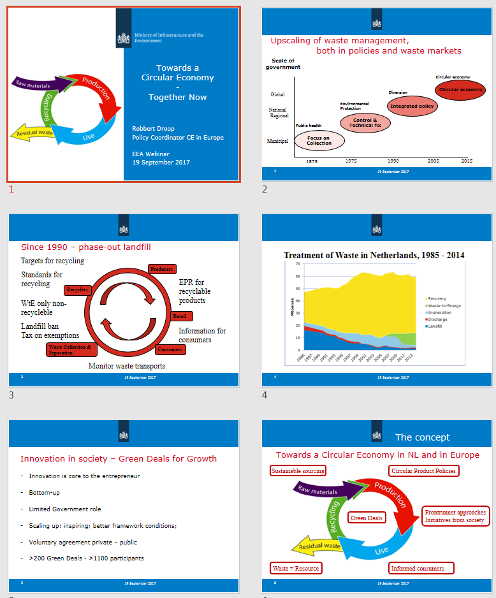

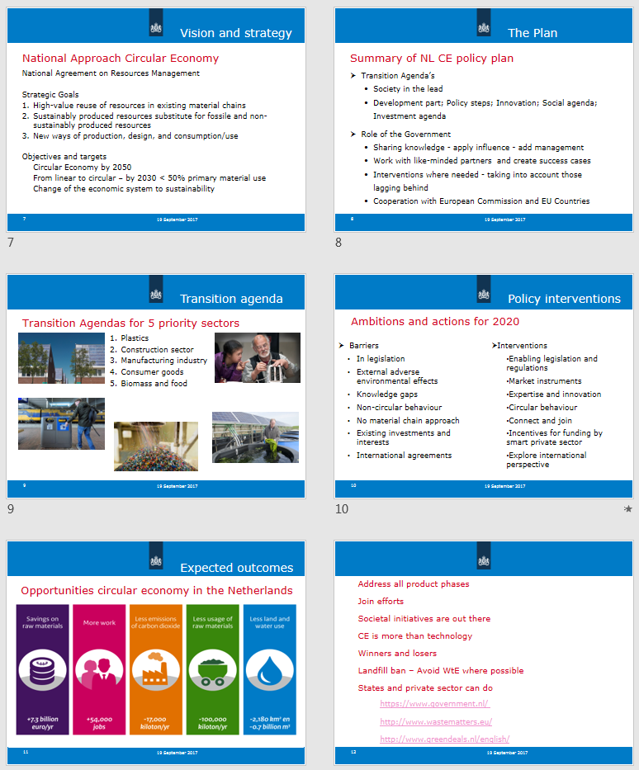

Kari Herlevi, Finland

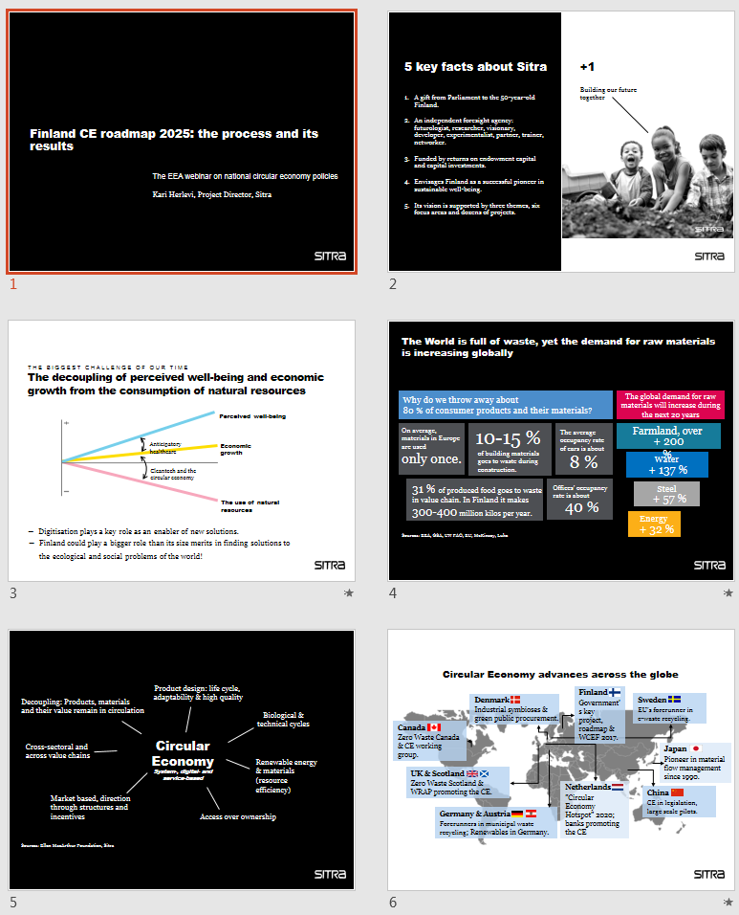

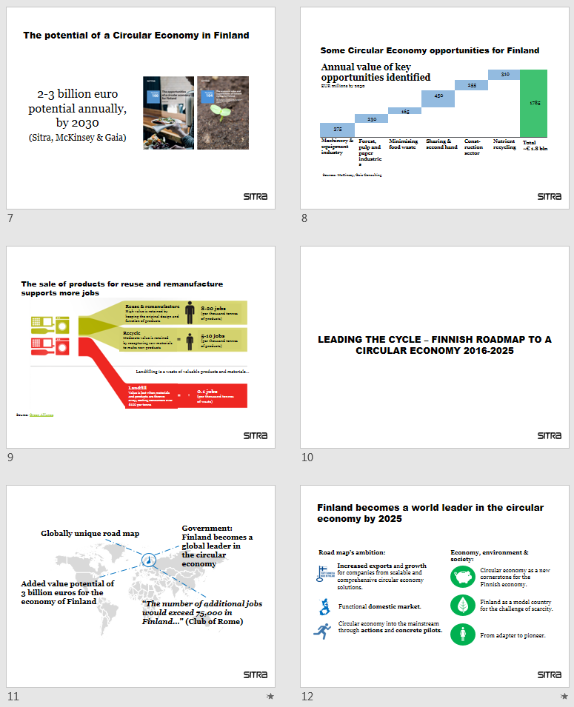

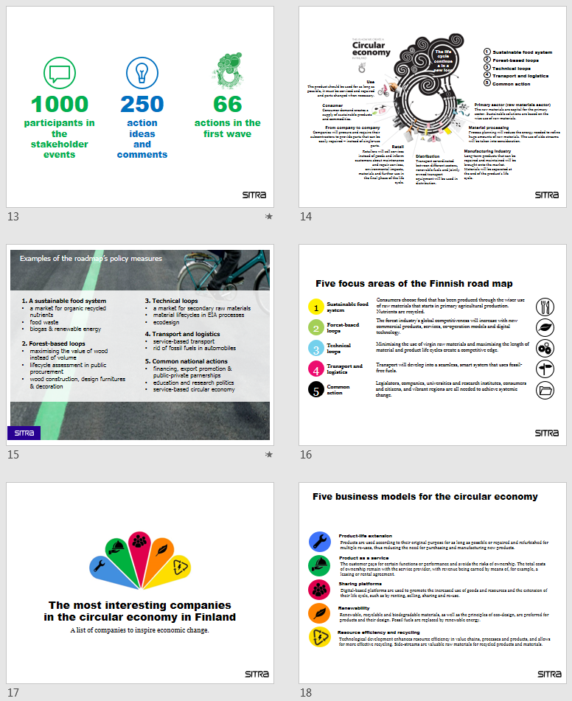

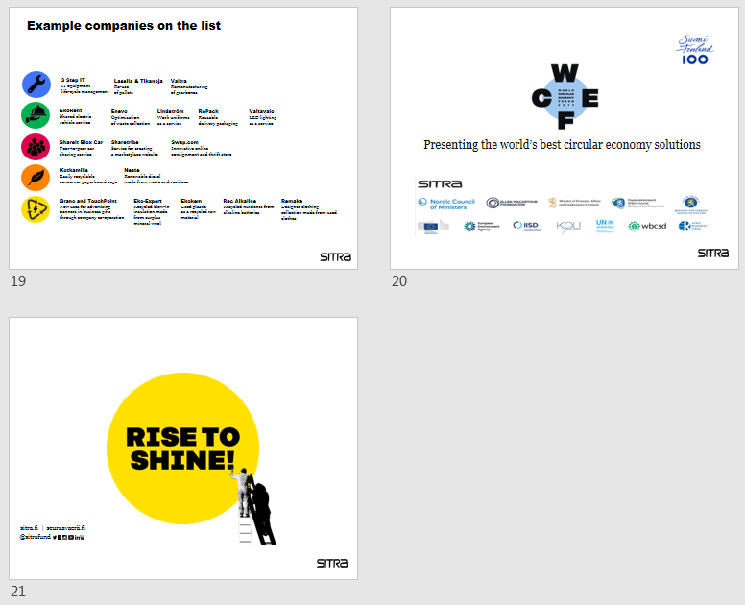

Iain Gulland, UK/Scotland

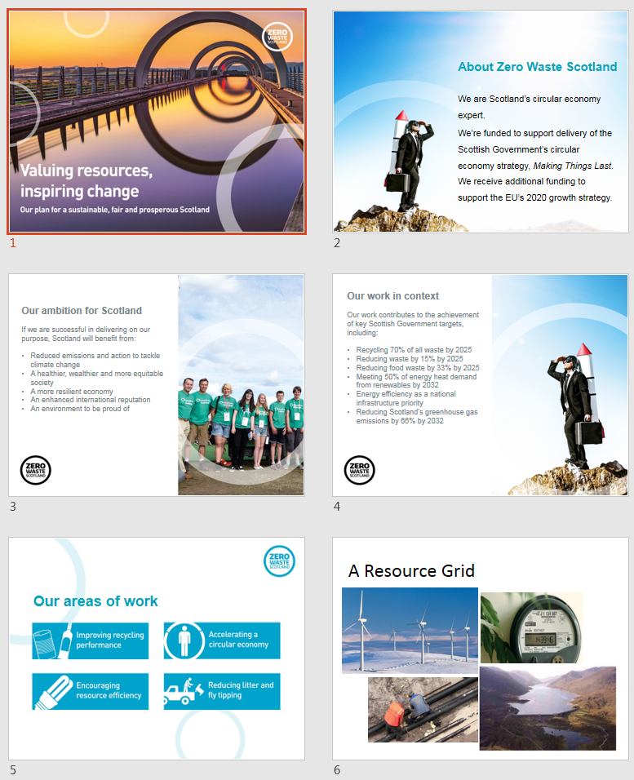

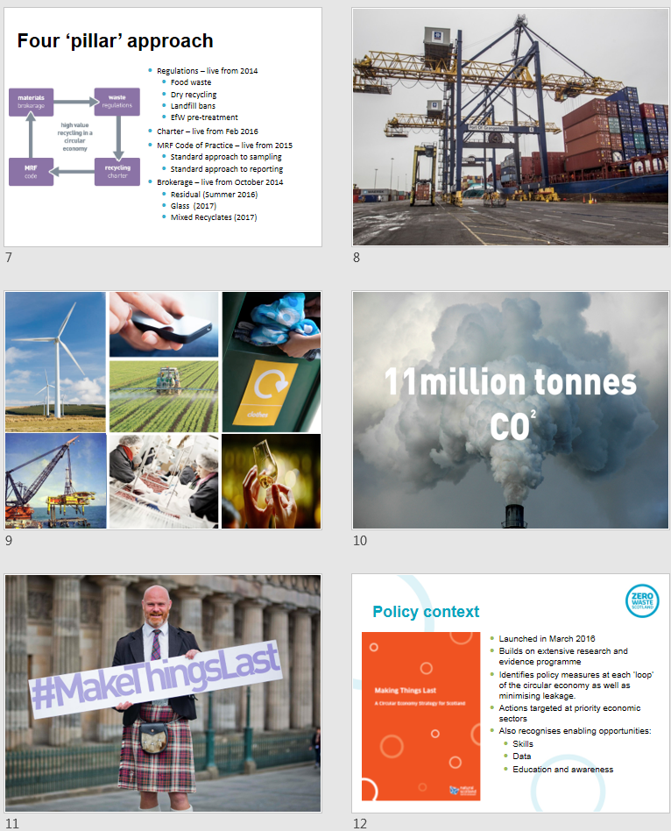

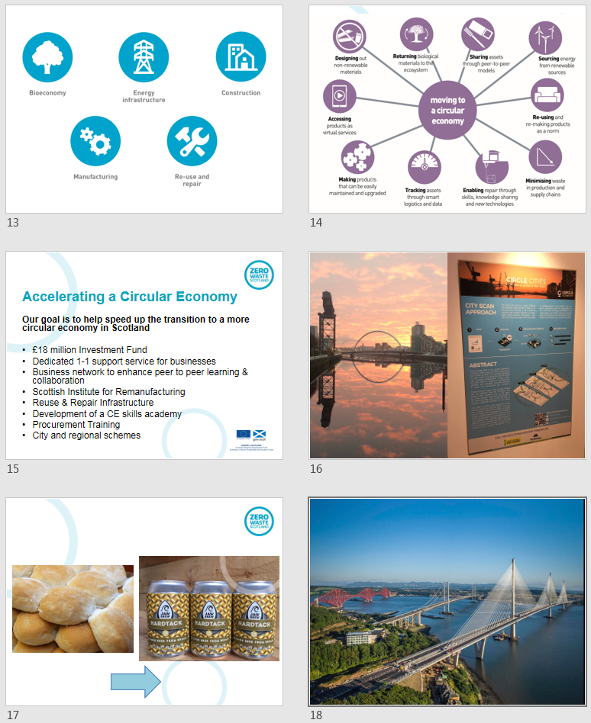

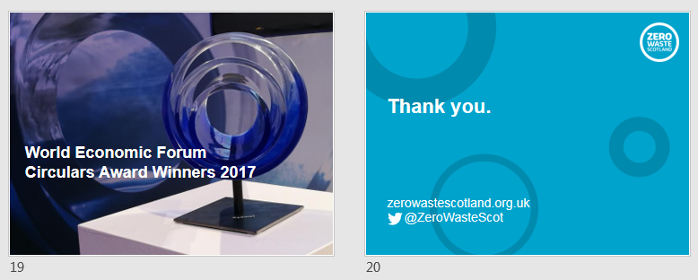

6. List of participants

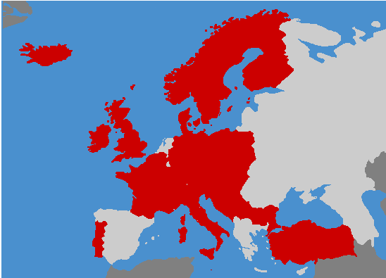

Name | Organization | Country
PRESENTERS

Robbert Droop | Policy Coordinator, Circular Economy in Europe, Ministry of Infrastructure and the Environment | Netherlands
Kari Herlevi | Project Director, Finnish Innovation Fund SITRA | Finland
Iain Gulland | Chief Executive Officer, Zero Waste Scotland | UK/Scotland
REGISTERED PARTICIPANTS

Andreas Berthold | Environment Agency Austria | Austria
Caroline Vogl-Lang | Federal Ministry of Environment | Austria
Dagmar Hutter | Environment Agency Austria | Austria
Francesca Montevecchi | Austria Environment Agency | Austria
Igor Struyf | Flanders Environment Agency | Belgium
Yirka Beeckman | National Focal Point Belgium | Belgium
Dragan Jovović | Agency for Statistics of Bosnia and Herzegovina | Bosnia and Herzegovina
Mirza Agić | Agency for Statistics of Bosnia and Herzegovina | Bosnia and Herzegovina
Tanya Vladimirova | Bulgarian Executive Environment Agency | Bulgaria
Ines Katić | Croatian Agency for the Environment and Nature | Croatia
Mira Zovko | Croatian Agency for the Environment and Nature | Croatia
Jana Bašistová | National Focal Point Czech Republic | Czech Republic
Jiri Valta | CENIA, Czech Environmental Information Agency | Czech Republic
Vaclava Vlckova | CENIA, Czech Environmental Information Agency | Czech Republic
Vladimir Dobes | EMPRESS - SCP platform | Czech Republic
Vojtěch Pilnáček | Ministry of the Environment of the Czech Republic | Czech Republic
Almut Reichel | European Environment Agency | Denmark
Anders Fink | Danish EPA | Denmark
Birgitte Kjær | Danish EPA | Denmark
Charlotte Münter | Danish EPA | Denmark
Lykke Feld | Danish EPA | Denmark
Mette Marie Nielsen | Danish EPA | Denmark
Mieke De Schoenmakere | European Environment Agency | Denmark
Elise Järvenpää | Finnish Environment Institute | Finland
Jáchym Judl | Finnish Environment Institute | Finland
Malin zu Castell-Rüdenhausen | European Topic Centre WMGE  VTT Oy | Finland
Margareta Wahlström | VTT Ltd | Finland
Mona Arnold | VTT | Finland
Riina Antikainen | Finnish Environment Institute | Finland
Sarianne Tikkanen | Finnish Environment Institute | Finland
Hélène Morvan | ADEME (French Environment and Energy Management Agency) | France
Jens Günther | German Environment Agency | Germany
Lidia Wojtal | Wuppertal Institut | Germany
Raymond Slaughter | CSCP - Collaborating Centre on Sustainable Consumption and Production | Germany
Susanne Fischer | Wuppertal Institut | Germany
Elemer Szabo | Ministry of Agriculture | Hungary
Henrietta Enikő Csató | Prime Minister’s Office | Hungary
Magdolna Sztarenszky | Ministry of Agriculture | Hungary
Szilvia Szentesi | Ministry of Agriculture | Hungary
Guðmundur B. Ingvarsson | Environment Agency of Iceland | Iceland
Celine Horner | EPA Ireland | Ireland
Fiona McCoole | EPA Ireland | Ireland
Isabelle Kurz | Environmental Protection Agency | Ireland
Felice Cappelluti | Italian Ministry for the Environment, Land and Sea | Italy
Felice Cappelluti | Italian Ministry for the Environment, Land and Sea | Italy
Maria Gabriella Simeone | ISPRA - Italian National Institute for Environmental Protection and Research | Italy
Claudio Toscano | Environmental Resources Authority | Malta
Christoffer Back Vestli | Norwegian Environment Agency | Norway
Beata Kłopotek | Ministry of the Environment | Poland
Katarzyna Nowacka | Ministry of the Environment | Poland
Malgorzata Bednarek | Chief Inspectorate for Environmental Protection | Poland
Ana Sofia Vaz | Portuguese Environment Agency | Portugal
Cecilia Loÿa | General Secretary of Environment | Portugal
Sofia Rodrigues | Portuguese Environment Agency | Portugal
Maja Krunić-Lazić | Serbian Environmental Protection Agency | Serbia
Tatiana Gustafikova | Slovak Environment Agency | Slovakia
Alenka Burja | NRC on waste | Slovenia
Barbara Bernard Vukadin | Slovenian Environment Agency | Slovenia
Annica Carlsson | Swedish Environmental Protection Agency | Sweden
Ninni Lundblad Borén | Swedísh EPA / NFP | Sweden
Banu Gözet | Ministry of Environment and Urbanization | Turkey
Ladislav Tvaruzek | Department for Environment, Food and Rural Affairs | United Kingdom
Lindsay Holmes | Department for Environment, Food and Rural Affairs | United Kingdom
Ainhoa Carpintero | UN Environment, International Resource Panel | UN
ORGANIZING TEAM
Theo Geerken | VITO / ETC-WMGE | Belgium
Bettina Bahn-Walkowiak | Wuppertal Institute / ETC-WMGE | Germany
Francesca Grossi | CSCP - Collaborating Centre on Sustainable Consumption and Production / ETC/WMGE | Germany
Nora Brüggemann | CSCP - Collaborating Centre on Sustainable Consumption and Production / ETC/WMGE | Germany
Paweł Kaźmierczyk | European Environment Agency | EEA/Denmark

7. Technical guidance
Thank you for signing up for the upcoming EEA webinar on resource efficiency policies. The webinar will take place on 19 September from 11:30 to 13:00 (CET). You can log in from 11:00(CET) onwards. In fact, we encourage everyone to login well before the start of the webinar at 11:30 sharp.
To participate, you will need to:
- Register for the webinar (latest by end of the day on 18 Sept)
- Test your technical equipment before the event to make sure that it is configured properly.
- Log in on the day of the webinar
Below you will find detailed instructions for each of these steps

7.1 To register for the webinar
To register for the webinar, please click on the link below and complete the form with the information requested:
https://docs.google.com/document/d/1FmMGMDNfE8PkdUIYVxEwa9UwkVP3Zcj4o5nz3HnKWtI/edit

While we will do our best to accommodate late registrations, please register by the end of Monday, 18 September at the latest, to help us support your participation.

7.2 . Technical equipment check – simple self-test to do before the webinar

Before the event, we kindly ask you to test your computer to make sure that everything is configured properly to enable you to log in successfully. We invite you to do this, so as to identify any problems with your hardware and give you time to ask your IT team for help if necessary.

To do an interactive test with WebEx Meeting Center (which you can do at any time), please click on: http://www.WebEx.com/test-meeting.html. After the check of your computer’s compatibility is complete, you should get a message ‘Congratulations, your test was successful!

If this is the first time that you are using WebEx Meeting Center program, you will be asked to add WebEx to your computer. The screenshots below show the steps you will need to do if using Chrome

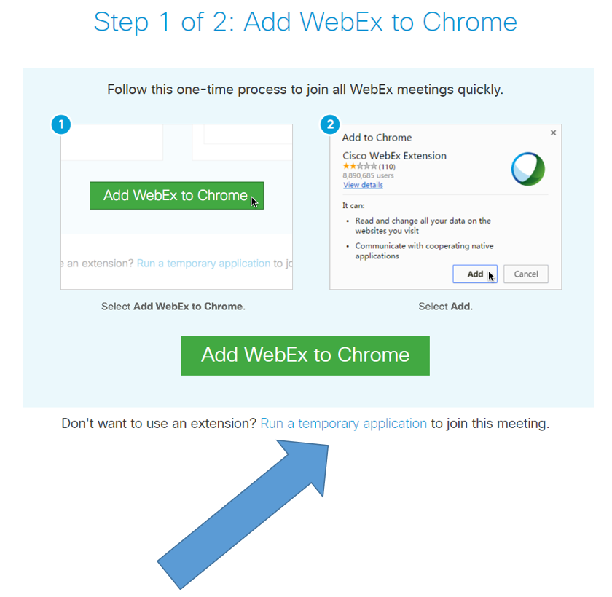

You may choose to add WebEx to Chrome (especially if you are a regular EEA webinar participant), but this requires you to have the administrator password for your computer. Therefore, we recommend that rather than installing the WebEx plugin, you Run a temporary application instead. Using this temporary application will allow you to join the webinar without installing anything on your computer (which most of us cannot do on computers at the office, due to IT policies).

Simply click on the link shown with the blue arrow above to download the file, then double click on the downloaded file, and confirm that you want to run it.

If you are using a different browser and/or a Mac computer, your dialogue windows may look different, but there will always be an option somewhere to ‘run a temporary application.’ Please click on that, and run the file that pops up or downloads. In the screenshot below, you will see a dialogue window for the Internet Explorer browser.

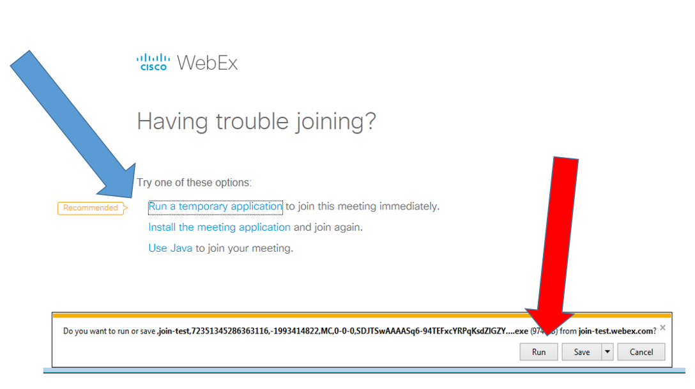

Again, please click first on ‘run a temporary application’ shown with the blue arrow, and then on RUN (red arrow).

7.3 Instructions how to join the webinar on 19 September 2017

Shortly before the webinar you will receive, at the email address with which you registered, a message with the link to join the webinar and instructions how to do it, as well as the agenda and the background paper introducing the topic (i.e., this document).
On 19 September, from 11:00 (CET, Brussels, Berlin, Paris time) onwards, please click on the provided link and you will be redirected to the starting page of WebEx.
https://eea.WebEx.com/eea/j.php?MTID=ma0493cd1f3b057388ee5635f525081a5
In case you are asked for a password to join the webinar, please enter “Panel“
Again, please remember to click Run a temporary application, a procedure which you should already know from doing the self-test described in the section 6.2 above.
When logging in, please enter your name and COUNTRY (e.g. Francesca ITALY, Pawel POLAND, etc) so that we can easily identify you if you want to ask questions during the webinar. Then, provide your email address (optional) and click on “Join”. (Screenshot below)

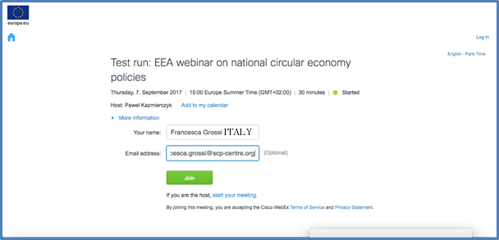

IMPORTANT NOTE - audio is NOT automatically activated when you join the webinar.
Once you have joined the webinar, you will still need to activate your audio in order to be hear the presenters and other participants, and to ask questions during the webinar if you so like.
To do that, please click on the Quick Start tab (top left corner). The first circle on the left will say either ‘Connect to Audio’ or ‘Call Using Computer’ as shown in the screenshot below.

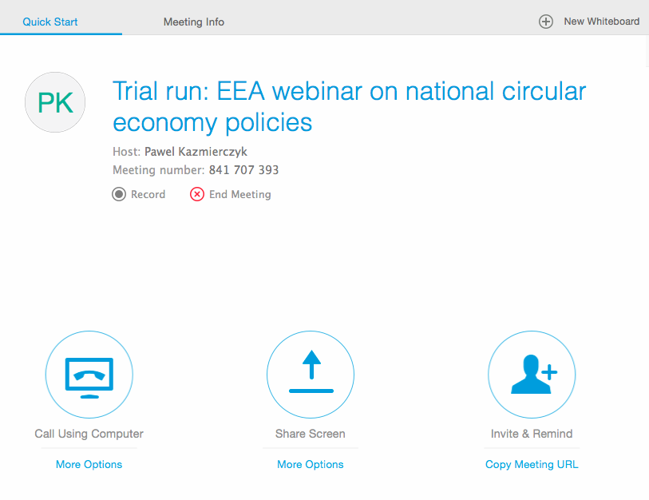

Just click on that circle. In case you should see a three-item pop up menu for Audio Connection (illustrated in the screenshot below), please click on “Call Using Computer” (the other two options are not active, but they may still display depending on your IT system).

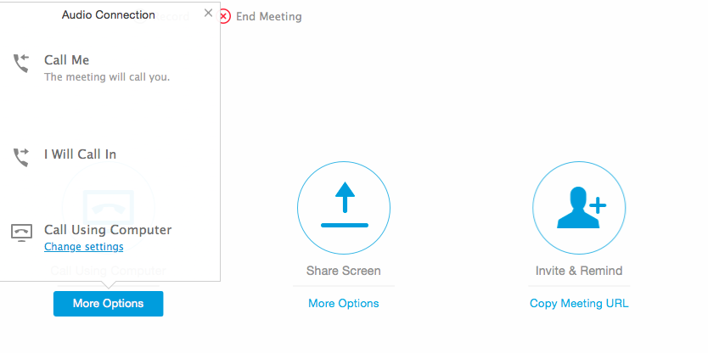

Finally, once you have successfully completed the above steps, please also make sure that the “participant” and “chat” functions are activated. You do that by clicking on the icons in the top right-hand side of the screen, as indicated by the arrows in the screenshot below. Once active, both icons will turn from grey to blue and you will then be able to see the list of other participants/presenters, and use the chat function (which will be needed during the webinar).

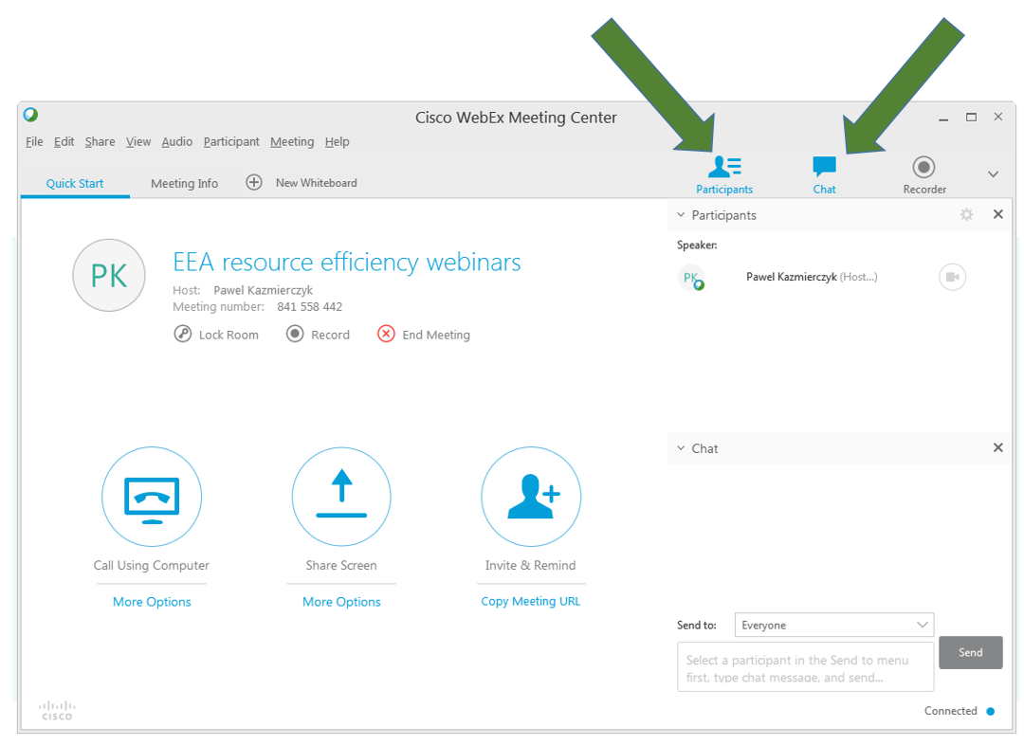

With any further questions, please do not hesitate to contact Ms. Francesca Grossi via email at Francesca.grossi@scp-centre.org.

that goes back to the Packaging and Packaging Waste Directive of 1994, the Landfill Directive of 1999, the Thematic Strategy on the prevention and recycling of waste of 2005 and the Waste Framework Directive of 2008
Country responses to question 7: What is the policy approach towards closing the material loop(s) in the economy/circular economy?
The European Parliament adopted the first readings of the proposals for amended waste, landfill, packaging, ELVs, batteries and WEEE directives. The Council has adopted the general approach but details are under discussion. Trilogues between council, parliament and committee are underway.

