Eionet resource efficiency webinar series:
Recently adopted national circular economy policies: updates from Denmark, France and Slovenia

Thursday, 13 December 2018, 11:30 - 13:00
(Central European Time = Berlin, Brussels, Paris, Warsaw)

Agenda and log-in instructions

ETC/WMGE 2.1.1.b Task Manager:
Bettina Bahn-Walkowiak (Wuppertal Institute), and Francesca Grossi (Collaborating Centre on Sustainable Consumption and Production - CSCP)
European Topic Centre on Waste and Materials in a Green Economy

EEA project manager:
Paweł Kaźmierczyk

Documents, presentations and video recordings from previous EEA resource efficiency webinars are available on the Eionet Forum: http://forum.eionet.europa.eu/nrc-scp-waste/library/eionet-webinars/webinars-resource-efficiency

Contents

1. Background and objectives of the webinar 3
2. Short bios of the speakers 5
3. Webinar Agenda 6
4. Technical guidance and the link to log in 7

1. Background and objectives of the webinar

Webinars on policies and instruments for resource efficiency and the circular economy are organized by the European Environment Agency for the Eionet network. They aim to support the exchange of information and sharing of experience among national institutions responsible for development and implementation of policies for the resource-efficient, circular economy at the country level.

The main objectives of these webinars are to keep countries informed about on-going and upcoming EU policy initiatives, and to provide a forum where countries themselves can present examples of their national initiatives that support the transition to a resource-efficient circular economy.

Previous webinars covered such topics as financing mechanisms for the circular economy; national strategies for resource efficiency; targets and indicators; industrial symbiosis; Raw Material Consumption and the European target on resource productivity; decoupling; policy mixes for resource efficiency; or national action plans for the circular economy.

The next webinar in this series will be held on 13 December 2018, from 11:30 to 13:00 Central European Time.

Many experts are familiar with circular economy initiatives in Belgium, Finland, or the Netherlands. However, in 2017 and 2018, several more countries adopted their national CE roadmaps, strategies, or action plans, or are in the process of doing so, as shown on the map below.

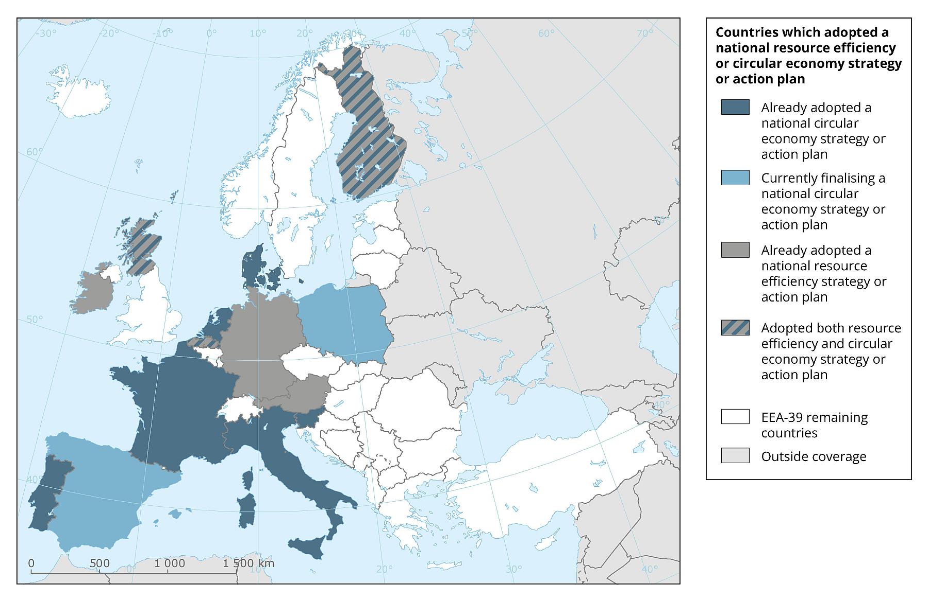

The webinar on 13 Dec 2018 will focus on three of the most recent initiatives. The presenters include:

Mr Søren Mørch Andersen: Danish Strategy for Circular Economy, September 2018
(https://stateofgreen.com/en/uploads/2018/10/Strategy-for-Circular-Economy-1.pdf ) and (https://en.mfvm.dk/fileadmin/user_upload/MFVM/Miljoe/Cirkulaer_oekonomi/Advisory-Board-for-Circular-Economy-Report-2017-Content_Single_pages_WEB.pdf )

Mr Sylvain Chevassus: the French roadmap for the Circular Economy, April 2018 (https://www.ecologique-solidaire.gouv.fr/sites/default/files/FREC%20anglais.pdf ) and (http://www.statistiques.developpement-durable.gouv.fr/fileadmin/documents/Produits_editoriaux/Publications/Datalab/2017/datalab-18-economie-circulaire-Edition-2017-anglais.pdf )

Mme Janja Kreitmayer: Slovenian Roadmap towards the Circular Economy, April 2018 (http://www.mop.gov.si/fileadmin/mop.gov.si/pageuploads/medijsko_sredisce/2018/05_Maj/04_SJ_Kazipot/18_05_04_SJ_Kazipot_EN.pdf)

Detailed instructions how to log in to the webinar - AND THE LINK - are included in the last section of this document.

2. Short bios of the speakers

Mr Søren Mørch Andersen, Ministry of Environment and Food, Denmark

Søren Mørch Andersen works at the Ministry of Environment and Food, Denmark. He holds a PhD degree in Microbiology. Prior to joining the Ministry in 2018, he worked at the Environmental Protection Agency, Denmark (2001-2018) and the Geological Survey of Denmark and Greenland (1996-2001).

Since 2001, Søren’s work areas and interests included Sustainable Consumption and Production, especially with ecolabelling and green public procurement, but also other SCP instruments like environmental management, Ecodesign, and latest Product Environmental Footprint, and the Circular Economy.

Email: san@mfvm.dk

Mr Sylvain Chevassus, Ministère de la transition écologique et solidaire, France

Sylvain Chevassus studied geography and European public policies. After some years in various Brussels-based organisations, since 2010 Sylvain has been working on sustainable consumption and production policies at the French Environment Ministry. One of his missions is to establish links between national policy and the EU and international levels

Email: Sylvain.Chevassus@developpement-durable.gouv.fr

Mme Janja Kreitmayer, Ministry for the Environment and Spatial Planning, Slovenia

Janja Kreitmayer McKenzie is a Secretary (Senior Policy Advisor) at the Ministry for the Environment and Spatial Planning, Slovenia. She is a circular economy and urban development expert and policy advisor. Since 2014 she has worked on the transition to a green and circular economy in Slovenia. From 2015 to July 2018 she worked as a Deputy Head of Partnership for Green Economy in Slovenia, which was led by the Office of the Prime Minister. She has also extensive experience in the international environment as a member various bodies within the EU, UN and OECD in the area of urban development and circular economy.

During Slovenian Presidency of the Council of the EU in 2008, she was in charge of the urban development dossier, and after continued to be responsible for urban development policy and EU territorial cohesion policy. She also worked as a coordinator and a researcher for international and national research projects on urban development issues. From 2009 to 2012 she was the Head of Sector for Strategic Spatial Development, and prior to that the Head of Department for National Spatial Planning, and Deputy Director for territorial development at the Office for National Spatial Planning of the Republic of Slovenia.

Janja started her career as an architect, and then obtained a Master’s degree in Urban Planning from Columbia University in New York.

Email: Janja.Kreitmayer@gov.si

3. Webinar Agenda

Wednesday 26 September 2018, 11:30 - 13:00 (CET)
Webinar will be open for login at 11:00 (CET) to ensure we can start at 11:30 sharp. The log-in link and instructions are in the next section of this document

11:30  -  11:35 | Start of the webinar.  Welcome and introduction  Mr Daniel Montalvo, EEA
11:35  –  11:45 | Setting the context - overview of recent national policy initiatives supporting transition to a resource-efficient circular economy  Mr Paweł Kaźmierczyk, EEA  (10 min presentation)
11:45  –  12:05 | Strategy for the Circular Economy in Denmark, (September 2018)  Mr Søren Mørch Andersen, Ministry of Environment and Food  (15 min presentation + 5 min Q&A)
12:05  –  12:25 | Roadmap for the Circular Economy in France (April 2018)  Mr Sylvain Chevassus, Ministère de la transition écologique et solidaire  (15 min presentation + 5 min Q&A)
12:25  –  12:45 | Roadmap towards the Circular Economy in Slovenia (April 2018)  Mme Janja Kreitmayer, Ministry for the Environment and Spatial Planning  (15 min presentation + 5 min Q&A)
12:45  –  13:00 | Round of discussion, general questions and answers
13:00 | End of the webinar

4. Technical guidance and the link to log in

Thank you for signing up for the EEA webinar on recently adopted national circular economy policies: updates from Denmark, France and Slovenia.

The webinar will take place on Thursday, 13 December 2018, 11:30 - 13:00 (CET). You can log in from 11:00 (CET) onwards. We encourage everyone to login well before the webinar starts at 11:30 sharp.

To log in, please click on the link below, or copy-paste it into your browser:

https://eea.webex.com/eea/j.php?MTID=m0ff5f9d1ba3b1c104995718cb317518b

In case you are asked for a password to join the webinar, please enter “bmDPg333“ (case sensitive).

IMPORTANT: If this is the first time that you are using WebEx Meeting Center platform, you will notice that there is quite a procedure to successfully log in. Details are described below.

First, you will be asked to install WebEx on your computer, or alternatively, run it as a temporary application instead.

You may choose to install WebEx (especially if you are a regular EEA webinar participant), but this will require you to have the administrator password for your computer. Using the temporary application will allow you to join the webinar without installing anything on your computer (which most of us cannot do on computers at the office, due to in-house IT policies).

Therefore, we recommend that instead of installing WebEx permanently, you should Run a temporary application instead.

The screenshot below illustrates how to do it for Google Chrome

Simply click on the link shown with the blue arrow above to download the file, then double click on the downloaded file, and confirm that you want to run it.

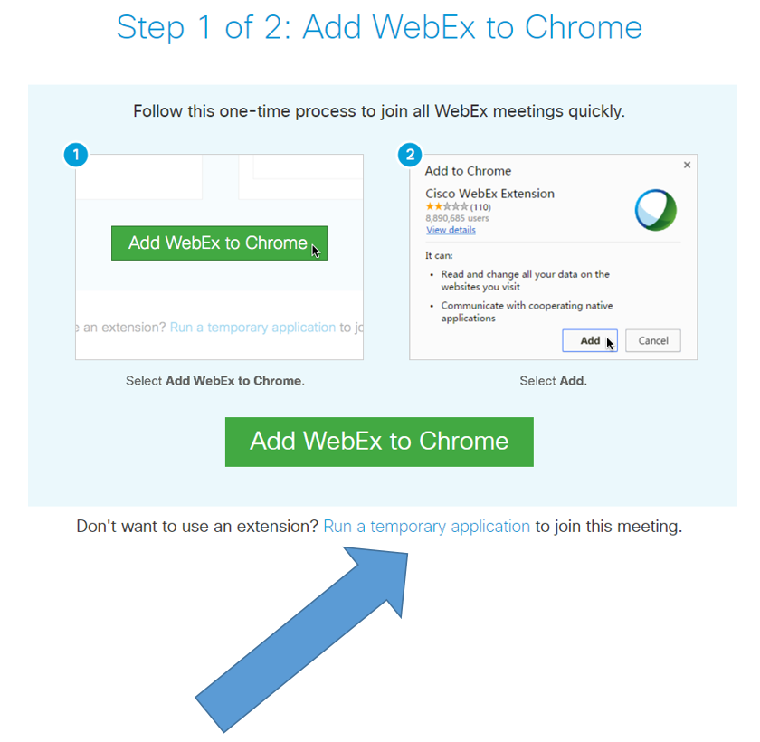

If you are using a different browser and/or a Mac computer, your dialogue windows will look different, but there should always be an option somewhere to ‘run a temporary application.’ Please click on that, and run the file that pops up or downloads.
The next screenshot illustrates the dialogue window for the Internet Explorer browser.
Please click first on ‘run a temporary application’ shown with the blue arrow, and then on RUN (red arrow).

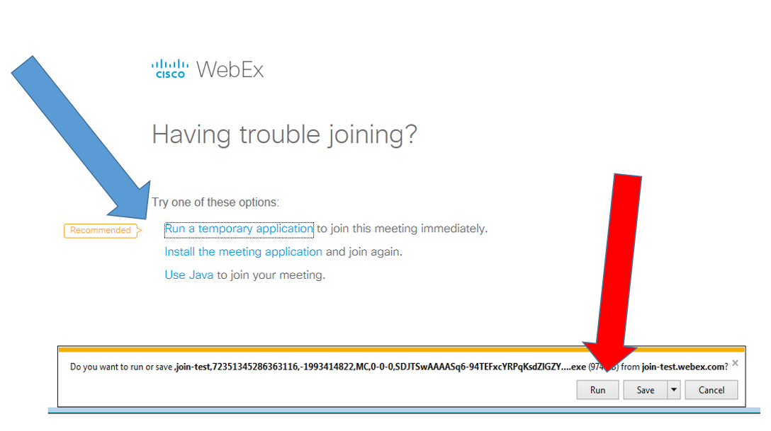

When you log in, please enter your name and COUNTRY (e.g. Francesca ITALY, Pawel POLAND, etc) so that we can easily identify you if you want to ask questions during the webinar. Then, optionally provide your email address and click on “Join”. (Screenshot below)

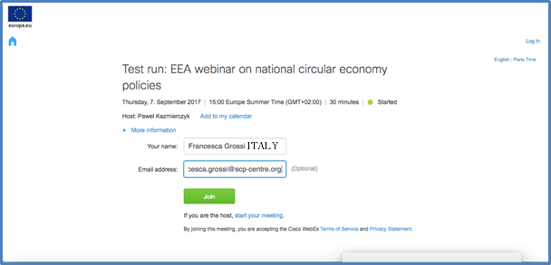

IMPORTANT NOTE - audio is NOT automatically activated when you join the webinar, and you need to activate it yourself.
Once you have joined the webinar, you still need to activate your audio (speaker and microphone) in order to hear the presenters and other participants, and to ask questions during the webinar.
To do that, please click on the Quick Start tab (top left corner). The first circle on the left will then say either ‘Connect to Audio’ or ‘Call Using Computer’ as shown in the screenshot below.

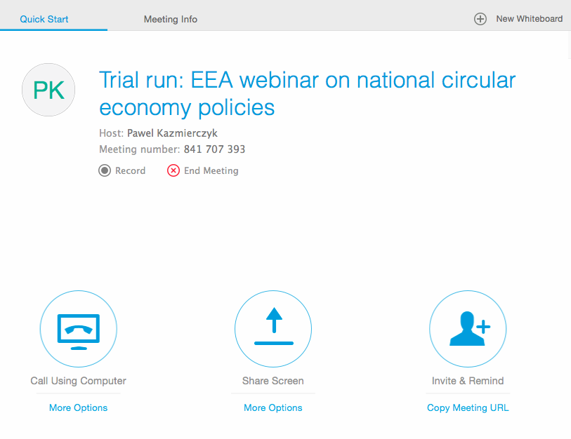

When you see a three-item pop-up menu for Audio Connection (shown in the screenshot below), please click on “Call Using Computer” (the other two options are not active, but they may still be shown, depending on your IT system. Please do NOT click on any of the options based on telephone.

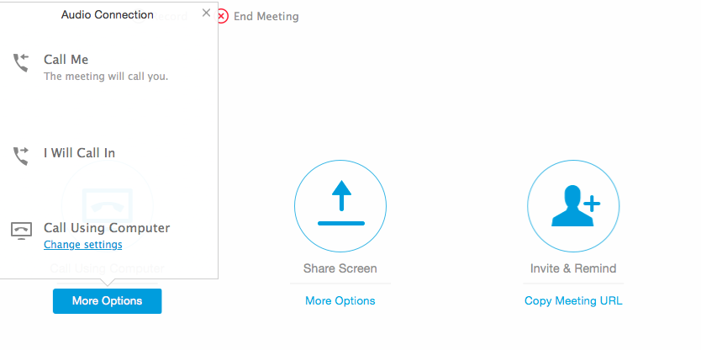

Once you have successfully completed the above steps, please also make sure that the “participant” and “chat” functions are activated. You do that by clicking on the icons in the top right-hand side of the screen, as indicated by the arrows in the screenshot below.
When active, both icons will turn from grey to blue and you will then be able to see the list of other participants/presenters, and use the chat function (which we will be using during the webinar). 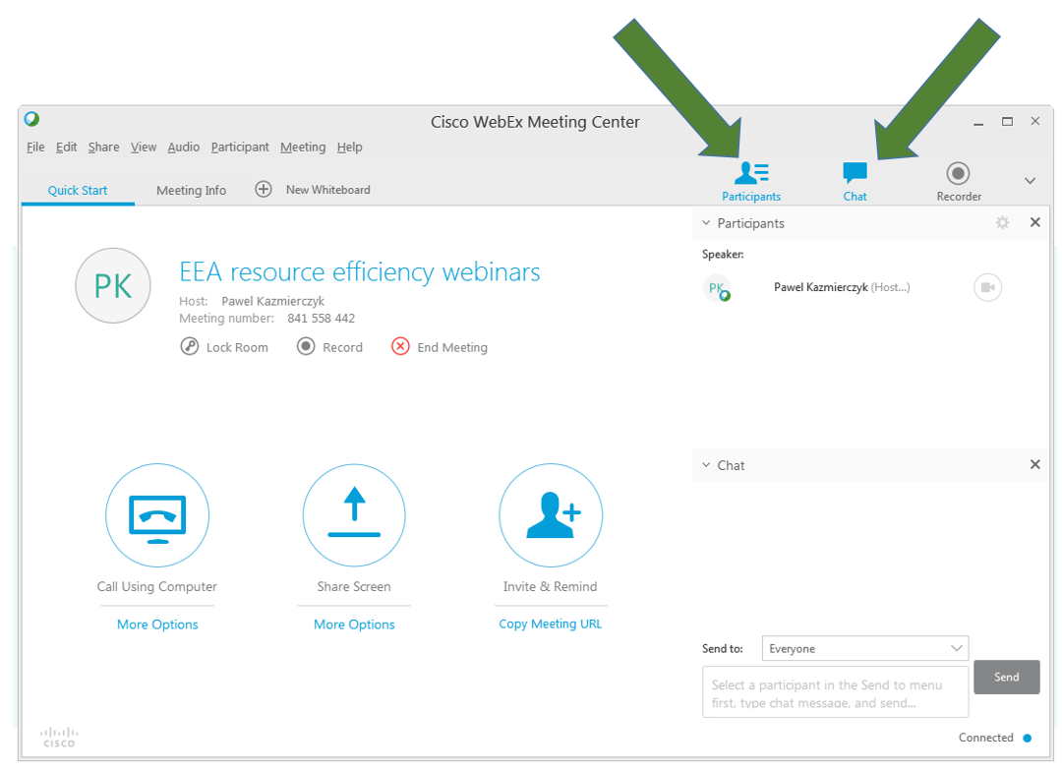

Finally, we ask everyone (except for the speakers) to deactivate your cameras if they are automatically turned on during the log in. The reason is that Webex allows only five cameras running at the same time, and we need those for the presenters.
If the camera icon next to your name is shown in blue, it means it is live and broadcasting. Please click on the icon to turn it off – it will then become light grey, as shown below with the red arrow.

