Please log in between 12.00 and 12.20 (CET)

Log-in instructions to join the Eionet webinar with Dr Janez Potočnik on transition to a new economic model

12:30 – 13:30 (CET) on Wednesday, 28 October 2015

Dear Colleagues,
Thank you for signing up for the EEA Resource Efficiency Webinar special – with Dr Janez Potočnik reflecting on transition to a new economic model. It will take place from 12:30 – 13:30 (CET) on Wednesday, 28 October 2015.
Many of you are already familiar with EEA resource efficiency webinars, but for the newcomers, just a short note that the technical aspect of webinars is quite straightforward. You will need a computer with a fast and stable internet connection, and an external microphone and speakers (or a headset).
If you will be using a laptop, you would probably want to use an external microphone (or a headset), as the quality of sound from built in microphones is often quite poor. This can be a problem if you would like to ask a question during the webinar.
To log in, we invite you to:
(1) First, please do a self-check, to make sure that your equipment is configured properly for Webex.
(2) Then, log in on Wednesday 28 October between 12:00 and 12:20 so that we can start at 12:30 sharp
Below you will find detailed instructions for these two steps.

In case of problems, you can reach us by email at: Marco.Veneziani@eea.europa.eu

- Technical test of your equipment (self-check)
Prior to the webinar, we kindly ask you to test your equipment (microphone and speakers, headset, etc.) to make sure that everything is configured properly and works well.

To do an interactive test with WebEx (self-check which you can do at any time), please click on: http://www.webex.com/test-meeting.html

You will be asked to provide a name an email address, and then click on the green button TEST A MEETING

IMPORTANT: When a welcome screen comes up, we recommend that you don’t install anything but instead click on ‘run a temporary application’ (illustrated with a red arrow on the figure below) and then when another small window pops up, you click on RUN (marked with a green arrow).

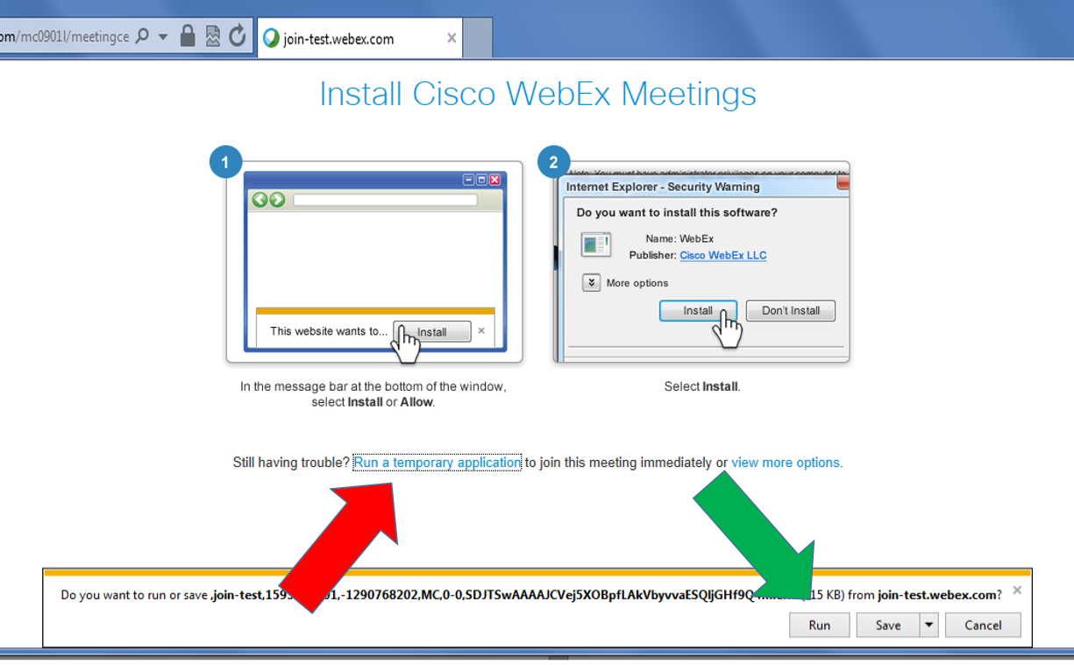

The screenshot above shows a dialogue window for Internet Explorer.

Below, is the same thing but in Google Chrome – note the ‘run a temporary application’ option marked with the red arrow.

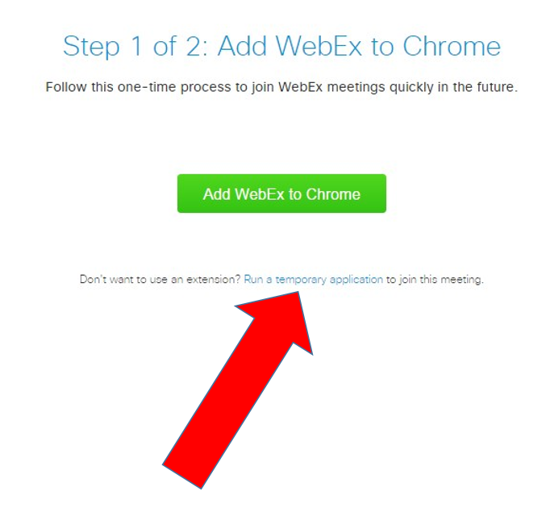

If you are using a different browser or operating system, your window may look different, but there should be an option to ‘run a temporary application.’ Click on that, and the run the file that pops up or downloads.

The reason why we recommend opting for the ‘temporary application’ is that with this method nothing will attempt to install itself permanently on your computer, a step which would typically require an ADMIN password on an office computer.

After the computer checks the configuration, you should get a message ‘Congratulations, your system is now set up properly.’

On Wednesday, 28 October 2015 please log in for the webinar between 12:00 and 12:20
To log in, please click on the link below:
https://eea-event.webex.com/eea-event/onstage/g.php?MTID=ec112629cac00063f7d59912cf2d4df9a
and fill in the requested info. Access should be password free, but if you are asked for it, the password is eionet (no capital letters)

Again, the most important thing is to ‘run a temporary application’ as described in section (1) above, rather than to try installing Webex software permanently.

When you are logged in, please click the two icons at the top right to activate the panels CHAT and PARTICIPANT. And take a moment to look around the Webex display window.
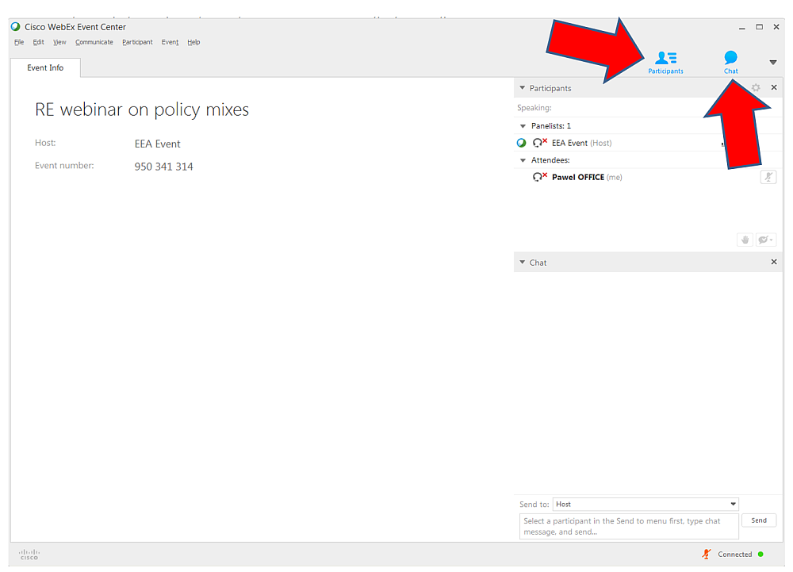

NB, everyone’s microphones will be muted on entry, to prevent unintended noise.
We will start the webinar at 12:30 sharp

See you tomorrow!
Paweł and the webinar team

INVITATION:
Resource Efficiency webinar special - Janez Potočnik on transition to a new economic model
12:30 – 13:30 (CET) on Wednesday, 28 October 2015

To:
National Focal Points
NRCs for Resource-efficient economy and the environment
NRCs for State of Environment
NRCs for Waste

Dear Colleagues,
As part of the series of resource efficiency webinars, former Environment Commissioner Janez Potočnik will share his thoughts on challenges and opportunities in transition to a new economic model.

In addition to presenting some examples how keeping resources as long as possible in the production and consumption cycle could work in practice, Mr. Potočnik will briefly touch on the existing policy proposals and instruments at the European Union level (the proposed Circular Economy Package) and on the global level (SDGs and International Resource Panel).

This special one-off webinar for the Eionet network will take place on Wednesday, 28 October 2015, from 12:30 till 13:30 (CET).

To register, please sign up at:
https://docs.google.com/document/d/1rjNun9IOsekwlavj4rqoiw7qlLZd66sBvFNGCU7Filw/edit?usp=sharing

On 27 October 2015, we will email the registered participants detailed log-in instructions for the webinar.

About the Speaker:

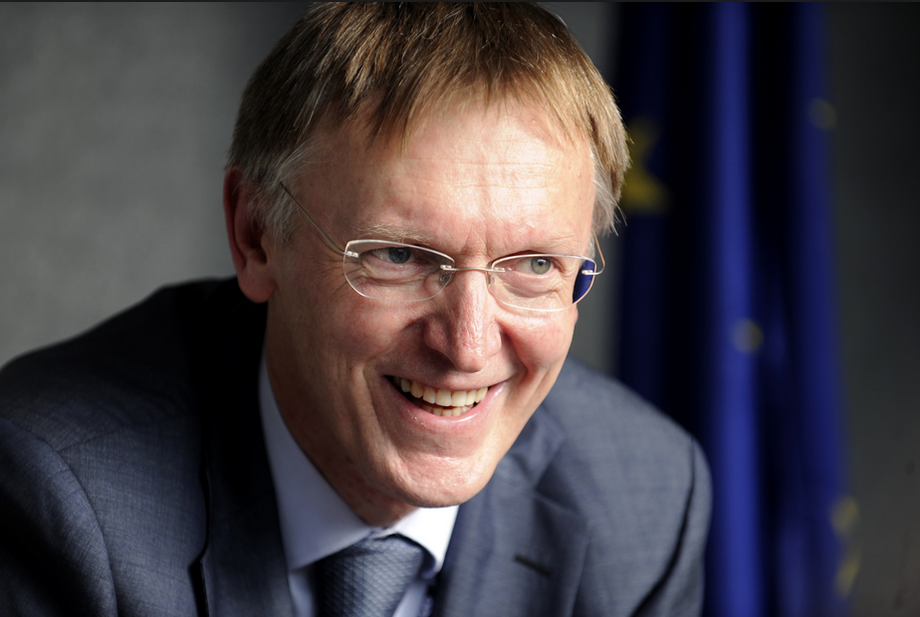

Dr. Janez Potočnik, the former European Commissioner for the Environment in the period 2010-2014, is arguably best known as the man who put ‘doing more with less’ on the EU environmental policy agenda. In response to the global economic recession of 2008, he initiated the work on the EU resource efficiency flagship initiative and the circular economy package.

Prior to the environment post, Mr. Potočnik served as the European Commissioner for Science and Research (2004-2010), and for a period after the 2004 EU accession, was also a "shadow" European Commissioner for Enlargement, jointly with the Commissioner Verheugen.

Before taking up duties at the European Commission in Brussels, Mr. Potočnik was the Slovenian Minister for European Affairs (2002-2004) and the Head of the Negotiating Team for the Accession of Slovenia to the EU (1998-2004).

An economist by background, in the period 1993-2001 he was the Director of the Institute of the Macroeconomic Analysis and Development, Ljubljana, Slovenia.

Mr. Potočnik currently serves as a co-chair of UNEP’s International Resource Panel.

About the International Resource Panel
http://www.unep.org/resourcepanel/Default.aspx?tabid=133307
The International Resource Panel was launched by the United Nations Environment Programme in 2007 to build and share the knowledge needed to improve the use of resources worldwide. Its mission is:

- to provide independent, coherent and authoritative scientific assessments of policy relevance on the sustainable use of natural resources and, in particular, their environmental impacts over the full life cycle; and
- to contribute to a better understanding of how to decouple economic growth from environmental degradation.

Bringing together world renowned scientists, the Resource Panel is a unique science policy interface on the sustainable management of natural resources, seeking to develop practical solutions for policymakers, industry and society.

To date, the International Resource Panel has published twelve reports :

- Towards Sustainable Production and Use of Resources: Assessing Biofuels (2009)
- Assessing the Environmental Impacts of Consumption and Production: Priority Products and Materials (2010)
- Metal Stocks in Society: Scientific Synthesis (2010)
- Decoupling Natural Resource Use and Environmental Impacts from Economic Growth (2011)
- Recycling Rates of Metals: A Status Report (2011)
- Measuring Water Use in a Green Economy (2012)
- Metal Recycling: Opportunities, Limits, Infrastructure (2013)
- City Level Decoupling: Urban Resource Flows and the Governance of Infrastructure Transitions (2013)
- Environmental Risks and Challenges of Anthropogenic Metals Flows and Cycles (2013)
- Assessing Global Land Use: Balancing Consumption with Sustainable Supply (2014)
- Building Natural Capital: How REDD+ can Support a Green Economy (2014)
- Decoupling 2: Technologies, Opportunities and Policy Options (2014)

Several additional reports are currently under preparation.

