Indicator name |  |  | Tourism flows (1. Tourism arrivals)
ASSESSMENT
Indicator Name |  |  | TOUR001a – Tourism arrivals (domestic vs international) at country level  TOUR001b – Tourism arrivals (domestic vs international) at NUTS2 level  TOUR001i – Tourism arrivals (time series)
Key policy question |  |  | What are the most tourism intensive regions in Europe?
Key message |  |  | Europe is the 1st destination of the world in terms of international tourism arrivals. If we add the domestic tourism arrivals to the former, then total numbers are even much more relevant, and they show that Europe as a whole has a strong capacity of tourism attraction. Moreover, this capacity has been constantly increasing during the last years and decades. However, there are significant differences of total number of tourism arrivals between countries and regions.
Key assessment |  |  | In 2014 there was a total number of 906 million tourism arrivals at all the 28 EU countries, 567 million of which were from residents (domestic tourists), and the other 339 million from non-residents (international tourists). These numbers include arrivals at tourist accommodation establishments, not border arrivals. Analysing these data country by country (and including also the other EEA countries) allows to see the significant differences between countries: a) in total numbers of annual arrivals (five countries stand out among all the rest, having more than 100 million tourism arrivals: Germany, France, Spain, Italy, and United Kingdom); and b) in relative numbers according to the percentage of domestic arrivals vs international arrivals (countries such as Germany, France, United Kingdom, Sweden, Poland or Norway have a much higher percentage of domestic arrivals than international arrivals, while countries such as Turkey, Austria, Greece, Croatia or Iceland is the opposite. There are also some countries, like Spain, Italy, Belgium or Hungary that, although with very different total numbers, have a well-balanced proportion between domestic and international arrivals).  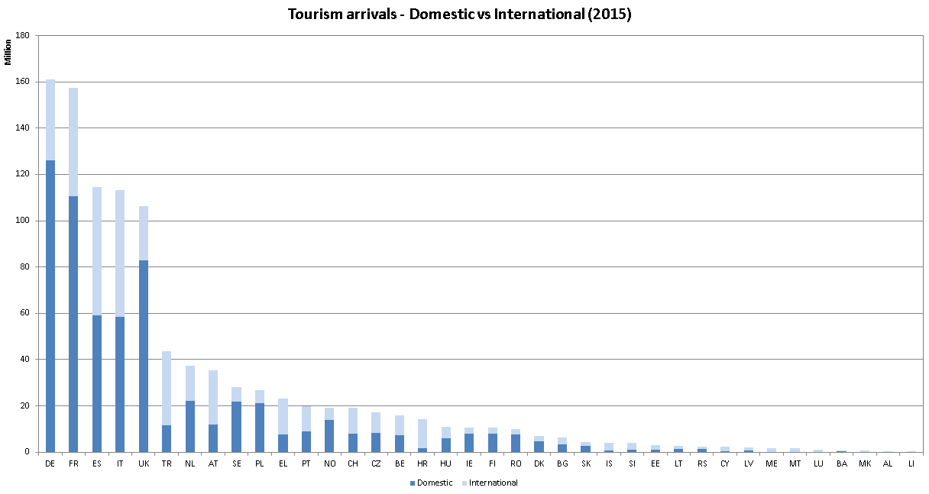  When analysing these numbers at regional level, it can be seen that there are also big differences at internal level for each country. For example, the countries that receive the highest number of tourists, concentrate a good number of them in very few regions. This is the case of Germany (Berlin and Munich regions), France (Ille de France, Provence-Alpes-Cote d’Azur, Savoie), Spain (Catalonia, Andalusia, Madrid, Canary Islands), Italy (Tuscany, Lazio, Lombardia, Veneto), United Kingdom (London region), or Turkey (Istanbul and Antalya regions).  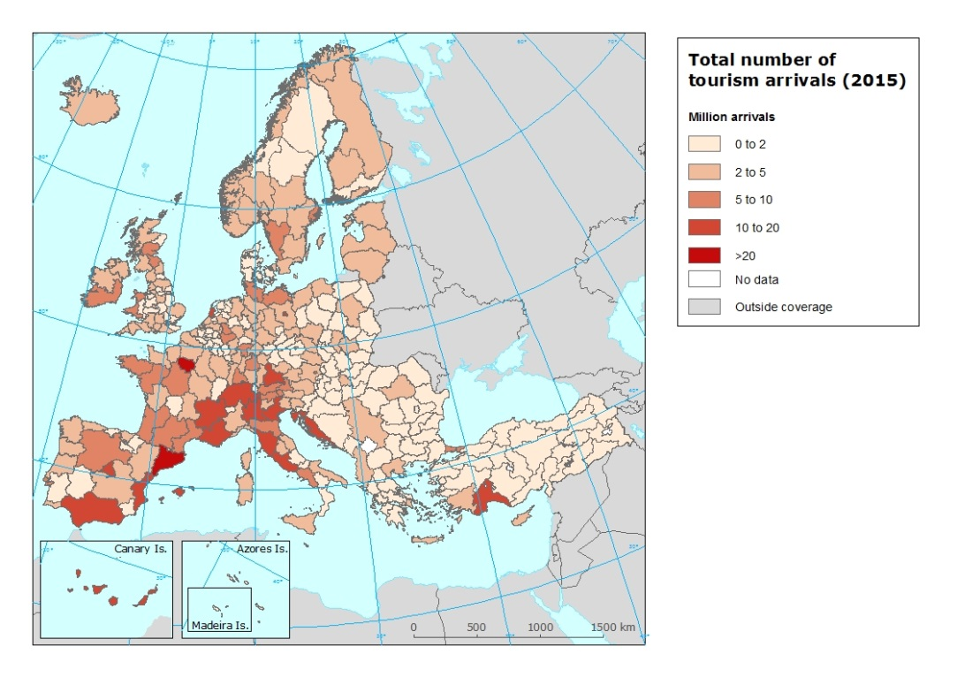
Specific policy question |  |  | How is the demand for visiting Europe increasing?
Specific assessment |  |  | If 2014 data is compared to 2000 data, it can be observed how tourism arrivals in Europe rose significantly during those first years of the 21st Century. Overall tourism arrivals (including domestic and international) at European Union countries and Switzerland, Norway, Iceland, Liechtenstein, and Macedonia passed from 684 million in 2000 to 988 million in 2014. Domestic arrivals passed from 432 million to 603 million in the same period, as well as international arrivals passed from 251 million to 353 million. These growing numbers were general for most of the European countries, although the rhythm of growth was different depending on the country.  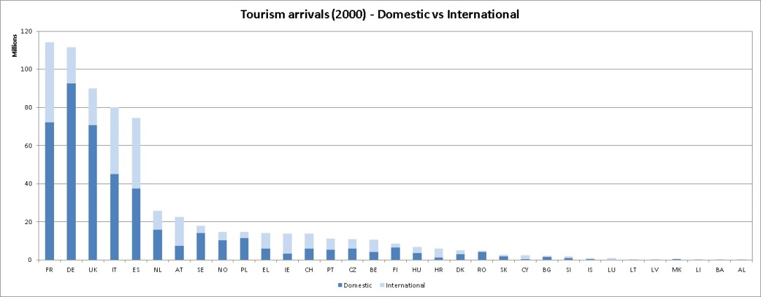
Examples
SPECIFICATIONS
Indicator definition |  |  | The indicator measures the total number of tourism arrivals per country and NUTS 2 region (internal tourism) and per year. Data is presented as total number of tourism arrivals, though this total number is also split into domestic arrivals (tourism arrivals by inhabitants of the same country or domestic tourism) and international arrivals (tourism arrivals by foreign visitors or inbound tourism).
DPSIR |  |  | D
Justification
 |  | Rationale | This is a very general indicator, but at the same time is a key indicator, since it informs about the global tourism attractiveness of each country and region and its evolution over time. It also informs about the origin of the visitors, distinguishing between domestic tourists (short distance tourists) and international tourists (longer distance tourists). This indicator and overnight stays indicator complement each other, since tourism arrivals indicator measures the total number of trips to a country, and overnight stays indicator measures the length of stay (in days) of those trips.
 |  | References
Policy context
 |  | Policy context | EC and national policies on tourism and sustainable tourism.
 |  | Targets
 |  | Related policy documents
Methodology
 | Methodology for indicator calculation |  | Data is directly provided by EUROSTAT statistics (and national tourism statistics when not provided by EUROSTAT). Each arrival means a person trip that at least did one overnight stay at tourist accommodation establishments.
 | Methodology for gap filling
 | References
Data specifications |  |  | Data comes from EUROSTAT (tour_acc_arn2), with the exception of Albania, Bosnia and Hercegovina, Switzerland, and Turkey, that they have been provided by national tourism statistics.
Uncertainties
 | Methodology uncertainty
 | Data sets uncertainties |  | Data only takes in consideration official commercial establishments. It does not cover other types of tourism accomodation (B&B, sharing economy establishments, second homes, etc.).
 | Rationale uncertainty |  | Same comment as data sets uncertainties.
Further work |  |  | Data needs to be regularly updated. This will allow analyzing trends.
Ownership and contacts |  |  | ETC – ULS

