Indicator name |  |  | Tourism flows (2 – Overnights spent)
ASSESSMENT
Indicator Name |  |  | TOUR001c – Overnights spent at tourist accommodation establishments (residents and non-residents)  TOUR001d – Share of overnights spent at tourist accommodation establishments  TOUR001e – Overnights spent at tourist accommodation establishments (time series)  TOUR001f – Percentage of total nights spent at tourist accommodations establishments in coastal areas
Key policy question |  |  | What are the most tourism intensive regions in Europe?
Key message |  |  | Nights spent by tourists are unevenly distributed in Europe at regional level. Data show significant differences between territories, as well as the distribution of resident and non-resident nights spent at tourist accommodation establishments.
Key assessment |  |  | The most attractive regions for tourists (in total number of overnight stays at official tourist accommodation establishments in 2015) are mainly concentrated in South-western Europe, including the Spanish Mediterranean fringe, Southern France (and Ille de France as well), the Alpine region, Northern Italy, and coastal Croatia. In absolute numbers, only few regions stand out among the others, with more than 50 million overnight stays. Four of them are in Spain (Catalonia, Andalusia, Balearic Islands, and Canary Islands), two in France (Ille de France, and Provence-Alpes-Cote d’Azur), one in Italy (Veneto), and one in Croatia (coastal Croatia). A good number (or the majority) of regions in Portugal, Spain, France, Italy, Austria, Germany, the Netherlands, United Kingdom, and Ireland register more than 5 million of annual overnight stays, which means a relatively high level of tourism attractiveness. On the contrary, some Scandinavian regions and most of the Eastern European regions register less than 5 million overnight stays.  Most part of European regions receive more residents (domestic tourists) than non-residents (international tourists). Exceptions use to be those regions that receive the highest number of total overnight stays, previously mentioned.  In the case of coastal NUTS 2 regions, overnight stays use to be highly concentrated in the coastal municipalities. This shows the high tourism attraction factor that sea exerts on tourism. This happens in a very clear way (concentration of more than 65 % of the total overnight stays at the region level in the coastal municipalities) in all of the Mediterranean islands, Portuguese and Spanish Atlantic islands (Açores, Madeira, Canary Islands), and the coastal regions of Southern Italy (and some Northern regions too), Mediterranean regions of Spain, United Kingdom (most part of its coastal regions), Denmark, Germany, Poland, Iceland, Estonia, Romania, and even in a most intensive way in Norway, Croatia, Bulgaria.  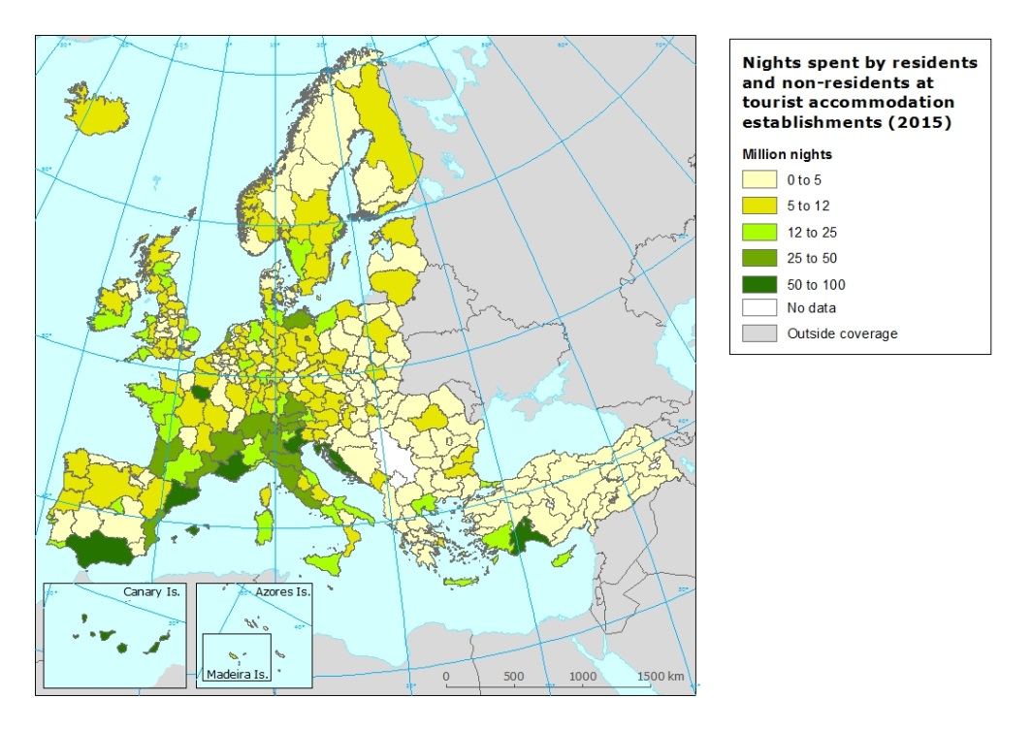  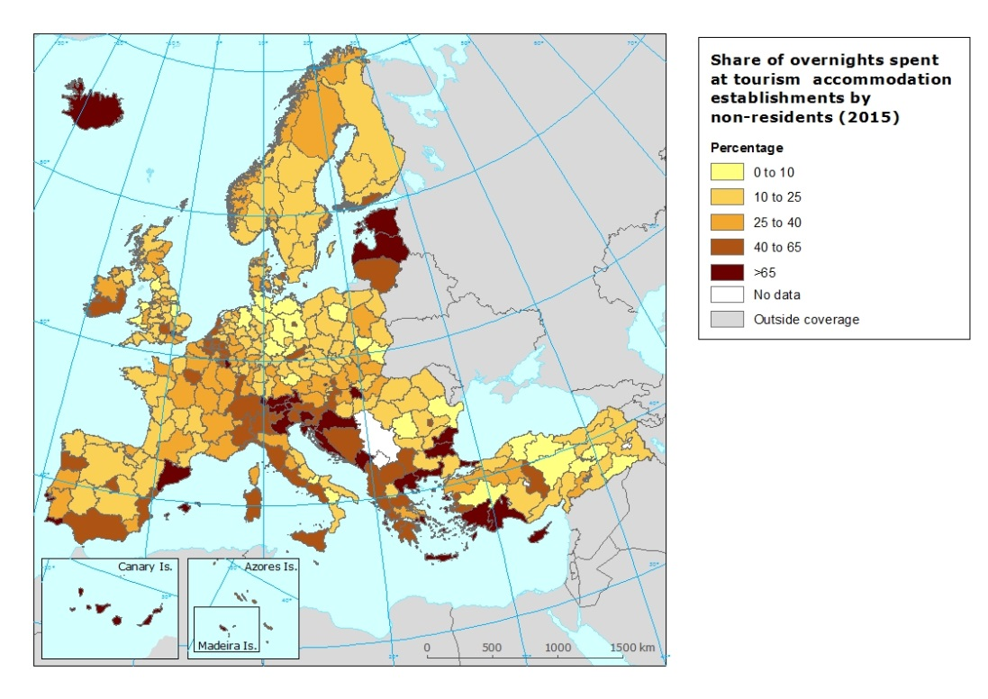  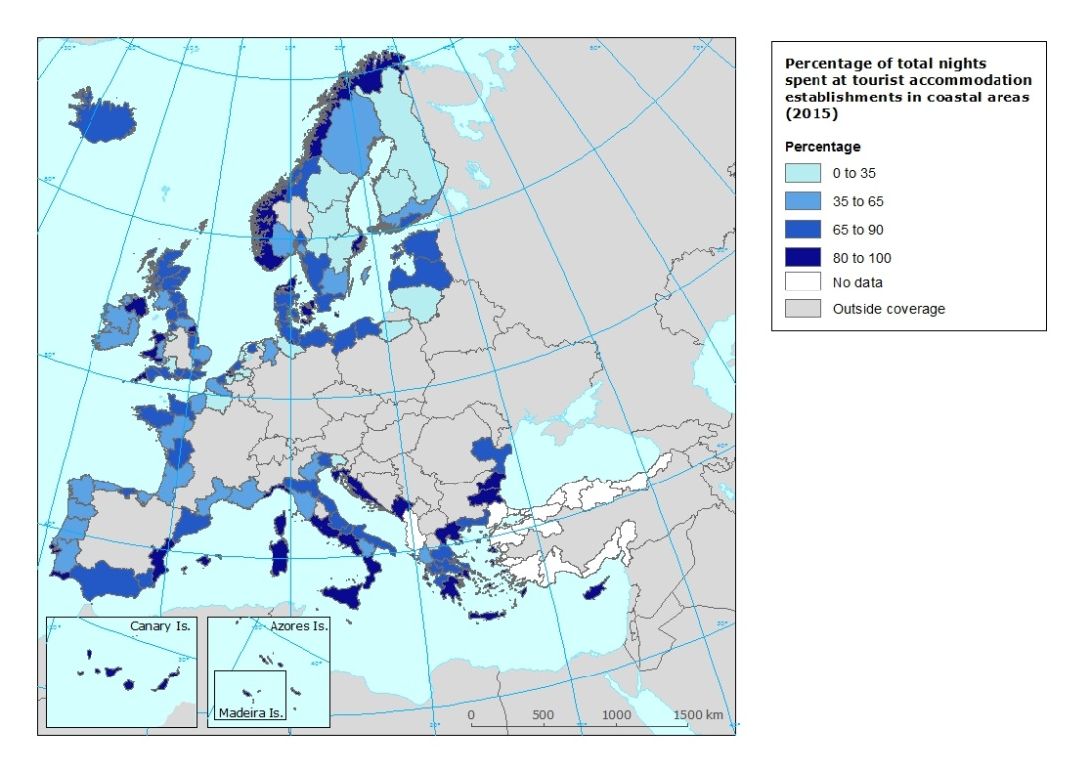
Specific policy question |  |  | How is the demand for visiting Europe increasing?
Specific assessment |  |  | The map of the evolution of overnight stays between 2004 and 2014 shows how there was a general increase of number of both overnight stays by residents and non-residents throughout Europe during that period. This is a reflection of the overall increase of tourism numbers that most of the European countries have experienced during the last years.  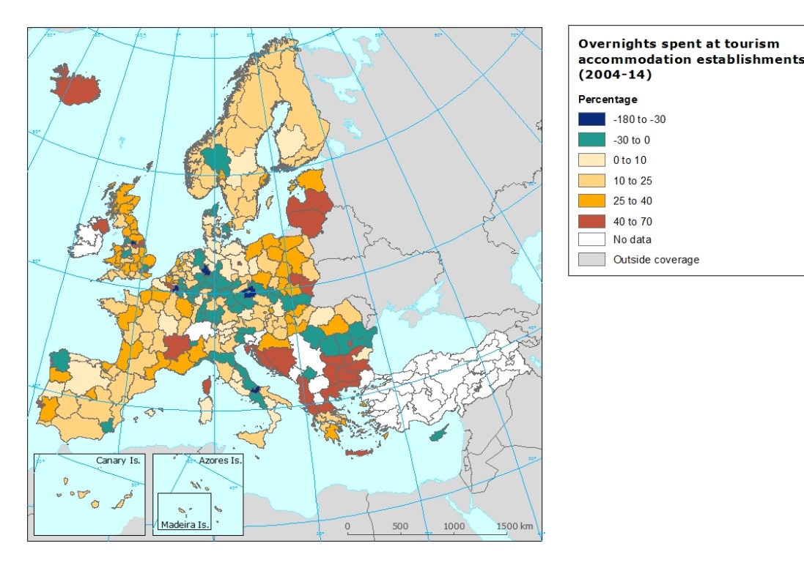
Examples
SPECIFICATIONS
Indicator definition
DPSIR |  |  | D
Justification
 |  | Rationale | This indicator informs about the tourism attractiveness of each region and its evolution over time. It also informs about the origin of the visitors, distinguishing between domestic tourists (short distance tourists) and international tourists (longer distance tourists). This indicator and tourism arrivals indicator complement each other, since tourism arrivals indicator measures the total number of trips to a country, and overnight stays indicator measures the length of stay (in days) of those trips. However, overnights better reflect the impact of tourism on the destination than tourism arrivals.
 |  | References
Policy context
 |  | Policy context | EC and national policies on tourism and sustainable tourism.
 |  | Targets
 |  | Related policy documents
Methodology
 | Methodology for indicator calculation |  | Data is directly provided by EUROSTAT statistics (tour_occ_nin2).
 | Methodology for gap filling
 | References
Data specifications |  |  | Data comes from EUROSTAT.
Uncertainties
 | Methodology uncertainty
 | Data sets uncertainties |  | Data only takes in consideration official commercial establishments. It does not cover other types of tourism accomodation (B&B, sharing economy establishments, second homes, etc.).
 | Rationale uncertainty |  | Same comment as data sets uncertainties.
Further work |  |  | Data needs to be regularly updated. This will allow analyzing trends.
Ownership and contacts |  |  | ETC – ULS

