Indicator name |  |  | Tourism flows (3. Seasonality of tourism)
ASSESSMENT
Indicator Name |  |  | TOUR001g – Monthly distribution of nights spent at EU-28 level  TOUR001h – Seasonal distribution of nights spent at country level
Key policy question |  |  | Do we better spread the tourism season over the year?
Key message |  |  | One of the key problems that tourism has to face -in sustainability terms- is its seasonality. Most countries and their tourism destinations suffer this problem. Seasonality of demand makes it very difficult to plan and manage the provision of tourism facilities efficiently. For a short period of time there is a need for additional infrastructures at the destination level (i.e. roads, parking spaces, etc.) that use more land. Moreover, to avoid environmental damages the waste and water management systems are under pressure to respond the higher demand during high season. A process of stimulating demand and use in less busy seasons, taking up existing capacity, would enable revenue from tourism to grow while putting less pressure on the environment and community than would result from a growth in peak demand.  However, from an environmental sustainability perspective, seasonality can also be seen as a positive issue, since during some parts of the year wildlife is not under tourism pressure (i.e. some mountain areas are closed to tourists during some part of the year, and this is crucial for some animal species reproduction).
Key assessment |  |  | Data from Eurostat show that, taking Europe (EU-28) as a whole, tourist overnights spent (by residents and non-residents) in August are on average four times higher than in the lowest month (January). July and August accounted for one third (33.0 %) of all nights spent in tourist accommodation in 2015. The period from June to September represented more than half (53.7 %) of all nights spent during the year.  Figure: Monthly share (%) of nights spent at EU-28 (2015)  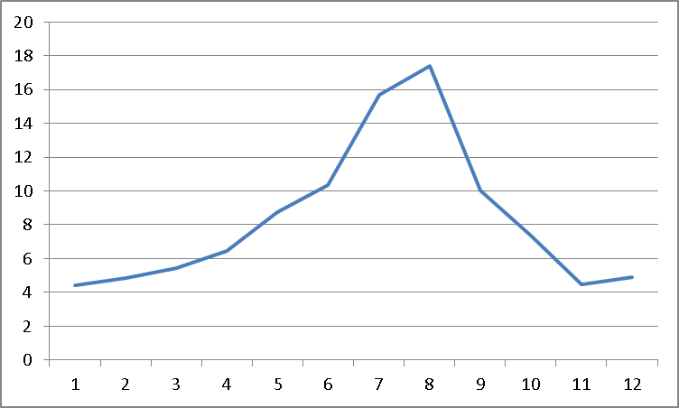  Data at country level show how in eight countries the seasonal variation in 2015 was above the EU average. This group included typical Mediterranean destinations (Croatia, Greece, Cyprus, Italy and France) but also Bulgaria, Denmark and Macedonia. However, there was no absolute geographical rule since other countries located in this region showed a much lower seasonal variation. Countries showing lower levels of seasonality are Hungary, Poland, Estonia, Latvia, Lithuania, Finland, Belgium, Germany, Czech Republic, and Slovenia. This does not mean, though, that those countries do not have regions with high seasonality. Finally, the Alpine countries of Austria and Liechtenstein show a false low seasonality, since in fact they have two high seasons clearly marked (winter and summer). When analysing the ratio between peak and bottom month, it can be seen how the EU average is 4.0 (the nights spent in the peak month of the year use to be 4 times the number of the bottom month). However, there are some countries that have a much higher ratio (especially Croatia, but also Greece, Cyprus, and Bulgaria). In the other extreme, countries like Slovakia, Finland, Serbia, Czech Republic, Germany, Estonia, and Poland, have a ratio below 3.0.  Figure: Nights spent at tourist accommodation establishments, distribution per season (2015)  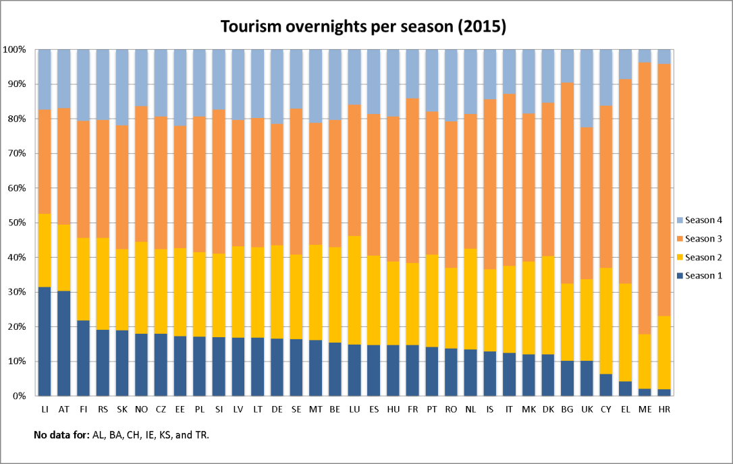
Specific policy question
Specific assessment
Examples
SPECIFICATIONS
Indicator definition |  |  | Data show monthly nights spent at tourism accommodation establishments at EU-28 level, and quarterly nights spent at tourism accommodation establishments per country.
DPSIR |  |  | D
Justification
 |  | Rationale | The concentration of tourism trips into certain periods of the year has a major effect on sustainability. Not only does it seriously reduce the viability of enterprises and their ability to offer year round employment, it can also place severe pressure on communities and natural resources at certain times while leaving surplus capacity at others. It is important to know the distribution of overnight stays all over the year in each destination, region and country, in order to promote, if necessary, actions to reduce seasonality and spread tourism activity over the year.
 |  | References | Tourism Sustainability Group (2007). Action for more sustainable European tourism. Brussels.
Policy context
 |  | Policy context | EC and national policies on tourism and sustainable tourism.
 |  | Targets
 |  | Related policy documents
Methodology
 | Methodology for indicator calculation |  | Data is directly provided by EUROSTAT statistics (tour_occ_nim).
 | Methodology for gap filling
 | References
Data specifications |  |  | Data comes from EUROSTAT.
Uncertainties
 | Methodology uncertainty
 | Data sets uncertainties |  | Data only takes in consideration official commercial establishments. It does not cover other types of tourism accomodation (B&B, sharing economy establishments, second homes, etc.).
 | Rationale uncertainty |  | Same comment as data sets uncertainties.
Further work |  |  | Data needs to be regularly updated. This will allow analyzing trends.
Ownership and contacts |  |  | ETC – ULS

