Indicator name |  |  | Tourism related modes of transport
ASSESSMENT
Indicator Name |  |  | TOUR002a – Trips made by European residents by main modes of transport
Key policy question |  |  | Are we using more environmentally friendly modes of transports for  tourism?  Are we going better at managing the tourism mobility?
Key message |  |  | When Europeans travel inside their own country (domestic trips) use to do it mainly by land, and more precisely by motor vehicle (75.8 % from all domestic trips), while when they go abroad (outbound trips, to any country of the world) they tend to use the airplane (53.8 % from all outbound trips). Significant differences among countries, though, are observed.
Key assessment |  |  | Data provided by Eurostat on means of transport used by European residents when they travel for tourism reasons in year 2014 show the main trends both for domestic and outbound trips. Motor vehicles (private or rented) were the main means of transport for 64.4 % of all trips, followed by air and railway transport (15.6 % and 11.6 %, respectively). Other modes of transport were relatively insignificant, though the pattern can be very different at country level. Waterways were the main means of transport for 36.1 % of trips that residents of Malta made, while in Romania residents took buses for 23.5 % of their trips. Not surprisingly, air transport was the preferred means of transport for outbound trips (53.8 %), while for domestic trips EU residents travelled mainly by motor vehicles (75.8 %), followed by rail (13.8 %).  Figure: Trips made by EU-28 residents by main means of transport, 2014  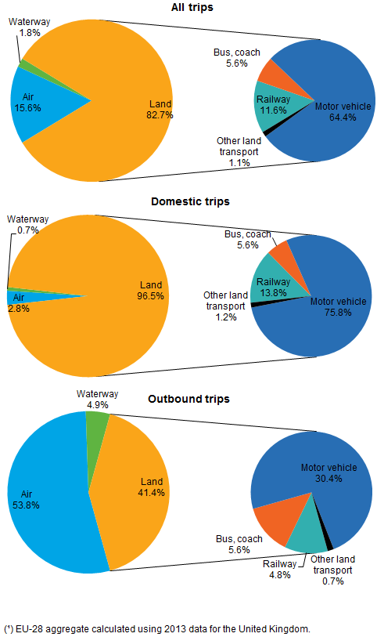  Source: Eurostat.  Table: Trips made by EU residents by main means of transport, 2014  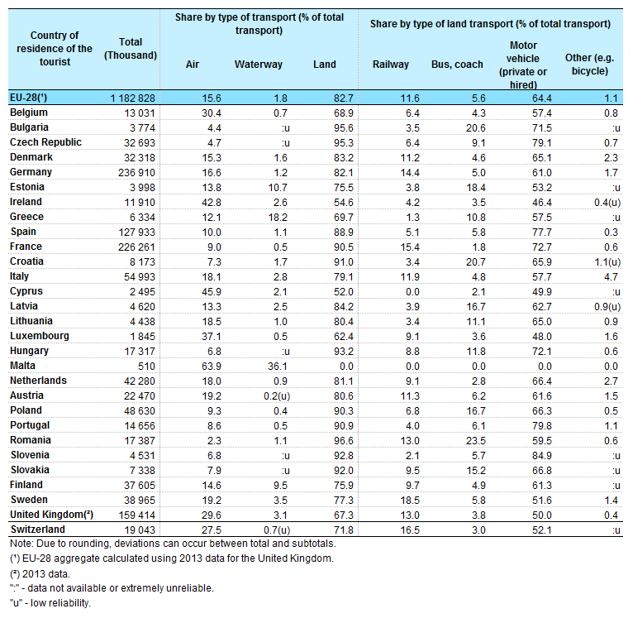  Source: Eurostat.
Specific policy question
Specific assessment
Examples
SPECIFICATIONS
Indicator definition |  |  | Share by type of transport used by European residents when they travel inside their country (domestic trips) and outside their country (outbound trips). Annual data at country level.
DPSIR |  |  | P
Justification
 |  | Rationale
 |  | References
Policy context
 |  | Policy context
 |  | Targets
 |  | Related policy documents
Methodology
 | Methodology for indicator calculation |  | Data is provided by Eurostat’s tourism statistics (tour_dem_tttr).
 | Methodology for gap filling
 | References |  | Eurostat (2016). Tourism statistics.
Data specifications |  |  | Data source: Eurostat
Uncertainties
 | Methodology uncertainty |  | The indicator does not include data from non-European residents travelling to and within Europe.
 | Data sets uncertainties
 | Rationale uncertainty
Further work |  |  | Analyse historical trends in order to identify changes in the modal distribution of means of transport.
Ownership and contacts |  |  | Eurostat  ETC/ULS

