Indicator name |  |  | Tourism related modes of transport (2. Airplane)
ASSESSMENT
Indicator Name |  |  | TOUR002b – Total air passengers carried  TOUR002c – Carried passengers per airport
Key policy question |  |  | What are the changes in the number of passengers per airport?
Key message |  |  | Air traffic and number of air passengers carried are steadily increasing in Europe. The environmental impacts of increased air traffic are relevant and have both a global (climate change) and local (noise) dimension. Tourism is the most important contributor to the increase in air traffic with a clear impact on touristic areas around the Mediterranean Sea and in bigger cities.
Key assessment |  |  | When looking at the overall distribution of air passengers carried by NUTS-2 regions, those with major airports are highlighted, e.g. Paris, London, Frankfurt, Munich, Barcelona, Madrid, Rome. Catalonia, Andalusia, Balear and Canary Islands and the French region of Provence-Alpes-Côte d'Azur are specific touristic regions with an elevated number of air passengers carried in comparison to other neighbouring regions.  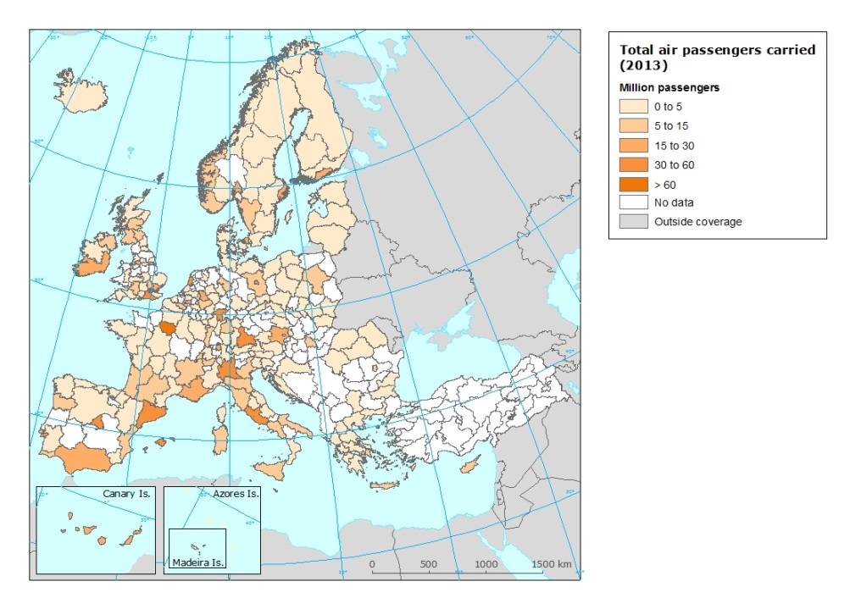  The number of passengers per airport provides a more detailed vision on the local/regional trends in air traffic. While there is a general increase of the number of passengers carried by airplane in Europe, this increase is taking place mostly in airports with more than 10 million passengers, with the exception of Madrid and Athens, for different operational and economic reasons. Most Turkish airports stand out with an increase over 30% between 2009 and 2013. Small, regional airports, in turn, loose passengers despite the steady growth of low cost airlines that seems to concentrate.  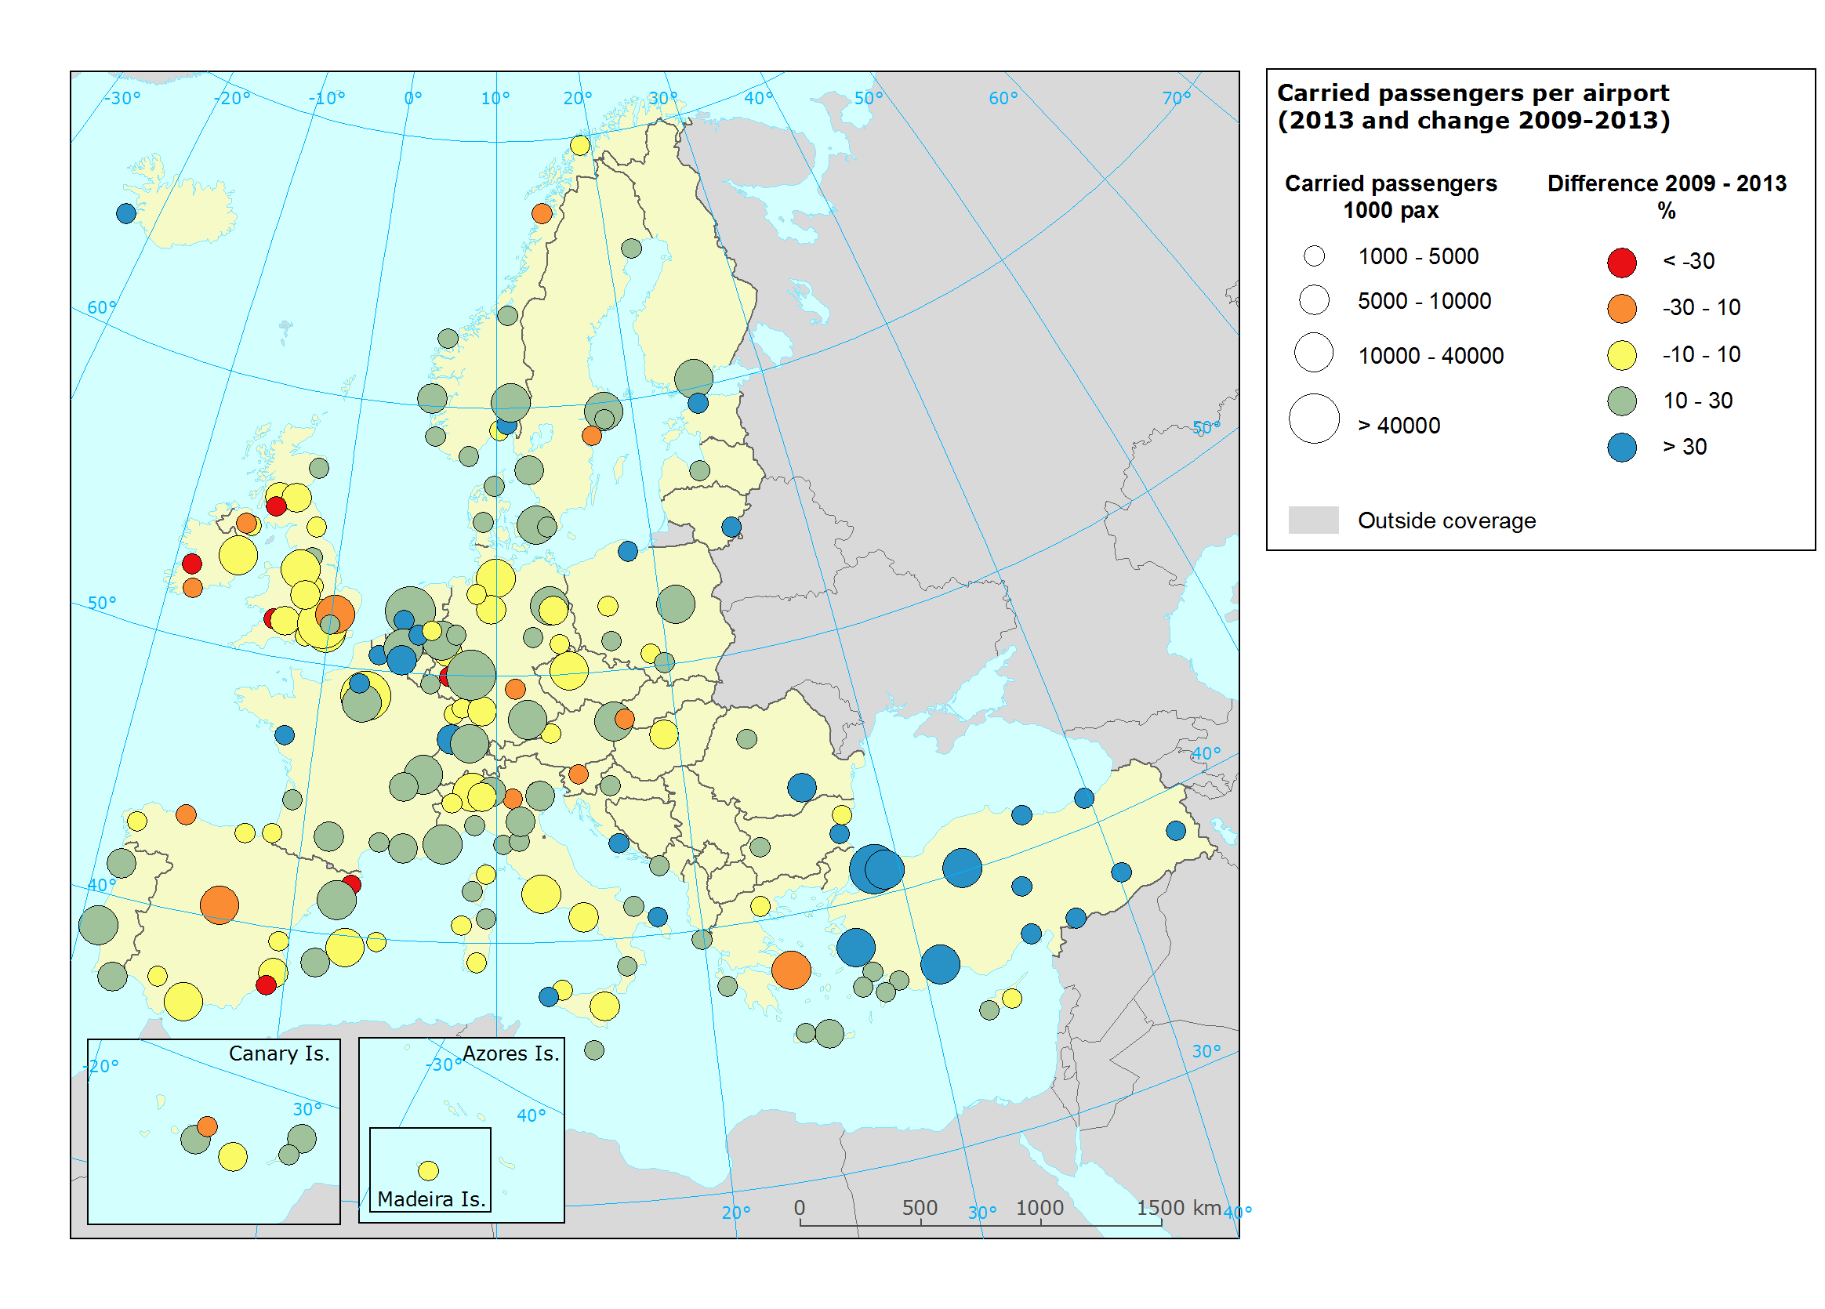  The country and airport pairs nicely show the main passenger flows between countries and airports respectively. The passenger flows between country clearly highlight the intra-EU touristic route between United Kingdom and Spain, and Germany and Spain, representing approximately 10% and 7% of the total intra-EU passenger movement respectively. Generally, the passenger flow between United Kingdom and the major European countries can be highlighted in this top-ten of country pairs.  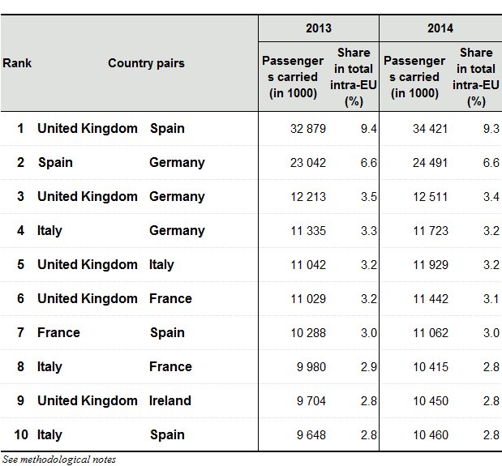  The most frequently used connections between airports correspond to airport pairs which are mainly characterised by business trips. National connections in Germany, Spain and France prevail as well as those between well-connected business centres like Dublin-London and Frankfurt-London.
Specific policy question
Specific assessment
Examples |  |  | 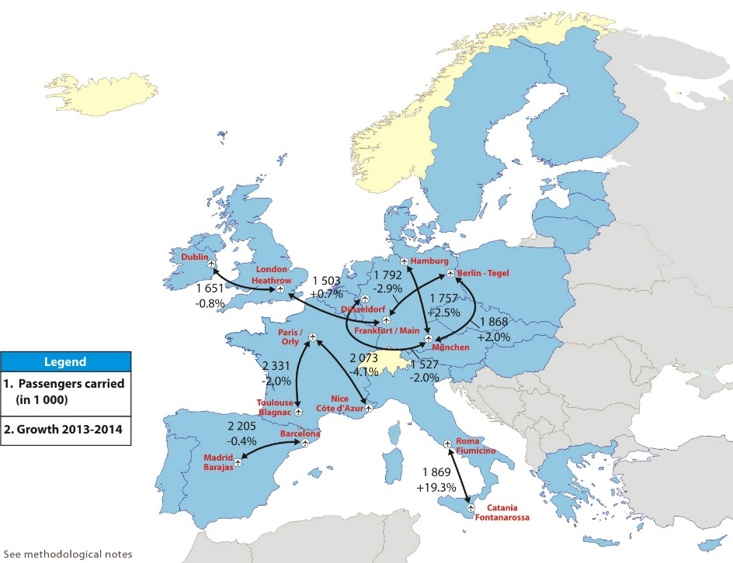
SPECIFICATIONS
Indicator definition |  |  | - Number of passenger per airport  - Trend in number of passengers per airport
DPSIR |  |  | P
Justification
 |  | Rationale | It is recognised that Europe’s aviation sector brings significant economic and social benefits. However, its activities also contribute to climate change, noise and local air quality impacts, and consequently affect the health and quality of life of European citizens, particularly taking into account the steady increase in air traffic over the last few years in Europe.
 |  | References | EASA, EEA, EUROCONTROL (2016): European Aviation Environmental Report 2016.
Policy context
 |  | Policy context | - Environmental Noise Directive (Directive 2002/49/EC)
 |  | Targets | - Noise mapping at Member State level
 |  | Related policy documents | - Directive 2002/49/EC of the European Parliament and of the Council of 25 June 2002 relating to the assessment and management of environmental noise
Methodology
 | Methodology for indicator calculation |  | Annual passenger data per airport were downloaded from Eurostat database (avia_paoa, total carried passengers) and linked to the airport layer acquired from the Geographical information system of the Commission (GISCO).
 | Methodology for gap filling |  | Missing values were gap filled with avia_tf_apal.
 | References
Data specifications |  |  | Data source: Eurostat (Air passenger transport by main airports in each reporting country [avia_paoa], Airport traffic data by reporting airport and airlines [avia_tf_apal])
Uncertainties
 | Methodology uncertainty
 | Data sets uncertainties
 | Rationale uncertainty
Further work
Ownership and contacts |  |  | Eurostat  ETC/ULS  Christoph.schroder@uma.es

