Indicator name |  |  | Tourism related modes of transport (3. Cruises)
ASSESSMENT
Indicator Name |  |  | TOUR002d – Number of cruise port passengers
Key policy question |  |  | What are the changes in cruise passenger per port?
Key message |  |  | Being of significant economic importance, cruise tourism also leads to unwanted externalities, as cruise ships create air emissions, waste and noise in EU ports and seas. These externalities are both located at the ports where cruise ships are calling and the shipping routes. Local pressures depend on the intensity of cruise traffic that is measured by the number of passengers per port.
Key assessment |  |  | There is an uneven distribution of the more than 27 million passenger visits on one of the 313 ports that receive cruise ships. 9 out of the 10 with most cruise passengers (> 900 000 pax) are located in the Mediterranean Sea. Even under the top 20, there are only 4 Northern European ports (Southhampton, Copenhagen, Hamburg and Tallin). This concentration of high numbers of passengers (and calls) within relatively short distance and with the semi-closed situation of the Mediterranean Sea provides a map of potentially very high pressure on the marine and coastal ecosystems and cities. When it comes to the trend over the period 2009-2013, it becomes clear that particularly the Mediterranean ports have the highest increase in numbers of passengers visiting the port. It can also be observed that a concentration of passenger visits takes place away from smaller ports towards the ports with already the highest numbers of passenger visits, with a clear focus on the Western Mediterranean region, and some exceptions in the Adriatic Sea.
Specific policy question
Specific assessment
Examples |  |  | 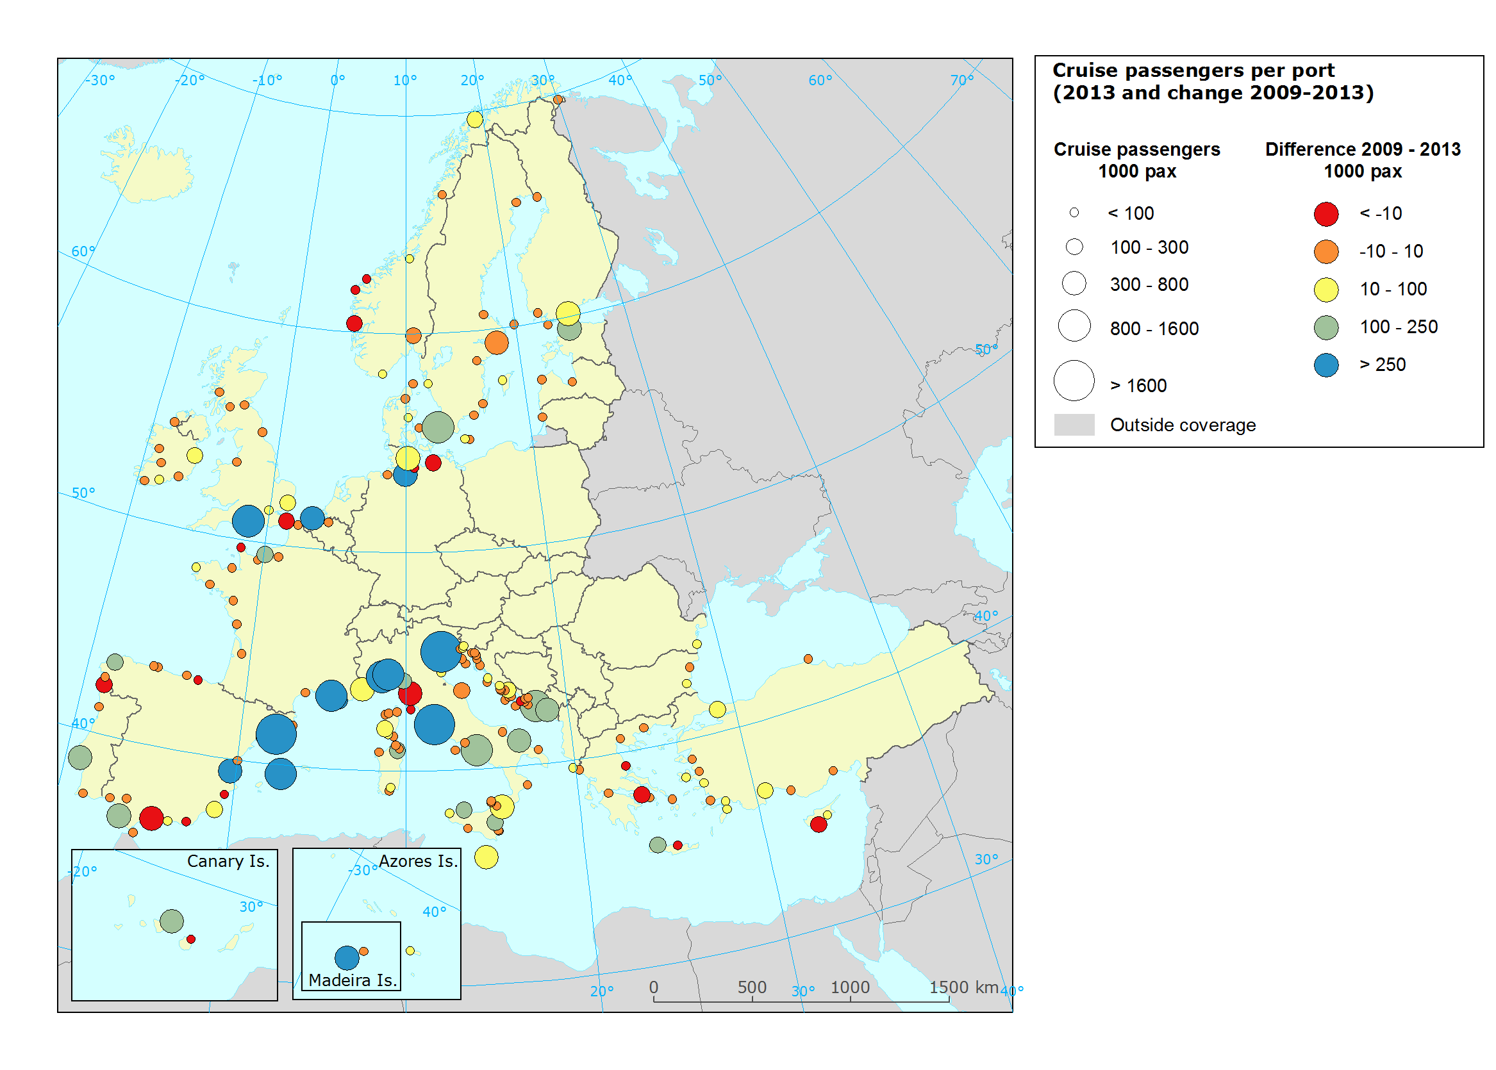
SPECIFICATIONS
Indicator definition |  |  | - Number of cruise passenger per port  - Trend in number of cruise passengers
DPSIR |  |  | P
Justification
 |  | Rationale | Since the cruise industry adds significant economic value to EU Member States, cruise tourism is an important sector for coastal regions and islands to attract. Nevertheless, it also leads to unwanted externalities, as cruise ships create air emissions, waste and noise in EU ports and seas. The Communication ‘An integrated Maritime Policy for the European Union’ (COM (2007) 575 final) stresses the importance of reconciling economic development, environmental sustainability and quality of life within coastal regions and islands. Due to the lack of accessible data on cruise ship routes, the number of passengers visiting or embarking/disembarking is a reasonable approximation of the pressure cruise tourism is exerting to the ports and the surrounding areas in terms of air pollution, waste and noise.
 |  | References | DG Mare (2009): Tourist facilities in ports. Growth opportunities for the European maritime economy: economic and environmentally sustainable development of tourist facilities in ports. Study report.  Johnson, D. (2002): Environmentally sustainable cruise tourism: a reality check. Marine Policy 26 (4): 261-270.  Maragkogianni, A. & Papaefthimiou, S. (2015): Evaluating the social cost of cruise ships air emissions in major ports of Greece. Transportation Research Part D: Transport and Environment 36: 10-17.
Policy context
 |  | Policy context | - European maritime policy to reconcile economic growth and environmental sustainability (Blue Growth)  - International efforts to reduce air emissions and improve waste treatment for cruise ships.
 |  | Targets | - ships must use 0.1% sulphurous fuel at berth  - minimize airborne emissions from ships (SOx, NOx, ODS, VOC shipboard incineration
 |  | Related policy documents | - Communication ‘An integrated Maritime Policy for the European Union’ (COM (2007) 575 final)  - EC Directive 2005/33/EC “Sulphur content of marine fuels”  - IMO regulations for the Prevention of Air Pollution from Ships”
Methodology
 | Methodology for indicator calculation |  | Annual passenger data per port were downloaded from Eurostat database and linked to port layer acquired from the Geographical information system of the Commission (GISCO).
 | Methodology for gap filling |  | Missing values were taken from MedCruise yearly statistics
 | References |  | Med Cruise (2014): Cruise activities in MedCruise ports: Statistics 2013.
Data specifications |  |  | Data source: Eurostat (Maritime transport - Passengers - Annual data - All ports - by direction [mar_pa_aa]), Does not include Gibraltar, Monaco,  MedCruise Statistical Yearbook 2013.
Uncertainties
 | Methodology uncertainty
 | Data sets uncertainties |  | Still missing values due to lacking reporting may occur.
 | Rationale uncertainty
Further work
Ownership and contacts |  |  | ETC-ULS  Christoph Schröder: christoph.schroder@uma.es

