Indicator name |  | Most attractive places
ASSESSMENT
Indicator Name |  | TOUR003a - Nr of pictures per km2  TOUR003b - Hotspots  TOUR003c - Percentage of area of hotspots by NUTS3
Key policy question |  | Where are the most attractive places?
Key message |  | People feel attracted by different values, some of them inherent to the place like nature, cultural values, aesthetics, but also for the possibility to develop certain leisure activities (like golf courses or hiking). The combination of these elements results in hot spots, i.e. places that justifies going there and sharing the experience on the social networks.
Key assessment |  | 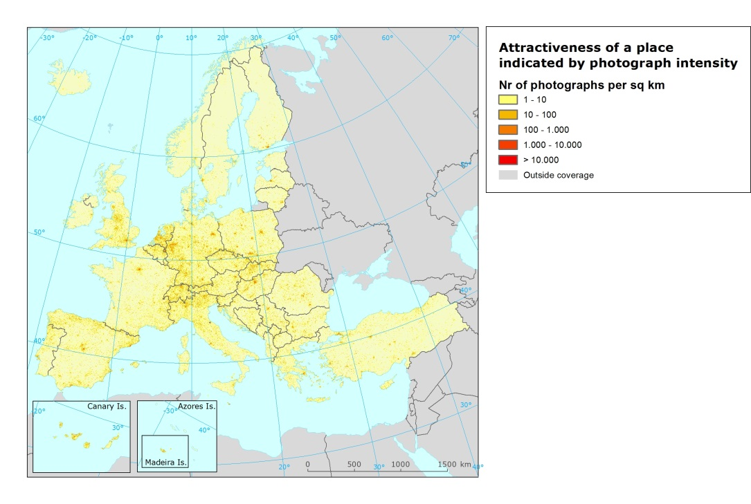  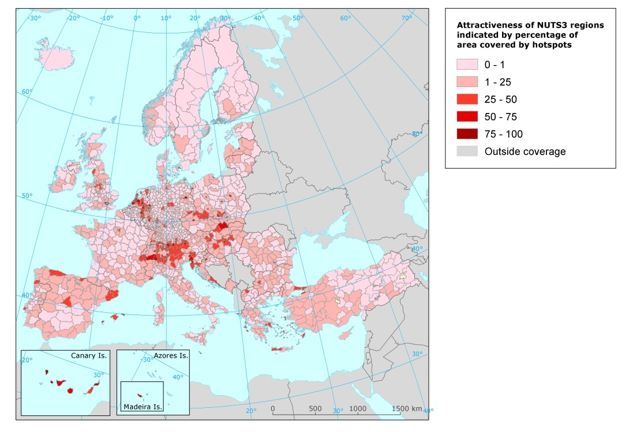  Attractive areas, measured as number of pictures per km², show a spatial pattern in Europe: there is a clear concentration in Central Europe, in particualr the area known as “blue banana” that follows an axis going from Belgium to Italy. This is an important economic area which include the Alps. Other attractive mountain areas also emerge as the Carpathian Mountains or the Pyrenees. It’s worthwhile to note the difference between Spain and France in terms of dissemination on the countryside: while attractive areas in France seem to be more concentrated in major cities and few regions, in Spain they are more disseminated in the country side. This trend is also consistent with the indicator on number of beds per NUTS and also with the occupation.  In order the better capture the attractiveness, an indicator on hot spots has been applied. Hot spots are areas with significant higher concentration of pictures compared with the rest of the region and have also a significant spatial aggregation.  It should be noted that the hot spot has a spatial extent, i.e. there is a high probability that people move inside the hot spot (in other words the same person will take pictures from different places inside the hot spot). This also makes a difference with areas outside hot spots; there can still be a relatively high number of points where pictures are taken, but these points are not spatially clustered.  Since one would expect higher number of pictures in cities or metropolitan areas because higher accessibility and density of population, two type of hot spots have been identified: hot spots in rural areas and hot spots in urban areas. These areas were selected according to the typology defined by DG Regio (2012). Urban areas are defined as those areas with higher population density and an agglomeration of minimum 50,000 inhabitants.  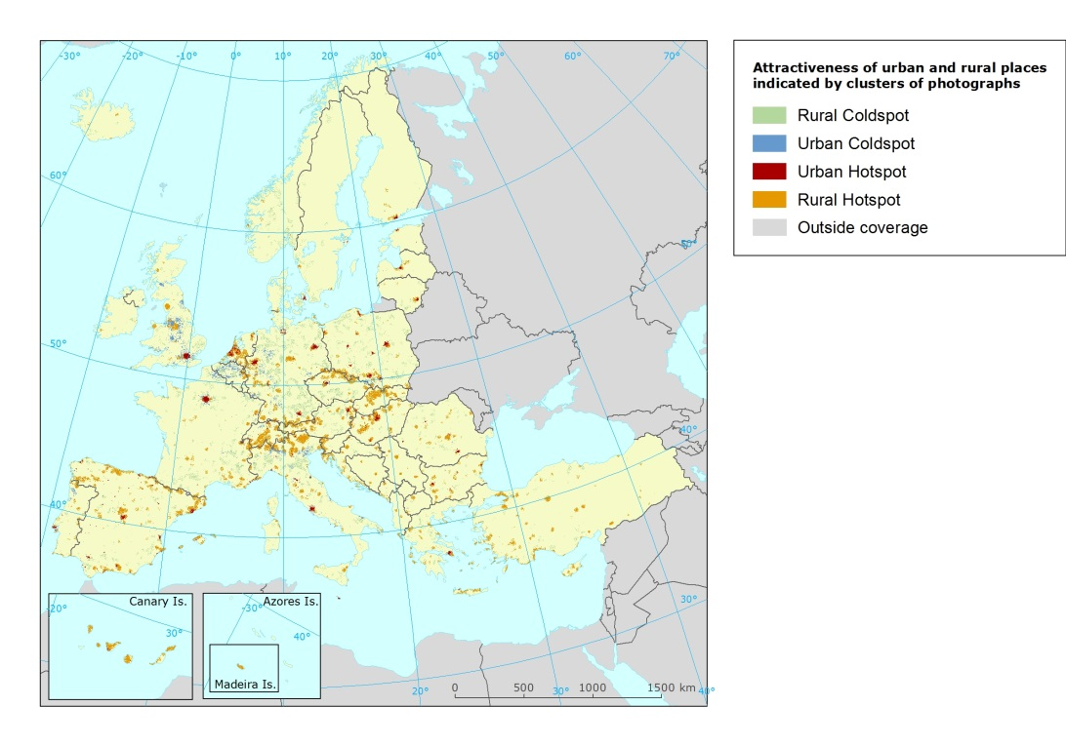  Hot spots in rural areas  The Pyrenees, the Alps and the Carpathian Mountains clearly emerge. Also the Netherlands. In addition, Spain, France, Greece and Croatia emerge as the most attractive countries on the coast. In the case of Italy, the pressure on the coast seems lower (with the sole exception of eastern Sicily), whereas the rural areas in the north-east and in the centre are more interested by this phenomenon.  There is also the so called cold spots (in blue) which are with few pictures (low frequency) but that are spatially correlated, or in other words areas that conform a certain unity. Those areas appear scattered across Europe and may be linked to different situations like remote areas, or, on the opposite, accessible areas of less interest/attractiveness. It means that there are fewer pictures (less people going there), but pictures are not randomly distributed. Consequently, pictures within these cold spots correspond to areas that have a unity, or minimum interest as a whole.  Hot spots in urban areas  All the capitals appear as a hot spot, with different geographic extent. In some countries secondary cities also emerge as in Spain (Barcelona, Valencia, Sevilla). Germany (Cologne and Munich) and Poland. Blue areas reflect cold spots, i.e., spots with less pictures like in UK, Germany and Italy.
Specific policy question
Specific assessment
Examples
SPECIFICATIONS
Indicator definition |  | Density of pictures uploaded in Panoramio
DPSIR |  | D
Justification
 | Rationale | People are attracted by different values, some of them inherent to the place like nature, cultural values, aesthetics, but also for the possibility to develop certain activities (like golf courses or hiking). The combination of these elements results in hot spots, i.e. places where more people feel attracted and the need to share on the social networks. Attractive places reflect areas with higher probability of tourism presence and, therefore, higher pressure either to the environment but also potential social conflicts with residents.  The growth of social media and access to them by most part of the population is generating new sources of information that can provide insights on people’s preferences and behaviour. Although the use of social media is still restricted to certain segments of population (technological divide) and not all those using this social media can be considered tourists, there is already some evidence on the potential uses and pitfalls.  The number of pictures per NUTS2 region shows a positive correlation with overnights spent (0.73). Therefore, this could be considered a preliminary validation on the relevance on the number of pictures.
 | References | Alessa, L. (Naia), Kliskey, A. (Anaru) i Brown, G., 2008, 'Social–ecological hotspots mapping: A spatial approach for identifying coupled social–ecological space', Landscape and Urban Planning, 85(1), p.27-39.  Crampton, J. W., Graham, M., Poorthuis, A., Shelton, T., Stephens, M., Wilson, M. W. i Zook, M., 2013, 'Beyond the geotag: situating ‘big data’ and leveraging the potential of the geoweb', Cartography and Geographic Information Science, 40(2), p.130-139.  García-Palomares JC, Gutiérrez J, Mínguez C., 2015, Identification of tourist hot spots based on social networks: A comparative analysis of European metropolises using photo-sharing services and GIS. Applied Geography 63:408-17.  Richards, D. R. i Friess, D. A., 2015, 'A rapid indicator of cultural ecosystem service usage at a fine spatial scale: Content analysis of social media photographs', Ecological Indicators, 53, p.187-195.  VMV i Magnor, M., Rosenhahn, B. i Theisel, H., European Association for Computer Graphics ed., 2009,'Analysis of community-contributed space- and timereferenced data by example of Panoramio photos', en: Proceedings of the Vision, Modeling, and Visualization Workshop 2009: November 16 - 18, 2009, Braunschweig, Germany, Otto-von-Guericke-Univ, Magdeburg.  Zeng, B. i Gerritsen, R., 2014, 'What do we know about social media in tourism? A review', Tourism Management Perspectives, 10, p.27-36.
Policy context
 | Policy context | - EC and national policies on tourism and sustainable tourism.  - EU regulations regarding coastal and marine ecosystems: Marine Strategy Framework Directive, Habitat Directive  - National and sub-national spatial planning regulations
 | Targets
 | Related policy documents | Habitat Directive: Council Directive 92/43/EEC
Methodology
 | Methodology for indicator calculation | Panoramio is a geolocation-oriented photo sharing mashup owned by Google. Accepted photos uploaded to the site can be accessed as a layer in Google Earth and Google Maps, with new photos being added at the end of every month. It is possible to access to the Panoramio photos database through a web API. The aim of this test analysis has been to link the number and density of photos taken with the N2000 network of protected sites. The different methodological steps carried out are detailed below:  Step 1: Downloading from Panoramio the photos database by different geographical windows within the study area*. Single photos details are obtained, including its location (latitude, longitude), owner, title or URL, amongst other.  Step 2: Merging of all photo database in one single file.  Step 3: Converting the photo database into a GIS point layer.  Step 4: Overlaying the photo point layer with the European Reference Grid at 1 km² resolution, in order to obtain the density of photographs (photos per square kilometre).  Step 5: Overlaying the density of photographs with the polygons corresponding to the N2000 sites, in order to add up the total number of photographs within each site and get the maximum density of photographs by km² within each site.  Step 6: Elaboration of a map which combines both the total number of photographs by each site and the maximum number of photographs in one single square kilometre.  * Depending on the size of the geographical windows, Panoramio gives back a different result, as they undertake some sampling rules when the number of photographs is very high. This fact demands some further testing and refinement of the script for future developments. Nevertheless, the total number of photos used in this case study has been of more than 147 000. The identification of hot spots has been based on the The Getis-Ord Gi* statisti c (pronounced G-i-star) for each feature in a dataset. The resultant z-scores and p-values tell you where features with either high or low values cluster spatially. This tool works by looking at eac h feature within the context of neighboring features. A feature with a high value is interesting but may not be a statistically significant hot spot. To be a statistically significant hot spot, a feature will have a high value and be surrounded by other features with high values as well. The local sum for a feature and its neighbors is compared proportionally to the sum of all features; when the local sum is very different from the expected local sum, and that difference is too large to be the result of random chance, a statistically significant z-score results.
 | Methodology for gap filling | No gap filling.
 | References | Alessa, L. (Naia), Kliskey, A. (Anaru) i Brown, G., 2008, 'Social–ecological hotspots mapping: A spatial approach for identifying coupled social–ecological space', Landscape and Urban Planning, 85(1), p.27-39.  VMV i Magnor, M., Rosenhahn, B. i Theisel, H., European Association for Computer Graphics ed., 2009,'Analysis of community-contributed space- and timereferenced data by example of Panoramio photos', en: Proceedings of the Vision, Modeling, and Visualization Workshop 2009: November 16 - 18, 2009, Braunschweig, Germany, Otto-von-Guericke-Univ, Magdeburg.
Data specifications |  | Panoramio is a geolocation-oriented photo sharing mashup owned by Google. Accepted photos uploaded to the site can be accessed as a layer in Google Earth and Google Maps, with new photos being added at the end of every month. It is possible to access to the Panoramio photos database through a web API. http://www.panoramio.com
Uncertainties
 | Methodology uncertainty | It is assumed that the most photographed areas are hot spots of tourist attraction too. However, there could be substantial bias between urban areas/more accessible areas from more remote areas. Therefore in the future hot spots will be differentiated by landscape type (urban, rural, mountain areas,…).
 | Data sets uncertainties
 | Rationale uncertainty
Further work |  | Differentiation of residents and visitors (García-Palomares et al., 2015)  Temporal analysis to observe seasonal and yearly patterns.
Ownership and contacts |  | ETC-ULS  Jaume Fons (jaume.fons@uab.cat)

