Indicator name |  |  | Occupancy rate
ASSESSMENT
Indicator Name |  |  | TOUR004k - Occupancy rate (Bedroom occupancy rate in hotels and similar establishments)
Key policy question |  |  | What are the most tourism intensive regions in Europe?
Key message
Key assessment |  |  | The regional analysis of bedroom occupancy rates in hotels and similar establishments in 2014 -offered by the attached map- shows how these bedroom occupancy rates were particularly high in the west of the EU, although with several regional disparities, and most of the regions showing a rate of below 50 %. Further south, there were several traditional tourist destinations which recorded relatively high rates, principally the island regions of Spain, France, Malta, Greece and Cyprus. Note that some hotels in these holiday destinations may close during the off-season, while others seek to keep their occupancy rates high through special offers which may, for example, encourage pensioners (typically from northern and western EU Member States) to spend longer periods on vacation during the winter months. In general terms, though, urban and metropolitan areas (i.e. regions of London, Paris, Berlin, Hamburg, Prague, Amsterdam, etc.) tend to record higher occupancy rates than rural regions.  The regions with occupancy rates of less than 30 % were mainly located across eastern and southern regions of the EU (southern Poland, eastern Austria, regions from Bulgaria, the Czech Republic, Slovakia, Hungary, Romania, Greece, and two each from Spain and Portugal, as well as Sicily in Italy), although there were also some of them located in the north-western Europe (some Norwegian, British and Belgian regions).  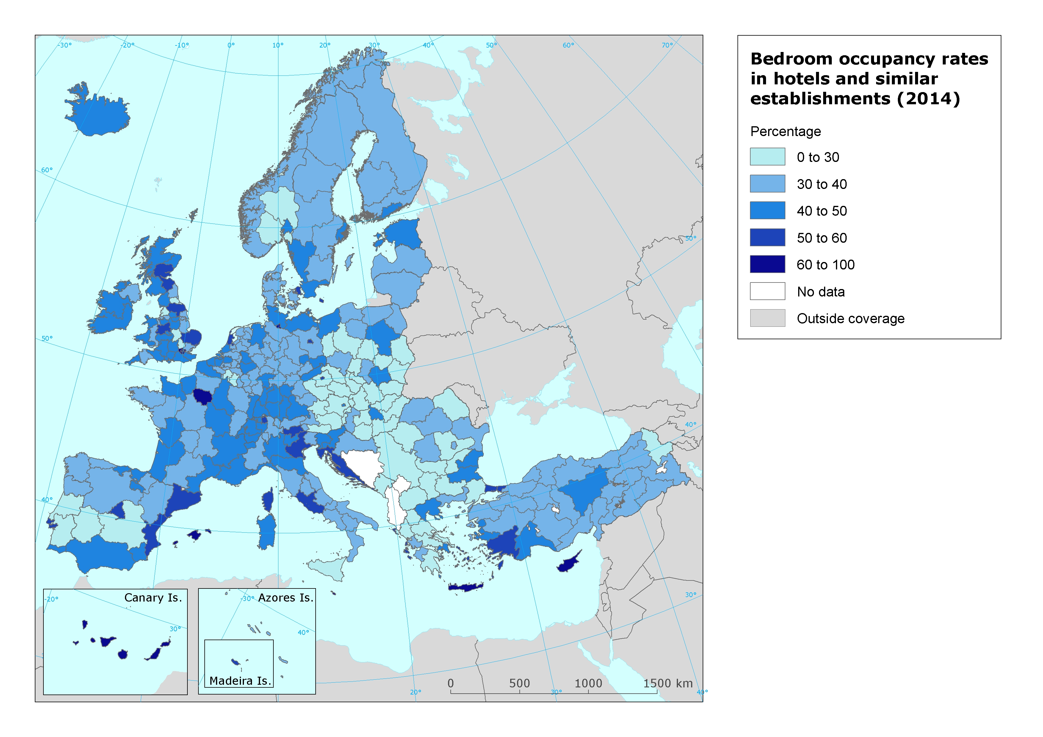
Specific policy question
Specific assessment
Examples
SPECIFICATIONS
Indicator definition
DPSIR |  |  | P
Justification
 |  | Rationale | While a count of the total number of bed places may be of interest in relation to the capacity of different regions to respond to tourism demand, those working within the tourism industry are more likely to be interested in net occupancy rates for bedrooms (room rates are often considered the preferred measure insofar as the turnover of a double room is often similar irrespective of whether the room is occupied by one or two persons).
 |  | References | Eurostat (2015). Tourism statistics at regional level. http://ec.europa.eu/eurostat/statistics-explained/index.php/Tourism_statistics_at_regional_level
Policy context
 |  | Policy context | EC and national policies on tourism and sustainable tourism.
 |  | Targets | In terms of economic sustainability, the main target for the tourism industry would be to increase net occupancy rates at all levels (local, regional, and national), although this should be well balanced with environmental and social sustainability of tourism activity.
 |  | Related policy documents
Methodology
 | Methodology for indicator calculation
 | Methodology for gap filling
 | References |  | Eurostat (2015). Tourism statistics at regional level. http://ec.europa.eu/eurostat/statistics-explained/index.php/Tourism_statistics_at_regional_level
Data specifications |  |  | Data comes from Eurostat (tour_occ_anor2).
Uncertainties
 | Methodology uncertainty
 | Data sets uncertainties |  | Data only takes in consideration official commercial establishments. It does not cover other types of tourism accomodation (B&B, sharing economy establishments, second homes, etc.).
 | Rationale uncertainty |  | Same comment as data sets uncertainties.
Further work
Ownership and contacts |  |  | ETC-ULS

