Indicator name |  |  | Tourism density
ASSESSMENT
Indicator Name |  |  | TOUR004a - Number of bed places per km2 by NUTS2  TOUR004b - Number of bed places per km2 in urban areas  TOUR004c - Number of bed places per km2 in rural areas  TOUR004d - Number of bed places per km2 in coastal areas  TOUR004l - Number of overnight stays per km² by NUTS 2
Key policy question |  |  | How is tourism concentrated in space?
Key message |  |  | Some European regions (regardless of their territorial context: mountain, coastal, rural, etc.) have a high density of tourist accommodation supply (official commercial bed-places) per km², showing a potential high pressure on the territory, and as a consequence, potential environmental and social impact, especially on sensitive areas. On the contrary, other regions (most of them in rural areas of Europe) show a low density. Regarding tourists or demand density, measured through the total overnight stays per km², in most of the European regions is relatively low (below 2,500 annual stays per km²). Higher numbers are mainly concentrated in urban and metropolitan regions.
Key assessment |  |  | Density of tourist accommodation at regional level in Europe (bed- places per km²) is relatively low (below 10 bed places per km²) for the majority of regions and countries. Higher densities (between 10 and 50 bed-places per km²) can be found in most of the regions of England, Netherlands, the continental Italy, Montenegro, and some of the regions of Spain, France, Germany, and Austria, among other countries. The highest densities (more than 50 bed-places per km²) appear in very small NUTS 2 regions, with the exception of the Balearic and the Canary islands in Spain.  However, differences can be seen if the analysis considers only urban areas, rural areas, or coastal areas inside each NUTS 2 region. The urban areas that have higher densities of tourist accommodation supply are mainly located in those regions that have high levels of urbanisation (although not all of them, i.e. Madrid, Dublin, Warsaw, Budapest, etc.). Rural areas of high density of bed-places are important in France, Italy, Greece, Austria, Czech Republic, England, Denmark, among other countries. Coastal municipalities that have very high levels of bed-places density are located in regions such as Balearic and Canary islands in Spain, Liguria in Italy, coastal Croatia, Ionia Nisia and Notio Aigaio archipelago regions in Greece, Southern and Western coastal regions of England, Noord Holland and Zeeland in the Netherlands, Algarve and metropolitan area of Lisbon in Portugal, Hovedstaden in Denmark, etc.  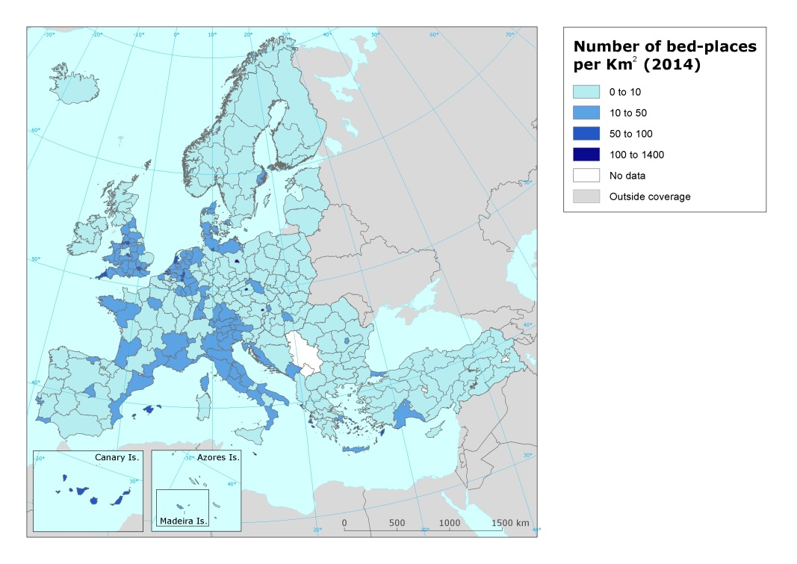  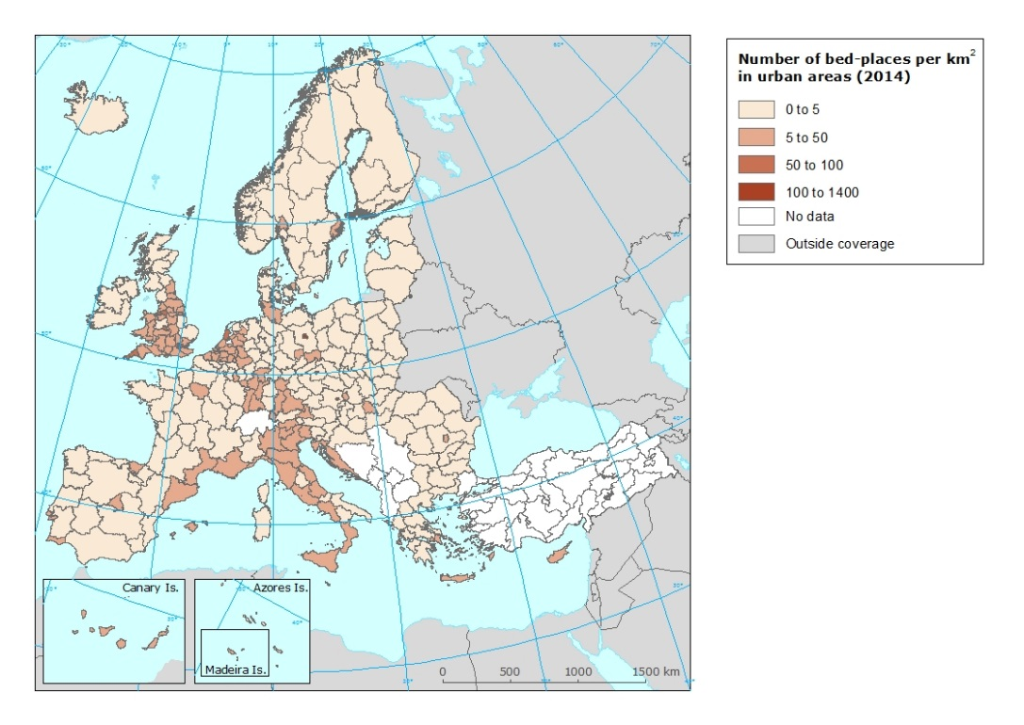  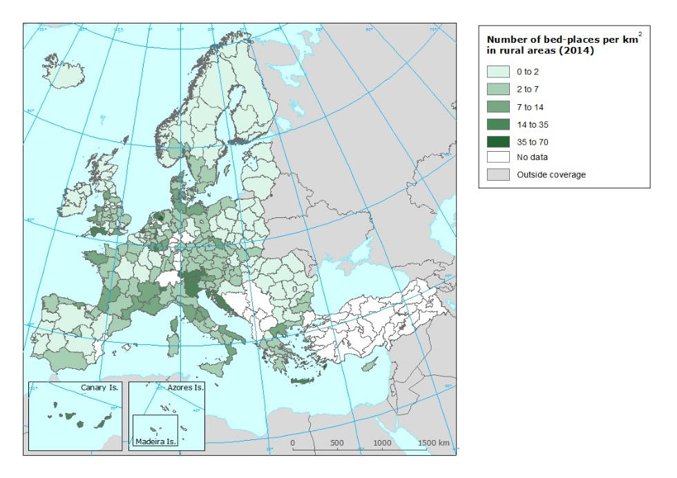  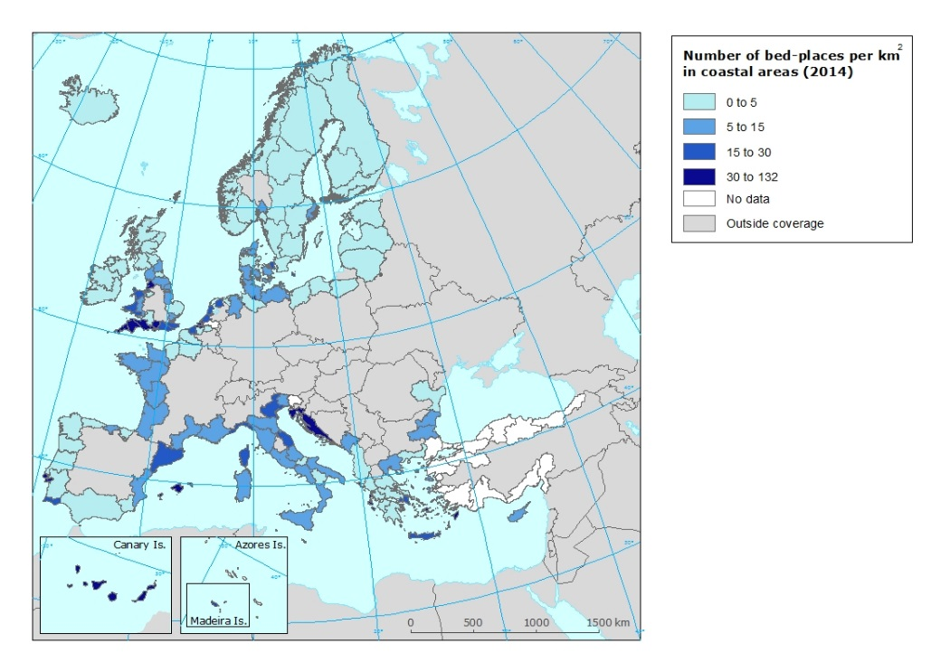  Regarding tourists or demand density, measured through the total overnight stays per km², in most of the European regions is relatively low (below 2,500 annual stays per km²). Higher numbers are mainly concentrated in urban and metropolitan regions, in some cases with a very small territory. These are the cases of country capitals such as London, Paris, Berlin, Madrid, Lisbon, Brussels, Amsterdam, Prague, Copenhagen, or Vienna, but also other metropolitan areas, such as Greater Manchester, Merseyside (Liverpool), and the West Midlands (Birmingham) in the United Kingdom; Bremen and Hamburg in Germany; or Zuid Holland (Rotterdam) in the Netherlands. If we do not consider those urban areas, there are only few regions that received in 2014 more than 2,500 overnight stays per km² during the year. Most of them -but not all- are located in Southern Europe: the Algarve and Madeira Islands in Portugal; the Balearic and Canary Islands in Spain; the Veneto and Bolzano-Bozen regions in Italy; the coastal region of Croatia; the Greek insular regions of Notio Aigaio, Kriti, and Ionia Nisia; the Tirol and Salzburg regions in Austria; Zeeland and Lindburg in the Netherlands; and Cornwall in the United Kingdom. From all this previous list of regions, though, only the Balearic Islands and Zeeland had more than 5,000 overnight stays per km² in 2014.  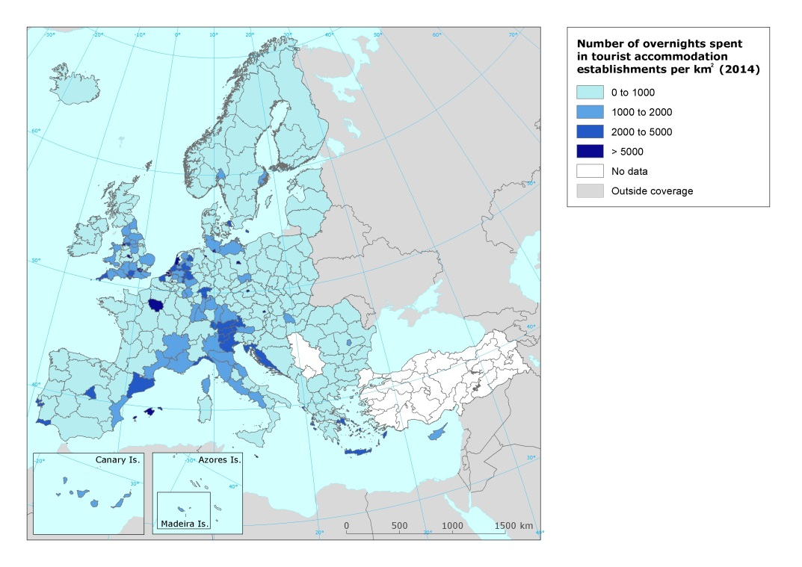
Specific policy question
Specific assessment
Examples
SPECIFICATIONS
Indicator definition |  |  | The indicator shows the social intensity geographical density of tourism supply and demand. From the supply side, it measures the density specifically from the commercial lodging point of view (data is based on the number of official bed places in tourist accommodation establishments available per each NUTS 2 region per km². in relation to the surface of that region). From the demand side, it measures the as well as tourism demand ( overnights spend at tourist accommodation establishments) also per NUTS 2. Accordingly, it is presented as two subindicators: 1) number of available beds per km² (global, in urban areas, in rural areas, and in coastal areas; and 2) number of overnights spent in tourist accommodation establishments per km²
DPSIR |  |  | P
Justification
 |  | Rationale | This indicator is highly relevant since it shows the relative importance of tourism lodging supply as well as total annual overnight stays in each territory in relation to its surface (pressure indicator). Tracking the number of available beds in a destination is also a way of measuring the potential impact of tourism on residents’ way of life.
 |  | References
Policy context
 |  | Policy context | EC and national policies on tourism and sustainable tourism.
 |  | Targets | Different depending on the region / country. Some mountain and rural regions, as well as some coastal regions show a high number of tourism supply and overnight stays in relation to their territory. It would seem that in those areas it would be recommendable to control further growing in order to avoid the exceeding of the social carrying capacity. On the contrary, some rural regions have a low density of tourism lodging supply and overnight stays. They would apparently have space to grow in the future, though specific assessments should be done in each case, considering specific territorial and environmental constraints.
 |  | Related policy documents
Methodology
 | Methodology for indicator calculation |  | The first subindicator has been developed by calculating the ratio of number of commercial tourism lodging (bed places) divided by the surface of the region (NUTS 2). Numbers are expressed as bed places per km². The same methodology has also been developed for calculation of bed places density in urban areas, bed places density in rural areas, and bed places density in coastal areas, in all these cases according to EUROSTAT classification of types of territory.  The second subindicator has been developed by calculating the ratio of total annual overnight stays in commercial tourist accommodations divided by the surface of the region (NUTS 2). Numbers are expressed as overnight stays per km².
 | Methodology for gap filling
 | References
Data specifications |  |  | Data comes from EUROSTAT (tour_cap_nuts2; tour_cap_nuts2c; tour_cap_nuts2d; tgs00111). Data from Albania, Bosnia and Hercegovina and Switzerland is reported at NUTS0.  Data from Switzerland and Turkey has been provided by national tourism statistics.
Uncertainties
 | Methodology uncertainty
 | Data sets uncertainties |  | Data only takes in consideration official commercial establishments. It does not cover other types of tourism accomodation (B&B, sharing economy establishments, second homes, etc.)..
 | Rationale uncertainty |  | Same comment as data sets uncertainties.
Further work |  |  | Data needs to be regularly updated. This will allow analyzing trends.
Ownership and contacts |  |  | ETC – ULS

