Indicator name |  |  | Tourism intensity
ASSESSMENT
Indicator Name |  |  | Tourism intensity:  Sub- indicators:  TOUR004e – Number of tourism arrivals per 100 residents  TOUR004f - Number of overnights spent per inhabitants  TOUR004g - Number of bed-places per 100 residents  TOUR004h - Number of bed-places per 100 inhabitants in urban areas  TOUR004i - Number of bed-places per 100 inhabitants in rural areas  TOUR004j - Number of bed-places per 100 inhabitants in coastal areas
Key policy question |  |  | What are the most tourism intensive regions in Europe?
Key message |  |  | Some European regions (regardless of their specific geographical, natural and cultural context) have a high intensity of tourism arrivals and tourism overnight stays per inhabitant, showing a potential high pressure on residents’ life and the local environment and resources. On the contrary, other regions show a low or very low intensity.
Key assessment |  |  | In the case of the number of tourism arrivals per 100 residents, there is a low number of regions that have more than 400 annual arrivals. These regions are from different geographical contexts (e.g. Balearic and Canary islands in Spain; Corsica in France; different Greek islands, Algarve in Portugal; the coast of Croatia; some Italian and Austrian Alpine regions; most of the Norwegian regions; Cumbria, North Yorkshire, Cornwall and Highlands in UK; Mecklenburg-Vorpommern in Germany; Iceland, among others). On an opposite situation, Lithuania, most part of Poland, Slovakia, Hungary, Romania, Bulgaria, Macedonia, Southern Italy, and Turkey, are examples of territories that recieve less than 100 annual tourism arrivals per 100 residents, showing a low tourism intensity or pressure. The other regions and countries (most of them in Western and Nordic Europe) show an intermediate situation, with an average of 100 – 400 tourism arrivals per 100 residents. In the case of annual overnight stays per inhabitant at regional level, when analysed in relative terms, not big differences can be appreciated in relation to the number of tourism arrivals.  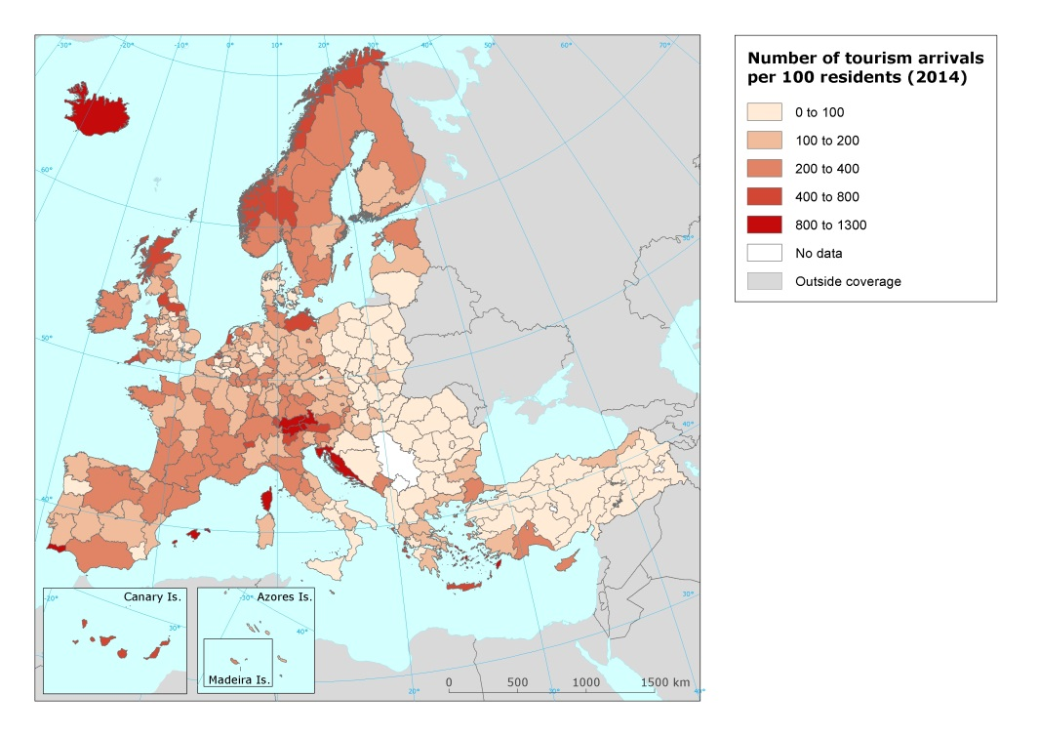  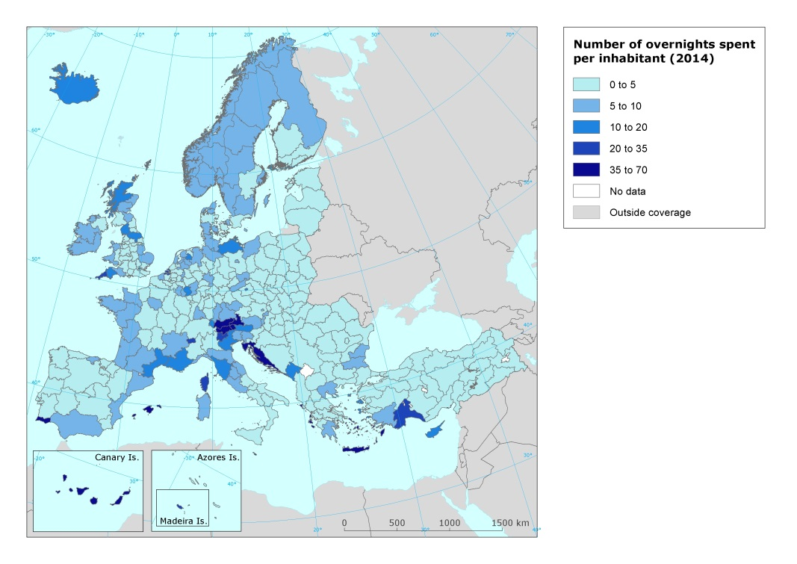  On its part, intensity of tourist accommodation in relation to population (bed-places per 100 residents) is relatively high (more than 25 bed-places per 100 residents) in very few European regions (Cornwall in United Kingdom, Algarve in Portugal, Balearic islands in Spain, Corse in France, Valle d’Aosta, Trento, and Bolzano/Bozen in Italy, Ionia Nisia, Kriti, and Notio Aigaio archipelago regions in Greece, Tirol, Kärnten, and Salzburg in Austria, and Zeeland in the Netherlands). The other regions show a lower intensity level, although with different degrees. However, differences can be seen if the analysis considers only urban areas, rural areas, or coastal areas inside each NUTS 2 region.  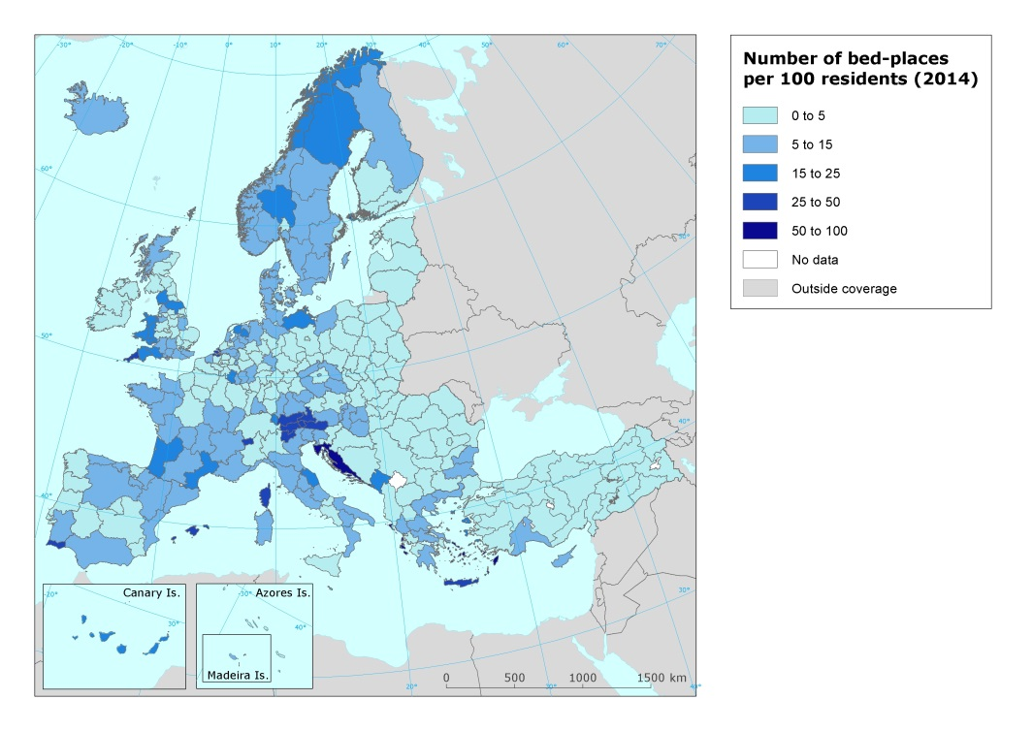  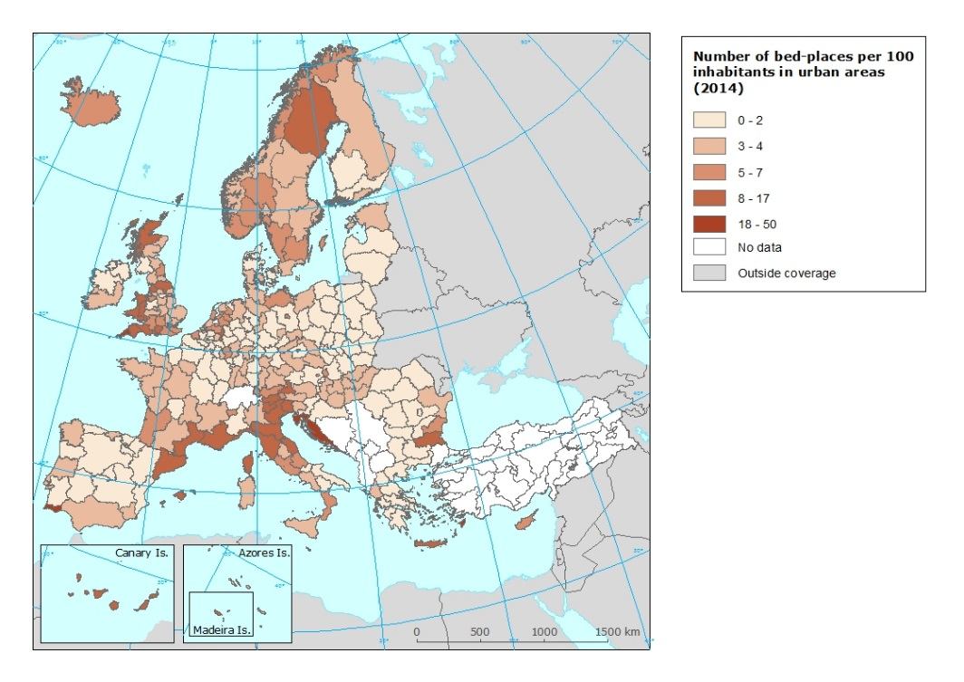  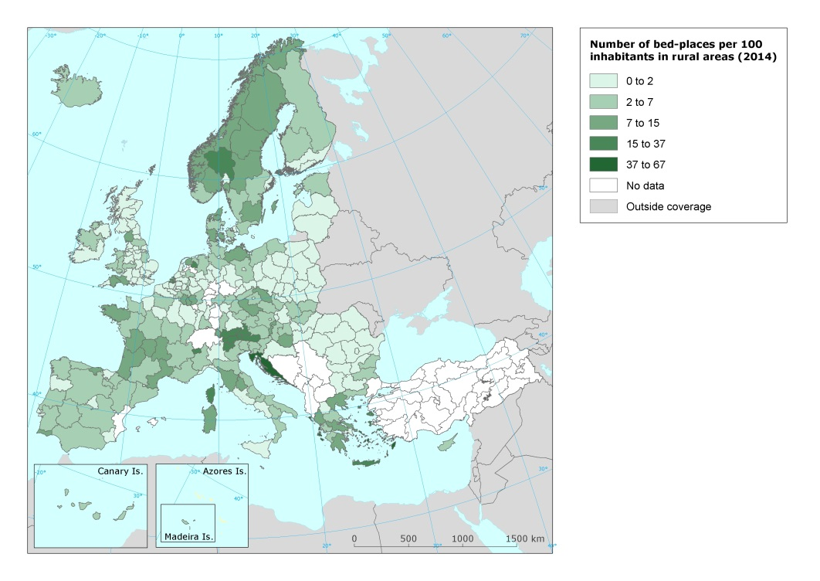  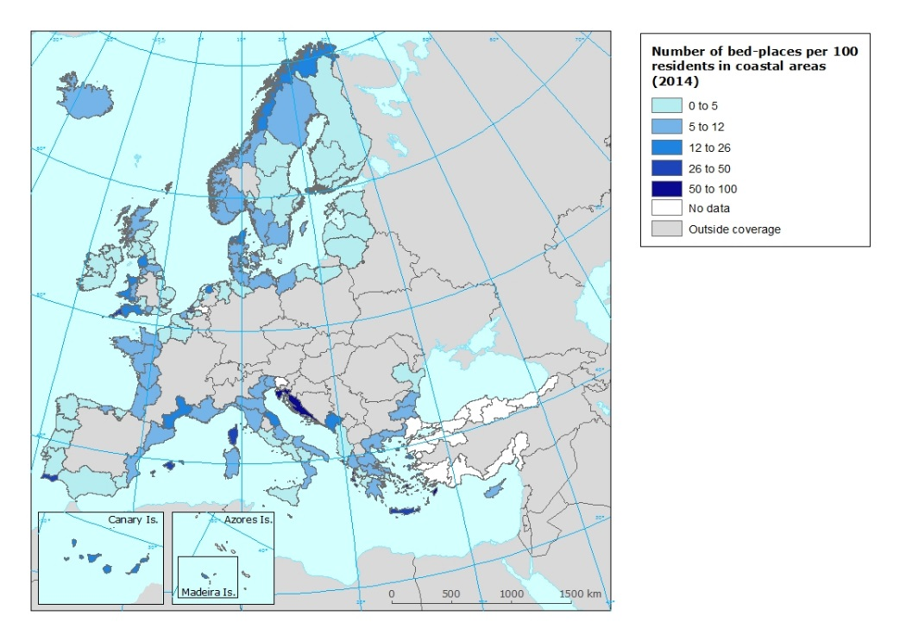
Specific policy question
Specific assessment
Examples
SPECIFICATIONS
Indicator definition |  |  | The indicator shows the social intensity of tourism demand. Data is based on the number of official total annual tourism arrivals (subindicator 1), total annual tourism overnight stays (subindicator 2), and bed places in tourist accommodation establishments (subindicator 3) per each NUTS 2 region in relation to the number of inhabitants of that region). It is presented respectively as 1) number of tourism arrivals per 100 residents, 2) number of overnight stays per inhabitant, and 3) number of bed-places in tourist accommodation establishments per 100 residents.
DPSIR |  |  | P
Justification
 |  | Rationale | This indicator is highly relevant since it shows the relative importance of tourism demand in each territory in relation to its inhabitants (pressure indicator). Tracking the number of tourists and (especially) overnight stays in a destination is also a way of measuring the relative impact of tourism on residents’ way of life, local environment and resources. Despite the difficulties of quantifying the real impact of tourism on the environment, any increase in the number of tourists and people in a certain area undoubtedly has an impact on environmental variables such as waste generation, water consumption and energy consumption (in terms of volume and local level), as well as air quality affected by local transport pollution.  The subindicator 1 corresponds to the C.1.1 indicator from the ETIS system (Section C: Social and cultural impact): Number of tourists/visitors per 100 residents.
 |  | References | European Commission (2016). The European Tourism Indicator System. Brussels.
Policy context
 |  | Policy context | EC and national policies on tourism and sustainable tourism.
 |  | Targets | Different depending on the region / country. Some mountain regions (i.e. Alps), as well as some coastal regions (i.e. coastal Croatia, Balearic, Canary, Greek islands, etc.) show a high number of tourism demand in relation to their population. It would seem that in those areas it would be recommendable to control further growing in order to avoid the exceeding of the social and environmental carrying capacity. On the contrary, the territorial fringe that goes from Southern Finland to Northern Greece has a low intensity of tourism demand. It would apparently have space to growth in the future.
 |  | Related policy documents
Methodology
 | Methodology for indicator calculation |  | Indicator is developed by calculating the ratio of number of total annual tourism arrivals divided by inhabitants and multiplied per 100 (subindicator 1), number of total annual overnight stays divided by inhabitants (subindicator 2), and number of bed-places in tourist accommodation establishments divided by inhabitants and multiplied per 100 (subindicator 3), all of them at a NUTS 2 scale. Numbers are expressed as annual tourism arrivals per 100 residents (subindicator 1), annual overnight stays per resident (subindicator 2), and number of bed-places in tourist accommodation establishments per 100 residents
 | Methodology for gap filling |  | For the indicators TOUR004h - Number of bed-places per 100 inhabitants in urban areas and TOUR004i - Number of bed-places per 100 inhabitants in rural areas the following steps have beed followed when total number of bed places available, but no data or only parcial data on degree of urbansation:  1. Share of the three types of degree or urbanisation has been calculated for the NUTS where the number of beds by dgree or uebanisation is available.  2. For each country a regression has been calculated being the number of beds by degree of urbanisation the dependent variable and the degree of urbanisation the independent variable.  3. The outcome of the previous regression has been applied to the NUTS where missing data on number of beds by degree of urbanisation.
 | References
Data specifications |  |  | Data comes from EUROSTAT (tour_occ_arn2; tgs00111 ; tour_cap_nuts2; tour_cap_nuts2c ; tour_cap_nuts2d).
Uncertainties
 | Methodology uncertainty
 | Data sets uncertainties |  | Data only takes in consideration official commercial establishments. It does not cover other types of tourism accomodation (B&B, sharing economy establishments, second homes, etc.).
 | Rationale uncertainty |  | Same comment as data sets uncertainties.
Further work |  |  | Data needs to be regularly updated. This will allow analyzing trends and identify intensive tourism regions and areas/zones.
Ownership and contacts |  |  | ETC – ULS

