Indicator name |  |  | Tourism pressure on protected areas
ASSESSMENT
Indicator Name |  |  | TOUR005c – Number of bed places in rural areas per km² of protected areas
Key policy question |  |  | Where are the potentially most frequented protected areas?
Key message |  |  | Protected areas (Natura 2000 and similar ones) could be very popular places given its natural and aesthetic values and, consequently, be exposed to the pressure of high levels of visitation. Leaving aside the urban and suburban parks, a good number of protected areas in Europe are located in rural areas. As we can identify the rural tourism lodging offer (bed places in rural areas) per each NUTS2, a proxy of the potential pressure on those protected areas is to calculate the number of bed places located in rural areas in relation to the protected areas surface of the region.
Key assessment |  |  | One of the possible approaches to understand the potential disturbance of recreation and tourism to biodiversity and the natural environment is to look at the tourism supply located around the most vulnerable and attractive areas, that is, the protected areas. In this regard, a first proxy has been calculated by combining the number of bed places offered by tourist establishments located in rural areas, with the land’s protected surface (in this case, the Common Database on Designated Areas, that include all the Natura 2000 network as well as other national protected areas). The results of this exercise show that in the majority of EU regions there is a relatively low pressure on natural sites (although we are referring always at the regional level and the spatial scale of this assessment do not look in detail specific cases of concrete protected areas). In any case, most of the NUTS 2 regions have an average of less than 1 bed place per km² of protected area. The exceptions, with higher numbers -and potentially higher pressures-, are found in Ireland, Northern Italy, Western Austria, the coastal region of Croatia, among other specific regions in other countries.  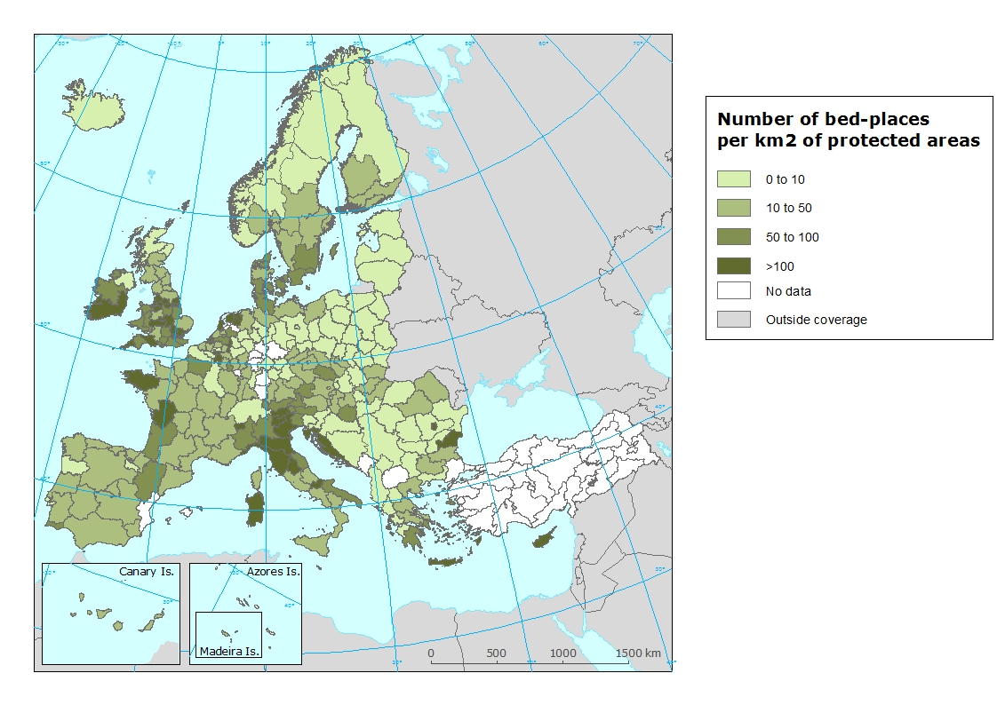
Specific policy question
Specific assessment
Examples
SPECIFICATIONS
Indicator definition |  |  | Number of bed places in official tourist accommodation establishments located in rural areas per square kilometre of protected areas at NUTS 2 region level. Protected areas as territory designated for protection under different protection figures included in the nationally designated areas (CCDA or Common Database on Designated Areas).
DPSIR |  |  | P
Justification
 |  | Rationale | This is a first proxy indicator created in order to identify those regions with a higher or a lower potential tourism pressure on the protected areas. In this case, it is calculated through 1) the tourism lodging offer in rural areas (these data substitute the unavailable tourism demand -overnight stays- in rural areas), and 2) the protected area surface, both at regional level. Combining these two types of data, it is possible to establish a potential pressure index. The specific rationale is that while it is not possible to know the actual number of visitors to protected areas at a reliable and at a whole European scale, some proxy had to be created. This proxy assumes as a hypothesis that most of the potential protected areas visitors that are tourists (excluding excursionists, that tend to be nearby residents from protected areas) are lodged in rural areas (because most part of protected areas are located in rural areas, with some exceptions of suburban protected areas). Then, the more the tourism offer (and, as a consequence, the tourism demand) in rural areas, the more the potential visitation levels of protected areas.
 |  | References
Policy context
 |  | Policy context | - EC and national policies on tourism and sustainable tourism.  - EU regulations regarding coastal and marine ecosystems: Marine Strategy Framework Directive, Habitat Directive  - National and sub-national spatial planning regulations
 |  | Targets
 |  | Related policy documents | Habitat Directive: Council Directive 92/43/EEC
Methodology
 | Methodology for indicator calculation |  | The indicator has been developed by dividing the number of commercial tourism lodging (bed places) located in rural areas of each NUTS 2 region (from the Eurostat classification of bed places according the degree of urbanisation) by the total surface of protected areas of the region (total surface included in the CCDA database).
 | Methodology for gap filling |  | Share of the three types of degree or urbanisation has been calculated for the NUTS where the number of beds by degree or urbanisation is available  For each country a regression has been calculated being the number of beds by degree of urbanisation the dependent variable and the degree of urbanisation the independent variable.  The outcome of the previous regression has been applied to the NUTS where missing data on number of beds by degree of urbanisation.
 | References
Data specifications |  |  | Number of establishments, bedrooms and bed-places by degree of urbanisation and by NUTS 2 regions (from 2012 onwards), offered by Eurostat (tour_cap_nuts2d).  The Common Database on Designated Areas (CDDA) is more commonly known as Nationally designated areas. It is the official source of protected area information from European countries to the World Database of Protected Areas (WDPA). The inventory began in 1995 under the CORINE programme of the European Commission. It is now one of the agreed Eionet priority data flows maintained by EEA with support from the European Topic Centre on Biological Diversity.
Uncertainties
 | Methodology uncertainty
 | Data sets uncertainties
 | Rationale uncertainty |  | The indicator does not consider the potential pressure of tourists lodged in urban areas on the nearby protected areas.  Not all the protected areas receive the same level of tourism visitation.
Further work
Ownership and contacts |  |  | ETC-ULS

