Indicator name |  |  | Tourism pressure on protected areas
ASSESSMENT
Indicator Name |  |  | TOUR005b - Ski resorts’ pressure on Natura 2000 sites
Key policy question |  |  | Are we reducing the spatial pressure from tourism infrastructures?
Key message |  |  | Ski resorts and the related infrastructure (slopes, lifts) have a major impact on sensitive mountain environments. The construction of ski slopes and lifts damage consistently the existing high mountain ecosystems and increase the risks for avalanches. At the same time, high mountain ecosystems are protected widely through the Natura 2000 network, which lead to potential pressure of skiing activities and its infrastructures on protected areas.  On the other hand, skiing is one major pillar of economic development in mountain regions and is concentrated at specific points in the different mountain ranges in Europe. The seasonal increase of population in the skiing resorts also raises questions about resource use, waste and pollution in these areas.
Key assessment |  |  | The potential pressure of ski resorts on protected areas of the Natura 2000 and the Emerald Networks, calculated for the Pyrenees and the Alps, shows the percentage of the area of the protected area that is potentially affected by ski resort. The protected areas with highest impact are located in the French Alps, particularly in the Savoie and Haute-Savoie Departments, as well as in the valleys of the Torino region on the border to France where the Natura 2000 site with the highest pressure value is located (Col Basset, 94.5) due to the high density of ski resorts. The Northern Italian NUTS-3 regions Belluno, Bolzano and Trento also include several Natura 2000 sites with relatively high (> 25%) pressure values. Both Austria and Switzerland do not show major pressure on protected areas.  In the case of the Pyrenees, the overall values are much lower compared to the Alps, being the N2000 network denser. The ski resorts are also much smaller and dispersed. The highest pressures can be observed in the French region of Hautes-Pyrénées. Generally, the N2000 sites in the Spanish Pyrenees have lesser pressure than on the French side.
Specific policy question
Specific assessment
Examples |  |  | 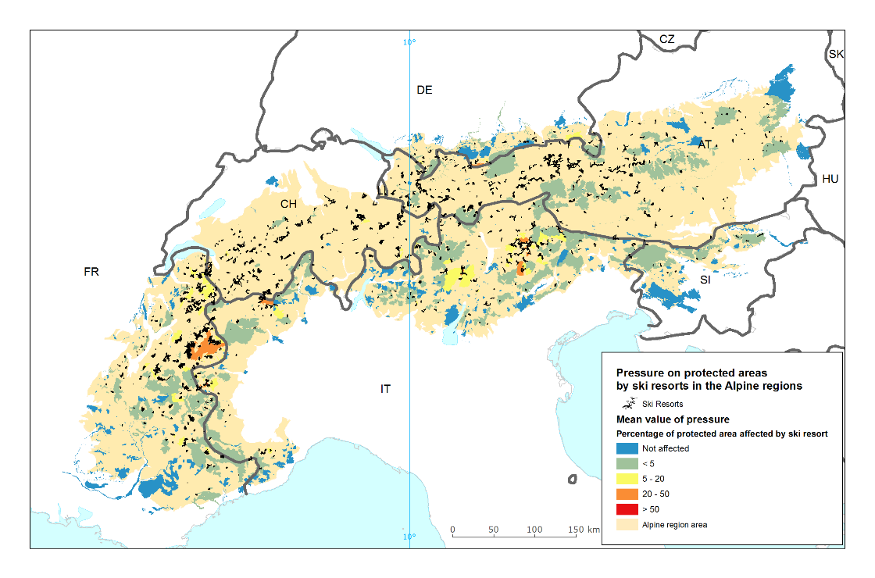  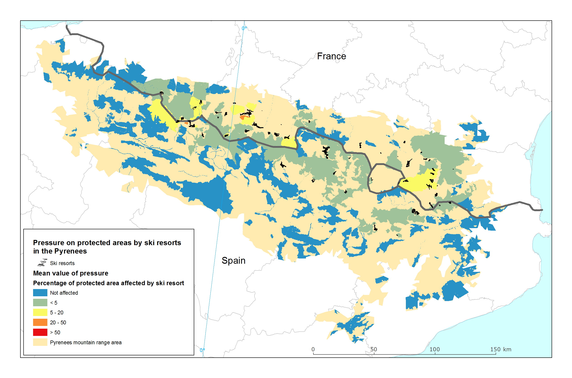
SPECIFICATIONS
Indicator definition |  |  | Ski resorts’ pressure on Natura 2000 sites
DPSIR |  |  | P
Justification
 |  | Rationale | The ski area can be mapped which provides a rough information about the overall area of pressure of this form of winter tourism. When applying a potential pressure area around the ski resort, the potential impact on Natura 2000 area can be mapped and analysed.
 |  | References | Nordregio (2004): Mountain Areas in Europe: Analysis of mountain areas in EU member states, acceding and other European countries. Final report of European Commission contract No 2002.CE.16.0.AT.136.  Patthey, P., Wirthner, S., Signorell, N., & Arlettaz, R. (2008): Impact of outdoor winter sports on the abundance of a key indicator species of alpine ecosystems. Journal of Applied Ecology 45 (6): 1704-1711.  Rolando, A., Caprio, E., Rinaldi, E. & Ellena, I. (2007): The impact of high-altitude ski-runs on alpine grassland bird communities. Journal of Applied Ecology 44 (1): 210-219.
Policy context
 |  | Policy context | - Habitat Directive  - Regional development funds (Alpine Space Programme, Caparthian Convention)
 |  | Targets | - Conservation of habitats  - Regional sustainable development
 |  | Related policy documents | Habitat Directive: Council Directive 92/43/EEC  Alpine Space Programme 2014-2020: http://www.alpine-space.eu/about/programme-documents/asp_cooperation_programme_final.pdf  Carparthian Convention: http://www.carpathianconvention.org/text-of-the-convention.html
Methodology
 | Methodology for indicator calculation |  | There is no Pan-European layer for ski slopes, lifts or areas. Data on ski runs and lifts are extracted and filtered from OpenStreetMap (OSM) data. The lines related to ski runs and lifts are tagged accordingly in the OSM files. The different line features can be summarized and overlaid with the EEA Reference grid to map the length of ski slopes and lifts per square kilometre. For the ski area, the convex hull of the line features is calculated and taken as polygon of the ski area. The potential pressure on Natura2000 site is based on a smoothing methodology elaborated originally for land cover data (see references). The results are expressed in percentage of the area of an polygon that is overlaid with the smoothing area.
 | Methodology for gap filling
 | References |  | Páramo, F. (2006): CORILIS (Smoothing of CLC data) Technical Procedure. ETC/TE Internal report (http://www.eea.europa.eu/data-and-maps/data/corilis-2000/corilis-methodology/corilis-methodology/download)
Data specifications |  |  | Data source: OpenStreetMap.  EEA: Natura2000 database
Uncertainties
 | Methodology uncertainty |  | Urban areas related to the ski area may not be part of the convex hull around the ski runs and lifts.
 | Data sets uncertainties |  | Being OpenStreetMap a voluntary mapping effort, the completeness and correctness of the dataset cannot be ensured completely. Not all ski areas may have been mapped in OSM, especially in remote mountain areas.
 | Rationale uncertainty
Further work
Ownership and contacts |  |  | OpenStreetMap: http://www.openstreetmap.org  Directorate-General for Environment (DG ENV)  Christoph Schröder (christoph.schroder@uma.es)

