Indicator name |  |  | Spatial impact of tourism facilities (I): Golf courses
ASSESSMENT
Indicator Name |  |  | TOUR007a - Territorial impact of tourism facilities (I): Golf courses
Key policy question |  |  | Are we reducing the spatial impact from tourism infrastructures?
Key message |  |  | Infrastructures for tourism activities, in particular golf courses, have a major impact on the surrounding environment. The resource consumption (e.g. water extraction, land occupation) and pollution generation (e.g. use of pesticides) are major concerns. Golf course maintenance can also deplete fresh water resources. In recent years, golf tourism has increased in popularity and the number of golf courses has grown rapidly. Golf courses require an enormous amount of water every day and, as with other causes of excessive extraction of water, this can result in water scarcity. If the water comes from wells, over pumping can cause saline intrusion into groundwater. Golf resorts are more and more often situated in or near protected areas or areas where resources are limited, exacerbating their impacts.
Key assessment |  |  | The indicator is expressed as the ratio between the area of golf courses and the area of the corresponding NUTS3 region. The distribution shows a high concentration of NUTS3 regions with a relatively high share of areas of golf courses in Great Britain, particularly from around the Greater London area northwest-wards to the Liverpool area. Similar high shares can be observed along the Firtho of Forth Bay in Scotland and in the Metropolitan Area of Dublin. There is also a high share of golf course area on both sides of the Oresund (DK, SE), Finally the central European countries of Switzerland, Austria, Germany and Netherland show also high shares of golf course area, partially due to the small are of the corresponding NUTS3 regions. Though with lower shares (between 0,5 and 1% of the total NUTS3 area) several Mediterranean NUTS3 regions such as Algarve (PT), Cádiz, Málaga, Murcia, Valencia and Girona (ES), Alpes Maritime and Var (FR) as swell as Antalya Province (TR) stand out. The large area of golf courses in these regions prone to water stress, particularly in summer is of major concern.  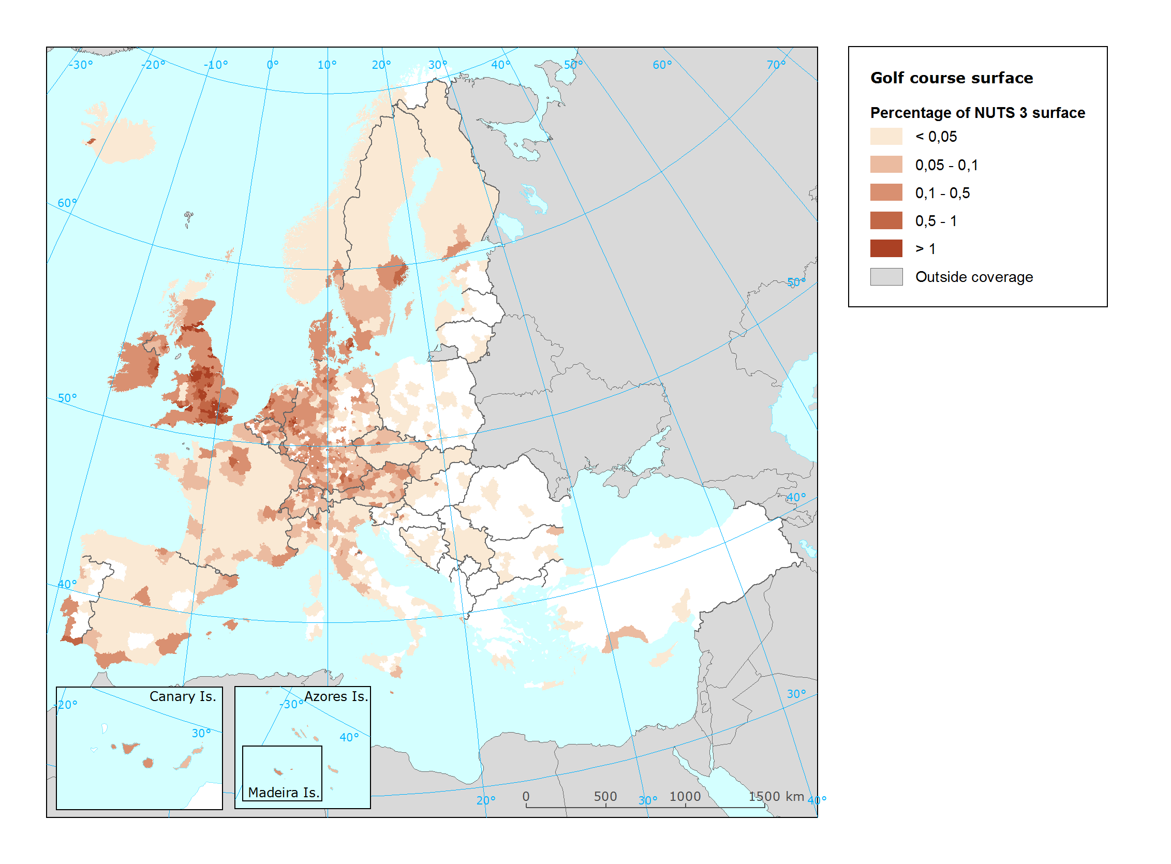
Specific policy question
Specific assessment
Examples
SPECIFICATIONS
Indicator definition |  |  | Area of golf courses per NUTS3 area
DPSIR |  |  | I
Justification
 |  | Rationale | Golf courses are important tourist attractions over all Europe. The golf resorts not only include the greens, but also - and most importantly in Mediterranean countries – they are the central part of touristic urbanisations and second home developments. The ratio of golf courses per administrative region (NUTS3) is seen as the most important attributes to illustrate.
 |  | References | Gössling, S., Peeters, P., Hall, C.M, Ceron, J.P., Dubois, G., Lehmann, L.V. & Scott, D. (2012): Tourism and water use: Supply, demand, and security. An international review. Tourism Management 33 (1): 1-15.  Tanner, R.A. & Gange, A.C. (2005): Effects of golf courses on local biodiversity. Landscape and Urban Planning 71 (2-4): 137-146)  Wheeler, K. & Nauright, J. (2006): A Global Perspective on the Environmental Impact of Golf. Sport in Society: Cultures, Commerce, Media, Politics 9 (3): 427-443.
Policy context
 |  | Policy context | - National and sub-national spatial planning regulations  - EC and national policies on tourism and sustainable tourism.  - Water Framework Directive
 |  | Targets | - Improvement of water management and recycling  - Reduction of fertiliser and pesticide pollution  - Sustainable regional planning
 |  | Related policy documents | Water Framework Directive: 2000/60/EC  COM(2014)86: A European Strategy for more Growth and Jobs in Coastal and Maritime Tourism
Methodology
 | Methodology for indicator calculation |  | Due to the lack of consistent official data sources on golf courses, the spatial data for golf courses in Europe have been extracted from Openstreetmap (OSM), using the descriptor “golf_course”. The resulting file of polygons for golf courses was cleaned from polygons not closely related to the extent of the golf course (buildings, access roads). The area was calculated for the final polygon layer and divided by the area of the corresponding NUTS3 region.
 | Methodology for gap filling
 | References
Data specifications |  |  | Data source:  - OpenStreetMap contributors The source data is available under the Open Database Licence  - Eurostat
Uncertainties
 | Methodology uncertainty
 | Data sets uncertainties |  | Being OpenStreetMap a voluntary mapping effort, the completeness and correctness of the dataset cannot be ensured completely. Nevertheless, visual test have shown a very detailed delineation and a good coverage of golf courses around Europe.
 | Rationale uncertainty
Further work
Ownership and contacts |  |  | ETC-ULS  Christoph Schröder (christoph.schroder@uma.es)

