Indicator name |  |  | Spatial impact of tourism facilities (II): Marina ports
ASSESSMENT
Indicator Name |  |  | TOUR007b - Territorial impact of tourism facilities (II): Number of moorings per km of coastline
Key policy question |  |  | Are we reducing the spatial impact from tourism infrastructures?
Key message |  |  | Tourism infrastructures, in particular marinas, have a strong impact on coastal and marine environment if not properly designed, managed and monitored. Marinas can modify coastal dynamics (changes on erosion and sediments deposition) with strong impact on the coastal morphology. The maintenance of yachts and the recreational shipping activities have also an impact on the quality of water and the seabed ecosystems in the surroundings of the yachting harbours (e.g. by application of anti-fouling material, cleaning of boats, oil discharges, etc.).
Key assessment |  |  | 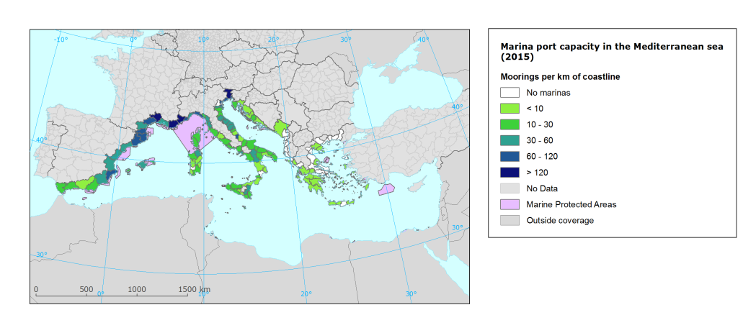  The highest pressure of marinas, considering the number of moorings per km of coastline, in the case of the Mediterranean Sea, is concentrated in the coastal NUTS3 regions of the Gulf of Lion (S of France and NE of Spain). The lowest pressure occurs on Greece and Western Balkans. Considering the islands, representing important tourism destinations in the Mediterranean, the highest pressures can be observed in Mallorca, while is lower on the Easter Mediterranean.  A large amount of Marine Protected Areas (MPAs) can be found around along the Mediterranean coastline and still many marine ecosystems are not properly protected. Recreational shipping activities, including anchorage can have major impact on sensitive marine sea beds close to the coast, if not regulated. The pollution by antifoulants, present in many port sediments, may affect as well sensitive ecosystems close to marina ports.
Specific policy question
Specific assessment
Examples
SPECIFICATIONS
Indicator definition |  |  | Number of moorings per km of coastline in NUTS3 regions
DPSIR |  |  | (P), I
Justification
 |  | Rationale | Marinas are important tourist attractions on the coast since they provide added value to the services offered in a particular place and tend to attract people with a specific tourism demands. The construction of the marinas often affects coastal ecosystems and has impacts the coastal morphology. However, the size of the marina in terms of moorings is an important indicator of the intensity of use. The more moorings a marina port has, the higher is the potential pollution by boat maintenance activities and the higher the potential pressure of recreational shipping activities. Studies have shown that antifoulants residues are present in many port sediments, but the mobilization of pollutants bound in surface sediments in the frequently disturbed port environment represents a serious threat for the local marine environment in general. Finally, since the indicator is aggregated at NUTS3 level, the number of moorings is provided per km of coastline in order to have comparable figures.
 |  | References | Anthony, E.J. (1997): The status of beaches and shoreline development options on the French Riviera: a perspective and a prognosis. Journal of Coastal Conservation 3: 169-178.  Cassi, R., Tolosa, I. & De Mora, S. (2008): A survey of antifoulants in sediments from Ports and Marinas along the French Mediterranean coast. Marine Pollution Bulletin 56 (11): 1943-1948.  Konstantinou, I.K. & Albanis, T.A. (2004): Worldwide occurrence and effects of antifouling paint booster biocides in the aquatic environment: a review. Environment International 30: 235-248.  Martínez, K., Ferrer, I., Hernando, M.D., Fernández-Alba, A.R., Marcé, R.M., Borrull, F. & Barceló. D. (2001): Occurrence of Antifouling Biocides in the Spanish Mediterranean Marine Environment. Environmental Technology 22 (5): 543-552.
Policy context
 |  | Policy context | - EC and national policies on tourism and sustainable tourism.  - EU regulations regarding coastal and marine ecosystems: Marine Strategy Framework Directive, Habitat Directive  - National and sub-national spatial planning regulations
 |  | Targets | - Improvement of quality and equipment of yachting harbours  - Good environmental status of marine environment  - Sustainable coastal development
 |  | Related policy documents | COM(2014)86: A European Strategy for more Growth and Jobs in Coastal and Maritime Tourism  MSFD: DIRECTIVE 2008/56/EC  Habitat Directive: Council Directive 92/43/EEC  IMO. 2005. International Convention on the control of harmful antifouling systems (AFS) on ships. 2005 Edition. IMO, London, 69pp.
Methodology
 | Methodology for indicator calculation |  | Yachting harbour location and its size in terms of moorings have been extracted from different sources for the Mediterranean coast. The EEA coastline dataset was split by NUTS3 regions in order to obtain the length of coastline within each NUTS3 region. The number of moorings corresponding to the NUTS3 regions was divided by the length of its coastline.
 | Methodology for gap filling |  | Missing data on locations and moorings were filled with available data on the portal Portbooker.com.
 | References
Data specifications |  |  | Data source: Plan Bleu, Federación Española de Asociaciones de Puertos Deportivos y Turísticos (FEAPDT), Portbooker.com.
Uncertainties
 | Methodology uncertainty
 | Data sets uncertainties |  | Data for Spain come from the National Federation of Yachting harbours, hence are validated. Data for other countries is taken from a regional assessment (Plan Bleu) and a commercial web portal, hence attached with certain uncertainty as it does not represent official reporting data.
 | Rationale uncertainty |  | The exact impact on coastal and marine environment has still to be validated by further studies. Available research already shows the impact on shoreline dynamics by the construction of marina ports and the existence of pollutants related to boat maintenance in the seabed. Monitoring studies should be conducted in other sensitive spots such as aquaculture farms and beaches.
Further work |  |  | Reported data for all countries but Spain needed.  To develop the indicator for all European coasts.  Collection of time series.
Ownership and contacts |  |  | ETC-ULS  Christoph Schröder: christoph.schroder@uma.es

