Indicator name |  |  | Spatial impact of tourism facilities (III): Ski resorts
ASSESSMENT
Indicator Name |  |  | - TOUR007c - (Length of) Ski lifts per km2  - TOUR007d - NUTS3 regions with largest sum of ski slopes
Key policy question |  |  | Are the spatial impact from tourism infrastructures being controlled?
Key message |  |  | Ski resorts and the related infrastructure (slopes, lifts) have a major impact on sensitive mountain environments. The construction of ski slopes and lifts damage consistently the existing high mountain ecosystems and increase the risks for avalanches. At the same time, high mountain ecosystems are protected widely through the Natura 2000 network, which lead to potential pressure of skiing activities and its infrastructures on protected areas.  On the other hand, skiing is one major pillar of economic development in mountain regions and is concentrated at specific points in the different mountain ranges in Europe. The seasonal increase of population in the skiing resorts also raises questions about resource use, waste and pollution in these areas.
Key assessment |  |  | Ski slopes and lifts are concentrated in Europe’s high mountain ranges such as the Alps, Pyrenees, Carpathian and Scandinavian mountain ranges as well as a number of lower mountain ranges over Central and Eastern and South Eastern Europe, Spain and Italy, as well as the British Islands. The French, Swiss, Italian and Austrian Alpine regions stand out, representing the first 10 regions in terms of length of ski slopes and lifts per NUTS3 regions.
Specific policy question
Specific assessment
Examples |  |  | 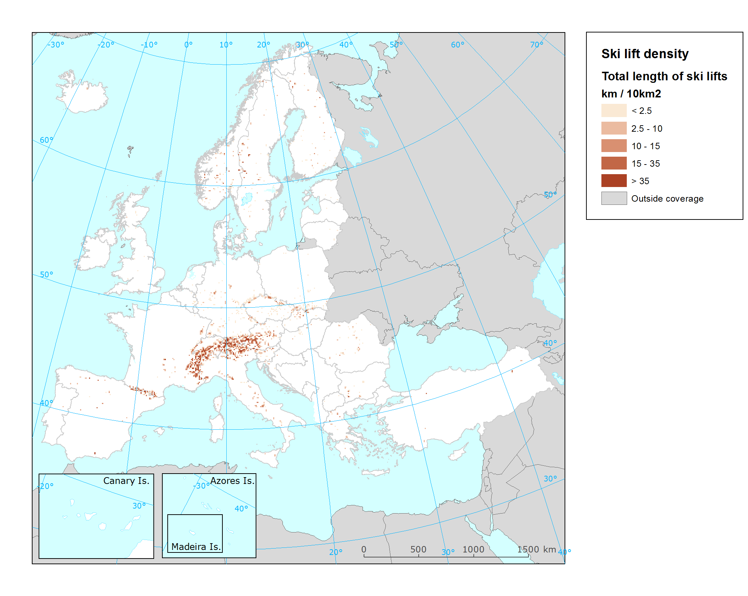  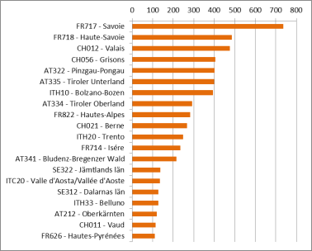
SPECIFICATIONS
Indicator definition |  |  | TOUR007c: Length of Ski lifts per km2. The dataset shows the density of ski lifts as the length ski lift infrastructure per 10 kilometer grid in Europe  TOUR007d: NUTS3 regions with largest sum of ski slopes. The graph illustrates the 20 NUTS3 regions with the largest sum of ski slopes in their territory (in km).
DPSIR |  |  | I
Justification
 |  | Rationale | Two subindicators are proposed to describe the impact skiing exerts on mountain environments. The length of slopes and lifts is an indication of the physical impact and intensity of use of the skiing resorts. The longer the slopes the higher the fragmentation of habitats and the risks of avalanches. The longer the lift lines, the higher the amount of sealing of land and the infrastructures needed for construction.
 |  | References | Nordregio (2004): Mountain Areas in Europe: Analysis of mountain areas in EU member states, acceding and other European countries. Final report of European Commission contract No 2002.CE.16.0.AT.136.  Patthey, P., Wirthner, S., Signorell, N., & Arlettaz, R. (2008): Impact of outdoor winter sports on the abundance of a key indicator species of alpine ecosystems. Journal of Applied Ecology 45 (6): 1704-1711.  Rolando, A., Caprio, E., Rinaldi, E. & Ellena, I. (2007): The impact of high-altitude ski-runs on alpine grassland bird communities. Journal of Applied Ecology 44 (1): 210-219.
Policy context
 |  | Policy context | - Habitat Directive  - Regional development funds (Alpine Space Programme, Caparthian Convention)
 |  | Targets | - Conservation of habitats  - Regional sustainable development
 |  | Related policy documents | Habitat Directive: Council Directive 92/43/EEC  Alpine Space Programme 2014-2020: http://www.alpine-space.eu/about/programme-documents/asp_cooperation_programme_final.pdf  Carparthian Convention: http://www.carpathianconvention.org/text-of-the-convention.html
Methodology
 | Methodology for indicator calculation |  | There is no Pan-European layer for ski slopes, lifts or areas. Data on ski runs and lifts are extracted and filtered from OpenStreetMap (OSM) data. The lines related to ski runs and lifts are tagged accordingly in the OSM files. The different line features can be summarized and overlaid with the EEA Reference grid to map the length of ski slopes and lifts per square kilometre. For the ski area, the convex hull of the line features is calculated and taken as polygon of the ski area. The potential pressure on Natura2000 site is based on a smoothing methodology elaborated originally for land cover data (see references). The results are expressed in percentage of the area of an polygon that is overlaid with the smoothing area.
 | Methodology for gap filling
 | References |  | Páramo, F. (2006): CORILIS (Smoothing of CLC data) Technical Procedure. ETC/TE Internal report (http://www.eea.europa.eu/data-and-maps/data/corilis-2000/corilis-methodology/corilis-methodology/download)
Data specifications |  |  | Data source: OpenStreetMap.
Uncertainties
 | Methodology uncertainty |  | Urban areas related to the ski area may not be part of the convex hull around the ski runs and lifts.
 | Data sets uncertainties |  | Being OpenStreetMap a voluntary mapping effort, the completeness and correctness of the dataset cannot be ensured completely. Not all ski areas may have been mapped in OSM, especially in remote mountain areas.
 | Rationale uncertainty
Further work
Ownership and contacts |  |  | OpenStreetMap: http://www.openstreetmap.org  Directorate-General for Environment (DG ENV)  Christoph Schröder (christoph.schroder@uma.es)

