Indicator name |  |  | Percentage of destination that is designated for protection
ASSESSMENT
Indicator Name |  |  | TOUR008 – Percentage of destination that is designated for protection
Key policy question |  |  | What is the potential for promoting nature-based tourism in each territory?
Key message |  |  | A necessary prerequisite to help increase ecotourism and nature-based tourism is to offer to tourists appropriate places where to undertake those associated activities, such as protected areas. Europe has different levels of nature protection in terms of protected surface, depending on the country and the region inside each country.
Key assessment |  |  | About 1,121,500 km² or 25.6 % of the EU 28 terrestrial land are protected under Natura 2000 or national designations or some combination of the two. Sites in the Natura 2000 network now account for 18 % of the EU's land territory, not only providing invaluable protection for vulnerable wildlife and habitats, but also being some of the most valued destinations for ecotourism or nature-based tourism. Protected areas more generally (including nationally and locally designated sites) now cover 21.8 % (excluding Greenland) of the land territory of the European Environment Agency's member countries and collaborating countries, in total 39 countries. At national level, though, these percentages present significant differences: countries like Ireland, Finland, Romania or Bulgaria have low percentages of protected surface, while others such as Germany, Poland or Slovenia have higher percentages. There are also other countries with big regional differences (i.e. France, Spain, Greece, UK, etc.).  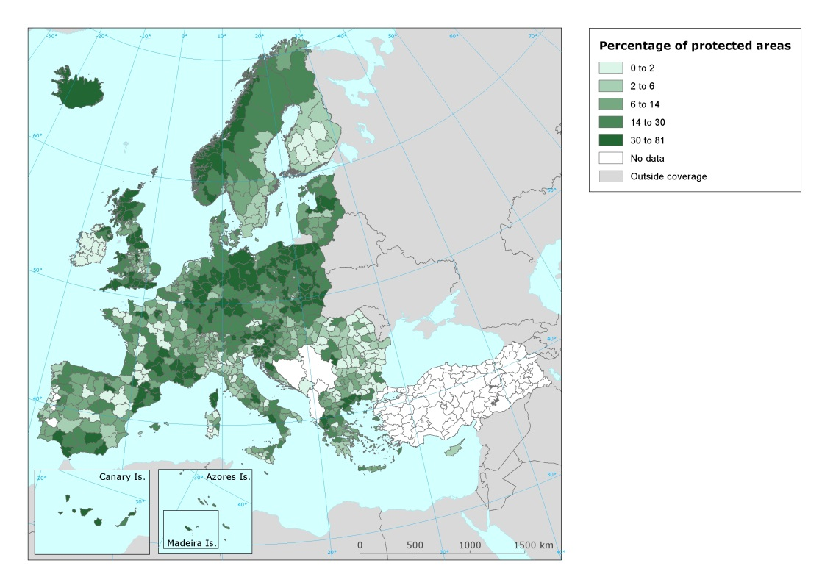
Specific policy question |  |  | What are the potential conflicts in land use by tourism (with other activities)?
Specific assessment |  |  | Protected areas visitation by tourists and leisure excursionists can be a benefit for those places and the surrounding areas, but at the same time it can create pressure and conflicts with other activities. In this case, though, there is no data at European level to analyse this issue so far.
Examples
SPECIFICATIONS
Indicator definition |  |  | Percentage of territory designated for protection under different protection figures included in the nationally designated areas (CCDA or Common Database on Designated Areas).
DPSIR |  |  | R
Justification
 |  | Rationale | The more the territory under any nature protection scheme (Natura 2000, national and regional protected areas, etc.) is protected, the highest the probability to increase its use for nature-based tourism or ecotourism, as protected areas are the key destinations for these types of tourism.
 |  | References
Policy context
 |  | Policy context | - EC and national policies on tourism and sustainable tourism.  - EU regulations regarding terrestrial and marine ecosystems: Marine Strategy Framework Directive, Habitat Directive  - National and sub-national spatial planning regulations
 |  | Targets
 |  | Related policy documents
Methodology
 | Methodology for indicator calculation |  | Calculation of the percentage of NUTS 3 total surface included in the CCDA database.
 | Methodology for gap filling
 | References
Data specifications |  |  | The Common Database on Designated Areas (CDDA) is more commonly known as Nationally designated areas. It is the official source of protected area information from European countries to the World Database of Protected Areas (WDPA). The inventory began in 1995 under the CORINE programme of the European Commission. It is now one of the agreed Eionet priority data flows maintained by EEA with support from the European Topic Centre on Biological Diversity.
Uncertainties
 | Methodology uncertainty
 | Data sets uncertainties
 | Rationale uncertainty |  | Not all the ecotourism and nature based tourism activity takes place inside protected areas, nor all the protected areas receive the same level of tourism visitation.
Further work
Ownership and contacts |  |  | ETC – ULS

