Indicator name |  |  | Tourism certification tools (3. Protected areas)
ASSESSMENT
Indicator Name |  |  | TOUR009d – Number of protected areas awarded with the European Charter of Sustainable Tourism
Key policy question |  |  | What is the potential for promoting nature-based tourism in each territory?
Key message |  |  | A necessary prerequisite to help increase ecotourism and nature-based tourism is to offer to tourists appropriate places where to undertake those associated activities, such as protected areas. Europe has different levels of nature protection in terms of protected surface, depending on the country and the region inside each country. Complementary to strict nature protection, a certification tool such as the European Charter of Sustainable Tourism has been developed in order to identify and promote those protected areas committed to sustainable tourism.
Key assessment |  |  | The European Charter for Sustainable Tourism is a certification tool for protected areas created and awarded by Europarc Federation. The Charter reflects the wish of authorities managing protected areas, of local stakeholders and representatives of the tourism business, to support and encourage tourism that accords with the principles of sustainable development. In this sense, the ECST can be seen as a booster for sustainable nature tourism in the places where it has been implemented. 146 protected areas throughout Europe hold this certification so far (2016), although more than 100 are concentrated in only three countries (Spain, France, and Italy). This fact shows the potential increase in the implementation and consolidation of this award throughout the continent.  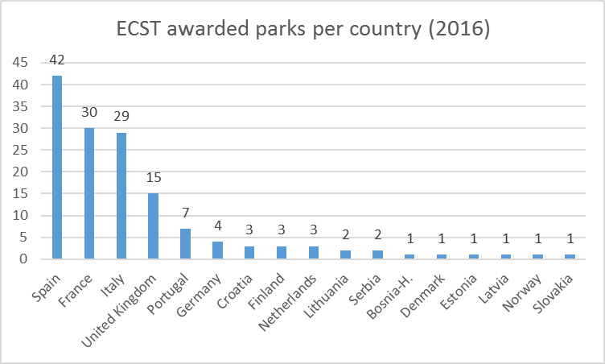
Specific policy question |  |  | What are the potential conflicts in land use by tourism (with other activities)?
Specific assessment |  |  | Protected areas visitation by tourists and leisure excursionists can be a benefit for those places and the surrounding areas, but at the same time it can create pressure and conflicts with other activities. In this case, though, there is no data at European level to analyse this issue so far.
Examples
SPECIFICATIONS
Indicator definition |  |  | Number of protected areas per country awarded with the European Charter for Sustainable Tourism.
DPSIR |  |  | R
Justification
 |  | Rationale | The more the territory under any nature protection scheme (Natura 2000, national and regional protected areas, etc.) is protected, the highest the probability to increase its use for nature-based tourism or ecotourism, as protected areas are the key destinations for these types of tourism. This should even be more evident in the case of those protected areas that have been recognized as “sustainable nature destinations”, such as those ones certified as ECST.
 |  | References
Policy context
 |  | Policy context | - EC and national policies on tourism and sustainable tourism.  - EU regulations regarding terrestrial and marine ecosystems: Marine Strategy Framework Directive, Habitat Directive  - National and sub-national spatial planning regulations
 |  | Targets
 |  | Related policy documents
Methodology
 | Methodology for indicator calculation |  | Number of ECST awarded protected areas according to Europarc Federation database.
 | Methodology for gap filling
 | References
Data specifications
Uncertainties
 | Methodology uncertainty
 | Data sets uncertainties
 | Rationale uncertainty |  | Not all the ecotourism and nature based tourism activity takes place inside protected areas, nor all the protected areas receive the same level of tourism visitation. Moreover, not all the protected areas that promote sustainable tourism have been awarded with ECST. However, it can be considered an indicator of commitment towards sustainability from management authorities and related stakeholders.
Further work
Ownership and contacts |  |  | ETC – ULS

