HABITATS DIRECTIVE
ARTICLE 17 REPORT
( 2001 – 2006 )

COVERAGE OF ANNEX I HABITATS AND ANNEX II SPECIES BY THE NATURA 2000 NETWORK

This paper is part of the web-based Article 17 Technical Report (2001-2006) http://biodiversity.eionet.europa.eu/article17
compiled by the European Topic Centre on Biological Diversity for the
European Commission (DG Environment)

DISCLAIMER:
The contents of this paper do not necessarily reflect the official opinion of the European Environment Agency, the European Commission or other European Communities institutions.

ETC/BD, Paris, 2008

Coverage of Annex I habitats and Annex II species by the Natura 2000 network
To compare the distribution of habitats and species with the corresponding Natura 2000 sites the distribution maps provided within Article 17 report, for each habitat and species were harmonised into a standard 10x10 or equivalent grids and the area of distribution was calculated. Similar grid based distribution maps for each habitat and species were produced using Natura 2000 site boundaries. These two maps were overlaid and the area of the overlap was computed for each Annex I habitat and Annex II species.

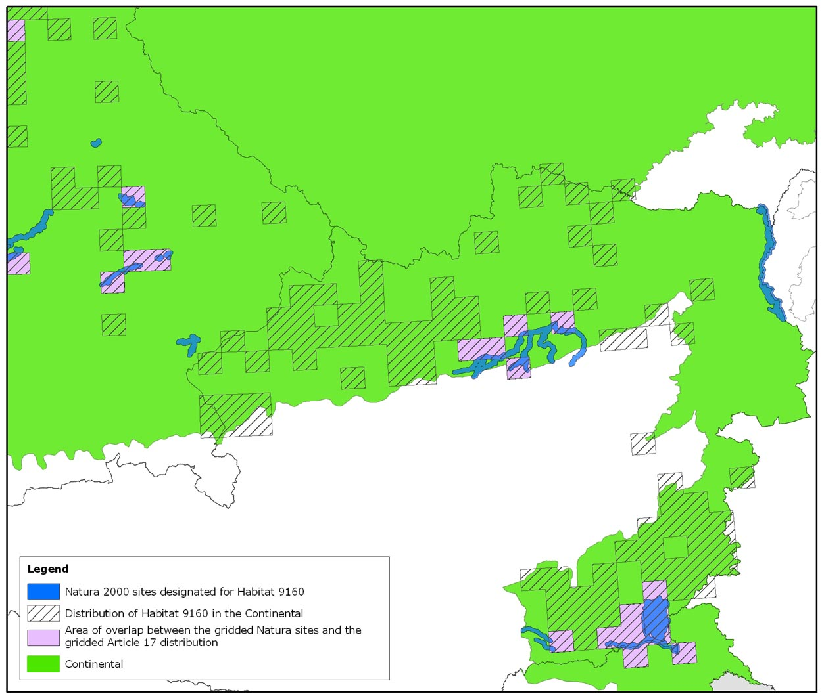
Figure 1: An extract from the distribution of Habitat type 9160 from the Continental biogeographical region to illustrate the overlap between the Natura 2000 boundaries and the Article 17 Distribution. Cells which have both part of the distribution reported by the Article 17 reports and with a SAC/SCI for the habitat are shown in pink. It can be seen that in this area of Europe only a small proportion of the habitat area is included within the Natura 2000 network.
The area of the overlap was expressed as a percentage of the area of the gridded habitat distribution. These percentages were split into classes and the number of habitats corresponding to each class was computed. For example for the Alpine biogeographical region 11 habitats were 100% covered while 10 were between 40 and 50% covered (see Figure 2a). The results of these calculations are available as an appendix (give link). In some cases an absence of maps means no calculation is possible and these have been assigned to the class ‘NA’.
Due to the use of gridded data this methodology should be interpreted as an indication of areas beyond the network rather than as an estimate of proportion of a habitat or species distribution covered by the sites.

Habitats
For the terrestrial habitats the coverage is generally between 20 - 60% although in the Continental region the most frequent class is 100%, with 40-50% just behind. The most frequent class is higher in the Mediterranean region than in most other regions, this may be due to countries basing their distribution maps for Article 17 on the Natura 2000 sites (it is known that Greece did this due to lack of data from areas outside the network and it is possible that Italy took a similar approach).
When the 25 habitats which fall into the 100% class for the Continental region are examined, all but four only occur in the Italian and Slovenian subregion and most only in Italy.
Habitat types which are rare are less likely to occur outside protected areas as site selection will have focused on these sites. In some cases we know that all known sites are included in the Natura 2000 network, for example the habitat 6460 *Peat grasslands of Troodos which is only known from one area in Cyprus. Of the 62 habitats with a 100% overlap 37 are reported with a distribution of 10 cells or less.
For some habitats a distribution has been reported in a region where there were no Natura 2000 sites proposed by the end of 2006. This is the case for several habitat types which were added in 2004 in the former EU15. For example, Germany has reported a distribution for habitat types 3190 Lakes of gypsum karst and 91T0 Central European lichen Scots pine forests, both added in 2004. Our analysis here shows 0% coverage as at the end of 2006 there were no German sites for these habitats although now (December 2008) there are 5 and 7 sites respectively.
There are 47 habitats reported for which the regional coverage is less than 20%.

Species
In comparison with habitats, the number of species where the species is not reported outside the Natura 2000 network is much higher, reaching a maximum of 134 in the Mediterranean region. A large number of the species with 100% coverage are endemics or species with a very restricted distribution within the EU25 which have been targeted when selecting sites such as the plant Centaurea alba ssp. princeps in Greece which only occurs within a single 10 km² cell. Spain did not provide maps for a large number of its Annex II species, approximately 80% of these species are plants. The number of species which are completely covered in Macaronesia is almost certainly greater than 23 as shown here due to missing maps.
There are 92 species where this analysis reports 0% coverage in a region
Some of these, for example Viola delphinantha in Greece, Microtus oeconomus mehelyi in Austria or Lycaena helle in Finland and Sweden are species which have been recently added to Annex II but for which no sites had been proposed by the end of 2006.
There are a few species, such as Dytiscus latissimus which has only recently been discovered in the Netherlands at for which, at present there are no SCI.
There are also problems arising from the use of different names for site proposals and for Article 17 reporting. For example Greece has used Sabanejewia balcanica reported for Art 17 but S. aurata in the Natura 2000 database. For a few species such as Bryhnia novae-angliae and Scapania massolongi (both Boreal Sweden) no GIS coverage of the proposed was available.
Many of the species noted as 0% overlap are Annex II species where the lack of sites has been identified during a biogeographical seminar. Examples include Aldrovanda vesiculosa and Sabanejewia aurata in Lithuania and Cochleria polonica and Galium cracoviense in Continental Poland. In some instances sites have now been proposed.
Finally there are a very few cases where there are sites proposed but where there appears to be no overlap between the proposed site(s) and the distribution as reported for Article 17. This is the case for the mosses Bruchia vogesiaca in Atlantic Portugal (see Figure 2) and Drepanocladus vernicosus in Mediterranean Spain (see Figure 3). The Spanish data is known to be incomplete (see report ‘Data completeness, quality and coherence’) and the distribution of D. vernicosus is much more than the single 10 km² grid reported (Fuertes et al , 2005) . Bruchia vogesiaca needs further examination.

Conclusion
The distribution data provided by the Member States as part of the Article 17 reports allows a verification of the Natura 200O network and will be invaluable for assessing new proposals made to complete gaps identified by the Biogeographic seminars and associated bilateral meetings. For many habitats and species the Article 17 distribution maps are more recent than those used during the Biogeographic seminars, particularly for the EU15 countries, and would also permit a re-evaluation of the network. The methodology described here will allow any such re-evaluation to be focused on the habitats and species where the network is most likely to be poor.

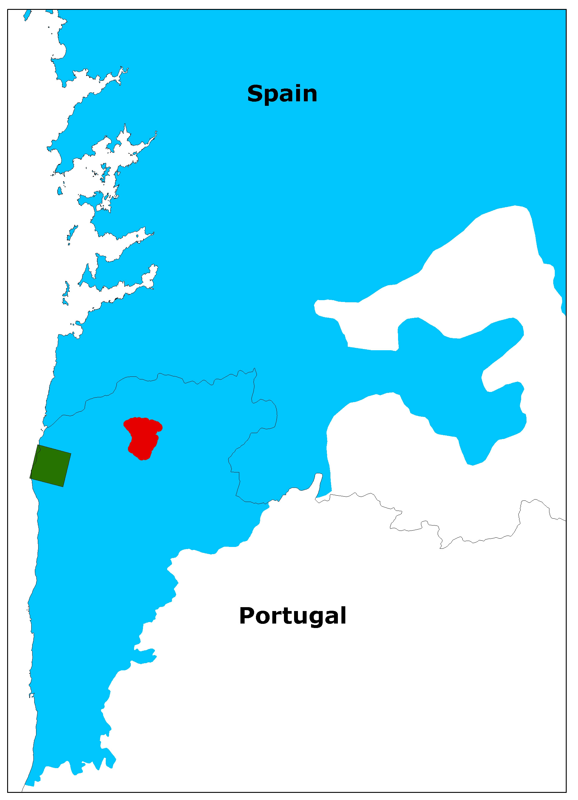

Figure 2 Distribution of the moss Bruchia vogesiaca as reported for Article 17 (green square) and the only SCI for this species in the Atlantic region of Portugal (red polygon).

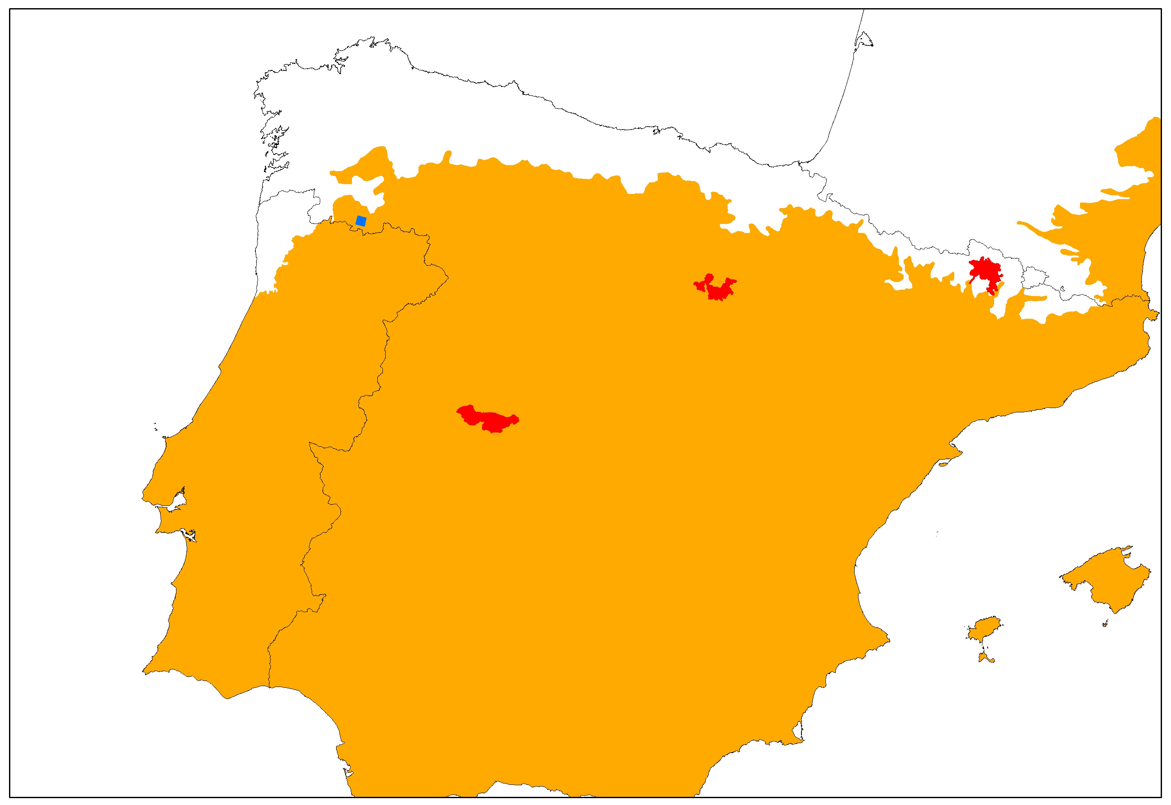
Figure 3 Distribution of the moss Drepanocladus vernicosus as reported for Article 17 (blue square) and the SCI for this species in the Mediterranean region of Spain (red polygons).

Fuertes, E., Acón, M. & Oliván, G. (2005) Hamatocaulis y Scorpidium (Calliergonaceae, Bryopsida) in the Iberian Peninsula. Lazaroa 26: 5-16

