Webinar on BWD 2020 reporting  17 November and 1 December 2020, MS Teams meeting room  Draft agenda | 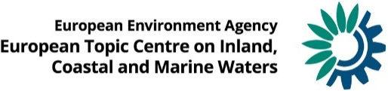

Webinar on BWD 2020 reporting, 17th November and 1st December 2020,
MS Teams meeting room

Draft Agenda (version 1)

Meeting documents:
Presentations will be available after the meeting at https://forum.eionet.europa.eu/nrc-eionet-freshwater/library/bathing-waters/2020-webinar-bwd-reporting

Chair: Lidija Globevnik (ETC/ICM - TC VODE)
Rapporteur: Luka Snoj (ETC/ICM - TC VODE)

1st day, Tuesday, 17th November 2020
MS Teams
Time | Item no. | Agenda item | Presenters
09:00–09:15 | 1 | Welcome from EEA project manager for BWD reporting | Mustafa Aydın (EEA)
 | 2 | Welcome from EC ENV - BWD implementation team | Maja Dorota Feder (DG ENV)
09:15–09:30 | 3 | Latest news on development of reporting system at EEA with introduction to Reportnet 3.0 | Jonathan Maidens (EEA)
09.30 - 10.30 | 4 | BWD reporting on 2020 season - Identification of Bathing Waters (ROD 788 - spatial data) | Luka Snoj (ETC/ICM)
 | 5 | BWD reporting on 2020 season - Monitoring and Classification of Bathing Waters (ROD 787 – attribute data) | Gašper Šubelj (ETC/ICM)
10:30-11.00 | 6 | Discussion and further clarifications | All

2nd day, Tuesday, 1st December 2020
MS Teams
Time | Item no. | Agenda item | Presenters
09:00-10:00 | 1 | Review of issues raised during the testing period  Participants should test the delivery in advance and send questions to BWD Helpdesk (bwd.helpdesk@eionet.europa.eu). | Luka Snoj, Gašper Šubelj (ETC/ICM)
10:00-10:30 | 2 | Demonstration of Reportnet 3.0 | Jonathan Maidens (EEA)
10:30-11:00 | 3 | Discussion and further clarifications | All

