Integration of Bathing Water Directive into WISE
Bathing water GIS and QC/QA for sites

Version: 1.0
Date: April, 2008
EEA activity:
ETC/Water task.milestone.submilestone: Task 4.3

Prepared by / compiled by: ETC/W
Organisation: IWRS

EEA Project manager: Stefan Jensen
Version History
Version | Date | Author | Status and description | Distribution
0.1 | 21/03/2008 | Lidija Globevnik  Dunja Vrenko | Milestone 2  Set up the deliverable 1 (BW data base) | ETC/W
0.2 | 30/04/2008 | Lidija Globevnik  Dunja Vrenko  Marko Kovačič | Milestone 2  Guidance protocols for QC/QA of bathing waters to be done by MS | ETC/W
Content:
1. INTRODUCTION 3
1.1. “Bathing water places” attribute table 3
2. GOOGLE EARTH 4
2.1. Instructions 4
2.2. Prepared files 5
3. VIEWING DATA in ESRI GIS environment 6
3.1. Instructions 6
3.2. Prepared files 7
4. PDF 7
4.1. Instructions 7
4.2. Prepared files 7
5. XLS 8
5.1. Instructions 8
5.2. Prepared files 8

Abbreviation used

EU – European Union
MS – Member State
QC – Quality Check

INTRODUCTION
In December 2007 EU MS have reported 2007 data for the Bathing Water Directive. In March 2008 EEA/ETCW has received from GIM (Geographical Information Management nv from Leuven, Belgium) all BWD data sets located at the COMM server in Luxembourg. The hand over to EEA/ETCW included the following data sets:
- MS Access database for each country
- EU-wide shapefile
- EU-wide Oracle database for Internet Atlas
- Scripts of bathing water website

In the beginning of April GIM has updated bathing water quality data up to 2007 and sent EU-wide shapefile and MS Access database to ETCW. Each bathing water place (point object) had geographical coordinates in WGS84. ETCW has integrated data as received from GIM into the WISE data system.

The quality check of locations is needed to set up working data base for the WISE data system and to produce reliable and confident WISE web pages on bathing water quality. The basic logical quality check is done by ETCW (if location falls outside the country, if there are doubles, if there are any missing locations as reported by countries...). It is recommended that quality check of names and codes of locations should be done by experts from each Member States (MS). Three options are prepared that MS might use for quality checking:
- To open the “Google Earth”, import prepared files and check bathing water locations (and data connected to chosen location) on maps
- To open data in any GIS software (files prepared for ARC MAP 9.2, but any other software might be used)
- To check the locations with names by looking at PC documents showing map as image (paper format A0)

For each MS one xls file is prepared with a list of bathing water locations (with names and coordinates). Corrections for bathing waters should be put into this file.

The following products are prepared:
  - Files in KML and/or KMZ format for exploration with the Google Earth maps
  - Files in MXD format with associated shape files for exploration with GIS software (MXD files can be opened in ARC MAP 9.2, shape files can be opened also in ARC VIEW or imported/opened in any other GIS software),
  - Files in PDF format (Adobe Reader format). Because images in PDF format are produced automatically, some names may overlap or even can not be seen. This option should be used only for quick overview and should be combined with one of the above options.

“Bathing water places” attribute table
attribute | description
FID | Object ID (field automatically created by GIS software)
Shape | Geometry of shape file (point) (field automatically created by GIS software)
numind | Access code of bathing water
lat | Latitude of bathing water in decimal degrees
long | Longitude of bathing water in decimal degrees
cc | Country code
WaterType | Type of bathing water corresponding to symbols used in mapping (see below)
Seawater | Type of water  O – Seawater  N – Freshwater
Region | Region name reported by Member State
Province | Province name reported by Member State
Commune | Commune name reported by Member State
Prelev | Bathing water name reported by Member State
y1990 | Quality status of bathing water for every year  1 – compliant to guide values  2 – prohibited throughout the season  3 – insufficiently sampled  4 – not compliant  5 – compliant to mandatory values  6 – not sampled
y1991
y1992
y1993
y1994
y1995
y1996
y1997
y1998
y1999
y2000
y2001
y2002
y2003
y2004
y2005
y2006
y2007

Table 1: Description of shape file attributes (e.g. DE_bplaces.shp)

GOOGLE EARTH

Instructions
Google Earth is a free software that can be downloaded from http://earth.google.com/ and installed on PC computer as instructed from producer. After installation one can add new layers using kmx or kml file formats with software option File/Open.

After uploading prepared kml or kmx files, the content of the file is listed on the left side in “Places window” and mapped on the map area. With mouse click on the point of interest (bathing water place) in the map area or in the place listed on the left side an attribute table appears in Google Earth window (picture 1).

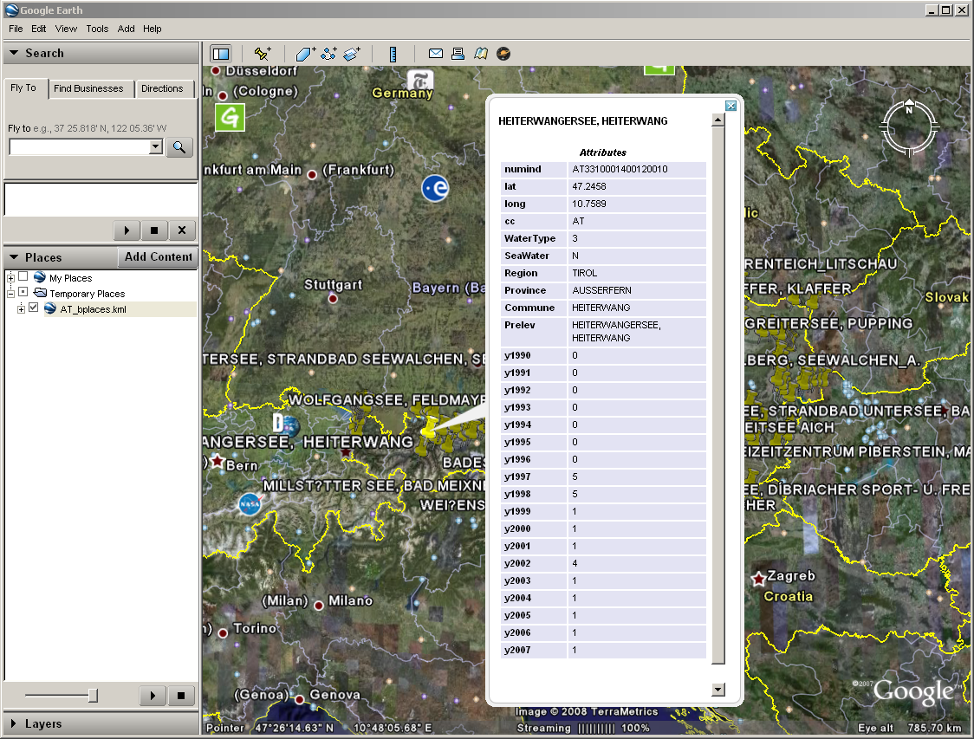

Picture 1: Google Earth window

Detailed instructions are on Google Earth user guide: http://earth.google.com/intl/en/userguide/v4/#adding_content

Coordinate system of the Google Earth is WGS84.

Prepared files

Prepared kmz and kml files are put on Eionet Circa under folder QC_ bathingwater_locations for every country separately as “GoogleEarth files.zip”:
http://eea.eionet.europa.eu/Public/irc/eionet-circle/water/library?l=/directive_locations&vm=detailed&sb=Title

GoogleEarth files.zip includes the following files:
- countrycode_bplaces.kml (kml file for bathing water places)
- countrycode_bplaces.kmz (kmz file for bathing water places)

VIEWING DATA in GIS environment

Instructions
Files for viewing locations in ARC MAP 9.2 software are prepared in mxd and shp format (Figure 2). Files in shp format (with attribute data) can be opened also in ARC VIEW or imported/opened in any other GIS software

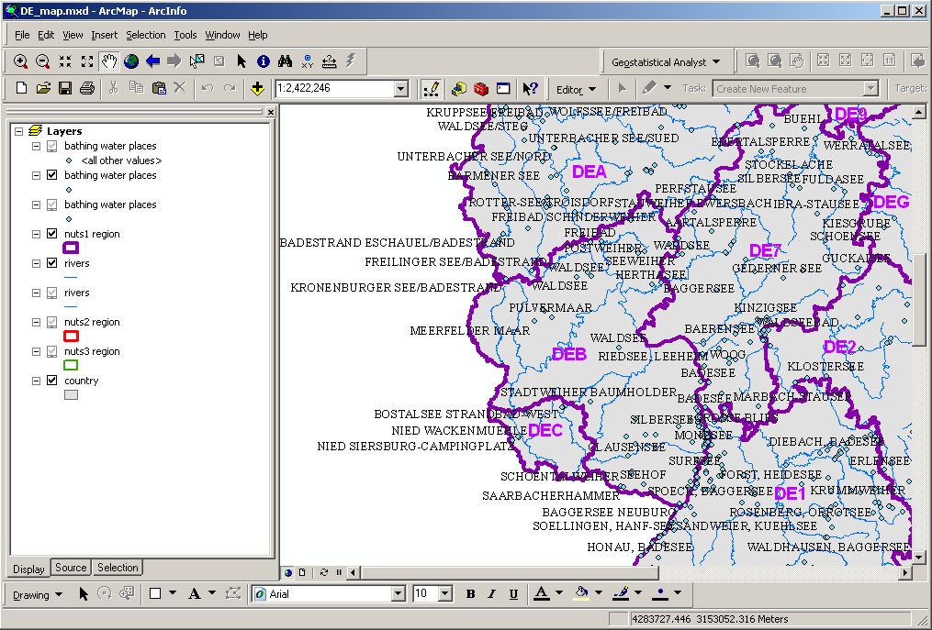

Figure 2: Window in ArcGIS v.9.2 of mxd file

For bathing water places they are prepared three different visualization levels:
- 1 : 24 000 000 – 1 : 3 000 001 (file countrycode_bplaces.shp)
- 1 : 3 000 000 – 1 : 1 500 001 (file countrycode_bplaces.shp)
- more or equal to 1 : 1 500 000 (file countrycode_bplaces.shp)

Prepared files
Prepared mxd and shp files are put on Eionet Circa under folder QC_ bathingwater_locations for every country separately as “WISE Viewer files.zip”:
http://eea.eionet.europa.eu/Public/irc/eionet-circle/water/library?l=/directive_locations&vm=detailed&sb=Title

WISE Viewer files.zip includes the following files:
- countrycode_bplaces.shp (shapefile for bathing water places)
- countrycode_bplaces_outliers.shp (shapefile for bathing water places with outliers attribute)
- countrycode _nueu10mv9m_region_country.shp (shape file for country)
- countrycode_nueu10mv9m_region_nuts1.shp (shape file for nuts 1)
- countrycode_nueu10mv9m_region_nuts2.shp (shape file for nuts 2)
- countrycode_nueu10mv9m_region_nuts3.shp (shape file for nuts 3)
- countrycode_RIVERS.shp (shape file for rivers)

PDF

Instructions
All pdf files can be open in Adobe Reader. All maps are put on ISO A0 paper size and scaled 1: 400 000 or 1 : 100 000 depends on the size of the country. For larger countries there is more pdf files prepared.

Prepared files
Prepared pdf files are put on Eionet Circa under folder QC_ bathingwater_locations for every country separately as “PDF files.zip”:
http://eea.eionet.europa.eu/Public/irc/eionet-circle/water/library?l=/directive_locations&vm=detailed&sb=Title

PDF files.zip includes the following files:

countrycode_map.pdf
or
- countrycode_map_number_of_map_part.pdf

XLS

Instructions
All xls files can be opened with Microsoft Office Excel. These files contain all bathing places for each country.

- Fields that need to be checked:
Bathing water name – name of bathing water
Longitude, Latitude – coordinates in ETRS89 coordinate system for each bathing place rounded to 4 decimal places

- Fields for corrections:

“CORRECT Bathing water name”: when bathing water name is not correct, put a new name into this field using regular national characters (i.e. ü, č, å, ø, ł, ...).

“CORRECT Latitude”: when latitude is wrong, put a correct coordinate in ETRS89 coordinate system, rounded to 4 decimal places. Please indicate in “Comments “ field if a new coordinate had been defined from the Google Earth map or if a new coordinate is in WGS84 coordinate system.

“ CORRECT Longitude”: when longitude is wrong, put a correct coordinate in ETRS89 coordinate system, rounded to 4 decimal places. Please indicate in “Comments “ field if a new coordinate had been defined from the Google Earth map or if a new coordinate is in WGS84 coordinate system.

“Comments”: field for any additional comments.

- Additional fields:

“ Remarks ETCW”: a field with pre-prepared remarks or guidelines, i.e. “wrong coordinates” (possible errors found by logical checking by ETCW). The field should not be changed, any remarks by MS should be put into “comments” field.

Prepared files
Prepared xls files are put on Eionet Circa under folder QC_ bathingwater_locations for every country separately as “countrycode_bathingwater_locations”:
http://eea.eionet.europa.eu/Public/irc/eionet-circle/water/library?l=/directive_locations&vm=detailed&sb=Title

XLS files are the following files:

countrycode_ bathingwater_locations.xls

For each MS a country code is used in the beggining of a file name

