Hydromorphology

draft for EEA 2012 state of water assessment

Version: Final draft

Date: July 2012

EEA activity: 1.4.2

ETC/ICM task, milestone: 1.4.2

Prepared by / compiled by: Peter Kristensen & ETC/ICM

EEA Project manager:

**Peter Kristensen**

Version History

| Version | Date | Author | Status and description | Distribution |
| --- | --- | --- | --- | --- |
| 1.0 | 22/11/2011 | PKR | Zero draft | To Advisory group |
| 2.0 | 22/02/2012 | PKR | draft for Eionet and stakeholder consultation | Eionet and stakeholders |
| 3.0 | 30/06/2012 | János Fehér, VITUKI | draft to PRK of EEA for comments | Forum |
| 3.1 | 06/07/2012 | Lidija Globevnik, Tina Kirn | Amended draft version | To János Fehér, |
| 4.0 | 15/07/2012 | János Fehér, VITUKI | Final draft to PRK of EEA for comments | Forum |

#### Contents

[1. Introduction 5](#_Toc330191016)

[1.1. The Water Framework Directive 5](#_Toc330191017)

[1.1.1. River basin management planning process 6](#_Toc330191018)

[2. Hydromorphological pressures and impacts 7](#_Toc330191019)

[2.1. WFD and hydromorphological pressures 8](#_Toc330191020)

[2.2. Drivers and activities 10](#_Toc330191021)

[2.3. Hydromorphological pressures and habitat alterations 12](#_Toc330191022)

[2.4. European overview of hydromorphological pressures 13](#_Toc330191023)

[2.4.1. Methodology issues 13](#_Toc330191024)

[2.4.2. Key messages 14](#_Toc330191025)

[2.4.3. European results 14](#_Toc330191026)

[2.4.4. Hydromorphological pressure groups 16](#_Toc330191027)

[2.4.5. Country results 18](#_Toc330191028)

[2.5. Barriers – transversal structures 21](#_Toc330191029)

[2.5.1. European overview 22](#_Toc330191030)

[2.5.2. Effects of barriers on rivers 24](#_Toc330191031)

[2.6. Abstraction and flow regulation and water level regulation 25](#_Toc330191032)

[2.6.1. European overview of abstraction and rivers with regulated flow 27](#_Toc330191033)

[2.7. Morphological alterations 31](#_Toc330191034)

[2.7.1. European overview 33](#_Toc330191035)

[2.7.2. Country examples of altered river habitats 33](#_Toc330191036)

[2.8. Hydromorphological issues in transitional and coastal waters 36](#_Toc330191037)

[2.8.1. European Overview 38](#_Toc330191038)

[3. Sectors and activities 40](#_Toc330191039)

[3.1. Hydropower and WFD 40](#_Toc330191040)

[3.1.1. Overview of hydropower in Europe 41](#_Toc330191041)

[3.1.2. Balancing WFD and Renewable Energy Directive (RES) requirements 43](#_Toc330191042)

[3.2. Navigation and WFD 45](#_Toc330191043)

[3.2.1. RBMP and inland waterway transport 47](#_Toc330191044)

[3.2.2. WFD and inland navigation 47](#_Toc330191045)

[3.3. Towards sustainable flood risk management 48](#_Toc330191046)

[3.3.1. RBMPs and flood defense activities 50](#_Toc330191047)

[3.3.2. WFD and flood risk management 51](#_Toc330191048)

[4. Designation of heavily modified and artificial waters 53](#_Toc330191049)

[4.1. European overview 53](#_Toc330191050)

[4.1.1. Key messages 54](#_Toc330191051)

[4.1.2. Assessment 54](#_Toc330191052)

[4.2. Water uses for which water bodies are identified as heavily modified water bodies 57](#_Toc330191053)

[4.3. Case studies 59](#_Toc330191054)

[4.3.1. HMWBs / AWBs in Germany 59](#_Toc330191055)

[4.3.2. Danube International RBD 60](#_Toc330191056)

[4.3.3. Rhine RBD 61](#_Toc330191057)

[4.3.4. Heavily modified water bodies in selected coastal areas 61](#_Toc330191058)

[4.4. Ecological status and potential 65](#_Toc330191059)

[4.5. Comparison of ecological status and potential of natural, HMWB and AWBS 65](#_Toc330191060)

[4.5.1. Key messages 65](#_Toc330191061)

[4.5.2. Assessment 66](#_Toc330191062)

[4.6. Case studies on ecological status and potential 67](#_Toc330191063)

[4.6.1. Case study of ecological status and potential 67](#_Toc330191064)

[4.6.2. Ecological status or potential in selected coastal areas 67](#_Toc330191065)

[References 70](#_Toc330191066)

[Appendix 1: Abbreviations used 75](#_Toc330191067)

# Introduction

2012 is the European year of water in which the EU Commission publishes its “Blue-print to safeguard European waters” comprising reviews of the Water Framework Directive (WFD), Water scarcity and drought and vulnerability and adaptation policies. In addition in March 2012 the 6th World Water Forum was held in Marseille, France while in May the 3rd European Water Conference was held during Green Week in Brussels.

To accompany and inform these events and policy processes European Environmental Agency (EEA) planed for 2012 a set of reports on the “State of Europe’s water”. Two of these reports were based on information reported by EU Member States (MS) in 2010 via River Basin Management Plans (RBMP) and supplemented with assessments of information from other sources. They were developed in close cooperation and coordination with the DG Environment’s assessment of the RBMPs and the development of the blueprint (impact assessment, reports, communication, staff working documents). The format of the EEA 2012 State of Europe’s water assessment was planned to consist of four thematic assessments and an overarching synthesis and integrated report. In terms of communication, several assessments were planned to be published on numerous occasions throughout 2012. EEA prepared the following thematic assessments with indication of when and where they were published:

1. Efficient Use of Water Resources (World Water Forum, Marseilles, March 2012)
2. Vulnerability (Water scarcity and drought, floods, water quality) – Autumn 2012
3. WFD: Ecological and chemical status and pressures – Autumn 2012
4. WFD: Hydromorphology – Summer 2012

The last two thematic assessments were based on information reported via the RBMPs and presented results on status and pressures.

First reporting of the River Basin Management Plans (RBMPs) under the Water Framework Directive (WFD) was due by end of 2009. Most Member States (26 out of 27 Member States) have reported their RBMPs and delivered a huge amount of data on status, pressures and measures to the WISE-WFD database. The current report is based on data delivered by the Member States via WISE up to May 2012 and information available in digital version of RBMPs. Where a Member State did not deliver data or the RBMP was not available, information from that specific Member State or RBD were not presented in this reprot (Latvia and Slovakia have not designated lake water bodies; Malta designated only coastal water bodies, but no river, lake and transitional ones; Cyprus has not designated transitional water bodies).

## The Water Framework Directive

The Water Framework Directive (WFD), which came into force on 22 December 2000, established a new framework for the management, protection and improvement of the quality of water resources across the European Union (EU).

EU Member States should aim to achieve good status in all bodies of surface water and groundwater by 2015 unless there are grounds for derogation then achievement of good status may be extended to 2021 or by 2027 at the latest. Good status means that certain standards have been met for the ecology, chemistry, morphology and quantity of waters. In general terms ‘good status’ means that water only shows slight change from what would normally be expected under undisturbed conditions. There is also a general ‘no deterioration’ provision to prevent deterioration in status.

The WFD establishes a legal framework to protect and restore clean water in sufficient quantity across Europe. It introduces a number of generally agreed principles and concepts into a binding regulatory instrument. In particular, it provides for:

* Sustainable approach to manage an essential resource: It not only considers water as a valuable ecosystem, it also recognises the economy and human health depending on it.
* Holistic ecosystem protection: It ensures that the fresh and coastal water environment is to be protected in its entirety, meaning all rivers, lakes, transitional (estuaries), coastal and ground waters are covered.
* Ambitious objectives, flexible means: The achievement of “good status” by 2015 will ensure satisfying human needs, ecosystem functioning and biodiversity protection. These objectives are concrete, comparable and ambitious. At the same time, the Directive provides flexibility in achieving them in the most cost effective way and introduces a possibility for priority setting in the planning.
* Integration of planning: The planning process for the establishment of river basin management plans needs to be coordinated to ultimately achieve the WFD objectives.
* The right geographical scale: The natural area for water management is the river basin (catchment area). Since it cuts across administrative boundaries, water management requires close cooperation between all administrations and institutions involved. This is particularly challenging for transboundary and international rivers.
* Polluter pays principle: The introduction of water pricing policies with the element of cost recovery and the cost-effectiveness provisions are milestones in application of economic instruments for the benefit of the environment.
* Participatory processes: WFD ensures the active participation of all businesses, farmers and other stakeholders, environment NGOs and local communities in river basin management activities.
* Better regulation and streamlining: The WFD and its related directives (Groundwater Daughter Directive (2006/118/EC); Floods Directive COM(2006)15) repeal 12 directives from the 1970s and 1980s which created a well-intended but fragmented and burdensome regulatory system. The WFD creates synergies, increases protection and streamlines efforts.

The WFD calls for the creation of River Basin Districts. In case of international districts that cover the territory of more than one EU Member State the WFD requires coordination of work in these districts.

### River basin management planning process

Implementation of the WFD objectives is to be achieved through the river basin management planning process which requires the preparation, implementation and review of a river basin management plan every six years for each river basin district (RBD) identified. River Basin Management Plans are plans for protecting and improving the water environment and have been developed in consultation with organisations and individuals. River basin planning is a strategic decision-making process that integrates the management of land and water within river basin districts. The river basin management planning process aims to improve and support sound and sustainable water management to deliver the requirements of the WFD while balancing the environmental, social and economic needs within the river basin district. This requires an approach to river basin planning and based on the plan management actions that takes all relevant factors and measures into account and considers them together. There are five main elements of the process:

* Governance and public participation;
* Characterisation of the river basin district and the pressures and impacts on the water environment;
* Environmental monitoring based on river basin characterisation;
* Setting of environmental objectives; and
* Design and implementation of a programme of measures to achieve environmental objectives.

The river basin planning process started more than ten years ago with implementation of the WFD in national legislation and establishing the administrative structures. The river basin planning process resulted in 2004 with an analysis of the pressures and impacts affecting the water environment in the river basin district. The findings were published in March 2005 in the characterisation report required by Article 5 of the WFD. River basin planning is a gradual cyclical process that involves public participation throughout. Characterisation is followed by a series of steps shown in Figure 1.1.

Figure 1.1 The WFD river basin planning process



Source: Adapted by CIS WFD (2003)

The current report on Hydromorphology aims at providing an overview of the results on status and pressures from the River Basin Management Plans (RBMPs). The parallel thematic assessment on ecological and chemical status, pressures and impacts has more detailed information on data reported via the RBMPs, data handling methodology etc.

# Hydromorphological pressures and impacts

Waters (surface, subsurface, transitional and coastal) are vital resources for humans, wildlife and plants. They shape landscapes, transport water and sediment, help to maintain the natural balance of ecosystems and are used for many purposes. However, their capacity to fulfill these functions is impaired by man-made structures, hydropower generation and high-intensity industrial or agricultural use.

Europe’s surface waters as well as transitional and coastal waters are affected by major modifications, such as water abstractions, water flow regulations (dams, weirs, sluices, and locks) and morphological alterations, straightening and canalisation, and disconnection of flood plains (Figure 2.1). These are called hydromorphological pressures.

Figure 2.1: Conceptual overview of the change from natural waters to different activities resulting in pressures and altered habitats

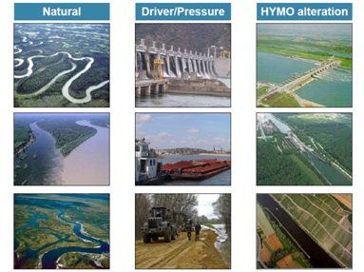

Source: Raimund Mair, ICPDR

Hydromorphological alterations are changes to the natural flow regime and structure of surface waters such as modification of bank structures, sediment/habitat composition, discharge regime, gradient and slope. The consequence of these pressures can impact aquatic ecological fauna and flora and can hence significantly impact the water status. Hydromorphological pressures comprise all physical alterations of water bodies modifying their shores, riparian and littoral zones, water level and flow.

## WFD and hydromorphological pressures

To maintain and improve the essential functions of our water ecosystems, we need to manage them well. This can only succeed if we adopt the integrated approach introduced in the WFD and other water policies. Many European water bodies are at risk of failing to meet the aim of the WFD of achieving good status by 2015 due to problems in the management of water quantity, modifications of the structure of river banks and beds and the connectivity of rivers, or unsustainable flood protection measures. Full implementation of the WFD throughout all sectors is needed to resolve these potential conflicts and to commit all users in a river basin to focus on the achievement of healthy water bodies with good status.

The WFD defines “good ecological and chemical status” in terms of low levels of chemical pollution as well as a healthy ecosystem defined as at least good ecological status. Classification of ecological status is based upon the biological elements (composition and abundance of aquatic flora; composition and abundance of benthic invertebrate fauna; composition, abundance and age structure of

fish fauna) plus hydromorphological, physico-chemical quality elements and non-priority pollutants.

The ecological status classification scheme includes five status classes: high, good, moderate, poor and bad. ‘High status’ is defined as the biological, chemical and morphological conditions associated with no or very low human pressure. This is also called the ‘reference condition’ as it is the best status achievable - the benchmark. These reference conditions are type-specific, so they are different for different types of rivers, lakes or coastal waters in order to take into account the broad variation of ecological conditions in Europe.

The Directive requires that the overall ecological status of a water body be determined by the results for the biological or physicochemical quality element with the worst class determined by any of the biological quality elements. This is called the “one out - all out” principle. The rationale of this principle is to avoid averaging the impacts on different quality elements due to different pressures and therefore overlook some significant pressures, and also to provide sufficient protection of the most sensitive quality element to a significant pressure.

*Hydromorphological quality elements*

The ecological classification system required under the WFD describes hydromorphological elements as 'supporting the biological elements' (Figure 2.2). This means assessing pressures and impacts on:

* hydrological regime (quantity and dynamics of flow, connection to groundwater);
* continuity (ability of sediment and migratory species to pass freely up and down rivers and laterally with the floodplain);
* morphology (i.e. physical habitat – compositions of substrate, width/depth variation, structure of bed, banks and riparian zone).

**Figure 2.2: Hydromorphological elements**

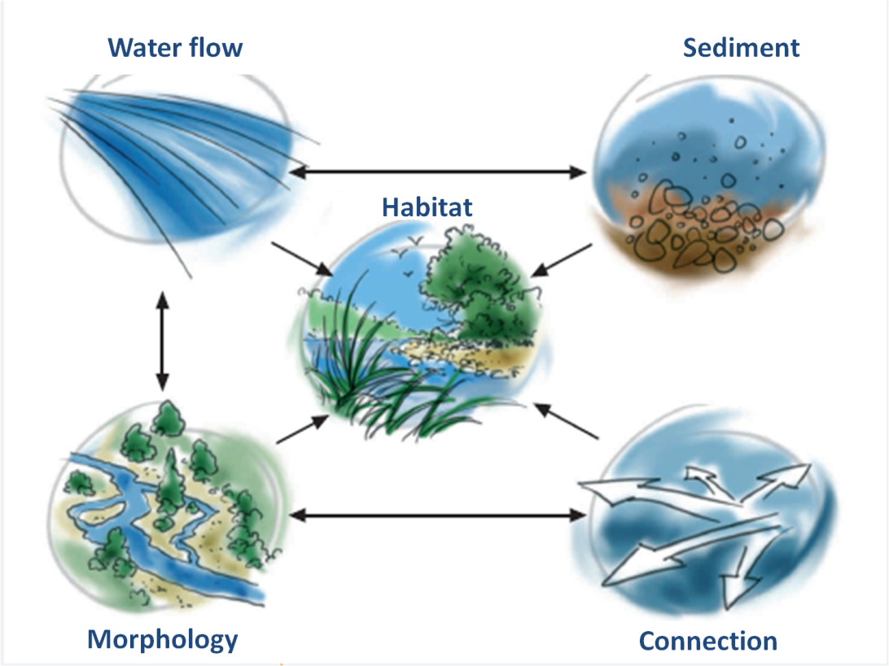

Source: France Hydromorphology <http://www.documentation.eaufrance.fr/entrepotsOAI/AERMC/R156/66.pdf>

For high status to be achieved, the WFD requires that there are no more than very minor human alterations to the hydromorphological quality elements. At good, moderate, poor and bad status, the required values for the hydromorphological quality elements must be such as to support the required biological quality element values for the relevant class. Each of the four surface water categories is ascribed specific hydromorphological quality elements (Table 2.1).

Table 2.1: Hydromorphological quality elements to be used for the assessment of ecological status or potential based on the list in WFD Annex V. 1.1.

|  |  |
| --- | --- |
| **Morphological conditions** | |
| Rivers   * river depth and width variation * structure and substrate of the river bed * structure of the riparian zone   Lakes   * lake depth variation * quantity, structure and substrate of the lake bed * structure of the lake shore | Transitional waters   * depth variation * quantity, structure and substrate of the bed * structure of the intertidal zone   Coastal waters   * depth variation * structure and substrate of the coastal bed * structure of the intertidal zone |
| **River continuity**   * availability of of sediment and migratory species to pass freely up and down rivers and laterally with the floodplain | |
| **Hydrological regime** | |
| Rivers   * quantify and dynamics of water flow * connection to ground water bodies   Lakes   * quantify and dynamics of water flow * residence time * connection to the groundwater body | Transitional waters   * freshwater flow * wave exposure   Coastal waters   * direction of dominant currents * wave exposure |

## Drivers and activities

There are many human activities considered as *driving forces* (such as agriculture, urbanisation, hydropower using reservoirs, navigation, flood protection and defence, mineral extraction, fishing, tourism, etc.) that result in *phisical modifications or with other words hydromorphological pressures* (i.e. water storage, transfer and abstraction, cross-profile and longitudinal constructions - such as dams, weirs, locks, sluices, culverts, dykes, levees -, bank reinforcement, deepening and mineral extraction, channelisation and straightening of river bed, land drainage and sealing, etc.) and eventually *habitat alterations* (change in flow frequency, duration, seasonality, rate of change; river and habitat continuity interruption; change in sediment transport and erosion; change in lateral connectivity, loss of floodplains or intertidal area, disconnection of wetlands and oxbow lakes; change in river profile and estuaries and change in connection with groundwater (Figure 2.3).

*Agricultural activities* have - in many places - affected the hydromorphological status of European water bodies. Water storage and abstraction for irrigated agriculture have, in particular in Southern Europe changed, the hydrological flow regime of many river basins. In the Northern of Europe, many landscapes have been ditched and lakes drained for agriculture. Besides "losing" a number of shallow lakes/wetlands, ditching for agriculture and forestry has strongly affected our aquatic systems (brownification of surface waters in recent years is a good example). Intensification of agriculture included many land reclamation projects affecting transitional and coastal waters and affected many rivers that were straightened, deepened and widened to facilitate land drainage and to prevent local flooding. However, it has to be mentioned that land reclamation took place not only for agriculture, but it was in some areas a prerequisite to allow agricultural land use (in some areas near the coast it is still quite extensive, e.g. sheep pastures). The straightening, deepening and widening of rivers is as well not only connected to agricultural land use – for sure agriculture has benefited from it by increasing the surface of agricultural land and in particular arable land in those areas – but it took place also, in some areas mainly for navigation / inland water ways and for flood defense (at least nearby the area where it took place). Intensification of agriculture is a result of a number of factors, one of them being the fact that hydrological modifications (including the pumping of water, underground drainage) happened.

Figure 2.3: Conceptual overview of the relation between drivers, hydromorphological pressures and habitat and flow alterations.

**Dri**

**vi**

**ng forces**

**Agriculture**

**Urban**

**Hydropower**

**Navigation**

**Flood**

**protection and**

**defence**

**Mineral**

**extraction**

**Fishing**

**Physical modifications**

Pressures and

a

ctivities

Water stor

age

, transfers

and

abstraction

Cross

-

profile constructions

(

d

ams, weirs,

locks/

sluices,

culverts

,

impoundments)

Longitudin

al pr

ofile con

struction

(dykes and

levees

)

B

ank reinforcement

and

embankments

Deepening and

mineral

extraction (channel

maintenance

,

dredging)

Channelisation and

straightening

Land drainage and sealing

**Habitat alteration**

Impacts on hydromorphology

Change in fl

ow (

+/

-

)

,

frequency,

duration, seasonality, and

rate of change

R

iver

and habitat continuity

interruption

Change

in sediment

transport

and

erosion

Change in lateral connectivity

loss of floodplain

s or intertidal

area

,

disconnection of wetlands

and oxbow lakes

Change in river profile

and

estuaries (length and transverse

profile)

Change in connection with

groundwater

*Urban development and water storage in reservoirs.* Reservoirs are human-made lakes created by the damming of rivers to serve one or more purposes, such as hydropower production, water supply for drinking, irrigation and flood protection. During the last two centuries there has been a marked increase in both size and number of large storage capacity reservoirs, especially with the development of hydropower and large basin management. There are currently about 7000 large dams in Europe. In addition, there are thousands of smaller dams. In 2008 hydropower provided 16 % of electricity in Europe and hydropower currently provides more than 70 % of all renewable electricity.

*Inland waterway transport and navigation* plays an important role in the movement of goods in Europe. Many thousands of kilometers of waterways connect hundreds of cities and industrial regions.

*Flood defence works* may cause significant pressures on hydromorphology. Today many sections of the major rivers have dykes. The building of dykes resulted in the loss of floodplains as retention spaces for flood water.

In many cases, *minerals are extracted* from surface water. Sand used to reinforce the coast is extracted from other sea areas, while clay and sand used for concrete and building are usually extracted from the flood plains of rivers. Gravel mining have occurred in several European river basins e.g. in north-eastern Italy, and some rivers of the Carpathians, resulting in widespread channel adjustments in the last 100 years, in particular incision and narrowing (Rinaldi et al. 2005; Surian, 2006; Surian et al., 2008).

Hydromorphological pressures, often connected with *construction, marine transportation and tourism*, and alter coastal zone, causing considerable changes in physical features of the coast including sediment transport and erosion.

## Hydromorphological pressures and habitat alterations

Hydromorphological pressures comprise all physical alterations / modifications of water bodies modifying their shores, riparian/littoral zones, water level and flow, (except water abstraction). Examples of such pressures are damming, embankment, channelization, non-natural water level fluctuations. The extent of hydromorphological alterations in European river basins has been significant over the past centuries. Hydromorphological pressures are the consequence of human activities (drivers) in the catchment area including hydropower production, flood defence structures, navigation, agriculture, land drainage, urban development and fisheries. Hydromorphological changes may result from more than one activity (e.g. a multi-purpose dam for hydropower generation, water supply and flood protection).

*Hydrological alterations* refer to pressures resulting from water abstraction and water storage affecting the flow regime such as change in seasonal flow, daily flow (hydropeaking) and water level fluctuations. In addition, river stretches may dry up and water levels of lakes and reservoirs may be heavily regulated. The flow regime of a water body may be significantly altered downstream of an impoundment or an abstraction. Alterations to the flow regime degrade aquatic ecosystems through modification of physical habitat and of erosion and sediment supply rates.

*Morphology* is the physical structure of a river, lake, estuary or coast including, for example, the banks and bed of a river and the shore of lakes or coastal waters. Engineering or the way the land is managed can change the morphology of these waters. This has a direct impact on animals and plants and can lead to increased flooding or erosion.

*Land reclamation, shoreline reinforcement or physical barriers* (such as flood defences, barrages and sluices) can affect all categories of surface waters. Weirs, dams and barrages can alter water and sediment movements, and may impede the passage of migratory fish. Using water for transport and recreation often requires physical alteration to habitats and affects the flow of water. Activities such as maintenance and aggregate dredging and commercial fishing using towed bottom-fishing gear can also damage physical habitats.

Typical *hydromorphological pressures* that arise in response to the uses (drivers) are the need for impoundment, channel modification, navigation structures etc., and result in specific engineering works such as dams, locks and embankments which change the characteristics of the natural flow regime and the shape of the river channel such as water depth, width, alignment, flow velocity and sediment transport. Examples of relationship between activities and hydromorphological pressures are

* Structures such as dams, weirs and sluices interrupt the longitudinal continuity of rivers.
* The use of water resources e.g. for energy production or abstraction for human uses can impact both the hydrology (e.g. reduced residual water, change in seasonality and hydropeaking) and morphology of rivers (e.g. longitudinal continuum interruption, reduced flow velocities, etc.).
* The disconnection of riverine floodplains and disturbance of the natural lateral connectivity of river systems can frequently result in a decrease of status.
* Navigation activities and navigation infrastructure such as cross profile constructions and impoundments; canalisation; straightening; bank reinforcement and deepening are typically associated with a range of hydro-morphological changes with potential adverse ecological consequences.
* Further, the morphology of rivers has been impacted by the channelisation of river stretches for human uses, erosion of the river bottom as a consequence of reduced sediment transport (due do dams) or dredging for navigation.
* Constructions performed as flood protection measures (lateral dykes, weirs, etc.) also impact the morphology of riverine systems.

These alterations can lead to a water body to be designated as a heavily modified water body (HMWB) if the water body shows substantial changes in character which are extensive/ widespread or profound, and the modifications neither temporary or intermittent and in general alter both hydrological and morphological characteristics.

#### *Impacts of hydromorphological pressures*

The physical modification of water bodies can affect the hydrology of freshwater systems, obstruct up and downstream migration, disconnect rivers from floodplains and wetlands, and change the water flow. The key components of hydro-morphological pressure are (Figure 2.2):

* change in hydrological regime;
* interruption of river and habitat continuity and disconnection of adjacent wetlands/floodplains; and
* change in erosion and sediment transport.

All these can have various ecological impacts including change and loss of habitat diversity, disruption of species migration and introduction of exotic species. Although the effects may not always be seen locally, they nearly always extend downstream and may also affect upstream reaches and the surrounding areas.

Hydromorphological alteration causes numerous, steeply studied, impacts in coastal zone. The general impact of hydromorphological alteration is reduction of complexity, dynamism and biodiversity (Elosegi et al., 2010 in Laukkonen, 2011). Alteration of coastal habitats causes physical changes that impact the biological diversity (Orlando-Bonaca et al., 2011:7 in Laukkonen, 2011). Coastal habitats have been altered in many ways; forms of hydromorphological alteration as dredging, land reclamation and reshaping to artificial substrate are activities that have weakened living conditions for natural habitats (Crain et al., 2009:40 in Laukkonen, 2011). There is evidence, that artificial structures and hydromorphological-alteration would develop new habitats for invasive species, while some of the original species disappear. As a result, no dramatic changes occur in biodiversity, but significant changes in composition of species are evident (Laukkonen, 2011).

## European overview of hydromorphological pressures

The extent of hydromorphological alterations in European river basins has been significant over the past centuries. Hydromorphological pressures and altered habitats are the most commonly occurring pressure and impact in rivers, lakes and transitional water; affecting half of river and transitional water bodies and third of the lake water bodies.

### Methodology issues

In RBMPs hydromorphological pressures on surface water bodies were categorized by the Member States into main pressure groups,

* Water abstraction: modifying significantly the flow regime of the water body
* Water flow regulations and morphological alterations
* River management
* Transitional and coastal water management
* Other morphological alterations, and
* Other pressures (including land drainage – in transitional and coastal water bodies other pressures were not included into hydromorphological analysis).

In each of the pressure groups Member States had the possibility to report different hydromorphological pressures such as barriers in rivers or dredging of sediment. However, many Member States (e.g. Austria, Germany, The Netherlands, and United Kingdom) did not report details on pressures and only reported that a water body was affected by the a pressure group. In addition, Member States did not report in the same pressure groups.

In the following are presented

* Results for water bodies being affected by at least one of the above pressures groups are presented as percentage of water bodies affected by hydromophological pressures and having classified ecological status or potential. (i.e. for each water body is checked if it is affected by pressures in one of the above pressure groups – these water bodies are identified as being affected by hydromorphological pressures). A water body may be affected by more than one hydromophological pressure.
* Results on water bodies affected by pressures in one of the above pressure groups are presented. Due to different reporting by Member States these results are presented as percentage of the sum of water bodies from Member States reporting the particular pressure group.
* To support the assessment are presented results of percentage of water bodies having altered habitats identified as an impact.

### Key messages

* Hydromorphological pressures and altered habitats are the most commonly occurring pressure and impact in rivers, lakes and transitional waters.
* Hydromorphological pressures affect more than half of classified transitional water bodies and arond half of river water bodies, while this level for lake and coastal water bodies only one third and one fourth, respectively.
* These pressures and impacts are less important in natural water bodies.
* Coastal waters generally have the lowest level of hydromorphological pressures and impacts.

### European results

*Hydromorphological pressures* are reported for a large proportions of water bodies in all water categories varying from 8.8% (coastal) to 54.2% (transitional) (Figure 2.4). The proportions of water bodies exposed to hydromorphological pressures are higher as those having altered habitats. In *rivers* these pressures are reported for more than half of all classified water bodies, while altered habitats impact was observed at about one fourth of river water bodies.

Figure 2.4: Percentage of classified water bodies being affected by hydromorphological pressures or having altered habitats.

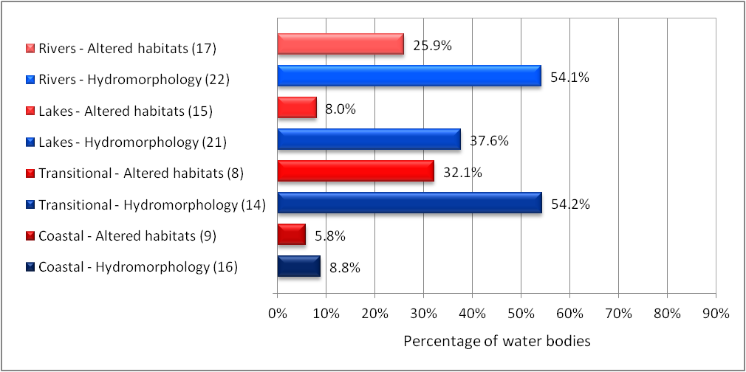

Note: The persenatge is calculated against total number of classified surface water bodies in Member States reporting hydromorphological pressures or altered habitats. Number of Member States reporting hydromorphological pressures or altered habitats is listed in parenthesis.

Source: WISE-WFD database May 2012; wfd.atkins.dk/report/WFD\_aggregation\_reports/SWB\_pressure\_status.

PKR: Error in the calculation of HYMO pressures and habitat alteration

In case of classified *lake* water bodies these ratios are lower, a bit more than one third of them have hypromorphology pressures and only 8.0% of classified LWBs has altered habitats impact. The hydromorphologicaly most affected classified water bodies are transitional waters (54.2%) and 32.1% are having altered habitats.

**Text Box 2.1: State, pressures and impacts in Swiss rivers**

|  |
| --- |
| Swiss rivers have been straightened, corrected and culverted for centuries, in order to protect settlements and agriculture from floods or to serve for transport or energy production. 22% (14,000 km) of the 65 000 km long Swiss water network has undergone severe human induced transformations: close to 4,000 km were culverted, another 10,000 km were altered by construction work and the installation of some 100,000 artificial obstacles. The actual hydromorphological status of the Swiss watercourses varies depending on parameters such as biogeographic region, elevation and land use. While 36 % of the rivers in the Swiss Jura and 38 % of the rivers in the Mitteland exhibit a poor hydromorphological status, this percentage is only 15 % in the Swiss Alps. Also, the number of water stretches of poor hydromorphological status decreases with increasing altitude. In total, 46% of the total river length in Switzerland can be considered to be affected by hydromorphological pressures. No corresponding national overview on lakes exists. It was estimated that as a result of these structural interventions 10,800 km of watercourses are in need of remediation (FOEN 2009). |

Hydromorphological pressures are significant in the *transitional water bodies*, being the second most important pressure (after point sources) affecting 54.2 % out of classified transitional water bodies reported by 14 Member States. Some 32.1 % of the transitional water bodies have altered habitats as an impact.

Hydromorphological pressures are less important in the *coastal water bodies* of the regional seas around Europe. Some 8.8% out of 1415 coastal water bodies reported by 16 Member States are impacted due to hydromorphological pressures and only 5.8% of the coastal water bodies have altered habitats as an impact.

The hydromorphological pressures in rivers and lakes are reported to be most severe in RBDs in the Netherlands, Germany, Poland, Hungary and south-east England, and less severe in RBDs in Finland, the Baltic countries, as well as in many RBDs in Spain, Italy, Greece, Bulgaria and Cyprus (Map 2.1).

In coastal and transitional waters the hydromorphological pressure is mainly a problem at the Estonian and German Baltic coast; along the Greater North Sea coast of Germany, the Netherlands and Belgium, as well as in the northern/Basque coast of Spain and southern coast of Italy (Map 2.1).

The highest share of transitional water bodies with hydromophological pressures has the Greater North Sea and the Mediterranean Sea regions (both 44%). The Celtic Seas, Bay of Biscay and the Iberian Coast region has 40% % of such water bodies, which is slightly below the EU average (41%). No hydromophological pressures were reported in the Baltic Sea and Black Sea regions.

The Greater North Sea and the Mediterranean Sea regions have almost 20 % of coastal water bodies under hydromorphological pressures (19 % and 17 %, respectively). The Celtic Seas, Bay of Biscay and the Iberian Coast region has 12 % of such water bodies, the same as the EU average. The Baltic Sea region has 8 % of such water bodies. No hydromorphological pressures were reported in the Black Sea region.

Map 2.1 Proportion of classified water bodies in different River Basin Districts affected by hydromorphological pressures for rivers and lakes (left panel) and for coastal and transitional waters (right panel) (percentage, based on number of classified water bodies).

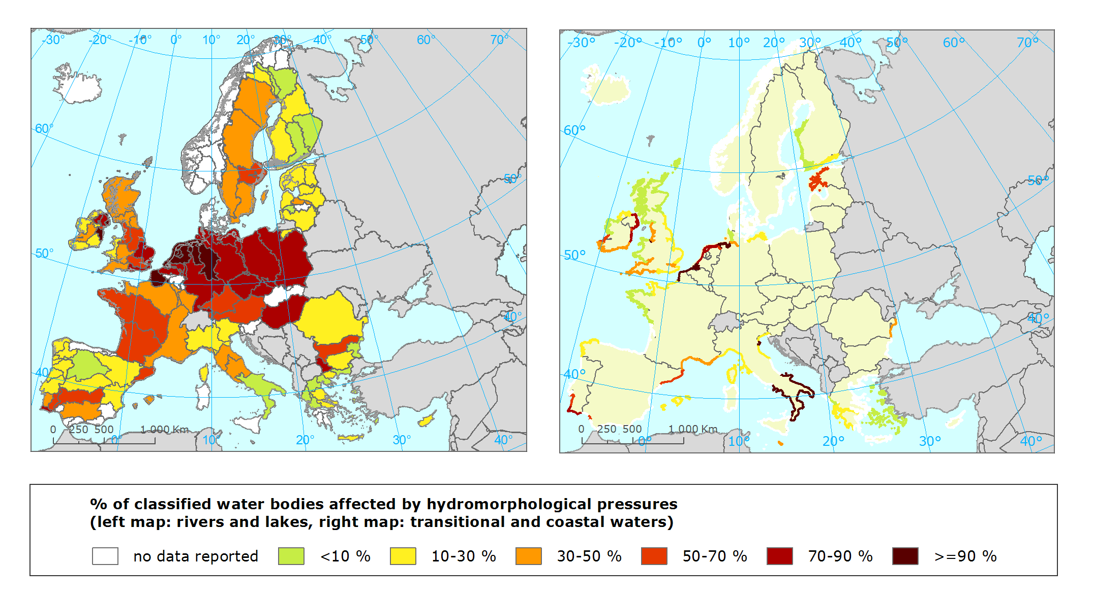

Note: A water body is defined as affected by hydromorphological pressures if it is reported with any of the aggregated pressure types “Water abstraction”, “Water flow regulations and morphological alterations of surface water“, “River management“, “Transitional and coastal water management“ and “Other morphological alterations“ and/or any of the corresponding disaggregated pressure types. Source: WISE-WFD database May 2012; <http://wfd.atkins.dk/report/WFD_aggregation_reports/SWB_pressure_status>

### Hydromorphological pressure groups

About 30 % of the *river water bodies* are affected by water flow regulation and morphological alteration (Figure 2.5). This pressure group includes impacts from storage of water in reservoirs, but also change in hydrological regime and impacts by weirs and locks. Member States has also reported impact of barriers under the other morphological alteration group affecting only 1.2 % of classified river water bodies.

The second most important pressure group is river management being a pressure affecting 15 % of river water bodies. The pressure group river management includes water bodies physical alteration of the river channel including effects of dredging, land drainage and barriers due to bridges, culverts etc.

Only seven percent of the classified river water bodies are affected by water abstraction.

Figure 2.5 Percentage of classified surface water bodies per water category being affected by hydromorphological pressures in main pressure groups

|  |  |
| --- | --- |
| Rivers | Lakes |
| Transitional waters | Coastal waters |

Source: WISE-WFD database early May 2012; <http://wfd.atkins.dk/report/WFD_aggregation_reports/SWB_pressure_status>

PKR: Error in the calculation of HYMO pressures

**Text Box 2.2 Examples of European rivers (Danube, Rhône, Shannon) and estuaries (Ireland) heavily impacted by hydromorphological pressures**

|  |
| --- |
| **Danube**  Source: ICPDR, 2010 and Umweltbundesamt, 2010  Like many other European rivers, the Danube and Rhine are heavily influenced by human activities including intensive navigation and habitat modification by hydraulic engineering. The natural structure on many stretches of the rivers has been changed, including their depth and width, flow regimes, natural sediment transport and fish migration routes.  Dams and reservoirs have been built in nearly all mountainous areas and some lowland regions of the Danube Basin and navigation channels, dykes and irrigation networks are widespread in the lowlands along the middle and lower reaches of the river.   * more than 80 % of the Danube is regulated for flood protection, and about 30 % of its length is impounded for hydropower generation; * about half of the Danube tributaries are used to generate hydropower. The generation capacity of all the hydropower plants in the Danube Basin is almost 30 000 MW; * more than 700 dams and weirs have been built along the main tributaries of the Danube.   **The Rhône River**,  Source: Souchon 2007  Over the last 400 years the Rhône was developed in successive phases for different purposes, levees have been built as flood defences; and groynes and ripraps were constructed to create a more navigable river. The basin has 19 hydroelectric schemes accounting for 20-25% of the French hydroelectric production. Water abstraction for irrigated agriculture has added to the many river uses. Canals straighten and shorten the watercourse to facilitate navigation, thus by-passing the old river channel. Today the flow regime of the Rhone is regulated by several large storage reservoirs that can hold more than 7 % of the annual runoff. Nearly 80% of this storage capacity is located downstream of Geneva.  The Rhône corridor is a densely populated and industrialized area. The morphology of the river channel has changed from braided to straight and canalized, often eroded and incised; the level of the ground water has been lowered; several natural biotopes disappeared; the riparian forest evolved to hardwood forest due to ground water depletion; and dams block the migration of fish (shads, eel, lampreys), where numerous lateral communications with tributaries or side channels have been modified, sometimes cut off. Shannon RBD Source: Shannon RBMP  Many of the surface water in the Shannon RBDs have physically been modified for water supply, recreation, transport, flood protection, hydropower, aquaculture and land drainage. There are in the RBD around 95 000 culverts and bridges on our rivers, almost 900 kilometres of river embankments, 19 large water reservoir or hydropower dams, 10 large ports and over 200 kilometres of coastal defences. |

For *lakes* water flow regulation and morphological alteration and water abstruction were the two most important pressures affecting 24.9 % and 8 % of the lake water bodies. Only few lake water bodies was affected by other morphological pressures (2.3 %).

Seven Member States (Portugal, France, Ireland, Spain, the UK, Belgium and Italy) have identified *transitional water* bodies being affected by water abstraction in the river basin district; accounting for 11 % of the transitional water bodies in these Member States. High water abstraction or water storage in the river basin district may markedly reduce the freshwater inflow, in particular in summer, and the dilution of pollutant discharges.

For transitional and coastal waters 7 to 10 Member States reported water bodies affected by water flow regulation, morphological alteration and transitional and coastal management. These pressure groups affected 15.8% of the transitional water bodies and less than 3 % of the coastal water bodies. Transitional and coastal management includes pressures related to land reclamation and dredging.

### Country results

Countries with high proportion of river and lake water bodies being affected by hydromorphological pressures are found in Central Europe towards North Sea as well as Baltic Sea. Figure 2.6 shows the percentage of classified water bodies per water category (river, lake, transitional and coastal) being affected by hydromorphological pressures or having altered habitats as an impact.

In Figure 2.6 the Member States are ranked by the percentage of water bodies achieving at least good ecological status or potential, while for coastal and transitional waters the ranking are for sea regions. Estonia has, for example, the highest proportion of river water bodies with good ecological status or potential, while Belgium (Flanders) has the worst status. Both for rivers and lakes there are good agreement between the ranking by proportion of water bodies with good status and the proportion of water bodies affected by hydromorphological pressures and altered habitats. Member States with high proportion of good ecological status also generally have lower proportion of water bodies being affected by hydromorphological pressures or altered habitats.

Figure 2.6 Percentage of classified surface water bodies affected by hydromorphological pressures and having altered habitats in different Member States (rivers and lakes) and by sea regions and Member States bordering the sea regions (transitional and coastal waters)

|  |  |
| --- | --- |
| Rivers | Lakes |
|  |  |
| Transitional waters | Coastal waters |
|  |  |

Source: WISE-WFD database early May 2012;

<http://wfd.atkins.dk/report/WFD_aggregation_reports/SWB_pressure_status> & <http://wfd.atkins.dk/report/WFD_aggregation_reports/SWB_impact_status>

Half of the Member States which delivered data had more than 40 % of their *river water bodies* being affected by hydromorphological pressures and six countries Poland; Germany; Belgium Flanders; Poland, the Czech Republic and The Netherslands had more than 60 % of river water bodies being affected by hydromorphological pressures. Member States with a high proportion of water bodies impacted by hydromorphological pressures also had a high proportion of water bodies with altered habitats as impact.

Five Member States, Belgium Flanders, The Netherlands, Czech Republic, United Kingdom and Hungary had more half of the *lake water bodies* being affected by hydromorphological pressures and altered habitats being an impact. This partly reflects the high number of reservoirs in these countries, exept of Hungary, where mine lakes and fishponds give the high number of water bodies affected by hydromorphological pressures. Most other Member States report around 20-30 % of the lake water bodies affected by hydromorphological pressures.

Of the few *transitional waters* in the Baltic Sea no water bodies were reported having hydromorphological pressures or altered habitats (Figure 2.6). All the transitional water bodies in Germany, The Netherlands and Belgium at the Greater North Sea coast have hydromorphological pressures; while around 40 % of the UK and French transitional water bodies at the Greater North Sea have hydromorphological pressures.

In the Mediterranean and Celtic Sea and Iberian coast the Member States reporting pressures and impacts at transitional waters identified that around 40 % of these water bodies are affected by hydromorphological pressures and altered habitats.

Most countries reported less than 20 % of the *coastal water bodies* being affected by hydromorphological pressures and having altered habitats. In the Netherlands, German North Sea coast, Estonia, Romania, Portugal, Malta and Italy more than a third of the coastal water bodies have hydromorphological pressures or altered habitats.

**Text Box 2.3: Significant hydromorphological issues in the Scotland RBD**

|  |  |  |  |  |  |  |  |  |  |  |  |  |  |  |  |  |  |  |  |  |  |  |  |  |  |  |  |  |  |  |  |  |  |  |  |  |  |  |  |  |  |  |  |  |  |  |  |  |  |  |  |
| --- | --- | --- | --- | --- | --- | --- | --- | --- | --- | --- | --- | --- | --- | --- | --- | --- | --- | --- | --- | --- | --- | --- | --- | --- | --- | --- | --- | --- | --- | --- | --- | --- | --- | --- | --- | --- | --- | --- | --- | --- | --- | --- | --- | --- | --- | --- | --- | --- | --- | --- | --- |
| The Scottish RBMP identified just under 14 % of surface water bodies as heavily modified water bodies and being substantially changed in character for purposes such as flood protection, hydropower generation, navigation, land drainage or water storage for drinking water supply. Another 1% of surface water bodies are artificial.  Different hydromophological pressures such as: alterations to water flows and levels; modification of beds, banks and shores, and barriers to river continuity for fish migration affected 18 %; 16 % and 14 % of the surface water bodies, respectively. In the Scottish RBD five types of morphological impacts have been identified as significant water management issues. Table 2.2 provides the lengths/areas of water bodies affected by each issue. The number of water bodies is given in brackets.  **Table 2.2: Significant morphology issues in the Scotland River Basin District**   |  |  |  |  |  |  | | --- | --- | --- | --- | --- | --- | | **Pressure type** | **Key sector** | **Rivers** | **Lochs** | **Transitional** | **Coastal** | | Morphology | Historical engineering | 2 182 km  (185) | 49 km2  (17) | 123 km2  (7) | 404 km2  (5) | | Urban development | 644 km  (60) | - | 0.2 km2  (1) | - | | Agriculture | 1 851 km  (162) | 1 km2  (1) | - | - | | Electricity generation | 904 km  (86) | 298 km2  (53) | - | - | | Land claim | - | - | 204 km2  (12) | 229 km2  (5) |   Many of Scotland’s freshwaters display a history of engineering interventions. Examples include:   * diverting and canalising rivers to utilise floodplains; * culverting to improve drainage or enable development; * building embankments to prevent flooding; * bridging waterways for transportation.  Table 2.3 below lists the principal pressures that are adversely affecting water flows and levels in Scottish rivers and lochs. Not any significant significant impacts were identified on water flows in estuary and coastal water bodies. There are two main types of pressure on water flows and levels; impoundment of rivers by damming to create a water storage reservoir; and direct abstraction without impoundment.The main activities for which reservoirs have been created are drinking water supply and hydropower generation. Water flows and levels in the reservoirs and in the rivers immediately downstream of the reservoir dams are altered by the impoundment of the water in the reservoir and its subsequent abstraction. Reservoirs used for hydropower generation are concentrated in the uplands of the central and northern parts of the Scotland RBD. Those for drinking water supply are typically found nearer to the larger towns and cities towards the south of the Scotland RBD.The main direct abstractions without impoundment are for irrigating crops or providing drinking water. The impacts of these activities are concentrated along the east and north-east coasts. Direct abstractions are also used for drinks production and fish farming. **Table 2.3: Principal pressures on water flows and levels in surface water bodies in the Scotland RBD in 2008**   |  |  |  |  | | --- | --- | --- | --- | | **Pressures** | **Principal activities** | **Water bodies in which pressure is preventing the achivement of good ecological status [including those designated as heavily modified] (%)** | | | **Proportion of all rivers** | **Proportion of all lochs** | | Abstraction,  including abstraction and regulation of river flows at dams | All activities | 21 | 25 | | Drinking water supply | 3 | 9 | | Hydropower generation | 9 | 14 | | Agricultural irrigation | 4 | 0 |   Source: Scotland RBMP |

## Barriers – transversal structures

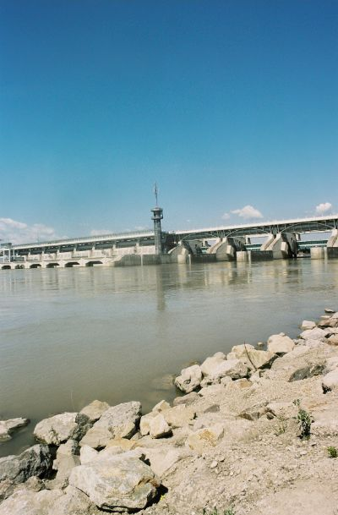A river that has been left in its natural state is generally freely passable to migrating aquatic organisms in an upstream and downstream direction. Structures such as dams, weirs, barrages and other in-stream structures alter the natural hydromorphological form of a channel, with impoundment of water and reduced velocity profile on the upstream side and may act as a sediment trap. Since dams interrupt the natural continuity of rivers and reservoirs and change the hydrological cycle, their ecological consequences can be manifold. For example, access to spawning sites for migratory fish may be prevented. This is a particular problem for fish such as salmon, trout, eel and sturgeon, but also invertebrate species may be affected. However, even small dams cause problems, as they are impassable to most species of fish (Figure 2.7). Bypass rivers, fish ladders or fish passes at such structures may maintain or improve the continuity. Dams and weirs have an effect on the natural transport of sediment, resulting in its retention upstream of dams and loss downstream, so that material may have to be imported to stabilise the river bed and prevent incision.

Figure 2.7: Examples of barriers and transverse structures in European rivers.

|  |  |
| --- | --- |
| [www](http://www.lebensministerium.at/fotoservice/fotoservice/fotodetail.html?galleryPath=/wasser/flieszgewaesser_seen/holzbruecke_ueber_einen_flusz) © Photo: BMLFUW | [www](http://www.lebensministerium.at/fotoservice/fotoservice/fotodetail.html?galleryPath=/wasser/wassernutzung/wasserkrafwerk_kematen_links_vertical_slot) © Photo: BMLFUW/Rita Newman |
| [www](http://www.lebensministerium.at/fotoservice/fotoservice/fotodetail.html?galleryPath=/wasser/wassernutzung/einlaufwehr_fuer_das_kraftwerk) © Photo: BMLFUW/Rita Newman |  |

### European overview

There are several hundred thousands of barriers and transverse structures in European rivers. Some of them are large dams for hydropower production or irrigation storage reservoirs, but the majority are smaller. WFD required river basin management plans report on hydromorphological pressures on water bodies. Five groups of hydromorphological pressure on surface waters (rivers and lakes) were included in the WISE-WFD database, namely (1) Water abstractions; (2) Water flow regulations and morphological alterations of surface water; (3) River management; (4) Other morphological alterations; (5) Other pressures. Member States have reported hydromorphological pressures differently. Some Member States have provided pressure data for the main pressure group only, while some have reported pressures only for the subgroups or for both. Consequently no comprehensive statistics can be gained on barriers from river basin management plans. However, information from selected countries and river basins could highlight the extend of pressures by barriers on surface waters.

*Examples of barries in river basins and countries*

During the last two centuries there has been a marked increase in both size and number of large dams and the storage capacity reservoirs, especially with the development of hydropower and irrigation reservoirs. There are currently about 7 000 large dams in Europe. In addition, there are thousands of smaller dams. Figure 2.8 illustrates the large number of barriers in the Thames RBS and the Seine-Normandy RBD. For both river basin districts large part of the river system is affected by barriers.

**Figure 2.8: Barrier on Thames RBD and Seine-Normady RBD**

|  |  |
| --- | --- |
| Thames Barriers | Seine-Normandy barriers |
|  |  |

1 688 barriers are located in the **large Danube RBD.**  600 of the 1 688 continuity interruptions are dams/weirs, 729 are ramps/sills and 359 are classed as other types of interruptions. 756 are currently indicated to be equipped with functional fish migration aids. Therefore, 932 continuity interruptions (55%) remain a hindrance for fish.

The **Dutch Rhine RBMP** identified over 9 000 dams, including over 700 in flowing waters and the Duthch Meuse RBMP identified more than 2 000 dams, half of them in flowing waters. The weirs and dams are needed for flood protection and for regulation water levels to different functions (such as urban, agriculture and nature). Only a small part is made passable for fish.

The **Loire-Bretagne RBMP** identifies over 10,000 infrastructures, which reduce longitudinal river continuity and have negative impacts on the ecological status.

There are over 2,500 weirs and impoundments, and 5,000 culverts on **Scottish rivers**.

There are currently thought to be some 200 000 transverse structures in **Germany**. In relation to the overall length of Germany’s network of watercourses of around 400,000 km, therefore, the continuity of the rivers is interrupted every second kilometre by a technical structure. The German Elbe RBD notes that 91% of river length is failing good ecological status (GES) due to hydromorphological pressures. 276 transversal structures out of 11.000, such as dams and weirs, are found to significantly disrupt fish migration in rivers that were identified as basin-wide priority for fish migration.

In **Czech Republic** around 6 000 barriers above 1 m height were identified and reported in Article 5 report. Out the total 2 153 barriers were in the Danube RBD; 2805 in the Elbe RBD and 1065 in the Odra RBD.

In the **Slovak RBMP** 779 barriers inpassable to fish have have been identified, only 84 of these have functional fish passes.

In **Belgium 779 barriers** have been identified on a 3000 km long priority network of rivers (Rivers in contact with the sea and those considered to have greatest value and strategic importance). In addition many barriers are found on other rivers.

In **Sweden** 3 875 out of 15 598 river water bodies (25 %) and 1372 of 7 252 lake water bodies (19 %) are affected by continuity interruptions. In Northern Baltic Sea RBD, for example, there are identified 945 dams, 2 825 other barriers and nearly 5 000 road crossings that may act as barriers.

Up to now, 14 000 km or 22 % of the **Swiss** surface water network have been altered appreciably through structural intervention, and 100 000 artificial obstacles with a height in excess of 0.5 m have been built.

Today lateral connectivity is highly limited in Swiss water courses, up to 101,000 artificial barriers reduce or hinder fish migration. Up to 50,000 of these barriers need to be reconstructed or refurbished. On average, one kilometer of river in Switzerland contains 1.6 artificial barriers (fall height > 50 cm), a strongly degraded section of 150 m and culverts of 70 m length. 41% of the assessed Swiss watercourses exhibit a strongly reduced natural sediment transport (FOEN 2007).

### Effects of barriers on rivers

* River fragmentation

In metropolitain France, more than 60,000 structures, dams, locks, weirs and mills, have been recorded on rivers. They are potential obstacles to river continuity causing fragmentation, change the natural morphology and hydrology of aquatic systems and have impacts on ecosystems. To improve knowledge about the the dams and weirs that fragment French rivers a Flow Obstructions Database (ROE- Référentiel des Obstacles à l'Ecoulement) has been established. This database ensures a good management and traceability of the data. The database lists all hydraulic structures that have already been identified troughout France. This inventory is published as an interactiv map, that shows the position of obstacles at a river or at an administrative scale.

Expansion of river fragmentation on Loire River, France is illustrated in the following two maps. Map on the left side shows river fragmentation by barriers for year 1700 while map on the right side shows

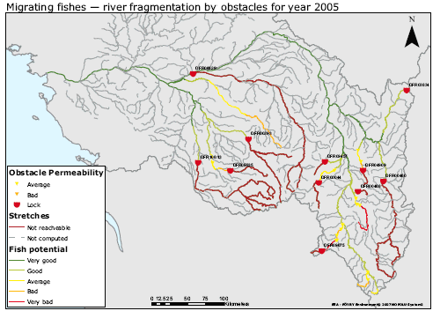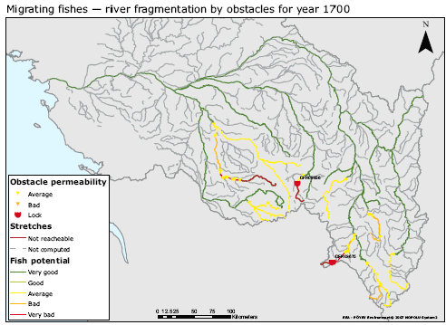the situation in 2005.

* Rediment retention in reservoires

Hydrological changes, interruptions to the river continuum and intervention into the watercourse structure all disrupt the sediment regime. Barriers, such as dams and weirs have an effect on the natural sediment transportation, resulting in the retention of sediment upstream of dams and the loss of sediment downstream of dams.

* Deepening river bed downstream

The river is only able to compensate for the deficit of sediments downstream by gathering material from the bottom, causing it to “dig into” the landscape more extensively along certain sections. As a result of such intervention, for example, the Rhine has become up to 7 m deeper, the Isar up to 8 m, and the Elbe up to 1.7 m deeper. This trend towards further deepening is continuing. It can be assumed that the majority of rivers in Germany exhibit an unnaturally high level of depth erosion.

* Change in suspended sediment budget

In the lower Danube the transport of suspended load currently reaches only 30% of the previous load before the construction of the Iron Gate dams ( Figure 2.9). In the Danube Delta Region, only 34% of the natural sediment load remains (18 instead of 53 million t/yr).

**Figure 2.9: Change in suspended sediment budget of River Danube**



(Source: WWF based on Ulrich Schwarz, 2007: Assessment of the balance and management of sediments of the Danube.)

The delta of the Ebro River is a site of high economic and environmental importance. Almost 50,000 people live on the delta, and several economic activities (fisheries, aquiculture, agriculture (rice farms) and tourism) are associated with the ecosystems of the delta. Existing dams in the Ebro River currently trap approximately 95% of the suspended sediment load as compared to measurements from the beginning of the 1900s. In the last forty years, low flows past the town of Tortosa, Spain, 40 km upstream of the mouth of the river, have decreased approximately 40 %. The decrease in river discharge at its mouth also leads to salt water intrusion within the river system and because the sedimentation rate has been reduced from 3-15 mm/year to 0.1-4 mm/year, the lack of accretion is leading to coastal retreat and land subsidence. A situation that may be aggrevated with increasing sea level rise due to climate change.

## Abstraction and flow regulation and water level regulation

The flow regime and water level fluctuations are one of the major determinants of ecosystem function and services in river and wetland ecosystems. Many European rivers have had their seasonal or daily flow regimes changed by various uses that have a significant impact on ecosystems. Many lakes and rivers have their water level regulated.

The water level regulation depends on the uses. With hydropower production water levels are normally high or rising during summer period, while during the winter period, when the need for electricity is normally at its highest, the water level is strongly lowered. However, this general picture could be different across EU. While northern countries have much higher electricity need in winter, this is the case for the summer period in the southern countries.

Rapidly varying flows can be generated in a hydropower facility (hydro peaking). This gives rise to conditions that are deleterious to watercourse hydromorphology and aquatic biota downstreams, thus jeopardizing the goal of achieving good ecological status or potential. Hence, such artificial discharge regimes should be avoided for ecological reasons. However, if artificial discharge regimes cannot be avoided entirely, the ecological status of the water bodies affected can still be improved through operational modifications (e.g. downstream “buffer” reservoirs) that attenuate the volume and frequency of artificially generated abrupt waves and avoid unduly precipitous water level fluctuations.

Variation in flows and water levels is also important in all surface waters to maintain their characteristic ecological diversity. In lakes serving as reservoirs, extreme variation in water levels between winter and summer can result in the lake margins becoming a hostile environment for water plants and animals and the creation of a scar zone of bare sediments. In rivers, higher flows provide a trigger for migratory fish like salmon to make their runs upstream and successfully navigate waterfalls and other obstacles to migration. They also move fine and larger sediments around as well as detritus and other food sources. This creates the diversity of shifting habitats on which different water plants and animals depend. An estuary without the ebb and flow of the tide or inputs of river flows will not provide the conditions necessary for a natural complement of estuarine plants and animals.

Flood prevention regulation follows a similar pattern during winter time than hydropower generation, but in summer time some storage capacity is left empty to catch flash floods. When the major objective of the regulation is recreation or navigation, then regulated water levels are often more stable than natural ones. If the water level is regulated for water supply use, the water level fluctuation is more irregular and depends on the specific use of raw water. In reservoirs used for storage of water for irrigation collection takes place during winter period and water is used during the vegetation period, in particular during late spring and early summer in order to provide sufficient water supply to crops.

Abstracted water is used for a diverse range of processes including public water supply, water for agricultural irrigation and livestock management, domestic supply for individual dwellings (Figure 2.10), cooling for power stations, water supply for industry as well as many other purposes.

Irrigation reservoirs generally store water during wet seasons and release it during dry seasons. Release of water from hydropower reservoirs depends on electricity demand. Flows downstream of hydropower plants may fluctuate daily when increased water volumes are channelled through turbines during periods of high electricity demand (Figure 2.10). The effects of changes in the seasonal flow regime below dams and reservoirs and reduction in flow caused by water abstraction and diversion, upon lotic and riparian ecosystems have been demonstrated for rivers in a range of geographical regions.

Figure 2.10: Reservoire used for water supply (Hasznos, Hungary - left) and dam on River Rába at Nick for irrigation water use and partly hydropower generation - right

|  |  |
| --- | --- |
|  | Description: D:\VITUKI\TÉMATÁR\1 ÉLŐ\724-65-8341 ETC ICM\15 Peter Kristensennel EEA 2012 jan 11-13\Zóka Bélától\Nick.JPG |

The main challenge in managing abstraction is to meet the reasonable needs of water users, while leaving enough water in the environment to conserve river, lake and wetland habitats and species.

Dry river stretches may appear downstream of some reservoir dams where whole streams are diverted into reservoirs or during periods of dry weather in summer, where abstractions can suck out the remaining river flow. More commonly, water abstraction during dry weather can reduce the wetted width of rivers. This loss of habitat can result in a loss of species and decreased abundance of others. It can also increase the vulnerability of water plants and animals to pollution and high summer temperatures.

In order to meet the criteria of good ecological status or potential, the minimum flow should at least leave water in the river (except in naturally dry falling rivers) and aim at maintaining and restoring the river’s type-specific aquatic community; promote the continuity of the original river bed, as well as the bypass at its termination; achieve nearly natural flow dynamics and groundwater status in floodplain; and maintain distinct water exchange zones. Instead of gathering statical data on minimum flow, the feasibility of implementing an ecological control mechanism for minimum dynamic flow should be ascertained. This mechanism should maintain a constant and inflow-driven minimum flow, or should at least be seasonally controlled and meet the aforementioned criteria. A river’s ecological status or potential can be ameliorated through the realization of measures that upgrade watercourse structures along original riverbeds in the light of site-specific characteristics, management goals, and minimum flow data, consideration should be given to site-specific characteristics.

### European overview of abstraction and rivers with regulated flow

WFD required river basin management plans report on hydromorphological pressures on water bodies. Five groups of hydromorphological pressure on surface waters (rivers and lakes) were considered included in the WISE-WFD database, namely (1) Water abstractions; (2) Water flow regulations and morphological alterations of surface water; (3) River management; (4) Other morphological alterations; (5) Other pressures. In the reporting system several subcategories of hydromorphological pressures were used. In case of *Water abstractions* subcategories include pressures from Agriculture, Public Water Supply, Manufacturing, Electricity cooling, Fish farms, Hydro-energy, Quarries, Navigation, Water transfer, and Other; while in case of *Water flow regulations* and morphological alterations of surface water include pressures from Groundwater recharge, Hydroelectric dam, Water supply reservoir, Flood defence dams, Water Flow Regulation, Diversions, Locks, and Weirs.

*Key messages*

* 6.8% of European river water bodies are affected by water abstraction pressures.
* The most water abstraction affected river basins are in Poland, Bulgaria, Spain and France exceeding 20% of their classified river water bodies.
* About 8% of the lake water bodies are affected by water abstraction pressures.
* Water flow regulation and morphological alterations as well as transitional and coastal management are the most significant hydromorphological pressure type on the EU transitional water bodies, followed by water abstraction.
* The predominant hydromorphological pressure type on EU coastal water bodies is coastal water management. Water flow regulation and morphological alterations are the second most important pressure types. Other pressures and water abstraction are less important pressures.

*Surface water bodies affected by direct water abstractions*

Almost all Member States reported that their river water bodies were affected by water abstraction, and only Cyprus, the Czech Republic and Latvian did not report any river water bodies affected by water abstraction. Overall, less than one tenth of European river water bodies are affected by water abstraction pressures. Countries with the highest percentage of water abstraction pressure on rivers are Poland, Bulgaria, Spain and France when only classified water bodies were taken into account (Figure 2.11).

**Text Box 2.4: Rivers being affected by high abstraction rates**

|  |
| --- |
| **Catalonia Case:** The abstraction of water for urban and agricultural use, the regulation of the rate of flow of rivers (in order to satisfy demand for water using reservoirs), and the proliferation of plantations of phreatophytic trees (with deep roots which reach down to the phreatic level) are all activities which reduce the quantity of available water and directly affect the quality of 8.9% of rivers and 58.8% of groundwater.  Those areas most affected by water extraction and river flow regulation are the basins of the Muga, the Ter, the Llobregat, the Cardener, the Noguera Ribagorçana, the Segre and the Ebro, with particular problems being experienced in the final sections of the Foix, the Gaià and the Riudecanyes stream, with practically non-existent flows as a result of reservoir regulation.  The groundwater systems most affected by extraction for irrigation, water supply or industrial uses include most of the aquifers close to the coast (but also inland areas, such as Carme-Capellades and the Moianès, the alluvial fan of Terrassa and the Tàrrega limestones), while the effect of phreatophytic tree plantations is particularly significant in the basins of the Tordera, the Onyar and the lower sections of the Ter.  Source: Catalonia Water Agency, 2010 |

Figure 2.11: Percentage of river (left panel) and lake (right panel) water bodies having water abstraction identified as a significant pressure, by countries

|  |  |
| --- | --- |
| Rivers | Lakes |
|  |  |

Note: Number of water bodies affected by water abstraction are given in parenthesis. Percentage of affected water bodies is calculated as percentage of water bodies with known ecological status/potential

Source: WISE-WFD database of early May 2012; wfd.atkins.dk/report/WFD\_aggregation\_reports/SWB\_pressure\_status

16 Member States reported that their classified *lake water bodies* being affected by water abstraction, however only 400 lake water bodies were identified as affected by water abstraction, which represent only 3% of the lake water bodies. This fact maybe read in a way that only few lakes are used as source for water supply for public water supply or irrigation or fish farming. The highest percentage of water abstraction affected lake water bodies are located in France, Poland, Italy and United Kingdom, while Austria, Cyprus, Czech Republic, Estonia, Greece, Lucenburg, Netherlands, Slovakia and Sweden there is no lake water body under water abstraction pressure (Figure 2.11).

Four Member States (UK, France, Spain and Italy) have identified *transitional water bodies* being affected by water abstraction in the river basin district; accounting for 12 % of the transitional water bodies in these Member States. High water abstraction or water storage in the river basin district may markedly reduce the freshwater inflow, in particular in summer, and the dilution of pollutant discharges.

*Water bodies affected by water flow regulation and morphological alteration*

Most Member States reported water bodies being affected by *water flow regulation and morphological alteration* pressures (Figure 2.12). More than 30 % of the classified *river water bodies* are affected by water flow regulation and morphological alteration. These pressures include impacts from storage of water in reservoirs, but also change in hydrological regime and impacts by weirs and locks.

Figure 2.12: Percentage of river and lake water bodies having water flow regulation and morphological alteration identified as a significant pressure, by countries

|  |  |
| --- | --- |
| Rivers | Lakes |
|  |  |

Note: Numbers of water bodies affected by water flow regulation and morphological alteration are given in parenthesis. Percentage of affected water bodies is calculated as percentage of water bodies with known ecological status/potential

Source: WISE-WFD database of early May 2012; wfd.atkins.dk/report/WFD\_aggregation\_reports/SWB\_pressure\_status

In central Europe generally more than half of the river water bodies have water flow regulation and morphological alteration as a significant pressure. In Germany, Poland and Belgium Flanders more than three quarters of the river water bodies have water flow regulation and morphological alteration as a significant pressure.

**Text Box 2.5: Change in flow regime**

|  |
| --- |
| The Ebro River and its tributaries (North-Eastern Spain) are regulated by over 187 dams, with a total capacity equivalent to 57% of the total mean annual runoff. Annual runoff did not show strong trends, but the variability of mean daily flows was reduced in most cases due to storing of winter floods and increased baseflows in summer for irrigation. Monthly flows ranged from virtually no change post-dam to complete inversion in seasonal pattern, the latter due to releases for irrigation in the summer, formerly the season of lowest flows.  Illustrative plots of mean monthly flows pre and post dam for Guadalope and Ebro (below Ebro Dam near headwaters)    Note: IR is the ratio of reservoir capacity to annual runoff; *Φ* is the correlation coefficient between pre and post dam monthly flows. |

For *lakes* pressures from water flow regulation and morphological alteration were affecting 27 % of the lake water bodies. In Member States, relative proportion of regulated lakes to the total number of lakes is the lowest in Finland (8 %) even though hundreds of lakes are regulated in Finland. The total amount of the lakes (>50 ha) in Finland is approximately 4500 and the number of regulated lakes and reservoirs is 350.

**Text Box 2.6: Finland – Regulated lakes and rivers**

|  |  |
| --- | --- |
| 1. The water levels and flows in many of Finland's inland waters are regulated with the help of dams, weirs or other structures connected to hydropower plants. Most of this water level regulation work was done between the 1950s and the 1970s in order to reduce flooding, to produce hydropower, to facilitate water transportation, and to improve the water supply. 2. Around 220 water level regulation projects have been carried out in Finland, affecting water levels in more than 300 lakes with a combined area of around 10,100 km2 - or about a third of all the country's surface water. There are also 22 artificial reservoirs in Finland, with a total area of 610 km2 (2% of Finland's surface water), while seven bays around the Finnish coast have been dammed to create freshwater reservoirs. 3. Almost all of Finland's major rivers have been harnessed to generate hydropower, with dams controlling their flow and water levels. There are a total of 250 hydropower plants in Finland, around 60 of which have a capacity of more than 10 MW. About 15 % of Finnish electricity is generated by hydropower.   Source: Finnish Environment Institute |  |

In Belgium Flanders, the Czech Republic, United Kingdom and the Netherlands more than half of the lake water bodies have water flow regulation and morphological alteration as a significant pressure. In Sweden 2150 lake water bodies have water flow regulation and morphological alteration as a significant pressure; accounting for 30 % of the Swedish lakes. There are 9 countries which did not report water flow regulation and morphological alteration as significant pressure on their lake water bodies.

## Morphological alterations

Morphological alteration pressures occurring on surface water bodies are connected dominantly with agriculture (irrigation and excess water drainage), flood protection related river regulation, hydropower generation, while in case of transitional and coastal water bodies alteration pressures are connected with urbanization, industry and navigation.

These anthropogenic activities cause major pressures being driven by trade and transportation, agricultural production, water supply and sewage, safety, food production and recreation. Concurrently, anthropogenic changes of hydromorphological factors like channelized streams, discinnected floodplains and rivers, land reclamation are also pressure to the ecological status of water bodies. In the transitional and coastal waters morphological conditions such as: depth variation, quantity, structure and substrate of the bed, structure of the intertidal zone, tidal regime, freshwater flow, etc. are physico-chemical elements supporting the biological communities.

In the past it was common practice to channelize or straighten the streams meandering through agricultural lands. Straightening the channel was mainly done to reduce the wetness of the soil in order to enable an earlier land use and a more profitable land use. Straightening the channel also made their fields more farmable because they could farm along a straight waterway (Figure 2.13).

|  |  |
| --- | --- |
| Figure 2.13: Straightened and regulated shape streams, rivers | |
| Source: Eider RBMP p. 30 |  |
| [www](http://www.lebensministerium.at/fotoservice/fotoservice/fotodetail.html?galleryPath=/wasser/wassernutzung/blick_auf_den_ausgebauten_teil_der_enns) © Photo: BMLFUW/Rita Newman | Photo: Rebecca Müller |

However, channelization often makes things worse in the long run. By increasing the velocity of water moving in the channel, the flowing water scours the stream bed and deepens the channel (Figure 2.13). The banks get higher and often more unstable. Channelization increases stream bank erosion, more sediment enters and clogs the stream. In addition, channelization reduces the amount of vegetation along the stream bank, which means less food and cover for wildlife. Increased sedimentation makes it difficult for some fish to feed and spawn, and the increased velocity of the stream drives out fish that cannot tolerate fast-moving water.

River channels are fundamentally conduits for water and sediment, but the specific processes of water and sediment movement vary widely among channels. These processes create unique habitats and patterns of nutrient exchange to which the local in-channel and floodplain communities of plants and animals are adapted.

The morphology of *transitional and coastal waters* is influenced, inter alia, by the following anthropogenic interventions:

* Land reclamation and polders;
* Dredging; sand and gravel extraction; and sand replenishment and similar coastal protection measures;
* Flood barriers in estuaries, dams and diversion structures;
* Marine structures including offshore wind farms, transformer substations, shipyards and harbors; and
* Bottom-trawling.

Hydromorphological alteration causes numerous impacts in coastal zone. The general impact of hydromorphological alteration is reduction of complexity, dynamism and biodiversity (Elosegi et al., 2010 in Laukkonen, 2011). Hydromorphological alteration affects a wide range of factors in coastal environment. Human activities hydromorphologically alter coastal zone, causing considerable changes in physical features of the coast (Figures 2.14 and 2.15), e.g. by accelerating erosion processes. Erosion is significantly intensified by anthropogenic impacts (e.g. coastal defence, land reclamation, vegetation clearing, river regulation etc.), affecting majority of shoreline in Europe. Loss of sediments and space for coastal processes accelerate erosion, which leads to sea-level rise and flooding, loss of material assets and biodiversity, and negative impacts on cultural landscape, economy and human health.

Large-scale structures such as coastal defence constructions and harbours disturb natural circulation of sediments. Transportation and deposition of sediments are prevented by anthropogenic constructions and fragmentation of coastline. This causes weakening of natural buffering systems against erosion and sea level rise. That is why constructions built to slow down the erosion processes not always fulfil their purpose, but even make the erosion problem worse (Laukkonen, 2011).

|  |  |
| --- | --- |
| **Figure 2.14: Breakwaters at public beach** | **Figure 2.15: Groynes to protect the beach** |
| Source: EUCC - The Coastal Union.  Copyright Stefanie Maack, 2002) Source: OSPAR Commission, 2009 | (Source: EUCC - The Coastal Union. Copyright EUCC-Deutschland)  Source: OSPAR Commission, 2009 |

In different coast types hydromorphological alteration causes different impacts. When an artificial seawall made of hard material is constructed in rocky coast, change in biodiversity is not significant. Only small changes in biota occur because anthropogenic structure reminds the natural habitat. The impact is different, when similar structure is constructed to soft sandy coast; anthropogenic seawall of hard material, completely different from soft sandy environment, creates new habitat where original species do not succeed. New ecosystem, consisting of invasive species, will be developed. Habitats of soft sandy coasts have experienced major changes due to hard anthropogenic constructions by replacement of original species by species typical for hard bottom coasts (Laukkonen, 2011).

### European overview

Historical bends were lost to channel straightening projects, as it is well documented on many rivers and streams in Europe (Brookes 1987, Goldi 1991, Iversen et al. 1993). Moreover, hundreds of kilometres of small streams and ditches have been replaced by under-soil drainage systems both in Denmark and other parts of Europe (Brookes, 1987; Wingfield & Wade, 1988; Iversen et al., 1993).

Many lowland rivers in Western Europe have been substantially modified to aid land drainage supporting first of all conversion from grassland to arable land use and support the intensification of agriculture. Low-gradient rivers flowing through agricultural and urban landscapes of north-west Europe have long been subjected to intensive management (Purseglove 1988; Moss 1998; Rackham 2000). Probably more than 95% of lowland river channels in south-east England and Denmark have been modified to enhance land drainage, river navigation and flood prevention (Iversen et al.,1993; Brookes 1995). As a result, many have highly simplified and uniform channels, unnaturally steep banks and little dynamic connectivity with their flood plains.

**Text Box 2.7: Status of channel water bodies in Hungary**

|  |
| --- |
| Hungary is one of the few countries in Europe with a geography that is completely landlocked. Great proportion of the geographical land of the country is taken up by the Great Plains located in central and eastern part of Hungary, where the lie of the land is generally low and flat.  In the late nineteenth century, during the large-scale river regulation works canal systems were also created partly as artificial waterways, partly to help the agricultural landuse, and partly to drain inland excess water. As a consequence of large scale river regulation works and construction more than 4500 km long flood protection levee system, nowadays roughly one forth of the country area is under 100 year probability flood level. There are about 43 000 km long inland excess water drainage channels in Hungary dominantly on the areas at inland excess water risk. Out of the total 869 river water bodies 350 were classified as heavily modified, 146 were artificial and 373 were natural types. There are 235 water bodies with channel name, but it does not reflect the type of the watercourse. Most of them are artificial or heavily modified water bodies, but in few cases also can be found natural type among them. In one hand the explanation is that a natural watercourse traditionally can be called “channel” (like the La Manche channel), and in other hand if an artificial watercourse is developed in a former ancient riverbed, its type will be natural. |

Analysis of WFD river basin management plans shows that about half of the Member States had more than 40 % of their river water bodies being subject to impact by altered habitats and two countries, Hungary and Germany had more than 60 % of river water bodies being subject to impact from altered habitats. In the Czech Republic, United Kingdom and Hungary more than 60 % of lake water bodies have altered habitats as a significant impact.

### Country examples of altered river habitats

River modification accelerated in the twentieth century in Europe. Many rivers and streams were channelized and straightened, total stream length was shortened, many connected side-arms got lost, and the number of oxbow lakes reduced. There are many national examples illustrating that a large proportion of waters have been significantly modified. In the following selected examples are given from country assessments of altered river habitats.

**Austria**

Up to 80% of the large rivers in Austria are moderately to heavily impacted. As water pollution is not the main problem anymore, the main impacts on Austrian running waters concern hydromorphological alterations. The main pressure types are channelisation, continuum disruption, impoundment, water abstraction, hydro peaking and land use. In Austria only about one third of the total length of the main rivers remains free flowing. The remainder has been impounded or otherwise modified for hydroelectricity generation or flood protection and erosion control (Lebensministerium, 2010).

**Finland**

Source: Laitinen and Jormola 2008

Almost every ditch and stream in Finland has been starightened for agricuture and forestry. Many natural streams have been widened to increase drainage, deepened and straightened for agriculture. Drainage of agricultural areas is a prerequisite for cultivation in the Finnish climate, soil and lowland conditions. Aim of the forestry drainage is to increase growth conditions and thus productivity. Almost all brooks and ditches in farming lands have been widened, deepened and straightened to allow sufficient drainage depth and prevent local flooding. Regular dredging has weakened the ecological condition of brooks and increased erosion, sedimentation and invasion by aquatic plants of the downstream sections. Decreased water flow and poor water quality also cause problems. In addition, biodiversity suffers and the form of the streambed becomes monotonous. Only few species can live in straightened and deepened streams. At these days drainage is focused mainly on renovation and restoration of existing streams following principles of environmental hydraulic engineering. Completely new drainage projects are very rare.

**Text box 2.8:** **Channelized rivers for timber floating in Finland and Sweden**

|  |  |
| --- | --- |
| Most Finnish rivers were channelised during the 19th and 20th century to facilitate timber floating. The development of the export-oriented forest industry played also an essential role in the industrialisation of Sweden at the end of nineteenth century. A very important factor was the available watercourses: these could be used to transport timber from inland forests to the saw mills on the coast. Figures show the streams used for timber floating in 1930.  During the first half of the 20th century forest industry grew strongly in Finland and other countries in the boreal zone. One prominent feature of this development was the increasing exploitation of forest resources in remote areas. Therefore, the majority of running waters was dredged to facilitate water transport of timber, especially in the northern and eastern parts of the country. In the 1950s and 1960s, this network of floatways was further expanded, and almost all streams wide enough for log floating (often no more than 4–5 m) were dredged, mainly using excavators (Jutila, 1992; Yrjänä, 1998). At its maximum, the total length of dredged channels in Finland amounted to approximately 40 000 km, of which 13 000 km were in use by the 1950s (Lammassaari, 1990). In the 1970s, water transport of timber was eventually replaced by road transportation. This marked a turning point in stream management, with a strong and continuously growing interest in the restoration of dredged stream channels. A similar sequence of phases from intense dredging to restoration can be identified in northern Sweden, north-western Russia and forested parts of the northern U.S.A. and Canada (Sedell, Leone & Duval, 1991; Törnlund & Östlund, 2002). | |
| **Finnish river affected by timber floating** | **Rivers in Sweden used for timberfloating in 1930.** |
|  | Source: Naturvårdsverket |

**Germany**

Source: UBA 2010

The morphological changes of rivers in Germany are recorded directly for an assessment of structural water body quality. As shown by the 2001 morphological water structure map prepared by LAWA in collaboration with the Federal Environment Agency (UBA), morphological deficits with structure class 4 or below exist in around 79 % of cases. Only 21 % of Germany’s rivers and streams – predominantly in less populated regions – are still in a semi-natural state, i.e. with little to moderate modification by humans.

The large German rivers have generally been technically modified with weirs and locks for the benefit of navigation and hydropower use. Furthermore, large parts of their floodplains have been separated off from the river and restricted by dykes. Installations and interventions for the purpose of flood alleviation may cause significant pressures on hydromorphology. Today nearly all sections of the major rivers have dykes. The building of dykes resulted in the loss of floodplains as retention spaces for flood water. For example, the development of the Upper Rhine resulted in a river bed up to 12 km wide giving way to a channel between 200 and 250 m in width; the Rhine floodplains between Basel and Karlsruhe decreased by 87 %. Overall, the natural floodplain area of the Upper Rhine was reduced by 60 % or 130 km2, which in turn entailed considerable expenditure for the associated increased risk of flooding in downstream areas.

Only 10-20 % of the former floodplains on major rivers are now available to retain flooding. Only 10 % of the floodplains analysed in river basins > 1000 km2 can be described as slightly or moderately changed. Most of the rivers covered by floodplain mapping are Federal waterways. The usage pressure on the major rivers is also reflected in their structural quality. Over 90 % of Federal waterways have had their natural structure “distinctly” to “completely changed”.

**England and Wales**

Source: Environment Agency 2011

|  |  |
| --- | --- |
| The Environment Agency published in 2011 a report on the state of river habitats in England and Wales. The main results are:  River channels are extensively modified across England, Wales and the Isle of Man.  Over many centuries, rivers have been straightened, widened, deepened and dammed, mainly to improve drainage of land for housing, industry and farmland, and to reduce the risk of local flooding. As a result, river and bankside habitats have become impoverished and the variety of wildlife they support has declined. |  |

**Switzerland**

Hydropower generation, flood defense, urban planning and agriculture are the key drivers behind increased hydromorphological degradation in Switzerland (FOEN 2009). Structural and spatial changes in flow regimes using, for example, stream control measures threaten the habitat function of watercourses. Clear examples of this impact can be observed in Alpine rivers downstream from hydropower plants where hydropeaking (i.e. extreme changes in flow and non-flow conditions) impairs the natural habitats. Indeed, in the early 1990s, rivers and streams downstream from hydropower plants regularly ran dry. In early 2009, around 500 new small hydropower plants were planned or being constructed to promote renewable energies. These dams further increase the pressure on watercourses; it was estimated that 20 % of these projects are located on watercourses in protected areas or in areas of high natural and landscape value (FOEN 2011). Land use within the river basins is also an important factor triggering hydromorphological alterations. In urban areas, 81 % of the rivers show a poor hydromorphological status. This figure is much lower, at 48%, in rural areas (FOEN 2009).

**The Netherlands – Vecht River**

Source: <http://edepot.wur.nl/176364>

Canalisation of the river Vecht went along with changes in land-use and took place during three major time-intervals: ±1895-1905, 1925-1935, and 1955-1965. The area of heather and moorland peat decreased dramatically as the agricultural, urban and other human uses increased. The percentage of forest remained the same over the whole period. In general, the morphological features of the streams in the Vecht catchment show degradation over the last one hundred years. The total stream length was shortened by about 20% while the valley length remained about the same. Forty percent of the connected side-arms got lost and the number of oxbows increased in the thirties due to straightening of the major streams but decreased until today with about 38%. In general, most streams were meandering around 1900, in the thirties and sixties some were still slightly meandering, and currently most are straight.

## Hydromorphological issues in transitional and coastal waters

European coastline comprises rich biodiversity, at the same time being vulnerable and sensitive environment. Simultaneously, coast of Europe faces strong anthropogenic pressures. The European coastline is of the most altered coastlines in the world (Kull et al. 2006:251 in Laukkonen, 2011). Human activities have altered significantly natural coastal landscape, since coastal areas are favourable living environments due to several advantages. Although coasts have been altered by human activities for centuries, there are still areas with natural coast left (Laukkonen, 2011). Coastal zones are densely inhabited by a large percentage of the EU citizens (Figure 2.16.).

**Figure 2.16: Coastal regions population density, by country (Eurostat, 2005)**

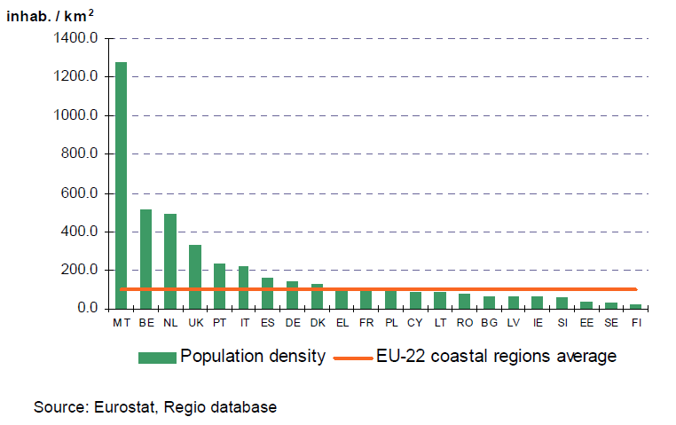

Anthropogenic pressures cause different impacts in different coastal environments due to special features of habitats (Viles and Spencer 1995:13 in Laukkonen, 2011). Those are also a major source of food and raw materials, and a vital link for transport and trade. Some of our most valuable habitats as well the most favoured destinations for our leisure time are in the coastal zones. Coastal zones are facing serious problems due to a number of human pressures, such as water contamination, coastal erosion, habitat destruction and resource depletion. The importance of coastal tourism in a country implies an interest in the maintenance of beaches (DEDUCE, 2005).

Human are causing hydromorphological changes in the coastal zone that are both due to pressures in the marine as well as in the terrestrial side of the coastal zone. Hydromorphological changes, such as construction of harbours, urban dwelling and developments, underwater constructions for energy activities, dredging for navigation as well as abstraction of gravel and other materials from the sea bed are leading to increasingly frequent conflict between uses, such as between nature protection and development for urban dwellings and other human activities.

Important long term goals for the EU coastal zones are the sustainable development of coastal zones and the conservation of dynamic habitats, especially on the remaining undeveloped coast. This requires a protection, and in many cases restoration of the natural habitats and functioning of the coastal system and hence sustaining the natural resilience of coastal zones to impacts of hydromorphological changes, such as erosion.

Anthropogenic pressures cause changes to coastal hydromorphology affecting the physical features as geomorphology and hydrological regime. Often these pressures become more obvious along with population growth, urbanization, and development of tourism and industry (Kull et al. 2006:252 in Laukkonen, 2011). Coastal defence constructions are becoming more common in European coastal zone due to sea level rise, erosion and concentration of economic activities to the coasts. Flood protection constructions have negative impacts on coasts by fragmenting continuous coastline and changing habitats (Laukkonen, 2011).

Across Europe, economic development has physically altered coastal and transitional waters for navigation, trading activities, flood and erosion control, urbanisation and tourism. These activities are driving forces for hydromorphological alterations. Natural structural and functional elements such as habitat composition, sediment and water flow of coastal and transitional waters have been modified with bank and flood protection structures, dams, land reclamation, dredging, port and marine facilities construction (Figures 2.17a-d).

The impact of global warming and climate change is becoming increasingly important in coastal areas due to expected sea level rise and due to increased probability of storm surges and associated coastal floods. People are increasingly occupying low-lying areas that are exposed to flooding, thus exacerbating the vulnerability of coastal systems to extreme events. The importance and scale of coastal defences will thus increase, with potentially commensurate environmental impacts (OSPAR Commission, 2009:14).

|  |  |
| --- | --- |
| **Figure 2. 17a: Revetments** | **Figure 2.17b: Seawall in Kent, UK** |
| Source: Scottish Natural Heritage, 2011 | Source: Channel Coastal Observatory, 2011 |
| **Figure 2.17c: Storm Surge Barrier, Netherlands** | **Figure 2.17d: Artificial transitional water body with port, Zeebrugge, Belgium** |
| Source: Deltawerken, 2011 | Zeebrugge Port_GoogleSource: Google Earth, 2011 |

### European Overview

Hydromorphological pressures impact 41 % of the EU transitional water bodies. Hydromorphological pressures are less important in the EU coastal water bodies impacting only 12% of these water bodies.

The predominant hydromorphological pressure type in the EU coastal water bodies is the coastal water management. Water flow regulation and morphological alterations of surface water are the second most important pressure type. Other pressures can be found in lower extent.

Water flow regulation, morphological alterations and water management of transitional waterare the most significant pressure type in the EU transitional water bodies. Water abstraction, other morphological alterations and river management are less important.

**By sea region**

***Coastal waters***

The Greater North Sea and the Mediterranean Sea regions have almost 20 % of coastal water bodies under hydromorphological pressures (19 % and 17 % respectively). The Celtic Seas, Bay of Biscay and the Iberian Coast region has 12 % of such water bodies, the same as the EU average. The Baltic Sea region has 8 % of such water bodies, while no hydromorphological pressures were reported in the Black Sea region. However, this region has identified heavily modified and/or artificial water bodies in coastal water bodies.

Coastal water management is the most important hydromorphological pressure type in the Mediterranean Sea and the Baltic Sea regions, while water flow regulations and morphological alterations of surface water are more important pressure type in the Greater North Sea. In the Celtic Seas, Bay of Biscay and the Iberian Coast regions all pressures are equally important.

***Transitional waters***

The highest share of transitional water bodies under hydromorphological pressures has the Greater North Sea and the Mediterranean Sea regions (both 44%). The Celtic Seas, Bay of Biscay and the Iberian Coast region has 40 % of such water bodies, which is slightly below the EU average (41%). No hydromorphological pressures were reported in the Baltic Sea and Black Sea regions. However, both sea regions have identified heavily modified and artificial water bodies in transitional water bodies.

Water flow regulations and morphological alterations of surface water are the most important hydromorphological pressure type in the Mediterranean Sea region. In the Greater North Sea region, hydromorphological pressure types are represented quite similarly, except for river management. In the Celtic Seas, Bay of Biscay and the Iberian Coast region, the most important hydromorphological pressure type is transitional water management, followed by water flow regulations and morphological alterations of surface water.

**By country**

***Coastal waters***

The Netherlands has the largest share (80%) of coastal water bodies under hydromorphological pressures in the EU. Countries with more than 10 % of the coastal water bodies with hydromorphological pressures are the Netherlands, Estonia, Malta, Ireland, Italy, Portugal, Spain, Germany and France. Coastal water management is the most important hydromorphological pressure type in most countries. In the Netherlands, the pressure types "transitional and coastal water management" and "water flow regulations and morphological alterations of surface water"are equally important pressures of both coastal and transitional water bodies. In Germany, water flow regulations and morphological alterations of surface water are the only hydromorphological pressure type. This type of pressures is the most important in the UK, where it includes alteration of water flow and water level as well as modification of coastal beds, banks and shores (Scottish Government 2009). Physical modification is determined as a significant pressure type affecting majority of surface water bodies including coasts. Examples of such activities are flood protection, urbanization, land drainage, barriers to fish migrations and water storage and supply (UK Environment Agency 2009).

In Ireland, France and Finland, river management was reported as a pressure in coastal water bodies. According to Kymijoki river basin district management plan of Finland (Uudenmaan *et al.,* 2010), river management activities such as construction, dredging and water level regulation cause changes in water flow especially during flood time. This, for one, diminishes productivity and biodiversity in coastal water bodies.

Belgium, Bulgaria, Cyprus, Denmark, Greece, Lithuania, Latvia, Poland, Romania and Sweden reported no significant hydromorphological pressures in coastal water bodies.

***Transitional waters***

In the Netherlands, Belgium and Germany, all transitional water bodies are under hydromorphological pressures.

Countries with more than 30 % of the transitional water bodies under hydromorphological pressures are Greece, Portugal, Ireland, Italy, Spain, the UK and France. Water flow regulations and morphological alterations of surface water are the most important hydromorphological pressure type in most countries (Germany, Belgium, France and Spain). In other countries, other hydromorphological pressure type(s) are similarly important or even more significant. For example, in the UK, other morphological alterations and water abstraction are more significant. In Greece, hydromorphological pressures are represented by transitional water management.

Bulgaria, Lithuania, Latvia, Poland, Romania and Sweden reported no significant hydromorphological pressures in transitional water bodies.

# Sectors and activities

## Hydropower and WFD

In this report hydropower has been identified as one of the main drivers to hydromorphological alterations, loss of connectivity and to alter water and reduced sediment flow (Figures 2.3, 2.6 and 3.1). Hydropower installations create barriers to the movement of aquatic speacies and risks for fish getting into turbine intakes. These engineering structures alter flow regime and water level fluctuation thus influencing shore zone habitats. The altered sediment tarnsport and sediment retention cause changed physico-chemical conditions of water bodies. Pressures related to hydropower may be one of the reasons for many water bodies not to achieve good ecological status by 2015 or the subsequent RBMP cycles.

Figure 3.1: Conceptual overview of different impacts of hydropower installations on biology, flow conditions and sediment transport



In the context of the EU Directive on the promotion of the use of energy from renewable sources 2009/28/EC (EC, 2009), hydropower is an important measure for increasing the share of renewable electricity but, depending on its management, hydropower can impact water bodies and adjacent wetlands.

It is important to ensure that existing and forthcoming EU policies to promote hydropower ensure coherence with the Water Framework Directive/other EU environmental legislation and clearly consider the ecological impacts on the affected water bodies and the adjacent wetlands.

### Overview of hydropower in Europe

In 2008 hydropower provided 16 % of electricity in Europe and hydropower currently provides more than 70 % of all renewable electricity (Eurelectric 2009), more than 85 % of which is produced by large hydropower plants. The share of hydropower in electricity production is generally high in the northern and Alpine countries.

The total number of hydropower stations in the EU-27 amounts to about 23 000. There are about 10 times more small (P < 10 MW) than large hydropower plants (P > 10 MW). However, the electricity generation of small hydropower only amounts to 13% of the total generation of all hydropower stations. Today large hydropower plants account for 87% of the hydropower generation with only 9% of the stations (DG ENV*/*ARCADIS & Ingenieurbüro Floecksmühle 2011).

In absolute numbers, Germany has most hydropower plants more than 7700 of which 7300 are small plants. Austria, France, Italy and Sweden all have more than 2000 hydropower plants. The highest numbers of large hydropower plants (> 10 MW) are found in Norway (333): Italy (304); France (281) and Sweden (206) (Kampa et al. 2011).

Three types of power stations can be found (DG ENV*/*ARCADIS & Ingenieurbüro Floecksmühle 2011):

* *Hydropower stations with storage reservoir*. A storage reservoir offers the opportunity to store energy and to meet e.g. the peak electricity demands. Such reservoirs can comprise daily, seasonal or yearly storage. Many of the large stations operate with a reservoir.
* *Run-of-the-river stations*. This type of installation uses the natural flow of a water course in order to generate electricity. There is no intention to store water and to use it later on. This type is most common for small hydropower stations, but can also be found with large stations.
* *Pumped storage hydropower plants*. Pumped hydropower stations utilize two reservoirs located at different altitudes. Water can be pumped from the lower into the upper reservoir and can be released, if needed, to the lower reservoir producing energy on ts way through the turbines. In times of high demand e.g. during peak hours electricity is produced to satisfy the demand. When there is a surplus of electricity in the system, water can be pumped to the upper reservoir.

The different types of hydropower plants have different effects on the ecosystems and hydromorphology. Hydropower plants with storage reservoirs generate more severe impacts on the river system including loss of connectivity, change in water flow regime and reduced sediment flow. The reservoir type hydropower plants are found in the mountainous areas with steep relief, while the larger run-of-the-river stations are found on the main course of larger rivers and their tributaries. Smaller hydropower plants are often found on relative smaller rivers and with limited storage, but often acting as migrating barriers. However, compared to the impacts generated per electricity production the impacts by many small hydropower plants may be comparable to or larger than one large hydropower plant.

Text box 3.1: Location of different types of hydropower plants

|  |  |
| --- | --- |
| In the mountainous Upper Danube watershed (77 000 km²) covering parts of Germany and Austria there are in the alpine headwaters 20 big reservoir hydropower plants (annual hydropower generation of more than 250 GWh) and there are 120 relative smaller run-of-the-river stations hydropower plants (annual hydropower generation of 20 to 500 GWh) mainly situated on the river Danube and its larger tributaries Iller, Lech, Isar, Inn and Salzach.  Source: Koch et al. 2011 |  |

RBMPs and hydropower

The effects of hydropower production are taken up in most of the RBMPs. The plans generally provide an overview of the hydropower plants and their location. River basins with hydropower schemes generally have several water bodies designated as heavily modified such as lakes and reservoirs that have their water levels regulated due to operation of the hydropower scheme e.g. storage of water during summer and hydropower production during winter; or river section that are affected by dams and/or changed flow regime.

In 2011 a questionnaire to Member States on WFD and hydropower resulted in answers from 24 countries (23 EU27 Member States except (Denmark, Estonia, Greece, Ireland and Malta) and Norway. The results from the questionnaire were presented in an issue paper (Kampa et al. 2011) and discussed at a CIS WFD hydromorphology workshop in September 2011. In summary it was found that Sweden, Norway, Finland, Czech Republic and Austria have the highest percentage of HMWB due to hydropower (above 50% of total HWMBs) while The Netherlands, Germany, United Kingdom, Latvia and Italy have the lowest percentage of HMWB due to hydropower (below 10% of total HMWB).

*Measures related to hydropower*

The majority of countries plan to make improvements to water bodies affected by hydropower by 2015. Mainly in the context of the WFD programme of measures, there are new ecological flow regimes being implemented (e.g. Portugal and Bulgaria) and other measures to make hydropower plants more ecological friendly (e.g. via fish ladders in The Netherlands).

In the context of making improvements to water bodies via specific measures 10 Member States have agreed national or local criteria for determining what impact on hydropower generation is acceptable (i.e. not a significant adverse effect). However, in an equal number of countries, no criteria on impact determination could be determined so far (see table).

|  |  |  |
| --- | --- | --- |
|  | **Yes** | **No** |
| Are improvements to any water bodies affected by hydropower schemes planned by 2015? | BG, FI, FR, IT, LV, LT, LU, NL, NO, PT, RO, SW, UK, CZ, IS, ES, SI, SK, (*AT, DE*)2) | CH |
| Have national or local criteria for determining what impact on hydropower generation is acceptable (i.e. not a significant adverse effect) been agreed? | AT, FR, IT, LV, LT, NL, RO, CH, IS, ES | BG, DE, FI, LU, NO, PT, SE, UK, CZ, SI |

Notes: (1) No answer by BE, HU and PL. (2) AT and DE have replied “No” to the making of improvements to water bodies affected by hydropower by 2015. However, for both countries, it is explained in their questionnaires that improvements will be made by 2015 in a selected number of water bodies. (3) For Finland, The Netherlands and Romania the construction of new plants, modernisation and maintenance are considered to be contributors to the 2020 renewable energy targets from hydropower.

##### Legal requirements for environmental improvement

Most countries have relevant legislation on national level (in few cases also on regional level) to ensure minimum ecological flow and upstream continuity via fish passes at hydropower plants. For downstream continuity and hydropeaking mitigation, fewer countries have legislative requirements to ensure environmental improvement. Requirements for measures are rather defined in individual cases (e.g. as a condition of authorisation) and, in some countries, there is generally no relevant legislative means.

For mitigating the disruption of sediment/bedload transport, several countries have no relevant legislative means. Only a few countries have national legislation and, in several countries, mitigation measures are defined in individual cases.

### Balancing WFD and Renewable Energy Directive (RES) requirements

Member States should avoid taking action that could further jeopardize the achievement of the objectives of the WFD, notably the general objective of good ecological status of water bodies. The further use and development of hydropower should consider the environmental objectives of the WFD in line with the requirements of Article 4 (in particular, the requirements of Article 4.7 when new hydropower plants are considered). The requirements of Art. 4.7 for new hydropower include amongst others that there are no significantly better environmental options, that the benefits of the new infrastructure outweigh the benefits of achieving the WFD environmental objectives and that all practicable mitigation measures are taken to address the adverse impact of the status of the water body.

In the same time, the Renewable Energy Directive (2009/28/EC) sets legally binding national targets for electricity and transport from renewable sources (not specifically for hydropower), adding up to a share of 20 % of gross final consumption of energy in the EU as a whole. By June 2010, each EU Member State had to adopt a national renewable energy action plan (NREAP) setting out its national targets for the share of energy from renewable sources consumed in transport, electricity, heating and cooling in 2020 and describing the way and the extent to which different renewable sources (wind, hydropower, etc.) will contribute to the achievement of targets*.* In several European Member States, an increase in hydropower generation is needed for the achievement of these targets by increasing efficiency in hydropower generation at existing sites but also by building new hydropower plants.

Most European rivers are already heavily affected by dams and reservoirs and most of the suitable stretches have already been used. However, there are still many plans and studies for new dams, reservoirs and small hydropower projects:

* in the Danube basin there are plans to built dams on the Bavarian Danube, the Sava, and the Drava (ICPDR, 2010);
* in December 2007 the Portuguese government approved the National Programme for Dams with High Hydroelectric Potential (PNBEPH) leading to the construction of ten new dams (PNBEPH, 2008);
* in February 2010, the Council of State, Greece’s highest administrative court, ordered the suspension of a controversial project to divert the country’s second-longest river, the Acheloos, from western Greece to the heavily-farmed Plain of Thessaly, approving an appeal by environmentalists against the plans (Katemerini 2010; WWF 2010)
* a recently-published Scottish government study estimates a potential for more than 7 000 new small hydropower projects (Scottish Government, 2010) and a study by the Environment Agency (EA 2010) identified between 4 000 and 12 000 potential new small hydropower projects in England and Wales;
* In June 2008, the French environment minister announced a plan to boost hydropower by 2020. The government wants to increase production capacity by 30 % by installing more efficient turbines. It does not propose to build more dams (ENDS, 2008 and Gouvernement, 2008).

This list is just a snapshot, it is neither an exhaustive nor a complete overview of planned water infrastructure projects in Europe. Many of the projects are being discussed between governments, local administrations, different user groups, and industrial and environmental organisations. The new projects may conflict with the WFD objectives of achieving good ecological status/potential. Article 4.7 of the WFD requires that all practicable steps are taken to mitigate the adverse impacts of new infrastructures on the status of water bodies and that the projects should have overriding public/societal interest and/or benefits to the environment and society (EC, 2006).

Text Box 3.2: State of small hydropower in the Alps

|  |
| --- |
| In 2010 several hundred applications for new small hydropower stations have been reported across the whole Alpine area (with considerable difference of numbers between countries), thus potentially adding to the high number of facilities already in place. This boom has been triggered in particular by the financial incentives and support schemes in place in all countries of the Alps. It presents a particular challenge for competent authorities in handling the huge amount of applications and deciding on authorisations for new facilities, due to variety of aspects to be taken into account (energy generation, CO2 emission reduction, ecological impact etc.).  Despite its clear benefits, hydropower generation can also have substantial negative impacts on the aquatic ecology, natural scenery and ecosystems which are not always perceived by the wider public. This is not only the case for large dams, reservoirs and related hydropower facilities but also for small and very small hydropower stations, indeed the high number of such facilities already in place in the Alps, have a cumulative effect which is already impacting on a considerable number of river stretches.  From the collected data on hydropower plants it is evident that the larger plants contribute by far the major share of total electricity production from hydropower , i.e. over 95% of the total production comes from facilities with greater than 1MW power output. Plants with a capacity of less than 1 MW constitute around 75% of all hydropower plants within the Alpine area but contribute less than 5% to the total electricity production.  The decision on new facilities is still mostly determined for sites individually (with exception that in some countries projects within National Parks, Nature2000-Sites, etc. are subjected to specific rules). Environmental legislation has developed significantly in recent decades. Residual water (or environmental minimum flows) as well as fish passes are now seen as basic provisions of new hydropower plants. However, many old facilities do not meet modern environmental standards. For instance, older hydropower facilities may not provide sufficient residual water or be equipped with fish-passes, hence causing a fragmentation of river stretches and habitats. In such cases, adaptations to the facilities may be required in order to meet environmental objectives.  When licences or authorisations have to be renewed, or when a new one is granted, the conditions for the water use are based on the current environmental legislation. Thus, if existing hydropower facilities request and need a renewal, extension or a new licence or authorisation then they have to comply and adjust to the new requirements of the actual environmental legislation, such as the residual water flow conditions.  However, in some countries, once a water licence or authorisation has been granted, this legal right can only be varied during the set period of the licence or authorisation (between 30 to 90 years) if it is economically bearable for the owner or for reasons of higher public interests and against compensation. Furthermore, some water rights from the past do not have a license or authorisation period at all, i.e. the right is for an unlimited time period.  Due to the length of time for which a licence or authorisation is granted, the effectiveness of new regulations on upgrading existing facilities in order to enhance the ecological situation can be limited. In order to allow for progress, some countries have set up promotion schemes and incentives to support operators or licensees in upgrading existing facilities with the aim of fulfilling environmental objectives.  Source: Alpine Convention 2011 (reduced text of draft provided by Alpine Convention Nov. 2011) |

The table below indicates how European States intend to achieve the objectives set for the contribution of hydropower to the 2020 renewable energy targets via construction of new hydropower plants, refurbishment or modernization and maintenance. The table is based on qualitative statements of countries on the level of importance of the contribution of each option to the targets.

The following trends can be detected for specific countries:

* In Austria, Slovenia and the UK, mainly the construction of new plants will contribute to the 2020 renewable energy targets. In the UK, new hydropower development is expected to be dominated (in terms of numbers of schemes) by small (< 1.5 MW) run-of-river schemes. In Austria, modernisation will play a considerable role for small hydropower while in the UK, refurbishment and modernisation are considered negligible contributions.
* On the other hand, in Germany, Spain and Italy, the construction of new hydropower plants is considered a minor contribution, whereas the refurbishment, modernization and maintenance of plants will be the main source of contribution to renewable energy targets. In Latvia, the situation is similar. In Spain, any new constructions will focus on increasing pumping storage capacity.
* France considers all options to be a main source of contribution for achieving the 2020 renewable energy targets. The refurbishment and modernisation targets are to balance the loss of production due to minimum flow rising in 2014 for all existing plants. On the contrary, Luxembourg considers all options to be minor contributions to the 2020 renewable energy targets.
* For Finland, The Netherlands and Romania, the construction of new plants and modernisation and maintenance will be the main contributors to the 2020 renewable energy targets from hydropower.
* For Norway and Portugal, the main source of contribution to the 2020 renewable energy targets from hydropower will come from the construction of new plants and refurbishment.
* Sweden mainly plans to refurbish hydropower plants in order to contribute to the 2020 renewable energy targets.

|  |  |  |  |
| --- | --- | --- | --- |
|  | Main source of contribution | Minor source of contribution | Negligible source of contribution |
| Construction of new hydropower plants | AT, BE, FI, NL, NO, PT, RO, UK, SI | DE, IT, LU, CZ, | LV, SE, ES |
| Refurbishment of plants | DE, FR, IT, LV, NO, PT, SE, CZ, ES | AT, LU, RO, IS | FI, UK, SI |
| Modernisation and maintenance of plants | DE, FI, FR, IT, LV, NL, RO, CZ, ES | AT, LU, NO, PT, SE, IS | UK, SI |

Notes: (1) No information in the questionnaires of PL, LT, HU, BG. (2) For CH: Refurbishment and modernisation: 2.TW; New plants: small HP: 1.9 TW, large: 2.4 TW the numbers refer to 2035.

Source: *DG ENV/Ecologic (Kampa et al.) September 2011: Issue Paper Draft 2*

## Navigation and WFD

Nearly 90% of the EU’s external trade and more than 40% of its internal trade goes by sea, which underlines that European countries depend on maritime transport. Almost 2 billion tons of freight are now handled in more than 1200 EU ports each year, and volumes are continuing to increase. As a result, recent years have seen a number of applications and approvals for major seaport developments. Many such developments have been required in order to accommodate the significant global increase in containerised transport, and further increases in such cargoes are anticipated. In addition to rationalised or new cargo handling and transhipment facilities, new container vessels require deeper access channels to certain ports.

Inland waterway transport plays also an important role in Europe today, and shifting more freight transport to water is considered a significant option to improve Europe’s transport system as a whole and to deal with constantly growing freight flows. Inland navigation is seen as an environmentally friendly transport mode with compared to other inland transport modes as it produces relative low CO2 emission.

More than 37 000 kilometres of inlandwaterways connect hundreds of cities and industrial regions. Some 20 out of 27 Member States have inland waterways, 12 of which have an interconnected waterway networks.

Navigation activities and/or navigation infrastructure works are typically associated with a range of hydromorphological alterations with potential adverse ecological consequences (Figure 3.2). Deepening including channel maintenance, dredging, removal or replacement of material is a major activity. Dredging, in turn, is of vital importance to many of the EU’s ports, harbours and waterways - providing and maintaining adequate water depths and hence safe navigational access. Channel works such as channelisation and straightening, training walls or breakwaters often are needed. Bank reinforcement, bank fixation, and embankments (training wall, breakwater, groynes etc.) often have been constructed. Some developments may also involve land claim and/or impoundment. Inland waterways as corridors can contribute to spreading of invasive species.

Potential impacts associated with these modifications can include:

* the physical removal of habitats or species;
* changes to physical processes (erosion, accretion and sediment transport);
* barriers to movement of species or the loss of connectivity between habitat sites (eg.

due to impoundment or reclamation)

**Figure 3.2: Illustrative range of possible alterations typically associated with navigation activities and/or navigation infrastructure with subject to biological alterations**

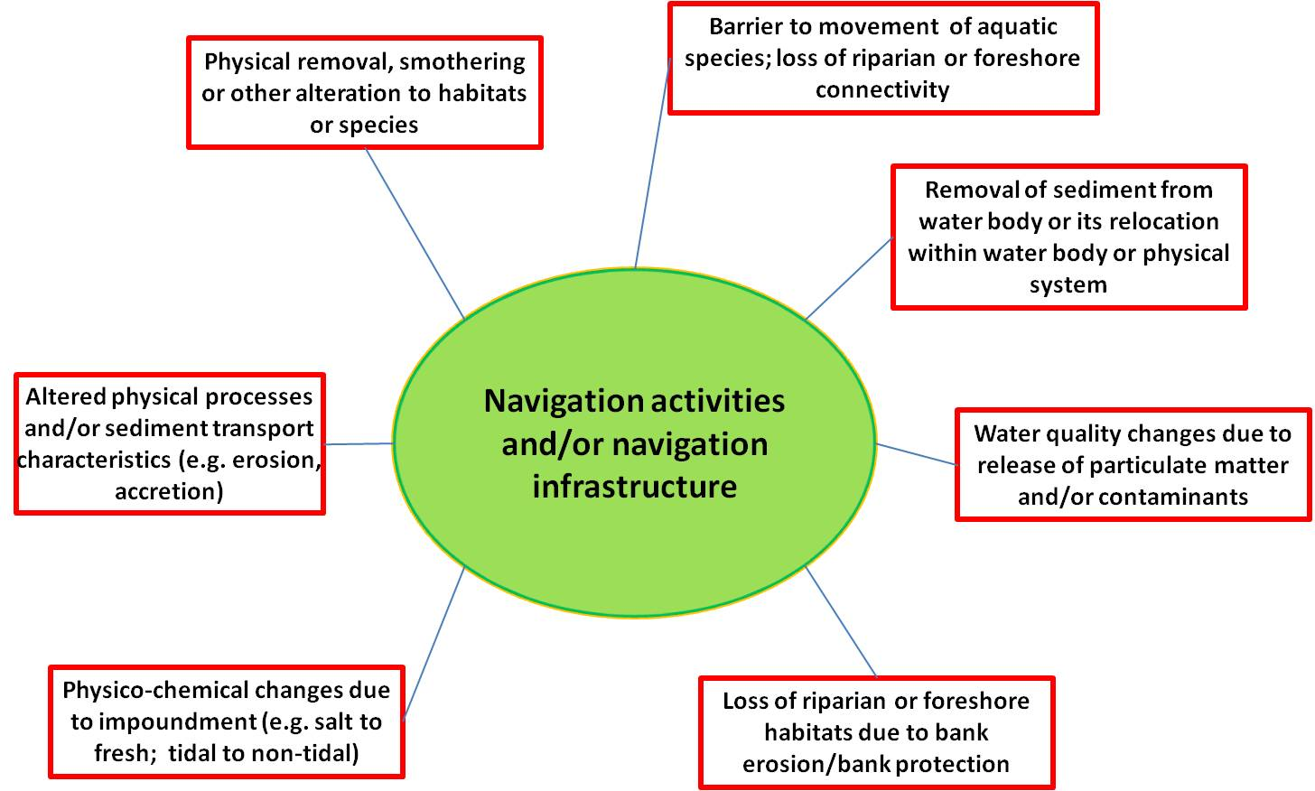

### RBMP and inland waterway transport

*Invasive species spread through inland waterways*

The extensive networks of inland waterways in parts of Europe have allowed species from different bio-geographical regions to mix, altering communities, affecting the food webs and introducing new constraints to the recovery of the native biodiversity .

**Text box 3.3: Invasion of large European rivers**

|  |
| --- |
| Invasive species have become a major concern in the Danube. The Joint Danube Survey in 2007 found killer shrimps, Dikerogammarus villosus, at 93 % of the sites sampled along the river, Asian clams at 90 % and carpets of weeds at 69 %. Killer shrimps can adapt to a wide range of habitats and cause significant ecological disruption such as species reduction. The water hyacinth (Eichhornia crassipes) is considered one of the worst aquatic weeds in the world.  Over the past two centuries, the connection of the Rhine with other river catchments through an extensive network of inland waterways has allowed macro-invertebrate species from different bio-geographical regions to invade the river. A total of 45 such species have been recorded. Transport by shipping and dispersal by man-made waterways are the most important dispersal vectors. |

Source: Danube Watch, 2008; Bernaur and Jansen, 2006; Leuven et al., 2009.

### WFD and inland navigation

WFD potentially have significant implications for navigation, both for ongoing port activities such as dredging and disposal, and for new development proposals. The Program of Measures established by the RBMPs could potentially affect ports, navigation and dredging in a number of ways. For example, measures could require the modification of existing structures such as training walls or breakwaters to mitigate their effects. Measures affecting activities or operations are also possible - for example, the introduction of technical or temporal constraints on dredging and disposal activities to meet ecological targets. (Information is from PIANC WFD Navigation Task Group <http://www.pianc.org/euwfd.asp>.)

**Text box 3.4: Update of the Danube Regional Strategy aspects of increasing inland water transport by 20 % by 2020**

|  |
| --- |
| EC calls for more cargo transport on the Danube. Cargo transport on the Danube river should be increased by 20% by 2020, according to an EU strategy for the region unveiled by the European Commission on Thursday. The plan follows a consultation with member states in February.  Regional policy commissioner Johannes Hahn said: The Danube is only using 10% of its shipping potential, pointing out that inland waterways are a greener mode of transport. The Rhine river carried 330 million tonnes of cargo in 2007 compared with just 50Mt for the Danube, a river more than twice as long.  Green group WWF accused the commission of focusing too heavily on increasing cargo shipping. This would require a deepening and widening of the river, which could destroy valuable biodiversity and associated ecosystem services.  Member states will decide whether to endorse the plan during the Hungarian presidency of the EU in the first half of 2011. They will decide how the proposed targets will be monitored and which of the 14 countries in the basin area, including six non-EU states, will participate. The commission has only a coordinator role. |
| WWF (Dec. 2010): Danube river to be severely impacted by plans to increase navigation  http://wwf.panda.org/what\_we\_do/how\_we\_work/policy/wwf\_europe\_environment/news/?197714/Danube-to-be-severely-impacted-by-navigation |

## Towards sustainable flood risk management

Millions of European citizens are threatened by flooding events from rivers, estuaries and the sea. Over the past ten years Europe has suffered more than 175 major floods, causing deaths, the displacement of people and significant economic losses. Although many flood defense measures were implemented in the European river basins and coastlines during the last century, the ongoing urban developments and changes in land use, as well as the social and economic development have increased the potential for flood damages. This significant increase of the flood risk is furthermore due to climate change and extreme weather events e.g. heavy rainfalls.

The EU Floods Directive (2007/60/EC) aims to reduce and manage the risks of floods to human health, the environment, cultural heritage and economic activity. The Directive requires Member States to assess what rivers and coast lines are at risk from flooding, to map the possible extent of flooding and the assets and humans atrisk in such areas, and to take adequate and coordinated measures to reduce the risks. All EU Member States have to develop such flood hazard and risk maps by 2013. Using hazard maps, this planning aims to limit increases in potential damage, to avoid aggravating it in risk areas, and even to reduce it in the longer term. European countries outside the EU generally have similar legislation.

The implementation of the Water Framework Directive means a chance for many European countries to combine those measures to reach a Good Ecological Status (GES) with rehabilitation measures.

#### *Working with nature, not against it*

For centuries, hard infrastructure, including bank enforcements and dykes, navigation including canals, locks, dredging and bank reinforcement, water storage reservoirs and dams, and drainage through straightening rivers and pumping canals, has been used for flood defences. All these activities are typically associated with a range of hydro-morphological alterations and adverse ecological effects. In many countries, activities in relation to the WFD and flood risk planning have been an impetus for changing the way we manage flooding to enhance the environment and protect people from the damage.

Flood defence works besides their positive effects on flood safety could cause possible ecological alterations and impacts associated with flood defence measures. Figures 3.3 illustrates such alterations and impacts in case of river channelling and application of flood defence dykes.

The traditional management response to a severe flood was typically an ad hoc reaction – the quick implementation of a project that considered both the problem and its solution to be self-evident, and that gave no thought to the consequences for upstream and downstream flood risks. Thus, flood management practices have largely focused on reducing flooding and reducing the susceptibility to flood damage. Traditional flood management has employed structural and non-structural interventions, as well as physical and institutional interventions. These interventions have occurred before, during and after flooding, and have often overlapped.

Source controls intervene in the process of the formation of runoff from rainfall or snowmelt, and take the form of storage in the soil or via the soil. The use of this strategy normally considers the consequential effects on the erosion process, the time of concentration in the soil and the dynamics of evapotranspiration. The assessment of the likely effectiveness of source control also considers pre-flood conditions such as the state of saturation of the soil, and whether or not the ground is frozen.

Thus, a potential drawback with some forms of source control, and other forms of land-use modification such as deforestation, is that the capacity to absorb or store rainfall depends on the antecedent conditions of the catchment.

Figure 3.3: Illustrative range of possible ecological alterations and impacts typically associated with flood defence works – river corridor channelling (straightening and deepening) and dykes

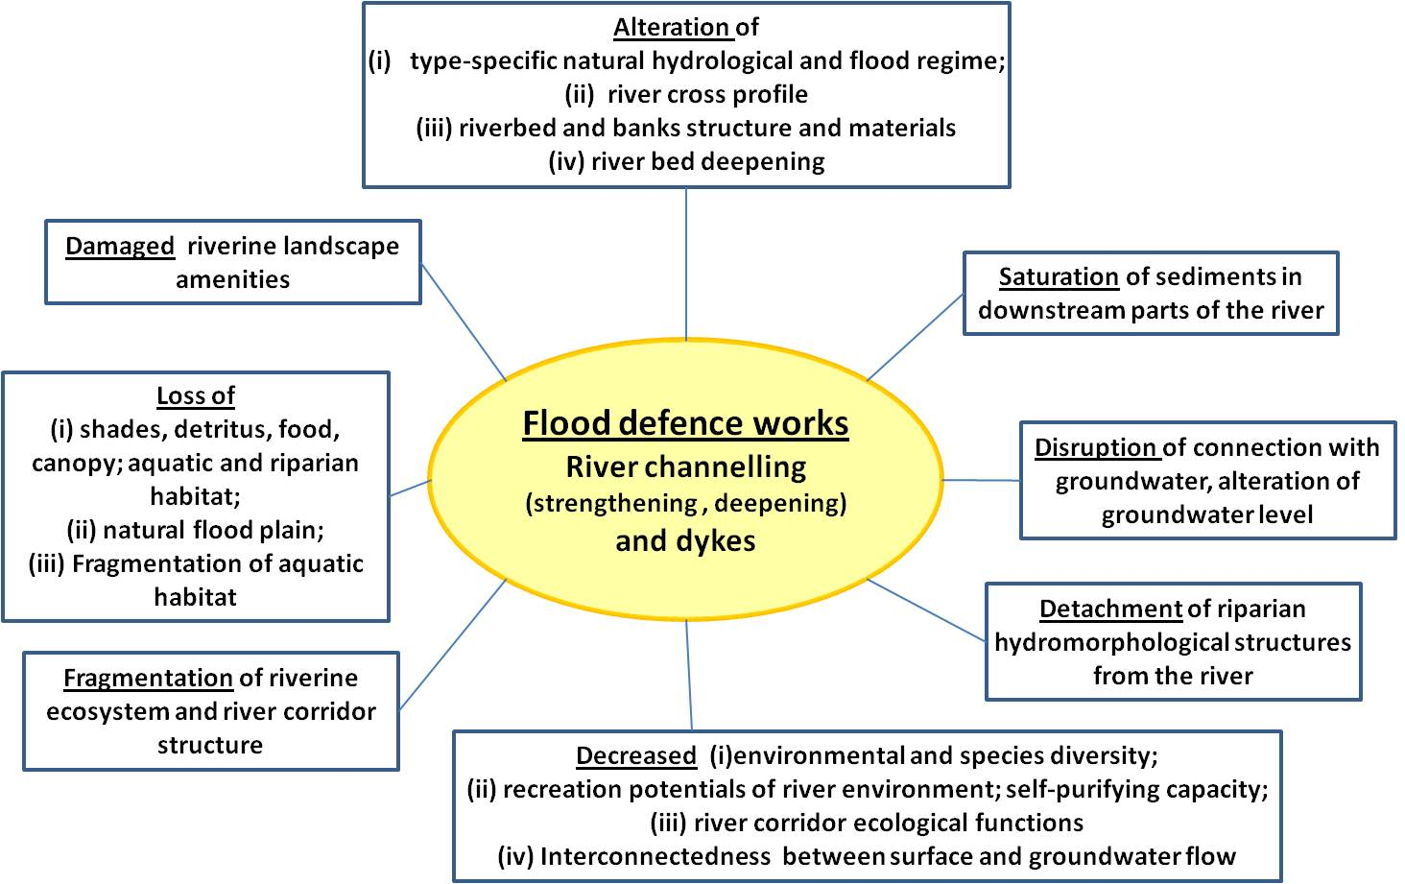

Surface water storage, through such as devices as dams, embankments and retention basins, is a traditional approach to attenuating flood peaks. Water storage modifies floods by slowing the rate of rising waters, by increasing the time it takes for the waters to peak and by lowering the peak level. More often than not, such storage serves multiple purposes, and flood storage can be the first casualty in any conflict among purposes. Moreover, by completely eliminating the low floods, such measures can give a false sense of security. Storage has to be used in an appropriate combination with other structural and non-structural measures. Seemingly self-evident, but regularly overlooked in practice, is the need to make flood management a part not only of the planning and design, but also of the operation of reservoirs. Releases from reservoirs can create risks, and the careful operation of reservoirs can minimize the loss of human life and property due to such releases. In this context transboundary cooperation is indispensable.

Increasing the carrying capacity of a river changes its natural morphological regimes and ecosystem, affects other river uses and has a tendency to shift the problem spatially and temporally. Deepening of channels may also affect the groundwater regime in the region. Dikes or flood embankments are most likely to be appropriate for floodplains that are already intensely used, in the process of urbanization, or where the residual risks of intense floodplain use may be easier to handle than the risks in other areas (from landslides or other disturbances, for example).

Land-use control is generally adopted where intensive development on a particular floodplain is undesirable. Providing incentives for development to be undertaken elsewhere may be more effective than simply trying to stop development on the floodplain. Where land is under development pressure, however, especially from informal development, land-use control is less likely to be effective. Flood proofing or house raising are most appropriate where development intensities are low and properties are scattered, or where the warning times are short. In areas prone to frequent flooding, flood proofing of the infrastructure and the communication links can reduce the debilitating impacts of floods on the economy.

### RBMPs and flood defense activities

**Ireland – Flood protection and WFD**

Source: Gilligan 2008

The Office of Public Works (OPW) is the lead authority for Flood Risk Management in Ireland. OPW maintains 11,500 km of watercourses for drainage & flood relief purposes and implements an ongoing programme of urban Flood Relief Schemes.

Ireland's Article 5 Initial Characterisation Report under the WFD establishes that Hydromorphology is the 2nd largest pressure behind Diffuse Pollution. Hydromorphology accounts for 40% of the river waterbodies being designated either “At Risk” or “Probably At Risk” of failing Good Ecological Status (GES). Channelisation and Flood Relief structures account for over half of these pressures.

For Drainage/Flood Relief pressures in Ireland, the Programme of Measures under the WFD will focus on enhancement of drained rivers and sustainable flood relief practices. In addition, Ireland is incorporating River Continuity into the hydromorphological criteria, which will set a new framework to manage fish passage obstructions. A recent example of river continuity improvements is where the OPW replaced a weir obstacle with a new Rock Ramp structure as part of an urban Flood Relief Scheme.

**Germany increased floods due to morphological changes and loss of flood plains**

Source: UBA 2010

The man-made changes to many German rivers were designed to create land for industry and housing, make waters navigable, intensify agriculture, utilise hydropower, and protect against flooding. Owing to the straightening and shortening of river courses, flood waves now travel faster and transport larger volumes of water per unit of time. For example, since the first large-scale straightening of the Rhine in the mid-19th century by hydro-construction master Johann Gottfried Tulla, the number of riverine meadows on the Upper Rhine between Basle and Karlsruhe has diminished by 87 %.

All in all, the flood plain of the Upper Rhine was reduced by 60 % or 130 km2. River straightening measures lead to a shortening of the run – on the Upper Rhine by approximately 82 km, and on the Lower Rhine by approximately 23 km – which in turn led to an acceleration of runoff. For example, the flow rate of the flood wave in the Rhine on the section between Basle and Maxau has been reduced from 64 to 23 hours.

**Restoring flood plains in the Rhine river basin**

Source: SDF

The Rhine flows through large areas of Germany and the Netherlands. In the past, measures to straighten the river resulted in an increased risk of flooding in the Rhine Delta. The reclamation of historical floodplains is an important means of flood protection. More room for the river: restored floodplains on the upper and middle sections of the Rhine are intended to reduce the height of the flood waves during future flood events. On the other hand, the aim of the measures taken on the lower stretches and in the Rhine Delta is to ensure that the water drains away quickly. In this case, floodplains are being expanded, lowered or supplemented with new or reactivated side channels.

**Text Box 3.5: The New Vásárhelyi Plan for the Tisza River Valley**

|  |
| --- |
| Following a long spell of arid years, several dangerous flood waves have passed down the Tisza between 1988 and 2002. Solutions guaranteeing the safety of over one million people in the endangered flood plains were urgently needed.  The updated concept of enhancing flood safety in the Tisza Valley is built on the ambitious reclamation project devised by Pál Vásárhelyi and realized in the 19th century. The improvement over the present state consists of diverting to, and storing on parts of the flood plain the excess flow conveyed by the especially dangerous floods. Appropriate use of this water would open new perspectives of development along the river and provide opportunity to introduce a new type of agro-ecological farming and environment management.  Along the Upstream- and Middle Tisza sections 30 potential reservoir sites have been identified. The implementation phase 1 includes projects aimed at clearing the flood bed to improve its conveying capacity and the development of six reservoirs for the controlled diversion and retention storage of abnormally high peak flood flows (See map). At the time of flood waves, potentially damaging water surpluses could be diverted in a regulated way into newly constructed water retention reservoirs in the river valley, while the riverbed would also have undergone refurbishment to increase its water-bearing capacity. |

### WFD and flood risk management

In general, measures for managing flood risk and mitigating hydromorphological pressures that work with nature rather than against it should be promoted, such as making more room for rivers.

Sustainable flood risk management is a shift away from our predominantly hard-engineering flood defences to a river basin approach, which uses natural processes and natural systems to slow and store water in addition to measures such as flood warning, spatial planning and emergency response. Natural floodplains are allowed to flood and wetlands to act as giant sponges to soak up excess water then release it slowly back into the river.

This is generally a cost-effective way of achieving many objectives, including the good status objective of the WFD and national water policies. For many European rivers, restoring former floodplains and wetlands would both reduce flood risk and improve the ecological and quantitative status of freshwater. Opportunities to enhance the natural environment and improve its capacity to perform ecosystem services should be identified.

There are many national activities in Europe aimed at more sustainable flood management and restoring rivers. Examples include the Dutch Room for the River (Ruimtevoorderivier, 2010), the UK programme for making space for the river (DEFRA, 2008), the Swiss guiding principles for sustainable water management (BAFU, 2010; the SOER 2010 country assessment on Switzerland (EEA, 2010g)), the Austrian Stream Care Scheme (Lebensministerium, 2010) and the Spanish National Strategy for Restoring Rivers (MARM, 2010).

**Text box 3.6: Natural flood defenses**

Probably the most visible signs of flood risk management are flood defenses. Typical hard defenses include embankments, walls, weirs, sluices and pumping stations. Typical use of natural processes could involve using washlands, mudflats and saltmarshes to provide space for floodwater and prevent flooding from occurring elsewhere. At the same time, this can benefit wildlife by providing areas of habitat and are often used in combination with hard defenses to provide areas for recreation and tourism. Upland areas could be managed by restoring peat bogs or blocking artificial drainage channels. Replanting forests in floodplains will help to slow the flow of water run-off and help it filter through the soil. In urban areas green roofs, permeable paving, surface water storage areas can be used to reduce flood risk. By working with natural processes alongside traditional hard defences a more sustainable approach to flood risk can be achieved.

Source: Environment Agency

The development of riparian forests is valuable for retaining water in upstream areas of river catchments and therefore to lower the floodwater levels in the river. Another measure, which has an effect on the water level in the main river, is the construction of secondary gullies. But if those are planned very well, the positive effects are dominant.

If densely populated areas are at a risk, still heightening of dikes or the implementation of technical measures is a solution. Especially in urban areas space along the riverbanks is very much limited and therefore, barriers along the river promenade in combination with footpaths or other combination of functions can be a useful option. Cities along rivers should carefully look right now whether planning with the river or water in the city can prevent future problems. Maybe a new consciousness or attitude to floods of the people living in a catchment can contribute to this.

**Text box 3.7: Germany – flood risk management**

|  |
| --- |
| From a nationwide perspective, at present, only around 1/3 of the former flood plains can now be used to retain the water in the event of major flooding. In large river basins such as the Rhine, Elbe, Danube and Oder, in some sections only 10 % - 20 % of the former riverine meadows remain (BfN “Auenzustandsbericht - Flussauen in Deutschland” Bonn, 2009). As well as changes to the rivers and water meadows, climatic factors also influence the scale, frequency and timing of flood events.  In Germany, there are a wide range of measures available in various different sectors for addressing flood risk management:   * Land precautions, e.g. restriction of construction in flood plains, flood-adjusted usage in flood risk areas, representation in regional plans * Natural water retention, e.g. decentralised rainwater seepage, reduction of land sealing, retention and reintroduction of water meadow sites, recovery of flood plains * Technical flood prevention, e.g. dykes, dams, retention basins, property protection, protection of oil tanks * Construction precautions (building to cater for floods) * Risk precautions, e.g. formation of reserves, insurance policies * Supply of information, e.g. flood warning * Behavioral precautions, e.g. public education and preparation for flooding with specific recommended actions for the general public * Preparation for risk aversion in disaster plans, e.g. alarm and deployment plans, drills and training of rescue teams. |

# Designation of heavily modified and artificial waters

Hydromorphological alterations, which were discussed in earlier chapters, can lead to a water body to be designated as a heavily modified water body if the water body shows substantial changes in character which are extensive / widespread or profound, and the modifications neither temporary or intermittent and in general alter both hydrological and morphological characteristics.

Water Framework Directive (WFD) allows Member States (MS) to designate their surface waters as *heavily modified water bodies* (HMWB) or *artificial water bodies* (AWB) whereby they will not need to meet the same quality criteria required for natural type surface waters. A heavily modified water body refers to a body of surface water that as a result of physical alteration by human activity is substantially changed in character. A surface water body is considered as artificial when created by human activity. According to WFD Article 2 and 4(3), EU MS may designate a body of surface water as artificial or heavily modified, when:

* its hydromorphological characteristics have substantially changed so that good ecological status cannot be achieved and ensured
* the changes needed to the hydromorphological characteristics to achieve good ecological status would have a significant adverse effect on the wider environment or specific uses
* the beneficial objectives served by the artificial or modified characteristics of the water body reasonably cannot be achieved by a better environmental option, which is:
  + technically feasible and/or
  + not disproportionate costly.

Examples of water bodies that are considered as artifical in case of river has a character of a completely artificial dug canal or subject of significant water transfer (water diversion, leats, reservoir feeder), and for lake has a character of one of the followings: flooded gravel pit, flooded surface mine working, flooded clay pit, flooded peat working, large ornamental lake, pumped storage reservoir, drainage ditch/channel. Examples of artificial water bodies in docks and harbours are dug docks, flooded clay pits, which experience some saline intrusion and storage reservoirs.

In the United Kingdom, for example, upper stretches of the Thames River remain largely in their natural state. But the lower stretches of the Thames, which are modified by embankments and other public works as they flow through London. Other example is in Germany, where heavily modified water bodies dominantly comprise shipping routes and impounded river reaches, whereas artificial water bodies can be, for example, canals or open-cast mining lakes.

## European overview

Designation of HMWBs / AWBs practices varies from river basin disctrict to river basin district. An example is the Danube River basin case. The harmonised designation of HMWBs for the Danube River was encountered with difficulties as the agreed criteria were not applied by all riparian Danube countries. Due to the fact that the intercalibration exercise has not yet been completed for all countries in the Danube RBD only Austria, Germany and Slovakia can provide water status assessment results *(ecological status / ecological potential)* with high confidence and perform a final HMWB designation according to the agreed criteria in the frame of Danube River Basin District Management Plan, ICPDR, 2009. Although clear cut situations have been identified to enable a harmonised final designation of HMWBs, the exercise has not been completed. Therefore, the HMWB designation for the Danube River reflects only partly a harmonised outcome based on the agreed ICPDR criteria. It can be concluded that the final HMWB designation still needs further validation analysis.

### Key messages

* There is a wide range of differences in the number of designated surface water bodies among the countries.
* In the Netherlands majority of the river water bodies are heavily modified while in Sweden almost all river water bodies are in natural condition.
* The Netherlands, Czech Republic and Belgium, Flanders designated nearly all of their lake water bodies as being either heavily modified or artificial.
* A total of 21 EU Member States have on average identified 6.3 % of their coastal water bodies as heavily modified (5.8 %) and artificial (0.5 %).
* The share of transitional water bodies identified as heavily modified and artificial in 16 EU Member States is much larger (25.3 %), of which 23.4 % are heavily modofied and 2.0% are artificial.
* Two sea regions of Europe (Greater North Sea and Black Sea) and seven Member States (the UK, Spain, Malta, the Netherlands, Cyprus, Poland and Romania) have more than 10 % of their coastal water bodies identified as heavily modified or artificial.
* In the Greater North Sea region more than 60 % of transitional water bodies are identified as heavily modified or artificial, while in the Black Sea region almost 60% of such water bodies are identified. In other sea regions this percentage is less than 25 %.
* Seven Member States (Portugal, Poland, the UK, Bulgaria, Belgium, Germany and the Netherlands) have more than 25 % of their transitional water bodies identified as heavily modified or artificial.
* Heavily modified and artificial water bodies are clearly associated with densely populated, urbanised areas with industrial areas and ports as well as low-lying or mountainous regions.

### Assessment

Overall, 16.7 % of European classified river water bodies and 15.8 % of the classified lake water bodies are designated by the Member States as either heavily modified water bodies or artificial water bodies (Figures 4.1). The situation varies widely between Member States.

The countries with the highest percentage (more than 50%) of HMWBs and AWBs for rivers are the Netherlands, Belgium, Hungary and Germany, while countries, such as Finland, France, Slovakia, Sweden and Ireland designated only 5% or less of their river water bodies in these two types (Map 4.1.a).

In case of lakes the highest percentage (above 60%) of designated HMWBs or AWBs are in Belgium, Czech Republic, The Netherlands, Bulgaria, France, The United Kingdom, Hungary and Italy. The lower end of such rank (less than 5%) is represented by Sweden, Estonia, Latvia, Ireland and Finland (Map 4.1.b).

In general, heavily modified and artificial water bodies are clearly associated with densely populated, urbanised areas as well as low-lying or mountainous regions (Map 4.1). In sparsely populated river basin district (RBD) nearly all river water bodies are natural, while in river basin districts with population density higher than 100 inhabitants per km2 around one third to 40 % of the river water bodies have been identified as being heavily modified or artificial.

The Netherlands, for instance, has very few natural water bodies; more than 95% are HMWB or AWB. The low-lying position, the intensive land use and the transport over water have drastically changed the water system in many places. Particularly in the low-lying part of the Netherlands, most of the smaller surface waters were excavated by humans. There is large-scale damming up of tidal outlets and embankments of large rivers to protect the country from flooding.

Figures 4.1 Percentage of natural, heavily modified (HM), artificial (A) and unknown status for river, lake, transitional and coastal water bodies (WBs)

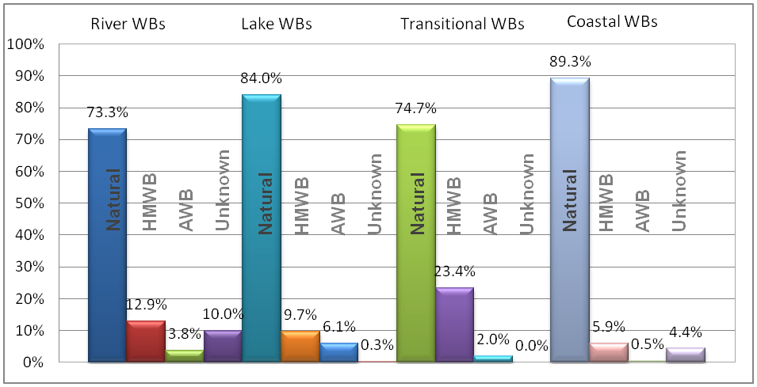

Source: WISE-WFD database early May 2012

Note: The figure represents 104311 river water bodies from 26 countries and 19053 lake water bodies. There are 1010 transitional water bodies and 3033 coastal water bodies. All water bodies are included, i.e. water bodies with classified ecological status or potential and water bodies with unknown status or potential.

Some 6.3 % of the classified coastal water bodies in Member States are identified as heavily modified (5.8%) and artificial (0.5%). One fourth of the transitional water bodies in EU16 Member States are identified as heavily modified (23.4 %) and artificial (2.0 %). This accounts for 191 HMWB/AWBs out of 3027 coastal water bodies and 256 HMWB/AWBs out of 1010 transitional water bodies in EU (Figure 4.1).

The situation varies widely between Member States in case of transitional and coastal water bodies, as well. Malta, the Netherlands, Cyprus, Poland and Romania designated more than 20 % of their coastal water bodies as heavily modified or artificial. Artificial water bodies in coastal waters are designated only in the United Kingdom and the Netherlands. Belgium, Germany and the Netherlands identified all their transitional water bodies as heavily modified or artificial, although the numbers of them are low, six or five. In the Netherlands, for example, major proportion of water bodies has been morphologically altered during the last thousand years. Land reclamation was a large-scale activity in coastal parts of the Netherlands. Flood protection is a major pressure as well, aim of which is to protect millions of people (Delta dilemmas, 2005:9).

In the Greater North Sea region more than 60 % of transitional water bodies are identified as heavily modified or artificial, while in the Black Sea region almost 60% of such water bodies are identified (Maps 4.1c). In other sea regions this percentage is below the EU average of 25.3%. Seven Member States (Portugal, Poland, the UK, Bulgaria, Belgium, Germany and the Netherlands) have more than 25 % of their transitional water bodies identified as heavily modified or artificial. Spain, Lithuania and France had 25% of such bathing waters.

The largest number of coastal and transitional HMWB/AWBs can be found in the United Kingdom (65 and 107, respectively), followed by Spain (33), Sweden (23) Finland (13), France (10) and Greece (10) for coastal water bodies, and Spain (50), France (24), Italy (16), Portugal (15), Bulgaria (10) and Ireland (10) for transitional water bodies. In contrast, no heavily modified or artificial coastal water body has been identified in Belgium, Bulgaria, Latvia and Lithuania. No transitional water body is designated as heavily modified or artificial in Greece, Latvia and Romania (Maps 4.1c and d). Cyprus, Denmark, Malta, Estonia and Finland reported no transitional water bodies, natural or HMWB/AWBs.

|  |  |
| --- | --- |
| Map 4.1 Percentage of heavily modified and artificial water bodies for rivers and lakes and division natural, heavily modified, artificial and unkown water bodies for transitional and coastal waters | |
| a) river WBs by river basin district | b) lake WBs by river basin districts |
| D:\VITUKI\TÉMATÁR\1 ÉLŐ\724-65-8341 ETC ICM\19 Draft EEA HYMO report\3 Ábrák Kingától\02_river_hmwb_awb_vagott.jpg | D:\VITUKI\TÉMATÁR\1 ÉLŐ\724-65-8341 ETC ICM\19 Draft EEA HYMO report\3 Ábrák Kingától\02_lake_hmwb_awb_vagott.jpg |
| c) transitional WBs | d) coastal WBs |
|  |  |
| Source: WISE-WFD database early May 2012  Note to c): 69 water bodies (natural and one artificial) are not presented on the map due to missing coordinates. All are located in Italy (Sardinia and Southern Apennines).  Note to d): 323 water bodies (natural and unknown type) are not presented on the map due to missing coordinates. All are located in Italy (Sardinia and Southern Apennines). | |

Two sea regions of Europe (Greater North Sea and Black Sea) and seven Member States (the UK, Spain, Malta, the Netherlands, Cyprus, Poland and Romania) have more than 10 % of their coastal water bodies identified as heavily modified or artificial (Map 4.1d). The percentage heavily modified or artificial water bodies is above the EU average of 6.3% also in the Celtic Seas, Bay of Biscay and Iberian Coast regions while it is below average in the Mediterranean Sea and Baltic Sea regions.

Common features for the North-East Atlantic Ocean coasts are rich biodiversity, growing tourism and recreation use as well as heavy traffic. Especially in the Greater North Sea, sediment extraction, world's largest harbours and growth of both industry and population cause pressures for coastal zone (OSPAR Commission 2011, in Laukkonen, 2011). The Greater North Sea coastal zones of Belgium, the Netherlands and Germany are almost uninterruptedly covered by protecting structures, leading to extensive habitat fragmentation. These countries have a long tradition in coastal protection. Mostly hard structures have been used, such as dikes, groyne fields and seawalls. However, the length of soft defences, such as beach nourishment schemes, is increased each year and already significant parts of the Belgian, Dutch and Danish North Sea shores are defended using these techniques. On the contrary, countries with long coastlines, including cliffs and rocks, protect only a small portion of the coastline. This protection against erosion is generally restricted to hard defence techniques near harbours and cities (OSPAR Commission 2009:2, 10, 14).

As one of the most heavily transported sea, many coasts of the Baltic Sea have been altered due to harbours, but also flood protection, bridges and underwater cables and pipes have changes hydromorphology of Baltic Sea coastline (Helcom, 2010 in Laukkonen, 2011).

The Mediterranean is one of the most popular tourist destinations in the world, which causes significant pressures in coastal zone (Stanners & Bourdeau 1995:116, cited by Laukkonen, 2011). As Mediterranean tourism is predominantly of a seaside character, all installations constructed specifically on the coastline contribute to the artificial coasts cover. The development of boating also contributes in exacerbating this phenomenon via the construction of ports and of marinas, both of which are large area consuming. These impacts are strongly aggravated by seasonal and spatial concentration of tourism activities. Thus, the high population density on holiday sites exerts pressure on water resource and natural medium (UNEP/MAP-Plan Bleu 2009:101).

## Water uses for which water bodies are identified as heavily modified water bodies

In 2009 a questionnaire to Member States on water uses for which water bodies are identified as HMWB resulted in answers from 24 countries (EU27 Member States except (Denmark, Greece, Italy and Malta) and Norway). Member States reply relates to designation of all categories of surfaces water bodies and it has not been possible to split the results by rivers, lakes, transitional and coastal waters. The 2009 questionnaire reply is based on information from 12 148 HMWBs comparable to the 13 950 HMWBs reported by Member States ultimo 2011 .

According to WFD Article 4(3) for a water body designated HMWB different reasons may be accepted, such as:

* the wider environment;
* navigation, including port facilities, or recreation;
* activities for the purpose of which the water is stored, such as drinking water supply, power generation, irrigation and other water storage;
* water regulation, flood protection, land drainage; or
* other equally important sustainable human development activities (activities).

Figure 4.2 summarises the absolute HMWB numbers per water uses based on the questionnaire replies.

Figures 4.2 Absolute numbers of designated heavily modified water bodies per water use

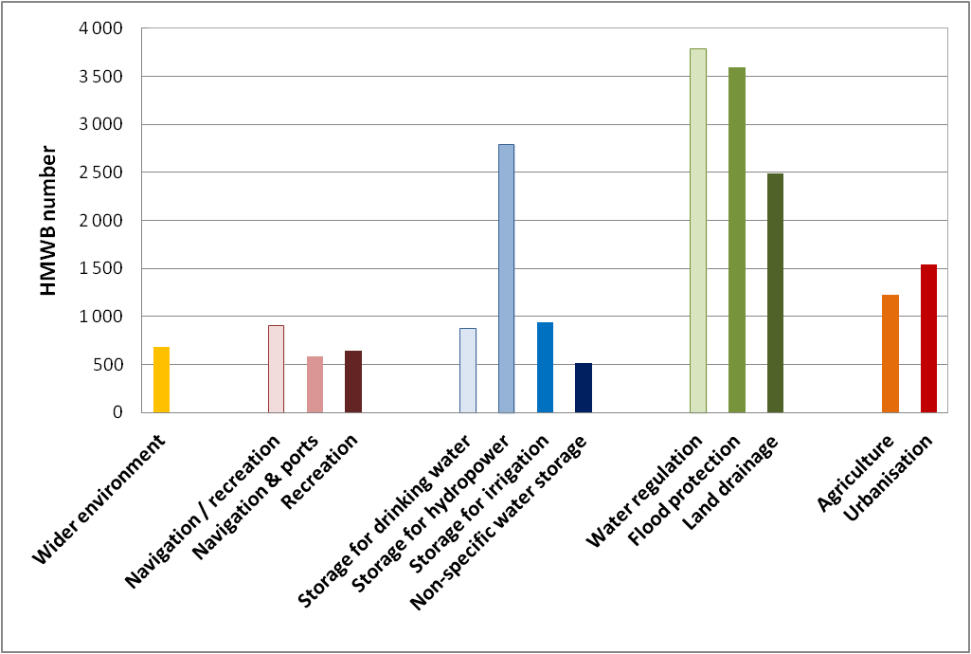

Note: Based on questionnaire replies from 23 Member States and Norway in 2009.

Source: Discussion paper: <http://ecologic-events.eu/hmwb/documents/Discussion_Paper_Updated.pdf>

From the water uses for designation of HMWB water regulation, flood protection, storage for hydropower and land drainage are the most common uses. Agriculture and urbanisation, which have been defined as equally important sustainable human development activities, follow in the order of importance as uses related to HMWB designation. It turned out from the survey that navigation (including port facilities), recreation and the wider environment are the uses with the lowest number of designated HMWB.

In the designation process water bodies can be designated as heavily modified for more than one uses. Two-thirds of the designated HMWBs have only one water use, while 19 % had two uses and 13 % had multiple uses. In terms of regional and sector variation, the followings may be noted:

* Navigation (total 583 WBs): The three Member States (United Kingdom, Germany, Spain) which reported the highest numbers of HMWB for navigation account for about 57% of all navigation-HMWBs;
* Recreation (total 642 WBs): The five Member States (DE, UK, PL, CZ, LT) which reported the highest numbers of HMWB for recreation account for about two-thirds of all recreation-HMWBs;
* Storage for drinking water (total 874 WBs): The four Member States (UK, NO, ES, FR) which reported the highest numbers of HMWB for drinking water storage account for about 70% of all drinking-water-storage-HMWBs;
* Storage for power generation (total 2793 WBs): The five Member States (NO, SE, DE, AT, UK) which reported the highest numbers of HMWB for hydropower account for about 70% of all hydropower-HMWBs;
* Storage for irrigation (total 941 WBs): The five Member States which reported the highest numbers of HMWB for irrigation storage (PL, BG, CY, ES, PT) account for about 82% of all irrigation-storage-HMWBs;
* Water regulation (total 3784 WBs): The three Member States which reported the highest numbers of HMWB for water regulation (NO, DE, PL) account for about 79% of all water-regulation-HMWBs;
* Flood protection (total 3598 WBs): The four Member States which reported the highest numbers of HMWB for flood protection (UK, DE, AT, PL) account for about 72% of all flood-protection-HMWBs;
* Land drainage (total 2488 WBs): The four Member States which reported the highest numbers of HMWB for land drainage (DE, UK, LT, EE) account for about 96% of all land-drainage-HMWBs;
* Agriculture (total 1222 WBs): Germany alone accounts for 96% of the HMWB designated due to agriculture including forestry;
* Urbanisation (total 1543 WBs): Germany and United Kingdom account for 91% of the HMWB designated due to urbanisation.

## Case studies

### HMWBs / AWBs in Germany

Source: UBA 2010:

Heavily modified water bodies in Germany comprise shipping routes and impounded river reaches, whereas artificial water bodies can be, for example, canals or opencast mining lakes. Less than half of German surface waters are classified as natural one, while 37 % and 15 % of the surface waters were classified as heavily modified and as artificial ones, respectively. Most of the HMWBs are located in the North West of the country, in the low-land part of the Rhine, Weser, Ems, Elbe, and Eider RBD (Map 4.2).

In the Alpine region and highland generally more than two thirds of the river water bodies are in natural state, while in the lowlands streams, rivers and large rivers the majority of river water bodies have been designated as HMWBs (Figure 4.3).

The main reasons for classifying German water bodies as heavily modified are land drainage, urban and infrastructure use, agriculture, but also water regulation and flood protections are important causes for designating water bodies as heavily modified (Figure 4.4).

|  |  |
| --- | --- |
| Map 4.2 Map of natural, HMWBs and AWBs in Germany | Figure 4.3 Classification into natural and heavily modified water bodies of different German river types |
| |  |  |  | | --- | --- | --- | | **Natural WBs** | **HMWBs** | **AWBs** | |  |  |  | |  |

Source: <http://www.uba.de/uba-info-medien-e/4021.html> Source: UBA 2010

Figure 4.4 Main grounds for classifying German water bodies as heavily modified

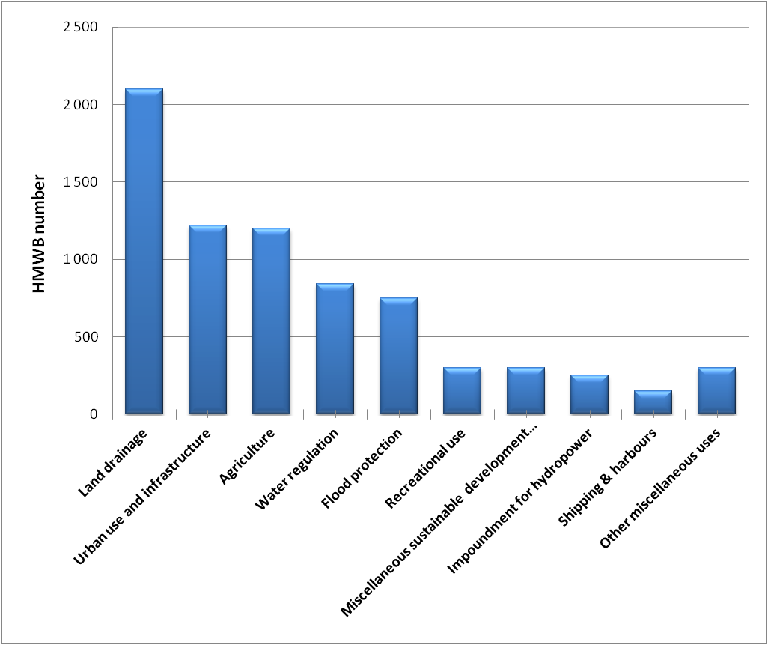

### Danube International RBD

The Danube Integrated River Basin District Management Plan[[1]](#footnote-1) provide a detailed overview of the final designation of heavily modified and artificial water bodies, which have catchment area larger than 4000 km2. Out of overall 681 river water bodies in the entire DRBD (Danube River and DRBD Tributaries) a total number of 270 are designated as heavily modified (241 final and 29 provisional HMWBs). These are 40 % of the water bodies. Further, 21 water bodies are AWBs. This means that 9,835 km out of 25,117 river kilometres are heavily modified (83 % final HMWBs and 17 % provisional HMWBs) due to significant physical alterations causing a failure of the *good ecological status*. 1,592 km of the Danube River itself are designated as HMWB – this is 56 % of its entire length (83 % final and 17 % provisional). Table 4.1 summarises the designation of HMWBs for all DRBD rivers, the Danube River itself and the three transitional water bodies in the DRB indicating absolute numbers and length of water bodies designated as HMWB.

Table 4.1 Designated HMWBs in the Danube River and all rivers of DRBD

|  |  |  |
| --- | --- | --- |
| ***Rivers – Danube River Basin District (DRBD)*** | | |
| Total WB length (km): 25 117 | Total HMWB length (km): 9 835 | Proportion HMWB (length): 39% |
| Total number of WBs: 681 | Total number of HMWBs: 270 | Proportion HMWB (number): 40% |
| ***The Danube River*** | | |
| Total WB length (km): 2 857 | Total HMWB length (km): 1 592 | Proportion HMWB (length): 56% |
| Total number of WBs: 45 | Total number of HMWBs: 26 | Proportion HMWB (number): 58% |

Source: Danube River Basin District Management Plan, ICPDR, 2009.

Out of a total of 45 Danube River water bodies, 21 water bodies were designated as finally heavily modified by the EU MS. 5 were designated as provisionally heavily modified by the Non EU MS. Therefore, 1,592 rkm of the entire Danube River length (56%) have been designated as HMWB. No artificial water body has been designated.

In the DRBD out of seven lake water bodies (one of them being transitional), none was designated as finally heavily modified. No lake water body was identified as artificial. Out of the five coastal water bodies, two were designated as finally heavily modified. No coastal water body was identified as artificial.

### Rhine RBD

The Internationally Coordinated Management Plan for the International River Basin District of the Rhine provides information on the classification of the water bodies of the main stream of the Rhine. The sections of the river as of heavily modified, artificial or natural character are shown in Map 4.3 which indicates the percentages of water bodies in the main stream of the Rhine. 12% of the water bodies are classified as natural, 76% as heavily modified and 12% artificial type calculated by the number of water bodies. Closer to the mouth of the river water bodies are dominantly artificial or heavily modified.

Map 4.3 Categories of waters (natural, artificial and heavily modified surface water bodies) in the Rhine River Basin District

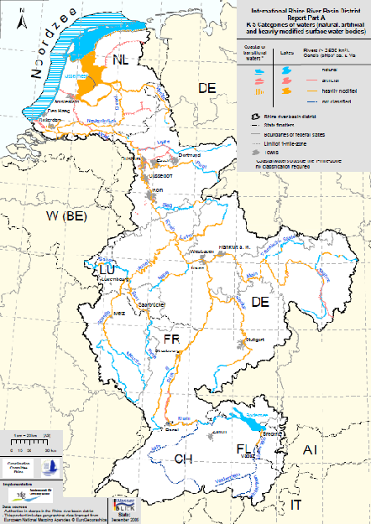

Source: Internationally Coordinated Management Plan for the International River Basin District of the Rhine, ICPR, December 2009.

### Heavily modified water bodies in selected coastal areas

*Heavily modified water bodies in Malta*

The coastal waters around the Maltese Islands have been divided into nine distinct water bodies of which two are heavily modified. A water body has been designated as heavily modified water body by applying the following criteria:

* The failure to achieve good status results from physical alterations to the hydromorphological characteristics of the water body and not due to chemical pollution.
* The water body must be substantially changed in from its natural condition such that the change in character is extensive/widespread or profound and therefore permanent and irreversible (Malta Resources Authority, 2011a).

Two water bodies include two major industrial coastal harbours (Il-Port Il-Kbir and Il-Port ta’ Marsamxett (MTC 105) and Il-Port ta’ Marsaxlokk (MTC 107) along the NW-NE coast of Malta (Figure 4.5). As expected, hydromorphological changes within these major inlets consisting of extensive marine constructions and land reclamation, were considered to have had a significant impact on the ecosystems. For this reason, these water bodies were identified as heavily modified water bodies (HMWB) (Malta Resources Authority, 2011b).

The harbours are subject to continuous morphological change, not to mention the historical impacts on the morphology of the harbours ever since the Knights of St. John used the harbour as the major point of defence during the 16th Century. Dredging continuously takes place; land has been reclaimed for the building of weirs, platforms, quays and also for the carrying out of ship repairs. The port of Marsaxlokk has also been subject to intensive physical alteration with the development of the Freeport and oil terminals. Changes to the coastline within established port areas are inherent for their continued commercial operation especially in order to retain competitiveness within the Mediterranean (Malta Resources Authority, 2011a).

In case of water body at port of Kbir and port of Marsamxett (MTC 105), historical and contemporary coastal reclamation linked to industrial and tourism and related to port development and transformation has inevitably led to a change in the hydrological dynamics of water and sediments and transformation of the biological communities (particularly the benthic biological communities). Dredging works is related to capital projects. In case of water body at port of Marsaxlokk (MTC 107), large-scale marine constructions and land reclamation activities is related to the construction and operation of Malta Freeport at the mouth of the harbour. Periodic operational dredging activities are associated with Malta Freeport operations. Quay development is related to the development of the Delimara power station. Quay development in inner-harbour area is related to fishing harbour activities. There is beach reclamation at Birzebbugia (inner harbour area) at Pretty Bay (Malta Resources Authority, 2011b).

Small-scale marine constructions, land reclamation and recreation (boating) affect one natural water body (L’Irdumijiet t’Għawdex - MTC 101). Various coastal developments along the accessible coastline and within the many inlets and bays related to urban development, tourism and recreation affect another natural water body (Il-Mellieħa/Tas-Sliema - MTC 104). However, impact is not considered important on the large-scale because of open nature of coastline. There are also beach replenishment projects (Malta Resources Authority, 2011b).

*Transitional and coastal HMWB/AWBs in the Thames RBD (the UK)*

The Thames RBD stretches from the source of the River Thames in Gloucestershire through London to the Greater North Sea. Dominated by Greater London, the eastern and northern parts of the river basin district are heavily urbanised. The estuaries and coastline provide varied biodiversity, recreation and industrial opportunities for the people living and working in the Thames RBD. But this has lead to many environmental pressures being concentrated in this area. The estuaries and coastlines have been the subject of physical modification over the years. Continued development has been identified as a need within this catchment, particularly associated with the ‘Thames Gateway’ growth area. Future development and associated infrastructure includes flood defences and provision of drinking water and sewerage. Estuaries and coasts are also physically managed to facilitate navigation to ports and to enable commercial fisheries activities (Environment Agency, 2009: 79-80).

Figure 4.5 HMWB/AWBs in Malta, the RBD Thames (the UK) and the RBD Schledt (Belgium and the Netherlands)

|  |  |
| --- | --- |
| Arial photos of the **two Maltese HMWBs** | |
| Source: Google Earth, 2011 | Source: Google Earth, 2011 |
| **HMWB/AWBs in the RBD Thames (the UK)**  **Description: Kép1.jpg** | |
| **HMWB/AWBs in the RBD Scheldt (Belgium and the Netherlands)**  **Description: Kép2.png** | |

Note: The two lower maps based on WFD Art.13 reporting, Corine Land Cover 2006, Eurosion data 2004, ETC/ICM-ICES, 2011.

There are eleven transitional water bodies in the Thames RBD stretching from the upper Thames estuary in London to coastline (Figure 4.7). All are designated as heavily modified or artificial water bodies except for one small natural water body. The Thames RBD includes one coastal water body identified as heavily modified. The neighbouring coastal water bodies are heavily modified as well. The lower Thames estuary and coastline of the bay is defended by coastal erosion defence structures.

*Scheldt RBD (Belgium and the Netherlands)*

RBD Scheldt encompasses parts of Belgium and the Netherlands and a small part of NW France. The river flows into the Scheldt estuary, the Westerschelde. This estuary has a large tidal range and consists of a mixture of channels and large tidal flats that are exposed during low tide. Starting from as early as the year 1000 the first dikes were constructed in this estuary for land reclamation. This practice of land reclamation and modification of the water bodies has continued since.

After the flood disaster of 1953 in which 1836 people and 30 000 animals lost their lives, it was decided to improve flood protection in the Scheldt estuary. As part of the Delta Project, new dams, flood barriers and dikes were constructed. This drastically changed the Delta area in the SW Netherlands. Almost all transitional water bodies with exception of the Western Scheldt, have been closed off completely or have reduced exchange with the North Sea. Therefore these water bodies were converted into basins with a strongly regulated hydrological regime. Salinity differs between basins and ranges from freshwater to brackish water to fully saline water. The preferred salinity and water level of each compartment are managed using sluices and weirs (Ministry of Transport, 2009:19).

*Pressures and impacts*

The majority of the coastline in the Dutch part of the RBD as well as parts of the Belgian RBD are protected and armored mainly by hard infrastructure for coastal protection and erosion management. This changes the flow dynamics and shore geomorphology resulting in loss of habitat and biodiversity. Next to using hard structures, in 1990 The Netherlands adopted a dynamic coastal management strategy on beach and foreshore nourishments to strengthen the natural flood defense system of the coast. These sand nourishments counteract erosion and allow for natural dune growth. For the years 2011/2012 over 2 million m3 of sand will be used for nourishments within the Scheldt RBD. More recently, the “Building with Nature” principles are adopted, in which natural processes, such as siltation, the role of organisms and ecosystem services are incorporated in planning and designing innovative ecodynamic protection works.

The transitional and coastal waters in the Dutch and Belgian parts of the Scheldt RBD are among the most heavily navigated in the world, containing two major shipping routes in the North Sea with an average traffic density exceeding 45 ships per 1000 km2. The port of Antwerp, the second largest sea port in Europe is situated in the upper Scheldt estuary. To keep this port accessible for large container ships, the estuary has to be dredged on a regular basis to maintain a channel depth of 13.1m. Deepening of the main shipping channel alters the hydrodynamic properties of the Scheldt and also impacts various habitats within the estuary. Additionally, boating is very popular in Dutch and Belgian transitional and coastal waters (FOD Volksgezondheid... 2009:33, 36).

*Hydromorphological status*

The Western Scheldt estuary in the Netherlands is designated as a heavily modified transitional water body (HMWB), while the neighboring Eastern Scheldt estuary is designated as heavily modified coastal water body. The canal that connects both estuaries (about 7 km) is designated as artificial coastal water body (AWB). One port along the Belgian coast is heavily modified and three others are artificial. The large port in the upper Scheldt estuary (Antwerp) is also a heavily modified transitional water body. The Belgian part of the tidal inlet on the border between Belgium and the Netherlands is identified as a natural coastal water body, while the Dutch part is heavily modified.

*Ecological status*

As a result of the hydromorphological and other pressures and the extensive modifications of the water bodies of the Scheldt RBD, there is hardly any water body with a good ecological status/potential. The hydromorphological conditions constrain the ecological status due to reduced tides, hard structures for coastal protection and dredging of the channel. It should be noted, however, that there is presently no standard frame of reference to determine the ecological status of HMWB/AWB’s. Therefore, the risk assessment for these waters was done using the ecological status scale for natural waters. In the coming years a standard frame of reference will be set up to effectively evaluate the HMWB/AWB’s of the Scheldt using metrics appropriate to modified water bodies.

## Ecological status and potential

Water Framework Directive (WFD) defines “Ecological status” as the quality of the structure and functioning of aquatic ecosystems associated with surface waters. *Ecological status* results from assessment of the biological status of all WFD biological quality elements (fish, macroinvertebrates, phytoplankton, phytobenthos, macrophytes) and the supportive physico-chemical parameters (general and specific ones). According to ecological status water bodies can be classified into five categories, such as high, good, moderate, poor and bad.

When a water body designated as heavily modified or artificial it means that instead of “good ecological status” (GES), an alternative environmental objective, namely “good ecological potential” (GEP), has to be achieved for those water bodies, as well as good chemical status. The objective of GEP is similar to good ecological status, but takes into account the constraints imposed by social and/or economic uses. However, artificial and heavily modified bodies will still need to achieve the same low level of chemical contamination as other water bodies. Good ecological potential provides a sustainable balance between the socio-economic heritages and/or conservation interests that cause hydromorphological pressures versus doing all that can to improve the ecological condition of the water body.

A HMWB or AWB is at GEP when the hydromorphological characteristics have been improved to the fullest extent, but without a significantly adverse impact on the use or wider environment. However, heavily modified and artificial bodies will still need to achieve the same low level of chemical contamination as other water bodies.

## Comparison of ecological status and potential of natural, HMWB and AWBS

### Key messages

* Less than half of surface water bodies in Europe are reported to be at least good ecological status or potential
* Only few heavily and artificial water bodies have been classified as having high ecological potential
* The overall ecological status are generally better for the natural water bodies compared to the heavily modified and artificial water bodies ecological potential:
  + Nearly half (47,3 %) of the natural river water bodies have at least good ecological status, while only 15 % of the heavily modified and 26% of artificial river water bodies have at least good ecological potential.
  + More than 60 % of the natural lake water bodies have at least good ecological status, while only 29 % of the heavily modified and 28% of artificial lake water bodies have at least good ecological potential.
  + Around 40 % of the natural transitional water bodies have at least good ecological status, while less than 20 % of the heavily modified and artificial transitional water bodies have at least good ecological potential.
  + More than half (53 %) of the natural coastal Water bodies have at least good ecological status, while one third (35 %) of the heavily modified and artificial coastal water bodies have good ecological potential.

### Assessment

Overall, more than half of the total number of classified surface water bodies designated as HMWBs or AWBs in Europe has less than good ecological potential. All these water bodies thereby need management measures to restore their ecological potential to fulfil the WFD objective. A higher proportion of water bodies with moderate or worse ecological status or potential are reported for rivers and transitional waters than for lakes and coastal waters.

There are only a few river heavily modified water bodies which have been classified as at least good ecological potential, while no artificial water bodies of rivers or lakes are having high ecological potential (Figure 4.6).

The overall ecological status is generally better for the natural water bodies compared to the heavily modified and artificial water bodies ecological potential. Nearly half of the natural river water bodies have at least good ecological status, while heavily modified and artificial river water bodies have much lower ration of at least good ecological potential.

Figure 4.6: Ecological status or potential of natural and heavily modified and artificial water bodies.

|  |  |
| --- | --- |
| River WBs by count | Lake WBs by count |
|  |  |
| Transitional WBs by count | Coastal WBs by count |
|  |  |

Note: Based on water bodies with classified ecological status or potential (water bodies with unknown status not included). Source: WFD-WISE database of early May 2012;

wfd.atkins.dk/report/WFD\_aggregation\_reports/SWB\_pressure\_status

More than 60 % of the natural lake water bodies have high or good ecological status, while only 28 % of the heavily modified and artificial lake water bodies have good ecological potential.

Around 40 % of the natural transitional water bodies have at least good ecological status, while less than 30 % of the heavily modified and artificial transitional water bodies have good ecological potential (Figure 4.6, Map 4.4).

More than half of the natural coastal water bodies have at least good ecological status, while one third of the heavily modified and artificial coastal water bodies have good ecological potential.

Map 4.4: Overall ecological potential of classified HMWB/AWBs and overall ecological status of classified natural water bodies with hydromorphological pressures for transitional and coastal waters.

|  |  |
| --- | --- |
| Transitional waters | Coastal waters |
|  |  |

Source: WISE-WFD database early May 2012

Note: Based on water bodies with classified ecological status or potential (water bodies with unknown status not included).

## Case studies on ecological status and potential

### Case study of ecological status and potential

*A case study illustrating ecological status and potential of rivers and lakes to be included. Member States or RBDs are appreciated.*

*Add a short case study on rivers and lakes*

### Ecological status or potential in selected coastal areas

*Black Sea region and its catchment (Romania)*

In the Black Sea region of Romania, two coastal water bodies are identified as heavily modified and two as natural. Both HMWBs are located along ports (Constanca and Mangalia). Coastal water bodies have moderate status/potential except for HMWB in long narrow coastal bay (about 7 km) along Mangalia with bad potential. Two natural transitional water bodies are designated in the Danube Delta with lagoons along the northern part of the Black Sea coast of Romania. They are of poor and bad status respectively. Ecological status/potential of freshwater water bodies close to the coastline is manly moderate (Figure 4.7).

*Baltic Sea region and its catchment (Germany)*

In the Baltic Sea region of Germany, five coastal water bodies are identified as heavily modified. All are located in bays with ports (Kiel, Lübeck, Travemünde, Wismar and Rostock) and accompanying dredging sites. For two HMWBs in Wismar and Rostock, hydromorphological pressures and impacts have been reported (water flow regulations and morphological alterations of surface water; altered habitats). All HMWBs have poor ecological potential. Other non-modified coastal water bodies that predominate are of moderate to bad status, except for one water body of good status. hydromorphological pressures were identified for none of natural water bodies despite the ports, dredging and coastal erosion defence works. No transitional water bodies are designated in German part of Baltic Sea region. Ecological status/potential of freshwater water bodies close to the coastline is manly poor to bad status.

*Western Mediterranean Sea region and its catchment (France)*

There are many TC water bodies in the Western Mediterranean Sea region of France. Six coastal and four transitional water bodies are identified as heavily modified. In addition, 12 natural transitional water bodies are affected by hydromorphological pressures and impacts. Coastal HMWBs are located in bays along tourist resorts with ports (Sète, Marseille, Toulon and Nice). They are affected by coastal water management. Four of them suffer hydromorphological impacts - altered habitats. Four out of six coastal HMWBs have already reached good potential, while other two have moderate potential. Natural coastal water bodies are of good to moderate status with good status prevailing.

Transitional water bodies are located in lagoons and the mouth of the Rhone River and its western branch in the western part of the region. hydromorphological pressures have been reported for two transitional HMWBs. One of them is used for water abstraction, while other is affected by water flow regulations and morphological alterations resulting in altered habitats. This pressure also affects natural transitional water bodies with hydromorphological pressures reported. Two transitional HMWBs have reached moderate potential, while two have poor potential. Transitional water bodies that are natural and affected by hydromorphological pressures have poor to bad status, except for two water bodies with good and moderate status respectively. Ecological status of other natural water bodies ranges from good to bad. Ecological status/potential of freshwater water bodies close to the coastline is manly good to moderate.

Figure 4.7: Ecological status and potential of surface water bodies in three coastal regions.

|  |  |
| --- | --- |
| Black Sea region in Romania with catchment area. |  |
| Baltic Sea region in Germany |  |
| Western Mediterranean Sea region in France | HYMO_1_MAP_Med_Rhone |

**Note:** Map based on WFD Art.13 reporting, Corine Land Cover 2006, Eurosion data 2004, ETC/ICM-ICES, 2011., HELCOM, 2011.

# References

Alpine Convention 2011: Situation Report on Hydropower Generation in the Alps focusing on Small Hydropower, platform “Water management in the Alps”, 2011

<http://www.alpconv.org/documents/Permanent_Secretariat/web/WG/2011_Situation_Report.pdf>

ARCADIS & Ingenieurbüro Floecksmühle 2011 <http://circa.europa.eu/Public/irc/env/wfd/library?l=/framework_directive/implementation_conventio/hydropower_september&vm=detailed&sb=Title>

BAFU 2010: Flood protection and ecology of watercourses. http://www.bafu.admin.ch/wasser/01444/01993/index.html?lang=en [accessed 13 September 2010].

Batalla, R.J., Gomez C., nd Kondolf M. 200xRiver impoundment and changes in flow regime, Ebro River Basin, Northeastern Spain. Available at <http://www2.uah.es/econ/Papers/BatallaGomezKondolf03.pdf>

Bernauer, D. and Jansen W. 2006: Recent invasions of alien macroinvertebrates and loss of native species in the upper Rhine River, Germany. Aquatic Invasions. Volume 1, Issue 2: 55-71.

Binder 2008: River restoration: an European overview on rivers in urban areas. In proceedings from 4th ECRR Conference on River Restoration Italy, Venice S. Servolo Island 16-21 June 2008. Avaiable at <http://ecrr.org/archive/conf08/pdf/proceed_all.pdf>

Brookes A 1987: “The distribution and management of channelized streams in Denmark”, Regulated Rivers: Research & Management 1, no. 1 (1987): 3-16.

Brookes, A. (1995): River channel restoration: theory and practice. In: Changing River Channels (eds A.M.Gurnell & G.E.Petts), pp. 369–388. Wiley & Sons, Chichester, UK.

Danube watershed. Available at <http://iahs.info/conferences/CR2010/2010_Praha/full/128.pdf>

Channel Coastal Observatory, 2011 (<http://www.channelcoast.org/gallery/viewphoto/beaches/mixed/1970>) accessed 21 November 2011.

Danube Watch. 2008: Invasion of the Danube. <http://www.icpdr.org/icpdr-pages/dw0803_p_07.htm> . [accessed 20 February 2012].

DEDUCE, 2005, 26.- Coastal erosion and accretion (http://www.deduce.eu/IFS/IFS26.pdf) accessed 21 November 2011

DEFRA 2008: *Making space for water*. Available at <http://www.defra.gov.uk/environment/flooding/policy/strategy/>. [accessed 13 September 2010].

Delta Dilemmas, 2005, Implementing the European Water Framework Directive in the Netherlands. Ministry of transport, public works and water management, Netherlands. Directs Dutch Publications, the Hague. 20 p.

Resource management in Germany, part 1 fundamentals p. 55-56

Deltawerken, 2011. The Delta Works (http://www.deltawerken.com/Deltaworks/23.html) accessed 23 November 2011

DG Transport Inland Waterway Transport <http://ec.europa.eu/transport/inland/index_en.htm>

DSI 2009

EA 2010. Opportunity and environmental sensitivity mapping for hydropower in England and Wales. Environment Agency, London, UK. Available at: http://www.environment-agency.gov.uk/shell/hydropowerswf.html [accessed 13 September 2010].

EEA/SOER 2010 country assessment on Switzerland

EEA, 2011, Corine Land Cover 2006 seamless vector data - version 15 (<http://www.eea.europa.eu/data-and-maps/data/clc-2006-vector-data-version-1>) accessed on 13 October 2011.

EC 2009: Directive 2009/28/EC on the promotion of the use of energy from renewable sources.

http://europa.eu/legislation\_summaries/energy/renewable\_energy/en0009\_en.htm [accessed 13 September 2010].

Engström, Johanna, Christer Nilsson and Roland Jansson (2009): Effects of stream restoration on dispersal of plant propagules. Journal of Applied Ecology 46, no. 2 (2009): 397-405.

ENDS 2008: France unveils plan to boost hydropower. News article from ENDS Europe

24 July 2008 http://www.endseurope.com/15357?referrer=search [accessed 13 September 2010].

ENTSO-E Statistical Yearbook <https://www.entsoe.eu/resources/publications/general-reports/statistical-yearbooks/>

Environment Agency <http://www.environment-agency.gov.uk/homeandleisure/floods/31738.aspx>

Environment Agency (2009): River Basin Management Plan, Thames River Basin District (<http://wfdconsultation.environment-agency.gov.uk/wfdcms/en/thames/Intro.aspx>) accessed 23 November 2011.

Environment Agency 2011: The state of river habitats in England, Wales and the Isle of Man. Available at <http://www.environment-agency.gov.uk/static/documents/Leisure/GEHO0310BRTM-E-E.PDF>

ESHA <http://www.esha.be/fileadmin/esha_files/documents/publications/publications/tnshp/pub_tnshp_soa_en.pdf>

ETC/ICM - ICES, 2011, TC reference layers 20111013 (<http://eea.eionet.europa.eu/Members/irc/eionet-circle/etcwater/library?l=/subvention_2011/activities_2011/151b_wise_reference/milestone_reference&vm=detailed&sb=Title>) accessed 19 October 2011

Eurelectric 2009: Key Statistics 2008. Report from Eurelectric.

http://www2.eurelectric.org/content/Default.asp?PageID=618 [accessed 13 September 2010].

Eurosion data 2004. European Commission, Directorate General Environment. Eurosion - Geomorphology, Geology, Erosion trends and Coastal defence works (http://www.eea.europa.eu/data-and-maps/data/geomorphology-geology-erosion-trends-and-coastal-defence-works) accessed 17 October 2011

Finnish Environment Institute: Regulated lakes and rivers Available at <http://www.environment.fi/default.asp?contentid=356128&lan=EN>

FOD Volksgezondheid, Veiligheid van de Voedselketen en Leefmilieu and Dienst Marien Milieu ( 2009): Stroomgebiedsbeheersplan voor de Belgische kustwateren ter implementatie van de Europese Kaderrichtlijn Water (2000/60/EG)

(<http://cdr.eionet.europa.eu/be/eu/wfdart13/BENoordzee_FED/envtdygyg/STROOMGEBIEDSBEHEERSPLAN_VOOR_DE_BELGISCHE_KUSTWATEREN_.pdf>) accessed 28 Nov 2011.

FOEN 2007, Federal Office for the Environment (FOEN): Gewässer: Geschiebe. <http://www.bafu.admin.ch/gewaesserschutz/04854/index.html?lang=de>

Gilligan 2008: Hydromorphology and river enhancement for flood risk management in Ireland. In proceedings from 4th ECRR Conference on River Restoration Italy, Venice S. Servolo Island 16-21 June 2008. Avaiable at <http://www.ecrr.org/archive/conf08/pdf/proceed8.pdf>

Goldi, C. (1989): Resuscitation programme for flowing waters in the Canton of Zurich. Anthos 2:1-5.

Goldschmid and Schmid 2006 [pdf](http://ttl.tuwien.ac.at/docs/wfd06proceedings.pdf)

Gouvernement, 2008. Un plan de relance de la production hydraulique française. News article 23 July 2008. http://www.gouvernement.fr/gouvernement/un-plan-de-relance-de-la-production-hydraulique-francaise [accessed 13 September 2010].

Harrison, S. S. C., J. L. Pretty, D. Shepherd, A. G. Hildrew, C. Smith and R. D. Hey (2004): The effect of instream rehabilitation structures on macroinvertebrates in lowland rivers. Journal of Applied Ecology 41, no. 6 (2004): 1140-1154.

Hartnett, M., Wilson, J. G., and Nash, S. 2011: “Irish estuaries: Water quality status and monitoring implications under the water framework directive,” Marine Policy In Press, Corrected Proof (n.d.), <http://www.sciencedirect.com/science/article/B6VCD-526YMMH-1/2/e885524f9f4821a7046ea112b6197af3>.

HELCOM, 2011, Dredging sites, HELCOM Map and Data Service (<http://maps.helcom.fi/website/mapservice/index.html>) accessed 17 October 2011

HELCOM, 2011, Harbours, HELCOM Map and Data Service (<http://maps.helcom.fi/website/mapservice/index.html>) accessed 17 October 2011

ICPDR 2009: Danube River Basin Management Plan. Available at <http://www.icpdr.org/icpdr-pages/river_basin_management.htm>

ICPR, 2009: Internationally Coordinated Management Plan for the International River Basin District of the Rhine, ICPR, December 2009. Available at <http://www.iksr.org/index.php?id=240&L=3>

ICPDR, 2010

ICPDR. 2010. Dams and Structures. International Commission for the Protection of the Danube River. Vienna http://www.icpdr.org/icpdr-pages/dams\_structures.htm [accessed 13 September 2010].

Iversen, T. M., B. Kronvang, B. L. Madsen, P. Markmann, and M. B. Nielsen (1993): Re-establishment of Danish streams: restoration and maintenance measures. Aquatic Conservations: Marine and Freshwater Ecosystems 3:73-92.

Jähnig, Sonja C., Stefan Brunzel, Sebastian Gacek, et al., “Effects of re-braiding measures on hydromorphology, floodplain vegetation, ground beetles and benthic invertebrates in mountain rivers”, Journal of Applied Ecology 46, no. 2 (2009): 406-416.

Kampa et al./Ecologic 2011: Water management, Water Framework Directive & Hydropower. Issue Paper Final. Available at <http://circa.europa.eu/Public/irc/env/wfd/library?l=/framework_directive/implementation_conventio/hydropower_september/issue_paper/issuepaper_draft2pdf/_EN_1.0_&a=d>

Katemerini 2010: Court suspends Acheloos works. News article 11 February 2010. http://ekathimerini.com/4Dcgi/4Dcgi/\_w\_articles\_politics\_1100011\_11/02/2010\_114822 [accessed 13 September 2010].

Koch et al. 2011: Climate Change effects on hydropower plants in the Upper

Kondolf, G. M. (1995) Geomorphological stream channel classification in aquatic habitat restoration: uses and limitations. Aquatic Conservation 5:127-141.

Kondolf, G. M. (2006): River restoration and meanders.Ecology and Society 11(2): 42. URL: http://www.ecologyandsociety.org/vol11/iss2/art42/

Laitinen and Jormola 2008: Drainage and fishery needs in the restoration of agricultural brooks In proceedings from 4th ECRR Conference on River Restoration Italy, Venice S. Servolo Island 16-21 June 2008. Avaiable at <http://www.ecrr.org/archive/conf08/pdf/proceed8.pdf>

Laukkonen, E., 2011, Pressures and impacts of hydromorphological alteration of coastal and transitional water bodies in European Union. Draft M.Sc.thesis. 45 p.

Lebensministerium. 2010: Wassernet: *Running waters – Rivers and brooks*. Vienna, Austria <http://www.wassernet.at/article/articleview/67691/1/1460>. [accessed 13 September 2010].

Leuven, R.S.E.W., van der Velde, G., Baijens, I. et al. 2009: The river Rhine: a global highway for dispersal of aquatic invasive species. Biological Invasions. Vol.9. No.11, 1989-2008, DOI: 10.1007/s10530-009-9491-7. Springer-Verlag GmbH, Heidelberg. Germany.

Malta Resources Authority and Malta Environment and Planning Authority (2011a): The Water Catchment Management Plan for the Maltese Islands. 148 p. (<http://cdr.eionet.europa.eu/mt/eu/wfdart13/envto2osw/MT_Water_Catchment_Management_Plan_FINAL.pdf>) accessed 28 Nov 2011.

Malta Resources Authority and Malta Environment and Planning Authority (2011b): Technical Document No 1: Characterisation and designation of coastal waters. The 1st Water Catchment Management Plan. (<http://cdr.eionet.europa.eu/mt/eu/wfdart13/envtogwug/WCMP_Coastal_Waters_final_1_.pdf> ) accessed 28 Nov 2011.

MARM 2010: *Estrategia Nacional de Restauración de Ríos*. <http://www.mma.es/portal/secciones/acm/aguas_continent_zonas_asoc/dominio_hidraulico/conserv_restaur/index.htm> [accessed 13 September 2010].

Marttunen et al. 2006: <http://www.ewaonline.de/journal/2006_05.pdf>

Ministry of Transport, Public Works and Water Management, Ministry of Housing, Spatial Planning and the Environment, Ministry of Agriculture, Nature and Food Quality, 2009, River basin management plans 2009 - 2015, Ems, Meuse, Rhine Delta and Scheldt - a summary (<http://cdr.eionet.europa.eu/nl/eu/wfdart13/nlsc/envtaukqa/sgbpsamenvatting2009-2015-en.pdf/manage_document>) accessed 28 November 2011

Muhar S., Schwarz M., Schmutz S., Jungwirth M. (2000) - Identification of rivers with high and good habitat quality: methodological approach and applications in Austria. Hydrobiologia, 422/423, 343-358.

Muotka, Timo and Jukka Syrjänen (2007): Changes in habitat structure, benthic invertebrate diversity, trout populations and ecosystem processes in restored forest streams: a boreal perspective. Freshwater Biology 52, no. 4 (2007): 724-737.

Naturvårdsverket <http://www.naturvardsverket.se/ImageVault/Images/conversionFormatType_WebSafe/id_5081/scope_0/ImageVaultHandler.aspx>

OSPAR Commission, 2009, Assessment of the impact of coastal defence structures (http://qsr2010.ospar.org/media/assessments/p00435\_Coastal\_defence.pdf) accessed 21 November 2011.

PNBEPH 2008 Programa Nacional de Barragens com Elevado Potencial Hidroeléctrico Web-site http://pnbeph.inag.pt/np4/home.html [accessed 15 September 2010].

Poppe et al. 2008: The prioritisation of restoration measures in multiple-affected rivers. An Austrian approach. In proceedings from 4th ECRR Conference on River Restoration Italy, Venice S. Servolo Island 16-21 June 2008. Available at <http://ecrr.org/archive/conf08/pdf/proceed_all.pdf>

Riis T. and Sand-Jensen K. 2001: Historical changes in species composition and richness accompanying perturbation and eutrophication of Danish lowland streams over 100 years. Freshwater Biology 46, no. 2 (2001): 269-280

Rinaldi M., B. Wyżga, og N. Surian, «Sediment mining in alluvial channels: physical effects and management perspectives», *River Research and Applications* 21, nr. 7 (September 2005): 805-828.

Ruimtevoorderivier 2010: Homepage for the Dutch project “Room for the River”. <http://www.ruimtevoorderivier.nl/meta-navigatie/english.aspx> [accessed 15 September 2010].

Scotland River Basin Management plan available at <http://www.sepa.org.uk/water/river_basin_planning.aspx>

Sánchez Navarro, Rafael et al., “Hydrological impacts affecting endangered fish species: a Spanish case study,” *River Research and Applications* 23, no. 5 (June 1, 2007): 511-523.

Scottish government, natural Scotland, 2009, The river basin management plan for Scotland river basin district 2009-2015. Chapter 1: State of the environment.*.* 41 p.

Scottish Government 2010: The Employment Potential of Scotland's Hydro Resource. Study report from the Scottish Government. http://www.scotland.gov.uk/Publications/2010/01/19141527/0 [accessed 15 September 2010].

Scottish Natural Heritage, 2011, A guide to managing coastal erosion in beach/dune systems.

(http://www.snh.org.uk/publications/on-line/heritagemanagement/erosion/appendix\_1.16.shtml) accessed 13 October 2011

SDF The former INTERREG IIIB project SDF - “Sustainable Development of Floodplains” <http://www.ecrr.org/sdfproject/sdfproject.htm>

Skoulikidis , Nikolaos Th, “The environmental state of rivers in the Balkans—A review within the DPSIR framework,” Science of The Total Environment 407, no. 8 (April 2009): 2501-2516.

Source: Souchon 2007: The Rhône river: hydromorphological and ecological rehabilitation of a heavily man-used hydrosystem. Available at <http://www.uicnmed.org/web2007/cdflow/conten/2/pdf/2_1_France_%20MedCS.pdf>

Surian 2008: Channel adjustments and sediment fluxes in gravel-bed rivers of north-eastern Italy: implications for river restoration. In proceedings from 4th ECRR Conference on River Restoration Italy, Venice S. Servolo Island 16-21 June 2008. Avaiable at <http://ecrr.org/archive/conf08/pdf/proceed_all.pdf>

UBA 2010: Water, 2009

UBA 2010: Water management in Germany. Part 2 Water Quality.

UBA 2010: Water management part I p. 104-107

Umweltbundesamt, 2010

UK Environment agency, 2009, River basin management plan Anglian river basin district, water for life and livelihoods. 68 p.

UNEP/MAP-Plan Bleu, 2009, State of the Environment and Development in the Mediterranean (http://www.planbleu.org/publications/SoED2009\_EN.pdf) accessed 21 November 2011

Uudenmaan, Etelä-Savon, Hämeen, Kaakkois-Suomen, Keski-Suomen ja Pohjois-Savon ympäristökeskus (2010). Kymijoen-Suomenlahden vesienhitoalueen vesienhoitosuunnitelma vuoteen 2015. Yhteistyöllä parempaan vesienhoitoon. Edita Prima Oy. 193 s.Viles, H. & T. Spencer (1995). Coastal Problems: geo-morphology, ecology and society at the coast. 350 p. Arnold, London.

WWF 2010: Justice for Acheloos. News item at the WWF Greeece web-site http://www.wwf.gr/en/index.php?option=com\_content&view=article&id=659:justice-for-acheloos&catid=70:2008-09-16-12-10-46&Itemid=90 . [accessed 15 September 2010].

# Appendix 1: Abbreviations used

AWB – Artificial water body

EEA – European Environmental Agency

ETC / ICM – European Topic Centre on Inland Coastal and Marine Waters

EU – European Union

GEP – Good ecological potential

HMWB – Heavily modified water body

MS – Member States

WFD – Watre Framework Directive

WFD-CIS – Water Framework Directives Common Implementation Strategy

1. <http://www.icpdr.org/icpdr-pages/river_basin_management.htm> [↑](#footnote-ref-1)