SoWater 2012 assessment template
For each of the assessments done by the ETC/ICM on results from RBMPs an assessment document is produced. The assessment will be 5-10 pages document providing an overview of the main results and document the methodology. The document will follow a general template to ensure that the relevant aspects are covered. Keep it simple and try to tell a story.

Draft PKR 22/06/2011
All assessments should be document with information on date, version number and contact person. – Several related assessments may be produced e.g. on aquatic species and Natura 2000 – or on Floodplains and Natura 2000

Title Natura 2000 and River Basin Districts
The document should have a short title describing the assessment.

Key messages
- 2-5 brief key messages should describe the main results.

Main diagrams
Include 1-2 main diagrams that support the main messages. All diagrams based on RBMPs have in 2011 to be marked with preliminary results
Source: http://circa.europa.eu/Public/irc/env/wfd/library?l=/framework_directive/implementation_conventio/biodiversity_legislation/workshop_presentations/conservation_sleinerppt/_EN_1.0_&a=i <Describe how the map could be updated for the 2012 State of water report>

Table/diagram on the area of Nature 2000 in RBD

Assessment
This is the main part of the assessment document.
Include analysis text that describe and analyse the results. More diagrams, case studies (as ½-1 page text boxes) may be included.
The text should not only describe what can be read out of the graphs/maps (e.g. four countries have classified more than half of their water bodies as being heavily modified), but try to explain the results (The Netherlands has very few natural water bodies, more than 95% are HMWB or AWB. The low-lying position, the intensive land use and the transport over water have drastically changed the water system in many places. Particularly in the low-lying part of the Netherlands, most of the smaller surface waters were excavated by humans. There are large-scale damming up of tidal outlets and embankments of large rivers to protect the country from flooding.)

Do not overload the assessment with graphs and text, but try to tell a rounded story. If more aspects need to be covered start a new assessment document.

Background information
Add background contextual information. Such as text from the directive and other sources.
Example text
Nature protection plays a role in implementation of the Water Framework Directive in that the purpose of the EU’s Bird Protection and Flora-Fauna Habitat Directives is to establish Natura 2000, a coherent ecological net-work of special protected areas in Europe. The aim of Natura 2000 is to protect or in some cases restore endangered Europe-wide habitats and ensure the survival of protected species. Water Framework Directive measures are harmonized with the applicable Natura 2000 conservation and development objectives in connection with the management of groundwater and surface waters that are located in a Natura 2000 site, and are coordinated with nature conservation authorities.

Birds and Habitat Directive: Both of these directives have similar conservation aims: protecting natural habitats, fauna and flora and creating a European network of protected sites including water-dependent species and habitats. The resulting Special Areas of Conservation and Special Protection Areas designated by Member States make up the European Natura 2000 network.

Definitions

Methodology notes
Add a brief description of the methodology aspects.

References
Keep always the reference list updated

Annex: Examples of Natura 2000 areas in selected RBD

Weser RBMP
3.4 Wasserabhängige EG- Vogelschutz- und FFH-Gebiete
Erfasst wurden die FFH-Gebiete (92/43/EWG) und EG-Vogelschutzgebiete (79/409/EWG). Diese Daten bilden die Grundlage für die Übersichtsdarstellungen der wasserabhängigen Natura 2000-Gebiete. In der Flussgebietseinheit Weser sind 611 wasserabhängige FFH- bzw. 146 wasserabhängige Vogelschutzgebiete ausgewiesen. Diese verteilen sich auf 4.770 km² (9,7 % der Gesamtgebietsfläche) wasserabhängige FFH- bzw. 5.580 km² (11,4 % der Gesamtgebietsfläche) wasserabhängige Vogelschutzgebiete.
Eine Überschneidung beider Schutzgebietstypen betrifft ca. 2.770 km² bzw. 5,7 % der
Fläche der Flussgebietseinheit Weser. Die ausgewiesenen EG-Vogelschutz- und FFH-Gebiete sind in Abb. 3.2 dargestellt.
Google translation: Data was gathered for Special Areas of Conservation (92/43/EEC) and EC bird protection areas (79/409/EEC). These data form the basis for easy viewing of water dependent Natura 2000 sites. In the Weser river basin water-dependent FFH 611 and 146 water-dependent bird protection areas have been designated. These are spread over 4770 km ² (9.7% of the total surface area), water-dependent habitats or 5580 km ² (11.4% of the total surface area), water-dependent bird sanctuaries.
A cross between these two types of protected areas affects approximately 2770 km ² or 5.7% of
Area of ​​the Weser river basin. The reported EC Birds and Habitats Directive areas are shown in Figure 3.2.
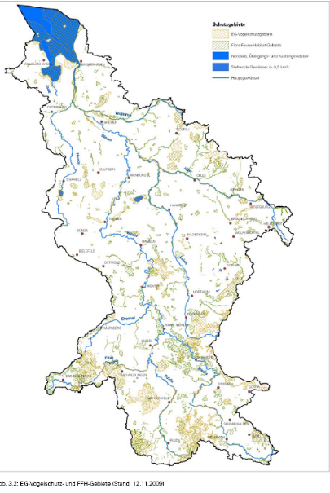

(German part of) Elbe RBMP
3.5 Wasserabhängige FFH- und Vogelschutzgebiete (Anhang IV 1 v)
Gebiete, die der Europäischen Kommission zur Aufnahme in das europäische ökologi-sche Netz „Natura 2000“ vorgeschlagen wurden, d. h. die ihr als FFH-Gebiete nach der Fauna-Flora-Habitat-Richtlinie (92/43/EWG) oder als Vogelschutzgebiete nach der Richt-linie 79/409/EWG (Vogelschutzrichtlinie) benannt wurden, sind nach Anhang IV 1 v WRRL ebenfalls Bestandteil des vorliegenden Schutzgebietsverzeichnisses. Für das Verzeichnis wurden diejenigen Schutzgebiete ausgewählt, in denen die Erhaltung oder Verbesserung des Wasserzustands ein wichtiger Faktor für das jeweilige Gebiet ist (wasserabhängige FFH- und Vogelschutzgebiete). Rechtsgrundlagen für die Umsetzung der Richtlinien sind das Bundesnaturschutzgesetz und das Wasserhaushaltsgesetz sowie z. T. Rechtsnor-men der Bundesländer (v. a. Landesnaturschutzgesetze, Vogelschutzverordnungen).
Im deutschen Einzugsgebiet der Elbe sind insgesamt 1.830 wasserabhängige flächenhaf-te FFH-Gebiete mit einer Gesamtfläche von 9.812 km² und 38 wasserabhängige linienhafte FFH-Gebiete mit einer Gesamtlänge von 2.314 km gemeldet worden. Darüber hinaus sind insgesamt 401 wasserabhängige Vogelschutzgebiete mit einer Gesamtfläche von 14.839 km² gemeldet worden (s. Karte 3.3 für Koordinierungsräume und Anhang A3-4). Die Flächen der gemeldeten FFH- und Vogelschutzgebiete können sich überschneiden.

Ireland
A Strategic Environmental Assessment and Appropriate Habitats Assessment, under the EU Habitats Directive, have also been prepared as part of the Plan development process.
See http://www.wfdireland.ie/docs/4_HabitatsAssessment/

Example from RBMP
The protected areas in the Eastern River Basin District are shown in Maps 5.1 and 5.2 and listed in Tables 5.1 – 5.8:
- 16 Special Protection Areas (SPAs);
- 33 candidate Special Areas of Conservation (cSACs);
- 99 Natural Heritage Areas (NHAs) (9 designated as NHAs and 90 Proposed NHAs);

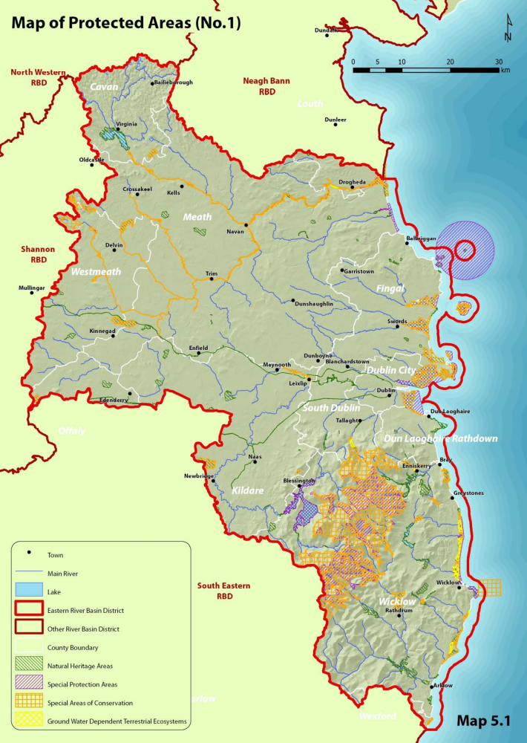

Netherlands
The Dutch part of the Ems river basin contains several protected areas: eight Natura 2000 areas, one area for shellfish waters, 48 bathing waters, one surface water body and one groundwater body for the abstraction of water for human consumption.

International River Rhine RBMP
The total surface area of Natura 2000 areas in the IRBD that are dependent on water amounts to approximately 19,000 km² (about 10 % of the total area of the Rhine RBD).

Map K 7: Fauna-flora-habitat areas dependent on water – Natura 2000 (Directive 92/43/EEC);
Map K 8: Bird protection areas dependent on water – Natura 2000 (Directive 79/409/EEC).
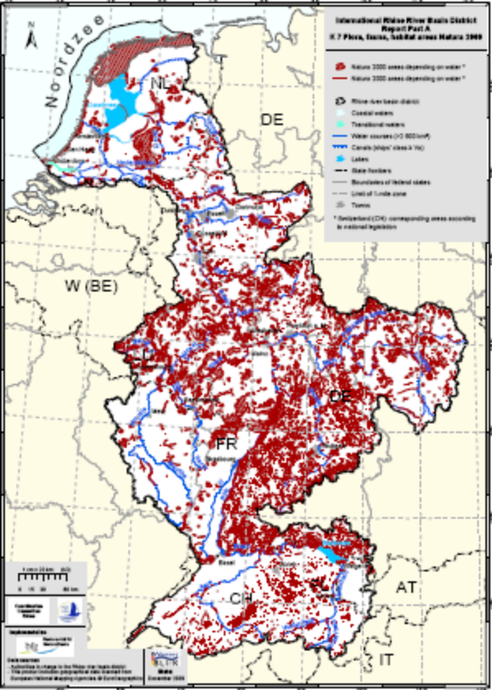
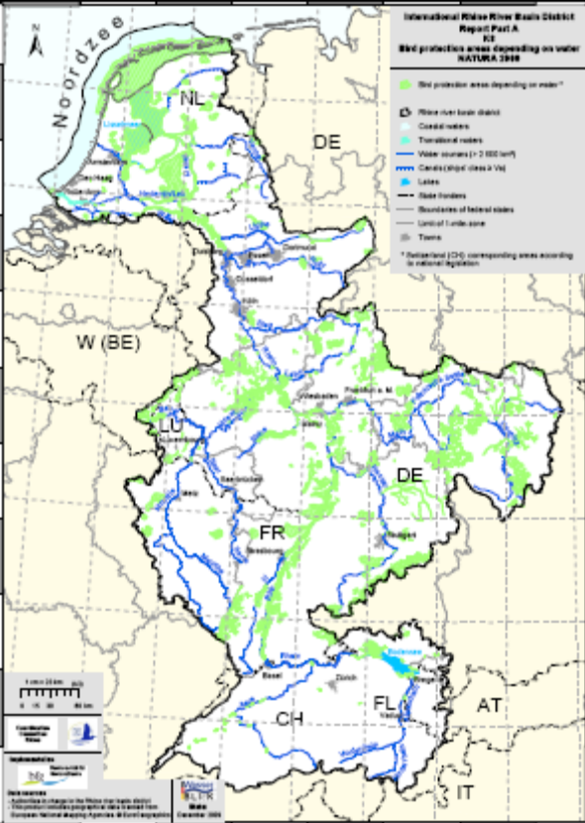

Sweden Western RBMP
5.5 Områden till skydd för livsmiljöer och arter (Natura 2000)
Områden vars natur är värdefull ur ett EU-perspektiv ska ingå i Natura 2000 nätverket. De naturtyper och arter som utpekats av medlemsländerna skall upprätthållas i gynnsam bevarandestatus, vilket innebär att de ska ha förutsättningar för att finnas kvar långsiktigt. Områdena är utpekade via art- och habitatdirektivet eller fågeldirektivet.

Enligt vattenförvaltningsförordningen är det vattenmyndigheternas uppgift att fastställa vilka Natura 2000-områden som omfattas av begreppet skyddade områden i förordningen. Områdena begränsas till dem där bevarandet eller förbättrandet av vattnets status är en viktig faktor för de naturtyper och arter som ska skyddas i området. I Naturvårdsverkets handbok 2007:3 om kartläggning och analys av ytvatten ges förslag till kriterier för detta urval.
I Norra Östersjöns vattendistrikt finns 307 Natura 2000-områden som omfattas av begreppet skyddade områden enligt vattenförvaltningsförordningen och som berör hela eller delar av ytvattenförekomster.

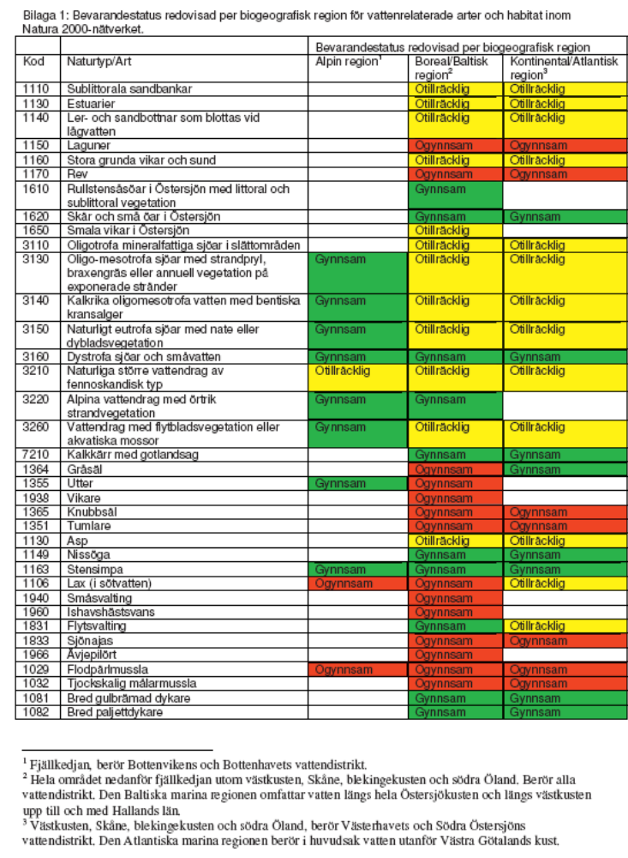
Separate assessment Natura 2000 & Floodplains
Floodplains and bottomlands are also crucial for species conservation and flood protection. Although 50 percent of Germany’s floodplains are located in Natura 2000 sites, many of them are extensively used as pastureland, for farming, as residential areas or for roads. Currently only about one third of former floodplains can be flooded when Germany’s rivers overflow their banks, and in many reaches of the Rhine, Elbe, Danube and Oder the figure is only 10-20 percent.
The status of Germany’s river and floodplain areas isshown in Figure 23.


