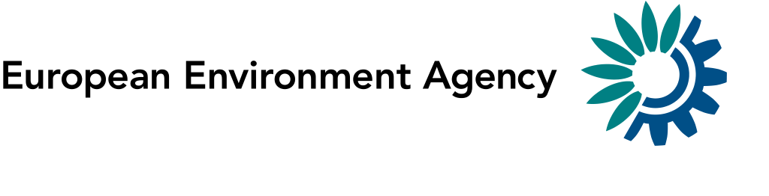

4 April 2014

To: EEA Eionet PCPs and NRCs ‘Rivers and Lakes’;‘Groundwater’; ‘Water Quantity and Use’; ‘Water Emissions’, JRC, DG ENV, Eurostat

EIONET PCPs and NRCs for Rivers and Lakes
EIONET PCPs and NRCs for Groundwater
EIONET PCPs and NRCs for Water Quantity
EIONET PCPs and NRCs for Water Emissions
JRC, DG ENV, Eurostat

Cc: EEA NFPs, ETC-Inland, Coastal and Marine waters

Announcement of the 2014 Freshwater Eionet Workshop

Dear Colleagues,

We are pleased to announce that the 2014 Freshwater Eionet Workshop is planned to take place on 26 and 27 June 2014 at the:

European Environment Agency
Conference Room, Kongens Nytorv 6, 1050 Copenhagen, K, Denmark
10:30 on Thursday 26 to 16:00 on Friday 27 June

Please let me take the opportunity to address ahead of this workshop some more general and fundamental issues on the water data flows.

At the recent NFP meeting on 5 and 6 March we received and understood messages from the NFPs, that there is a high concern about the relevance and continuation of the water priority data flows and the relationship of these data flows with the legal reporting, respectively the role Eionet takes in that.
Ronan Uhel, Head of the Programme on Natural Resources and Vulnerability, which the water area belongs to, gave a presentation to the NFPs in which he highlighted the needs for further integration of the data work between the different policy processes and between the thematic areas in the land-water biodiversity continuum. He also explained the recent strategic discussions within EEA to reinforce a streamlined and well quality assured data processing throughout all thematic areas in the context of the SEIS and INSPIRE implementation.

Quality assurance and follow-up of 2013 Eionet WS
As discussed already in the last Eionet Freshwater workshop (the minutes are uploaded on forum now), in particular quality issues are further prevailing and the recommendation given by you in 2013 kicked off in-depth discussions on
- the QA/QC data handling processes on all water data flows and
- on an in depth and content related quality review

The check, review and restructuring of the data flows to reflect these developments for better processing and QA/QC have several implications for EEA IT and content management and for the resources on your side to engage with us into the necessary data clean up. EEA will work on that in the context of the wider WISE development towards its version 2.0.

As mentioned already at the NFP meeting in March, EEA is currently developing a strategy how to most efficiently restructure the data flow without over stretching capacities on countries or EEA/ETC side. We should avoid a double work load of reporting in the old system on the one side and engaging in quality assurance of the old data and setting them up in a new structure on the other side.

Integration between EEA priority data flows and WFD- reporting
The Commission together with MS and the EEA currently revises the guidance for the upcoming reporting under the WFD. We see this as a very good window of opportunity to further streamline the monitoring and reporting and to propose to make use of the SOE reporting flows in the WFD context wherever possible and useful. This should further reduce double reporting and give political relevance to the SOE data collection.

Objectives of the Workshop and which NRCs to participate
These three elements on restructuring data processing, reviewing the content quality and the policy integration are further outlined and underpinned in the attached background document (Attachment 2).
We would like to structure the discussion at the next Eionet workshop around these three issues and develop together with our Eionet partners an efficient and sustainable way forward on the Eionet water data flows. The discussions last year (see minutes) were giving already a good starting point, but need to be further operationalised against the background of our common resource constraints.

The recent NFP meeting also decided on a new structure of the water NRCs. We will in future have three water NRCs, one on emissions to water, one on water quantity and one on water quality and good status, which in most countries will also take up the coordinating role between the three NRCs.

Although we distribute this announcement and the workshop preparation still to all water NRCs under the old NRC structure, we would much appreciate, if you could take the coordination between the current water NRCs into account in a way that is intended to be implemented with the upcoming NRC water structure..

The members of the working group D on reporting under the Common Implementation Strategy for the Water Framework Directive will also be informed about this meeting to facilitate the coordination between Eionet and the WFD community where necessary.

A first draft outline of an agenda (Attachment 1) for the meeting is attached to this letter.

We would very much like to receive your feedback on the background document and the outlined agenda by 30 April to Wouter Vanneuville and Beate Werner (e-mail: wouter.vanneuville@eea.europa.eu and beate.werner@eea.europa.eu. To further foster the cooperative approach in our meetings we would also like to encourage you to come forward with possible presentations from your side to support the discussions planned in the different sessions.

Practical information

EEA has the possibility to reimburse the travel costs for one representative per member country and few invited experts. In order to assist us with the logistics and budget planning for this, we would be grateful if you could please indicate your interest in participating (based on the nomination by NFPs/NRCs of one participant per country) by registering in the following link by 30 April 2014.

Accepted participants will receive more information regarding the possibility of reimbursement of travel expenses and the procedure for booking flight tickets. Please note that this request for registration does not constitute a commitment on the part of EEA to reimburse your travel costs. For practical questions, please contact Laura Gutierrez (Tel. +45 33 36 71 95, e-mail: laura.gutierrez@eea.europa.eu ).

If you have any questions regarding the preparation of this meeting, please do not hesitate to contact Head of Group, Beate Werner (Tel. +45 2368 3674, e-mail: beate.werner@eea.europa.eu), or Wouter Vanneuville (Tel. +45 33 36 71 81, e-mail: wouter.vanneuville@eea.europa.eu).

Thank you very much for considering this announcement, saving the date and informing us about your interest in participating.

Beate Werner
Head of Water Group
Natural Systems and Vulnerability Programme

Attachments:
- Draft agenda
- Background document

