EEA/NSV/13/002 – ETC/ICM

Content review on existing WISE SoE Water Quantity
data flow

Version: 4.0
Date: 29.09.2015
EEA activity: 1.5.1.a (AP2014-2)
ETC/ICM task, Milestone: 1

Prepared by / compiled by: Sandra Richter, Ursula Schmedtje
Organisation: UFZ, UBA
Demetrios Panagos, George Bariamis,
Alexandros Zachos, Alexandros Psomas,
Dimitra Konsta, Evangelos Baltas, Maria Mimikou
Organisation: NTUA

EEA TM: Sandra Richter, Ursula Schmedtje
EEA PjM: Peter Kristensen
EEA: Nihat Zal, Fernanda Timóteo Gonçalves Néry

Version history
Version | Date | Author | Status and description | Distribution
0.1 | 24/12/2014 | EBA,DPA,GBA,  AZA,DKO,APS | Pre-Draft for ETC | EEA  NTUA
1.0 | 18/1/2015 | NZA,FNE,EBA,DPA,GBA,  AZA, APS, DKO | First Draft for EEA | EEA  NTUA
2.0 | 17/2/2015 | NZA,FNE,EBA,DPA,GBA,  AZA,APS,DKO | Final Draft for EEA | EEA  NTUA
3.0 | 15/7/2015 | NZA,FNE,EBA,DPA,GBA,  AZA,APS,DKO | Revised final draft for EIONET consultation | ETC/ICM  NTUA
4.0 | 29.09.2015 | NZA, AZA, GBA, DPA, EBA |  | ETC/ICM, EEA

NZA: Nihat Zal, EEA
PKR: Peter Kristensen, EEA
FNE: Fernanda Timóteo Gonçalves Néry, EEA
USM: Ursula Schmedtje, UBA
SRI: Sandra Richter, UFZ
DPA: Demetrios Panagos, NTUA
GBA: George Bariamis, NTUA
AZA: Alexandros Zachos, NTUA
APS: Alexandros Psomas, NTUA
DKO: Dimitra Konsta, NTUA
EBA: Evangelos Baltas, NTUA
MMI: Maria Mimikou, NTUA

ACRONYMS
CTY Country (spatial scale)
ECRINS European Catchments and Rivers Network System
EEA European Environmental Agency
EU European Union
EG WSD Expert Group on Water Scarcity & Droughts
FEC Functional Elementary Catchment
GIS Geographic Information System
ISIC International Standard Industrial Classification of All Economic Activities
IWRM Integrated Water Resources Management
JRC Joint Research Centre
LTAA Long Term Annual Average
MS Member State of the European Union
NACE Statistical Classification of Economic Activities in the European Community (in French: Nomenclature Statistique des Activités économiques dans la Communauté Européenne),
OECD Organization for Economic Co-operation and Development
Eurostat European Union’s statistical agency
JQ IW OECD/Eurostat Joint Questionnaire on inland waters
RBD River Basin District
SB Sub-basin
SU Sub-Unit
SEEA-W System of Environmental – Economic Accounting for Water
SOE WQ DF State of Environment Water Quantity Data Flow
WEI+ Water Exploitation Index plus
WFD Water Framework Directive
WISE Water Information System for Europe

Contents
1 What is the information we need for the EEA water assessments from 2016-2018? 5
1.1 General framework 5
1.2 Preparation and consultation processes 5
1.3 Support of WEI+ Indicator (CSI 018/WAT 001) 7
1.4 Support of WREI004 9
1.5 Planned assessments 9
1.6 Assessment methodology for revising the SoE WQ parameters 13
2 SoE data flow alignment with WFD and other assessments 15
2.1 Conceptual clarifications on surface and groundwater resources 17
3 Analysis of the parameters of SoE Water Quantity data flow 20
3.1 General 20
3.1.1 Spatial scale requirements 20
3.1.2 Temporal scale requirements 20
3.2 General overview on the revision of the data 21
4 Annex - Complete list of the SoE WQ parameters 23
5 References 28

What is the information we need for the EEA water assessments from 2016-2018?

General framework

Due to the ongoing 7th Environment Action Programme, launched in 2014, certain initiatives and actions are needed for the protection of the natural capital in Europe. Under this programme, water resources must be preserved, as they are one of the most vital elements of the natural capital. What is crucial, from a technical point of view, is a reliable quantitative and qualitative estimation of the existing natural capital, in adequate temporal and spatial scales, in order to answer the following questions: how much, in what condition, where, and what is the trend.
A conceptual framework that addresses these issues is called Natural Capital Accounting system. Such an environmental-economic accounting system has already been developed for water and water related emissions in international level, by the United Nations Statistics Division and is called: System of Environmental – Economic Accounting for Water (SEEA-W). SEEA-W is comprised by a set of standard tables, where the national authorities are encouraged to compile. Once the hydrological and economic information is organized in such a standard and common (in terms of definitions) framework, the next step is the implementation of measures towards the proper management of the water resources. Efficient management on the water resources, protects against water scarcity, guarantees sustainable development and contributes in biodiversity protection throughout Europe’s ecosystems.
On that direction, the EU has set into force the Water Framework Directive (WFD) reporting guidance, which among others, requests by each Member State (MS), water quantity data. These data are aiming to identify the pressures on European water resources and are used for the set up of a program of measures (PoMs). The PoMs, in RBD scale, aim at the identification of ecological pressure, concerning the efficiency and use of the water resources and respond with actions and policies that must be implemented. Moreover WFD includes into water quantity data requirements the report of a water efficiency indicator called “water exploitation index plus” (WEI+). This index is an update of the former “water exploitation index” (WEI), and is able to capture in a more efficient way, in comparison with WEI, temporal and spatial water scarcity conditions, as it has incorporated into its calculation, the returned water to the environment. WISE SoE Water Quantity Data Flow (SoE WQ DF) is expected to support the WFD objectives, so these particular data parameters must be included and aligned in definitions into SoE WQ DF following the principle: Report once, use many times.
EEA addressing the goal for robust Natural Capital Accounting for water, has established the use of a Water Accounts tool, based on the conceptual framework of United Nations’ SEEA-W system. This development created the need for a subsequent updating of existing SoE water quantity database in order to have proper input data structure for the EEA’s Water accounts tool. The current SoE WQ DF update must combine all the above mentioned objectives, and result in a simple to report data flow, aligned in definitions with other EU data flows, in useful and meaningful way, for future EEA’s assessments.

Preparation and consultation processes
This water quantity data content review has been prepared and presented as background document in the Freshwater EIONET Workshop in June 2015. Member States and Cooperating Countries have played an active role through a consultation period by providing comments and feedback, based on national experiences in data management and acquisition methodologies.

The key messages by the MS and Cooperation countries during the consultation period were to

- Avoid further reporting burden
- Address the overlapping with OECD/Eurostat Joint Questionnaire IWA (towards the “Report once use many times” approach)
- Ensure the simplest possible data structure for the support of the future EEA assessments and Natural Capital Accounting for Water cycle
- Prepare this data flow structure for the upcoming 2015 SoE data request

After the consultation period, several parts of the parameters requested have been changed (mainly for those used for JQ purposes), by eliminating them from the current parameters’ list.

The content review was adjusted accordingly with an updated list of parameters in order to simplify more the SoE data reporting structure. Although the major differences between these two data flows (JQ and SoE WQ) are the more detailed spatial (Sub-Unit and RBD) and temporal (Monthly, Seasonal) scales that SoE requests in comparison with the JQ, some overlapping in the list of parameters still occurs.

In order to clarify the status of this overlapping, an analysis has been conducted;
OECD/ESTAT JQ internal structure is based on eight (8) main tables to be filled by the MS organized by major categories;
- Renewable freshwater resources
- Annual abstraction by source and sector
- Water made available for use
- Water use by supply category and sector / Water use in the Manufacturing industry – by activity and supply category
- Population connected to wastewater treatment plants
- Treatment capacity of wastewater treatment plants in terms of BOD₅
- Sewage sludge production and disposal
- Generation and discharge of wastewater

Given the tabular structure above and for simplicity reasons, the SoE dataflow was proposed to be categorized in seven (7) main classes, as they are presented in Chapter 2.The remaining overlaps are concentrated mainly in 43 parameters concerning the abstractions, returns, renewable water resources and additional water resources main classes. These parameters are needed for the Water Accounts and other EEA’s assessments in more detailed temporal and spatial scales than the respective parameters that are asked mandatorily by the JQ. Additional information can be found in the Annex.

Support of WEI+ Indicator (CSI 018/WAT 001)

The Water Exploitation Index (WEI) is an indicator capturing the level of pressure that human activity exerts on the natural water resources of a particular territory. It is aimed to identify areas prone in water stress conditions. Traditionally the WEI has been defined as “The annual total water abstraction as a percentage of available long-term freshwater resources”. It has been calculated so far mainly on a national level.
A review and upgrade of the WEI index called WEI+ has been developed by the Expert Group on Water Scarcity & Droughts (EG WS&D) with the purpose of better capturing the link between renewable water resources and water consumption, in order to assess the prevailing water stress conditions in a river basin (EEA, 2012a). The proposed WEI+ aims mainly at depicting the actual water exploitation, since it incorporates returns from water uses, tackling as well issues of temporal and spatial scaling. Thus the updated definition of the water exploitation index is implemented as the following; “the water exploitation index plus (WEI+) is the total water consumption as a ratio over the actual renewable freshwater resources in a given territory and time scale”.

The EG WS&D has agreed that WEI+ would be formulated in these terms:

WEI+ = (Abstractions – Returns) / Renewable Water Resources

Renewable Water Resources (RWR) can be estimated with the help of two different options:

Option 1. RWR = ExIn + P – ETa – ΔS_{nat}

Option 2. RWR = Outflow + (Abstraction – Return) – ΔS_{art}

Where:
ExIn: External Inflow is the volume of water entering a reference area from other areas
P: Areal Precipitation
ETa: Actual Evapotranspiration
Outflow: Outflow from the reference area either to the sea or a neighboring area
Abstraction: All abstractions by source (or alternatively by sector)
Return: Returned water to the environment by sector
ΔS_{nat}: Change in storage of the natural reservoirs (surface, soil and groundwater)
ΔS_{art}: Change in storage of the artificial reservoirs

Regarding option 1 which uses the physical water balance of the reference area, the input parameters ExIn, P and ETa are asked under the current SoE WQ DF and are straightforward to report. On the contrary, ΔS_{nat} is a more complicated to estimate parameter. It comprises by three sub-parameters: Changes in surface water storage (mostly lakes), changes in soil water storage (including snow) and changes in groundwater storage. It has to be pinpointed that in option (1) artificial reservoirs are excluded from the RWR estimation as this option refers to pristine reference areas. Generally lakes, reservoirs as well as groundwater aquifers play a significant role in efficient water resources management and are equally important to be reported.
The estimation of the change in groundwater storage is a quite difficult task and it certainly requires the use of hydrological modelling to some extent. Groundwater hydrological modelling involves many uncertainties due to the lack of sufficient data for input and calibration purposes. Also the complexity and variety of underground layer formations pose a great challenge in modelling processes.

- The accurate monthly calculation of WEI+ requires the subsequent estimation of the time lag that the precipitated water needs in order to reach an aquifer. This time lag is in the range of days to even months or years depending on the geological and geometrical features of the aquifer. Under option 1 this time lag must be taken into consideration in order to estimate WEI+ values.

Option 2 estimates the renewable water resources taking into account the manmade alterations inside the reference area. ΔSart is depicting the changes in artificial reservoirs’ volumes. The respective parameters under this dataflow are “Reservoir inflow”, “Reservoir outflow” and “Reservoir stock”. Given the importance of the calculation of WEI+, these parameters are very critical to be reported by the MSs. Reservoir stock is requested to be reported once in order to have a reference for estimating the change in water storage as requested by the Water exploitation index formulas. Regarding external inflow and outflow information, the Member countries are requested either to report on the station level or if this is not feasible, then, “wb_total_act_ext_inflow” and “wb_total_actual_outflow” can equivalently been replaced by the respective reporting of streamflow data time series on crucial junctions of the hydrological network, such as entries in a reference area (inflows) or exits (outflows). Streamflow data can replace external inflow and outflow reporting, as long as groundwater inflows and outflows in this reference area are negligible in comparison with the surface volumes.

- The need for extensive reporting is eminent in order for EEA to have reliable and comprehensive results on the analysis of water scarcity conditions in the European area. Abstractions, returns, water uses, as well as the parameters for the estimation of the renewable water resources that were mentioned in this section, are crucial for the estimation of WEI+ and must be reported in the same spatial and temporal scale in order to be compatible with each other.
Under the current content review, a provision has been made, to even support WEI+_{(groundwater)} and WEI+_{(surface water)} if the index is divided in the future, respectively. This is feasible through developing accurate links between water abstraction and water use parameters according to source and sector separations.

Support of WREI 004
Water Use Intensity (WUI) of irrigated crops (m³/€ PPS) is an index which combines water volumes used for irrigation for a specific crop and Economic Output_{crop} is the production value at producer price in € PPS (values at current prices) of a specific irrigated crop in a specified area (NUTS 2) under the formula:
WUI=Water Use Irrigation_{crop} (m³) / Economic Output_{crop} (€ PPS)

Water quantity data flow is going to be used for the support of this indicator only partially, due to the lack of adequate parameterization of water abstraction for irrigation per specific crop in each reference spatial unit. If water used for irrigation breaks down, according to the specific crop that it is intended to irrigate, then it will result in substantial increase in the number of requested parameters and respective increase in MSs reporting burden. An alternative would be to use modelled data or data reported in national agencies, in order to disaggregate the total reported water volumes for irrigation according to the area covered by each main crop.

Planned assessments

Except of the formulation of CSI 018 and WREI 04, water quantity data are also needed for a wide range of EEA’s assessments. First of all water abstraction and use have been characterized as top priority environmental pressures in Europe, and have a dominant place in EEA’s SoE Reports (EEA, 2015). Further attention was dedicated also on the monitoring of Water Scarcity and Droughts’ phenomena, especially after their exacerbation due to climate change. Climate change is moreover responsible for the increasing frequency of floods and many EEA’s assessments deal with this subject too (EEA, 2012b, EEA 2012c).
Another group of assessments is relevant to efficiency on water use practices. The water footprint, public water supply network losses, efficiency in irrigation practices or in industrial use, are only some of the assessments that can be derived with the use of water quantity data. Finally many assessments have a specialized subject such as the use of desalinated, reused, cooling water, or water for hydropower production. In Table 1.1 the possible products and assessments of water quantity data flow are presented.

Table 1.1 Overview on products / assessments
Topic | Policy relevance (list relevant EU Directives or policy areas) | Name of product/ information displayed | SoE data flow | Scale of information (Europe, RBDs, regional, broad types) | European overviews (X = yes;  '-- = no) | Country comparisons (X = yes;  '-- = no) | Trend analyses (X = yes; '- - = no) | Pressures-status-measures analyses (X = suggested; '-- = not suggested) | SoE determinants (or groups of determinants) needed for assessment | Used for (give CSI or no. of table/ figure/ map and publication) or describe if new | Identify link with other data flows (e.g. EU Directives, Biodiversity Strategy, Eurostat, OECD) | Suggested change in data dictionary (give brief description) | Comments
Over abstraction of water resources and its impacts | WFD | Water exploitation index plus (WEI+)/ Indication of the pressure on the water resources at national level as a consequence of water withdrawals | Water Quantity | SB, RBD, country level | X | X | X | X | Abstractions per economic sector, returns, Renewable water resources | CSI 018 | Groundwater DF, Lakes DF | Introduction of more detailed and aligned definitions in “return” parameters, in respect to WFD and Water accounts | Monthly versus annual values
Irrigated crops' efficiency | WFD | Water Use Intensity (WUI) of irrigated crops (m³/€ PPS) | Water Quantity | SB, RBD, country level | X | X | X | X | Water use irrigation | WREI 004
Water accounts | WFD | Water accounts/Volumes of water abstracted and used from the environment to the economy | Water Quantity | SB, RBD | X | X | X | X | Water volumes per physical asset and economic sector | Support of EEA assessments | SEEA-W, rivers DF | Increase in parameters due to physical assets and more economic sectors breakdown. | Enhanced detail in River Basin Management Plans (RBMPs)
water scarcity & droughts | WFD | water scarcity & droughts | Water Quantity | SB, RBD, country level | X | X | X | X | Precipitation, river discharge | Support of EEA assessments | SOER
Floods | WFD, Flood Risk Management Directive | Floods | Water Quantity | SB, RBD, country level | X | X | X | X | Precipitation, river discharge | Support of EEA assessments | SOER
Over abstraction of water and its impacts | WFD | Water Abstraction by source/ Share of abstraction between surface, soil and groundwater resources | Water Quantity | SB, RBD, country level | X | X | X | X | Abstractions by water asset | Support of WFD assessments | WFD 2016 9.4.2.1 Products from reporting
 | Water efficiency | WFD | Trends in Non-freshwater abstraction | Water Quantity | SB, RBD, country level | X | X | X | X | Non-Freshwater abstractions | EEA assessments | SOER | Reduction in parameters
 | WFD | Water leakage and losses/ Detecting water supply system efficiency | Water Quantity | SB, RBD, country level | X | X | X | X | Returns and losses parameters | Support of WFD assessments | WFD 2016 9.4.2.1 Products from reporting | Change in returns breakdown and definitions in current SoE
Water efficiency | WFD | Trends in water use by sector/ Identification of the main water users across Europe | Water Quantity | SB, RBD, country level | X | X | X | X | Abstractions by economic sector | Support of WFD assessments | WFD 2016 9.4.2.1 Products from reporting |  | SB and monthly scale
 | WFD | Water transfers, returns and reuse | Water Quantity | SB, RBD, country level | X | X | X | X | Returns parameters, exchange table and reuse parameters | Support of WFD assessments | WFD 2016 9.4.2.1 Products from reporting | Reduction in parameters | SB and monthly scale
 | WFD | Trends in hydropower production | Water Quantity | SB, RBD, country level | X | X | X | X | Abstraction for hydropower | EEA assessments | SOER |  | SB and monthly scale
 | WFD | Trends in agricultural management-aquaculture | Water Quantity | SB, RBD, country level | X | X | X | X | Abstractions-returns in agriculture-irrigation-aquaculture | EEA assessments | SOER |  | SB and monthly scale
 | WFD | Desalination Trends | Water Quantity | SB, RBD, country level | X | X | X | X | Abstractions -Desalination | EEA assessments | SOER | Reduction in parameters | SB and monthly scale
Thermal pressures in water bodies and their impacts | WFD | Trends in cooling water | Water Quantity | SB, RBD, country level | X | X | X | X | Abstractions-returns cooling water (industry or electricity) | EEA assessments | SOER |  | SB and monthly scale

Assessment methodology for revising the SoE WQ parameters

The following concept has been generally followed in order to decide about the existing parameters in SoE water quantity data flow.

Figure 1.1 Decision Principles
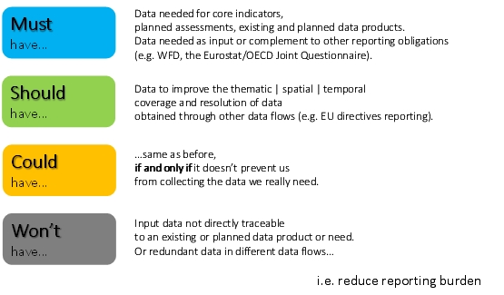

The decision principles of Figure 1 have been implemented in a form of algorithm and are presented in Table 1.2, which is applied throughout the current data revision.

Table 1.2 Decision algorithm
Case# | In WISE SoE? | In another Data Source? | Needed? | Decision | Criteria
a | 1 | 0 | 1 | Must | Because it is needed.
b | 1 | 0 | 0 | Won't | Because it is not needed. Also applies for variables that can be derived.
c1 | 1 | 1 | 1 | Must | If there is an agreement between the EEA and the other institution.
c2 | 1 | 1 | 1 | Should | If the spatial and/or temporal resolution of the other data source is not adequate.
c3 | 1 | 1 | 1 | Won't | If the other data source can be used.
d1 | 1 | 1 | 0 | Should | If, and only if, there is an agreement between the EEA and the other institution (e.g. DG ENV).
d2 | 1 | 1 | 0 | Won't | Because it's not needed.
e1 | 0 | 1 | 1 | Must | If, and only if, there is an agreement between the EEA and the other institution.
e2 | 0 | 1 | 1 | Could | If the spatial and/or temporal resolution of the other data source is not adequate.
e3 | 0 | 1 | 1 | Won't | If the other data source can be used.
f1 | 0 | 1 | 0 | Should | If, and only if, there is an agreement between the EEA and the other institution (e.g. DG ENV).
f2 | 0 | 1 | 0 | Won´t | If the other data source can be used.
g | 0 | 0 | 1 | Must | Because it is needed.
h | 0 | 0 | 0 | Won´t | (for completeness sake…) Because it is not needed.
Where 1=YES and 0=NO…

In Annex 1, there is a list of existing and proposed water quantity parameters labelled accordingly to the colours of Figure 1.1. Also there are accompanying comments following cases’ format described in Table 1.2.
Notes:
- Cases "c1" and "e1" are exceptional: if, regardless of the technical adequacy of the alternative data source, there is a commitment by the EEA in collecting the data, then the variable MUST be kept.
Case "d1" is again exceptional: in this case the variable is not directly relevant to the EEA. It SHOULD be kept if, and only if, there is a commitment by the EEA in collecting the data.
Another exceptional circumstance that might justify keeping an otherwise irrelevant variable, is if it would increase the reporting burden of Member Countries not collecting it: i.e. if Countries would then be required to report to two different obligations and Data Collectors instead of just one.
- Case "f1" is a variant of "d1" that would require an additional variable to be included in the data collection.

More explanations about Table 1.2 and the followed revision process are seen in Figure 1.2:

Figure 1.2 Followed data revision process
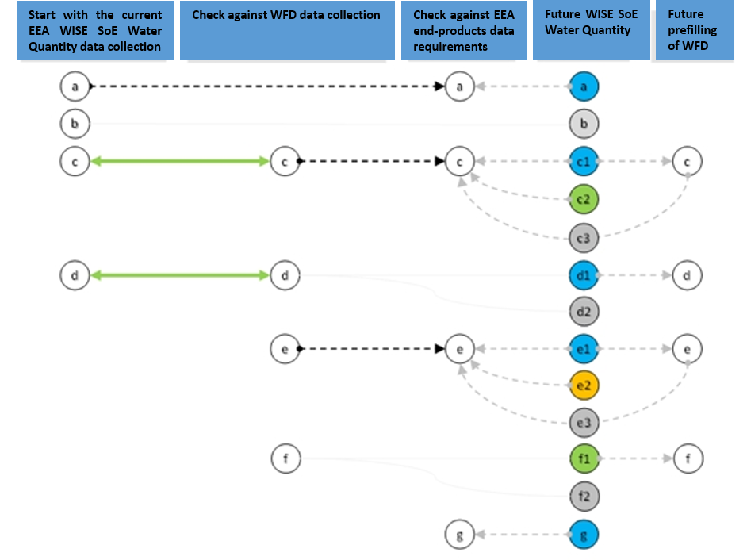
WFD: Water Framework Directive

SoE data flow alignment with WFD and other assessments
A major conceptual change is proposed to be adopted in this revision of the SoE WQ DF, in comparison with the current one, based on assessments and productions planned for 2016 - 2018. The current data flow is going to be aligned in definitions with other data flows such as WFD reporting, new parameters will be introduced and some parameters will be aborted in order to rearrange the reporting scheme in a more contemporary and efficient way. In addition to that, further alignment has been done with Eurostat/OECD Joint Questionnaire (JQ) with the purpose of avoiding from double reporting as much as feasible. Future prefilling of the JQ will be continued in the case prefilling can be automated.

Furthermore, as some parameters of the current data flow, were derived by other parameters, logical reporting discrepancies occurred occasionally. It is proposed to abort any additional parameter that can be derived by a combination of any other existing parameter.

The new data structure have been aligned according to the data requirements for the water quantity related indicators updating as well as WFD reporting schema. The current review proposes to have seven main tables in the new water quantity data set following the logic of estimating the water exploitation index plus.
- Monitoring data
- Renewable water resources
- Reservoir data
- Additional water resources
- Water abstraction
- Water Use
- Returned water

The new revision is aiming to get the information on water availability on the source e.g. rivers, lakes, reservoirs, groundwater from where water is abstracted and on the sectors that the water is used for any type of economic activity. For the economic sectors; NACE codes are proposed to be used in the data reporting for the economic sectors. In principle only main NACE classes are requested to be reported. But due to the importance of specific information on some certain sectors, the data is requested at the NACE two digit level for that areas (Table 2.1).
Supply categories (i.e. public and self-supply) have been dropped down from the list, as NACE 36 is identifying Public water supply. It is assumed that the rest should be considered as self-supply.

Table 2.1 Proposed economic sectors categorization
S/n | NACE sectors
1 | NACE A
2 | NACE A (Class 01.01-01.03 - irrigation)
3 | NACE A (Class 03.22 - freshwater aquaculture)
4 | NACE B
5 | NACE C
6 | NACE C (industrial cooling water)
7 | NACE D
8 | NACE D (Hydropower under Class 35.11)
9 | NACE D (cooling water on electricity sector)
10 | NACE E (Division 36)
11 | NACE F
12 | NACE I
13 | Other NACEs ( G, H, J-U )
14 | Domestic use (Households)

In the case the countries are using the ISIC categories instead of NACE, the following table clarifies the corresponding fields between these two economic sector classifications.

Table 2.2 NACE and ISIC comparison
s/n | ISIC Division | NACE breakdown | Sector
1 | 1 to 3 | Section A | Agriculture, forestry and fishing
2 | 5 to 33 and 41 to 43 | Sections B, C, F | Mining and quarrying, manufacturing and construction
3 | 35 | Section D | Electricity, gas, stream and air conditioning supply
4 | 36 | E / 36 | Water collection treatment and supply
5 | 37 | E / 37 | Sewerage
6 | 38,39 and 45 to 99 | E / 38,39 & Sections G,H,I,J,K,L,M,N,O,P,Q,R,S,T,U | Service industries
7 | - | - | Households

Conceptual clarifications on surface and groundwater resources

Surface water comprises of all water that flows over or is stored on the surface of the earth. Surface water includes artificial reservoirs, which are constructed for the storage, regulation and control of water resources; lakes, which are generally large bodies of standing water occupying depressions in the Earth’s surface; rivers and streams, which are bodies of water flowing continuously or periodically in channels; snow and ice, which include seasonal layers of these forms of frozen water on the ground surface; and glaciers, which are defined as an accumulation of ice of atmospheric origin, generally moving slowly on land over a long period. Snow, ice and glaciers are measured in water equivalents. The interconnections between these categories of water resources and the environment, in a reference area, are seen in Figures 2.1 and 2.2. In these figures “Other resources” stand for all other natural resources in the reference area, while “other changes” refer to unpredictable changes of water volumes (i.e. loss of water volume due to a seismic event).

Figure 2.1 “Artificial Reservoirs” or “Lakes” water transfers
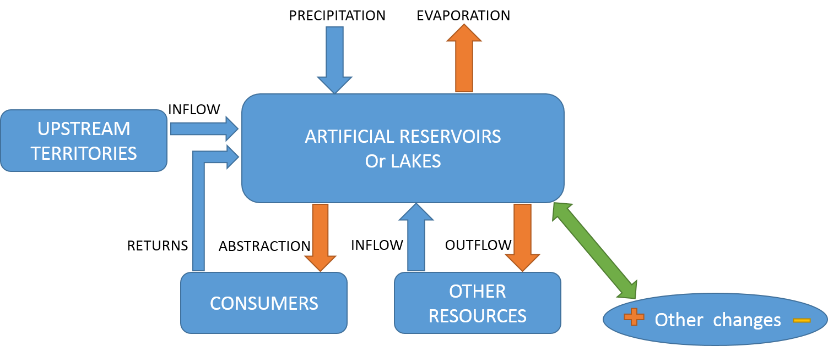
“Other resources” are referring to exchanges of water volumes inside the reference area.

Figure 2.2 Rivers or “Snow Ice and Glaciers” water transfers
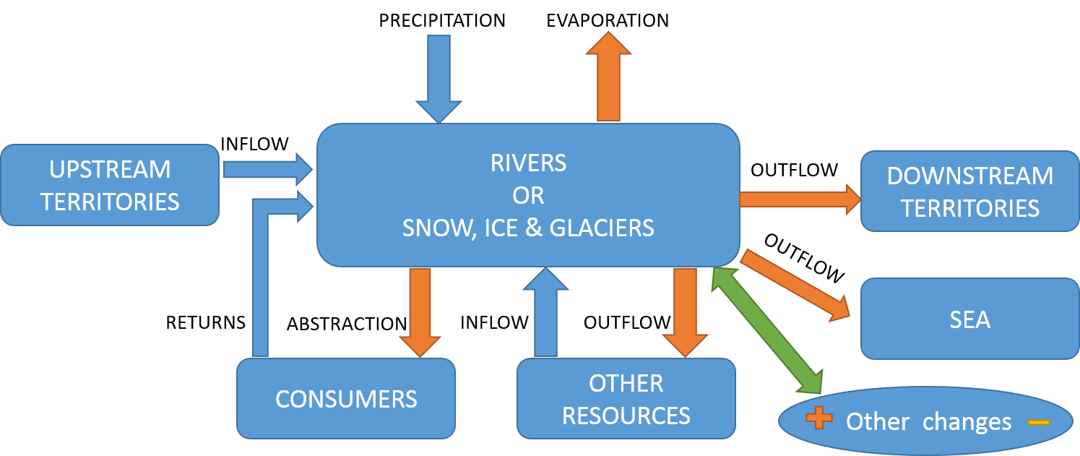
“Other resources” are referring to exchanges of water volumes inside the reference area.

Groundwater (Figure 2.3) comprises of water which collects in porous layers of underground formations known as aquifers. The parameters “Aquifer Recharge” and “Artificial Aquifer recharge” are asked under the updated data flow. Depending on the recharge rate of the aquifer, groundwater can be fossil (or non-renewable) in the sense that water is not replenished by nature during the human lifespan. It should be noted that the concerns about non-renewable water apply not only to groundwater, but also to other bodies of water: for example, lakes may be considered non-renewable when their replenishment rate is very slow compared with their abstracted volume of water.

Figure 2.3 Groundwater water transfers
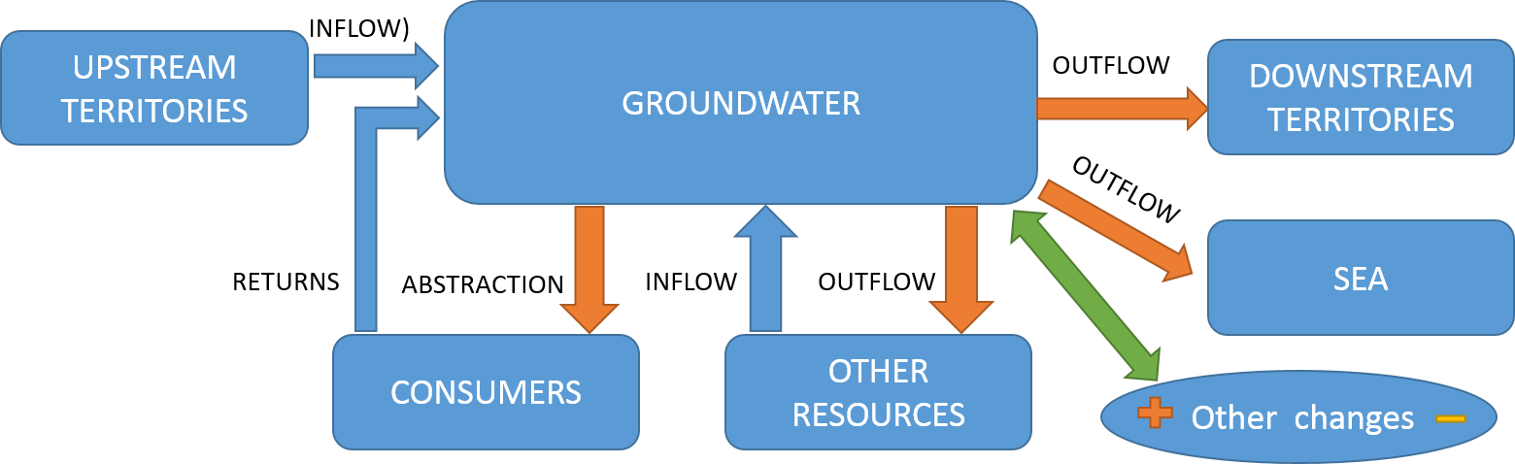
“Other resources” are referring to exchanges of water volumes inside the reference area.

Soil water (Figure 4) consists of water suspended in the uppermost belt of soil, or in the zone of aeration near the ground surface, that can be discharged into the atmosphere by evapotranspiration.

Figure 2.4 Soil water transfers
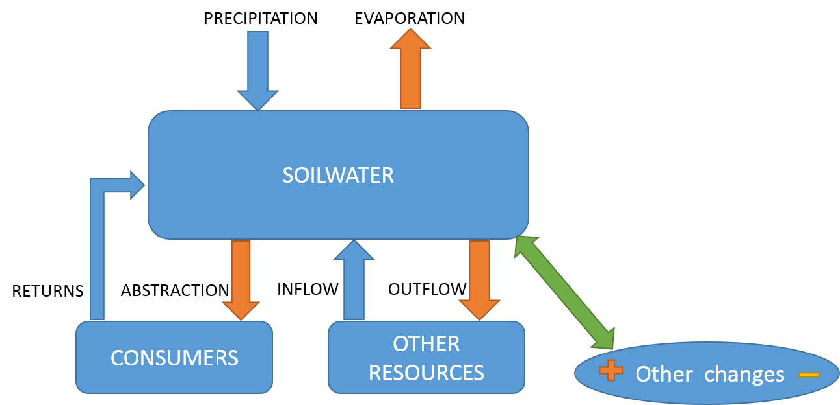
“Other resources” are referring to exchanges of water volumes inside the reference area.

Analysis of the parameters of SoE Water Quantity data flow

General

This chapter analyses the main components of the water exploitation index together with water accounting implementation scheme. This scheme is mainly divided in physical assets and the economic units. Interactions between the economy and the environment form a dense network of interrelations that play a key role in the new data flow.

Spatial scale requirements

The ideal spatial scale for reporting must capture localized phenomena such as water scarcity conditions without imposing enormous reporting burden. Coarser spatial scale, i.e. country scale, can’t reveal localised phenomena like significant pressures on the water resources due to anthropogenic activities, or unequal precipitation distribution due to geographical diversity. So there is a need for EEA’s assessments to have a detailed spatial scale reference in order to provide an in depth analysis of Europe’s environmental issues.

In general three spatial scales are proposed for reporting in SoE WQ DF. Starting from the finer one, there is Sub Unit (SU), River Basin District (RBD) and country (CTY) scale.

The needed spatial resolution without imposing reporting burden to the MSs is SU spatial scale. This scale is adequate enough for the production of detailed environmental assessments. Additionally, under WFD reporting framework there are in some cases very large RBDs, like the case of Danube’s RBD, that cover the area of many countries. MSs are encouraged to report in this scale only in small to medium sided RBDs (<50 000km²)

Finally if there are no data in SB or RBD spatial scales then CTY level is acceptable even though it has little practical value for instance in Water Accounting and will only contribute in EEA’s assessments that are relevant with country comparisons regarding water exploitation index. In general, MSs are encouraged to report as many parameters possible in the same spatial and temporal scale in order for the data to be compatible and comparable.

Temporal scale requirements
Similarly to the spatial scale requirements there are four applicable temporal scales for reporting in SoE WQ DF; namely daily, monthly, seasonal and annual. Furthermore if MSs provide 20 or more consecutive years of a reported parameter then EEA can aggregate these annual values in order to estimate Long Term Annual Average (LTAA) values.

Daily temporal scale is the most detailed scale and desirable especially for stream flow measurements. MSs are encouraged to report stream flow time series from gauges in the sections between SUs’ borders and crossing rivers, or the outlets to the sea.

Ideal temporal scale for the remained parameters in this data flow is monthly temporal scale. Many EEA’s assessments need this scale in order to identify the annual variation of the reported parameters.
If monthly resolution is not available then seasonal temporal resolution is the minimum one for identifying intra-annual variation. Seasonal variation is referring to 4 quarterly periods of the calendar year. More particularly Q1 is referring to JAN-FEB-MAR, Q2 to APR-MAY-JUN, Q3 to JUL-AUG-SEP and Q4 to OCT-NOV-DEC.

Annual values are acceptable but can only depict annual trends of the reported parameters. So MSs are encouraged to report in this scale only if there are no data available in finer temporal scales.

General overview on the revision of the data
The current datasets for the water quantity have been revised according to the workflow and data requirements for updating the EEA water quantity related indicators including WFD pressure assessment. Based on this approach, the data has been organized first as monitoring data and aggregated data. Monitoring data is covering groundwater level and streamflow observation to be reported. The remained parameters are mainly aggregated data which are going to be reported as volumes (hm³). From the thematic perspective the data are organized to explore the water availability at source and water use by sectors. In this context water availability has been divided into two main categories; renewable water resources and additional water resources. Additional water resources are containing only that water either exploited from non-freshwater resources (i.e. brackish water) or desalinated water. In addition to that, water export and import, reused and recycled water are also included into the additional water resources.

Water abstraction has been organised by source (in general groundwater and surface water). Accordingly water use also has been organized by sectors so as to follow the water exchange between environment and economy for the purpose of assessing water stress and resource efficiency.
The last table has been dedicated to returned water. This is for assessing the total returned water from the economy back to the environment and also assess the water loses in the water distribution system as a component of the resource efficiency assessment.

The detailed definitions of all parameters are provided in the new SoE Water Quantity Dictionary.

After all the revisions based on the above approaches and principles clarified under Chapter 1.4, the proposed changes with the SoE water Quantity parameters are illustrated in the following table.

Table 3.1 Proposed changes
Must | 74 (Of which 13 new)
Won’t | 123

Annex - Complete list of the SoE WQ parameters
MAIN_CLASS | New SoE Code | Description | Requested by OECD/Eurostat
Abstraction (ABS) | ABS_SW_RES | Total abstraction from artificial reservoirs. | Yes
Abstraction (ABS) | ABS_SW_LAKE | Total abstraction from natural lakes. | No
Abstraction (ABS) | ABS_SW_RIV | Total abstraction from rivers. | No
Abstraction (ABS) | ABS_RAINW_DOM | Total abstraction from rainwater harvesting for domestic purposes. | No
Abstraction (ABS) | ASB_SW | Total abstraction from surface water. | Yes
Abstraction (ABS) | ABS_GW | Total abstraction from groundwater. | Yes
Abstraction (ABS) | ABS_GW_DOM | Freshwater abstraction from groundwater for domestic use. | Yes
Abstraction (ABS) | ABS_GW_NACE_A | Freshwater abstraction from groundwater for Agriculture, forestry and fishing (NACE Section A). | Yes
Abstraction (ABS) | ABS_GW_NACE_A011_A013 | Freshwater abstraction from groundwater for Irrigation | Yes
Abstraction (ABS) | ABS_GW_NACE_A0322 | Freshwater abstraction from groundwater for aquaculture (NACE Section A - Class 03.22) | Yes
Abstraction (ABS) | ABS_GW_NACE_B | Freshwater abstraction from groundwater for Mining and quarrying (NACE Section B) activities. | Yes
Abstraction (ABS) | ABS_GW_NACE_C | Freshwater abstraction from groundwater for Manufacturing (NACE Section C) | Yes
Abstraction (ABS) | ABS_GW_NACE_C_CL | Freshwater abstraction from groundwater for Manufacturing - cooling water (NACE Section C). | Yes
Abstraction (ABS) | ABS_GW_NACE_D | Freshwater abstraction from groundwater for Electricity, gas, steam and air conditioning supply (NACE Section D) activities. | No
Abstraction (ABS) | ABS_GW_NACE_D_CL | Freshwater abstraction from groundwater for production, transmission and distribution of electricity - cooling water (NACE Section D - Class 35.11 to 35.13) | Yes
Abstraction (ABS) | ABS_GW_NACE_E36 | Freshwater abstraction from groundwater for Water collection, treatment and supply (NACE Section E - Division 36). | Yes
Abstraction (ABS) | ABS_GW_NACE_F | Freshwater abstraction from groundwater for Construction (NACE Section F) | Yes
Abstraction (ABS) | ABS_GW_NACE_I | Freshwater abstraction from groundwater for Accommodation and food service activities (NACE Section I) | Yes
Abstraction (ABS) | ABS_GW_OTHER | Freshwater abstraction from groundwater for Other economic activities (NACE Sections G, H and J to U) | No
Abstraction (ABS) | ABS_SW_DOM | Freshwater abstraction from surface water for domestic use. | Yes
Abstraction (ABS) | ABS_SW_NACE_A | Freshwater abstraction from surface water for Agriculture, forestry and fishing (NACE Section A). | Yes
Abstraction (ABS) | ABS_SW_NACE_A0322 | Freshwater abstraction from surface water for aquaculture (NACE Section A - Class 03.22) | Yes
Abstraction (ABS) | ABS_SW_NACE_A011_A013 | Freshwater abstraction from surface water for Irrigation (Part of NACE Section A - Groups 01.1 to 01.3). | Yes
Abstraction (ABS) | ABS_SW_NACE_B | Freshwater abstraction from surface water for Mining and quarrying (NACE Section B) activities. | Yes
Abstraction (ABS) | ABS_SW_NACE_C | Freshwater abstraction from surface water for Manufacturing (NACE Section C). | Yes
Abstraction (ABS) | ABS_SW_NACE_C_CL | Freshwater abstraction from surface water for Manufacturing - cooling water (NACE Section C). | Yes
Abstraction (ABS) | ABS_SW_NACE_D | Freshwater abstraction from surface water for Electricity, gas, steam and air conditioning supply (NACE Section D) activities. | No
Abstraction (ABS) | ABS_SW_NACE_D_CL | Freshwater abstraction from surface water for production, transmission and distribution of electricity - cooling water (NACE Section D - Class 35.11 to 35.13) | Yes
Abstraction (ABS) | ABS_SW_NACE_D3511_HYDR | Freshwater abstraction from surface water for production of electricity - hydropower (Part of NACE Section D - Class 35.11). | No
Abstraction (ABS) | ABS_SW_NACE_E36 | Freshwater abstraction from surface water for Water collection, treatment and supply (NACE Section E - Division 36). | Yes
Abstraction (ABS) | ABS_SW_NACE_F | Freshwater abstraction from surface water for Construction (NACE Section F). | Yes
Abstraction (ABS) | ABS_SW_NACE_I | Freshwater abstraction from surface water for Accommodation and food service activities (NACE Section I). | Yes
Abstraction (ABS) | ABS_SW_OTHER | Freshwater abstraction from surface water for Other economic activities (NACE Sections G, H and J to U). | No
Additional Water Resources (AWR) | NFW_C_CL | Water available for use for cooling purposes in manufacturing sector (NACE C) from Non freshwater sources | Yes
Additional Water Resources (AWR) | NFW_D_CL | Water available for use for cooling purposes in the electricity production sector (NACE Section D - Class 35.11 to 35.13) from Non freshwater sources | Yes
Additional Water Resources (AWR) | NFW_TOTAL | Total water available for use from Non freshwater sources | Yes
Additional Water Resources (AWR) | DSW_NACE_A011_A013 | Water made available for Irrigation (NACE Section A - Groups 01.1 to 01.3) from desalination processes. | Yes
Additional Water Resources (AWR) | DSW_NACE_E36 | Water made available for water collection, treatment and supply (NACE E - Division 36) from desalination processes. | Yes
Additional Water Resources (AWR) | DSW_TOTAL | Total water made available from desalination processes. | Yes
Additional Water Resources (AWR) | RUW_DOM | Water made available for domestic use in households from reused water. | No
Additional Water Resources (AWR) | RUW_NACE_A011_A013 | Water made available for Irrigation (Part of NACE Section A - Groups 01.1 to 01.3) from reused water. | Yes
Additional Water Resources (AWR) | RUW_NACE_C | Water made available for manufacturing activities (NACE Section C) from reused water. | Yes
Additional Water Resources (AWR) | RUW_TOTAL | Total water mada available for use from reused Water | Yes
Additional Water Resources (AWR) | IMP | Water Imports | Yes
Additional Water Resources (AWR) | EXP | Water Exports | Yes
Additional Water Resources (AWR) | RECL_NACE_C | Recycled water made available for use in manufacturing activities (NACE Section C). | No
Additional Water Resources (AWR) | RECL_TOTAL | Total recycled water made available for use. | No
Monitoring Data (MDT) | GWL | Groundwater level observations of wells | No
Monitoring Data (MDT) | SF | Discharge value of monitoring site in m3/s | No
Renewable Water Resources (RWR) | EVAP_TSP | Actual evapotranspiration | Yes
Renewable Water Resources (RWR) | AQUI | Aquifer Recharge | Yes
Renewable Water Resources (RWR) | PRECIP | Areal precipitation | Yes
Renewable Water Resources (RWR) | ART_GW_RECH | Artificial Groundwater Recharge | No
Renewable Water Resources (RWR) | SNOWP | Snowpack | No
Renewable Water Resources (RWR) | INFL | Actual external inflow | Yes
Renewable Water Resources (RWR) | OUTFL | Total actual outflow | Yes
Reservoir Data (RSD) | RINV | Inflow Volume in mio cubic meters (hm3) | No
Reservoir Data (RSD) | ROUTV | Outflow Volume mio cubic meters (hm3) | No
Reservoir Data (RSD) | RSTOCK | Reservoir stock mio cubic meters (hm3) | No
Returns (RET) | LOSS_LEAK | Leakage losses | Yes
Returns (RET) | NON_TREATED_EFFL | Non treated effluent | No
Returns (RET) | TREATED_EFFL | Treated effluent | Yes
Water Use (WU) | WU_DOM | Total freshwater used for domestic use. | No
Water Use (WU) | WU_NACE_A | Total freshwater used for Agricultural, forestry, fishing (NACE A) use. | No
Water Use (WU) | WU_NACE_A011_A013 | Total freshwater used for Irrigation (Part of NACE Section A - Groups 01.1 to 01.3) use. | No
Water Use (WU) | WU_NACE_B | Total freshwater used for Mining and quarrying (NACE Section B) use. | No
Water Use (WU) | WU_NACE_C | Total freshwater used for Manufacturing (NACE Section C) use. | No
Water Use (WU) | WU_NACE_C_CL | Total freshwater used for Manufacturing - cooling water (NACE Section C) use. | No
Water Use (WU) | WU_NACE_D | Total freshwater used for Electricity, gas, steam and air conditioning supply (NACE Section D) use. | No
Water Use (WU) | WU_NACE_D_CL | Total freshwater used for production, transmission and distribution of electricity - cooling water (NACE Section D - Class 35.11 to 35.13) use. | No
Water Use (WU) | WU_NACE_E36 | Total freshwater used for Water collection, treatment and supply (NACE Section E - Division 36) use. | No
Water Use (WU) | WU_NACE_F | Total freshwater used for Construction (NACE Section F) use. | No
Water Use (WU) | WU_NACE_I | Total freshwater used for Accommodation and food service activities (NACE Section I) use. | No
Water Use (WU) | WU_OTHER | Total freshwater used for Other economic activities (NACE Sections G, H and J to U) use. | No

References
EEA, 2012a, Update on Water Scarcity and Droughts indicator development

EEA, 2012b, European waters — current status and future challenges

EEA, 2012c, Water resources in Europe in the context of vulnerability

EEA, 2013, SoE Water Quantity data manual V3.1

EEA, 2015, State of the Environment Report 2015

ISIC codes, UN, http://unstats.un.org/unsd/cr/registry/regcst.asp?Cl=27

NACE codes, http://ec.europa.eu/competition/mergers/cases/index/nace_all.html

SEEA-W, 2012, System of environmental and economic accounting for water, UN

WFD 2016, 2014, Water Framework Directive Reporting Guidance V4.7, EU

