Thematic Eionet Workshop 'Emissions to Water', 11 – 12 September 2008
European Environment Agency, Kongens Nytorv 6, Copenhagen
WORKING DOCUMENT NUMBER 4; addressing workshop agenda item ‘C2’

Nutrient Emissions from Agriculture

Authors: Merete Styczen – ETC Water and Robert Collins - EEA

1. Background and Introduction

Excessive nutrient (Nitrogen and Phosphorus) levels promote eutrophication in surface waterbodies (both inland and marine), with an associated loss of plant and animal species, phytoplankton blooms and increased growth of macrophytes. Oxygen depletion, the introduction of toxins or other compounds produced by plants, reduced water clarity and fish kills can also result. Currently, concentrations of nutrients in many European waters are excessively high – and pose a major environmental concern (EEA, 2005). http://reports.eea.europa.eu/search_results?type=search&SearchTitle=source+apportionment

The European agricultural sector has changed dramatically over the last 50 years: mechanisation, increased use of mineral and organic fertilisers, farm specialisation, land drainage and advancements in animal feed, have all led to agricultural intensification in most European countries. In particular, the high use of fertilisers and manure associated with modern-day agriculture generally results in a nutrient ‘surplus’ being transferred to water bodies via diffuse pathways.

Agriculture, however, is not the only large source of nutrients observed in waterbodies; various point sources, particularly discharges from wastewater treatment plants and industry, can also provide a significant contribution as can a range of other diffuse sources such as urban runoff (including combined sewer overflows) and forestry.

In order for the issue of nutrient water quality to be addressed and appropriate measures implemented, it is clearly necessary to first quantify the nutrient emissions from all contributing sources within a river basin. Indeed, the quantification of significant emissions is a key component of river basin management planning with respect to water quality.

An earlier EEA study collated reported nutrient emissions data, building up a source apportionment map across parts of Europe. Although there were many data gaps and information was often only available at a regional or national scale, this work was able to show that agriculture is the main source (typically 50 to 80 %) of Nitrogen (N) and, about half the total load of Phosphorus (P) in Europe’s rivers, lakes and coastal zones. The remaining 50% of P was provided by point source discharges.

Such emissions and source apportionment information is very informative with respect to SoE assessment and is also directly relevant to all water related policy including the WFD, UWWTD, ND, E-PRTR, Marine Strategy Framework Directive and Agri-environmental issues under the CAP. As a result, it is anticipated that the streamlined SoE-WISE emissions reporting will enable the future development of regularly updated emissions/source apportionment ‘indicators’ with maps and supporting text.

To initiate the development of emissions/source apportionment indicators, reported information describing nutrient emissions from agriculture has been collated over recent months. This exercise has drawn on a wide range of sources including the SoE-WISE test data exchange, and has attempted to cover as much of Europe as possible with data at a River Basin District (RBD) scale. The resultant maps (Figures 2-5) have the potential to fulfil (in part) the diffuse inventory requirements, for 2009, under E-PRTR. Details of the collation exercise are provided as follows.

2. Data Sources

In addition to agricultural nutrient emissions information provided via the SoE test data exchange, a range of other sources were used including; WFD Article 5 reports, International River Basin Commissions reports, National Environment Agency websites and research papers (Table 1). Where more than one information source was available for the same RBD, the most recent one was preferred. The periods reported differ between sources, the oldest data covering 1986-92, the newest data from 2006. Some data represents single years, whilst other data represents an average over a number of years (typically 3-5 years).

3.) Data Analysis

The data sought was the annual nutrient (both N and P) emissions load from agricultural sources in a RBD, expressed as a ‘specific’ load that accounts for the total land area of that RBD, i.e. in units of kg/ha/year. The total N and P-loads (sum of all sources) were also recorded (where available) allowing calculation of the agricultural contribution to the total load.

In some cases just the total agricultural load per RBD (i.e. kg/yr) was reported, requiring that the RBD area be known before a specific yield could be determined.

As well as expressing the emissions loads in terms of total land RBD area, they were also derived in terms of total agricultural area (derived from the Corine land cover data set) within an RBD. This approach has the advantage of highlighting agricultural emissions in those RBD’s with little agricultural land, where other nutrient sources would otherwise mask the agricultural ‘signal’.

4.) Results

4.1) The ‘Retention’ Issue

From the collation exercise it became apparent that various methods are used to predict agricultural nutrient emissions. Of particular note is the distinction between those approaches that predict emissions to the ‘edge of stream’ (source-orientated approach) and those that predict (or measure) at the ‘mouth’ of a river basin (load-orientated approach). This difference is of significance because various ‘retention’ processes (here retention is used as a broad term to reflect various processes such as de-nitrification, plant uptake and sedimentation) can impact upon nutrients within a river network, reducing the load that is transported to the river mouth (Figure 1). As a consequence, emission estimates in the same RBD can differ significantly between the two approaches.

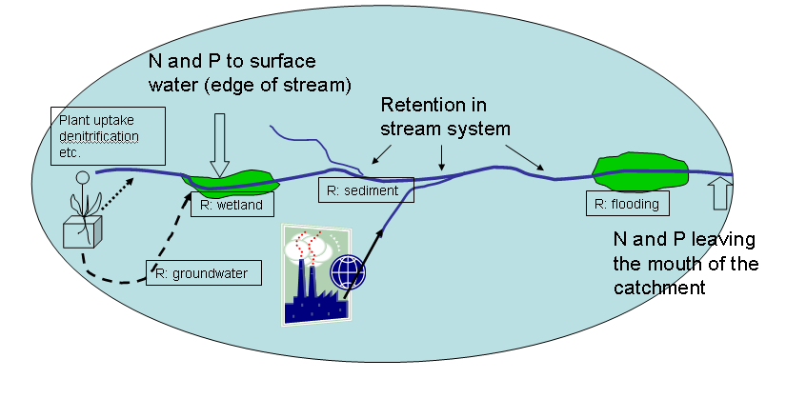
Figure 1. Illustration of nutrient pathways and some of the places where nutrients may be retained, and the difference between “edge of stream“ and “river mouth” estimates. From a field, leaching nutrients may reach the stream through groundwater or surface runoff. Retention of nutrients may take place in groundwater, wetlands, through sedimentation or interaction with river sediment, etc. In contrast to diffuse sources, point sources are generally delivered to “edge of stream”, so only retention in the river system influences the emission.

4.2) Maps

For the purposes of collating information for the agricultural emissions maps, data from both ‘edge of stream’ and ‘river mouth’ approaches has been used, but with a clear distinction between the two methods being made upon the maps. The maps (Figure 2-Figure 5) show annual nutrient emissions from agriculture expressed in terms of both total land RBD area and total agricultural area.

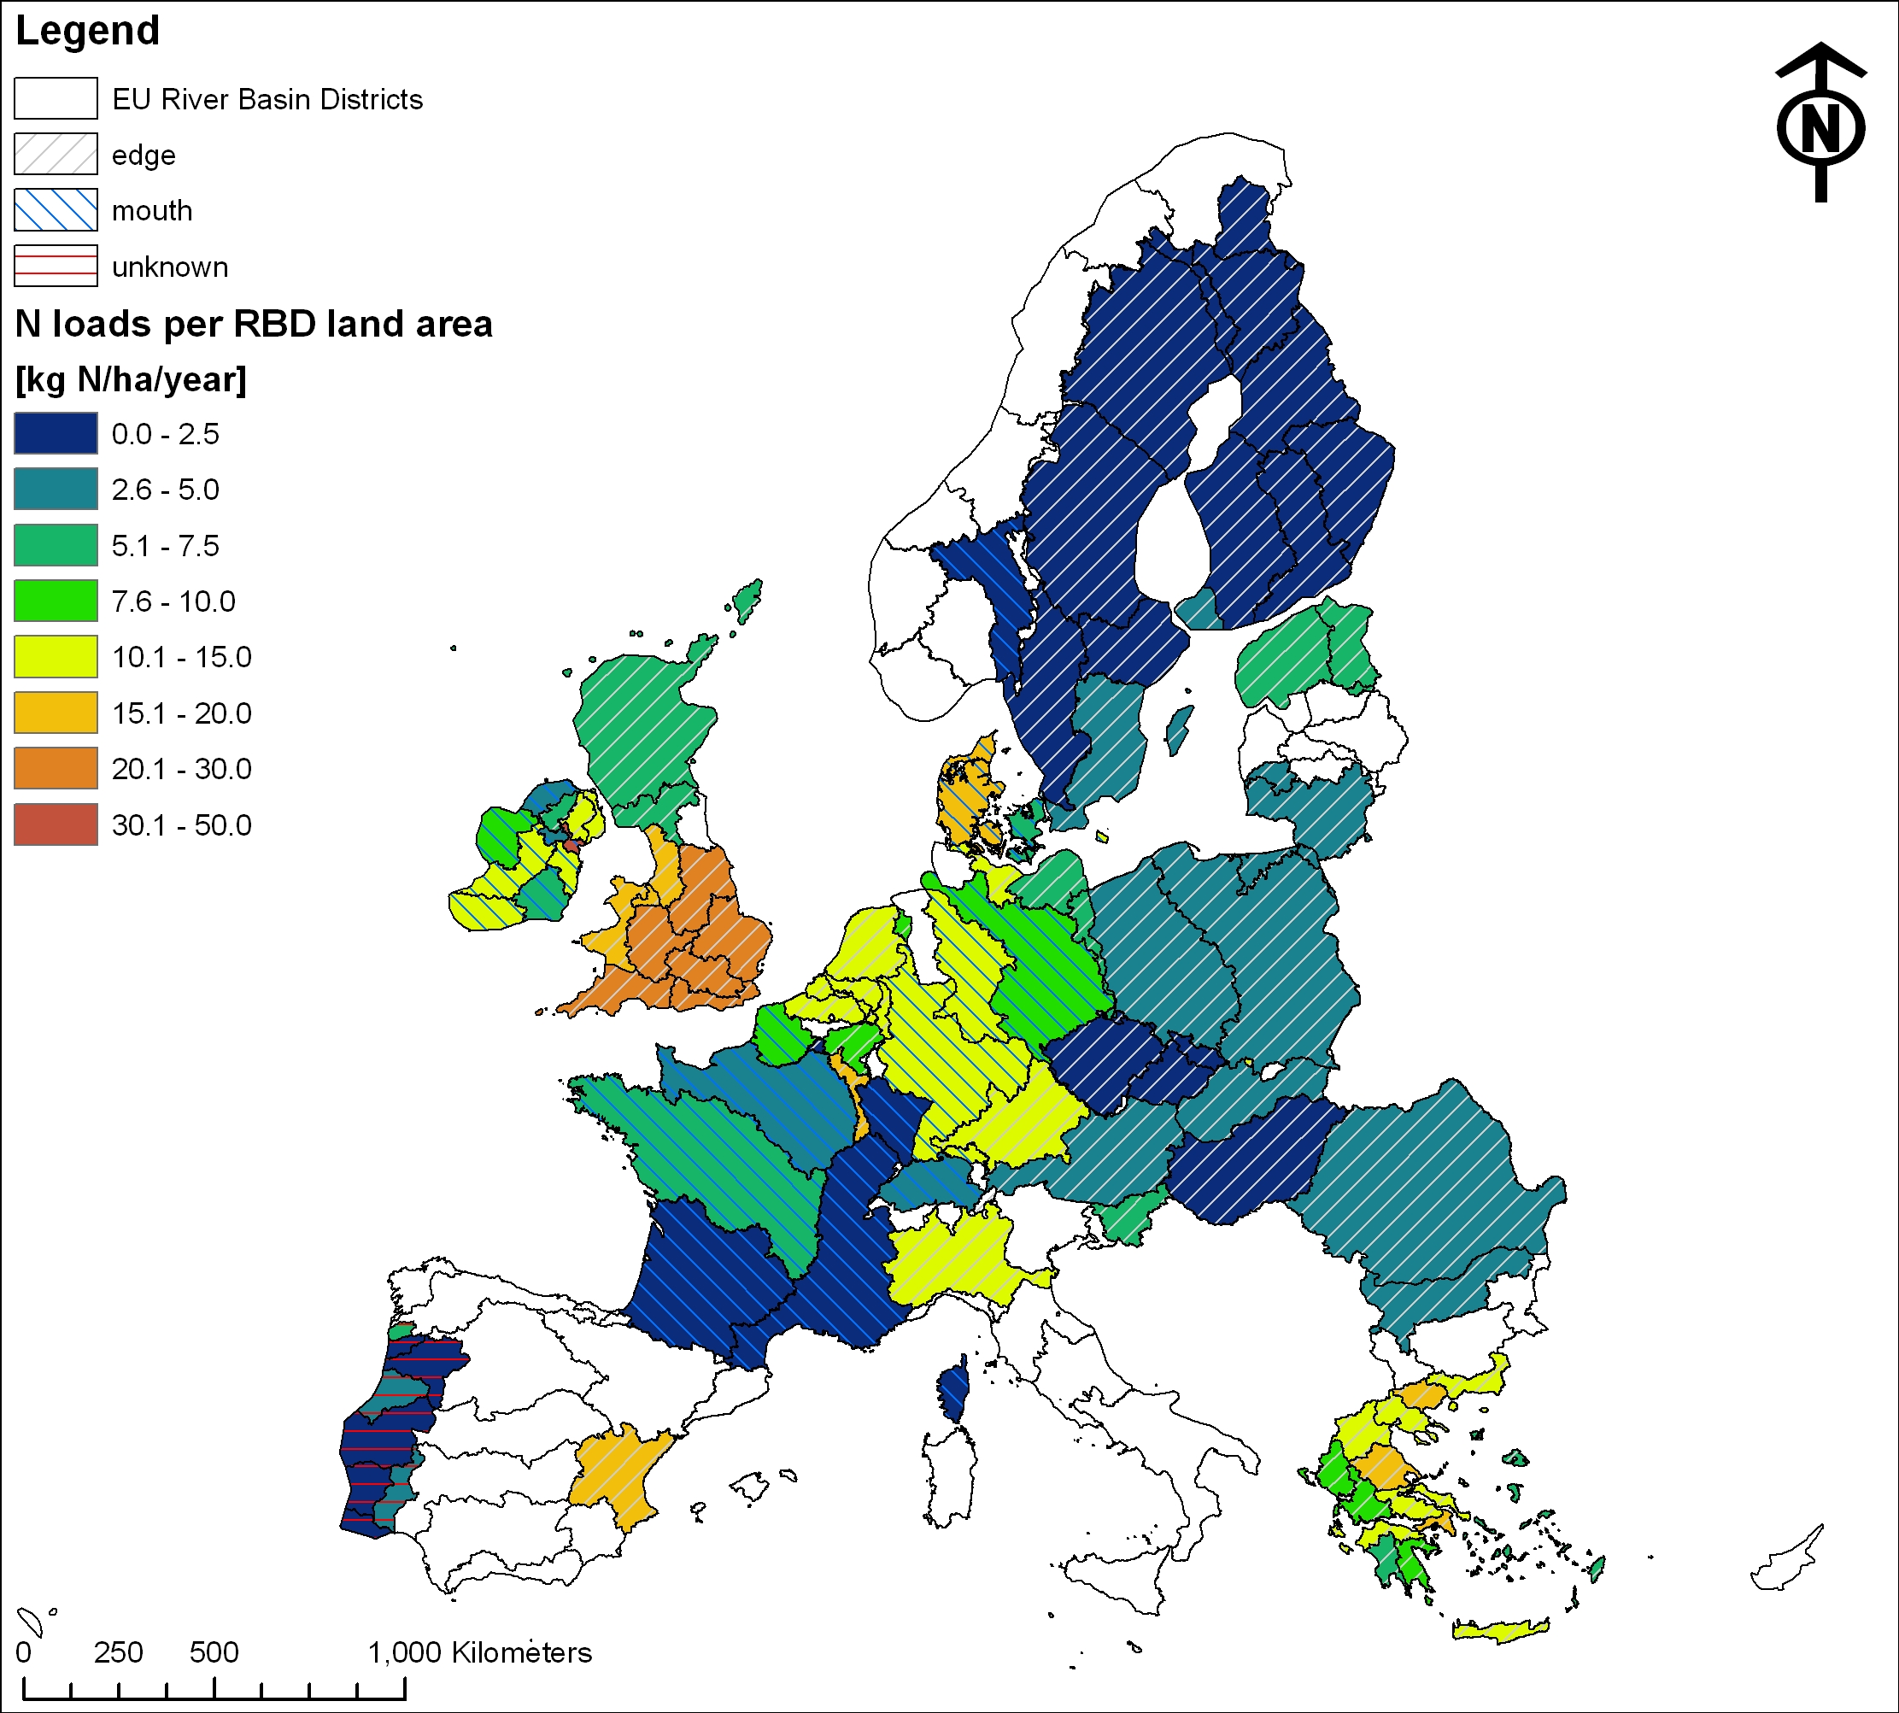
Figure 2. Annual nitrogen emissions from agriculture, expressed in terms of kg per total land RBD area.

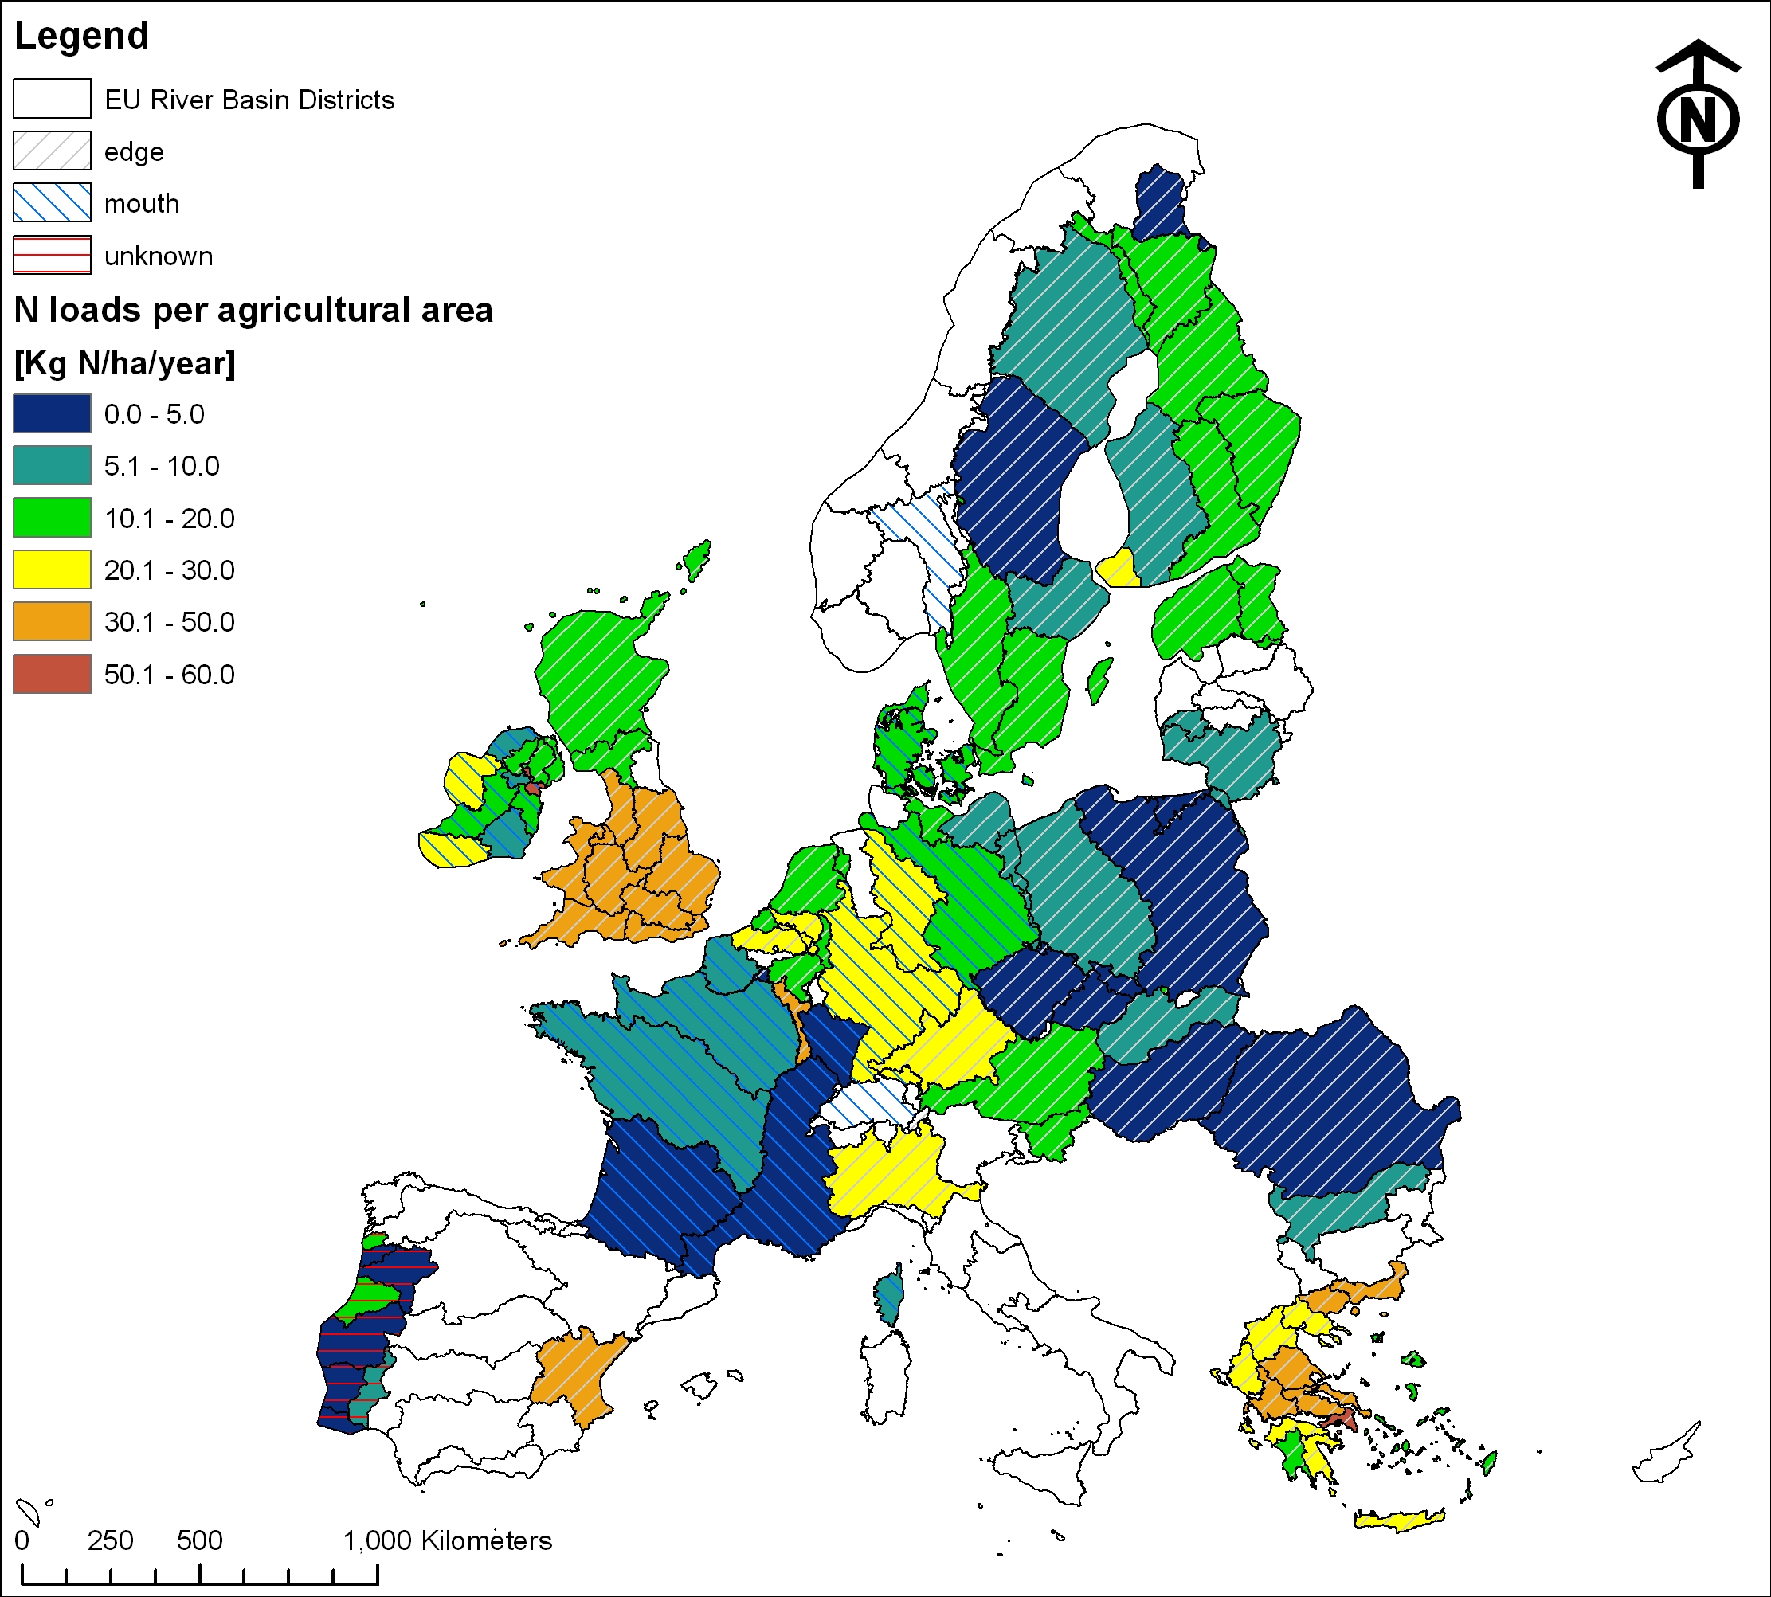

Figure 3. Annual nitrogen emissions from agriculture, expressed in terms of kg per agricultural area within the RBD. Note: Whilst the whole river basin is shaded, the agricultural area only covers a part of the RBD. Striped areas without colour are areas where land use data are missing, but emissions data exists.
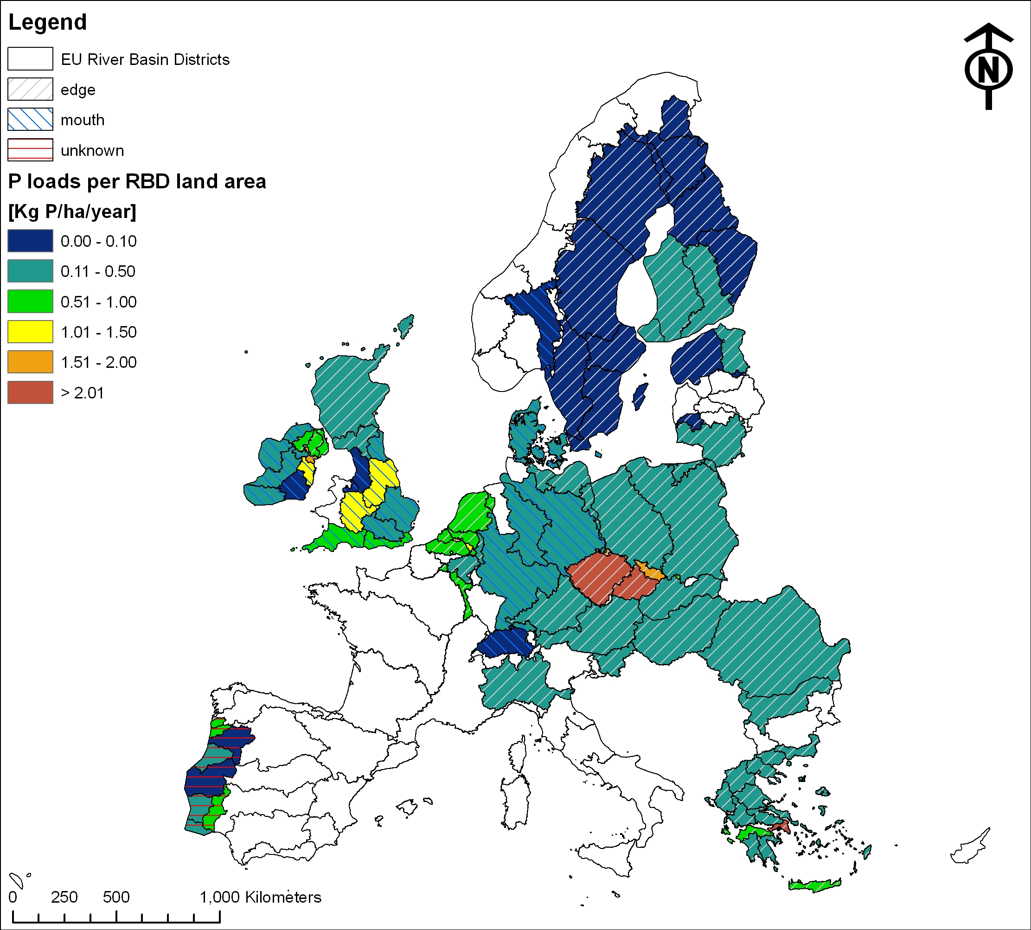

Figure 4. Annual phosphorus emissions from agriculture, expressed in terms of kg per total land RBD area.

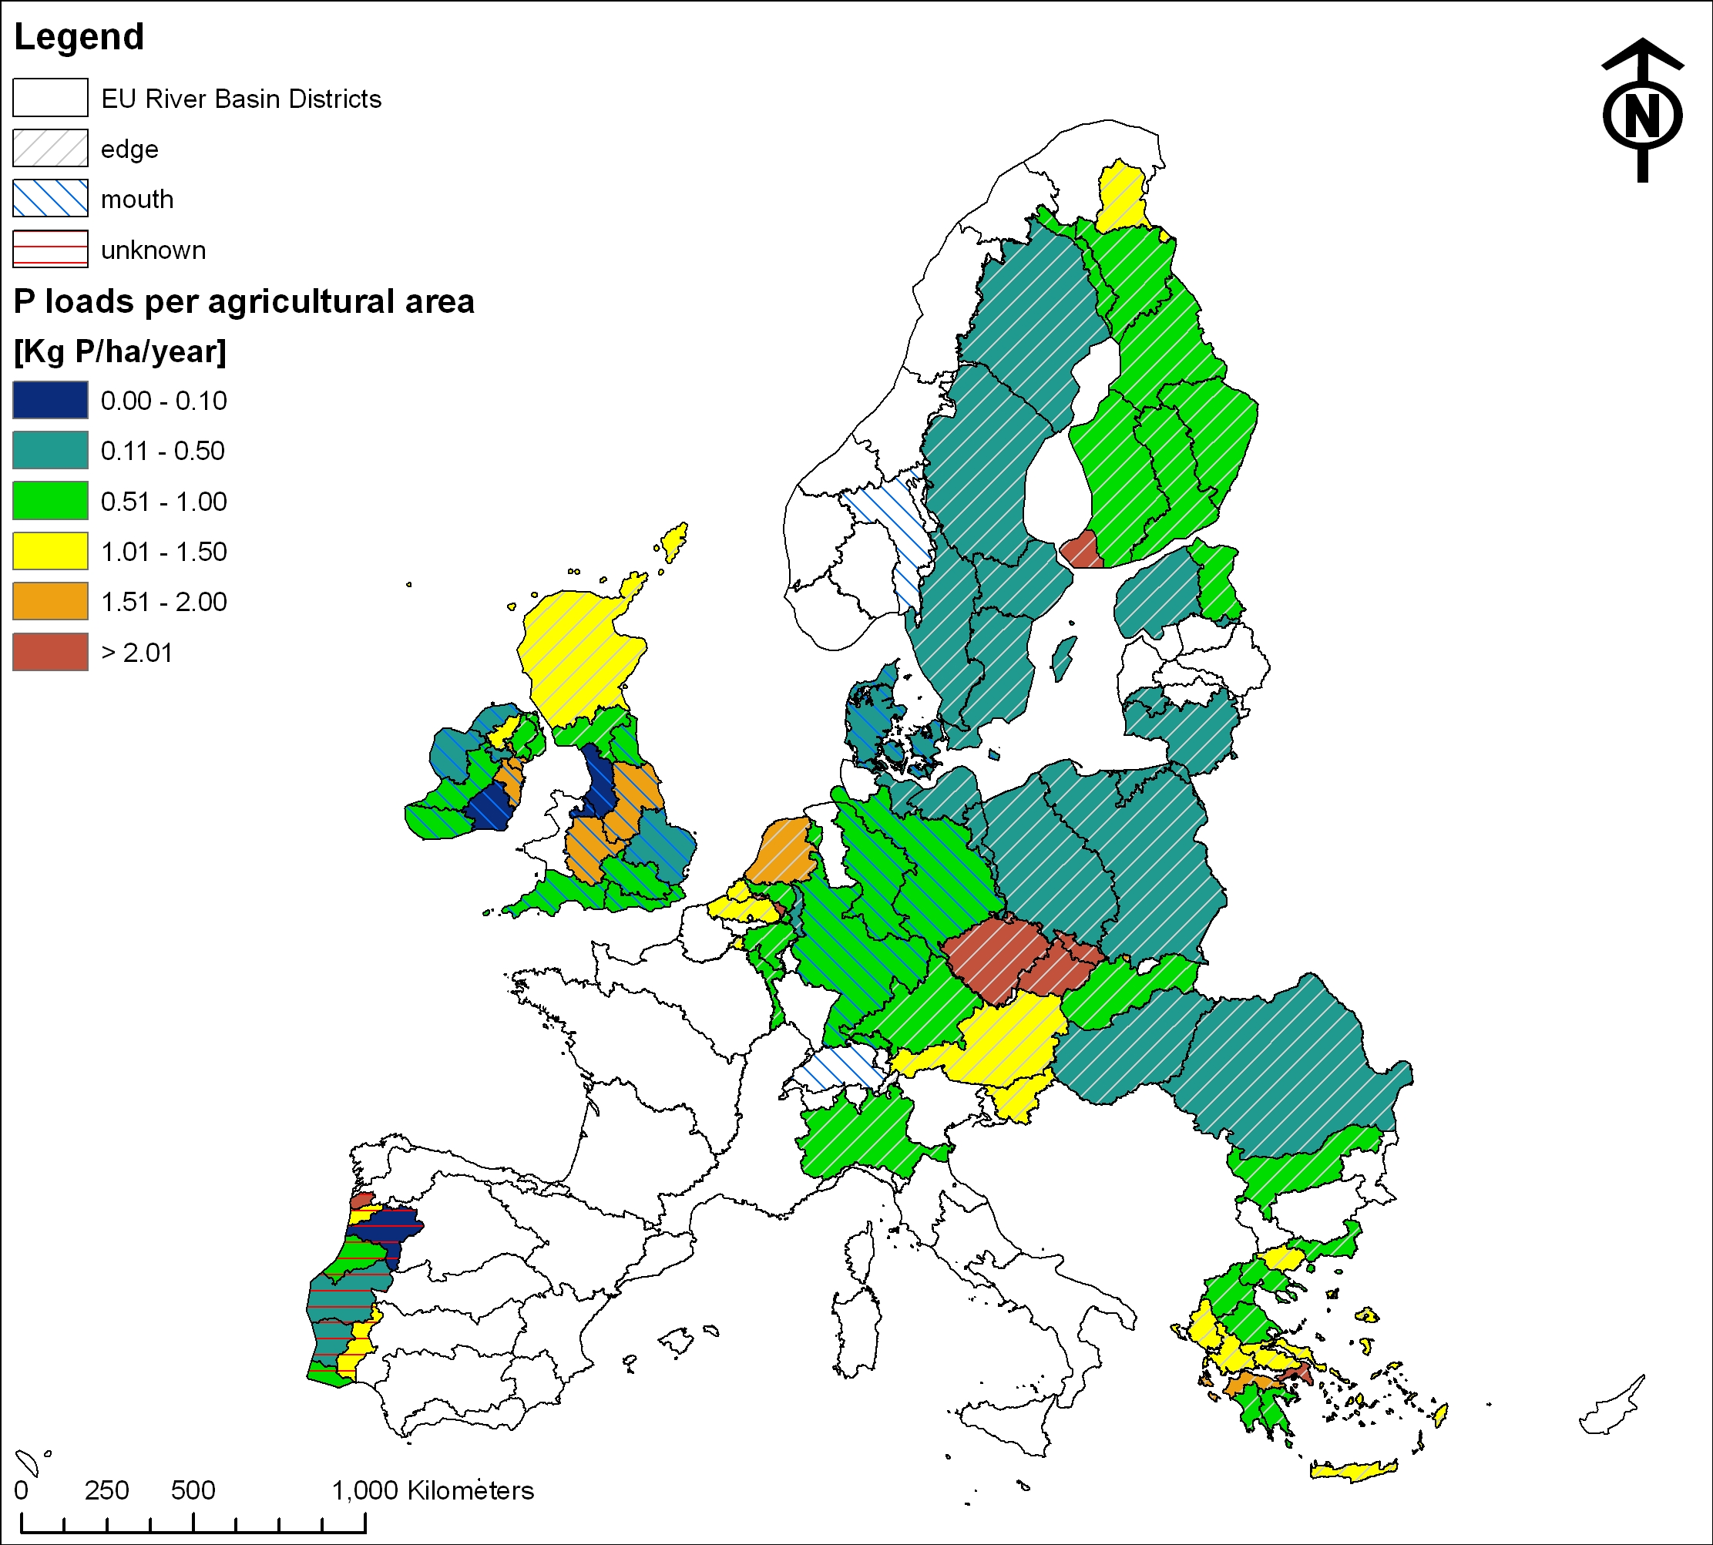

Figure 5. Annual phosphorus emissions from agriculture, expressed in terms of kg per agricultural area within the RBD. Note: Whilst the whole river basin is shaded, the agricultural area only covers a part of the RBD. Striped areas without colour are areas where land use data are missing, but emissions data exists.

The emissions values are generally higher, as expected, when expressed in terms of the area of agricultural land (rather than total RBD area). Annual N emissions are typically no greater than 50 kg/ha of agricultural land, with a median of 14 kg/ha, whilst emissions for P typically range up to about 10 kg/ha of agricultural land, with a median of 0.8 kg/ha.

Considerable spatial variation in emissions is apparent in part this will reflect variation in the type and management of agriculture across Europe. However, the year or years over which emissions have been calculated will also have a strong influence, due to hydrological variation. In addition, the method used will have a large impact on predicted emissions. This can be illustrated by data from the French part of the Meuse, where the edge of stream estimate for N is 18.6 kg/yr, whilst the river mouth value is only 1.4 kg/yr. These discrepancies underpin the need for a harmonised and regular provision of data under the SoE-WISE reporting process.

5.) Conclusions

This initial data collation exercise has illustrated the value of developing emissions indicators, particularly with respect to SoE assessment and informing policy. It is clear also that a strong SoE-WISE emissions reporting process will strengthen such potential indicators, not only in enhancing the spatial and temporal coverage of information, but also in addressing other nutrient sources (enabling source apportionment to be illustrated) and other pollutants.

Issues have arisen from this exercise that should be the focus of discussion during the relevant session of the Emissions Workshop, these include;

● Harmonisation, in particular, the issue of retention and the difference between emissions estimates at the edge of water and those made at the river mouth.

● Temporal resolution, where it should be noted that the emissions information collated and shown in these maps varies considerably with regard to the period over which it was measured or estimated; in some cases data from a single year is reported whilst in others the value was obtained as an average over more than one year. Diffuse emissions vary considerably with rainfall, being higher in wet years and lower in dry ones.

Table 1. Overview of data sources used

Area | N/P | Source
Belgium | N,P | For Sheldt and Meuse in Vlanderen, data were received through the SoE-WISE emissions test data exchange 2008.
Czech Republic | N,P | Rosendorf, P., Prchalova, H at al. 2004, 2008. Basis of WFD Czech Report 2005 and of Czech River Basin Management Plans. This information was identical to information provided by the  SoE-WISE emissions test data exchange 2008 by ‘’T.G.Masaryk Water Research Institute, Public Research Institution
Danube | N,P | Schreiber, H., Constantinescu, L.T., Cvitanic, I., Drumea, D., Jabucar, D., Juran, S., Pataki, B., Snishko, S., Zessner, M. and Behrendt, H. 2003. Harmonised Inventory of Point and Diffuse Emissions of Nitrogen and Phosphorus for a Transboundary River Basin. Environmental Reseach of the Federal Ministry of the Environment, Nature Conservation and Nuclear Safety. Water Research Project. Research Report 200 22 232.
Denmark | N,P | Hans Estrup Andersen, Fagdatacenter for Ferskvand, DMU, Århus Universitet. 16-04-2008, pers. Com.  Agricultural contribution calculated based on average information on point sources and distribution between agriculture and nature: Bøgestrand, J. (red) 2007: Vandløb 2006. NOVANA. Danmarks Miljøundersøgelser, Aarhus Universitet. 96 p. – Faglig rapport fra DMU nr. 624. http://www.dmu.dk/Pub/FR642.pdf.
Elbe, Weser, Rhine Danube | N,P | Behrendt, H., Huber, P., Kornmilch, M., Opitz, D., Schmoll, Ol, Scholz, G. and Uebe, R. 1993-1997) Nutrient Emissions into River Basins in Germany. Environmental Reseach of the Federal Ministry of the Environment, Nature Conservation and Nuclear Safety. Research Project Water. Research Report 296 25 515. UBA-FB 99-187/e.
Finland | N,P | SoE-WISE emission test data exchange. Source SYKE.
France | N | Preux, D. And Fribourg-Blanc, B. 2005. Overview of emissions to water. Existing data collections. European Topic Centre on Water.  In addition data concerning Meuse
Greece | N,P | Article5 – report on the pressures and qualitative characteristics of water bodies in the water districts of 9ellen and a methodological approach for further analysis (2006),9ellenic republic ministry of environment physical planning and public works.
HELCOM | N,P | HELCOM, 2004: The Fourth Baltic Sea Pollution Load Compilation (PLC-4). Balt. Sea Environ. Proc No. 93.
Ireland | N,P | The Environmental Protection Agency (Ireland) 2005: The Characterisation and Analysis of Ireland’s River Basin Districts. National Summary Report.  ‘’http://www.wfdireland.ie/Documents/Characterisation%20Report/Ireland_Article_5_WFD.pdf
Lithuania | N,P | CPVA and EPA (2007): Nemunas river basin district management plan. Procurement of services for the Institutional building for the Nemunas River Basin management Transition Facility project No. 2004/016-925-04-06. The project is implemented by DHI Water & Environment in collaboration with Institute of Ecology, NEPCON and HNIT-Baltic. Data stems from Appendix 9.  Article 5-report, not used.
Meuse | N,P | Meuse Roof Article 5 report
Netherlands | N,P | SoE-WISE emission test data exchange via ‘’Centre for Water Management (RWS Waterdienst)
Po, Rhine, Elbe | N,P | De Wit, M., Behrendt, H., Bendoricchio, G., Bleuten, W., van Gaans, P. The contribution of agriculture to nutrient pollution in three European rivers, with reference to the European Nitrates Directive. European Water Management Online. Official Publication of the European Water Association (EWA), EWA 2002.
Portugal | N,P | SoE-WISE emission test data exchange, 2008.
UK | P | Defra, 2006 – White and Hammond ''Updating the estimate of the sources of P in UK waters;
UK  England and Wales | N | Hunt, D.T.E., Dee, A.S. and Oakes, D.B. (2004): Updating an Estimate of the Sources of Nitrogen to Waters in England and Wales. Phase 2 Report to the Department for Environment, Food and Rural Affairs. Report No: Defra 6454
UK (Humber) | N,P | Suzanne Boyes, Michael Elliott, Organic matter and nutrient inputs to the Humber Estuary, England, Marine Pollution BulletinVolume 53, Issues 1-4, , Recent Developments in Estuarine Ecology and Management, 2006, Pages 136-143.  (http://www.sciencedirect.com/science/article/B6V6N-4HDP8FT-1/1/3a20f75ed3d584a067d53ea79c9a88ae)
Romania (Danube) | N,P | SoE-WISE emission test data exchange 2008: ''National Administration "Apele Romane"
Scotland, Northern Ireland | N,P | SNIFFER (Scotland and Northern Ireland Forum for environmental research) (2006). Diffuse Pollution Screening Tool: Stage 3. Final Report, Project WFD77, September 2006. 65 pp. Data from approx. 2004.
Spain, Jucar river basin. | N | 'Informe para la comision Europea, sobre los Artivulos 5y 6 de la Directiva Marco del Agu, Demarcation Hydrografica del Jucar,2005
Spain, Ebro river basin | (N) | 'UNEP/MAP/MED POL: Riverine Transport of Water, Sediments and Pollutants to the Mediterranean Sea. MAP Technical Reports Series No. 141, UNEP/MAP, Athens, 2003.
Sweden | N,P | SE_SoE test reporting 2008 - Emissions to water.xls (used), Swedish Environmental Protection Agency.
Switzerland | N,P | For the Rhine part of Switzerland data were received through the SoE-WISE emission test data exchange, 2008. Data earlier reported to OSPAR were used.
Norway | N,P | 'Data source: Selvik, J.R., Tjomsland, T and Eggerstad, H.O. (2007): Teoretiske tilførselsbergninger av nitrogen og fosfor til norske kystområder i 2006. SPFO-rapport: 1005/2007

