Thematic Eionet Workshop 'Emissions to Water', 20 – 21 October 2009
European Environment Agency, Kongens Nytorv 6, Copenhagen
WORKING DOCUMENT NUMBER 2; Addressing Agenda item ‘B3’

Test Data Exchange for Biological data 2009. Summary of the reported data and issues arising

Authors: Anne Lyche Solheim and Jannicke Moe, ETC/Water

1. Background and objectives
The biological test data exchange was established in close dialogue with the Ecostat CIS working group and serves as a first step towards the establishment of a new reporting process for biological quality elements. Successful establishment of biological data reporting will provide a comprehensive overview of the impacts of pollutant emissions on aquatic biota, across Europe, at a common spatial scale, aiding assessment of Europe’s water environment in a number of ways (see Working Document ‘Why the need for reporting of biological elements?’ that was sent out with the test data request in June 2009, see appendix). This reporting will provide added value relative to the WFD status reporting of water bodies, since the WFD reporting only shows the class for all quality elements combined (biological and chemical) and does not permit trend analyses for single ecosystem components (neither chemical nor biological), nor linking the data with specific pressures. Thus the WFD reporting alone is limited with respect to undertaking EEA State of the Environment assessment. The test reporting has proved successful with a comprehensive response from many countries and a number of issues identified for discussion and clarification during the forthcoming workshop.

2. Requested data
Information requested under the Test Data Exchange 2009 closely followed the structure of the Reporting Sheet # 5, 6 and 7 of the SoE guidance for macroinvertebrates in rivers, and phytoplankton and macrophytes in lakes respectively, and was formulated within an excel spreadsheet template. The spreadsheet (summarised in brief in Table 1) enabled the reporting of a range of biological metrics from a range of water body types, as well as the reference values and class boundaries applied for these metrics and types. Flexibility was built into the spreadsheet allowing countries to add their own types and/or metrics and the provision of information describing quantification methods was also encouraged. Annual data was requested at a station scale, but requesting also the water body ID and RBD for each station to allow aggregation to water body level and RBD level.

Table 1: Biological data requested (Test Data Exchange 2009)

- Station and water body info (reported only once and if changed)
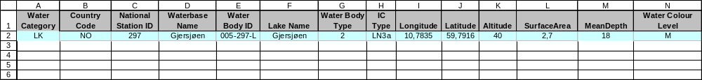

- Biology data table
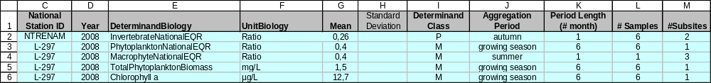

- Method and class boundaries (reported only once and if changed)
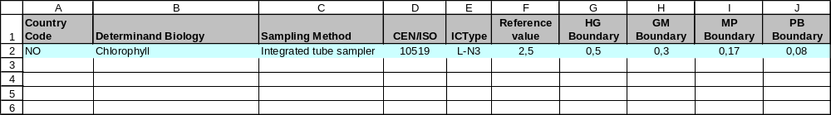

3. Overview of data provided

An overview of the data received is provided in Table 2 and Figures 1-7 and, summarised in brief below

- Overall Response
16 countries reported biological data from ca. 8300 stations under the Test Data Exchange 2009

- Spatial scale
All countries reported at station scale, but partly included water body ID and RBD ID to allow aggregation to higher levels.

- Years reported
Many countries reported data from 2007 or 2008, some countries reported data also from earlier years.

- Reporting for the different biological quality elements
16 countries reported data on macroinvertebrates in rivers (reporting sheet no. 5) for ca. 7000 stations
15 countries reported data on phytoplankton in lakes (reporting sheet no. 6) for ca. 1000 stations
8 countries reported data on macrophytes in lakes (reporting sheet no. 7) for ca. 500 stations

The stations and countries for each biological quality element are presented in Figures 1-2 (details shown in table 2 at the end of this document), whereas the ecological status class for each station and each quality element is given in the Figures 3-5. These data are aggregated to show proportion of stations in each ecological status class in Figures 6-7. Furthermore, the mean normalised EQRs (Ecological Quality Ratios) for stations in high/good classes and stations in less than good classes are shown as bar plots in figures 8-10. The figures can be used as a basis for trend analyses once a sufficient number of years are reported. The data is shown at country scale only and includes only data where normalised EQRs could be calculated. Data can also be aggregated at the RBD level.

The results for all the biological quality elements indicate that the majority of river stations reported have good or better status, except in Belgium, the Netherlands and Slovakia, where most of reported stations are in less than good status. The same basic pattern is seen for lakes. For some countries the ecological status class could not be calculated due to missing reporting of class boundaries. These are shown as grey circles in the maps.

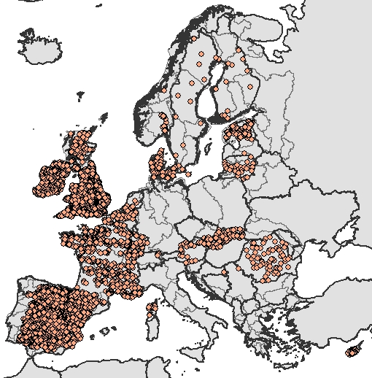
Figure 1: Stations reported for macroinvertebrates in rivers

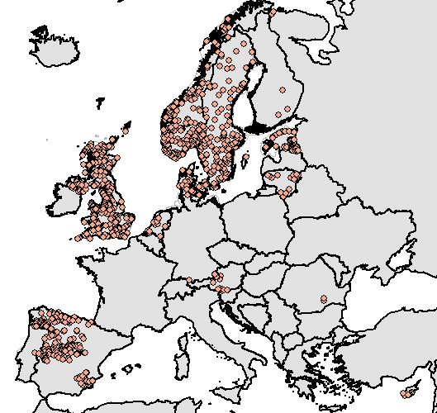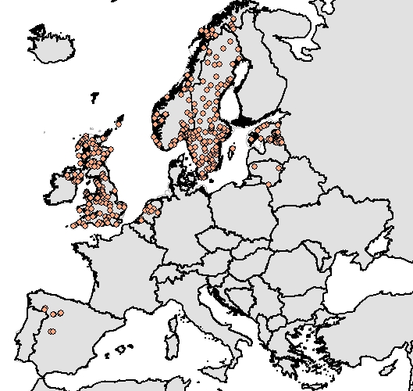

Figure 2: Stations reported for phytoplankton (left) and macrophytes (right) in lakes

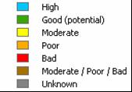
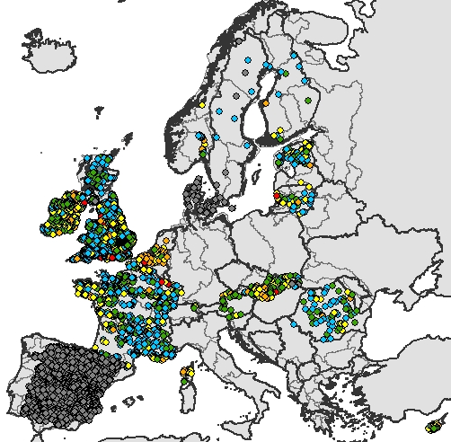
Figure 3: Ecological status class for stations reported for macroinvertebrates in rivers

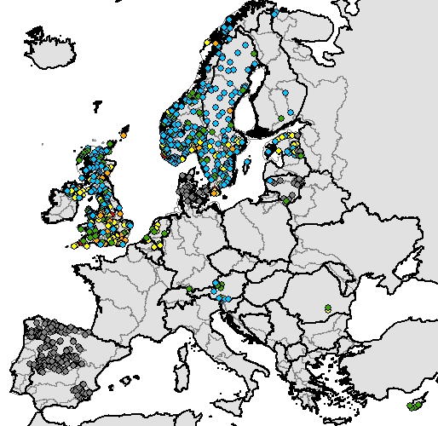
Figure 4: Ecological status class for stations reported for phytoplankton in lakes

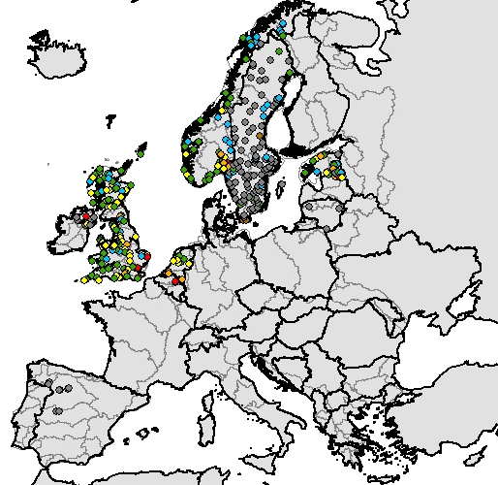
Figure 5: Ecological status class for stations reported for macrophytes in lakes

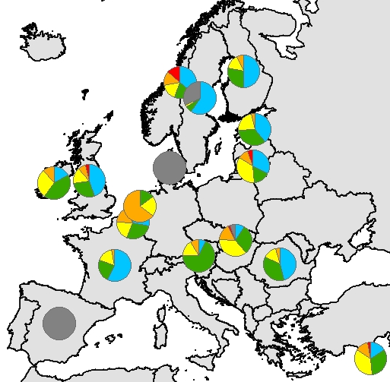

Figure 6: Proportion of stations in different Ecological status classes for macroinvertebrates in rivers

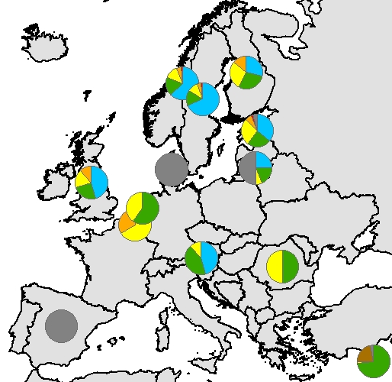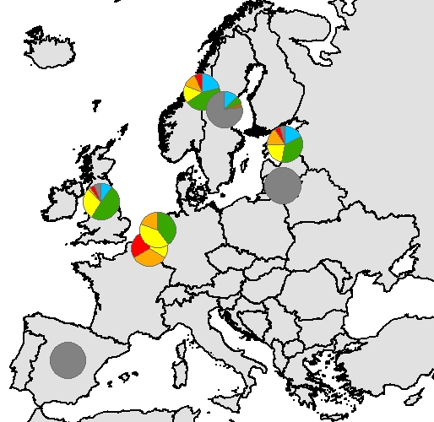

Figure 7: Proportion of stations in different Ecological status classes for phytoplankton (left) and macrophytes (right) in lakes. Map legend same as figure 6.

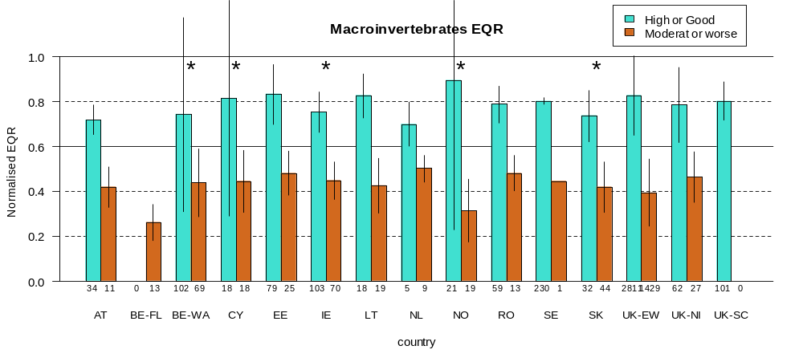

Figure 8: Bar plot showing mean normalised EQRs for stations in good or high status (blue) versus moderate or worse (brown) for macroinvertebrates in rivers. Vertical black lines are standard deviation of the mean, and numbers below the bars are number of stations. The stars indicate countries where the metrics and boundaries reported are in agreement with Intercalibration results (ref. JRC, ECOSTAT Steering Group).

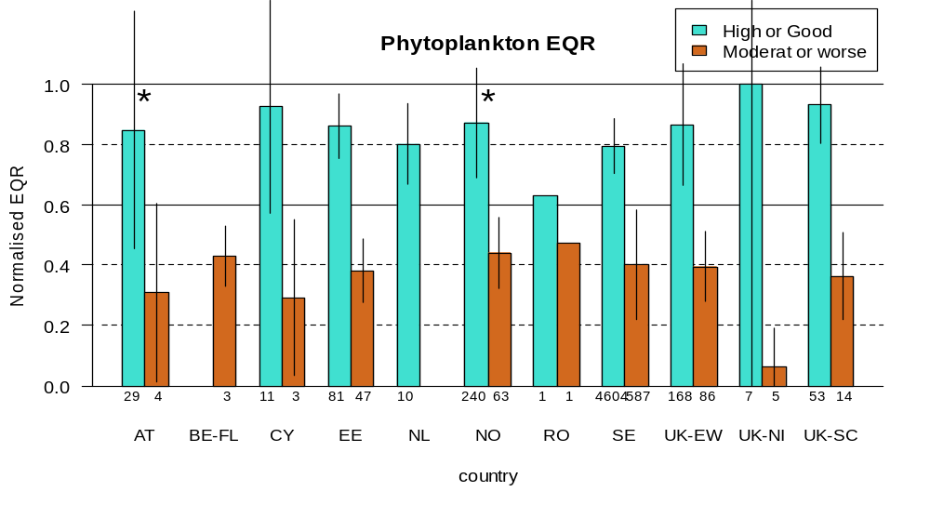
Figure 9: Bar plot showing mean normalised EQRs for stations in good or high status (blue) versus moderate or worse (brown) for phytoplankton in lakes. Vertical black lines are standard deviation of the mean, and numbers below the bars are number of stations. The stars indicate countries where the metrics and boundaries reported are in agreement with Intercalibration results (ref. JRC, ECOSTAT Steering Group).

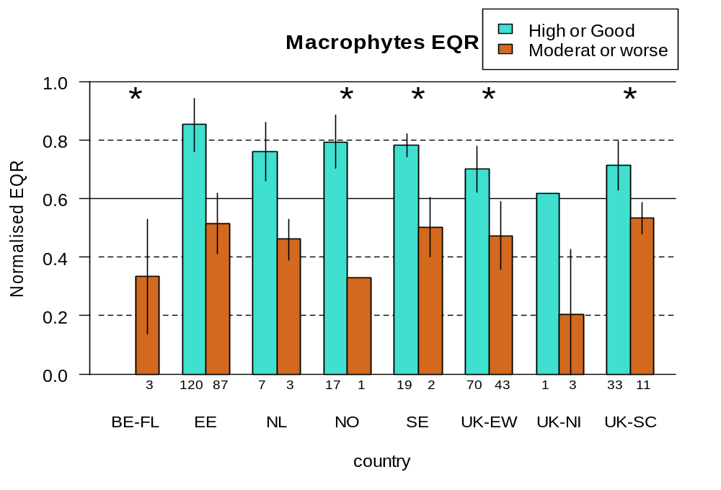

Figure 10: Bar plot showing mean normalised EQRs for stations in good or high status (blue) versus moderate or worse (brown) for macrophytes in lakes. Vertical black lines are standard deviation of the mean, and numbers below the bars are number of stations. The stars indicate countries where the metrics and boundaries reported are in agreement with Intercalibration results (ref. JRC, ECOSTAT Steering Group).
- Problems/Issues arising from the test data exchange

The test data received to date illustrate the feasibility of establishing a comprehensive biological data reporting process. The magnitude of data submitted was comprehensive: ca. 32.500 biological values from 8.300 stations in 16 countries reported biological data on rivers and lakes. In particular, the reporting of the EQRs of different biological quality elements enables an initial assessment of impacts of human pressure on different ecosystem components, and poses a clear potential for future trend analyses. The test data flow is also beneficial to the Intercalibration (IC) work of the Ecostat group, because it reveals problems with translating IC results into national assessment methods.

A number of issues have arisen from the exchange of test data that will be the subject of discussion at the EIONET workshop, with the aim of clarification and agreement with respect to regular reporting as soon as feasible. These issues are described in brief as follows;

Expanding the geographic coverage
Future reporting should involve more countries to get better geographic coverage of Europe. Some large countries (e.g. Germany, Poland, Italy) and several smaller countries have not participated in the test data flow in 2009 and should be encouraged to do so.

Representativity of stations:
Caution is needed for the interpretation of these test data results due to problems with representativity of stations. Many countries have reported mainly stations in high or good status (e.g. France). A more representative selection of stations is needed for future reporting with respect to; station density (per km²), water types, pressures and status classes (reporting only high and good status sites should be avoided). At the Ecostat workshop, many countries requested guidance from EEA on this issue. The stations selected for biodata reporting should preferably reflect the true distribution of water bodies on the different status classes. These stations should also be consistent with the stations/water bodies reported to SoE WISE for chemical parameters, and with stations included in the surveillance monitoring programmes, if these programmes are designed in a way that includes also water bodies in less than good status. If this is not the case, countries should consider to report also stations that are included in the operational monitoring programmes.
The test data reported in 2009 can therefore not be regarded to show the true impact of human pressures on the ecosystem components in most countries.

Comparability among countries:
Problems of comparability of the test data are related to reported metrics and/or boundaries that are not consistent with intercalibrated results, or types that are not related to the common intercalibration types. These inconsistencies should be reduced to ensure comparability of the results at the European level, as well as among member states. The issues will be addressed by the Ecostat group in 2010 by experts in several intercalibration groups, as part of the work in phase 2 of the intercalibration process.

Potential inconsistency with reporting of ecological status of water bodies in River Basin Management Plans (RBMPs)

At the Ecostat workshop there was a general agreement among the countries that due to the inconsistencies in metrics, boundaries and types relative to the intercalibration results, and the need to improve the representativity of stations reported, the test data submitted in 2009 should not be published in the SOER 2010 report or elsewhere. Countries fear that publication of these results by ETC/EEA will show inconsistencies with what they report to the Commission in their RBMPs.

Inconsistencies between SoE and WFD biological data can arise due to a number of reasons including; a bias towards selecting sites of only good or high status; differing ways of aggregating data from stations to water bodies and the use of differing frequencies of reporting between SoE (annual) and WFD (every 6 years). In most cases, however, the WFD reporting will show a worse picture than the single biological elements reported for the test data exercise, due to the one-out-all-out principle of the WFD. The WFD reporting should be consistent with the EEA reporting of the most sensitive biological quality element for different pressures.

JRC suggested that the results reported in the RBMPs should be compared with the results from the test data to identify where differences are and to analyse the underlying reasons.

Feedback on test data requested
To improve the quality of data in future reporting related to problems of comparability and representativity, the countries requested individual feedback from the EEA/ETC on their test data as a first step to prepare for improved future reporting.

Need for additional biological quality elements:
Future reporting of biodata should be expanded to include phytobenthos in rivers to get a more complete picture of the impact of eutrophication in rivers. Phytobenthos is normally the most sensitive quality element for this pressure and will in many cases show a worse ecological status than if the assessment of river status is based only on benthic macroinvertebrates. This quality element is partly intercalibrated (for benthic diatoms), so diatom metrics and class boundaries are in place in most countries. Development of new reporting sheet for this quality element is needed.

- Preliminary conclusions and way forward
The preliminary conclusion is that more time is needed to solve the issues related to comparability of metrics, boundaries and types, as well as representativity of stations and aggregation methods, before establishing a regular EEA data flow for biological data. The Ecostat group strongly recommends that the test data for 2009 should not be published due to these shortcomings.
However, the Ecostat members see the value of biodata reporting to EEA and clearly support the further development of this reporting along the lines described above. The value of the data for EEA and for WISE-SoE is to enable assessments of the impact of different pressures on different parts of the aquatic ecosystems, including biodiversity issues.

The biodata reporting to EEA has now been included in the Ecostat work programme for 2010, and will be a regular agenda item at Ecostat workshops.

Proposed way forward (to be discussed)
The next steps should therefore be the following:
- ETC should provide feedback to the countries on the quality of their test data concerning metrics, boundaries, types and representativity of stations selected.
- Comparison of test data results with those reported in RBMPs.
- Decision should be made concerning the spatial level of reporting – stations or water bodies, and the frequency of reporting, annual or less frequent.
- ETC should provide guidance with criteria for selection of representative stations / water bodies for future reporting.
- Development of reporting sheets for other BQEs: Phytobenthos in rivers
- ETC should revise the template of reporting to better clarify the reporting of reference values and class boundaries.
- Expanding the geographic coverage of the biodata reporting by encouraging more of the countries to participate in the next data request (Germany, Poland, Italy, Greece etc.)
- ETC should closely follow the progress of Ecostat work on clarification of reference and boundary values, comparability of methods, types and pressures sensitivity.
- Organize the next data request using the revised template, in autumn 2010 or in 2011 depending on progress on the points above
- The GIGs and JRC should be involved together with ETC in the interpretation and aggregation of the data at the regional level before data are published.

Table 2. Overview of biological data received under the Test Data Exchange 2009

  - macroinvertebrates in rivers

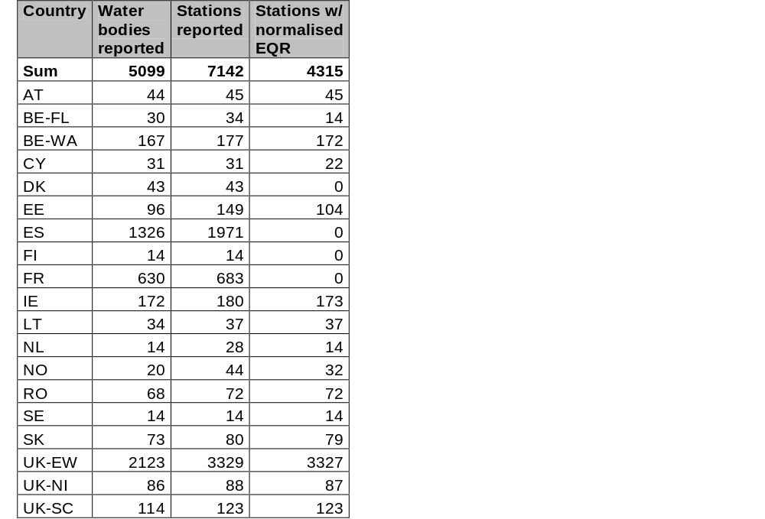

  - phytoplankton in lakes

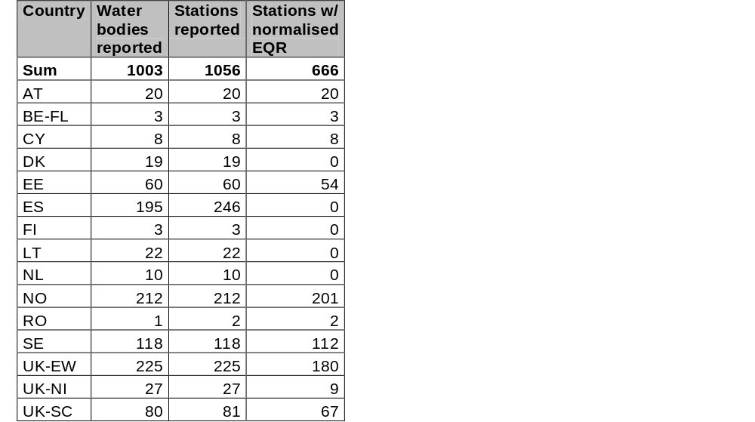
  - macrophytes in lakes

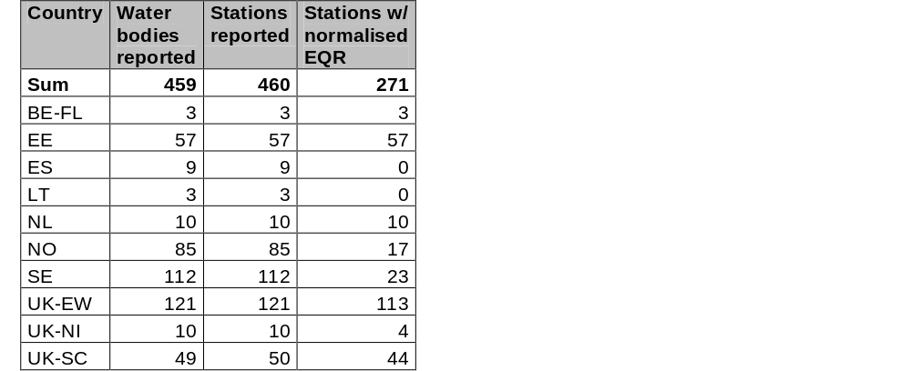

Appendix:
ECOSTAT Workshop 1 – 2 October 2008
Brussels
Agenda item no. 10

Why the need for reporting of biological elements?

Authors: Anne Lyche Solheim – ETC Water and Peter Kristensen, EEA

Effective State of Environment (SoE) assessment of Europe’s water environment requires not only monitoring of pollutant concentrations (‘state’) but also the identification and quantification of the impact of these pollutants on the biological elements and their variation over time (‘impact’). Such a comprehensive approach not only highlights problem areas, but also provides information with which to both identify and subsequently evaluate the effectiveness of appropriate measures.

Monitoring of biological elements is the core of the WFD, and is needed in order to fulfil the reporting obligations under article 13 (River Basin Management Plans), in which the ecological status of representative water bodies within the different river basins must be given. The draft WFD reporting sheets for article 13 reports require the overall classification result to be given for the water bodies, and a list of elements that have been used to arrive at the overall classification result (http://circa.europa.eu/Members/irc/env/wfd/library?l=/working_groups/new_wg_reporting/meetings/meeting_march1_2008/surface_water_sheets/_EN_1.0_&a=i ). This result should be based on monitoring of biological, physico-chemical and hydromorphological elements and the one-out-all-out principle.

This overall classification result is however not sufficient for effective State of Environment (SoE) assessment, because it does not contain results for the different elements, and thereby will not enable assessment of the impact of particular pollutants on particular biological elements, and also prevents the assessment of trends in particular elements over time. Class level reporting will also not allow the assessment of trends of change within a class. Thus, for SoE assessments, reporting of results for single elements are needed. Such reporting from the EEA member countries has been done for nutrients and organic loads (e.g. Tot-P, NO3, BOD) for a number of years. In order to assess the impacts of these and other pollutants or pressures on the biological elements, EEA now also is planning to request reporting of national EQR values and class boundaries for single biological elements, as presented by the reporting sheets for river macroinvertebrates, lake/reservoir phytoplankton and lake macrophytes. Since data on these elements anyhow is needed to calculate the total classification result for the WFD reporting to the commission, the additional burden of reporting the national EQR values for the single biological elements to EEA for SoE reporting should not be large. Additionally, for lake/reservoir phytoplankton and lake macrophytes, the actual value of a few relevant common metrics is also requested, because these data will allow reporting also from EEA countries that have not participated in the intercalibration of classification systems for these two biological elements.

The successful establishment of a reporting process for biological elements would provide a comprehensive and harmonised overview of the status and trends of the impacts of different pressures on water, across the whole of Europe, at a harmonised spatial (RBD) scale (see examples provided by EEA). Such reporting would address a key element of the EEA mandate and support the DPSIR (Drivers-Pressures-State-Impact-Response) analytical framework, thereby improving understanding of the linkages between economic activities and their impacts on the water environment.

A reporting process for biological elements can improve the assessment of Europe’s water environment in a number of ways, including;

● Support to the assessment of policy effectiveness on the different components of the ecosystem
● Trend identification with better resolution down to element level and change within a quality class
● Improved linkage of emissions and pollutant concentrations with their biological effects
● Improved data availability to feed into ecological models

Test data reporting

To further clarify the availability of biological data and to clarify constraints in reporting of biological data EEA suggests to run a test data reporting with countries in 2009 and discuss the results with countries at Ecostat and Eionet meetings. Based on the test data reporting EEA (ETC/water) will prepare a report on
- Presentation of the results from test data reporting of biological data
- Overview of how the information can be used to provide a better European overview of ecological status and how to link it to water quality in terms of available physico-chemical data
- Discussion of the feasibility of the data flows, their validity and respective indicators for the assessment to support national and EU processes such as WFD, and the activities of Ecostat.

