Austria – comparison of monitoring stations

Notes:

Rivers:
probably almost the same networks for NiD and SoE, high proportion of best results, problems with prefixes only; NiD monitoring network bigger than WFD, low match but few mistakes

Lakes:
probably almost the same networks for NiD and SoE, high proportion of best results, problems with prefixes only; similar amount of NiD and WFD network; no best matching stations but very good spatial comparison – possible problems with codes?

Groundwater:
less number of NiD monitoring sites than SoE, very low proportion of best results, but few mistakes, NiD monitoring network significantly smaller than WFD, good proportion of best results and few mistakes, problems with prefixes only

TCM:
not relevant, inland country

Legend:

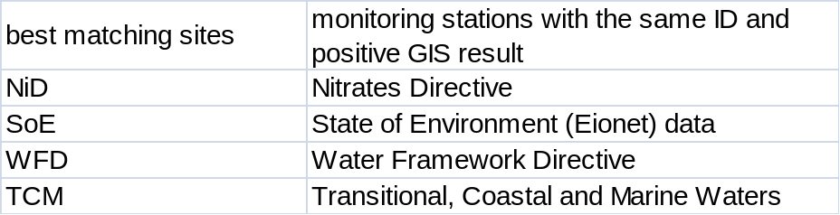

Position of reported stations
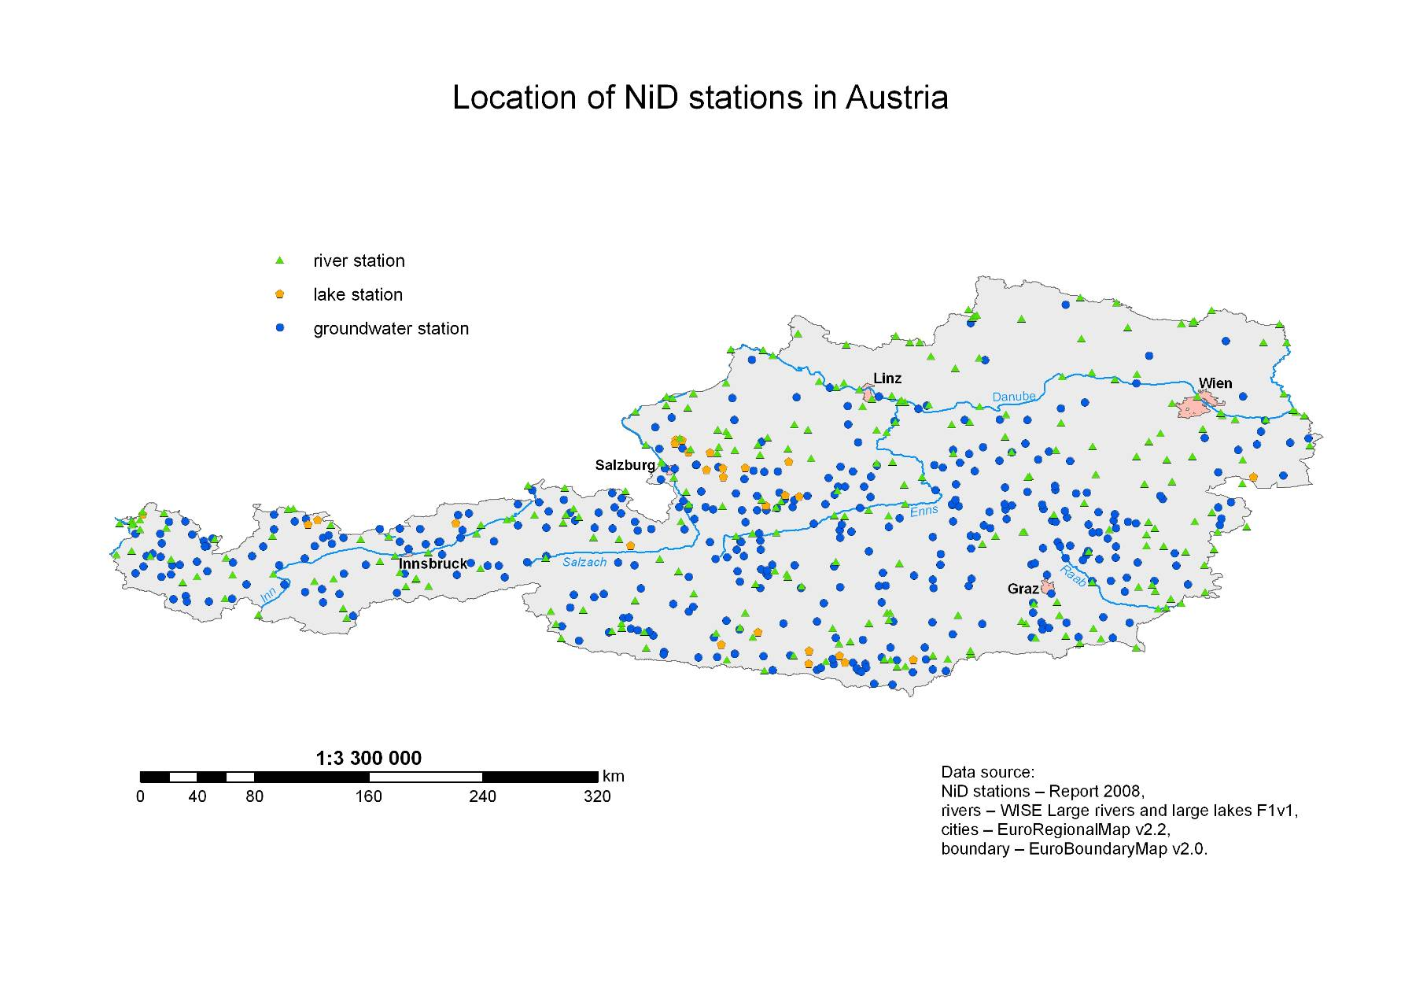
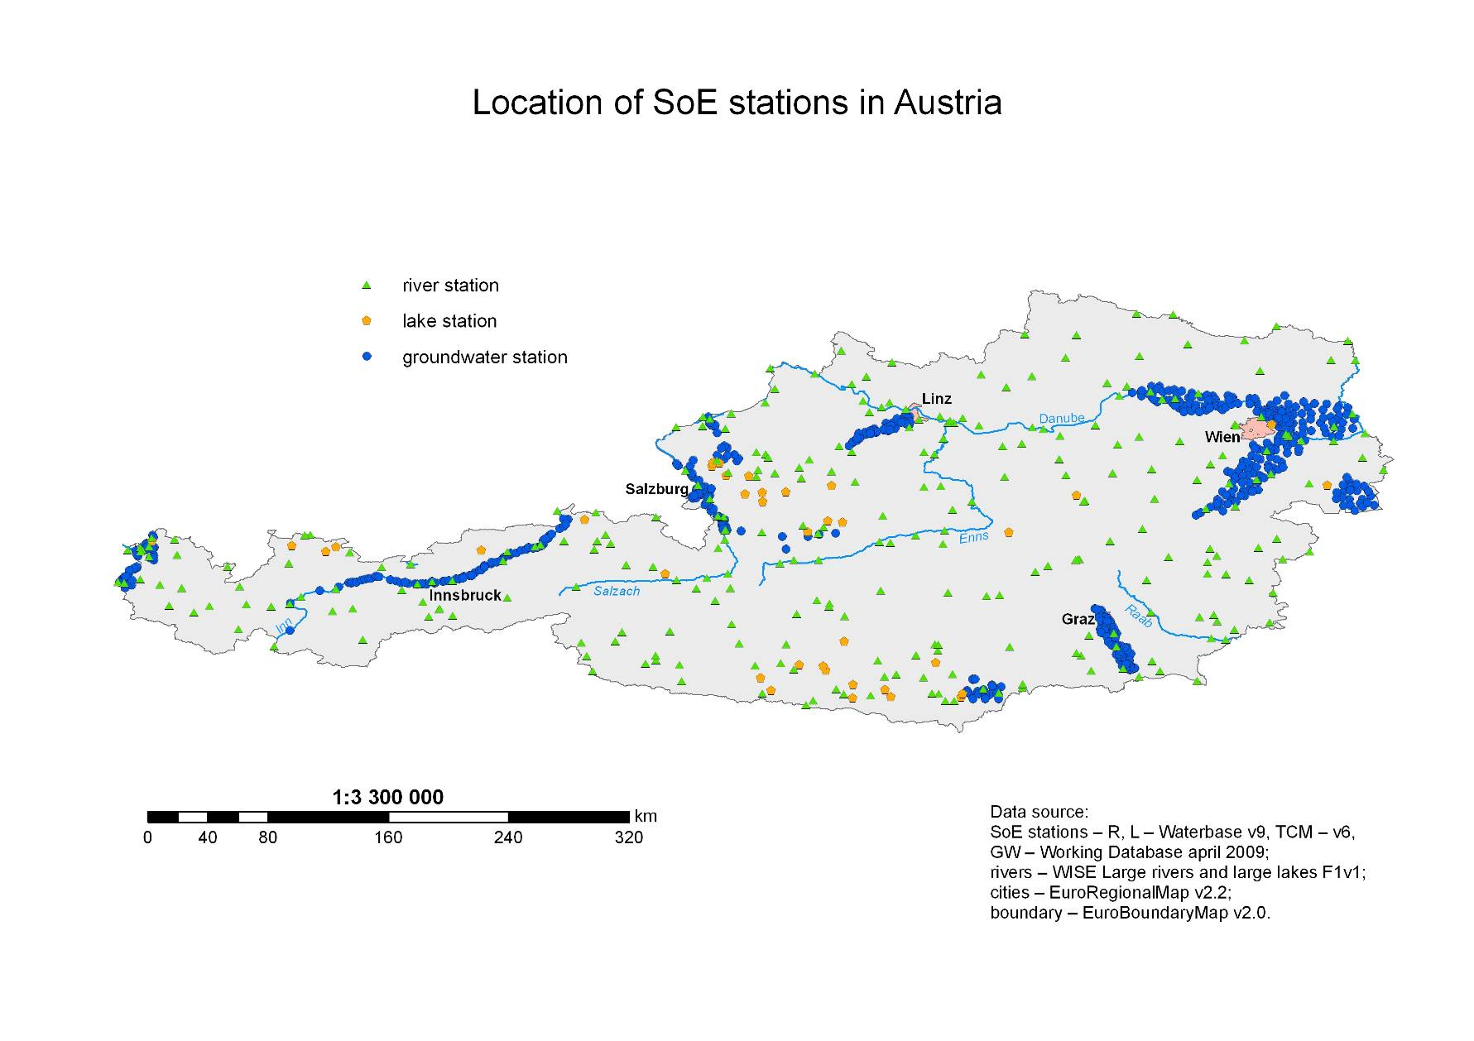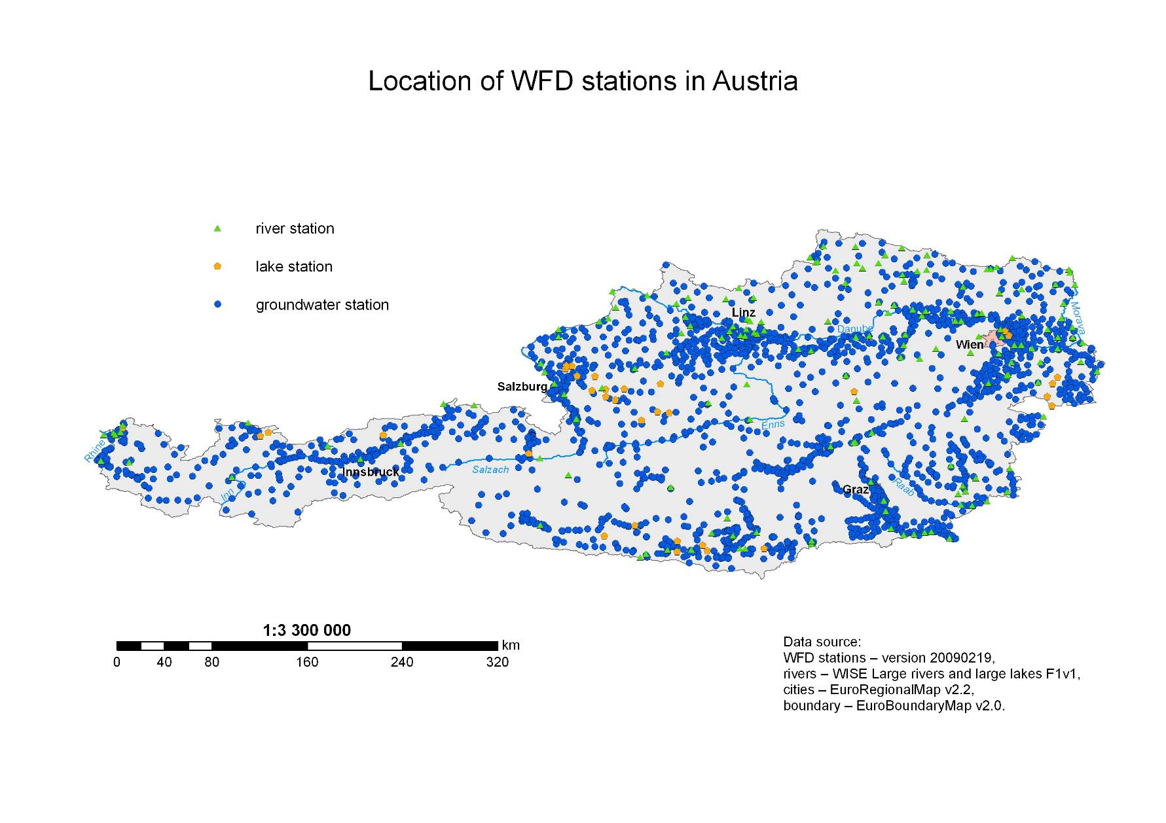
Results of Spatial Analysis 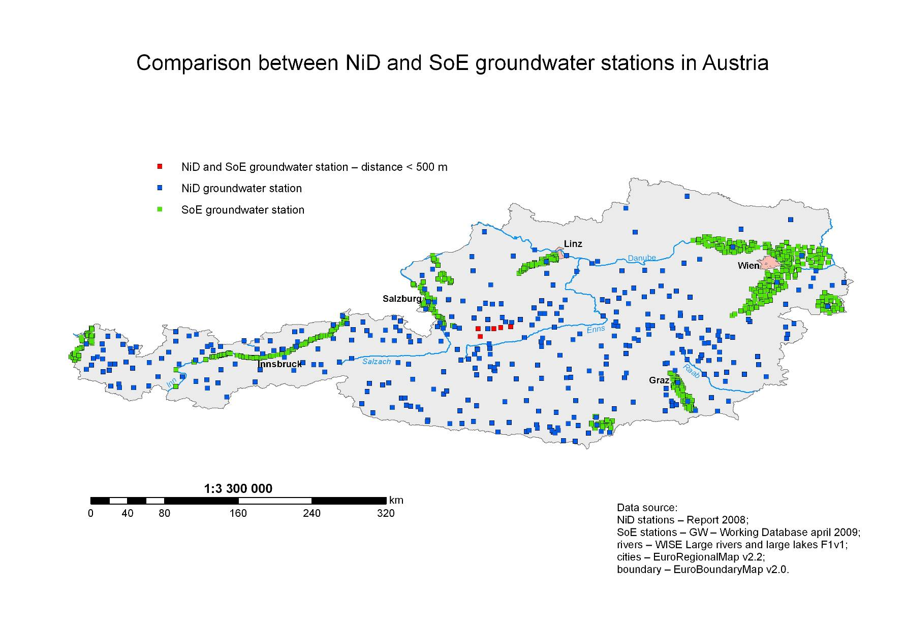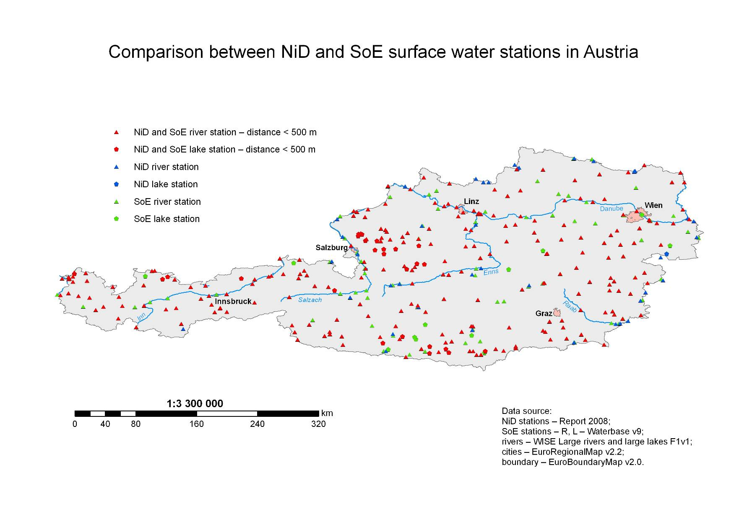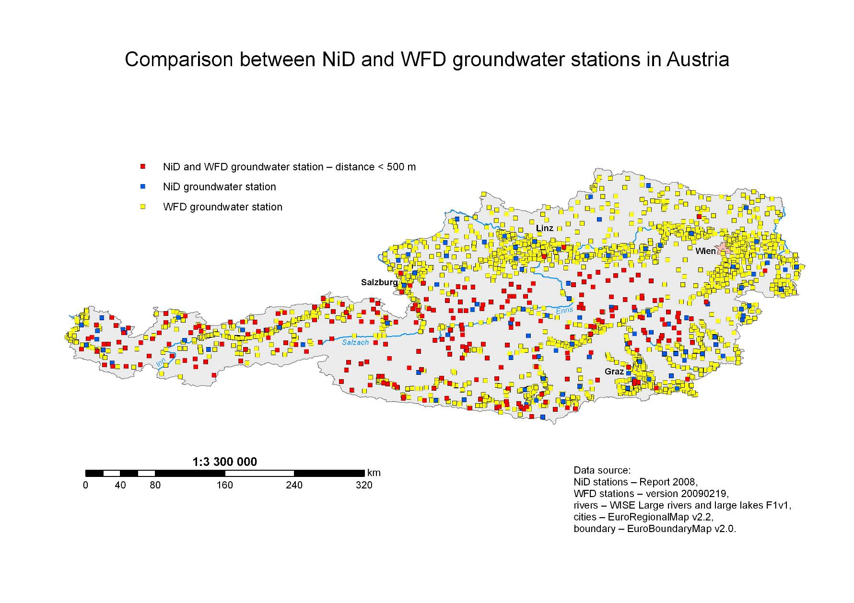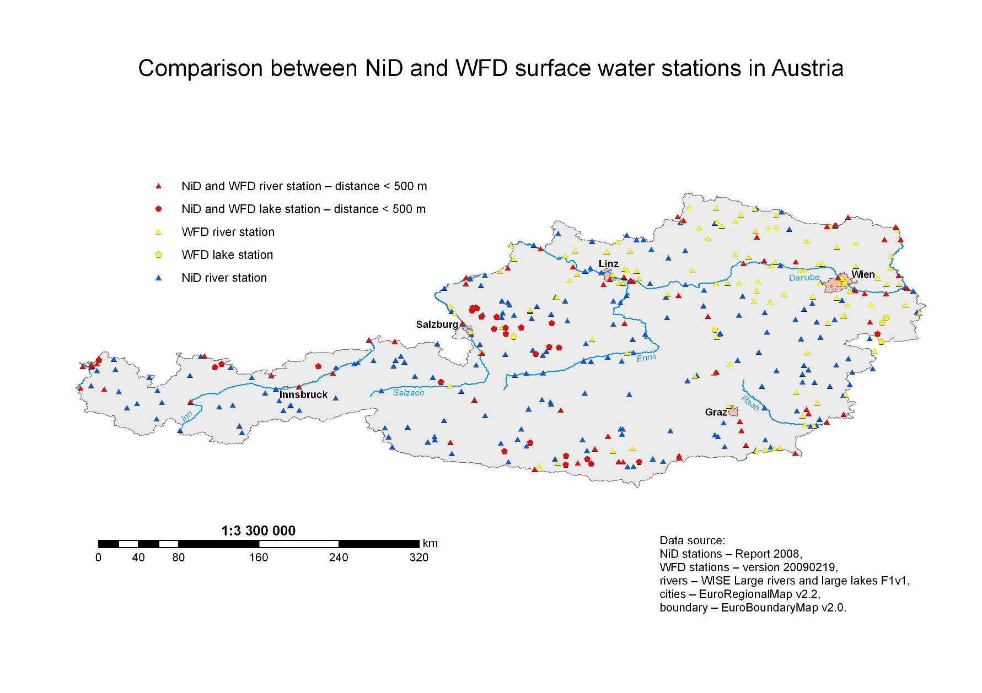
Final results – spatial and database together 

