Belgium – comparison of monitoring stations

Notes:

Rivers:
NiD monitoring network significantly bigger than SoE or WFD, SoE - low proportion of best results but few mistakes, problems with prefixes only; WFD - medium proportion of best results but few mistakes

Lakes:
NiD monitoring network bigger than SoE, WFD monitoring network bigger than NiD, low proportion of best results but few mistakes

Groundwater:
NiD monitoring network significantly bigger than SoE or WFD, medium proportion of best results, but few mistakes, different density of NiD reported station in Wallonia, Brussels and Flanders;

TCM:
NiD monitoring network bigger than SoE or WFD, low proportion of best results but few mistakes, problems with prefixes only

Legend:

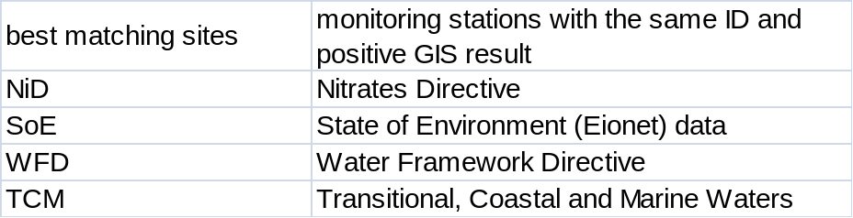
Position of reported stations 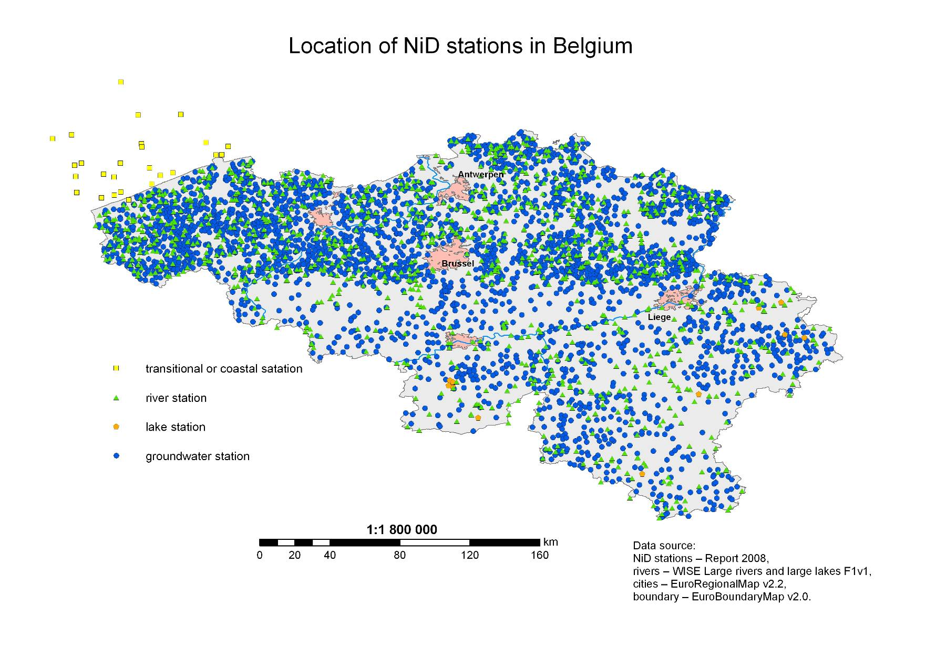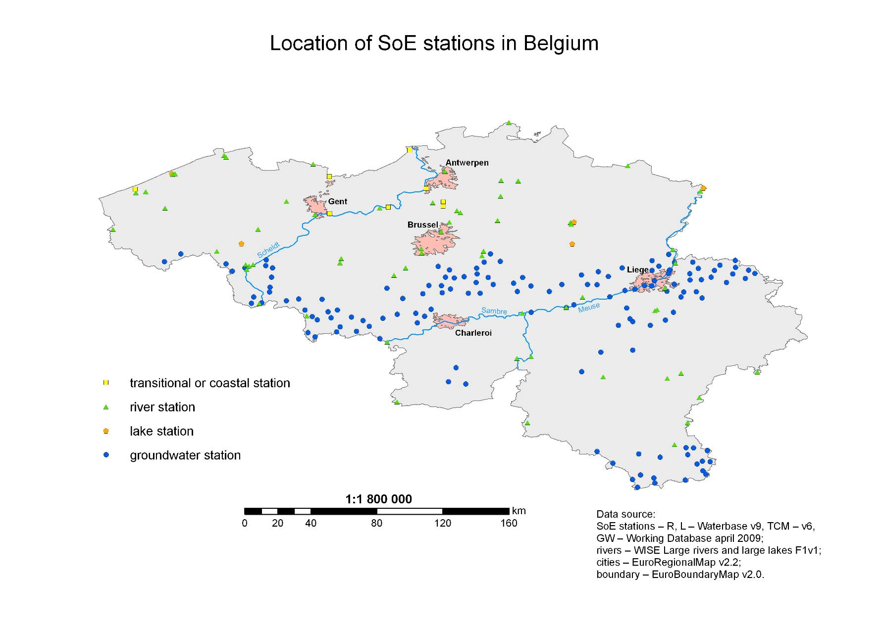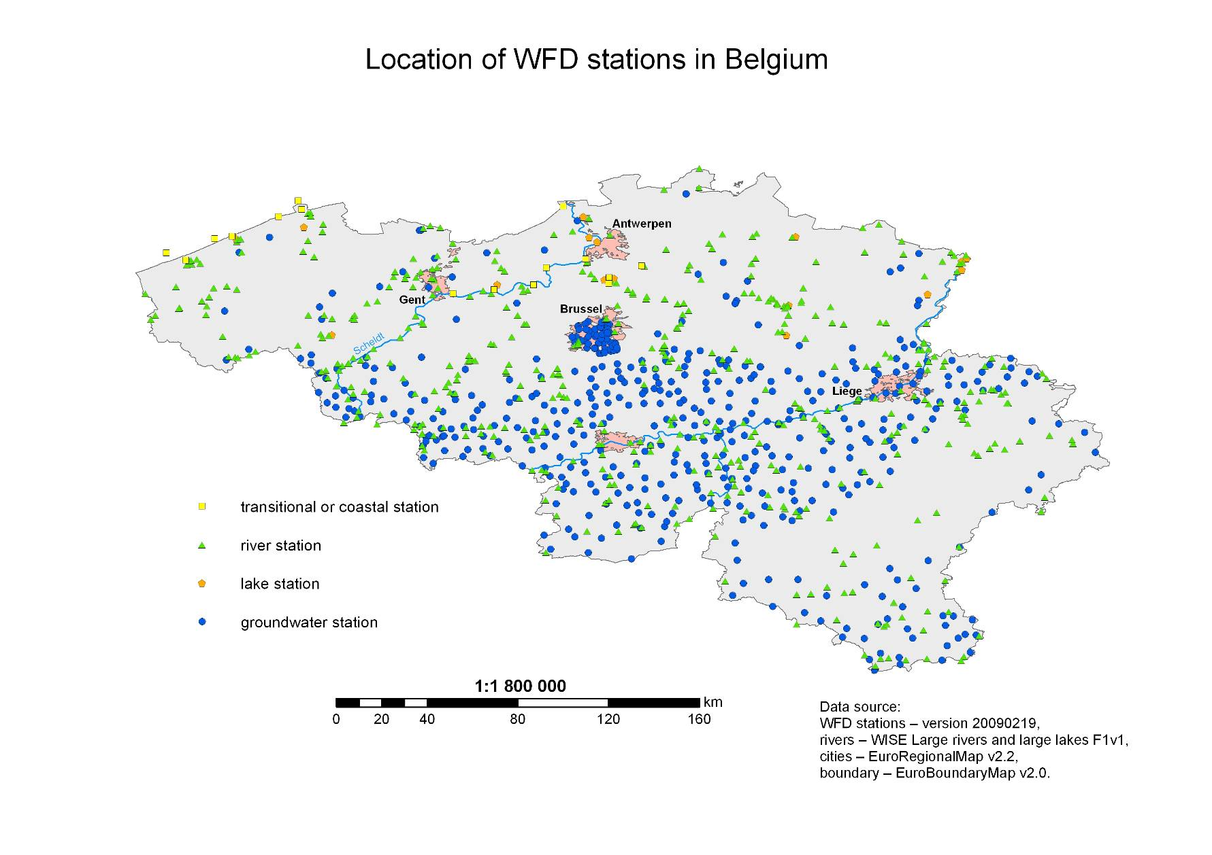
Results of Spatial Analysis 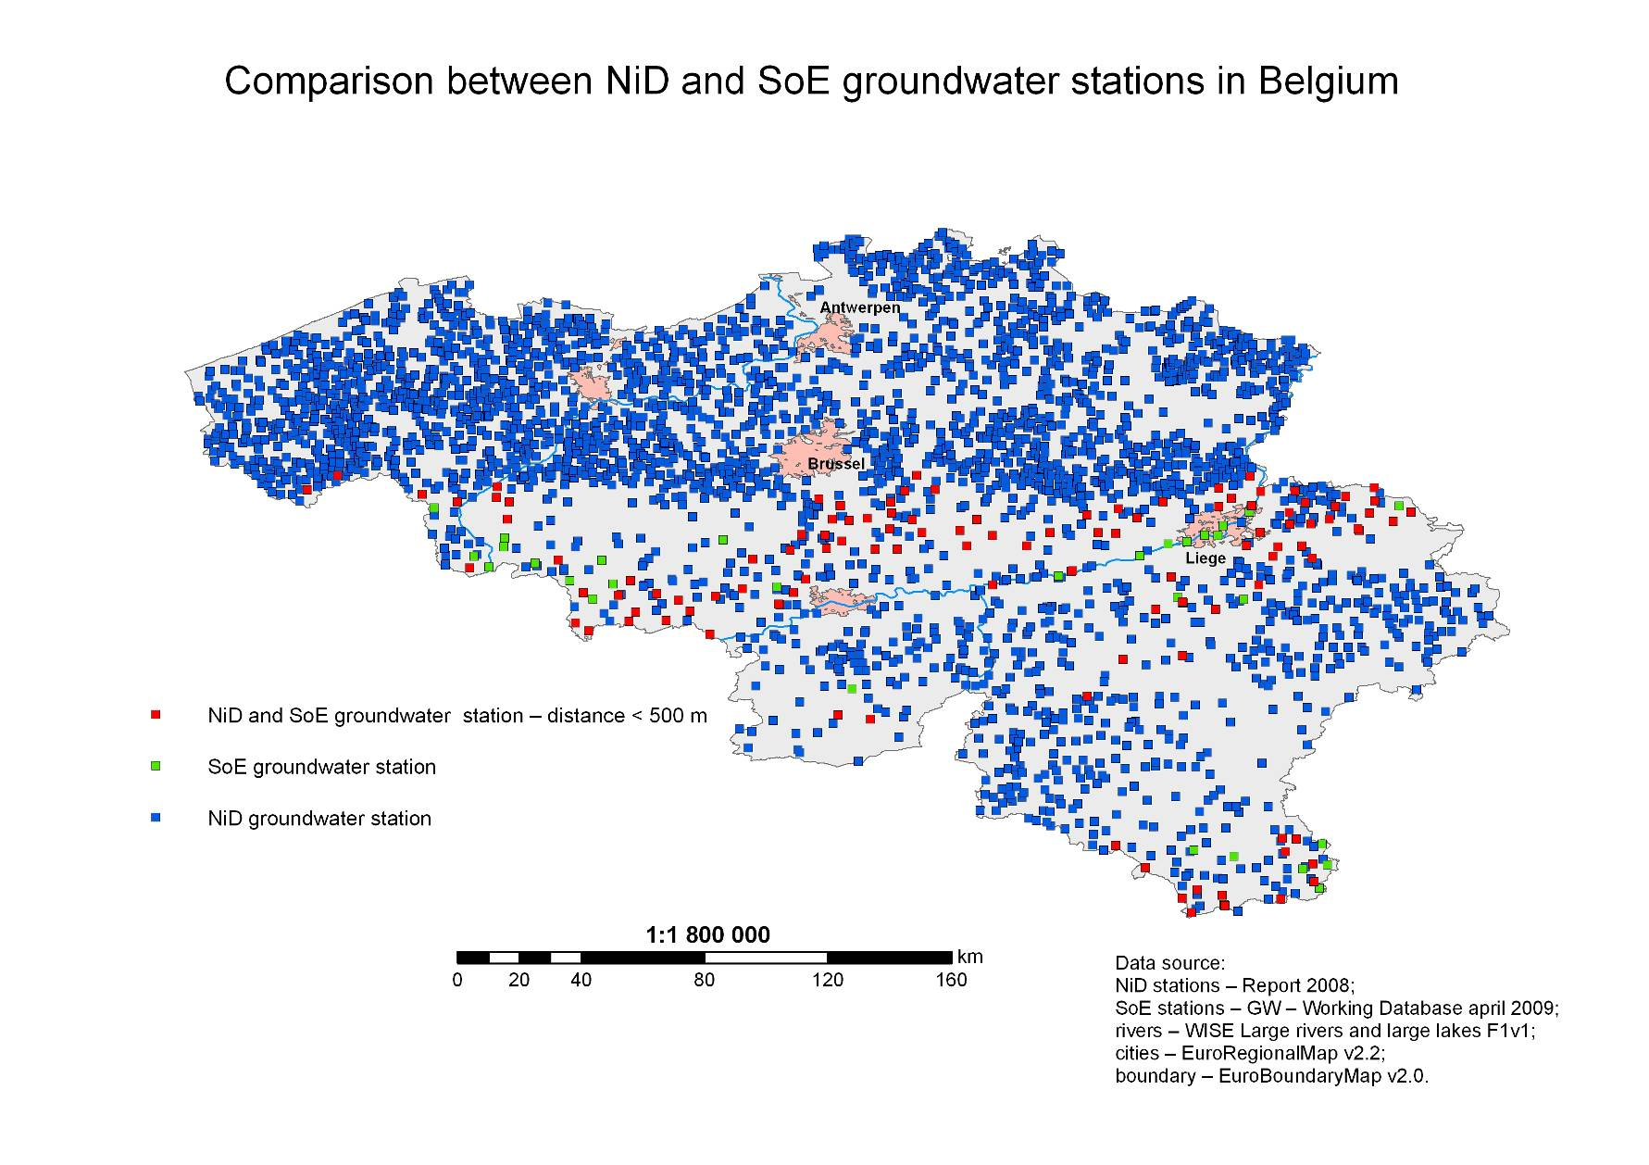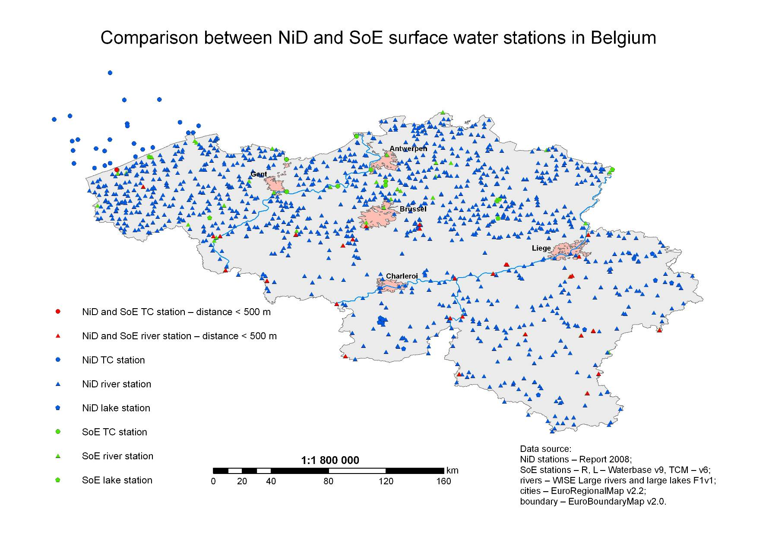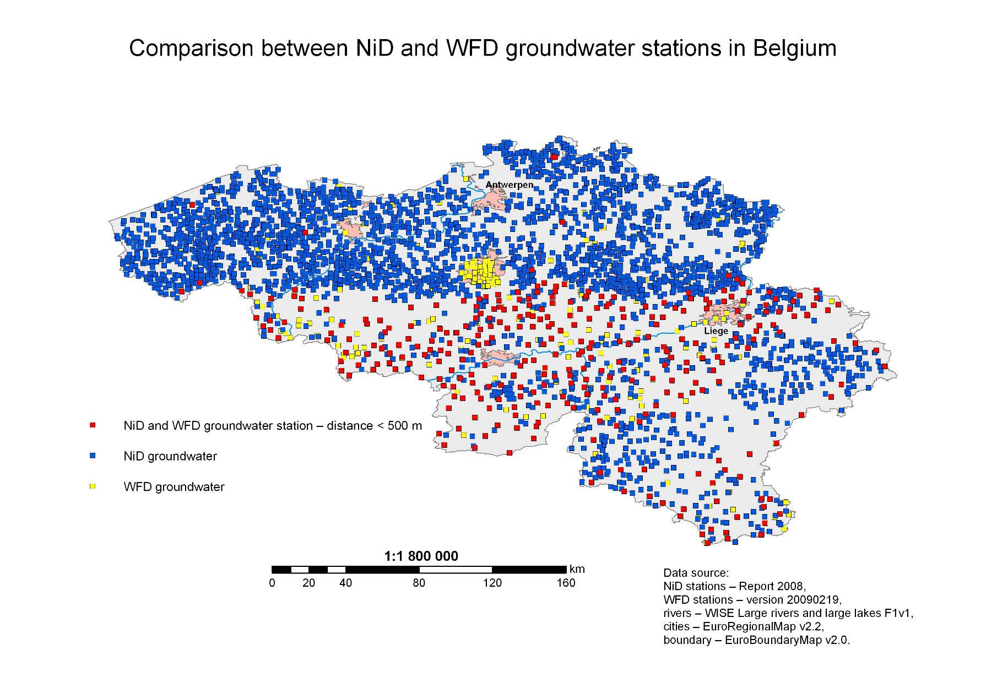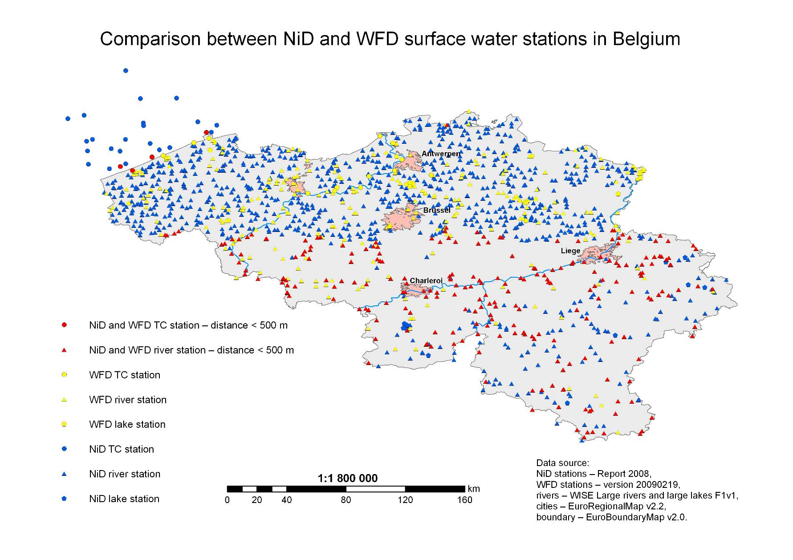
Final results – spatial and database together 

