Cyprus – comparison of monitoring stations

Notes:

Rivers:
NiD monitoring network smaller than SoE or WFD, low (WFD) or medium (SoE) proportion of best results but few mistakes, problems with SoE – NiD prefixes only

Lakes:
no data for NiD

Groundwater:
the same number of NiD and SoE monitoring sites, very low proportion of best results, but good proportion of database results, possible problems with position?; NiD monitoring network bigger than WFD, no best results but medium proportion of good spatial analysis

TCM:
NiD monitoring network significantly smaller than SoE but bigger than WFD, very high proportion of best results NiD – SoE; no best results but few mistakes

Legend:

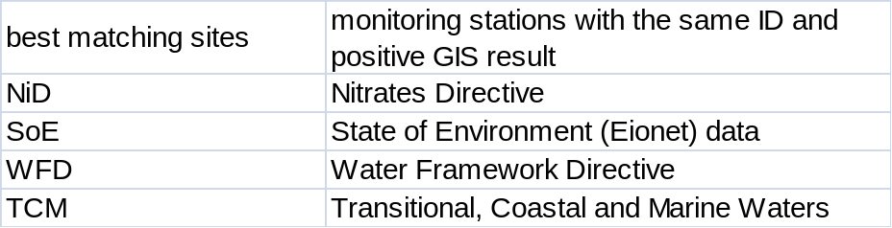
Position of reported stations 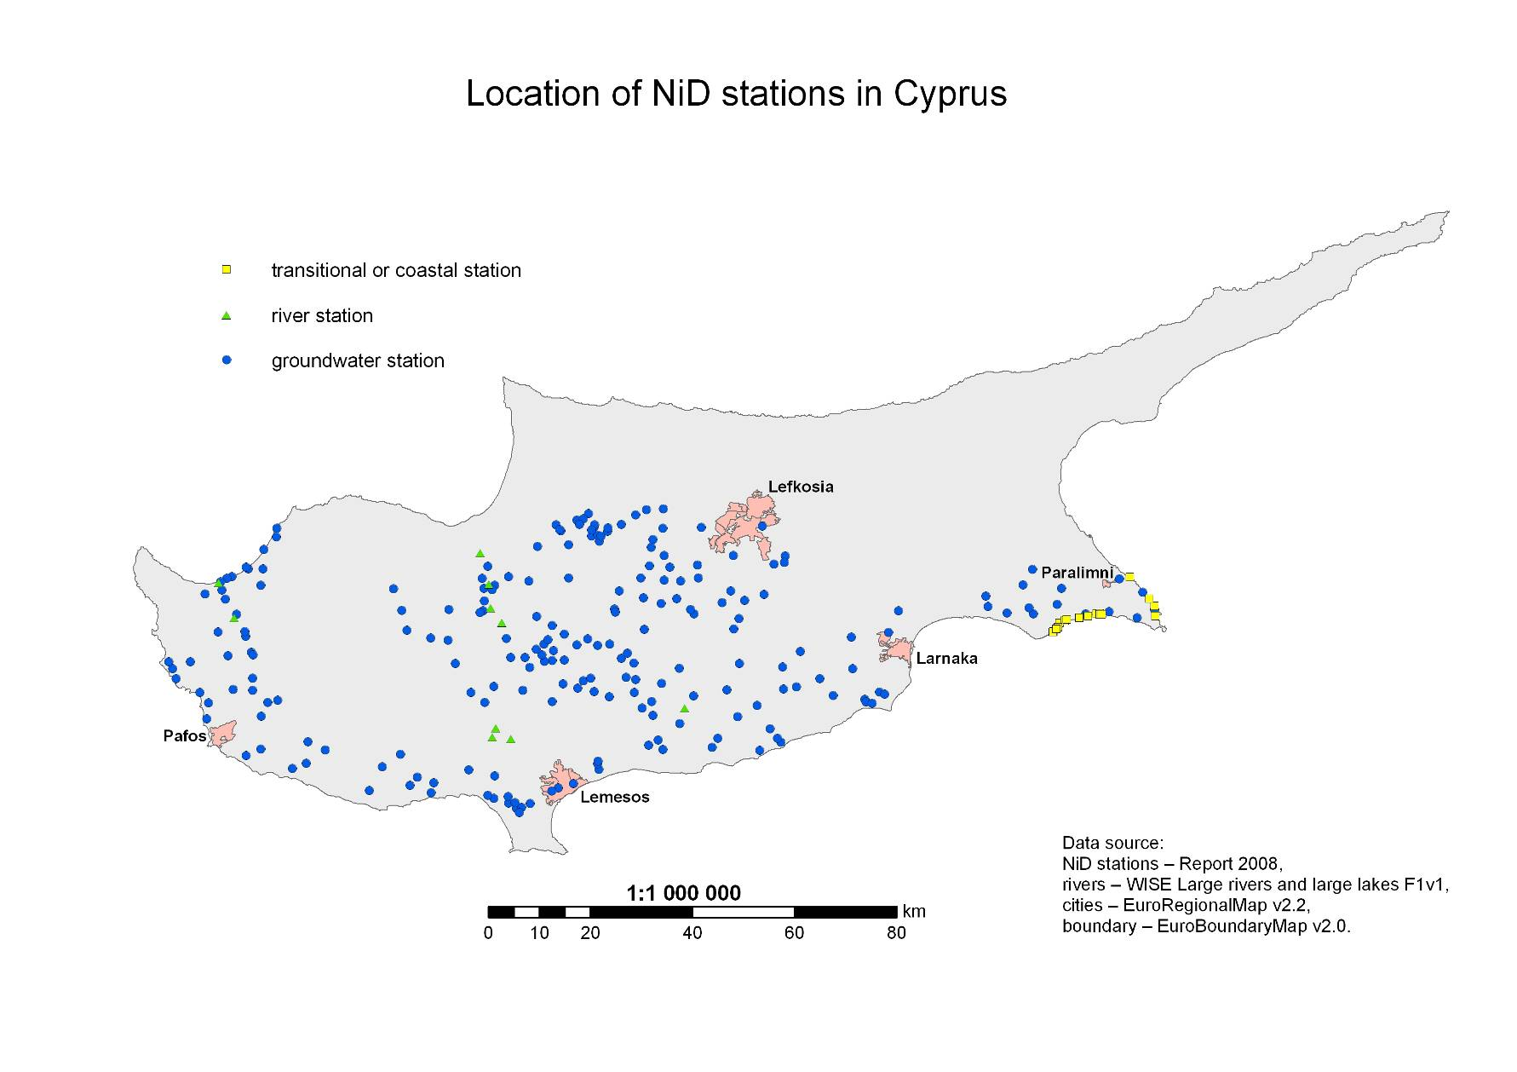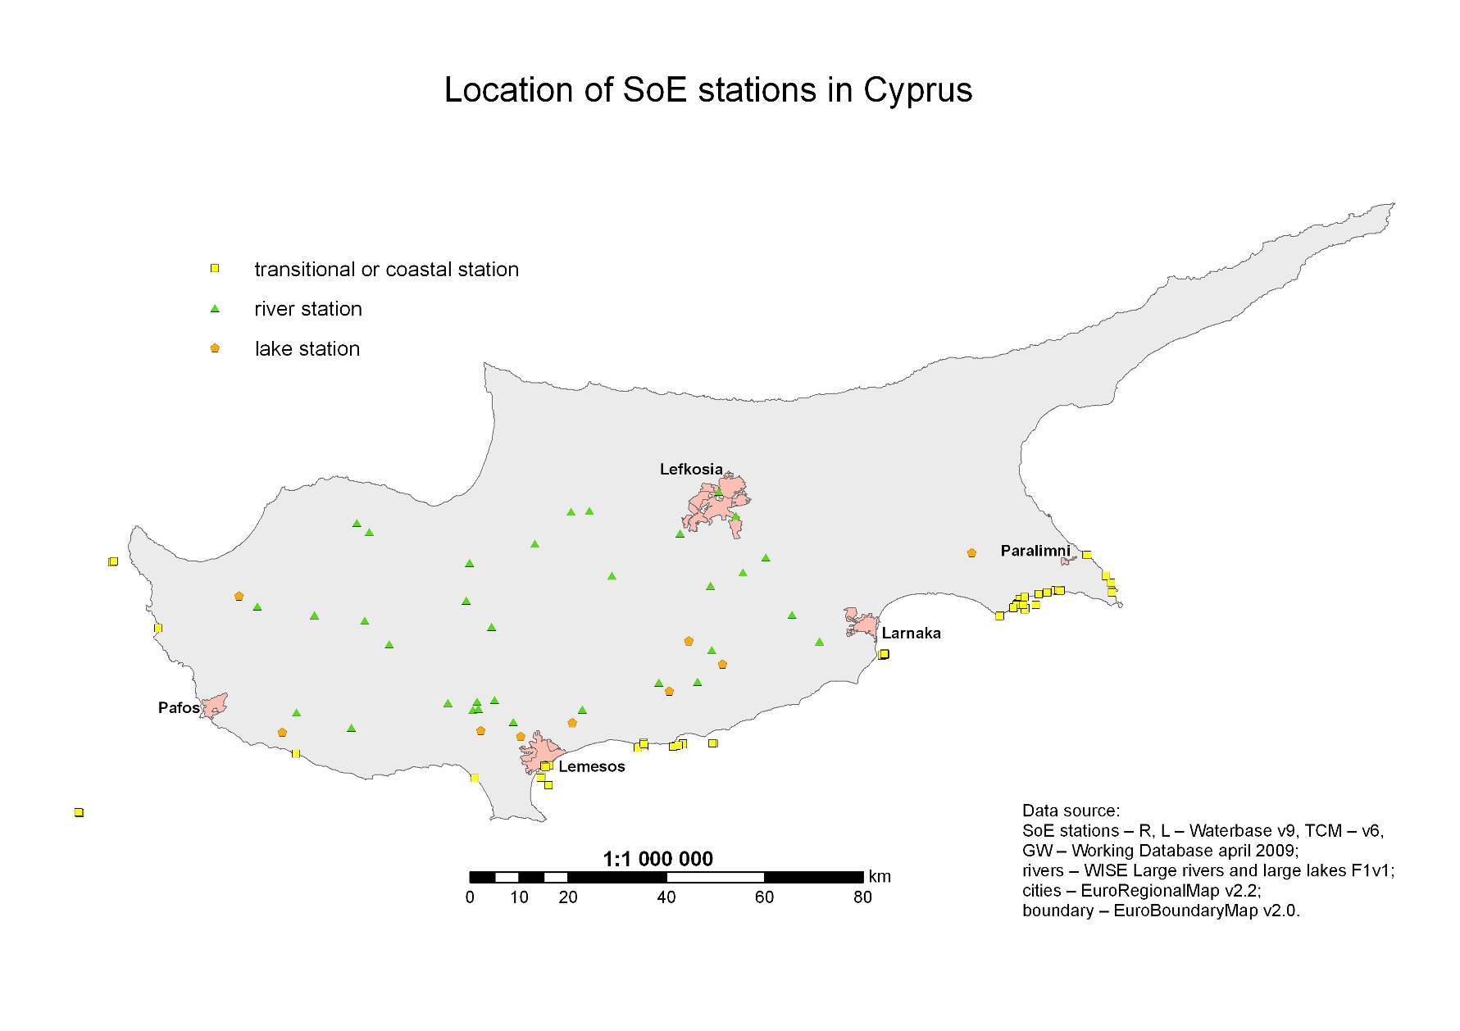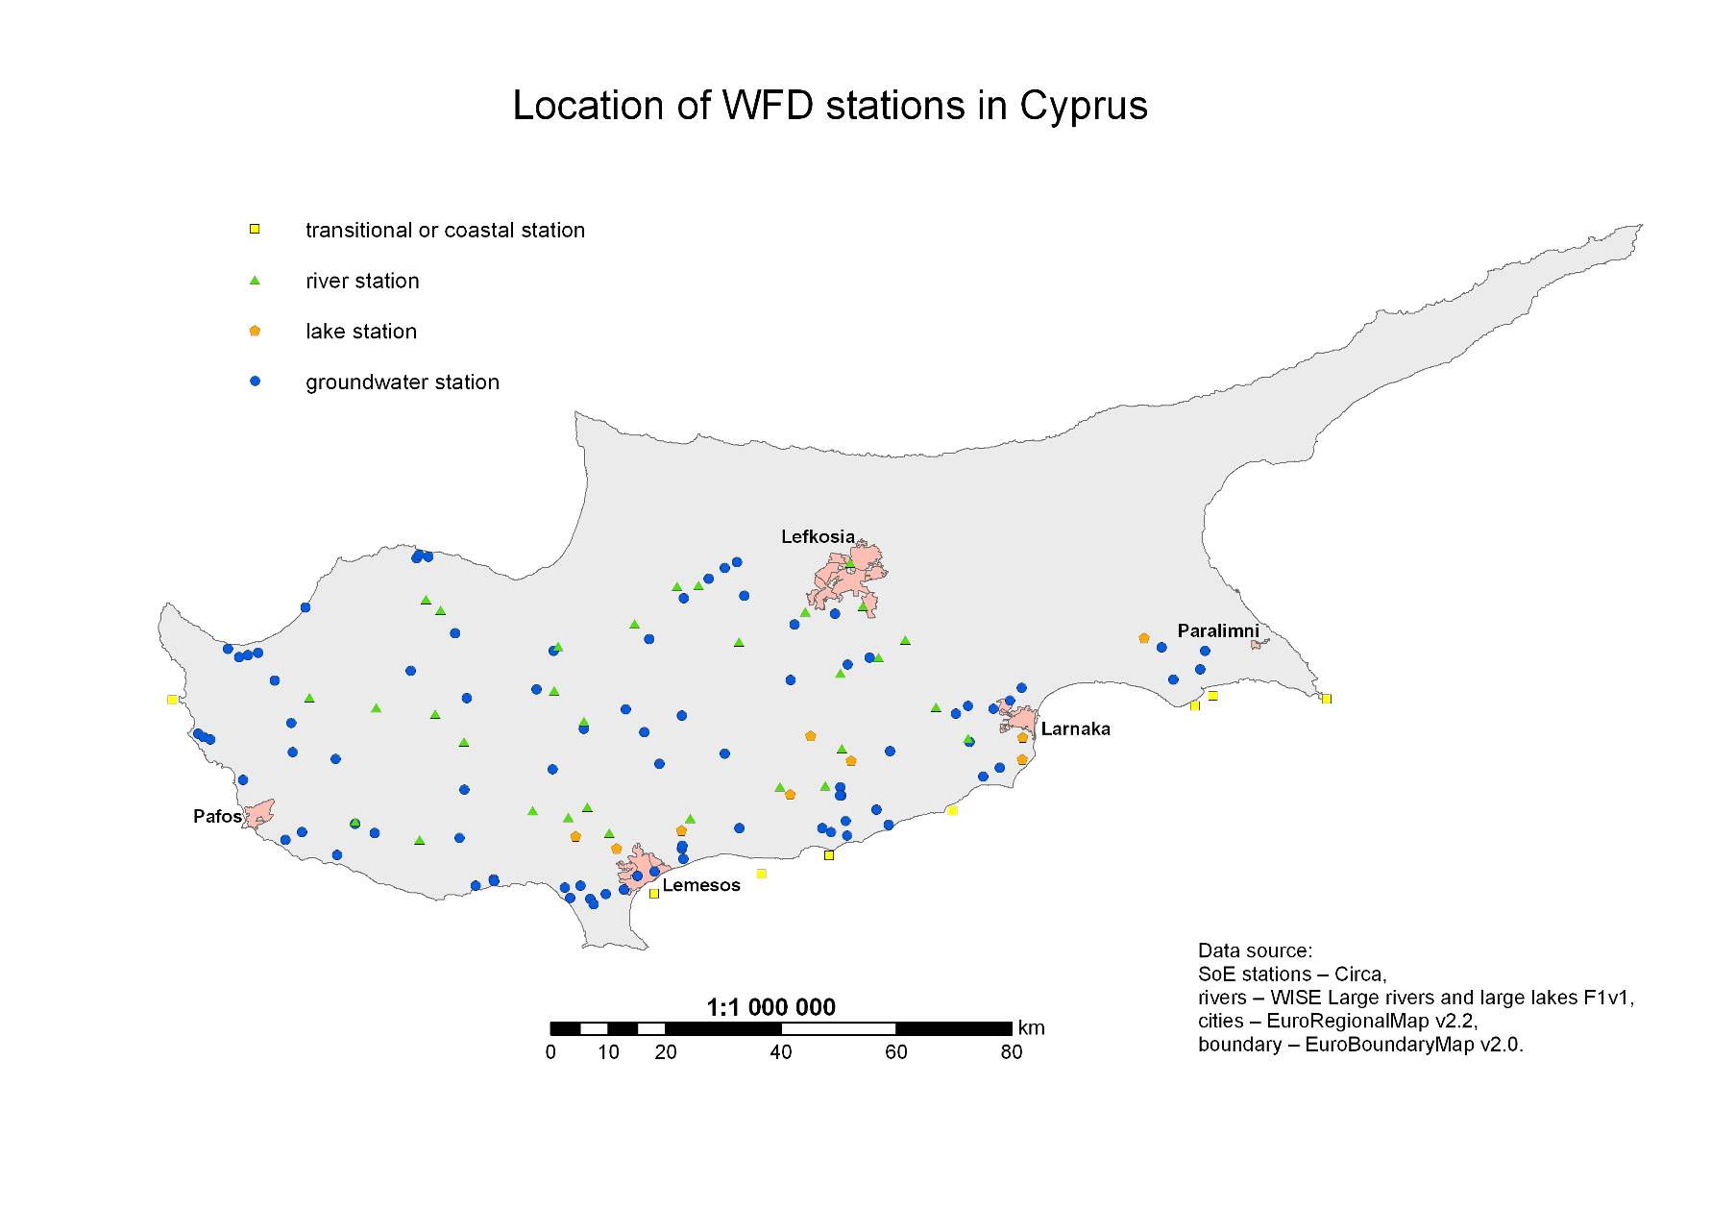
Results of Spatial Analysis 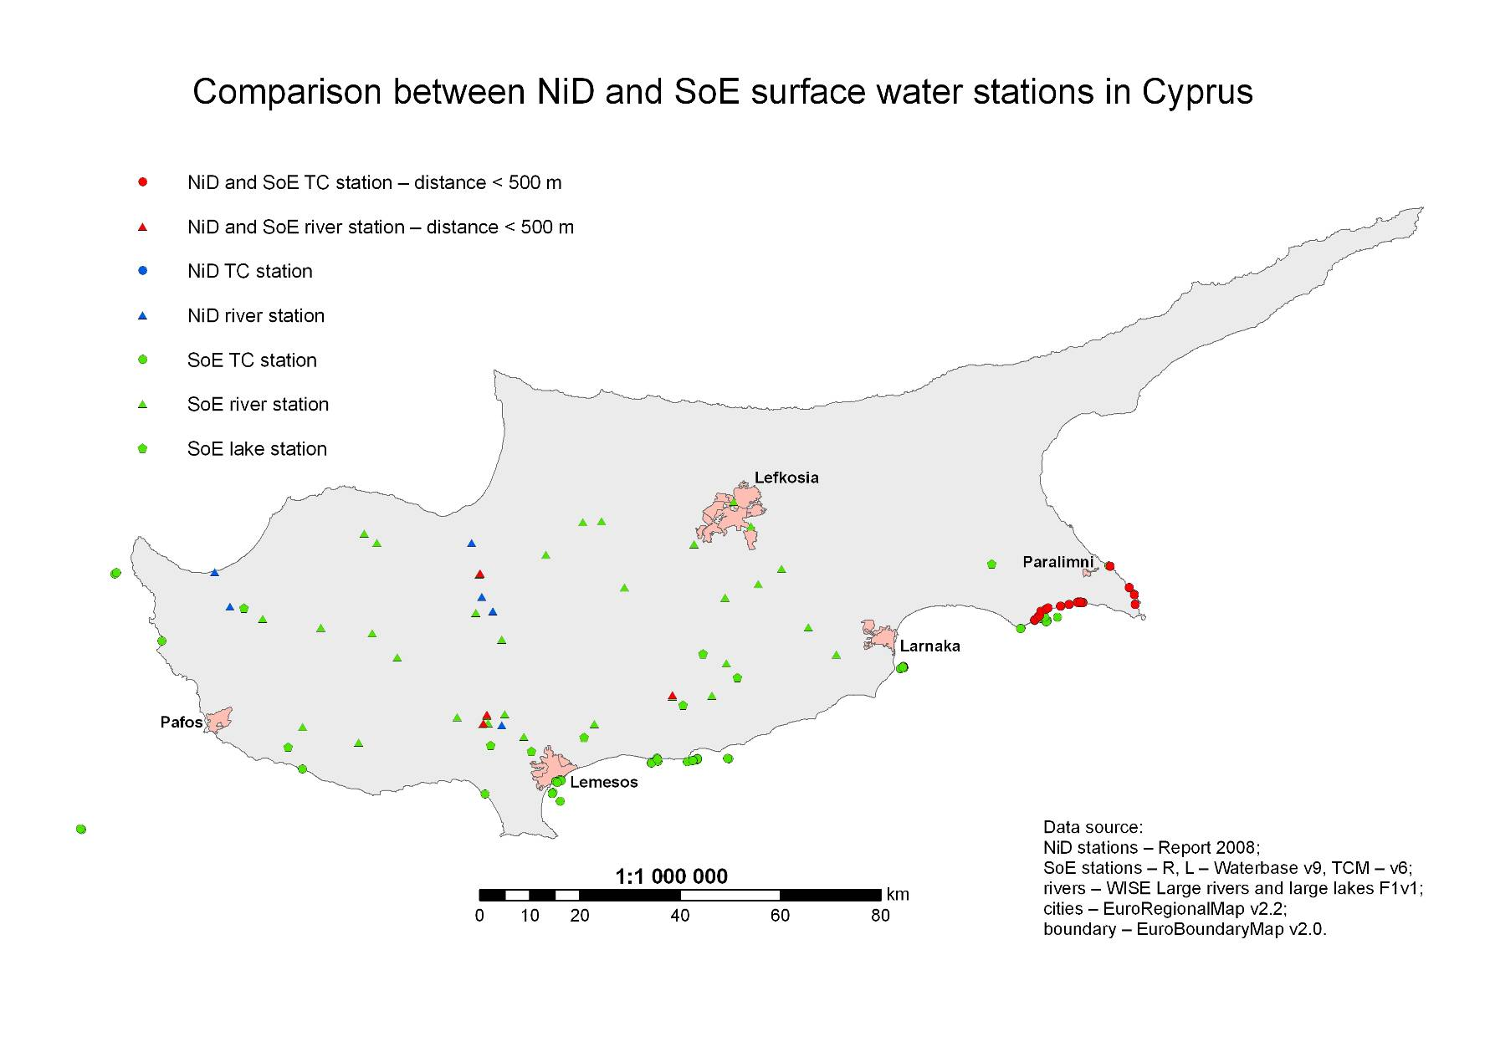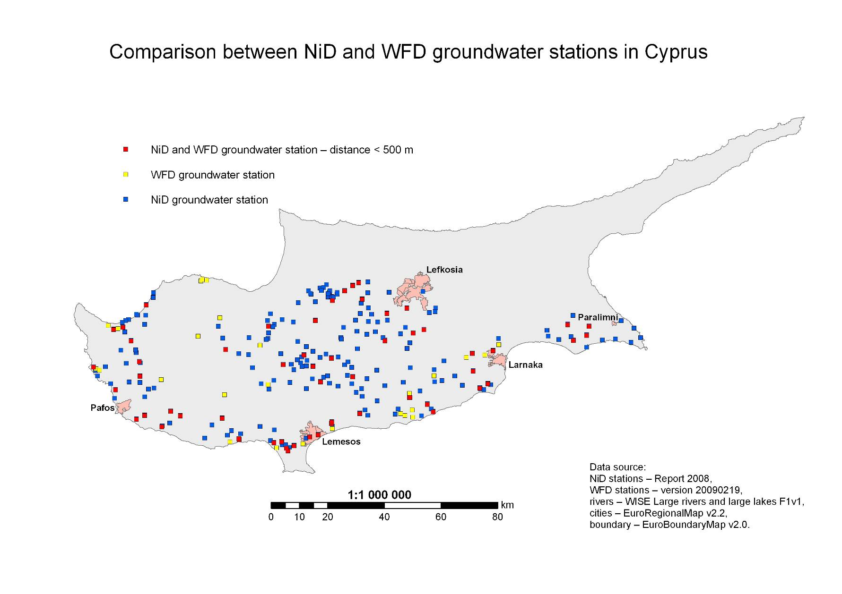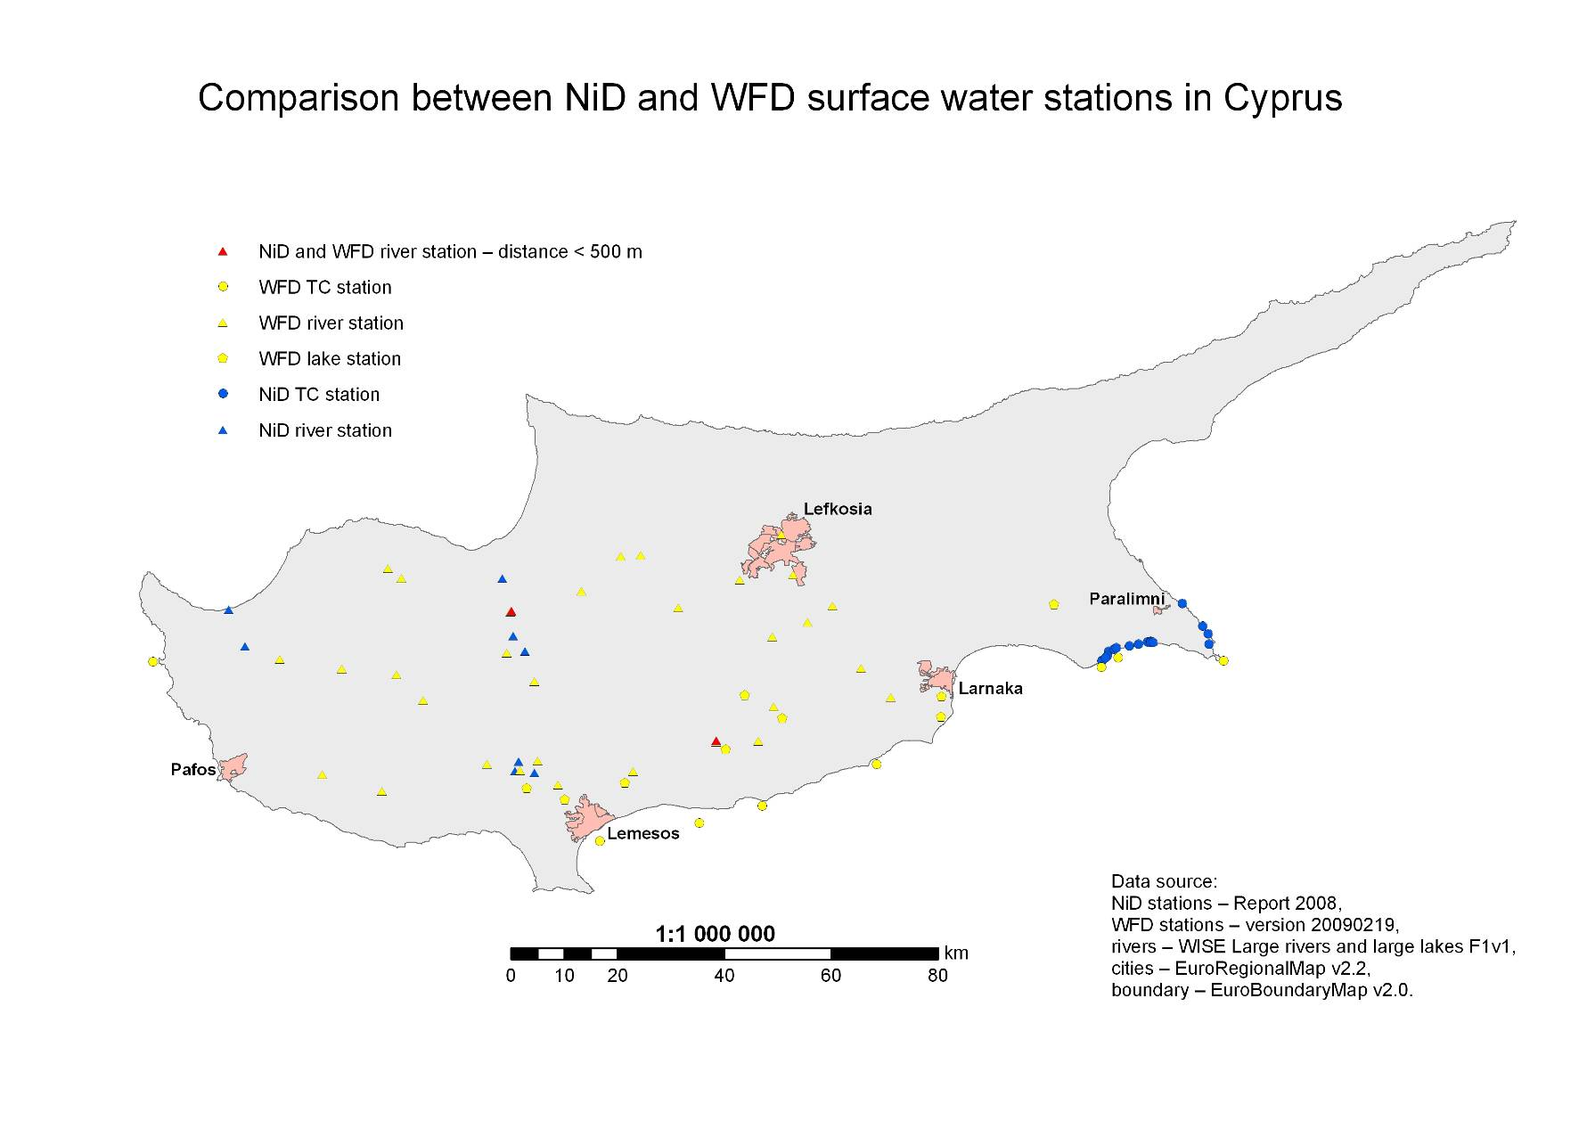
Final results – spatial and database together 

