Lithuania – comparison of monitoring stations

Notes:

Rivers:
NiD monitoring network significantly smaller than SoE or WFD; very high proportion of best matching sites; few mistakes

Lakes:
NiD monitoring network significantly bigger than SoE but significantly smaller than SoE; very low proportion of best matching sites, but very good results of spatial analysis, possible mistakes with codes?

Groundwater:
NiD monitoring network significantly smaller than SoE or WFD, very high proportion of best matching sites; few possible mistakes only

TCM:
almost the same number of NiD and SoE monitoring sites, medium proportion
of best matching sites and partly good results of spatial analysis, possible mistakes with codes?; no WFD data

Legend:

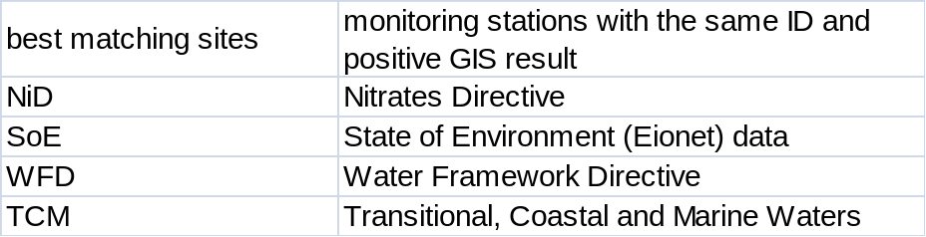
Position of reported stations 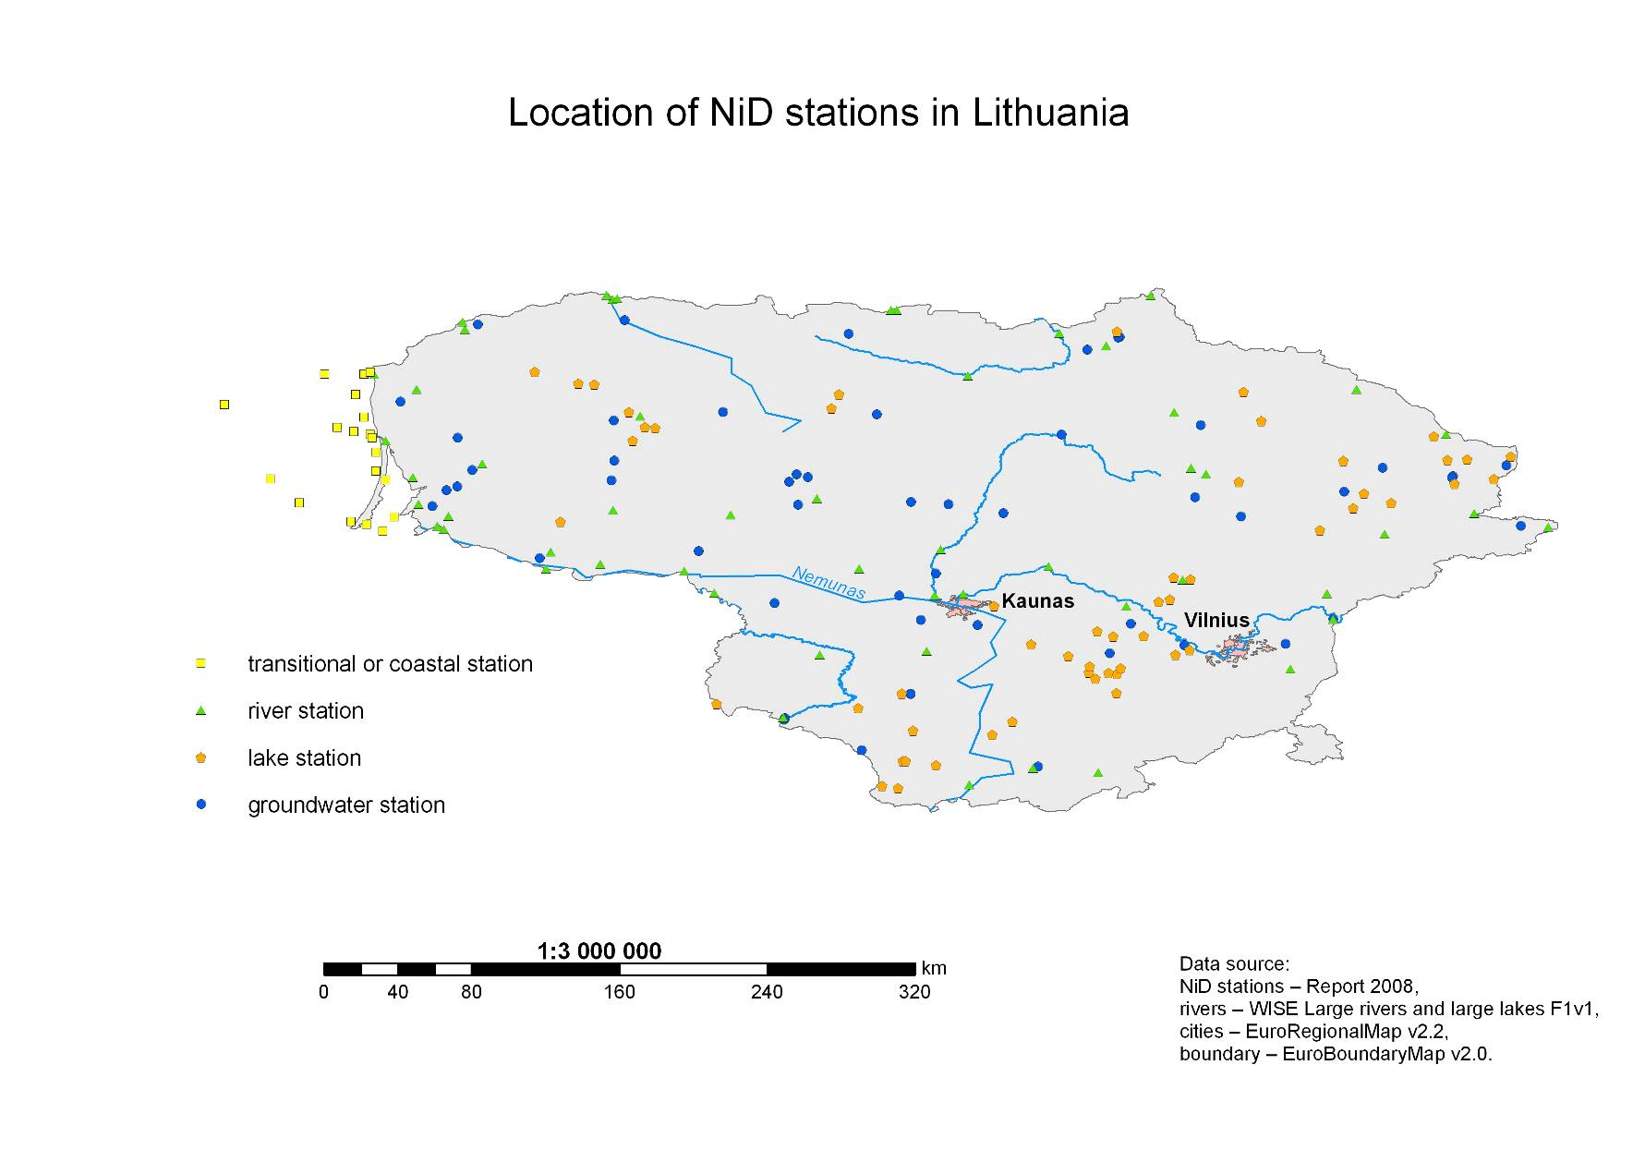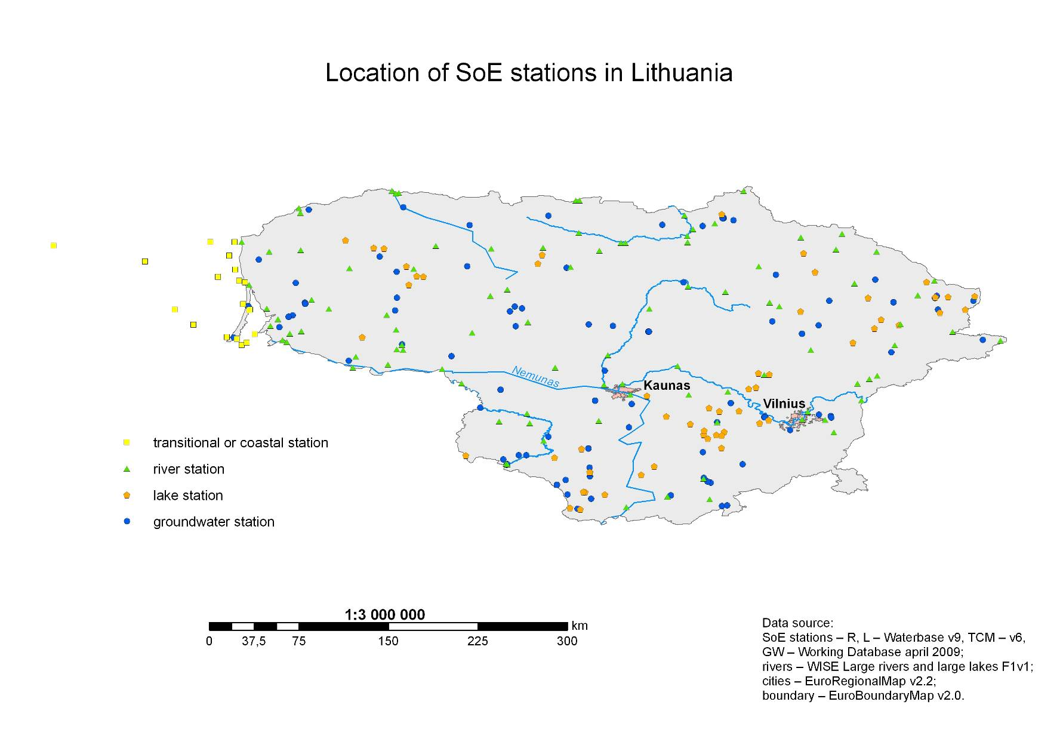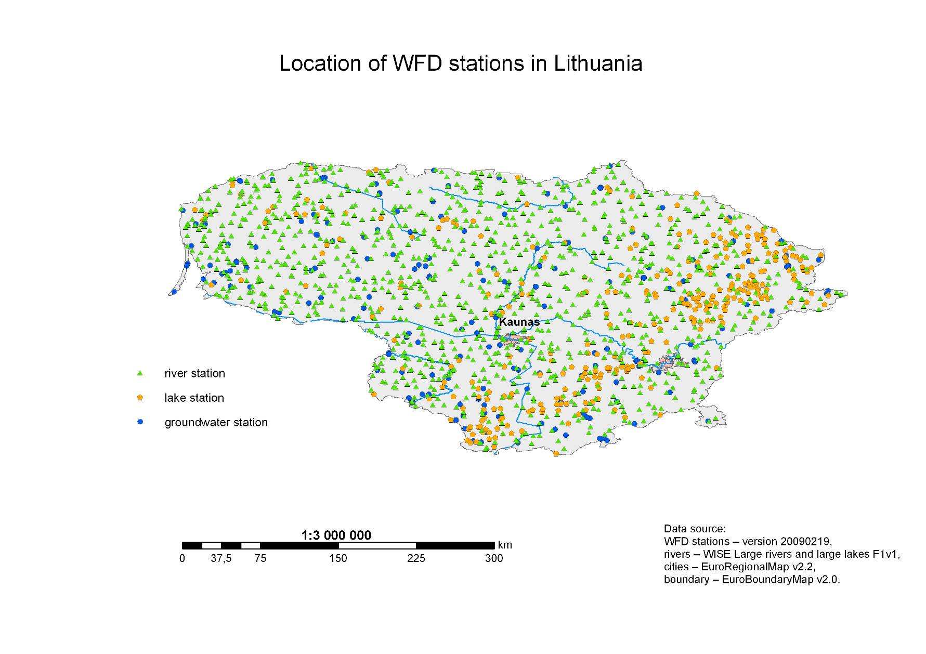
Results of Spatial Analysis 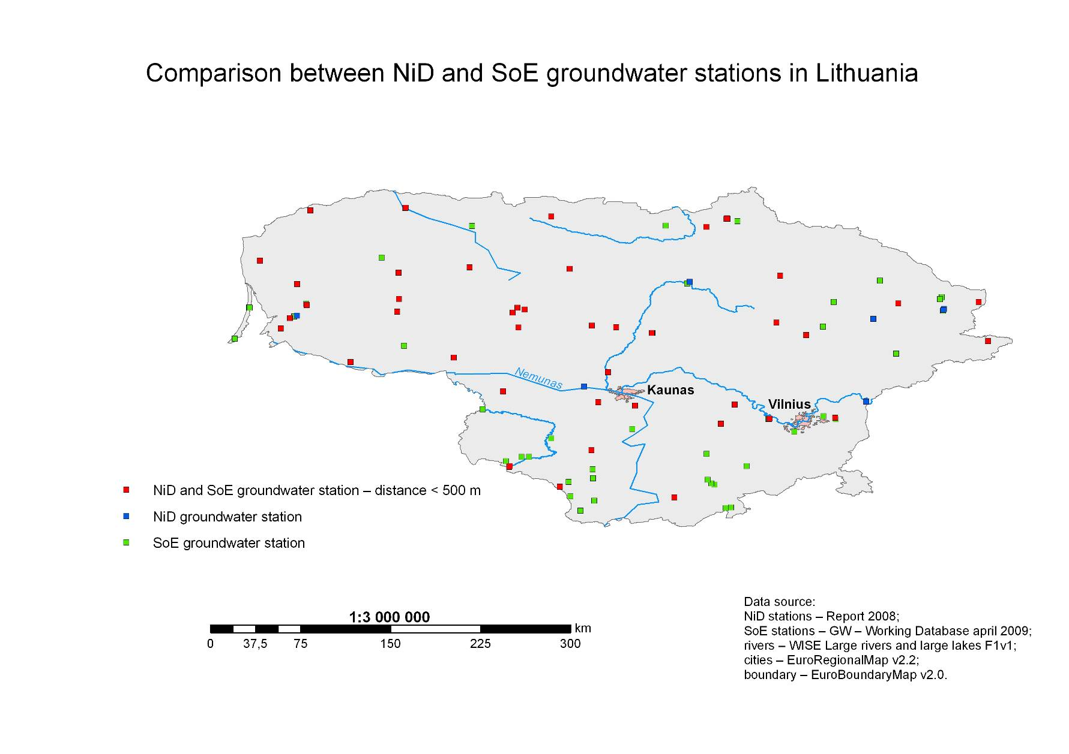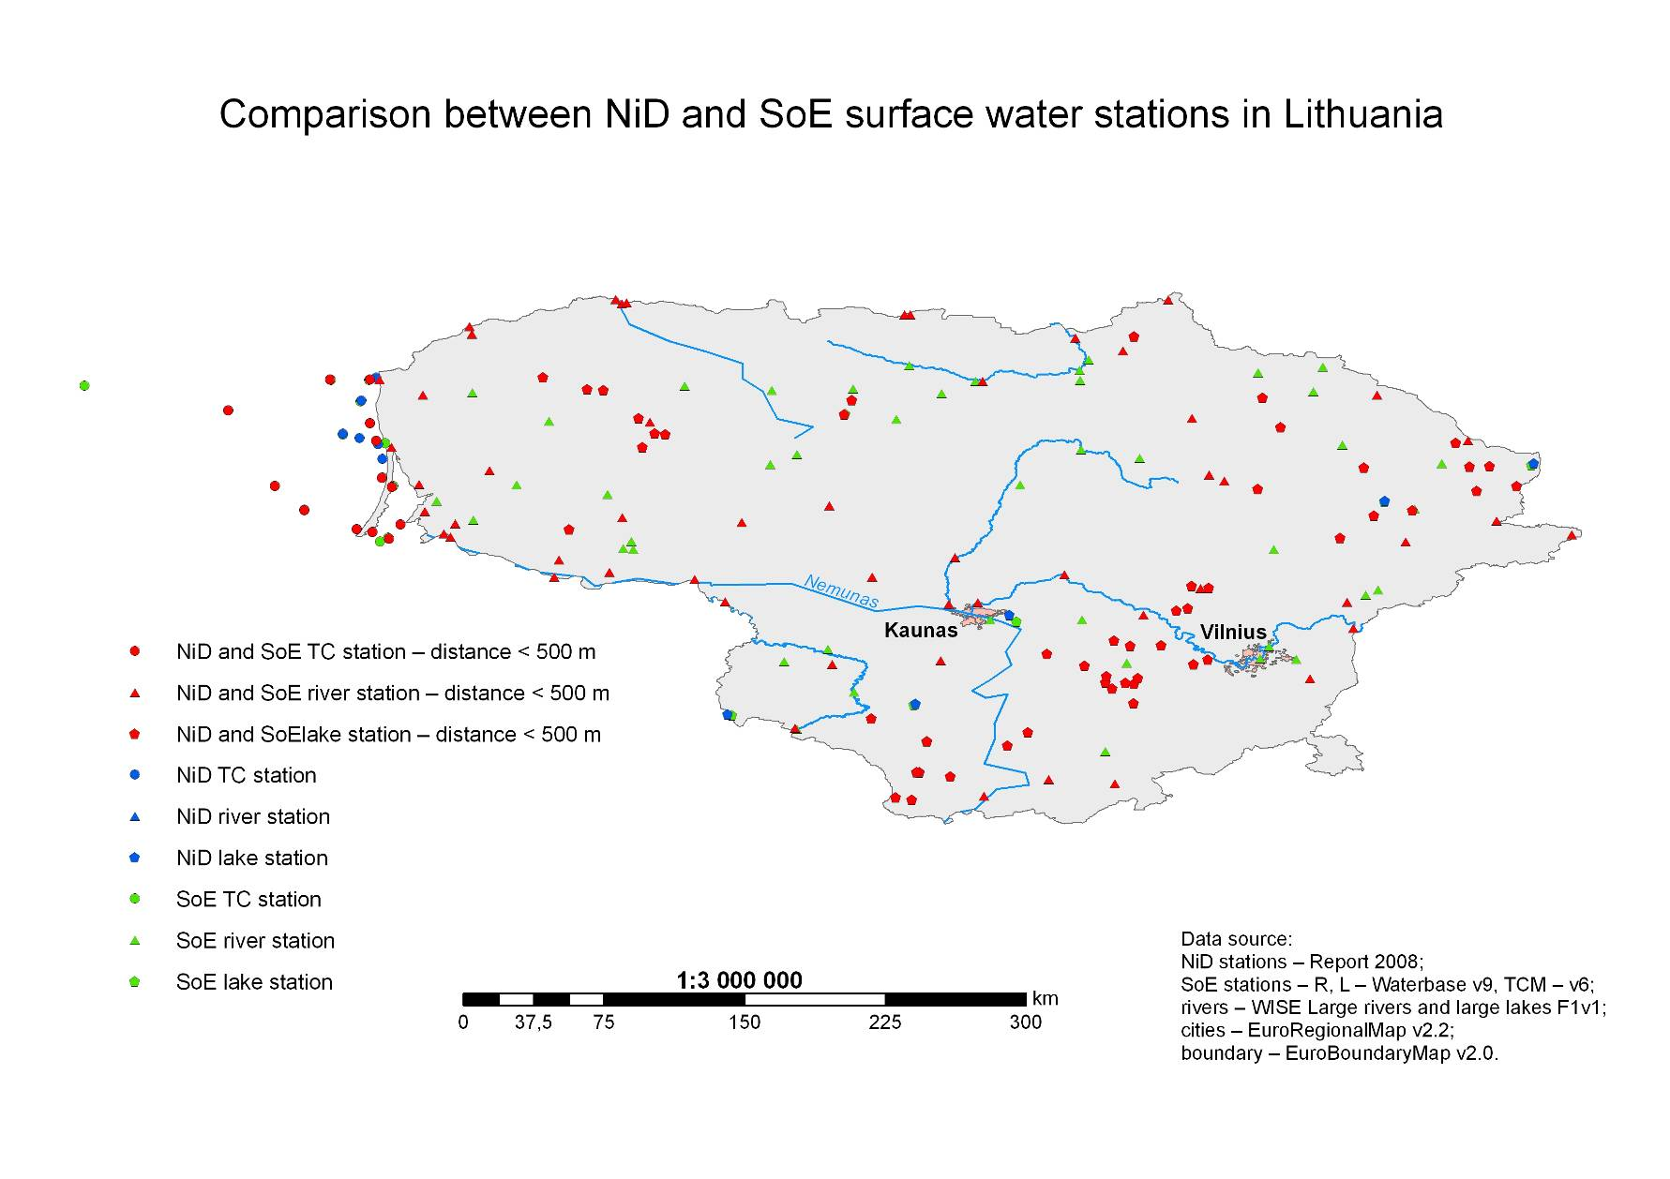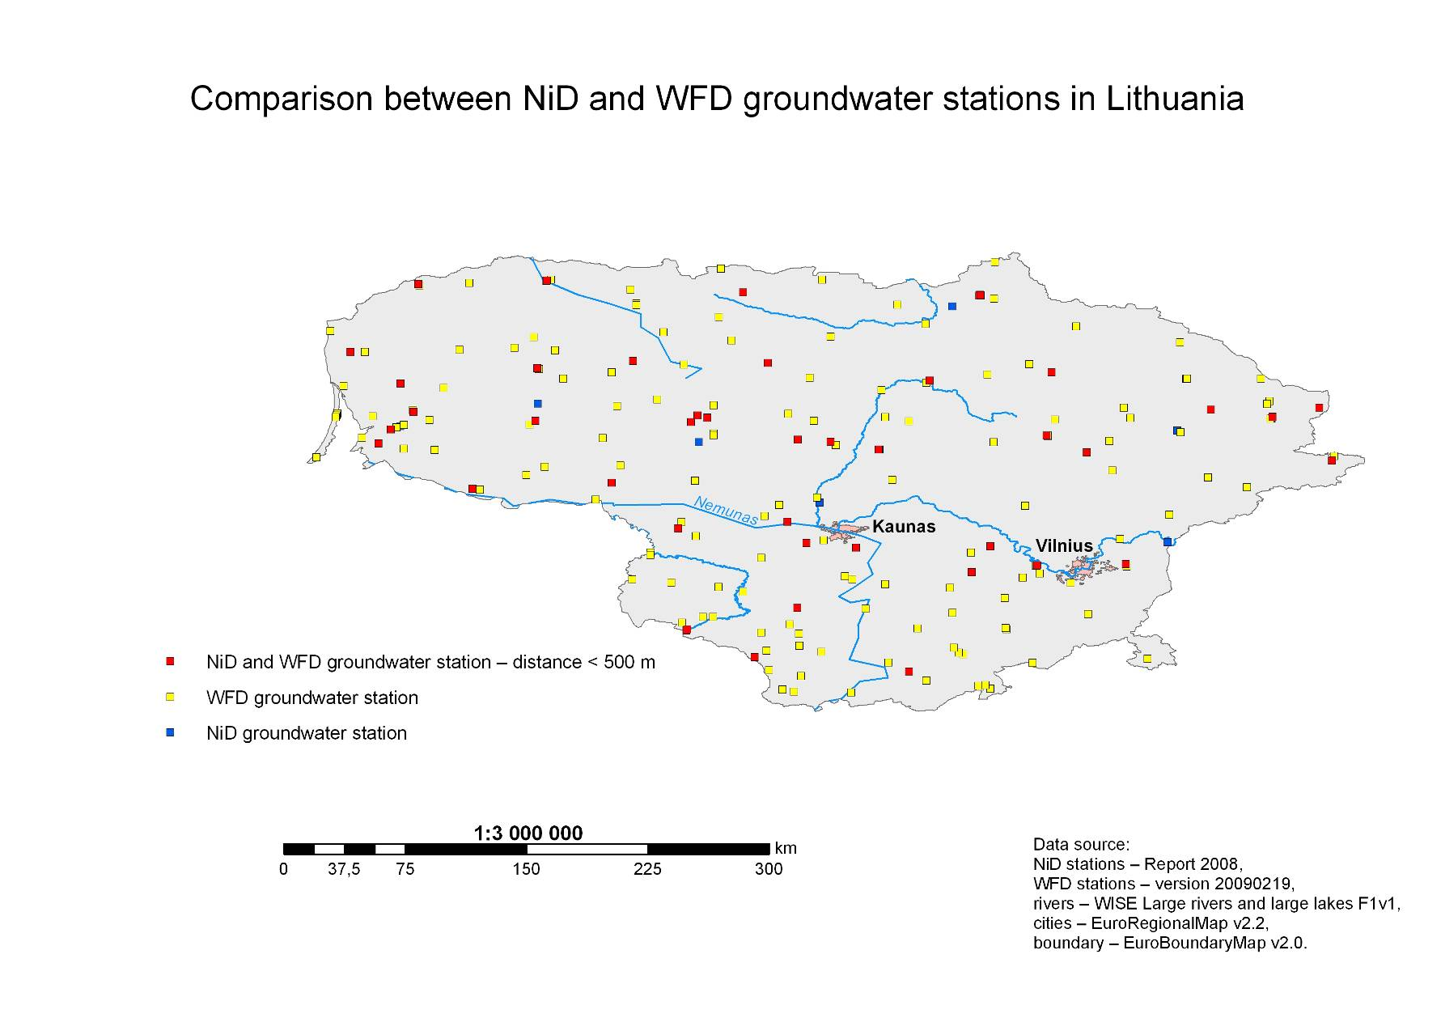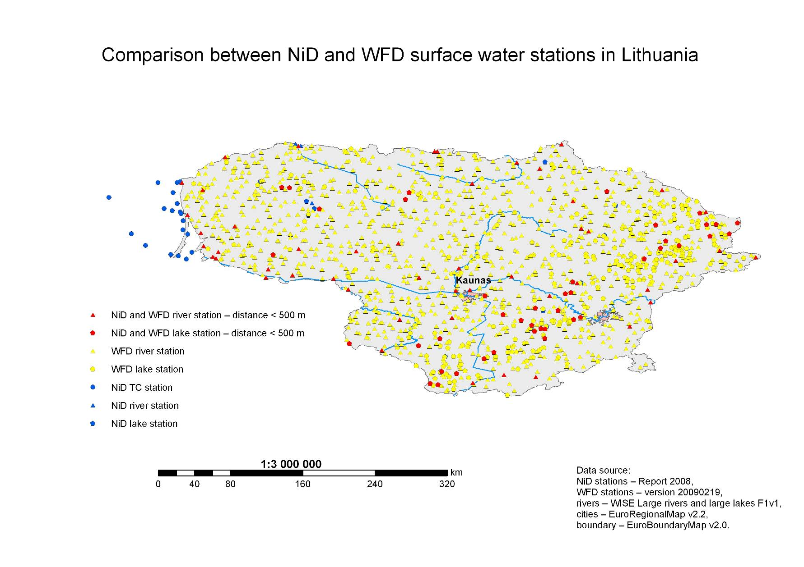
Final results – spatial and database together 

