Portugal – comparison of monitoring stations

Notes:

Rivers:
almost the same number of NiD and SoE monitoring sites, low proportion of best matching sites; few possible mistakes only; NiD monitoring network significantly smaller than WFD; medium proportion of best matching sites; few mistakes only

Lakes:
NiD monitoring network bigger than SoE but smaller than WFD; medium proportion of best matching sites; few mistakes only

Groundwater:
NiD monitoring network significantly bigger than SoE but smaller than WFD, very low proportion of NiD – SoE best matching sites but partly good results of database analysis; medium proportion of NiD – WFD best matching sites and partly good results of spatial analysis

TCM:
no SoE data; almost the same number of NiD and WFD monitoring sites, low proportion of NiD – WFD best matching sites; few mistakes only

Legend:

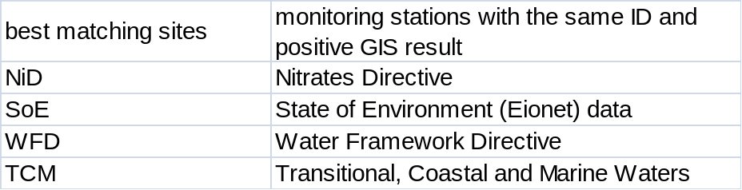
Position of reported stations 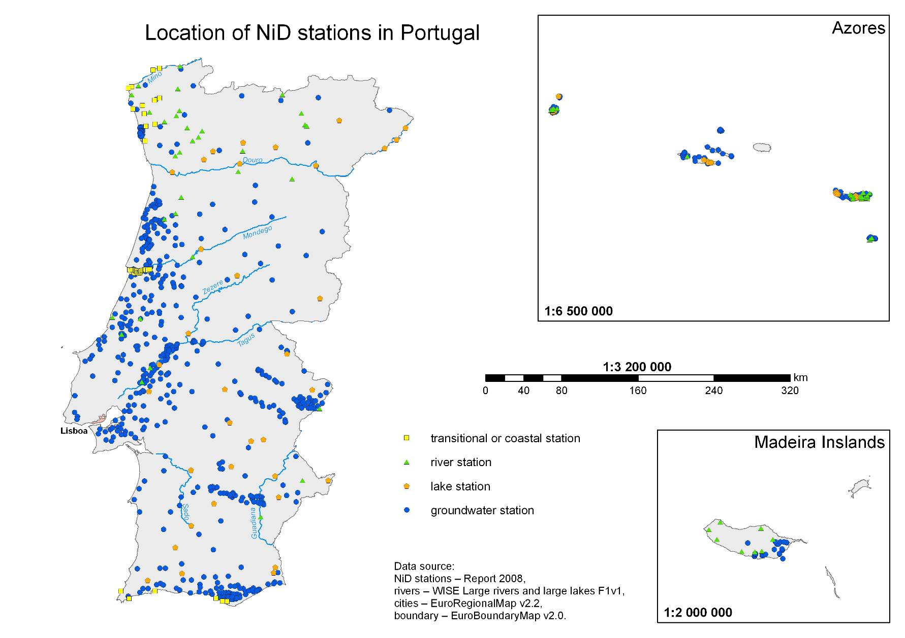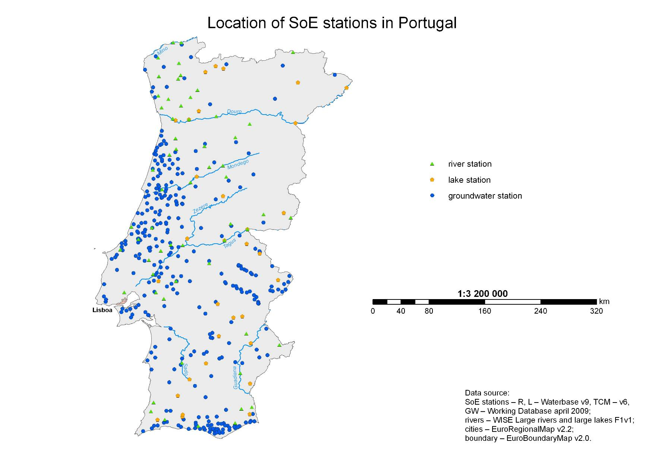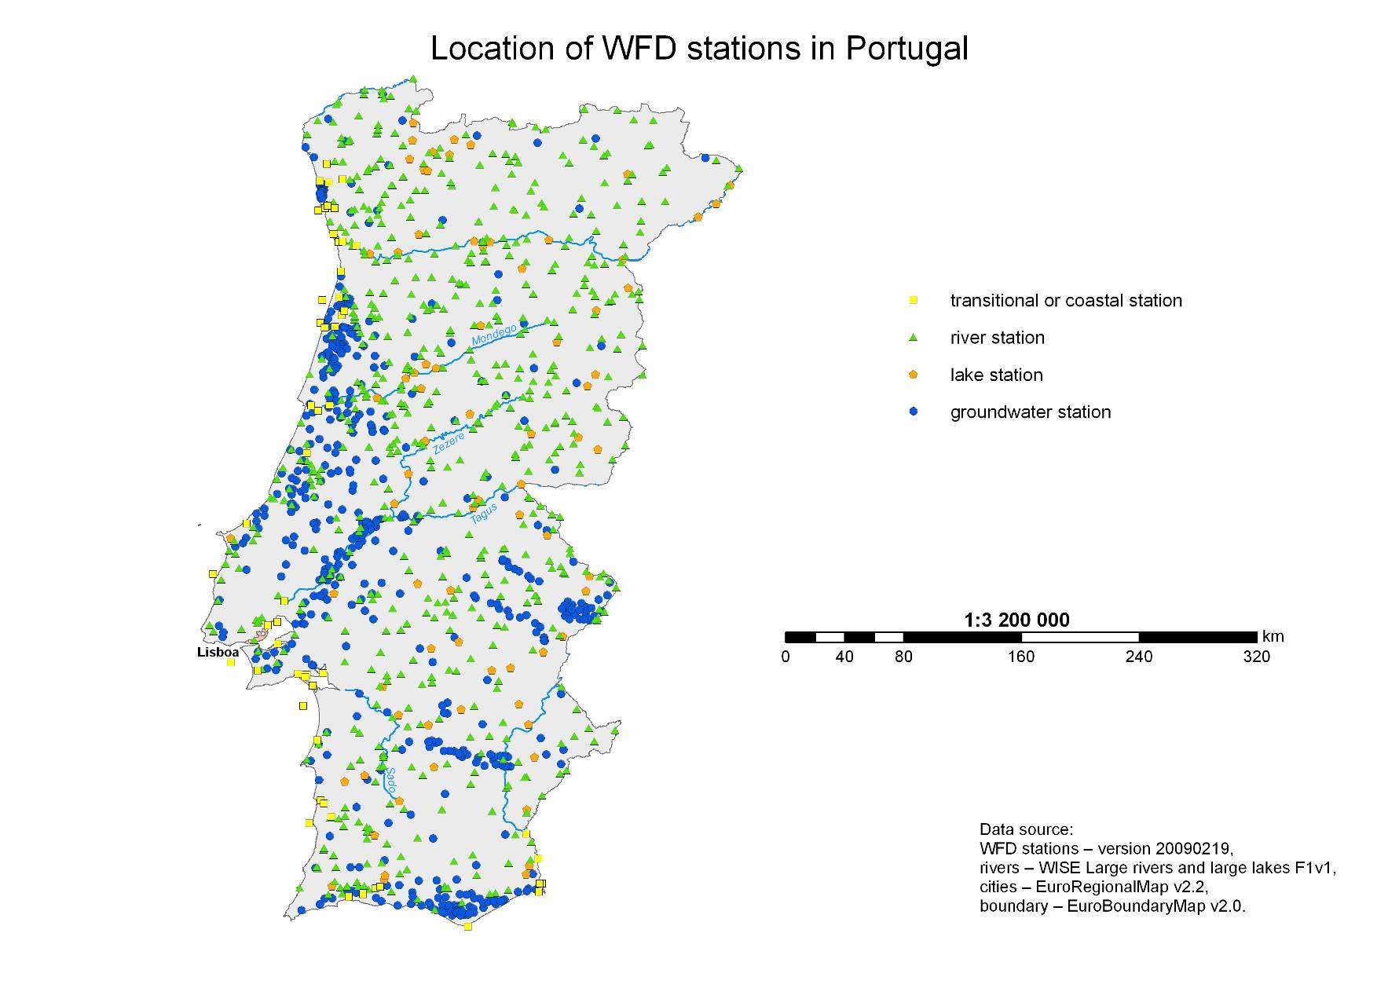
Results of Spatial Analysis 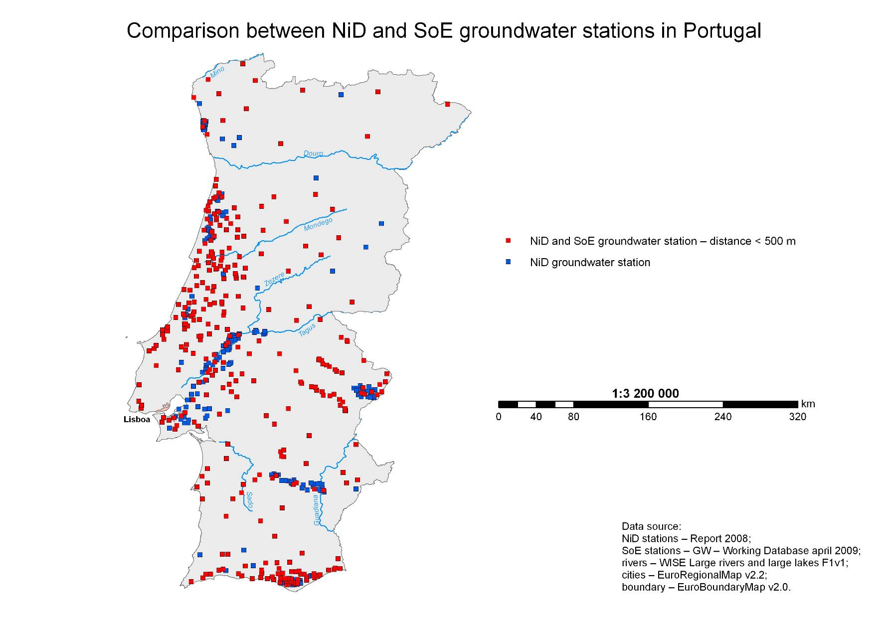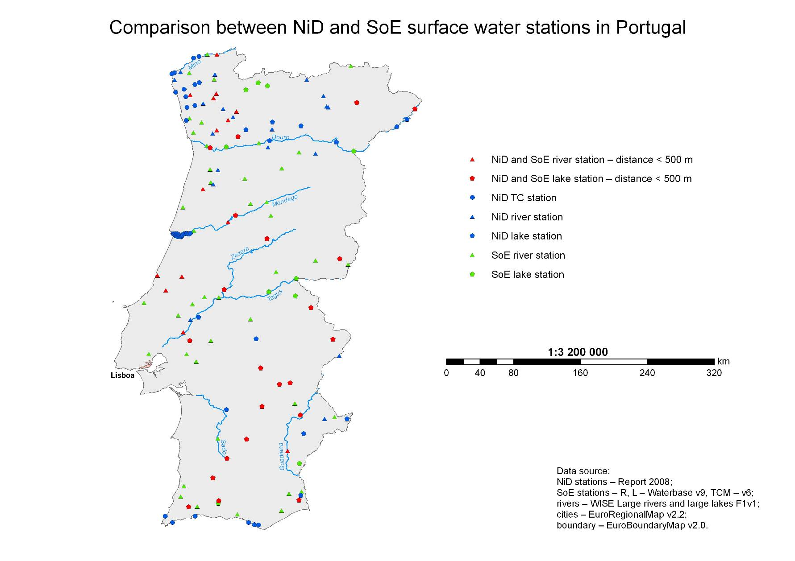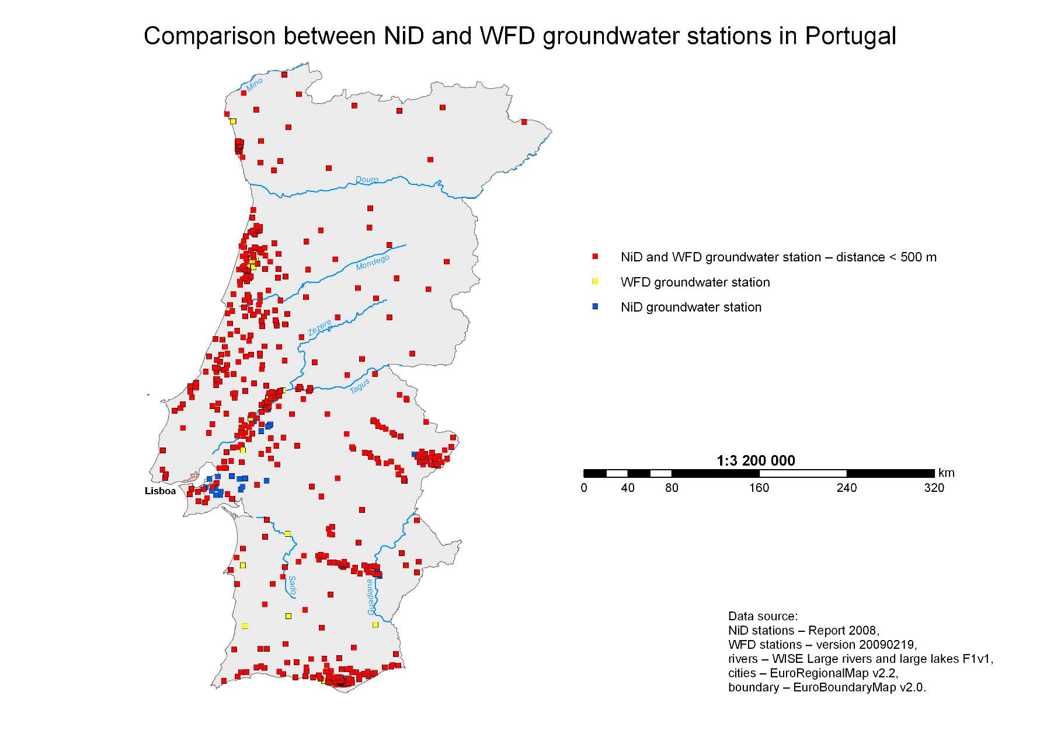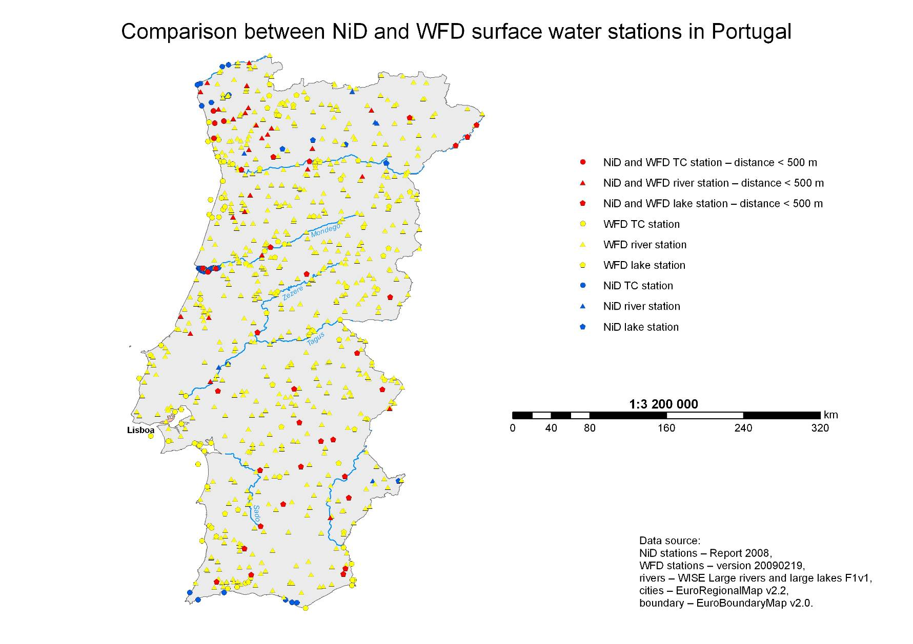
Final results – spatial and database together 

