Finland – comparison of monitoring stations

Notes:

Rivers:
NiD monitoring network significantly smaller than SoE, medium proportion of best matching sites but few mistakes only, problems with prefixes; almost the same number of NiD and WFD monitoring sites, low proportion of best matching sites but few mistakes only

Lakes:
NiD monitoring network significantly smaller than SoE or WFD, medium proportion of SoE best matching sites but few mistakes only, problems with prefixes; low proportion of WFD best matching sites but few mistakes only

Groundwater:
NiD monitoring network significantly bigger than SoE or WFD, low proportion of NiD – SoE best matching sites but few mistakes only; medium proportion of NiD – WFD best matching sites and few mistakes only

TCM:
no SoE data, NiD monitoring network smaller than WFD, low proportion of NiD – WFD best matching sites but few possible mistakes only

Legend:

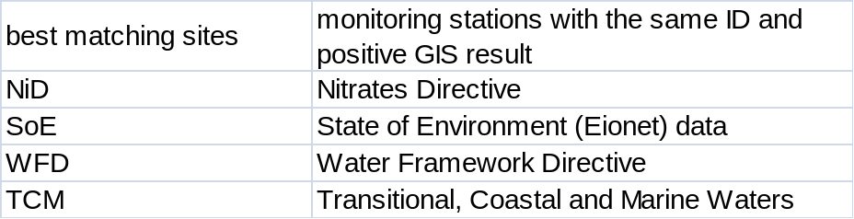
Position of reported stations 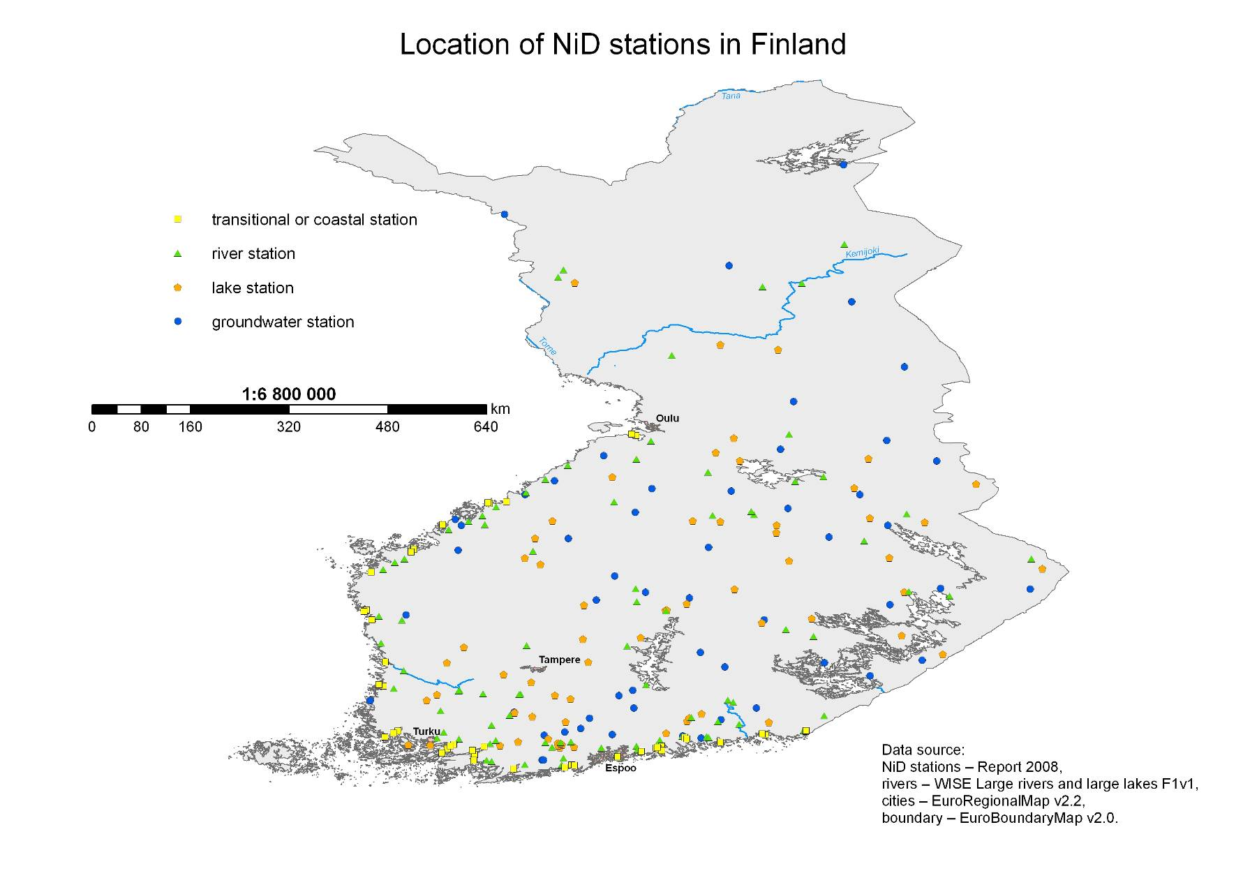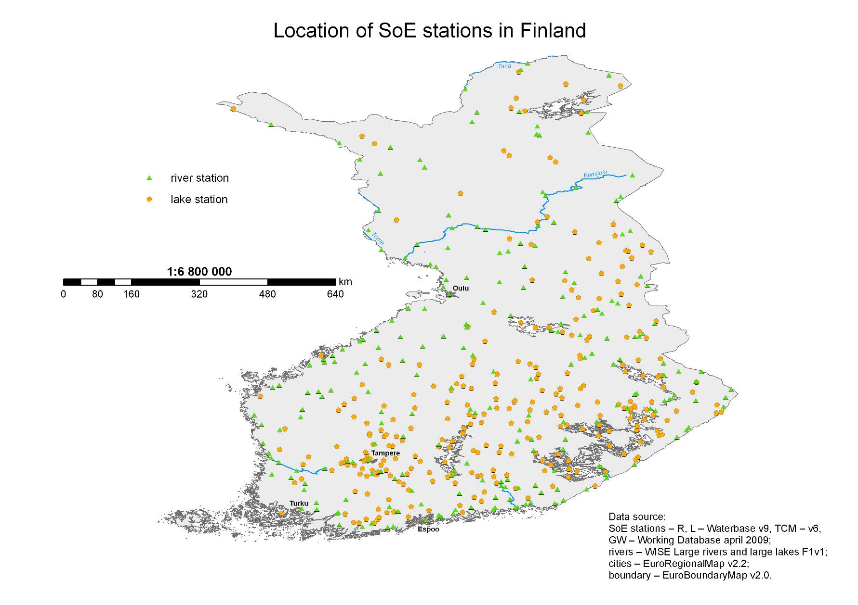
Results of Spatial Analysis 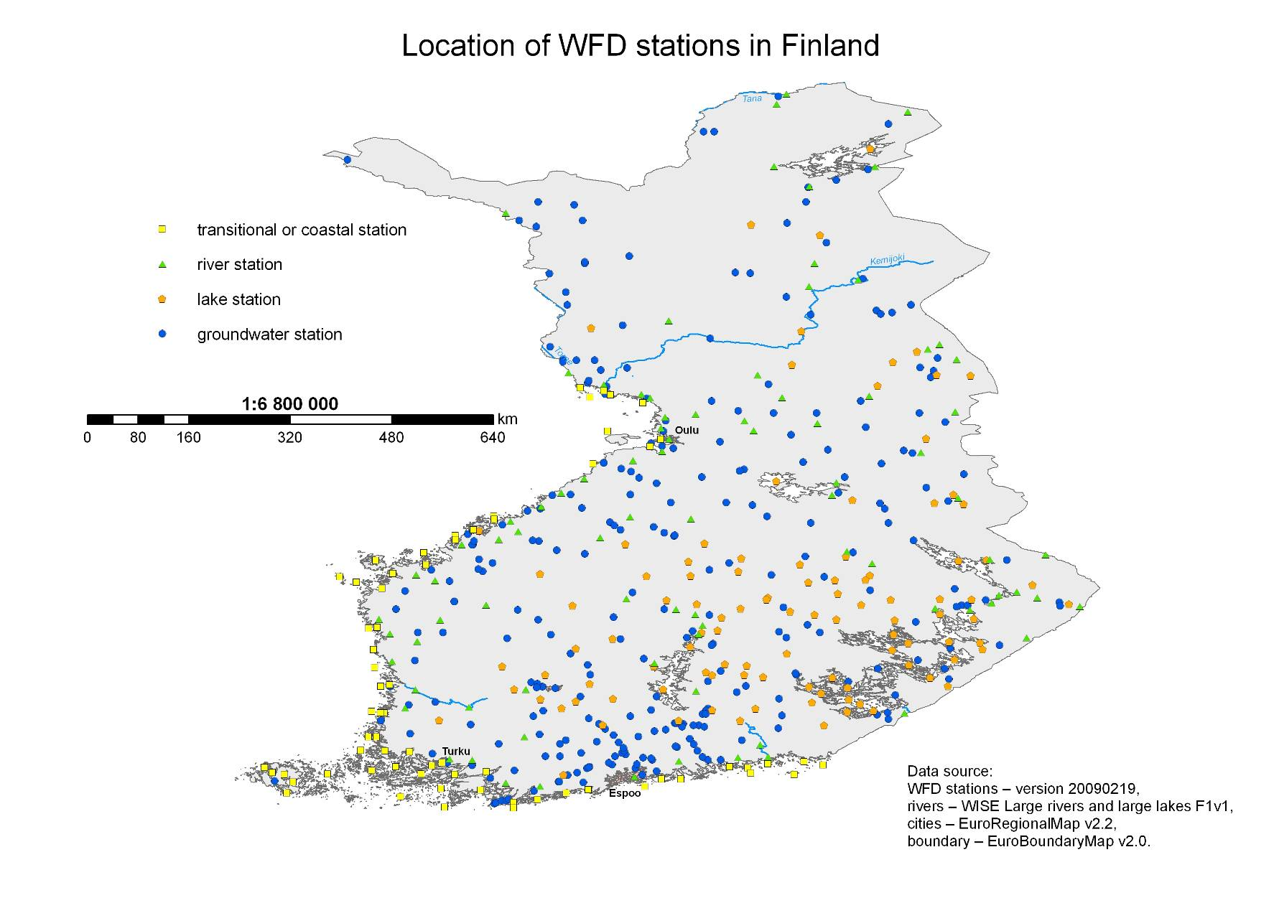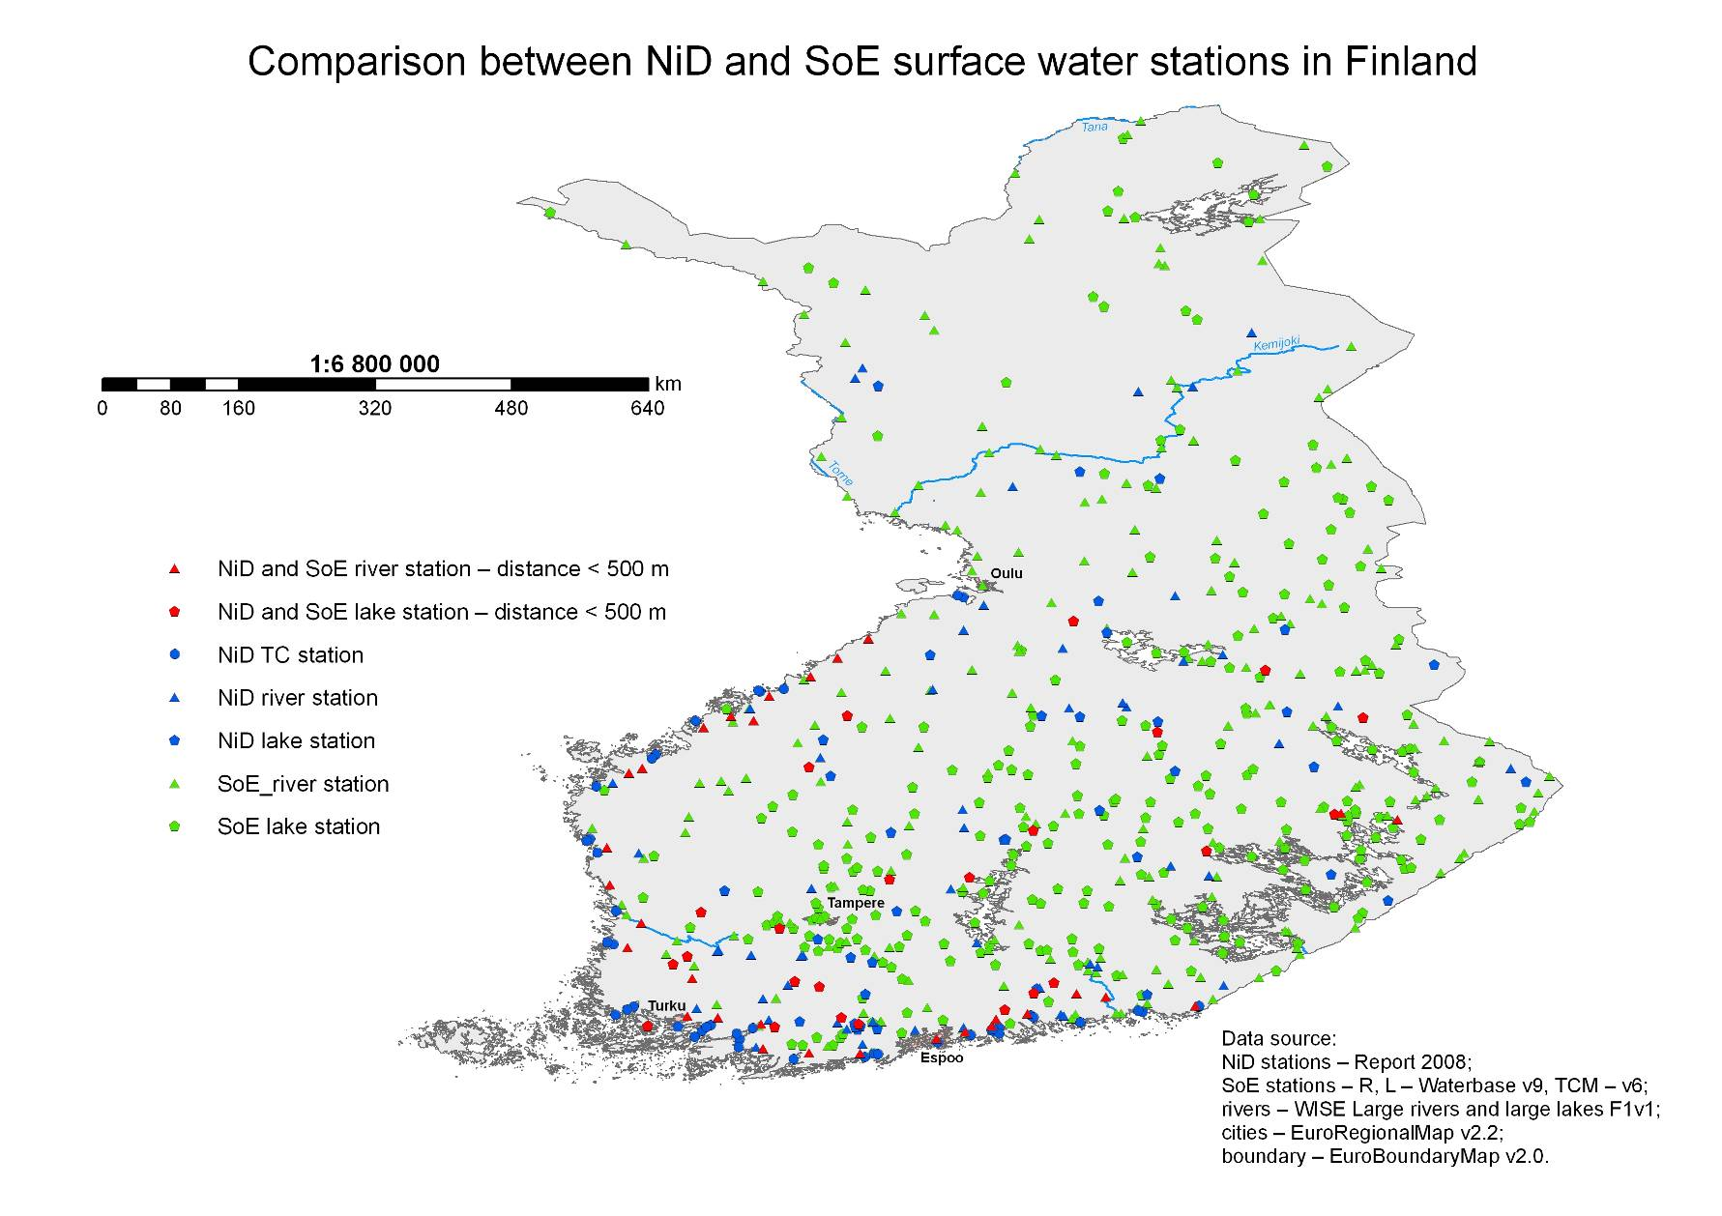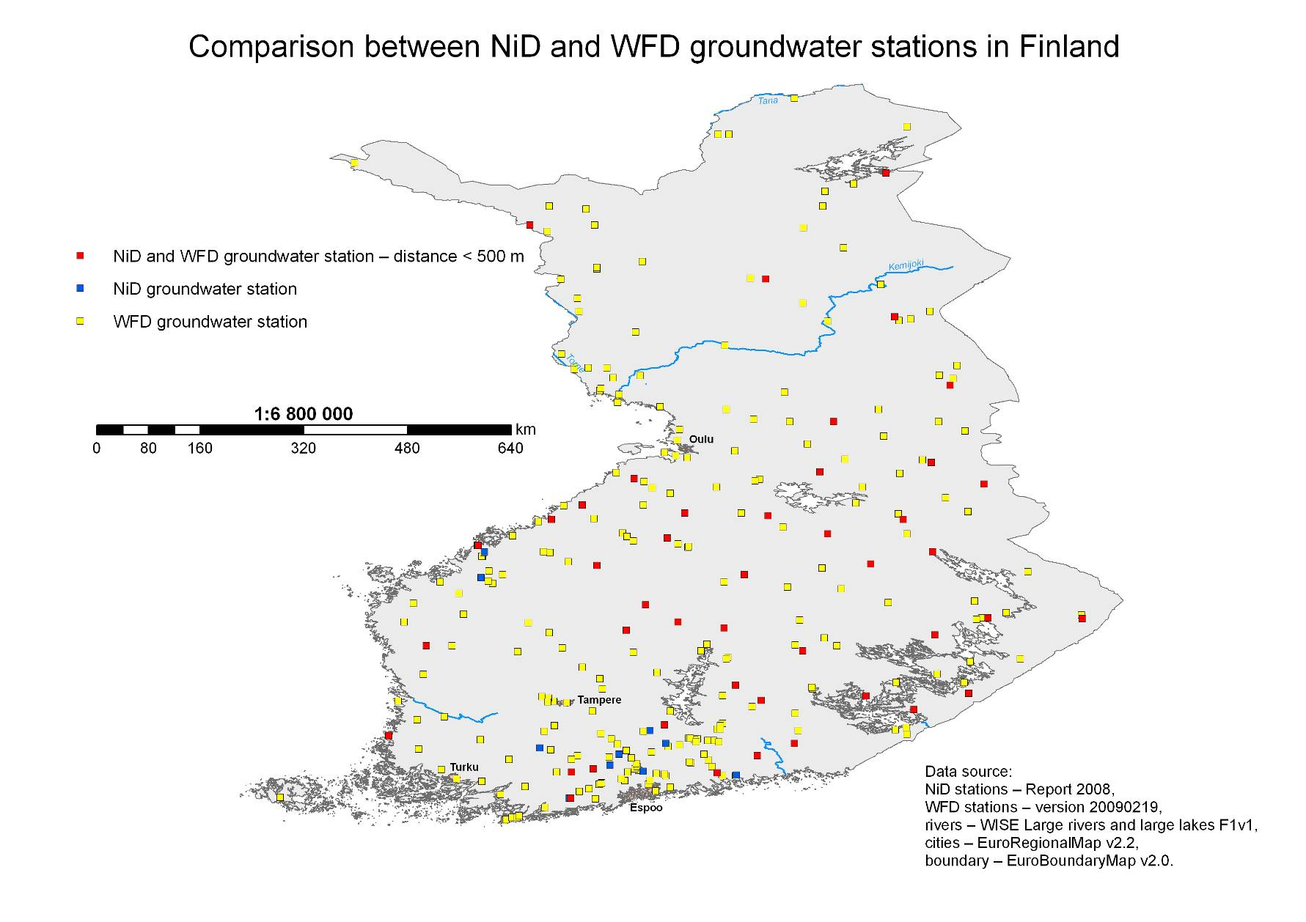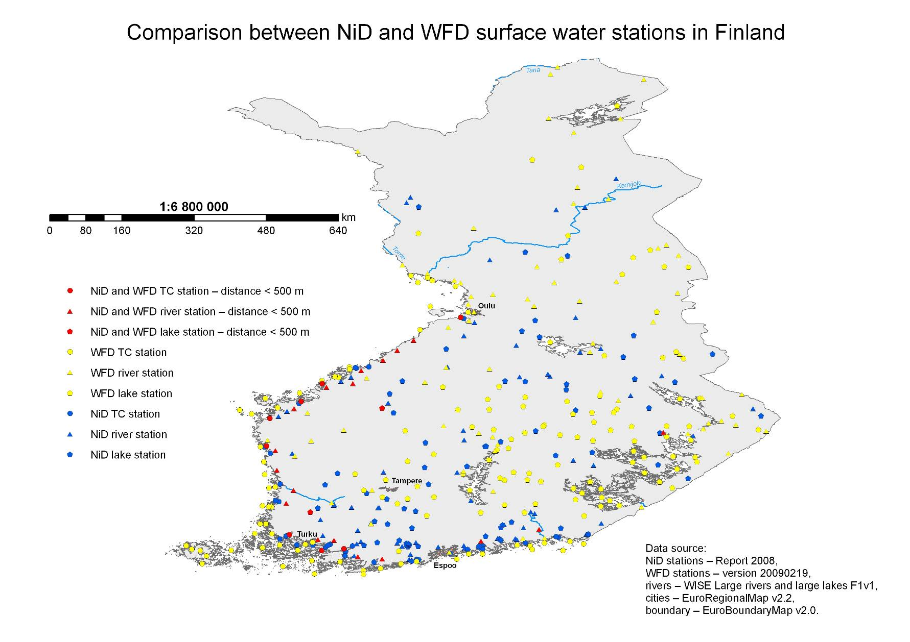
Final results – spatial and database together 

