United Kingdom – comparison of monitoring stations

Notes:

Rivers:
NiD monitoring network significantly bigger than SoE or WFD; high proportion of NiD – SoE best matching sites; few mistakes; very low proportion of NiD – WFD best matching sites but partly good results of spatial analysis

Lakes:
similar number of NiD and SoE monitoring sites; NiD monitoring network significantly smaller than WFD; very low proportion of best matching sites; few possible mistakes only

Groundwater:
very low number of SoE reported monitoring sites and no coordinates; NiD monitoring network smaller than WFD, high proportion of best matching sites; few possible mistakes only

TCM:
no SoE data; NiD monitoring network bigger than WFD, very low proportion of best matching sites; few possible mistakes only

Legend:

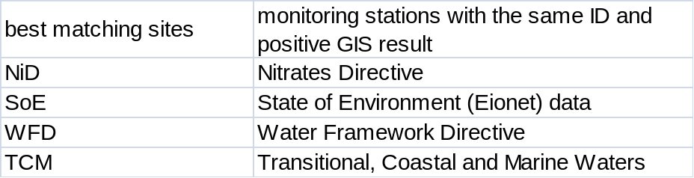
Position of reported stations 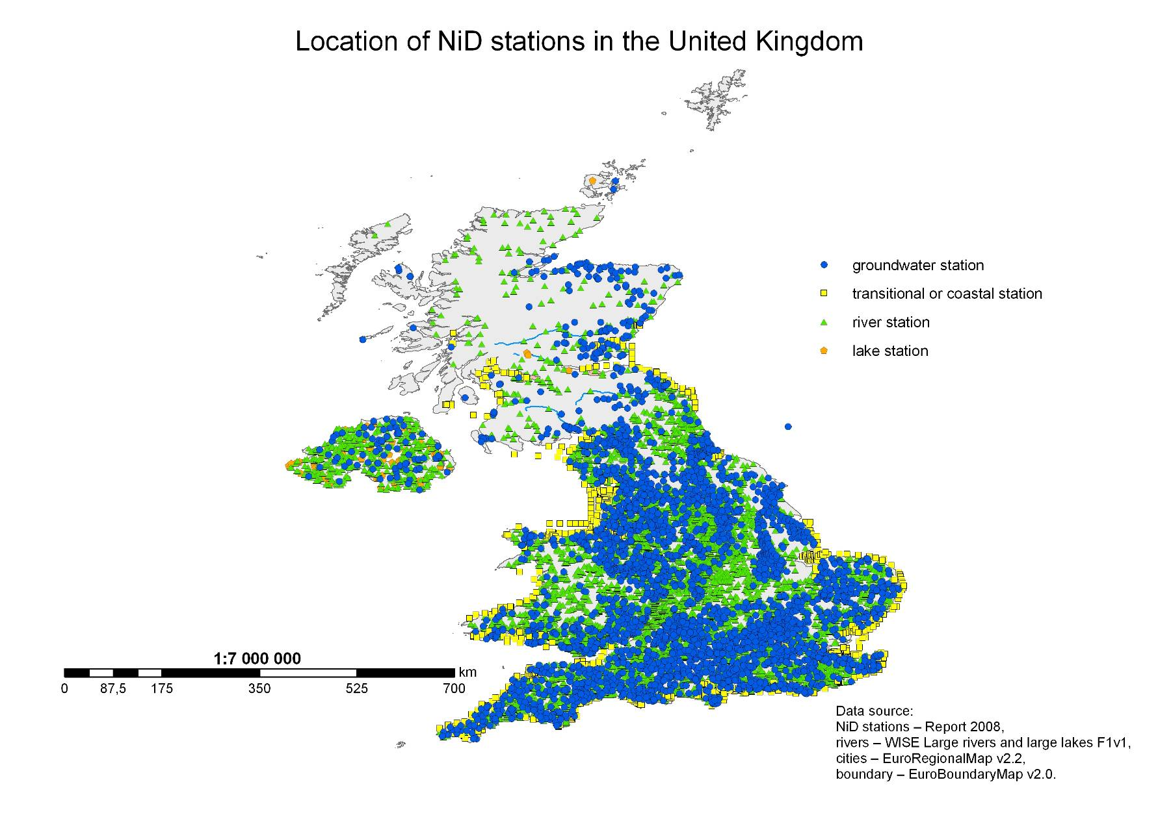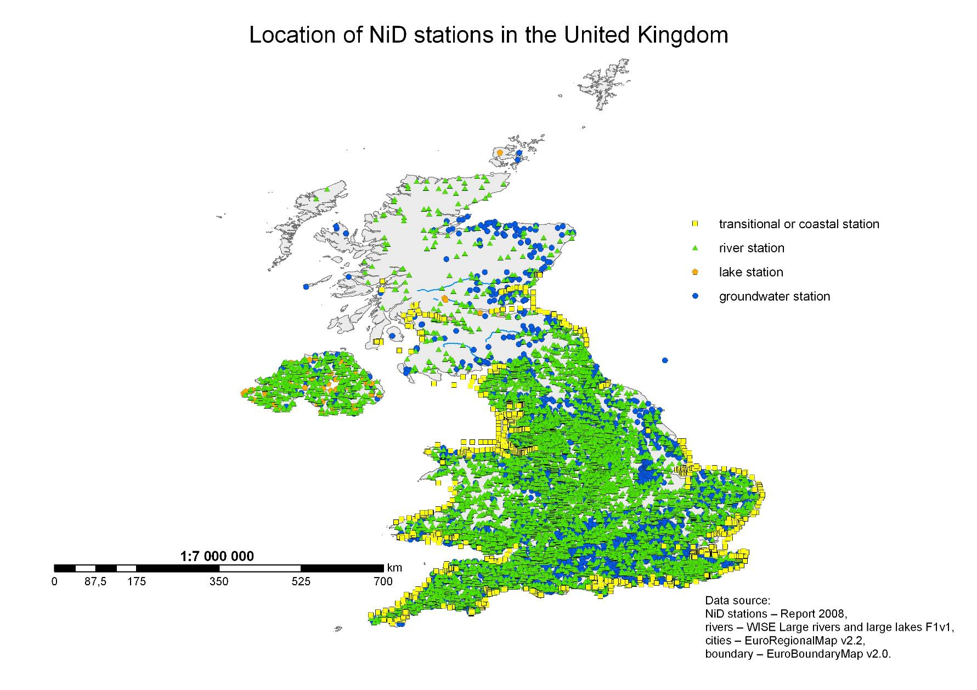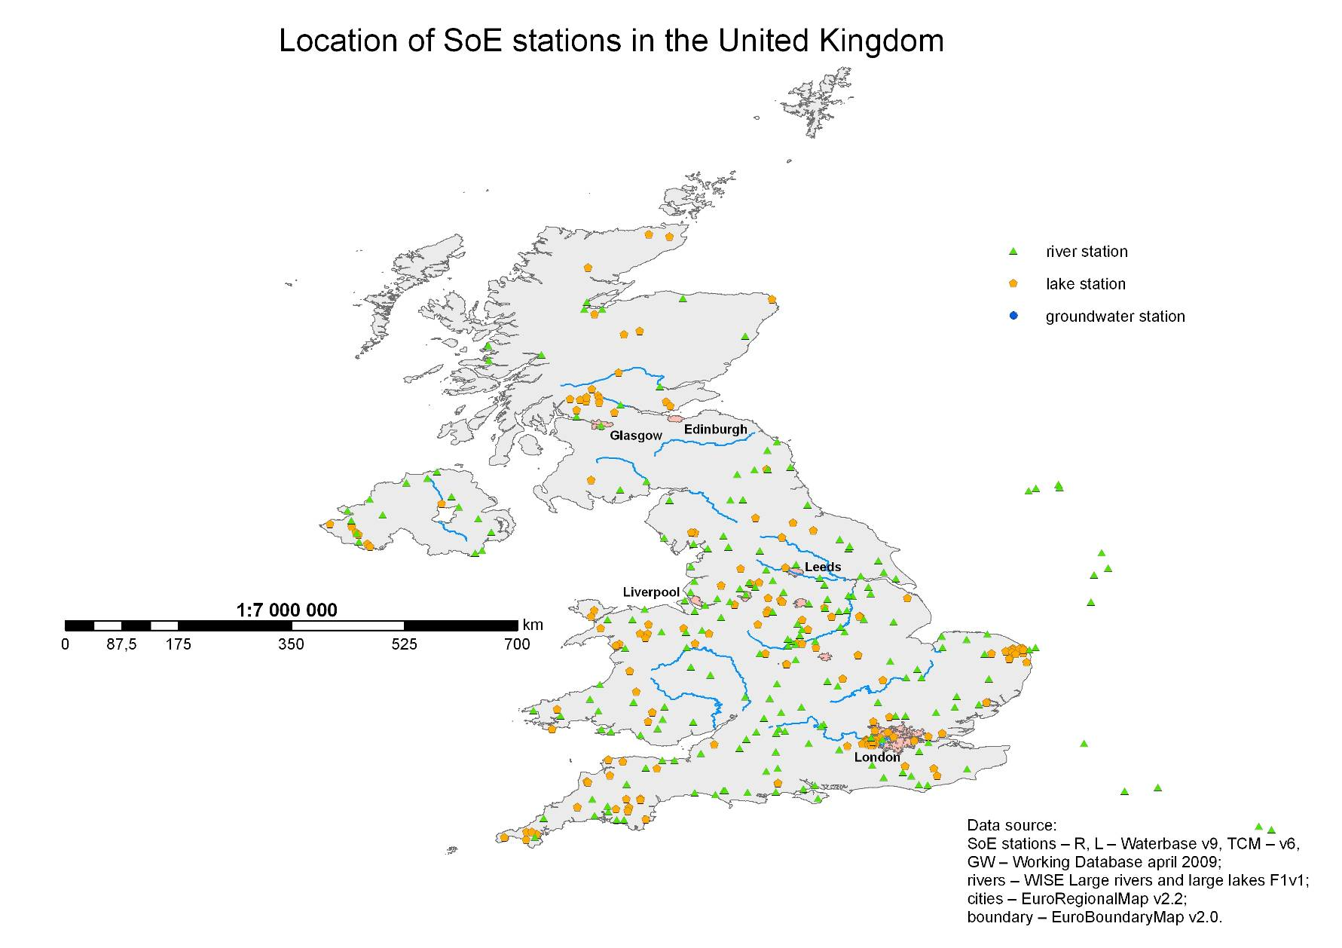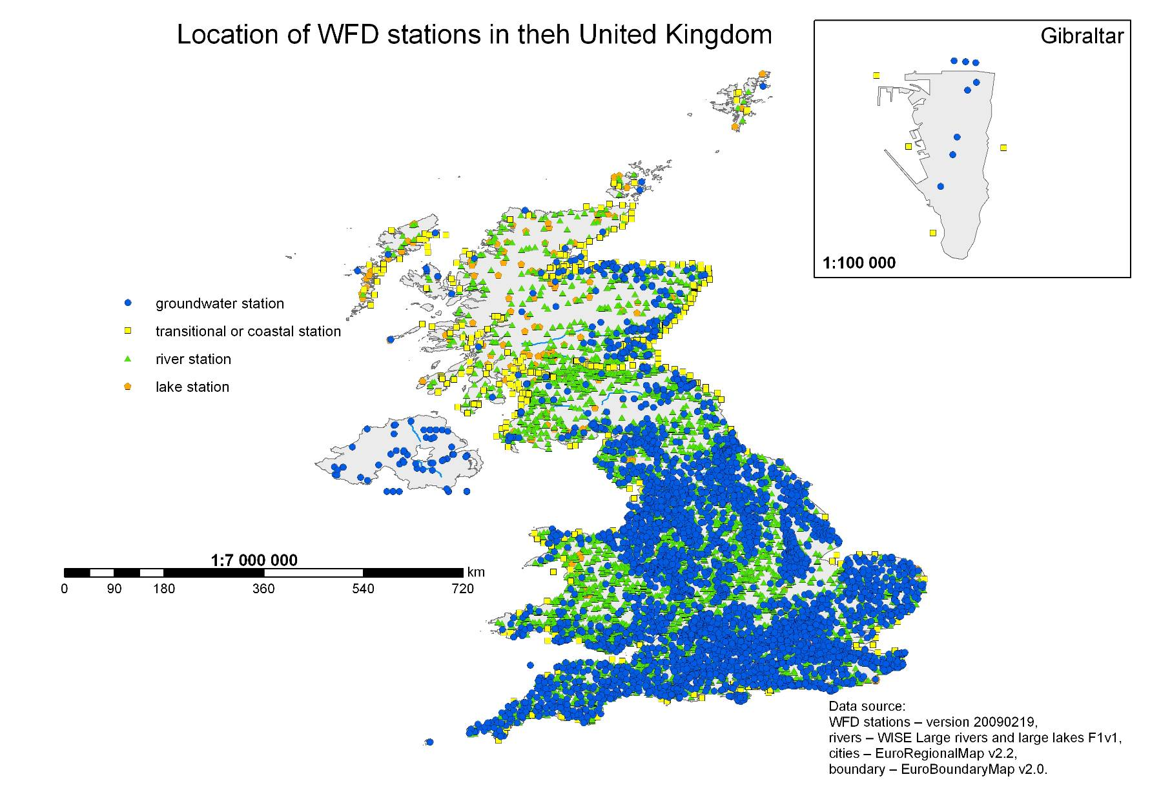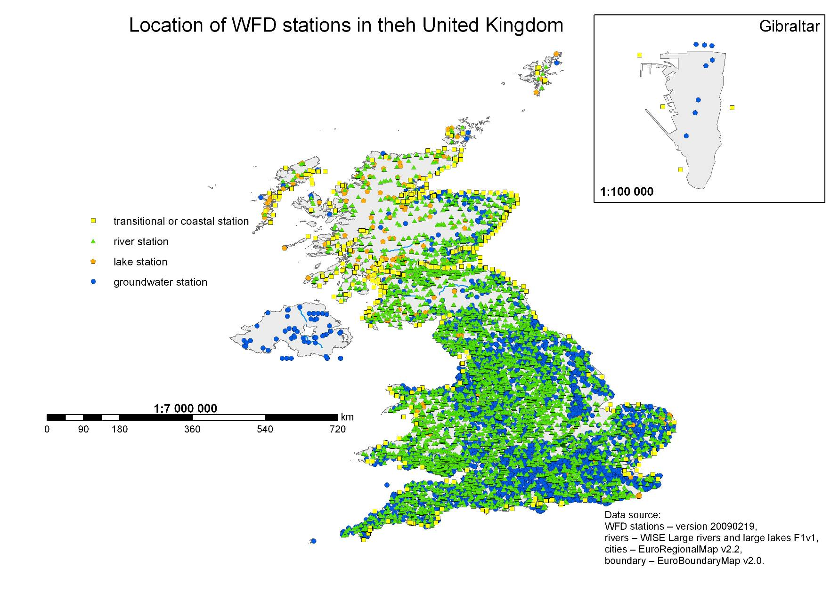
Results of Spatial Analysis 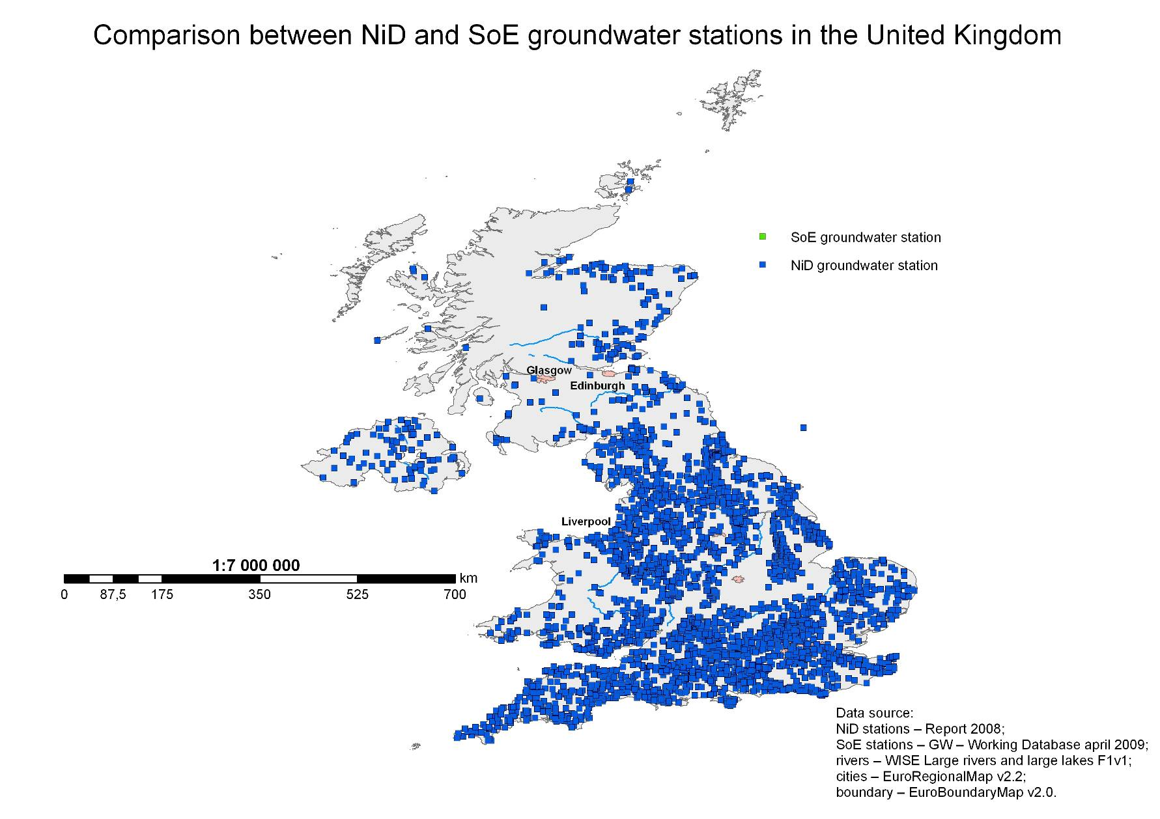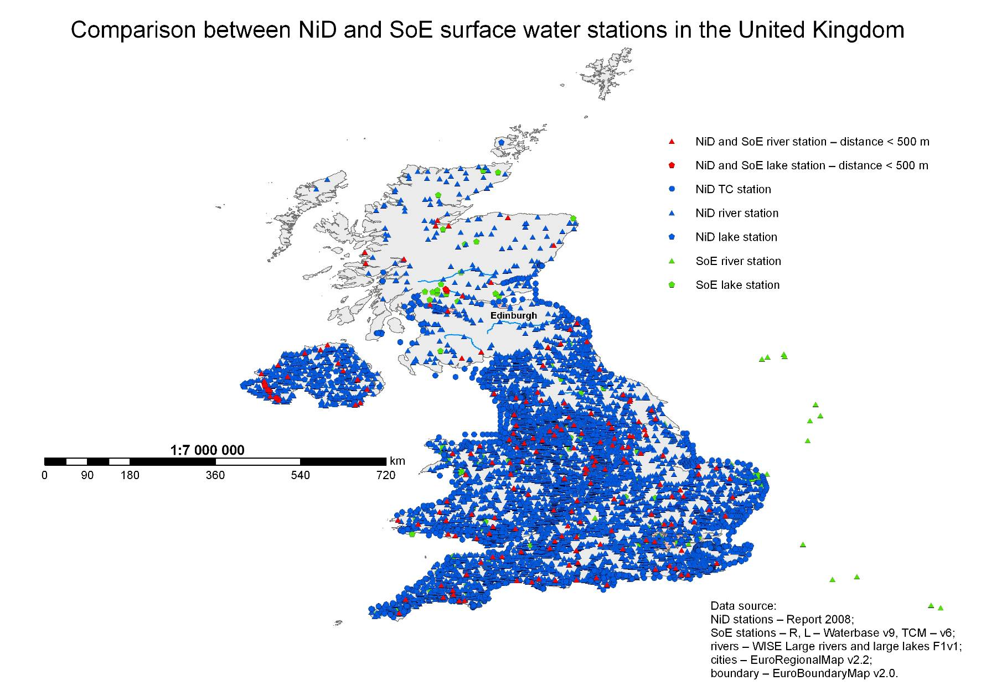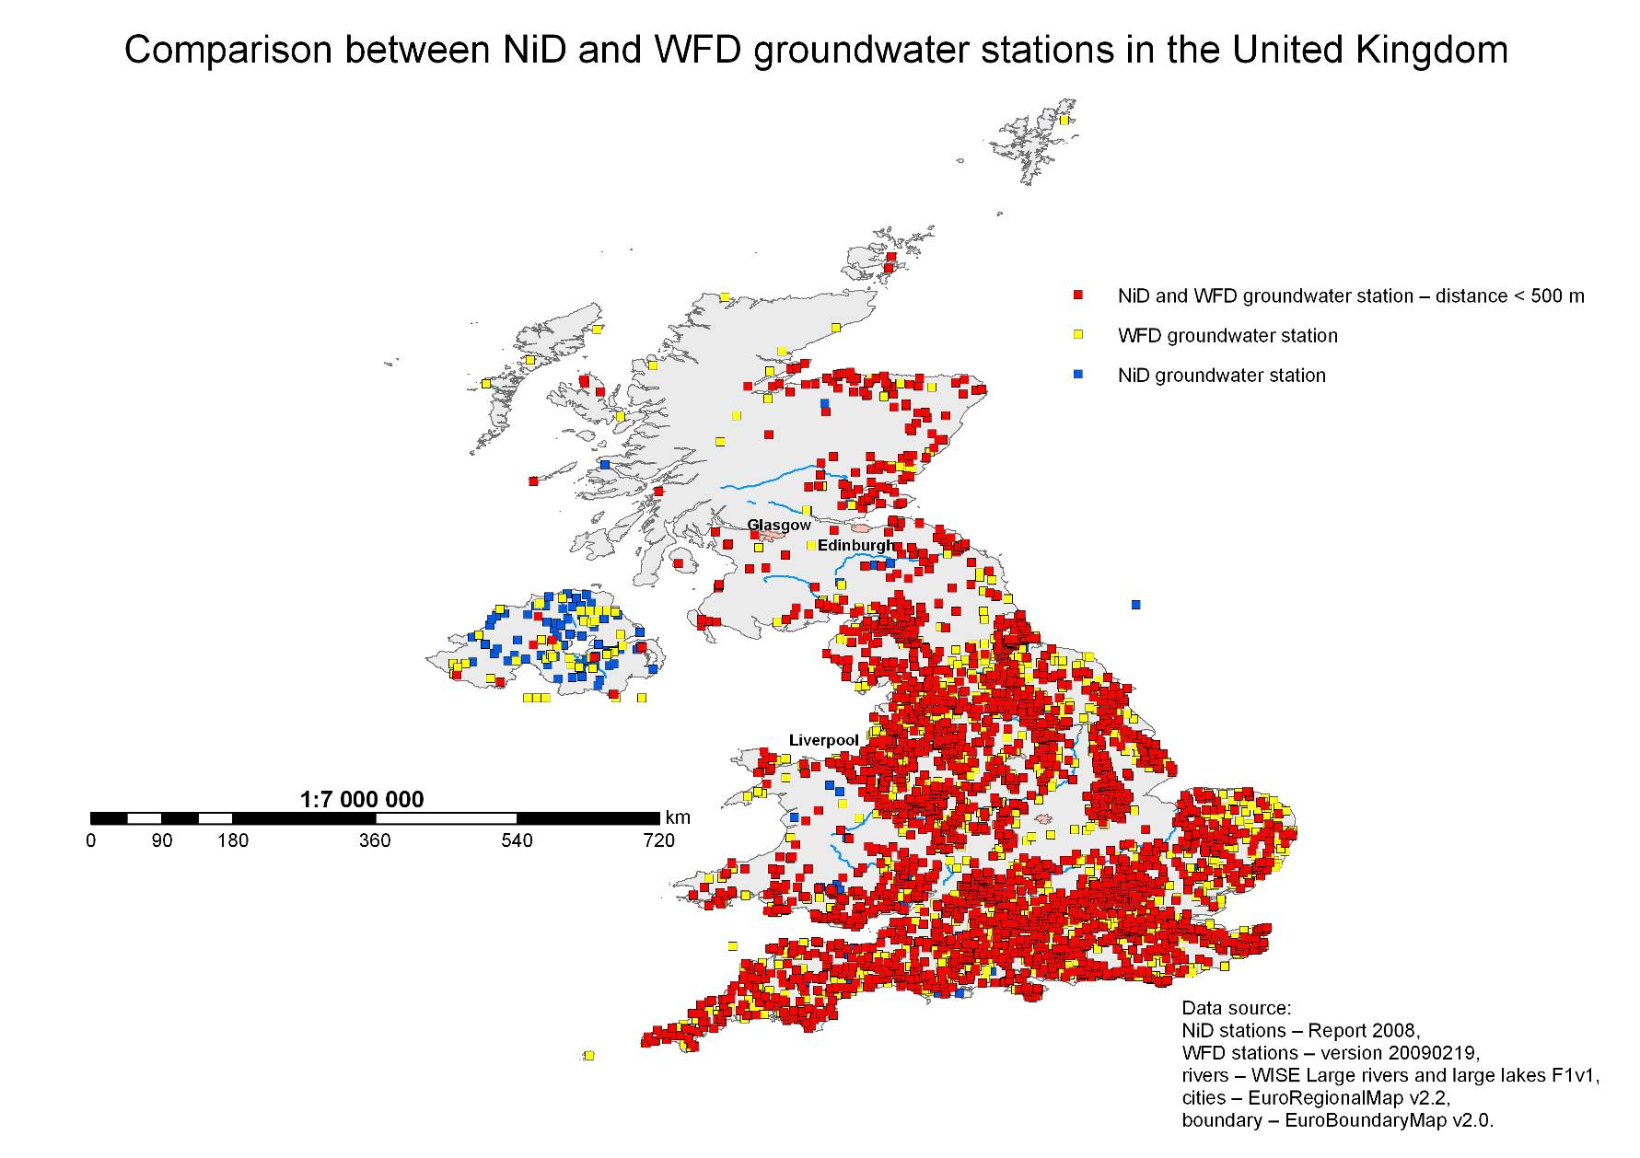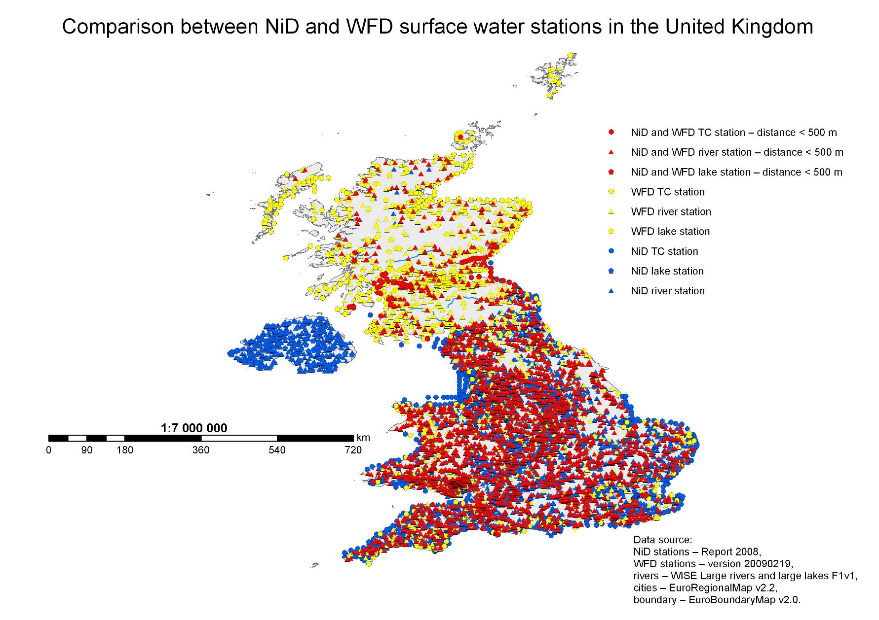
Final results – spatial and database together 

