Thematic Freshwater Eionet Workshop '
'SOER and WISE assessments', 20 – 21 October 2009
European Environment Agency, Kongens Nytorv 6, Copenhagen
WORKING DOCUMENT NUMBER 3; Addressing Agenda item ‘C1’
Streamlining analysis of SoE, Nitrates Directive and WFD Monitoring
Authors: Hana Prchalova, Lenka Jiraskova, Silvie Semeradova (CENIA)

- Background
Data describing nitrate concentrations in freshwater are required, currently, under two different reporting processes; the Nitrates Directive and the EEA’s State of the Environment (SoE) reporting (Eionet-Water). In addition, the WFD requires that monitoring of nutrient water quality be undertaken, although concentration data is not reported.
Theoretically, there is a potential for the different nitrate monitoring and reporting processes to be better streamlined, reducing the reporting burden of Member States. Even if full streamlining is not feasible, any situation whereby each dataset yields differing (and in a worse-case, conflicting) messages, for example with respect to trends, should be avoided and, the reasons for it identified.
Building on earlier theoretical exercises that explored the differences and similarities between the reporting streams (e.g. with respect to temporal and spatial coverage), ETC-Water have undertaken a detailed comparison of monitoring sites reported under the Nitrates Directive, SoE – Eionet and, Water Framework Directive. This comparison has identified, on a country by country basis, the degree to which monitoring sites match, under the differing reporting processes. The analysis has been undertaken for each waterbody type. The work has provided a platform for exploring, with Member Countries, the reasons behind poor matching. For example, in some countries very few SoE monitoring stations also lie within Nitrates Directive or WFD networks. To this end country specific maps and statistics have been produced for discussion at the Freshwater Workshop.
Close collaboration exists between the EEA and DG ENV on this streamlining issue.

Abbreviation used

WFD Water Framework Directive
GIS Geographical Information System
SoE State of Environment (Eionet) data
TCM Transitional, Coastal and Marine Waters
NiD Nitrates Directive
GW Groundwater
R Rivers
L Lakes
Abbreviations of countries are used from ISO 3166.

- Introduction
ETC Water has prepared a detailed comparison of monitoring sites reported under the Nitrates Directive, SoE – Eionet and, Water Framework Directive. The comparison provides a first step towards a potential future streamlining of reporting with respect to nitrate data.
The entire work focused on a comparison of monitoring stations of rivers, lakes, groundwater and TCM waters for existing (NiD and Eionet-SoE) or expected (WFD, Art. 8) data for Nitrates (or N-NO₃).
There are three different sources of nitrate data:
- Eionet (SoE) monitoring data
- Nitrates Directive reporting and
- Water Framework Directive (Article 8) reporting.
While Eionet and Nitrate Directive data are reported after measurement (station information with nutrient concentrations), WFD Article 8 reporting is focused on planned monitoring (station information without nutrient concentration data and before measurement).
Available datasets:
- Water Framework Directive Art. 8 data was obtained from the database http://eea.eionet.europa.eu/Members/irc/eionet-circle/eionet-telematics/library?l=/art8products/20090219&vm=detailed&sb=Title .
- Eionet (SoE) data for rivers, lakes and TCM was used from Waterbase (version 9 for rivers and lakes, version 6 for TCM) and groundwater from working database (status April 2009).
Links: GW http://eea.eionet.europa.eu/Members/irc/eionet-circle/etcwater/library?l=/subvention_2009/activities_2009/151_wise_centre/1512_directives/1512_directives/directive_integration
SW Waterbase_lakes_v9_mdb_selection.zip, Waterbase_rivers_v9__mdb_selection.zip
TCM http://eea.eionet.europa.eu/Members/irc/eionet- circle/etcwater/library?l=/subvention_2009/activities_2009/151_wise_centre/1512_directives/1512_directives/directive_integration /
- Nitrate Directive data was used from file: NiD_WQ_tabelsEU27_8juli.xls provided by DG ENV.
For the comparison it was possible to use all monitoring stations from Eionet and all or selected data from WFD and NiD. We used all data without preliminary selection. Nitrate Directive data is from the reporting period 2004 – 2007 and Eionet SoE data from the same period was used. Data regarding WFD monitoring programmes is officially from the end of 2006, but some of them were subsequently updated.
General method for comparison of stations
The comparison was performed for each country separately. A comparable time period was used for NiD data and SoE data (2004 – 2007).
Comparison of Nitrate Directive dataset with Eionet SoE and Water Framework Directive datasets was performed in following steps:
- Selection of stations of interest from all datasets
- GIS analysis of distance between NiDxSoE and NiDxWFD
- Database comparison of identifiers between NiDxSoE and NiDxWFD
- Synthesis - comparison of GIS and database results
.

Spatial comparison of monitoring stations
GIS analysis was undertaken to enable a spatial comparison of monitoring stations. The aim of this was to identify ‘identical’ monitoring stations according to their geographical position. Station locations were compared between NiD and SoE databases and between NiD and WFD databases. Groundwater and different categories of surface water monitoring stations were analysed separately. The surface water databases were divided into river, lake and transitional, coastal and marine categories.. Analyses were undertaken for each country separately.
The selected databases were used as a basis for creating GIS ‘point’ layers for station locations for each of the three databases (SoE, NiD and WFD) using the attributes “longitude” and “latitude”. Once completed, these were ‘joined’ with data available on nitrate concentration, resulting in stations with no information on nitrate concentration being discarded from further analysis.
The data of SoE - TCM was held in two databases, EIONET and MEDPOL (ICES). Both databases were used for the GIS analyses.
For each GIS layer the tool “Buffer” was used which selects a zone around a map feature (in our case the point – monitoring station) based on distance.. The radius of the Buffer was defined as 500 m from each monitoring station. This resulted in a newly created buffer layer for each type of reported data. Then each monitoring station layer was clipped by the buffer layer from a differing reporting type.. This step of the analyses was undertaken twice. So for example, the NiD monitoring station layer was clipped by the SoE buffer layer (marked as NiD_SoE) and, conversely, the SoE station layer was also clipped by the NiD buffer layer (marked as SoE_NiD). This two-way approach was used because the differing station density in each database means that the results vary as to which way round the analysis is done.
Example for NiD x SoE analysis: The NiD monitoring station layer illustrated by the blue dots (having weeded out any sites with no concentration data) is clipped by the layer of 500m buffers around each SoE site (red dots). The result identifies those NiD sites (yellow dots) that lie within 500m of an SoE site. The converse analysis is undertaken – not shown in the Figure – whereby the SoE monitoring station layer is clipped by the layer of 500m buffers around each NiD station.
500 m
Several zero results were caused by missing stations coordinates in the databases (the missing coordinates are figured as a [0;0] in the databases). This is particularly the case for DK, GR, NL and UK monitoring stations–see Table 1.

Tab.1: Missing coordinates in the databases
Country | Layer | [0;0] | Total | [%]
AT | AT_SoE_GW | 13 | 566 | 2.3
BE | BE_SoE_GW | 24 | 165 | 14.5
CZ | CZ_SoE_GW | 2 | 463 | 0.4
DE | DE_SoE_GW | 57 | 856 | 6.7
DK | DK_SoE_GW | 65 | 65 | 100.0
 | DK_NiD_GW | 4 | 1479 | 0.3
ES | ES_SoE_GW | 7 | 251 | 2.8
FR | FR_SoE_GW | 2 | 1675 | 0.1
 | FR_NiD_SW | 5 | 1769 | 0.3
GR | GR_SoE_GW | 303 | 303 | 100.0
 | GR_SoE_R | 5 | 94 | 5.3
IT | IT_SoE_GW | 3 | 2741 | 0.1
 | IT_SoE_L | 17 | 369 | 4.6
 | IT_SoE_R | 2 | 1403 | 0.1
 | IT_NiD_GW | 26 | 2572 | 1.0
 | IT_NiD_SW | 29 | 5397 | 0.5
NL | NL_SoE_L | 6 | 13 | 46.2
SE | SE_WFD_GW | 29 | 115 | 25.2
SK | SK_SoE_GW | 14 | 466 | 3.0
GB | GB_SoE_GW | 5 | 5 | 100.0
 | GB_SoE_L | 1 | 228 | 0.4
Layer is represented by code “Country_Database_DataType” where DataType means groundwater, river or lake; [0;0]… number of missing coordinates in the database;
Total…overall number of stations in the database;
[%]…percent of missing data in the database.

Attribute comparison of monitoring stations
Attribute analysis proceeded parallel to the spatial analysis. Each state and each water category (ground water, surface water rivers, surface water lakes and surface water – transitional, coastal, marine) was treated separately.
To get comparable results, relevant sites from all datasets had to be chosen. For SoE and NiD this meant that only stations with information on nitrate concentration were chosen. In the case of WFD, aggregated quality elements were used. The structure of WFD data allows the relating of quality elements both to monitoring station and monitoring programme. Information relative to station was preferred. The WFD dataset also includes information flagging whether a site is also used for NiD reporting. Stations with this flag were added to the list of selected stations.
The following process was applied for selecting stations of interest:
Selection of surface water monitoring sites from WFD dataset:
1. Stations which were assigned by member states as measuring Quality Elements QE3-1-6 or QE3-1 or QE3
2. For member states which did not deliver information about QE in each station, programmes with above mentioned QEs were selected and after that stations with these programmes were selected (DK,IT,IE,LV,PL)
3. column inter_networks and other_networks were analyzed, but no station with NiD indication, which was not selected before was found
Selection of groundwater monitoring sites from WFD dataset:
1. Programmes with Quality Elements GE2 or GE2-4 were selected.
2. Stations with these programmes were selected
3. column inter_networks and other_networks were analyzed, stations with NiD indication, which was not selected before were added to the list
Tab. 2: Relevant Quality Elements used in WFD dataset (Article 8 Schemas Guide v2)
Chemical and Physico-chemical Elements  Surface Water | Chemical and physico-chemical quality elements (e.g. those indicated in WFD, Annex V) are determined | QE3
 | General parameters – parameters (e.g. those indicated by Annex 5) are determined | QE3-1
 | - Nutrient conditions | QE3-1-6
Ground Water | General parameters – all sub-elements below are determined (as described by Annex 5.) | GE2
 | - Nitrate | GE2-4

After selection, monitoring stations with a matching identifier in SoE and NiD or in NiD and WFD datasets were searched for. Each of these three datasets gives more opportunities to identify a station (see Tables 3 – 6). Initially the WFD codes, water base codes and national codes were compared manually. Then systematic error removal was done – mostly by using substrings of identifiers („20.11.01.01“ = „DK20.11.01.01“ etc.). The overview of systematic error occurrence is provided in table 7. At the end the combination of best results was used for ID comparison.
Tab. 3: Station Identifiers (database columns) used for sites matching – red ones are available for 100 % stations
 | NiD code | WFD code | SoE code | National Code
NiD – dataset | UN_STATCODE | EU_CD | WATERBASEID | STATCODE
WFD – dataset | - | EU_CD | - | MS_CD
SoE - dataset | - | EU_CD | WATERBASEID | NATIONALSTATIONID

Tab. 4-6 Example of manually searched best matching pair of codes in Surface Water Rivers
Tab. 4: NiD dataset
CC | STATCODE | UN_STATCODE | EU_CD | WATER  BASEID | STATNAME | WATBOD NAME
CY | CY_5_M435_4 | CY_CY_5_M435_4_4 |  |  | 9-6-2-90 | KOURIS
CY | CY_5_M438_4 | CY_CY_5_M438_4_4 |  | 9-6-4-90 | 9-6-4-90 | KOURIS
CY | CY_1_M416_4 | CY_CY_1_M416_4_4 | CY_3-31_R2-S1 |  | 3-3-3-95 | KARGOTIS
CY | CY_4_M432_4 | CY_CY_4_M432_4_4 | CY_8-9-2_R3-S1 |  | 8-9-5-40 | VASILIKOS

Tab. 5: SoE dataset
COUNTRY | WATERBASEID | NATIONALSTATIONID | EU_CD | WATERBASENAME
CY | CY_RV_r9-6-2-90 | r9-6-2-90 |  | KRYOS R. NEAR ALASSA
CY | CY_RV_r9-6-4-90 | r9-6-4-90 |  | KOURIS R. U/S KOURIS DAM
CY | CY_RV_r3-3-3-95 | r3-3-3-95 |  | KARGOTIS R. NEAR EVRYCHOU
CY | CY_RV_r8-9-5-40 | r8-9-5-40 | CY_8-9-2_R3-S1 | VASILIKOS R. NEAR LAYIA

Tab.6: WFD dataset
C_CD | EU_CD | MS_CD | OTHER_NETWORKS | INTER_NETWORKS | INTER_SITE_CDS
CY | CY_3-3-1_R2-S1 | 3-3-3-95 | Not in Other Networks
CY | CY_8-9-2_R3-S1 | 8-9-5-40 | EIONET | EIONET | CY_8-9-2_R3-S1

Tab. 7: Overview of systematic errors:
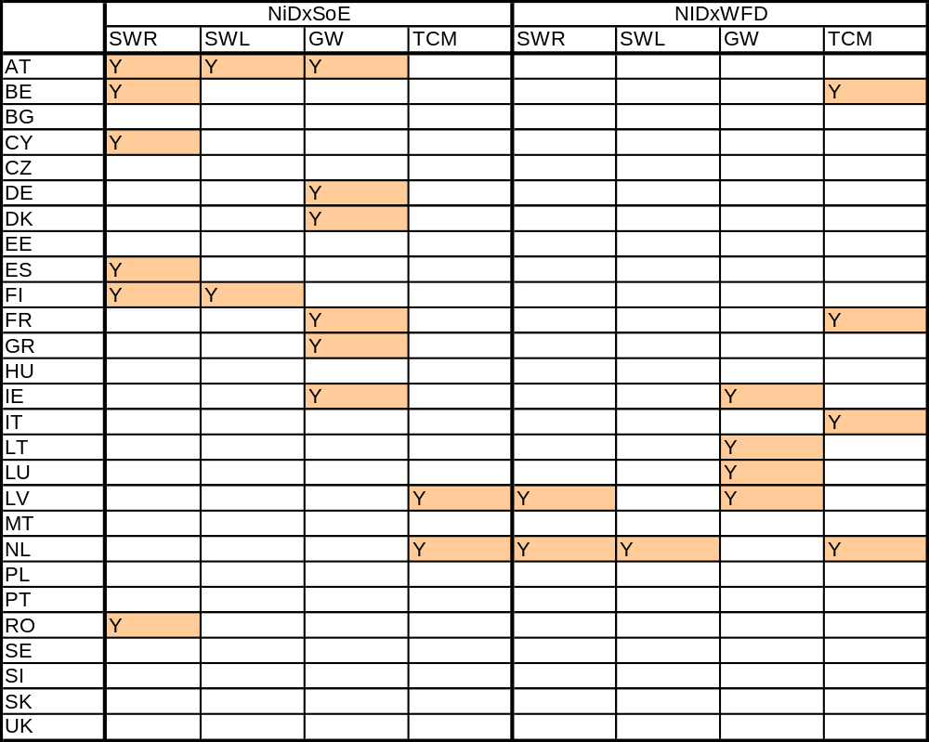
Y | systematic error

Synthesis of results and outputs
Results of the database analysis were compared with the results of the GIS analysis and divided according to their reliability. Monitoring stations with the same ID and positive GIS result are in the first category – ‘best match’. Monitoring stations with identical ID but with different localisation (or missing coordinates) are in the second category – ‘moderate match’. Sites with different ID and positive GIS results are in a third category – ‘possible match’. All the results are shown in the tables and summary maps.
Results of the comparison between NiD and SoE datasets are displayed in summary tables 8-9 and more detailed tables 10 - 13. Summary tables contain the proportion of different categories of results only.
The second and third columns of the detailed tables show the number of preselected stations (stations with information on nitrate concentration) in each dataset, the fourth column contains the ratio of preselected (but not matching) NiD and SoE sites. The next four columns (‘database analysis results’) give results of the database comparison (common identifier or a relevant part of it) – according WFD code, SoE (Waterbase) code or national codes and, the final result as a combination of them. The next two columns (‘GIS analysis results’) show the results of the GIS analysis – number of sites with positive results (closer than 500 m). The last two columns (‘GIS and DB comparison’) illustrate the ‘best results‘ for both datasets – number of station from Nitrate Directive in this category and the proportion of positive results on the NiD dataset. All the results are in the summary maps as well – separately for groundwater, rivers and lakes and transitional, coastal and marine water as a ratio of best results to the relevant NiD stations (Figures 1 – 4).
The same results for the comparison between NiD and WFD are in the tables 14 -19 and summary maps in figures 5 – 8.
Detailed maps with monitoring stations were produced separately for each country together with accompanying notes. Individual files per country are available at:
http://eea.eionet.europa.eu/Public/irc/eionet-circle/water/library?l=/copenhagen_freshwater_3/comparison_directive&vm=detailed&sb=Title
Conclusions
The best results are generally for rivers and groundwater, however only 5 countries have more than 75 % of best matching river sites for NiDxSoE (AT, DE, EE, IE and LT – see Table 8) and only 3 countries exceed 75% for lakes (AT, DE and IE – see Table 8), 7 countries for NiDxWFD rivers and 3 countries for NiDxWFD lakes – see Table 14 (3 and 4 countries respectively for groundwater – see Tables 9 and 15). Reasons for the low number of best matching monitoring stations are various but include: different monitoring networks for NiD and other purposes, differences with the codes reported, mistakes or missing coordinates and; a low number of sites reported for SoE. Code problems are especially problematical for future streamlining.

Tab.8: Summary table of comparison NiD x SoE– Surface Water Rivers and Lakes
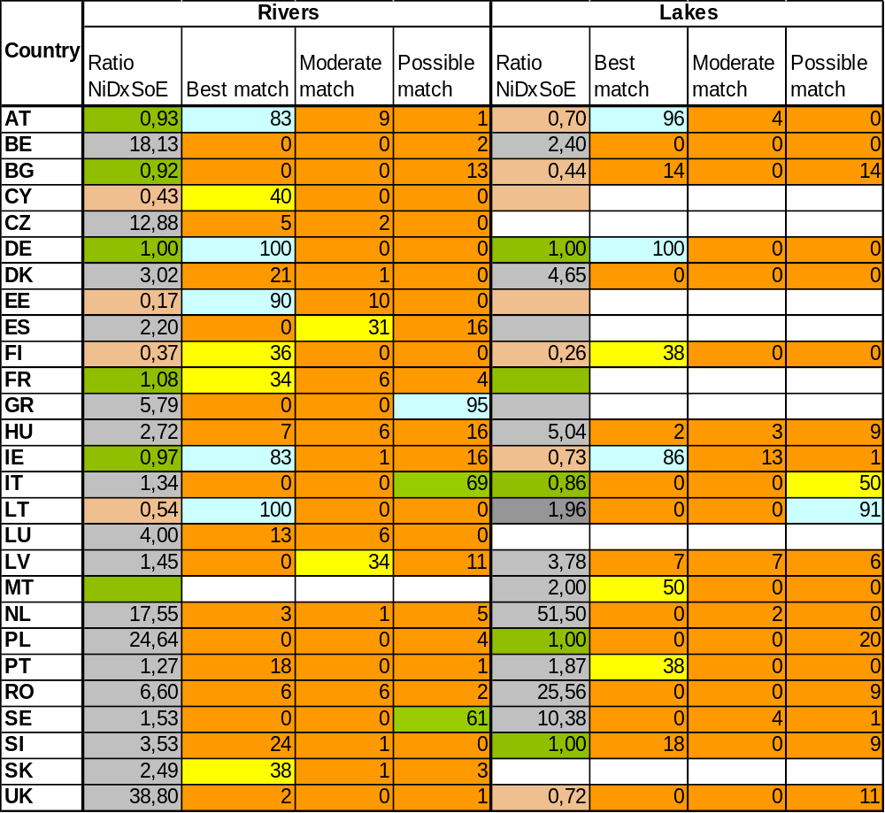
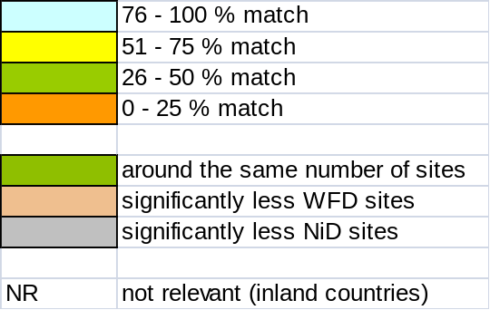

Tab. 9: Summary table of comparison NiD x SoE– Groundwater and TCM
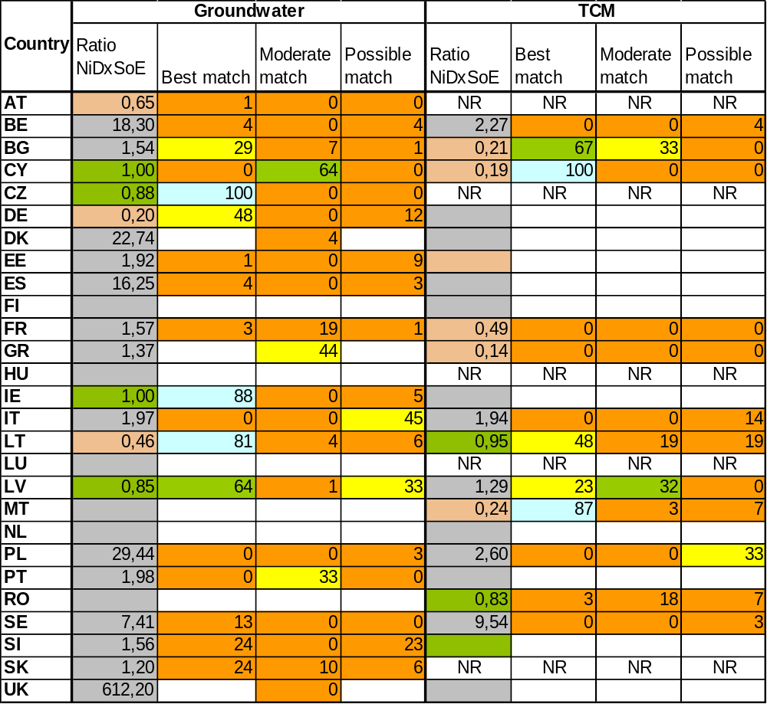
Tab.10: Detailed table of comparison NiD x SoE– Surface Water Rivers
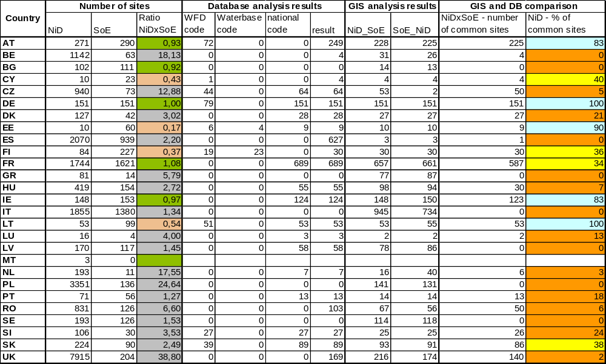

Tab.11: Detailed table of comparison NiD x SoE– Surface Water Lakes
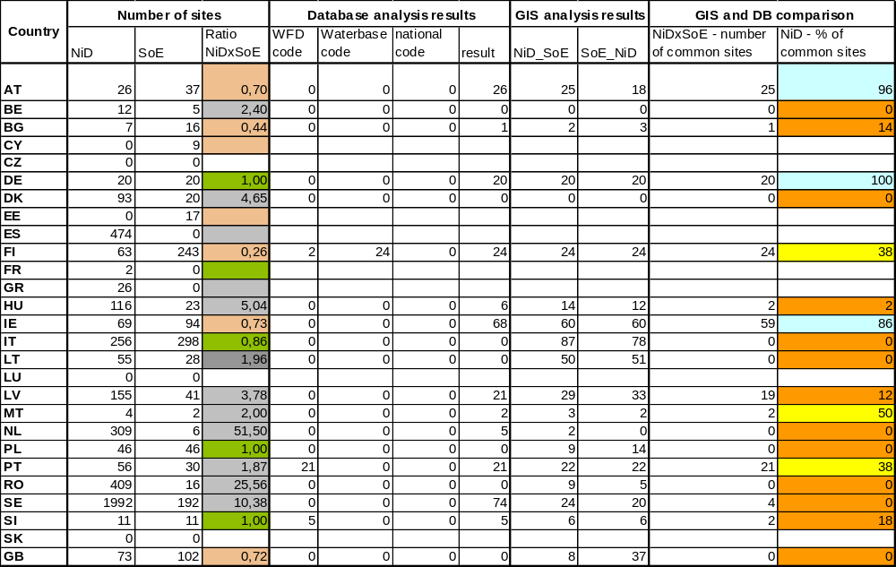

Tab.12: Detailed table of comparison NiD x SoE– Groundwater
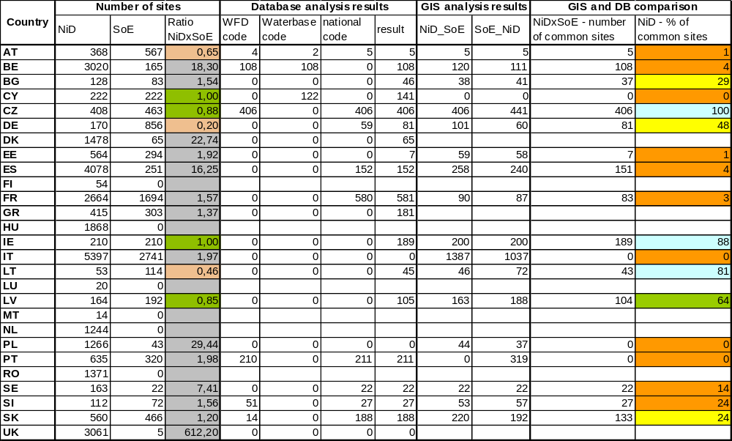

Tab.13: Detailed table of comparison NiD x SoE– TCM
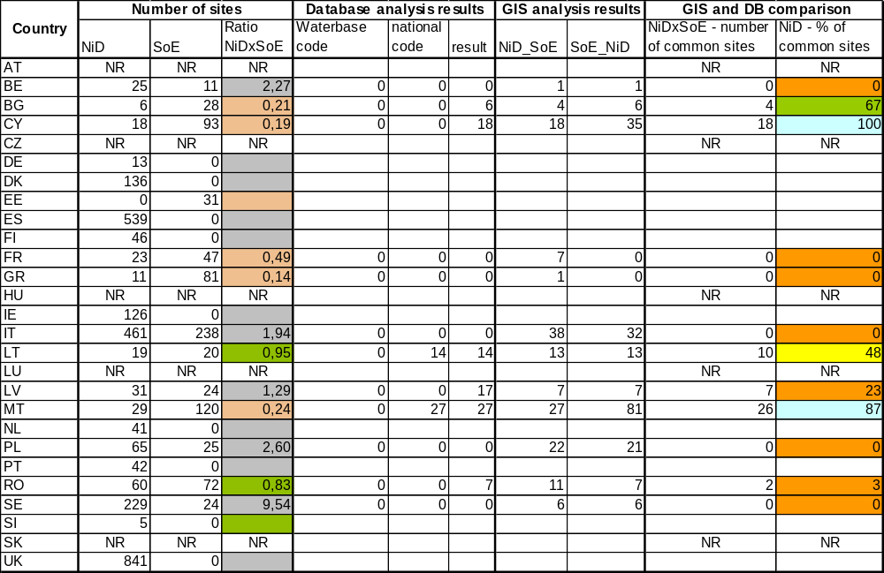

Legend:
4,2 | < 25 % of matching stations
35,7 | ≥ 25 % and < 50 % of matching stations
61,1 | ≥ 50 % and < 75 % of matching stations
81,9 | ≥ 75 % of matching stations

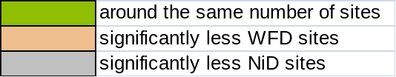
Tab.14: Summary table of comparison NiD x WFD– Surface Water Rivers and Lakes
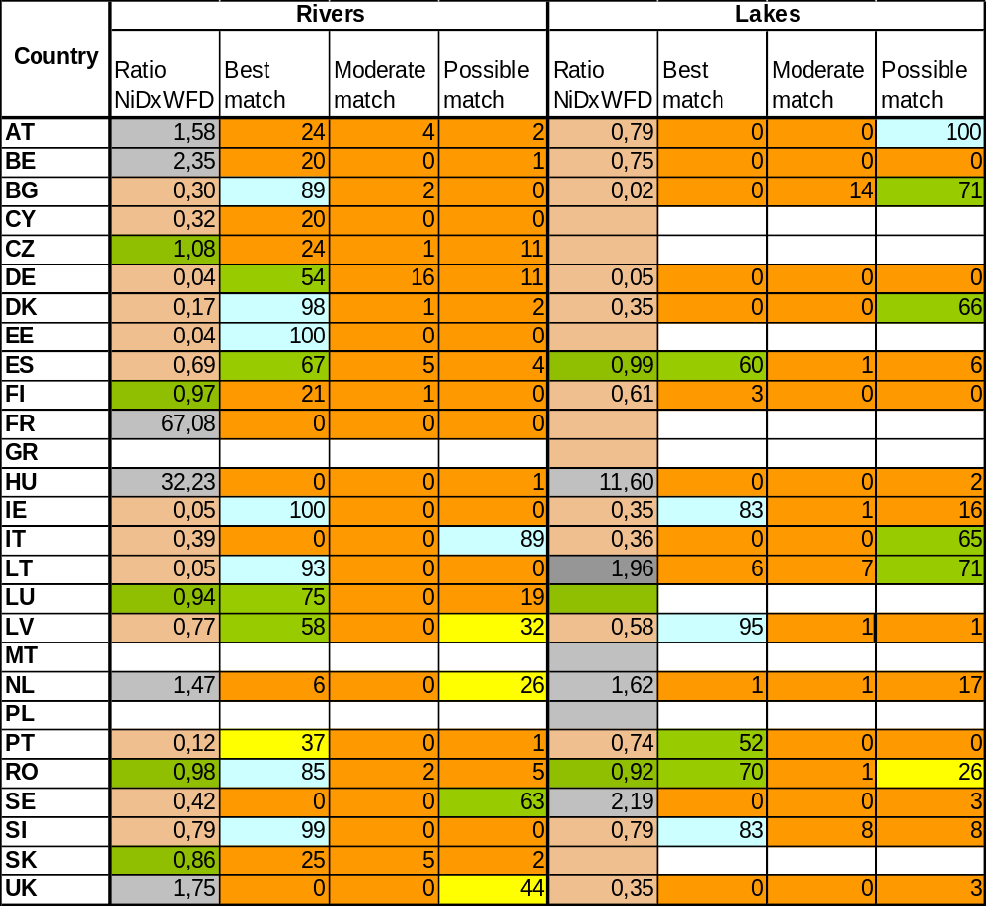
Tab. 15: Summary table of comparison NiD x WFD– Groundwater and TCM

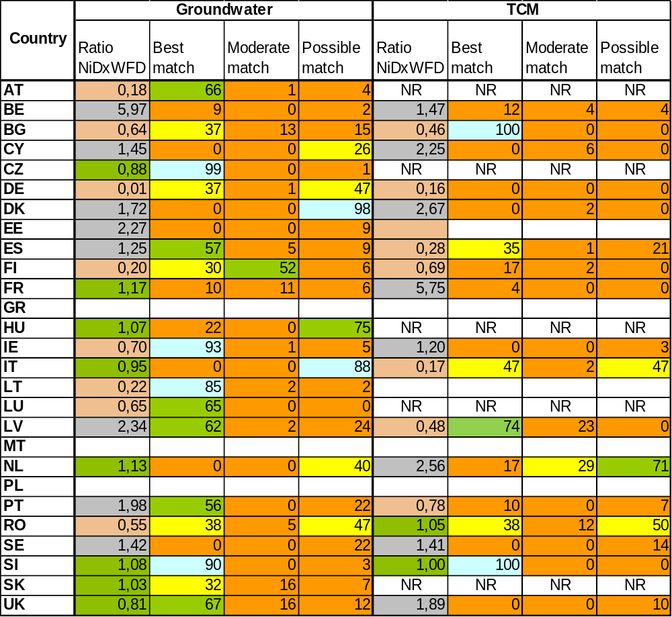
Tab.16: Detailed table of comparison NiD x WFD– Surface Water Rivers
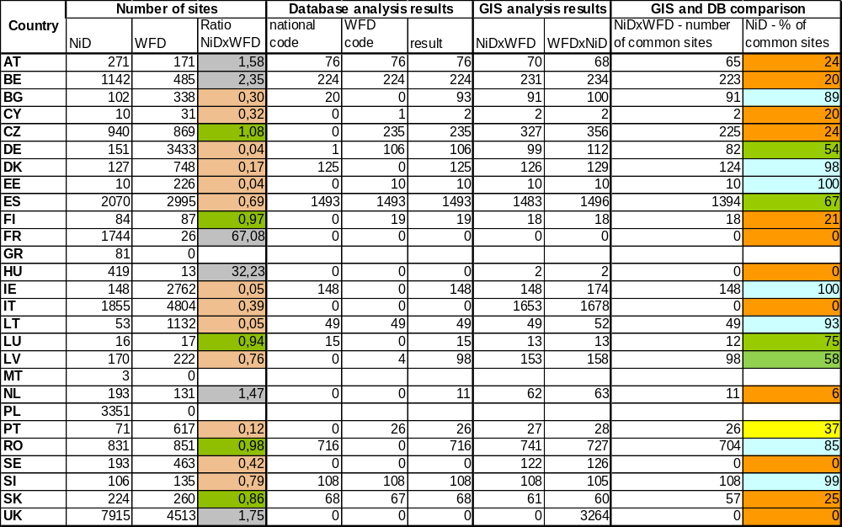

Tab.17: Detailed table of comparison NiD x WFD– Surface Water Lakes
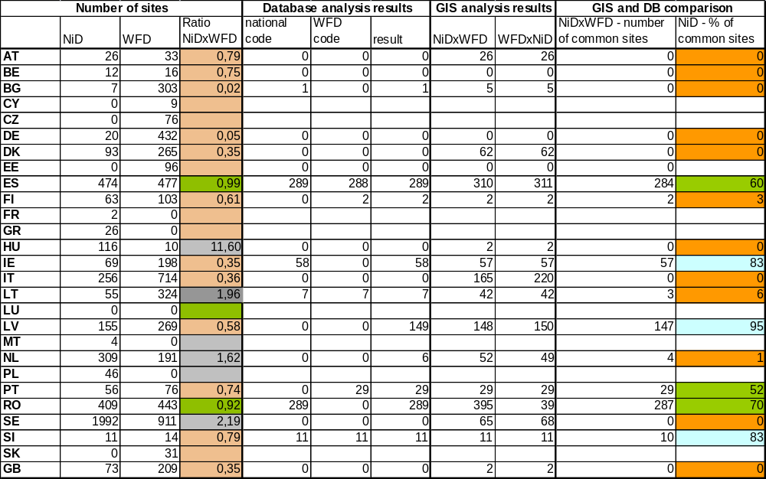

Tab.18: Detailed table of comparison NiD x WFD– Groundwater
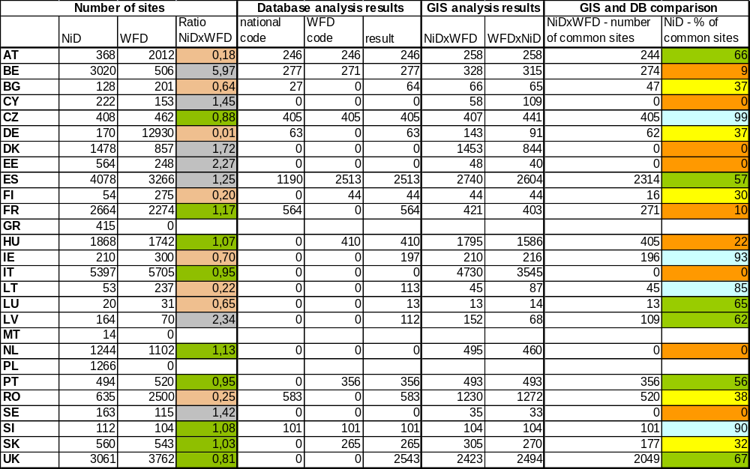

Tab.19: Detailed table of comparison NiD x WFD– TCM
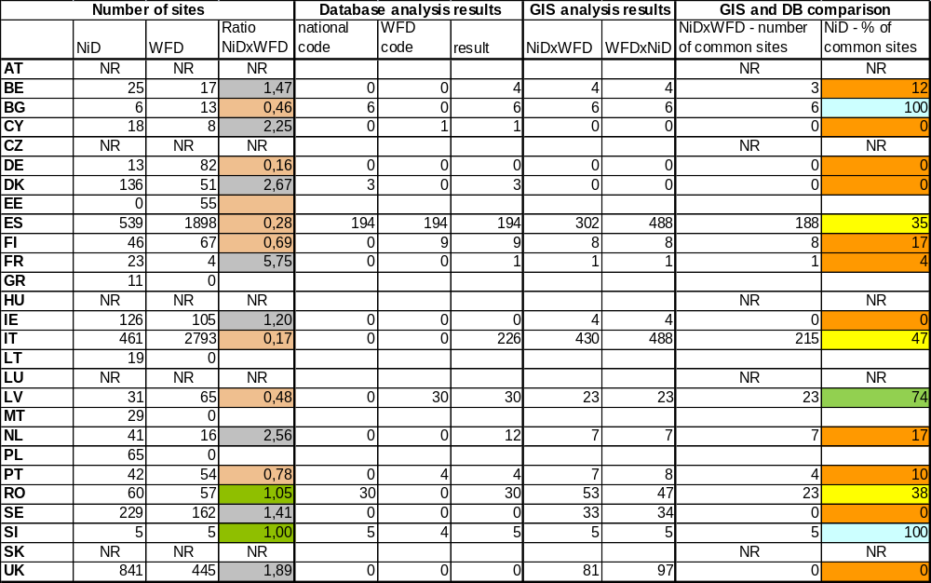

Legend:
4,2 | < 25 % of matching stations
35,7 | ≥ 25 % and < 50 % of matching stations
61,1 | ≥ 50 % and < 75 % of matching stations
81,9 | ≥ 75 % of matching stations

Summary maps
No matching monitoring sites in the maps mean no relevant data was provided.
Figure 1: Summary map for NiDxSoE river results
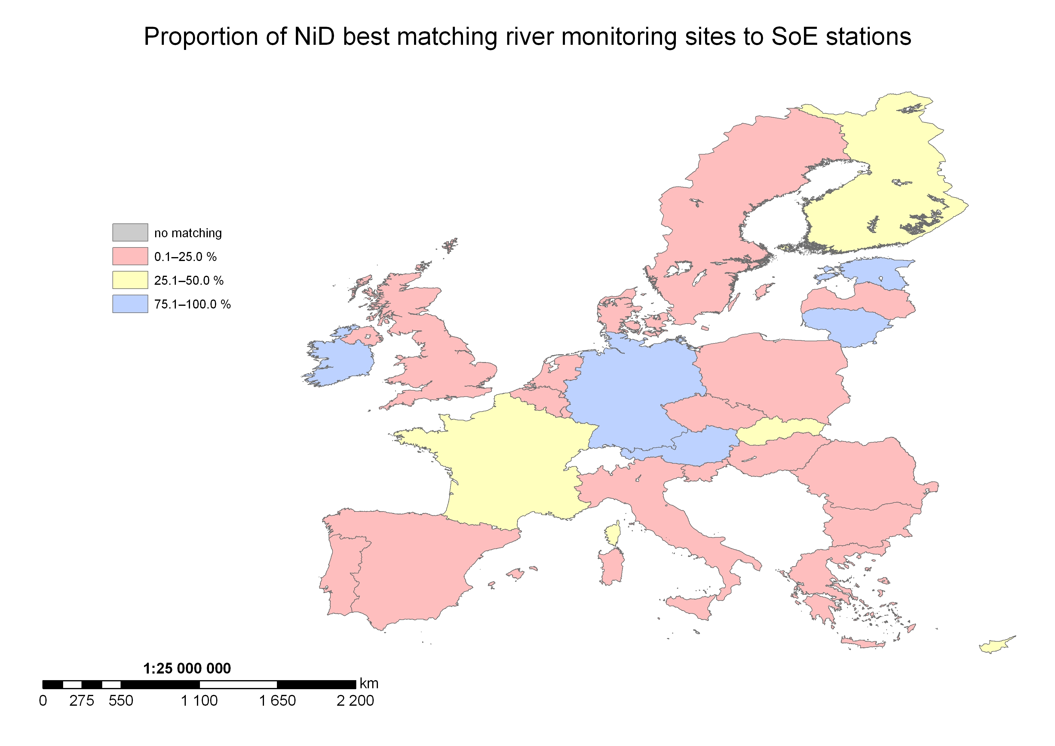
Figure 2: Summary map for NiDxSoE lake results
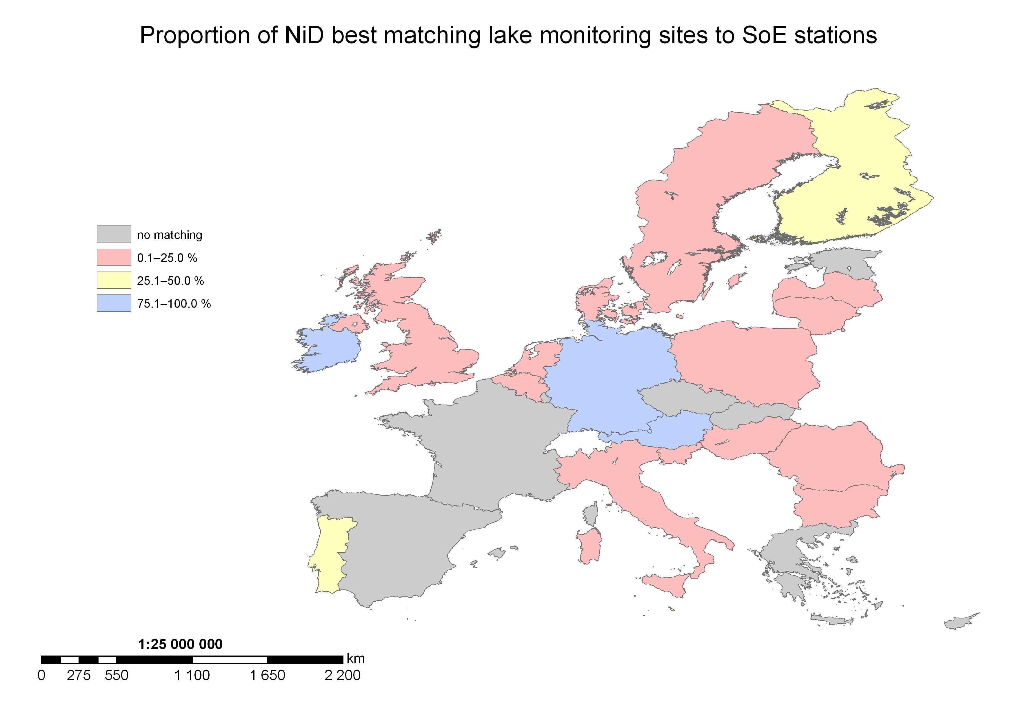
Figure 3: Summary map for NiDxSoE groundwater results
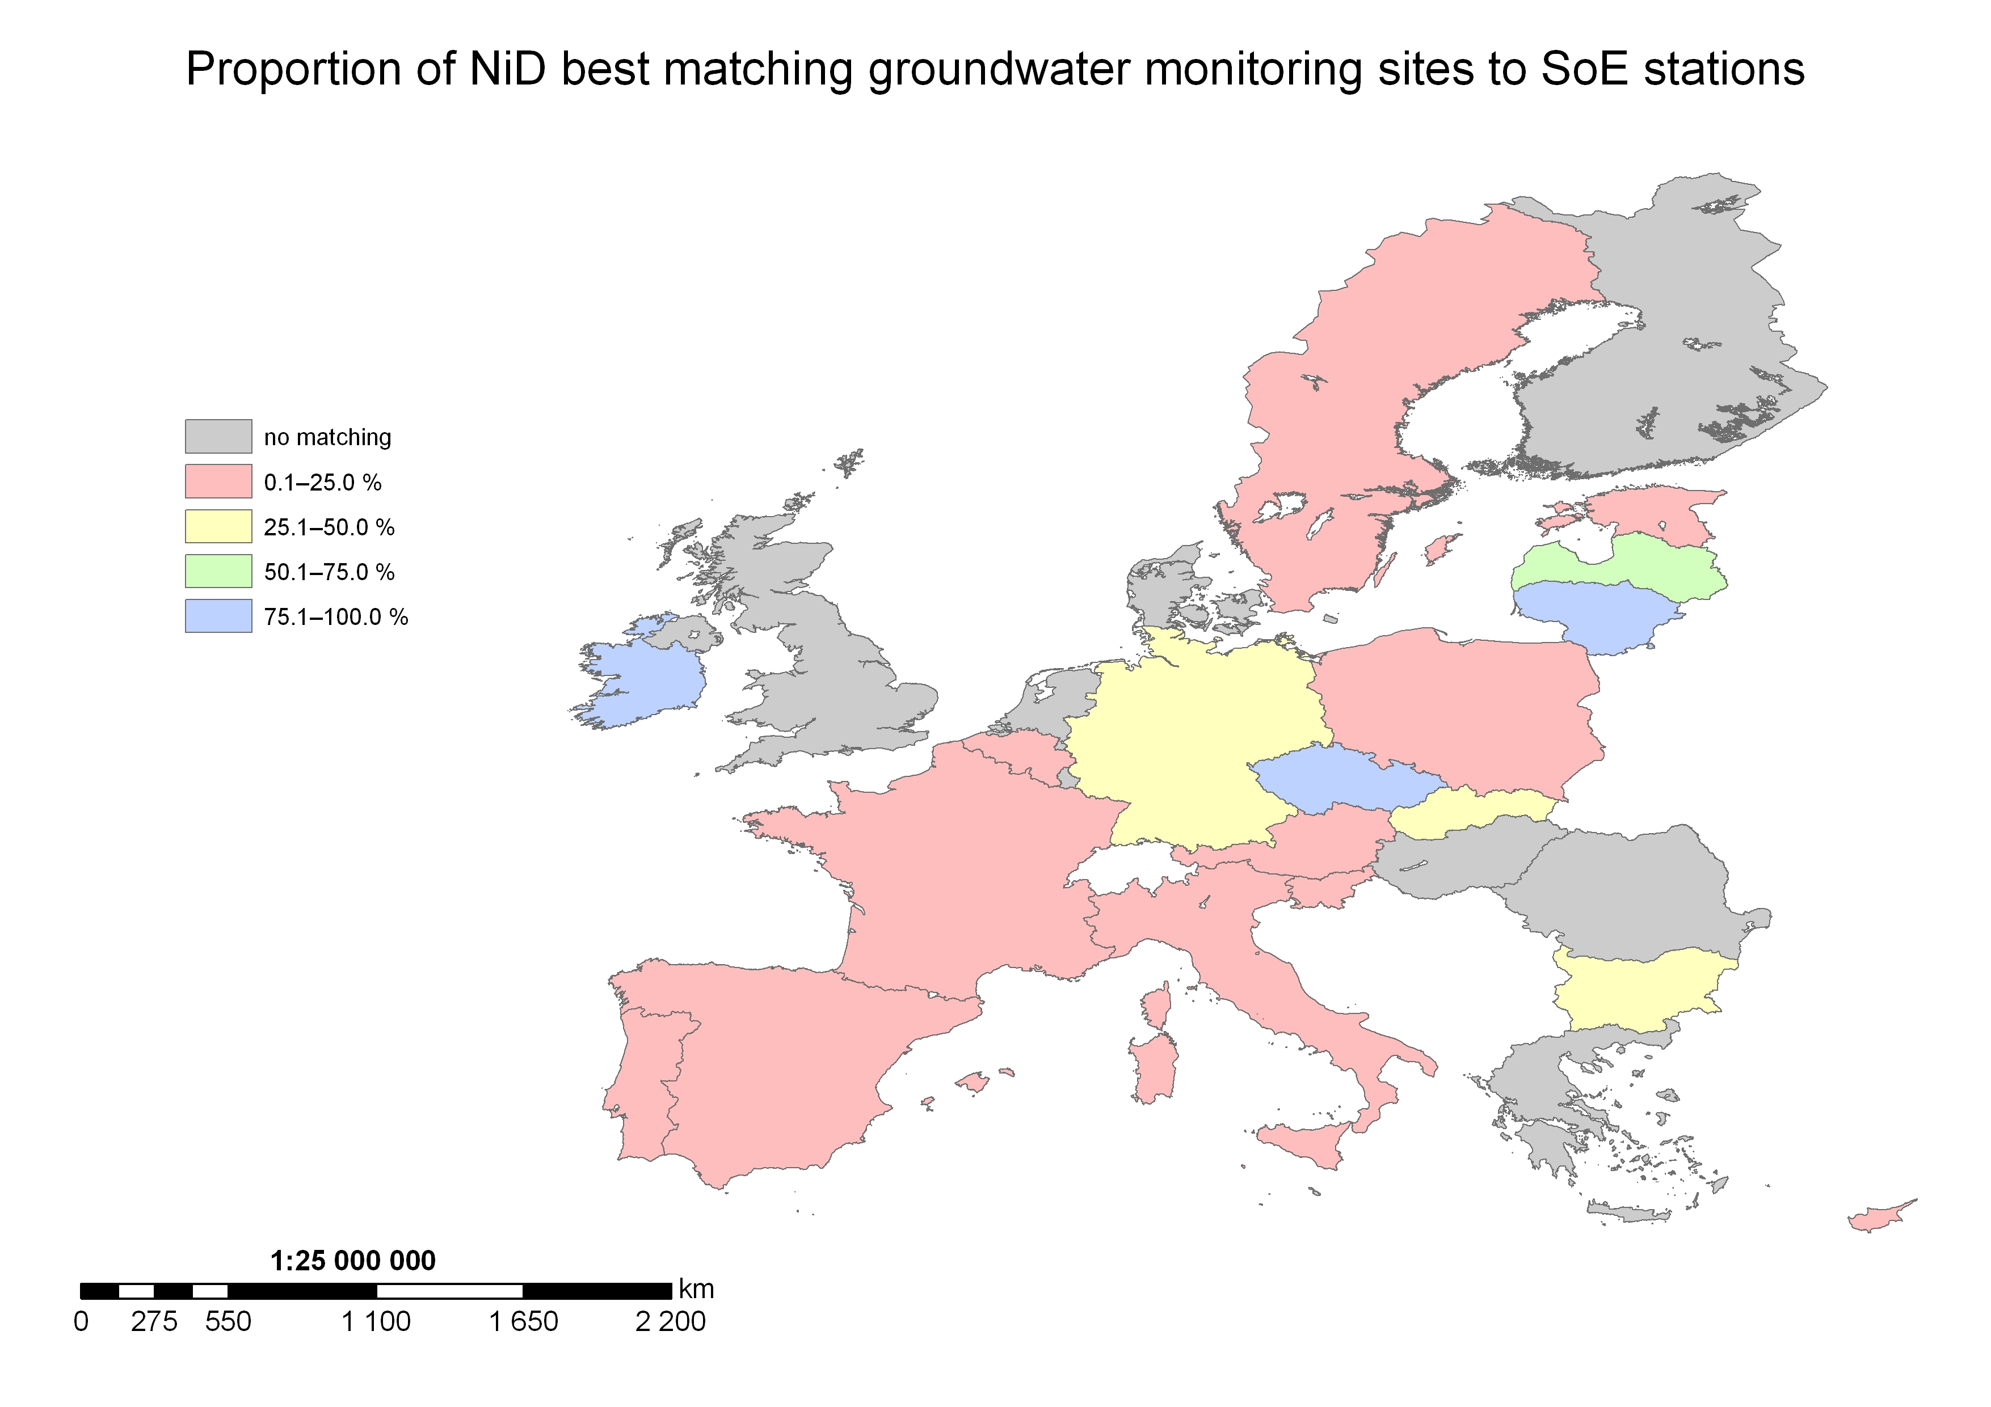
Figure 4: Summary map for NiDxSoE TCM results
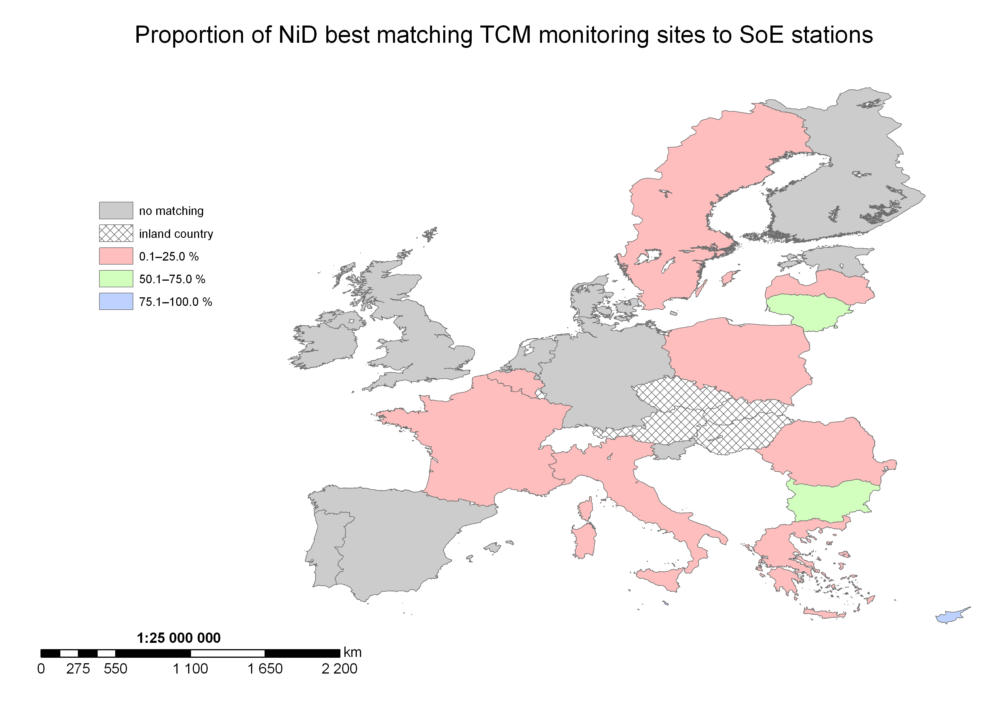
Figure 5: Summary map for NiDxWFD river results
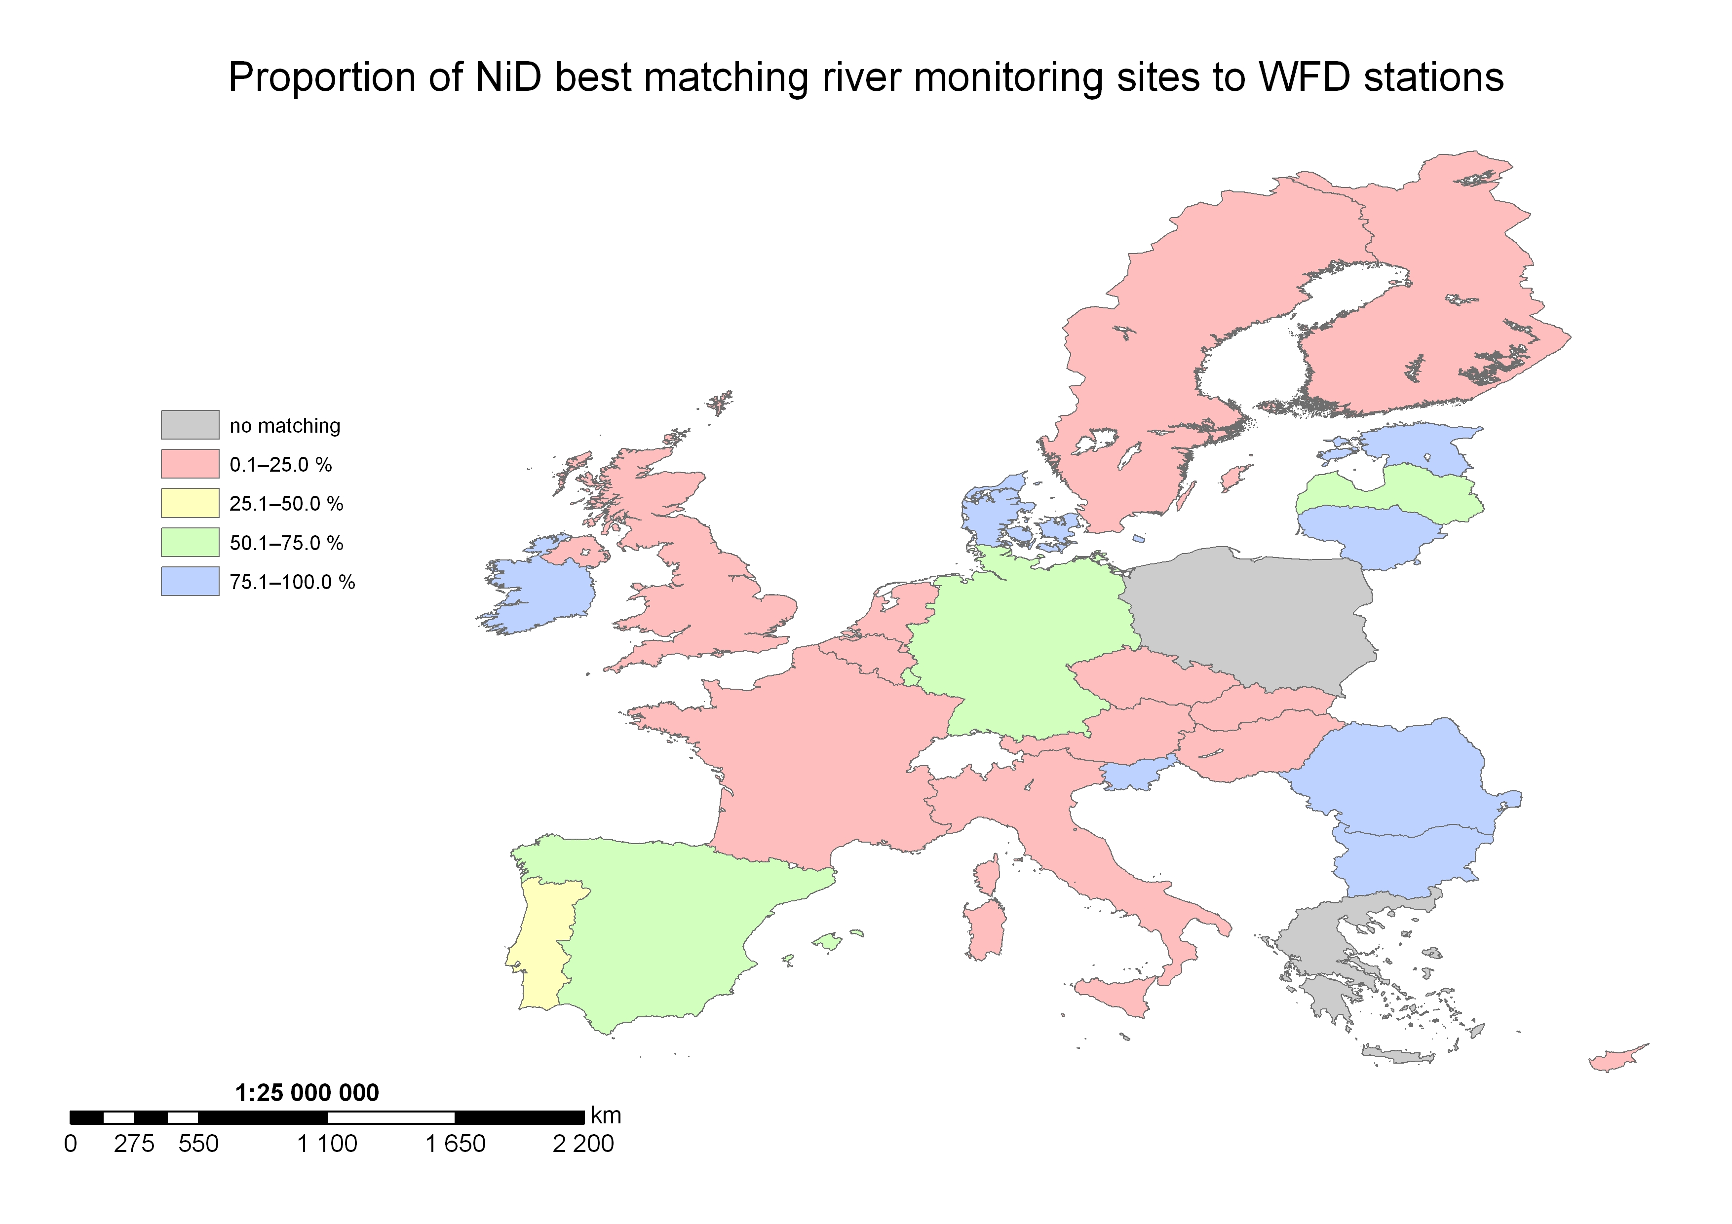
Figure 6: Summary map for NiDxWFD lake results
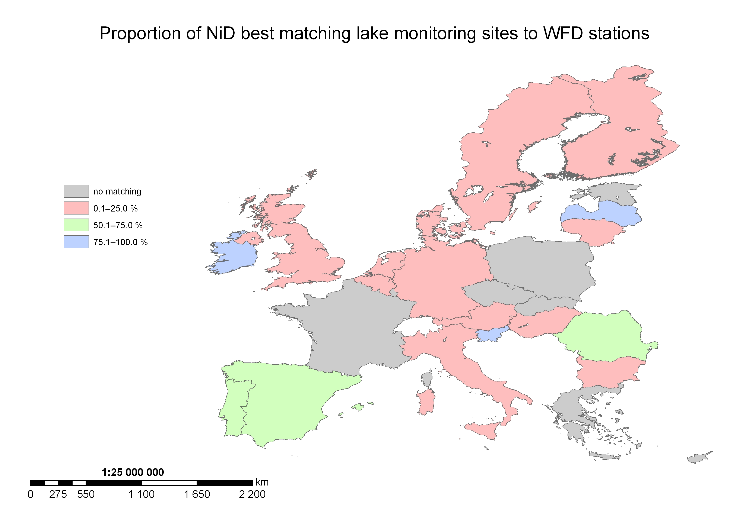
Figure 7: Summary map for NiDxWFD groundwater results
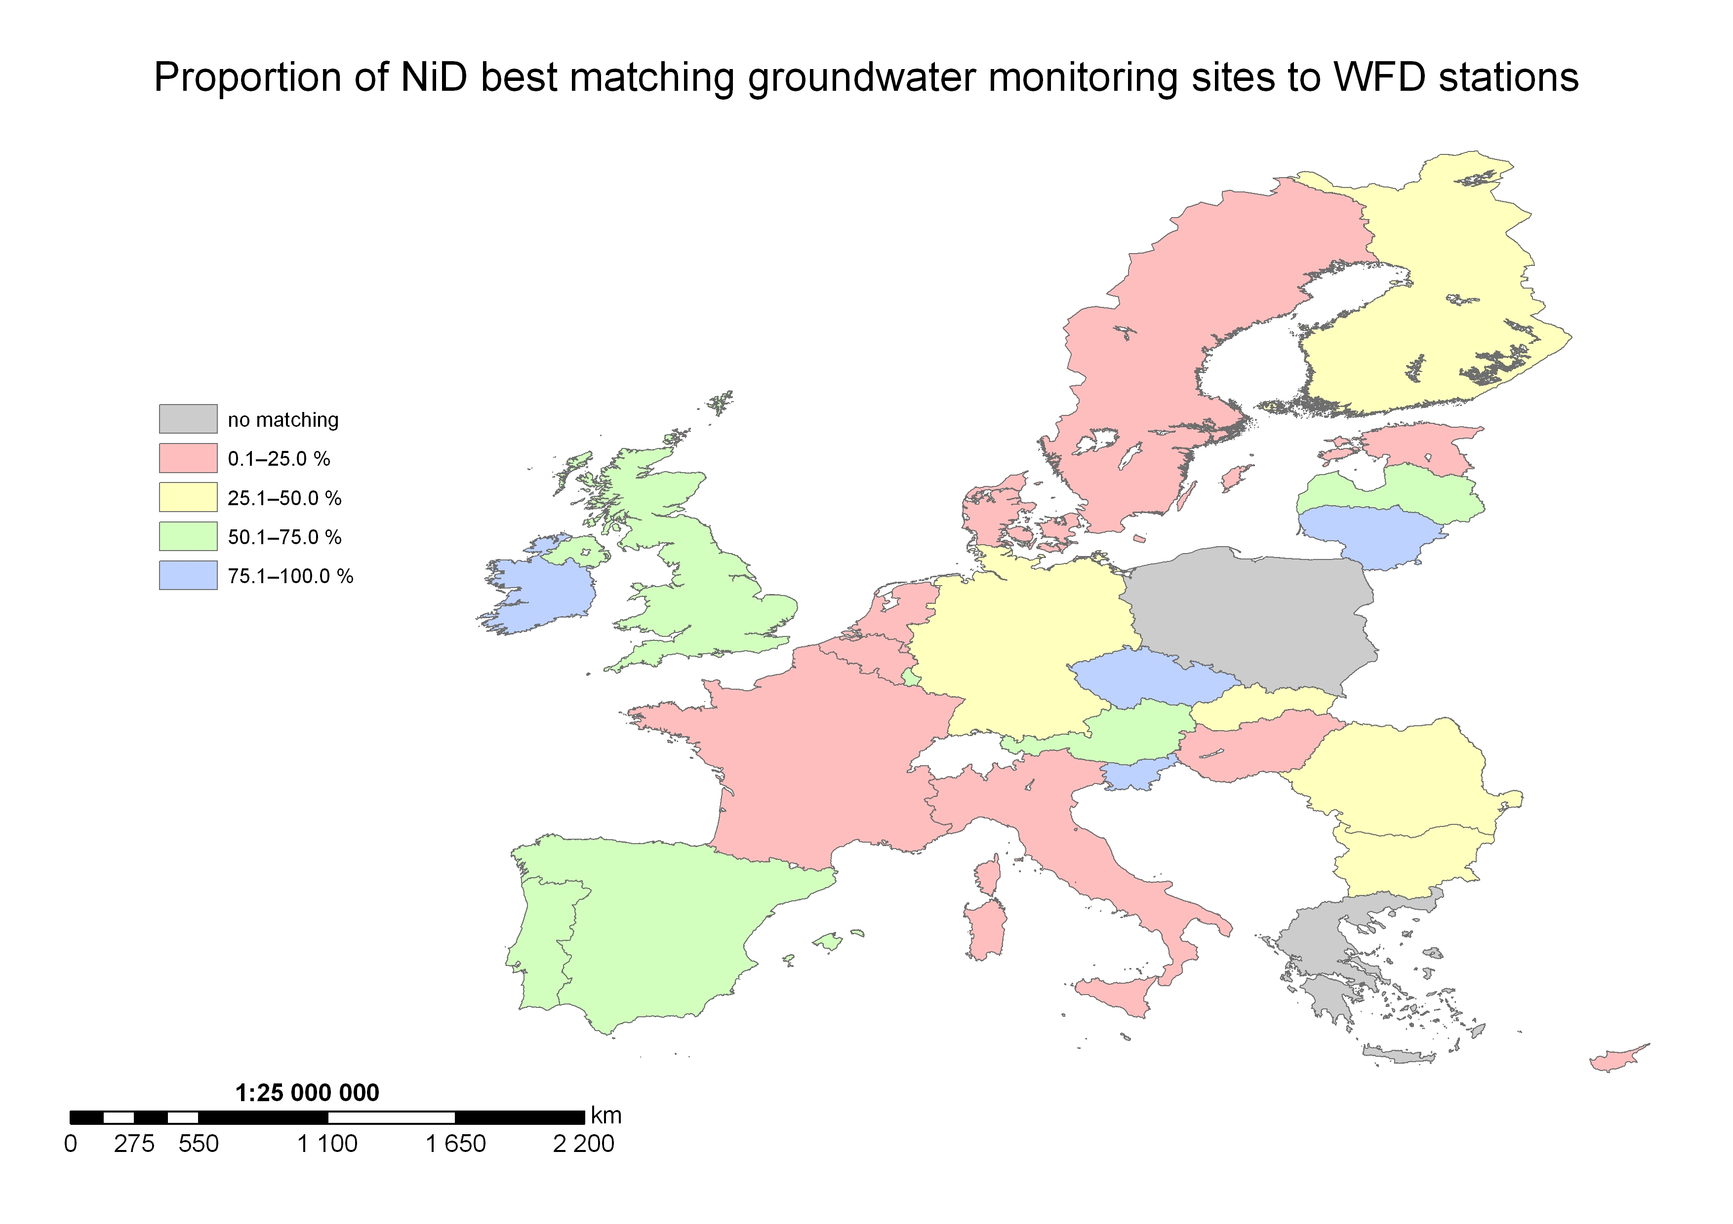
Figure 8: Summary map for NiDxWFD TCM results


