Thematic Freshwater Eionet Workshop '
'SOER and WISE assessments', 20 – 21 October 2009
European Environment Agency, Kongens Nytorv 6, Copenhagen
WORKING DOCUMENT NUMBER 4; Addressing Agenda item ‘C1’

Matching of WISE-SoE and WFD Article 8 monitoring stations

Authors: Miroslav Fanta (CENIA)

Introduction

This activity identified how many WISE-SoE water monitoring stations ‘match’ with those reported under WFD Article 8. The aim of the exercise was to identify those countries and water categories for which the match is poor, as a first step towards improving the matching.
For the continuity of time series, we therefore need to know, which WISE-SoE station equals or matches which WFD station.
We also analysed the match of SoE groundwater bodies with WFD groundwater bodies, since aggregated SoE data are reported by SoE groundwater body. Since only WFD groundwater bodies will be used from now on, a redelivery of aggregated data might be necessary, if SoE and WFD groundwater bodies differ.

Description of input datasets

WISE-SoE monitoring stations are reported by countries separately by water type categories (rivers, lakes, groundwater, TCM (transitional, coastal and marine waters)). International and national identifiers, station names, coordinates and other accompanying attributes (different for each water category) are required. Data are processed by ETC Water, one data manager is responsible for each water category.
WISE-SoE reporting period is undertaken on a yearly basis and, therefore, the list of monitoring stations is regularly updated, complemented and managed. New lists of stations are usually published in March / April. The current version of the datasets was finalised in spring 2009.

The list of WFD Art.8 stations is managed by EEA. This dataset is updated several times per year - last version was published on 7th of September 2009 and contains 58 041 surface water monitoring stations (from that 44 887 river stations and 5 898 lake stations) and 55 392 groundwater monitoring stations.

Structure of the list of WFD Art.8 stations is shown in the following:

WFD surface water monitoring stations:

Attribute name | Description
C_CD | the unique 2 character Member State code
DIST_CD | the unique European-level RBD code
NAME (NAME_RBD) | the name of the RBD
REPORTING_LEVEL | the area covered by the file
EU_CD | unique code for the Monitoring Station at EU level
MS_CD | unique code for the Monitoring Station at MS level
LON | longitude in ETRS89 of the monitoring station (decimal degrees)
LAT | latitude in ETRS89 of the monitoring station (decimal degrees)
NAME (NAME_Station) | name of the monitoring station
WB_LOCATION | unique code at EU level as reported in Article 5 of the surface water water body which the monitoring station is physically located on or near
SURVEIL | whether station is used for surveillance monitoring
OPERAT | whether station is used for operational monitoring
NO_SUBSITES | number of subsites normally associated with this station
INTERCAL_SITE | whether the station is part of the Intercalibration network
REFERENCE_SITE | whether the station s part of the national network of reference sites
DRINK_WATER | whether the station or associated water bodies are located in a drinking water abstraction area
OTHER_NETWORKS | other networks in which the station participates in
PROGRAMMES | EU code for WFD programme that this station is part of
INTER_NETWORKS | international network in which the station participates in
INTER_SITE_CDS
CATEGORY | surface water flag
BATHING, BIRDS, DRINKING, FISH, SHELLFISH, HABITATS, NITRATES, UWWT | type of protected area according the EU water directive, in which the station or associated waterbodies is located in, if any
ABSTRACTION | water abstraction

WFD groundwater monitoring stations:

Attribute name | Description
C_CD | the unique 2 character Member State code
DIST_CD | the unique European-level RBD code
NAME (NAME_RBD) | the name of the RBD
REPORTING_LEVEL | the area covered by the file
EU_CD | unique code for the Monitoring Station at EU level
MS_CD | unique code for the Monitoring Station at MS level
LON | longitude in ETRS89 of the monitoring station (decimal degrees)
LAT | latitude in ETRS89 of the monitoring station (decimal degrees)
NAME (NAME_Station) | name of the monitoring station
WB_LOCATION | unique code at EU level as reported in Article 5 of the groundwater water body which the monitoring station is physically located on or near
CHEM_SURVEIL | whether station is used for chemical surveillance monitoring
CHEM_OPERAT | whether station is used for operational monitoring
NO_SUBSITES | number of subsites normally associated with this station
QUANTITATIVE | whether the station is used for quantitative monitoring
WELL_OR_SPRING | whether the station is a well or a spring or other
DRINK_WATER | whether the station or associated water bodies are located in a drinking water abstraction area
OTHER_NETWORKS | other networks in which the station participates in
PROGRAMMES | EU code for WFD programme that this station is part of
INTER_NETWORKS | international network in which the station participates in
INTER_SITE_CDS
CATEGORY | groundwater flag

Methodology

At first sight, this exercise looks very simple – it should be sufficient to compare international identifiers of stations in both lists. Unfortunately, the reality is more complicated. Identifiers can change during the years, both datasets are at country level processed by different experts and institutions, coordinates are acquired by different methods, different precision, different rounding etc.

Therefore, the following methods were used and combined:
- Identical station code or decisive part of the code (EU_CD, MS_CD)
- Equal (or nearly equal) station coordinates
- Identical or nearly identical name
- Station was tagged by country as WFD Art.8 station within WISE-SoE reporting and EU_CD code was provided

As WFD is mandatory legislation for EU - member countries only, stations provided by non-EU countries within WISE-SoE reporting were excluded from the mapping of monitoring stations.

Results and statistics of mapping of monitoring stations

The whole set of EU27 WISE-SoE surface water (rivers, lakes) / groundwater monitoring stations was mapped against the whole set of WFD Art.8 surface water / groundwater monitoring stations.
Results were expressed in terms of how many / what proportion of WISE-SoE stations match with those reported under WFD article 8. The converse assessment was not made. For the purposes of this workshop the results presented are limited to freshwater categories. Station matching in transitional and coastal waters will be dealt with in a separate document, which will be presented at the Marine and Coastal Eionet Workshop in November 2009. Summary statistics are presented in the tables below whilst pan-European maps are provided to show the standard of matching per country and per water category. Maps for Latvia and Estonia are also shown as a detailed example.

RIVER stations match

Number of all WISE-SoE stations | 7 749
Number of EU27 WISE-SoE stations | 7 442
WISE-SoE stations matched with WFD by equal or nearly equal coordinates | 5 669
WISE-SoE stations matched with WFD by code (international, national) or name | 4 871
WISE-SoE stations matched with WFD by coordinates or code or name | 6 273 = 84.3 % of EU27 stations
WISE-SoE stations matched with WFD by coordinates or code or name and active during the period 2004 - 2007 | 5 166

Country | WFD Art.8 sw stations - rivers | all WISE-SoE stations | WISE-SoE stations matched with some of WFD stations | % of SoE stations matching WFD stations
AT | 550 | 290 | 114 | 39.3
BE | 692 | 63 | 63 | 100
BG | 352 | 111 | 43 | 38.7
CY | 31 | 33 | 30 | 90.9
CZ | 885 | 73 | 62 | 84.9
DE | 5952 | 151 | 129 | 85.4
DK | 749 | 42 | 42 | 100
EE | 226 | 61 | 60 | 98.4
ES | 3465 | 1514 | 1510 | 99.7
FI | 88 | 231 | 88 | 38.1
FR | 2857 | 1939 | 1721 | 88.8
GR | 432 | 94 | 7 | 7.5
HU | 338 | 154 | 104 | 67.5
IE | 2762 | 209 | 205 | 98.1
IT | 4804 | 1403 | 1321 | 94.2
LT | 1136 | 99 | 81 | 81.8
LU | 17 | 4 | 4 | 100
LV | 224 | 141 | 65 | 46.1
MT | 0 | 0 | 0 | 0
NL | 237 | 23 | 16 | 69.6
PL | 3594 | 136 | 108 | 79.4
PT | 617 | 59 | 59 | 100
RO | 1519 | 126 | 99 | 78.6
SE | 1003 | 127 | 94 | 74.0
SI | 225 | 30 | 29 | 96.7
SK | 707 | 125 | 111 | 88.8
UK | 11425 | 204 | 108 | 52.9
Sum | 44887 | 7442 | 6273
LAKE stations match

Number of all WISE-SoE stations | 2 544
Number of EU27 WISE-SoE stations | 2 201
WISE-SoE stations matched with WFD by equal or nearly equal coordinates | 317
WISE-SoE stations matched with WFD by code (international, national) or name | 859
WISE-SoE stations matched with WFD by coordinates or code or name | 1 176 = 53.4 % of EU27 stations
WISE-SoE stations matched with WFD by coordinates or code or name and active during the period 2004 - 2007 | 1 176

Country | WFD Art.8 sw stations - lakes | all WISE-SoE stations | WISE-SoE stations matched with some of WFD stations | % of SoE stations matching WFD stations
AT | 33 | 37 | 28 | 75.7
BE | 36 | 5 | 1 | 20
BG | 103 | 27 | 0 | 0
CY | 11 | 9 | 9 | 100
CZ | 76 | 0 | 0 | 0
DE | 644 | 20 | 11 | 55
DK | 266 | 26 | 20 | 76.9
EE | 96 | 17 | 7 | 41.2
ES | 481 | 402 | 245 | 61.0
FI | 104 | 274 | 104 | 38.0
FR | 312 | 212 | 193 | 91.0
GR | 50 | 25 | 0 | 0
HU | 46 | 35 | 19 | 54.3
IE | 198 | 96 | 75 | 78.1
IT | 714 | 369 | 174 | 47.2
LT | 325 | 56 | 46 | 82.1
LU | 0 | 0 | 0 | 0
LV | 271 | 42 | 21 | 50
MT | 0 | 2 | 0 | 0
NL | 236 | 13 | 4 | 30.8
PL | 0 | 46 | 0 | 0
PT | 76 | 32 | 32 | 100
RO | 467 | 16 | 6 | 37.5
SE | 989 | 200 | 135 | 67.5
SI | 17 | 12 | 5 | 41.7
SK | 31 | 0 | 0 | 0
UK | 316 | 228 | 41 | 18.0
Sum | 5898 | 2201 | 1176
GROUNDWATER stations match

Number of all WISE-SoE stations | 15 269
Number of EU27 WISE-SoE stations | 14 982
WISE-SoE stations matched with WFD by equal or nearly equal coordinates | 6 056
WISE-SoE stations matched with WFD by code (international, national) or name | 7 443
WISE-SoE stations matched with WFD by coordinates or code or name or confirmed by country as WFD Art.8 station | 7 986 = 53.3 % of EU stations
WISE-SoE stations matched with WFD by coordinates or code or name or confirmed by country as WFD Art.8 station and active during the period 2004 - 2007 | 7 535 = 62,3 % of active EU stations

Country | WFD Art.8 gw stations | all WISE-SoE stations | active WISE-SoE stations | WISE-SoE stations matched with some of WFD stations | % of SoE stations matching WFD stations
AT | 5371 | 782 | 782 | 605 | 77.4
BE | 692 | 418 | 395 | 370 | 88.5
BG | 377 | 387 | 223 | 171 | 44.1
CY | 237 | 382 | 227 | 29 | 7.6
CZ | 699 | 483 | 463 | 461 | 95.4
DE | 13270 | 1181 | 997 | 702 | 59.4
DK | 975 | 86 | 70 | 0 | 0
EE | 427 | 711 | 297 | 68 | 9.6
ES | 5886 | 551 | 540 | 543 | 98.6
FI | 275 | 0 | 0 | 0 | 0
FR | 3776 | 2892 | 2069 | 1822 | 63.0
GR | 524 | 442 | 440 | 0 | 0
HU | 3197 | 0 | 0 | 0 | 0
IE | 300 | 222 | 210 | 206 | 92.8
IT | 5705 | 3835 | 3020 | 842 | 22.0
LT | 250 | 265 | 115 | 256 | 96.6
LU | 31 | 6 | 6 | 4 | 66.7
LV | 88 | 192 | 192 | 192 | 100
MT | 0 | 9 | 9 | 0 | 0
NL | 2084 | 0 | 0 | 0 | 0
PL | 0 | 45 | 44 | 0 | 0
PT | 807 | 532 | 394 | 428 | 80.5
RO | 3422 | 0 | 0 | 0 | 0
SE | 115 | 26 | 24 | 22 | 84.6
SI | 219 | 76 | 72 | 59 | 77.6
SK | 1728 | 471 | 466 | 454 | 96.4
UK | 4937 | 988 | 762 | 752 | 76.1
Sum | 55392 | 14982 | 11817 | 7986
Conclusion on station match

A good match for river monitoring stations is evident with 84% of the WISE-SoE stations, across Europe as a whole, matching those of the WFD. For lakes and groundwater the matching is lower, about 53% in each case, again for Europe as a whole. Considerable variation is apparent, however, between countries, as evidenced by the maps. Going forward, close cooperation with some Member Countries is required, to understand why poor matching exists and to improve the situation.

Maps - Europe

Symbols in Legend are purposely bigger than in the map

River stations

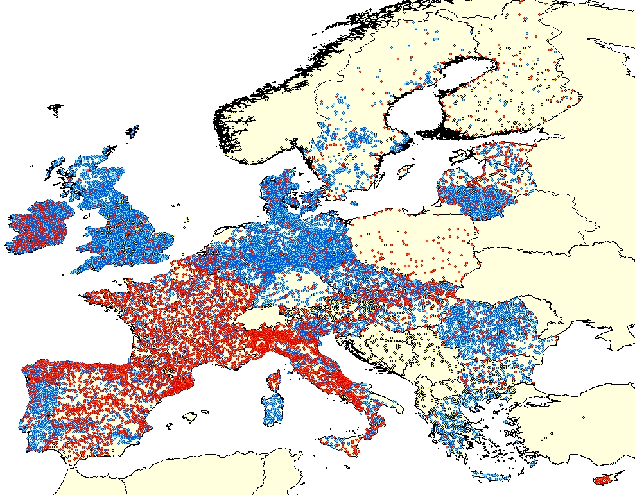

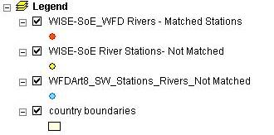

Lake stations

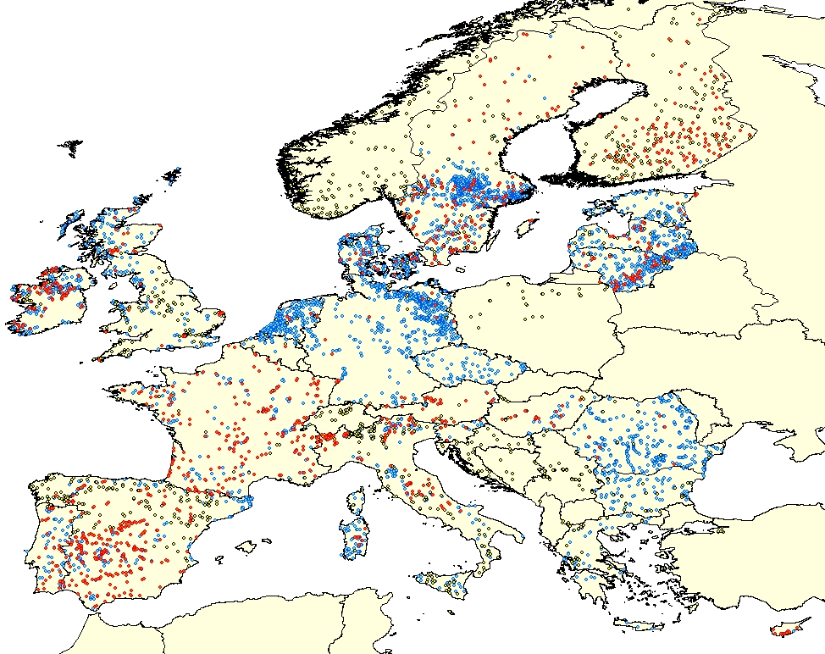

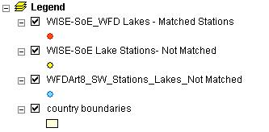

Groundwater stations

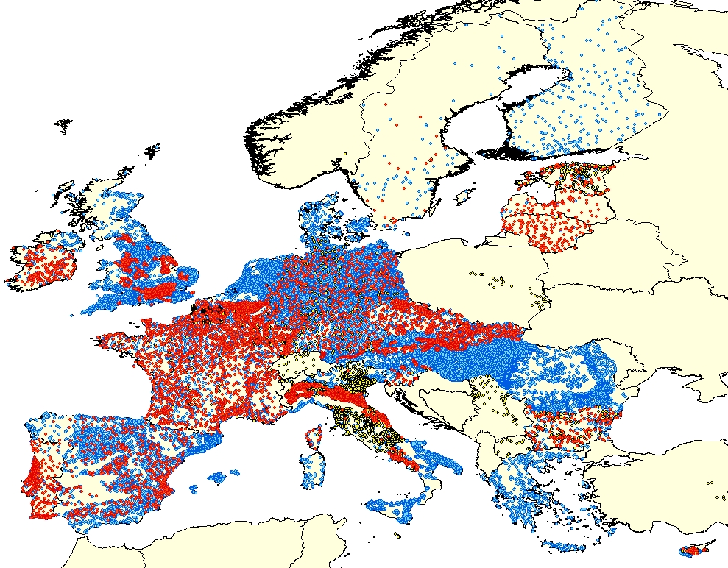

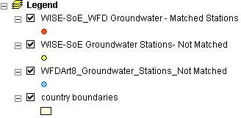

Maps – Detail (Estonia, Latvia)

River stations

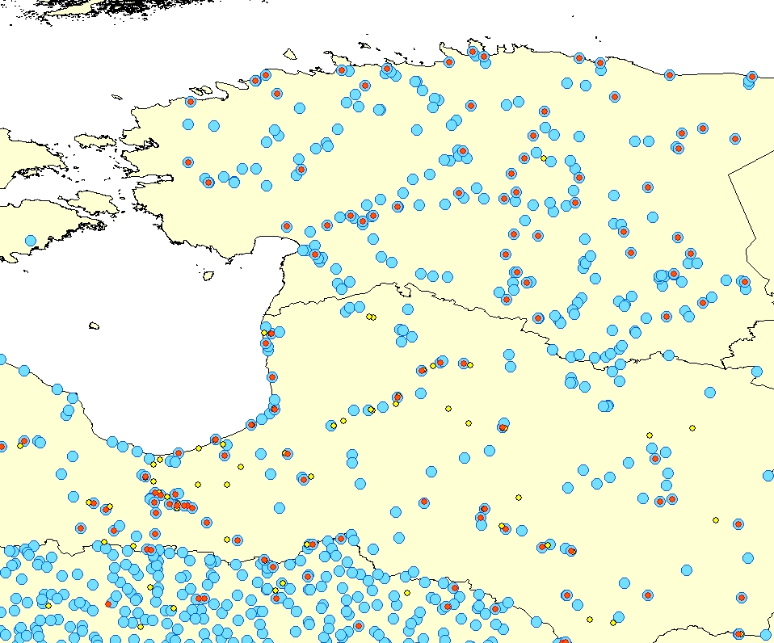

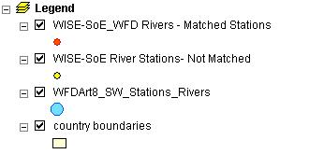

Lake stations

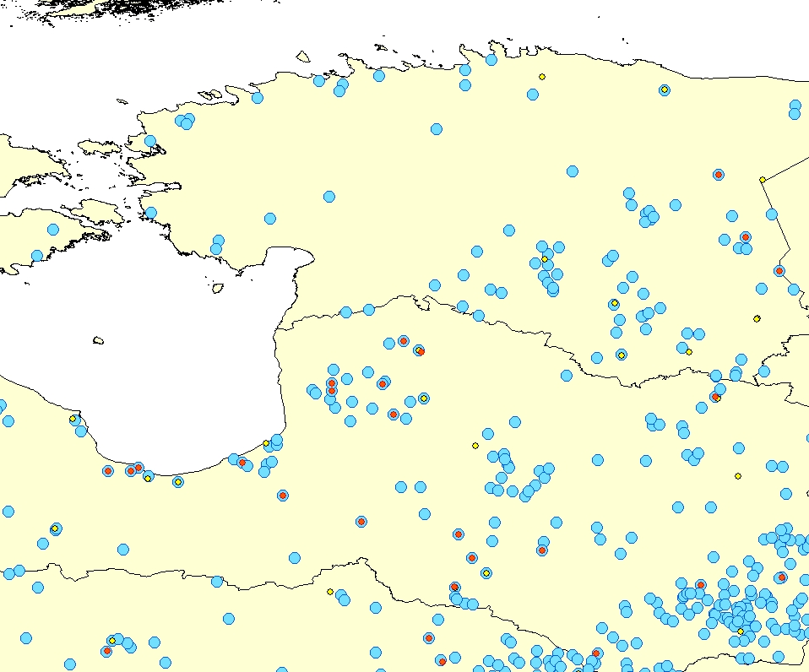

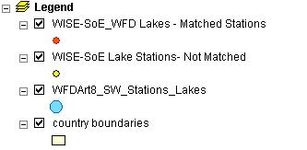

Groundwater stations

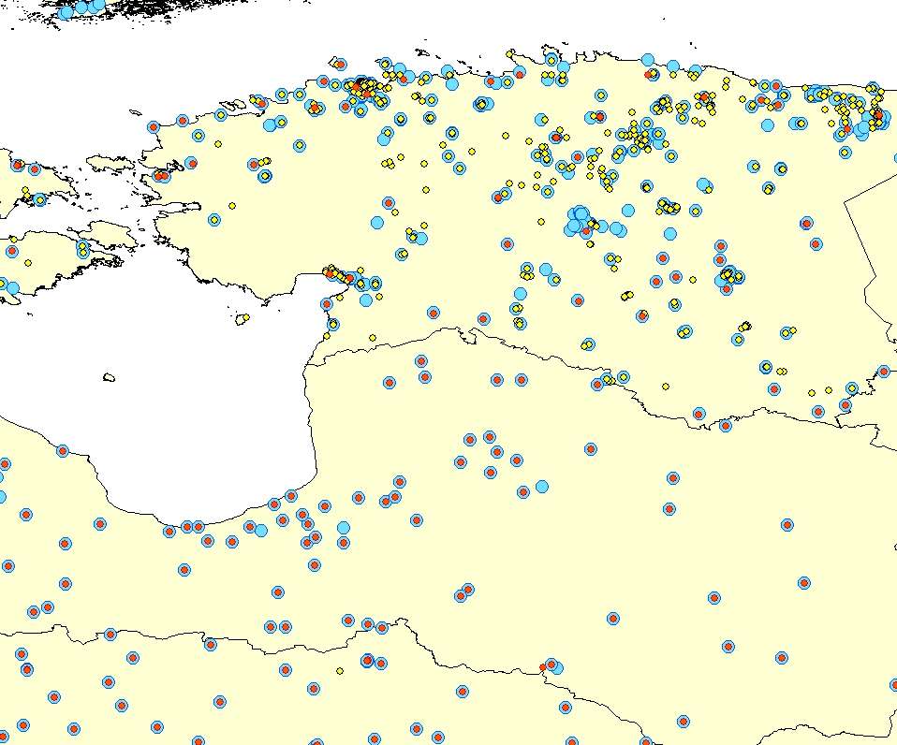

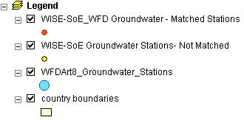

Results and statistics of matching of groundwater bodies

Linking of WFD Article 3 / 5 groundwater bodies within WISE-SoE reporting was done by member countries in the 2008 WISE SoE data request for the first time.
In certain countries (BE, BG, CY, FR, HU, LU, LV, MT, SE), the delineation of groundwater bodies was reported as fully identical between the EIONET (WISE-SoE) groundwater body and Water Framework Directive groundwater body. Such “pairs” of groundwater bodies can be used as mapped groundwater bodies and the time series of data aggregated per groundwater bodies can continue in the future without problems.
According to the ETC/W expert’s judgement, in many other cases, EIONET and WFD groundwater bodies can differ slightly only – the “algorithm” for delineation was identical, but the WFD groundwater bodies were delineated based on different data sources (maps in different scales, data inputs with higher precision, etc.) In case the area of ground water body covers identical sources of monitoring, such ground water bodies can be mapped even if their spatial area is different. Countries will be asked for cooperation to specify such pairs of ground water bodies and increase the number of matched ground water bodies.

Statistics of matching of groundwater (gw) bodies:

Country | SoE gw bodies + WFD gw bodies used by countries within WISE-SoE reporting | WFD gw bodies used by countries within WISE-SoE reporting | Matching SoE and WFD gw bodies with identical identifiers | Matching SoE and WFD gw bodies with different identifiers | % of SoE gw bodies matching WFD gw bodies
AT | 28 | 14 |  |  | 0
BE | 110 | 55 |  | 55 | 100
BG | 270 | 107 |  | 69 | 42
CY | 3 | 3 | 3 |  | 100
CZ | 265 | 173 |  |  | 0
DE | 438 | 428 |  |  | 0
DK | 3 | 0 |  |  | 0
EE | 5 | 0 |  |  | 0
ES | 434 | 275 |  |  | 0
FI | 41 | 0 |  |  | 0
FR | 3073 | 564 |  | 559 | 22
GR | 362 | 0 |  |  | 0
HU | 54 | 18 |  | 18 | 50
IE | 153 | 150 |  |  | 0
IT | 45 | 0 |  |  | 0
LT | 7 | 7 |  |  | 0
LU | 11 | 5 |  | 5 | 83
LV | 20 | 16 | 16 |  | 80
MT | 2 | 2 | 2 |  | 100
NL | 9 | 0 |  |  | 0
PL | 173 | 0 |  |  | 0
PT | 93 | 83 |  |  | 0
RO | 25 | 25 |  |  | 0
SE | 45 | 21 |  | 21 | 87.5
SI | 11 | 6 |  |  | 0
SK | 111 | 101 |  |  | 0
UK | 41 | 0 |  |  | 0
Sum | 5832 | 2053 | 21 | 727

Conclusion on groundwater body match

In all cases, where a SoE groundwater body cannot be matched to a WFD groundwater body and for which aggregated data have been reported, we propose a redelivery of the time series preferably disaggregated and measured in stations, which are linked to a WFD water body or as second option newly aggregated by the corresponding WFD water body. This redelivery could be done during the 2010 WISE SoE data request.
Map – WFD groundwater bodies – Europe

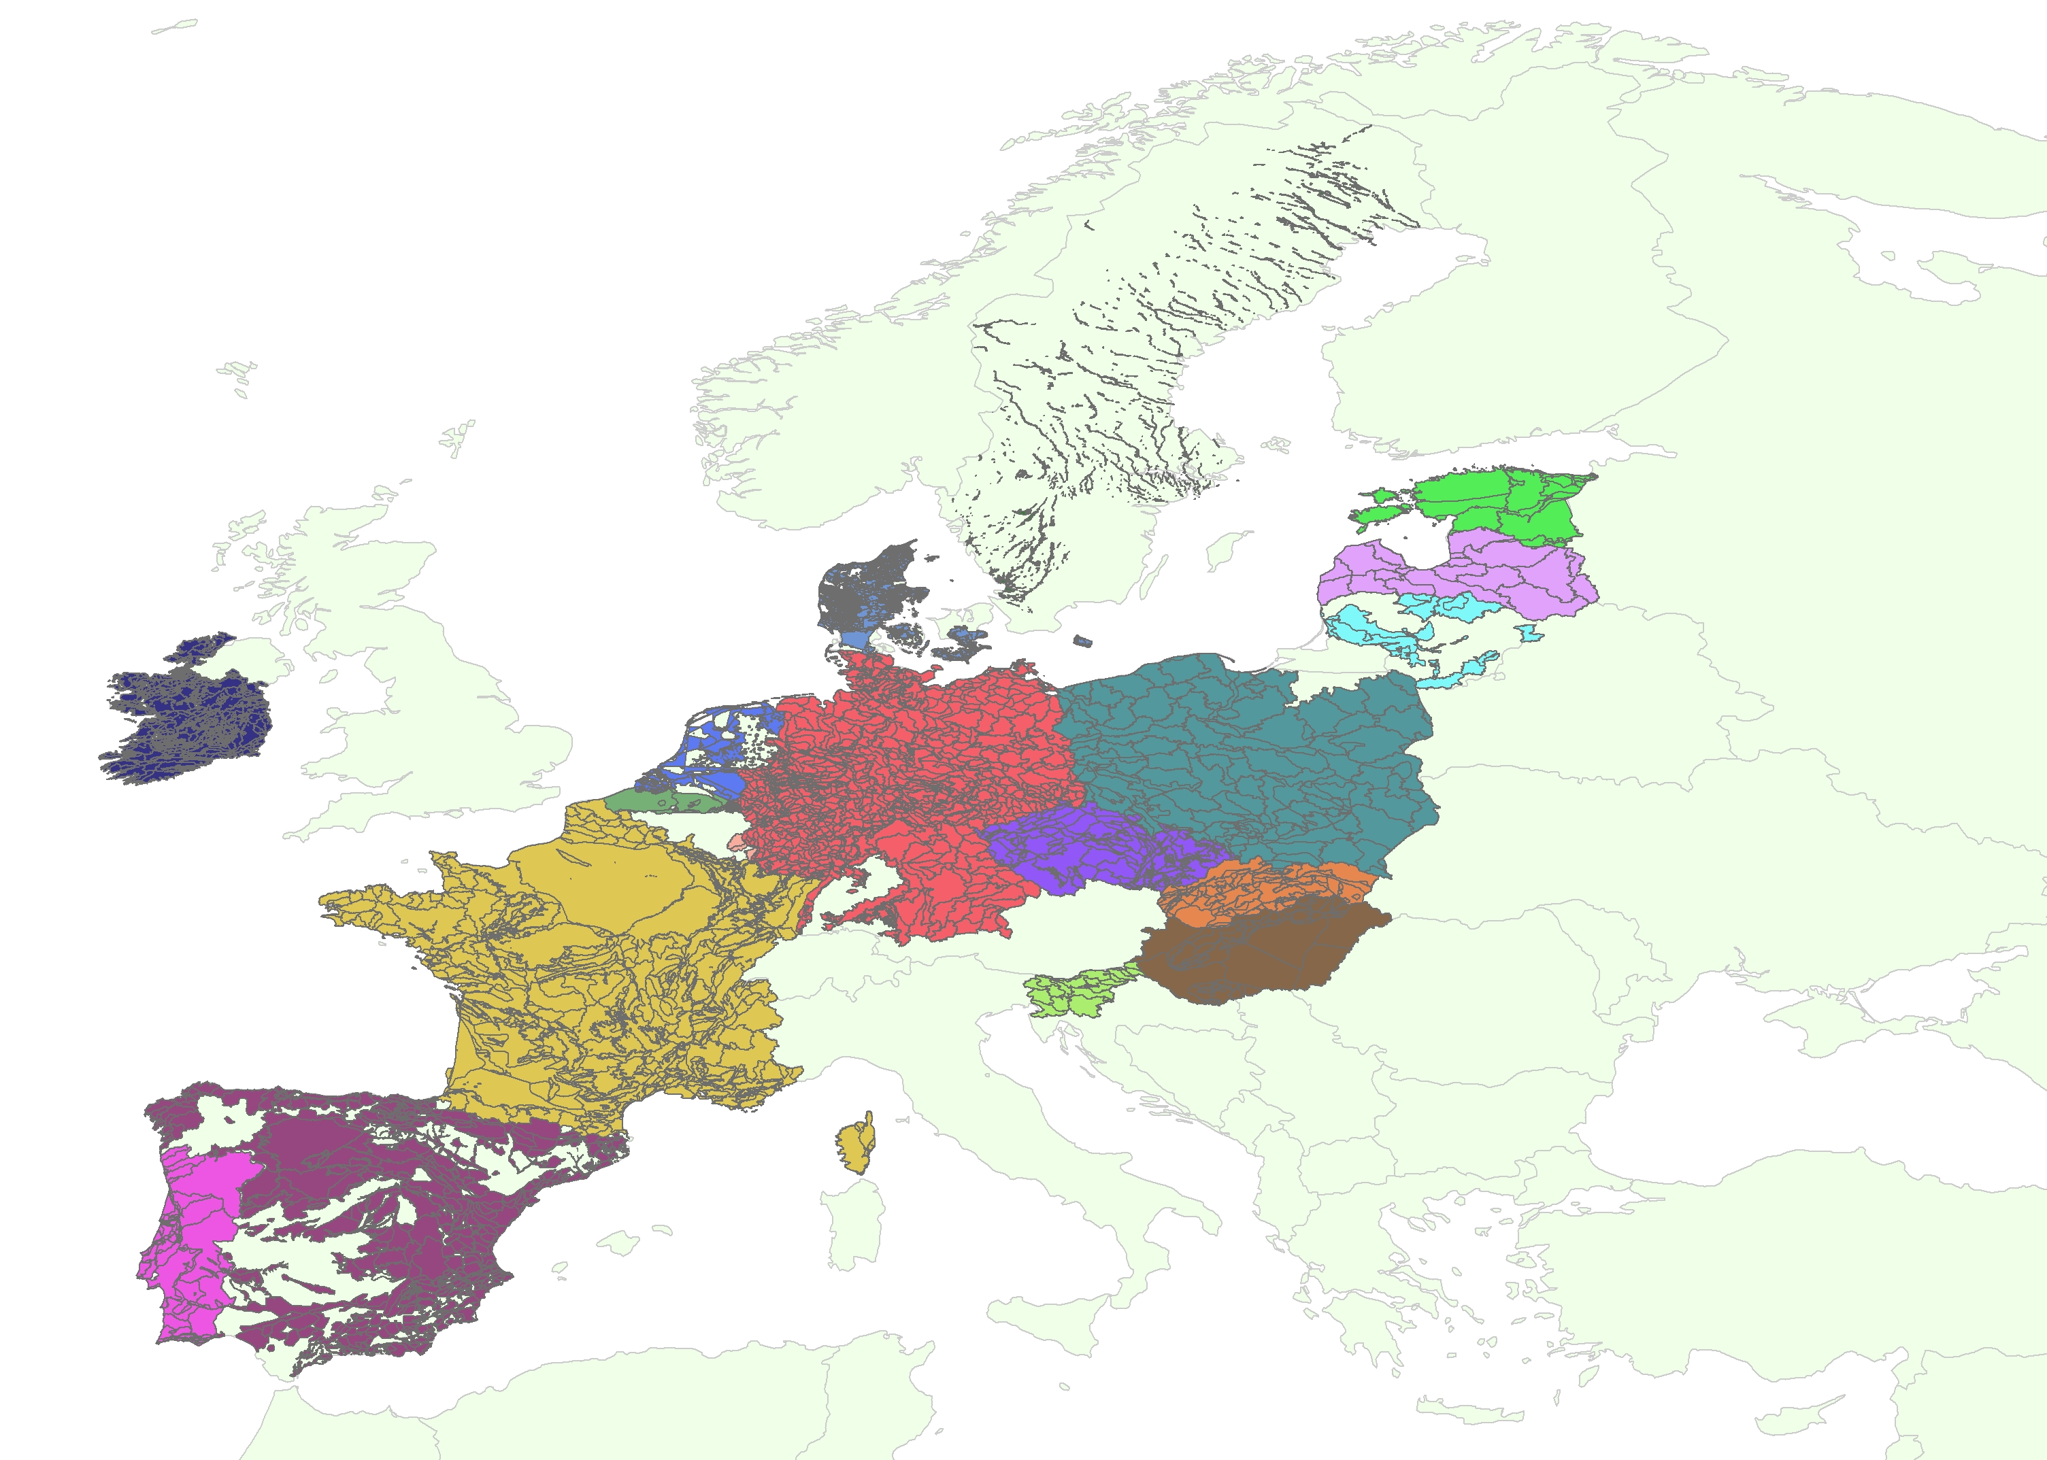

Map – WFD groundwater bodies – detail (Latvia)



