PROPOSAL FOR A SIMPLIFIED METHOD
FOR THE QUANTIFICATION OF EMISSIONS TO WATER
version 06-10-2021

Lead Authors: Joost van den Roovaart (Deltares), Antje Ullrich (UBA), Nanette van Duijnhoven (Deltares), Hana Prchalová (CENIA)
EEA Project Manager: Caroline Whalley

Document drafted under CIS WG Chemicals activity, sub-group on emissions.
Contributors:
BE: Sofie van Volsem, Jurgen Meirlaen, Katrien Bursens
AT: Manfred Clara, Oliver Gabriel
DK: Maj-Britt Bjergager, Birgitte Cordua, Anette Christensen, Rasmus Dyrmose Nørregaard
DE: Volker Mohaupt
FR: Pierre Boucard
IE: Simon O’Toole, Cara O’Loughlin
IT: Martina Bussettini, Emanuele Ferretti, Piva Francesca
NL: Dorien ten Hulscher, Jaap Postma
PL: Damian Bojanowski, Louis Courseau
SE: Asa Andersson

CEFIC: Thomas Kullick
ECPA: Klaas Jilderda
EEB: Aliki Kriekouki, Christian Schaible, Sara Johansson, Jean-Luc Wietor
Eurelectric: Marie-Jo Booth
EUROMETAUX: Chris Cooper, Frank van Assche, Nathalie Kinga Kowalski, Kevin Farley, Lara Van de Merckt, Stijn Baken, Chris Schlekat, Ellie Middleton. Consultants: Sean Comber, Adam Peters

List of abbreviations

AR Activity Rate
CIS Common Implementation Strategy
EC European Commission
EEA European Environment Agency
EF Emission Factor
E-PRTR European Pollutant, Release and Transfer Regulation
ETC/ICM European Topic Centre for Inland, Coastal and Marine Waters
EU European Union
EQS Environmental Quality Standards
ICPR International Commission for the Protection of the Rhine
IWWTP Industrial Waste Water Treatment Plant
MS EU Member States
OECD Organisation for Economic Cooperation and Development
PAH Polycyclic Aromatic Hydrocarbons
p.e. population equivalent
PHS Priority Hazardous Substances
PS Priority Substances
RBD River Basin District
RBDSU River Basin District Sub-Unit
RBMP River Basin Management Plan
RBSP River Basin Specific Pollutant
TGD Technical Guidance Document
UWWTD Urban Waste Water Treatment Directive
UWWTP Urban Waste Water Treatment Plant
WFD Water Framework Directive
WG Working Group
WISE-SoE Water Information System Europe – State of the Environment

Summary

Under the Water Framework Directive, Member States are required to report an inventory of emissions, discharges and losses of priority substances. Such information can give information on the success of measures to reduce emissions and indicate whether further efforts may be needed to deliver good chemical status. However, reporting of the inventory under the second river basin management plans was patchy and largely incomparable between Member States. While there is a Technical Guidance Document on the preparation of the inventory, it appears that further information is needed to help Member States report in a consistent and comparable way. This paper aims to provide steps towards that, to enable improved quality of reporting in the upcoming river basin management plans. A simplified method for the quantification of emissions to water is presented, which has been used as a basis for the Water Framework Directive (WFD) Working Group Chemicals sub-group on reporting of emissions to water.
This activity is carried out by the European Topic Centre for Inland, Coastal and Marine Waters (ETC/ICM) for the European Environment Agency (EEA), with support from Member States under the Water Framework Directive CIS WG Chemicals activity on emissions.

Introduction

Several projects related to emissions to water, carried out in recent years for the European Commission (EC) and the EEA,,,, show serious problems regarding consistency, completeness and quality of the EU reported emission data. More specific, the EEA reports have shown:
- very little reporting on diffuse sources;
- limited (incomplete) reporting on urban wastewater treatment plant (UWWTP) effluents (not all UWWTPs, not all relevant pollutants);
- unclear quality of emission data of industrial sources (not all facilities, not all relevant pollutants);
- inconsistent reporting in time and space (no comparable and consistent time ranges and not all river basin districts reported);
- some double reporting or reporting gaps between the most important EU emission reporting requirements: WFD, E-PRTR, Water Information System Europe – State of the Environment (WISE-SoE) and the Urban Waste Water Treatment Directive (UWWTD).

These problems are not limited to the EU, and are recognized also on a global scale, see recent OECD and World Bank publications.
As a consequence of this, regarding the EU reported emission data there is:
- no EU wide overview of relevant emission sources/pollutants;
- no consistent time series, so no idea of trends;
- limited insight in the effects of emission reduction measures carried out in the past;
- no clear relation between emissions and water quality;
- no insight which future measures are needed to meet the water quality targets;
- extra effort for EEA and others in evaluation reports and comparison of different datasets.

Aim of the work
The aim of the work has been to support MS with the WFD reporting on emissions to water for the 3rd cycle of the River Basin Management Plans (RBMPs), to be published by the MS by December 22nd, 2021. This work has regrettably been delayed for various reasons, so most MS are already close to completion in their emission inventories for the 3rd RBMP. Nevertheless, the work can be useful to those less advanced in progress and may help in cases where there is still missing data. In any case, new data or shared knowledge can be used in improving emissions data both for the next RBMP cycle and in other data collections, e.g. WISE-1 emissions.

Technical Guidance Document no.28 (TGD) was developed for the WFD inventory. However, reporting of 2nd RBMPs showed only a few MS succeeded in reporting on diffuse sources and for more than a few pollutants – as summarized in the EEA chemicals in water report (2018). To help support emissions reporting by MS, this proposal is drafted as supplementary advice, and is not intended to replace the existing TGD.

We see use of this proposal at two levels. For MS with limited data or capacity to develop quantification methods for diffuse emissions, information, data and methods already used by others is being made accessible. For MS already reporting diffuse emissions, the proposal provides an opportunity to benchmark emission factors and quantification methods. Use of the proposed approach and/or the data is optional.
This proposal must be seen as an attempt to make a step forward in the quality of the RBMP reporting of emissions to water. The proposal may also contribute to the harmonization of the methods used for the quantification of emissions to water and in that way improve the EU wide comparability of the reported emission data. The proposed method has been deliberately designed to be as simple as possible. It is still an incomplete version: not all the details have been fully worked out. It is not intended that simple methods override more detailed approaches already being used by MS: rather, the proposal is targeted towards those MS which currently lack data and or methods.

Simplified method for the quantification of emissions to water

General scheme
A general scheme in which the main principal sources, pathways and intermediates of emissions to water are represented was developed under the WFD Common Implementation Strategy (see Figure 1 below).
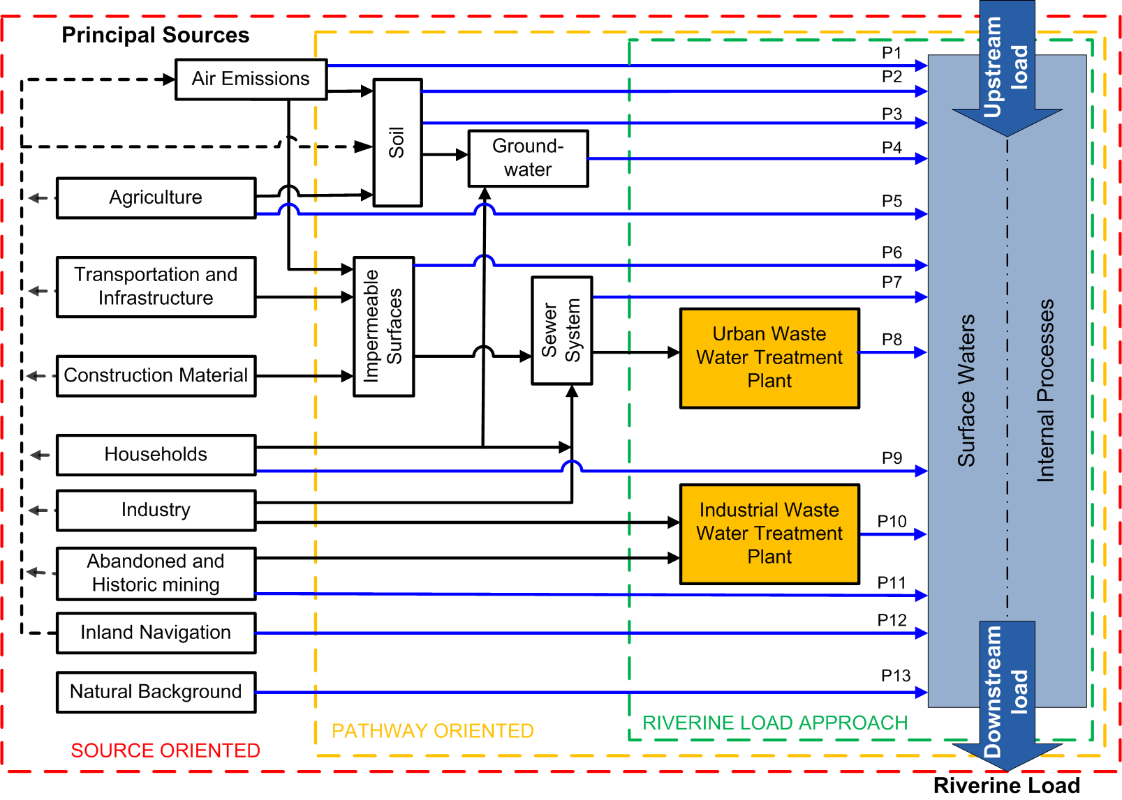
P1 Atmospheric Deposition directly to surface water | P8 Urban Waste Water treated
P2 Erosion | P9 Individual - treated and untreated- household discharges
P3 Surface runoff from unsealed areas | P10 Industrial Waste Water treated
P4 Interflow, Tile Drainage and Groundwater | P11 Direct Discharges from Mining
P5 Direct discharges and drifting | P12 Direct Discharges from Navigation
P6 Surface Runoff from sealed Areas | P13 Natural Background
P7 Storm Water Outlets and Combined Sewer overflows + unconnected sewers

Figure 1 Relationship between the different surface water compartments and pathways (P1-P13) (EC, 2012)

On the left in the scheme, the principal sources of the pollutants are shown, representing groups of sources which can be related to economic sectors or activities. The natural background is also represented as a separate source. In fact, this is a rather complicated source because natural background concentrations can also be a part of the other pathways and double counting must be avoided. Emissions, discharges or loads can follow different pathways, either directly to surface water, or to other compartments of the environment (air, soil, groundwater). A specific place is given to urban areas with the impermeable surfaces, the sewer system and the waste water treatment plants, both urban (UWWTPs) and industrial (IWWTPs).

Although different approaches are shown in the scheme (riverine load approach, source-oriented approach and pathway-oriented approach), the quantification of the different pathways (P1-P13) can be seen as the core of a complete emission inventory. Most of the existing emission reporting requirements can be related to one or more of these defined pathways.

Although the riverine load approach is more simple than the pathway approach (and is, of course, better than no inventory at all) and it is known several MS use this method, it is not the preferred method here, mainly because it doesn’t give insight into the different sources behind the pathways. As a result, it would not be easy to make a connection with possible mitigation measures. Of course, the riverine load approach stays available as a separate method and the calculation of river loads can play an important role in the quality assurance of the pathway approach, but this proposal will focus on the quantification of the pathways P1-P13.

It is interesting to have information on the primary sources (use of products, processes) within households and small and medium enterprises (SME’s) which end up in the sewer and the UWWTP’s, but this rather complicated exercise is something likely to be more appropriate in more advanced stages of emission inventories.

Simplified emission factor method
It is proposed to use a simplified emission factor method as developed in the International Commission for the Protection of the Rhine (ICPR), using a limited number of emission factors and statistical data. This method has been described, including the data used, in Water, Science and Technology, 2001. The method has been applied for 7 metals for the Rhine catchment. The estimated loads agreed rather good with the loads of the river Rhine, as measured at the Dutch-German border.
This emission factor method was also used in the EC project: Diffuse water emissions in E-PRTR. In this project diffuse emissions to water have been quantified for a selection of 40 key sources – key substance combinations, covering the EU Member States and the EFTA countries on a River Basin District sub-unit scale. The report and maps are available on the E-PRTR website.
A good explanation of emission factors used in emission inventories can be found in a publication of TNO: The Art of Emission Inventorying. Although this publication is related to air emission, a lot of the problems and solutions are also recognized in emissions to water inventories.
Emissions of a pollutant for an activity are calculated by multiplying an activity rate (AR_{a}) for a specific activity (or pathway) by an emission factor for this activity and a certain pollutant (EF_{p,a}), expressed in emission per AR unit. An example for an activity is the production of urban waste water. The AR will then be the number of inhabitants producing waste water. The EF for a pollutant, e.g. total-Nitrogen, will then be the yearly load total-Nitrogen in urban waste water per inhabitant.
The calculation method is shown in the formula below:
E_{p,a} = AR_{a} x EF_{p,a}
Where:
E_{p,a} = Emission of a pollutant for an activity
AR_{a} = Activity Rate for an activity
EF_{p,a} = Emission factor of a pollutant for an activity

The emission calculated in in this way is referred to as the total emission. For an activity where all emissions are released directly into surface waters (e.g. P12 Inland Navigation), the total emission equals the net emission to surface waters. When only a part of the calculated emissions ends up in the surface water, and the other part for example in soil, an extra factor needs to be introduced which describes the percentage of the emissions going to surface water.

Not all the pathways can be covered with the simplified emission factor method. Some pathways are too complex to be described with only an AR and an EF. For those pathways (e.g. P1 and P3) models are often used. Some models used by MS for the quantification of emissions to water are: MONERIS, MoRE, WEISS and Pegase. Different models may use different definitions of pathways, combine pathways or split up pathways in relevant sub pathways. All these models make use in a way of emission factors. When EU-wide models are known for specific pathways and quantified emissions are available, these models are mentioned in this paper.

Activity Rates (AR)
It is proposed for the AR’s to make use of freely-available statistical data, which are updated on a regular basis (e.g. the Eurostat Database). This will facilitate the regular updating of the emission inventory and limit the overall burden of emissions reporting. Examples of an activity rate are: inhabitant, population equivalent (p.e.), amount of km driven by cars. In an ideal situation, the chosen AR is as close to the real polluting activity or process as possible (e.g. km driven by cars).

In some cases, appropriate data for the ideal AR are not available. In other cases, the available data sets might contain gaps for specific areas or time periods. In such cases, application of a so-called “proxy variable” can help to derive at least a rough estimate of the AR.
- A proxy variable is a variable that is not directly related to the data that are needed but might have a good correlation with such data. Such proxy data could be the population size or gross domestic product or other high-level indicators of the size and the economic activities in a country.
When using a proxy, one has to assume or derive a relationship between the value of the data searched for and the value of the proxy in countries or years where data are available. The estimates for the gaps then follow from the application of this relationship (adapted text from TNO publication: The Art of Emission Inventorying, see footnote 19).

Emission Factors (EF)
Emission factors are related to a specific AR (and pathway) and are pollutant-specific.
An EF may vary in time and space, mainly as a result of:
- implementation of new technologies;
- implementation of mitigation measures (like banning or limiting specific products or uses);
- national or regional differences in the use of products or appliance of processes.

One of the big challenges for a simple emission inventory is to find an optimum between using general EFs where possible, but with the ability to differentiate if necessary.

Spatial scale
The easiest way of using the simplified emission factor method is to apply it at a country level, as a lot of statistical data is available at a country level. While rather high level, for some countries this would be a good place to start for the emission inventory. However, it should be noted that pollutants not relevant to the river basin do not need to be quantified and reported (see TGD 28).
As a first attempt the emission quantification on the country level and (for the moment) not detail the calculations to the level of River Basin District (RBD).

Temporal scale
Most emission inventories aim to estimate the total mass of one or more emitted pollutants within one specified year. Therefor the quantified emissions will be expressed in mass units per year, corresponding to a specific year (not to be confused with the year in which the inventory is compiled and reported).

Pollutants
The WFD inventory applies to the list of priority substances and other pollutants (EQS Directive, 2008 Article 5), which means that the inventory will have to address all inputs of those substances into the environment that are likely to reach surface waters.
An overview of reported emission data by EEA (see Table 1) shows the 17 pollutants most frequently causing failure to achieve good chemical status for the WFD. This Table also shows the limited number of MS reporting diffuse sources, with only about one third of MS reporting diffuse sources of metals. For other pollutants, even fewer MS manage to report.

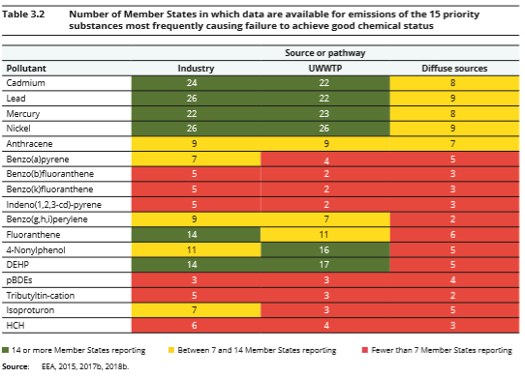
Table 1 From: EEA Report No 18/2018 Chemicals in European Waters (see footnote 25)

It was not possible to achieve a complete overview of all relevant pollutants within this project. We tried to focus on the most relevant pollutants as mentioned in Table 1, but could only include pollutants for which data were available. Relevant data on other pollutants was found when carrying out a literature check for different pathways. Monitoring data were found for many pollutants, particularly for the pathways P6, P7, P8 and P9. Pollutants most often described in the factsheets are metals and PAHs. For a small number of pesticides some data is included in the draft factsheets P1-P5.
The focus of this activity has been on the WFD priority substances, not nutrients. The ecological parameters total Nitrogen and total Phosphorus were therefore not included in the factsheets.

Factsheets per pathway
It was decided to make factsheets for the different pathways. These factsheets are enclosed as annexes to this paper.

A general structure has been used as format for the factsheets:

- Introduction
- Short description of the pathway
- Relation to other pathways (possible overlap)
- Main known (primary) sources behind the pathway
- Main pollutants
- Calculation methods
- Explanation of calculation method (often Emission = Activity Rate x Emission Factor)
- What activity rate can be used
- Available spatial distribution of the activity rate
- Or model results including data input, including short description of the model(s)
- Emission factors/concentrations of pollutants
- Overview of emission factors per pollutant
- Possible differences between MS when relevant
4 Conclusions
5 References to literature and other links

Due to differences between the pathways, not all paragraphs mentioned above are relevant for some of the pathways. In those cases, a modified format is used for the factsheet.

Without the use of detailed models, it was not possible to distinguish between pathways P2, P3, P4 and P5. Therefore, we combined these pathways in one factsheet. In the subgroup it was agreed that this factsheet needs further work, so it is marked as “DRAFT”. Also the factsheet P7 is not ready yet and is marked as “DRAFT”. It was agreed by the subgroup that factsheets for the other pathways to be sent to WG Chemicals as “finalised”. Of course, members of WG Chemicals may have suggestions for further improvements, and in future, these factsheets might be refined or extended with more pollutants.

Some remarks are needed for Pathway P13, Natural background. This is a kind of special pathway in the sense that natural background loads are also part of other pathways e.g. P1, P2-P5, P6 and P11. It is a relevant pathway, at least in some areas, and especially for metals, but isn’t easy to quantify. For metals, the CIS Technical Guidance Document for Implementing Metal Environmental Quality Standards (currently in preparation) includes a chapter on how to derive natural background concentrations.
Although not all pathways seem to be equally important for the selected pollutants, we tried to collect data for all pathways and did not deselect specific pathways à priori. For some pathways (like P5 and P12) no quantification of emissions has yet been calculated.

Follow-up

This paper and the factsheets of the different pathways will be input for the WFD CIS WG Chemicals October 2021 meeting. At this meeting it will be discussed how to proceed with the paper and other possible follow-up activities.

CIS WFD Guidance document No. 28 Preparation of Priority Substances Emission Inventory, EC 2012: https://circabc.europa.eu/sd/a/6a3fb5a0-4dec-4fde-a69d-ac93dfbbadd/Guidance%20document%20n28.pdf
Directive 2000/60/EC of the European Parliament and of the Council of 23 October 2000 establishing a framework for Community action in the field of water policy, OJ, No. L 327, p. 1 ff.
Roovaart, J., et al., 2013a/b, Diffuse water emissions in E-PRTR, Report No 1205118-000-ZWS0016/18, Deltares, Netherlands https://circabc.europa.eu/sd/a/dd20cdae-c76a-49b1-bf75-675c15a454d4/Diffuse%20water%20emissions%20in%20E-PRTR%202013%20background%20document.pdf
Roovaart, J. van den et al., 2016, E-PRTR completeness checks – water, ETC/ICM Technical Paper, version November 2016.
ETC/ICM Technical Report 3/2017 Emissions of pollutants to Europe’s waters: http://icm.eionet.europa.eu/ETC_Reports/EmissionsOfPollutantsToEuropeanWaters_SourcesPathwaysAndTrends
EEA Report No 18/2018 Chemicals in European Waters: https://www.eea.europa.eu/publications/chemicals-in-european-waters
EEA Report No 7/2018 European Waters, Assessment of status and pressures 2018: https://www.eea.europa.eu/publications/state-of-water
Regulation (EC) No. 166/2006 of the European Parliament and of the Council of 18 January 2006 concerning the establishment of a European Pollutant Release and Transfer Register and amending Council Directives 91/689/EEC and 96/61/EEC (Reg. (EC) No. 166/2006), OJ L 33, p. 1.
http://cdr.eionet.europa.eu/help/WISE_SoE/wise1
https://ec.europa.eu/environment/water/water-urbanwaste/index_en.html
Diffuse pollution, Degraded Waters, OECD 2017 https://www.oecd.org/environment/resources/Diffuse-Pollution-Degraded-Waters-Policy-Highlights.pdf
Damania, R. et al., Quality Unknown, The Invisible Water Crises, World Bank 2019 https://openknowledge.worldbank.org/handle/10986/32245
http://dd.eionet.europa.eu/datasets/latest/Emissions
EEA Report No 18/2018 Chemicals in European Waters: https://www.eea.europa.eu/publications/chemicals-in-european-waters
CIS WFD Guidance document No. 28 Preparation of Priority Substances Emission Inventory, EC 2012: https://circabc.europa.eu/sd/a/6a3fb5a0-4dec-4fde-a69d-ac93dfbbadd/Guidance%20document%20n28.pdf
V. Mohaupt, U. Sieber, J. van den Roovaart, C.G. Verstappen, F. Langenfeld and M. Braun, Diffuse sources of heavy metals in the Rhine basin, 2001, Water Science and Technology: https://iwaponline.com/wst/article/44/7/41/6428/Diffuse-sources-of-heavy-metals-in-the-Rhine-basin, https://doi.org/10.2166/wst.2001.0385
Roovaart, J., et al., 2013a/b, Diffuse water emissions in E-PRTR, Report No 1205118-000-ZWS0016/18, Deltares, Netherlands, https://circabc.europa.eu/sd/a/dd20cdae-c76a-49b1-bf75-675c15a454d4/Diffuse%20water%20emissions%20in%20E-PRTR%202013%20background%20document.pdf
http://prtr.ec.europa.eu/
Pulles, T. and D. Heslinga, The Art of Emission Inventorying, TNO: https://webdosya.csb.gov.tr/db/necen/editordosya/file/NEC/CollectER_Training/The_Art_of_Emission_Inventorying.pdf
https://www.igb-berlin.de/en/moneris
https://www.mdpi.com/2073-4441/9/4/239
https://weiss.vmm.be/
https://orbi.uliege.be/bitstream/2268/35224/1/Towards%20e_envi_ULG%20Aquapole%20Pegase%20paper_2009-03-26_vf.pdf
https://ec.europa.eu/eurostat/data/database
https://eur-lex.europa.eu/legal-content/EN/AUTO/?uri=celex:32008L0105
EEA Report No 18/2018 Chemicals in European Waters: https://www.eea.europa.eu/publications/chemicals-in-european-waters

