|  |  |
| --- | --- |
| **EEA/NSV/13/002 – ETC/ICM** |  |

Flood phenomena database – structure and assessment

Version: 3.0

Date: 14/07/2015

EEA activity: Floods and vulnerability

ETC/ICM task, milestone: 1.5.3.a, Milestone I

Prepared by / compiled by: ETC/ICM

Organisation: TC Vode

EEA project manager: Wouter Vanneuville

Version history

| Version | Date | Author | Status and description | Distribution |
| --- | --- | --- | --- | --- |
| 1.0 | 02/07/2015 | Luka Snoj (TC Vode),  Lidija Globevnik (TC Vode) | First draft for EEA | EEA, ETC |
| 2.0 | 09/07/2015 | Luka Snoj (TC Vode),  Lidija Globevnik (TC Vode),  Mathis Scholz (UFZ),  Henk Wolters (Deltares), Wouter Vanneuville (EEA) | Second draft for EEA | EEA, ETC, Eionet |
| 3.0 | 14/07/2015 | Luka Snoj (TC Vode),  Lidija Globevnik (TC Vode),  Mathis Scholz (UFZ),  Henk Wolters (Deltares), Wouter Vanneuville (EEA) | Final draft for EEA (public version) | EEA, ETC, Eionet |

Abbreviations

AKU: Anita Künitzer, ETC/ICM

HW: Henk Wolters, ETC/ICM

LS: Luka Snoj, ETC/ICM

LG: Lidija Globevnik, ETC/ICM

**MSC: Mathias Scholz, ETC/ICM**

**US: Ursula Schmedje**

**WV: Wouter Vanneuville, EEA**

Contents

1 Introduction 4

2 Flood phenomena database development 5

3 Flood phenomena datamodel 8

3.1 Flood phenomena – general characteristics 8

3.2 Flood phenomena – events & locations 12

3.3 Flood phenomena – impacts 14

3.4 Flood phenomena – country list 18

4 Assessment of flood phenomena in Europe since 1980 19

4.1 Flood phenomena by country 20

4.2 Fatalities caused by floods 20

Annex 1 Flood phenomena designation 22

Annex 2 Flood Severity assessment 23

Annex 3 Flood frequency - Hydrological magnitude of reported data 24

Annex 4 Fatalities and reported damage update using secondary data 25

# Introduction

Information on past flood events is the basis for a sound understanding of flood generating processes across Europe and for reliable predictions of future flood changes.

However, the Water Directors in 2009 concluded that a comprehensive and consistent overview of floods and their impacts was not available for Europe and that so far overviews of the impacts of floods throughout Europe were extracted from global databases. The incompleteness and sometimes incorrectness of these global databases was mentioned and the decision taken to create a European database on past floods.

In the EEA report (2010) on mapping the impact of natural hazards and technological accidents in Europe[1] one of the key conclusions on floods was:

*“Much information on flood events is available through global disaster databases. Nevertheless, the development of a comprehensive publicly available database of flood events and their impacts in Europe is desirable in order to strengthen disaster prevention at European level.”*

A survey in 2011 gave an overview of databases on floods and flood impacts available in different European countries, but made at the same time clear that the information could not simply be merged into one European dataset.

As EU Member States (for the EU Floods Directive[2]) had to report the preliminary flood risk assessments (PFRA) by 22/03/2012 to the European Commission, the Common Implementation Strategy for the Water Framework Directive Working Group on Floods commented that any efforts to create such a database could better wait until the PFRA reporting became available.

Since 2012, EEA, in collaboration with JRC and the European Topic Centres for “Climate Change Impact, Vulnerability and Adaptation” and “Inland, Coastal and Marine Waters” prepared several technical documents:

* Towards a potential European Flood Impact Database[3];
* What makes flood events significant for the European policies?[4]; and
* Historic flood events in Europe: European case studies based on the reporting under the Floods directive[5].

The amount of information increased significantly after the reporting of the PFRA (mainly on the impacts, although often not quantified or expressed in monetary terms) and the information was better structured due to the template imposed by the Floods Directive reporting schemas. Nevertheless the PFRA reporting in itself is insufficient to act as the single database on European floods and flood impacts. Some observations were that:

* some of the major events available in the global databases were not reported in the PFRA reporting (partly but not only because of use of art. 13§1b);
* the definition of a flood event was not clear (seen from the meteorology, hydrology or impacted area), leading to different areas of flooding and/or starting dates that probably have the same cause;
* the understanding of the impact categories as defined in the reporting template were not understood in the same way in all reported Member States’ assessments; and
* there were several potential inconsistencies.

In addition, floods are not bound to administrative boundaries and no information was available about non-EU European countries. In the end of 2014, the creation of a European flood impact database was still at the list of open issues for the Common Implementation Strategy for the Water Framework Directive and Floods Directive Working Group on Floods.

To create such a database, available flood data evidences were compiled and implemented with flood information provided by national authorities through consultation process. The outcome of these activities is new flood database that contains flood associated information on the European scale and leads to flood impact and location information.

# Flood phenomena database development

EEA is making an effort to compile European flood database with emphasis on characteristics such as flood severity, flood impacts, caused damage etc. Flood phenomena database compilation started from the Floods Directive (FD) reporting but went beyond including the evidence information for other countries in Europe[6] from global databases EM-DAT[7] and Dartmouth flood observatory (DFO)[8].

This document briefly describes flood phenomena database development, structure and provides some basic findings in regard to floods distribution and impacts. The most important data source which includes flood associated data for almost all EU Member States are data reported by the EU Member States under the Floods Directive (FD) reporting obligation of the preliminary flood risk assessment (PFRA)[9]. Besides the FD database, in the first place EM-DAT and in second place DFO databases[10] have also been used to supplement flood data reported under the FD with the data for countries which have not reported PFRA data into the FD database.

In February 2015, derived excel templates have been sent to 37 European countries for consultation, update and in order to obtain more flood information.

The majority of data sheets and fields have not been updated by countries since they have been directly derived either from the FD database and thus harmonized with national data. Updates have been mainly done on the topics which were not included in PFRA reporting as such (mostly associated with flood impacts on environment). In some cases, national authorities recognized EM-DAT and DFO data as incorrect and not harmonized with national data. Such data have been updated by countries participating in the task[11]. Beside FD, EM-DAT and DFO flood evidences, important flood associated information have thus been obtained directly by national authorities. Shares of data sources compiling flood phenomena database are visualized in Figure 1.

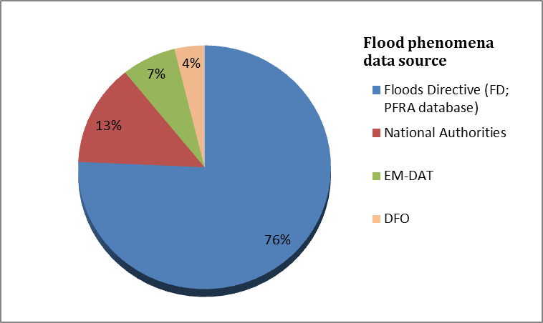

Figure : Shares of data sources compiling flood phenomena database.

Consultation with countries regarding flood phenomena data lasted until the end of May 2015. Upon the end of May, 26 countries have replied (Table 1); six countries have just confirmed the data accuracy (no new or updated data provided) while 20 countries have either updated selected attributes or reported new floods. Between February and May 2015 technical support and additional information have been provided by EEA and ETC/ICM to participating countries when needed. Delivered data have been aggregated to flood phenomena when necessary, quality assured, harmonized with the data reported by other data sources and compiled into a common database. The final past flood phenomena database comprises data reported and recorded between 1980 and 2015

Table : Countries actively participating in the data consultation.

|  |  |
| --- | --- |
| **Country** | **New/updated data provided** |
| Austria | No |
| Belgium | Yes |
| Bosnia and Herzegovina | Yes |
| Bulgaria | Yes |
| Cyprus | No |
| the Czech Republic | Yes |
| Denmark | Yes |
| Estonia | Yes |
| Finland | Yes |
| the former Yugoslav Republic of Macedonia | Yes |
| Germany | No |
| Greece | Yes |
| Hungary | Yes |
| Ireland | Yes |
| Kosovo (under UNSCR 1244/99) | Yes |
| Latvia | Yes |
| Lithuania | No |
| the Netherlands | Yes |
| Norway | Yes |
| Poland | Yes |
| Portugal | Yes |
| Romania | No |
| Spain | No |
| Sweden | Yes |
| Switzerland | Yes |
| Turkey | Yes |
| United Kingdom | No |

# Flood phenomena datamodel

Flood Phenomena database is composed of four relational tables (Figure 2) which consists of Floods Directive (PFRA), EM-DAT and DFO data as well as data reported by national authorities to the EEA.

Considering the large number of past flood events (more than 15 000 events have been reported since the year 1000) compiled into the FD database, just the events which have occurred since 1980 have been kept in the final flood phenomena database[12].

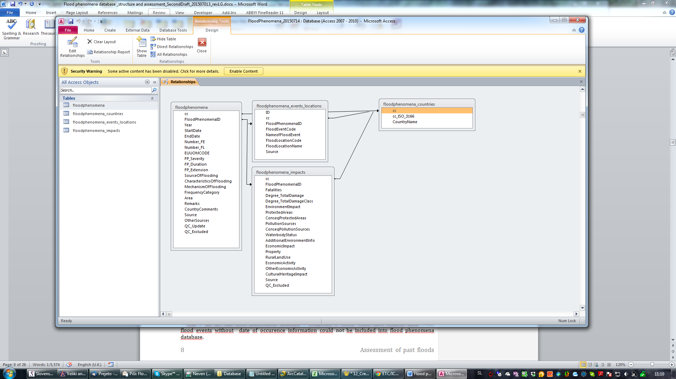

Figure : Flood phenomena data model.

Data structure and attributes are described for each table in the chapters below.

## Flood phenomena – general characteristics

The “floodphenomena” table provides general flood information such as flood duration, severity, and extension, aggregated on Flood phenomena (FP) level. Flood events as reported by countries under Flood Directive (PFRA) or by national authorities, were in many cases not reported as singular hydrological flood phenomena but rather as numerous floods within the same (or overlapped) time periods. To harmonize data reported by countries, such events had to be aggregated into groups where each group presents distinct meteorological situation which we understand as flood phenomenon. Flood phenomenon can occur on several, spatially separated locations within one or many river basins. Its extent is constrained with country borders. Flood phenomena were distinguished by grouping the events with the same or overlapped time periods into a singular unit. More information regarding flood phenomena designation procedure are given in Annex 1.

Structure, methodology and specification of data included in “floodphenomena” table are described in Table 2.

Table : “Floodphenomena” data dictionary.

|  |  |  |  |
| --- | --- | --- | --- |
| **Name** | **Definition** | **Methodology** | **Specifications** |
| **cc**  (CountryCode) | Country code. | Country code provided either by the national authorities or defined by ETC/ICM. | Datatype: String  Length: 2 |
| **FloodPhenomenaID (*)**  (FloodPhenomenaID) | Flood phenomena identification code. | Unique code assigned to every flood phenomena unit. First two characters of the code are equal to country code, while 4-13 characters are equal to phenomena “StartDate” (as reported in FD, EM-DAT or DFO databases). If beginning of flood phenomena is not known, “StartDate” is replaced with “FloodEventCode” as reported in FD database. | Datatype: String  Length: 80 |
| **Year**  (Year) | Year of flood phenomena occurrence. | Year of flood phenomena occurrence (time period 1980-2015). | Datatype: Integer  Minimum inclusive value: 1980  Maximum inclusive value: 2015 |
| **StartDate**  (StartDate) | Beginning of flood phenomena. | Attribute is equal to start date of the oldest flood event in flood phenomena group or to flood beginning as reported either in national deliveries or EM-DAT and DFO databases.    Format: “YYYY-MM-DD” | Datatype: Date |
| **EndDate**  (EndDate ) | Flood phenomena end date. | Attribute is equal to end date of the youngest flood event in flood phenomena group or to flood end date as reported either in national deliveries or EM-DAT and DFO databases.  Format: “YYYY-MM-DD” | Datatype: Date |
| **Number_FE**  (NumberOfFloodEvents) | Number of flood events in flood phenomena group. | Count of all flood events (FD) within flood phenomena group.  If flood phenomena data source is EM-DAT or DFO the field is empty. | Datatype: Integer |
| **Number_FL**  (NumberOfFloodLocations) | Number of flood locations in flood phenomena group | Count of all flood locations (FD) within flood phenomena group.  If flood phenomena data source is EM-DAT or DFO, the field is empty. | Datatype: Integer |
| **EUUOMCODE**  (EUUnitOfManagementCode) | EU unit of management code. | List of EU units of management grouped in flood phenomena group.  If flood phenomena data source is EM-DAT or DFO and have not been updated by national authorities the field is empty. | Datatype: String  Length: 255 |
| **FP_Severity** (FloodPhenomenaSeverity) | Flood phenomena severity. | Assessment of flood phenomena magnitude considering the values on flood frequency, damage category, number of flood events within one flood phenomena and severity classes as reported in DFO database.  Flood severity assessment procedure description is given in Annex 2. | Datatype: String  Length: 15 |
| **FP_Duration** (FloodPhenomenaDuration) | Flood phenomena duration. | Duration expressed as day difference between flood phenomena “StartDate” and “EndDate”.  If the Start and End date values are not reported, data on duration is empty. | Datatype: Integer |
| **FP_Extension** (FloodPhenomenaExtension) | Flood phenomena extension. | Flood phenomena extension assessed and reported by national authorities.  Extension codelist:  -Local;  -Regional;  -National;  -International. | Text codelist:  see methodology field  Length: 20 |
| **SourceOfFlooding** (SourceOfFlood) | Source of flooding. | Sources of flooding (FD) aggregated on flood phenomena.  Flooding sources codelist:  -Fluvial;  -Pluvial;  -Groundwater;  -Sea Water;  -Artificial Water-Bearing Infrastructure;  -Other.  If flood phenomena data source is EM-DAT or DFO the field is empty. | Text codelist:  see methodology field  Length: 255 |
| **CharacteristicsOfFlooding**  (CharacteristicsOfFlooding) | Characteristics of flooding. | Characteristics of flooding (FD) aggregated on flood phenomena.  Flood characteristics codelist:  -Flash flood;  -Snow melt flood;  -Other rapid onset;  -Medium onset flood;  -Slow onset flood;  -Debris flow;  -High velocity flow;  -Deep flood;  -Other.  If flood phenomena data source is EM-DAT or DFO the field is empty. | Text codelist:  see methodology field  Length: 255 |
| **MechanismOfFlooding** (MechanismOfFlooding) | Mechanism of flooding. | Mechanisms of flooding (FD) aggregated on flood phenomena.  Flood mechanisms codelist:  -Natural exceedance;  -Defence exceedance;  -Defence or Infrastructural Failure;  -Blockage / Restriction;  -Other.  If flood phenomena data source is EM-DAT or DFO the field is empty. | Text codelist:  see methodology field  Length: 255 |
| **FrequencyCategory** (FrequencyCategory) | Flood phenomena return period. | This field consist of aggregated FD, EM-DAT and DFO frequency and recurrence data.  Frequency codelist :  -Very Rare;  -Rare;  -Frequent.  Frequency classification procedure is described in Annex 3. | Text codelist:  see methodology field  Length: 50 |
| **Area**  (Area) | Flood phenomena area. | Extent by the flood inundated land in km2. Field value equals to sum of reported flood events areas within flood phenomena[13]. | Datatype: Decimal  Unit: km2 |
| **Source**  (Source) | Primary flood data source. | Default (primary) flood data source.  Available data sources:  -FD;  -National Authorities;  -EM-DAT;  -DFO. | Datatype: String  Length: 40 |
| **OtherSources**  (OtherSources) | Secondary flood data sources. | List of secondary data sources (used to update “Fatalities” and “Degree_TotalDamage” in cases when they were not reported by Member States into FD database).  Fatalities and damage update procedure is description is given in Annex 4. | Datatype: String  Length: 250 |

*used for primary key

## Flood phenomena – events & locations

Table “floodphenomena_events_locations” provides links from flood phenomena unit to flood events as reported in FD database. Distinct flood phenomena can be composed of one or numerous flood events (Table 3). Relation between “Floodphenomena” table (field “FloodPhenomenaID”) and “floodphenomena_events_locations” (field “FloodEventCode”) is therefore one to many.

Flood phenomena – events & locations table can be also used for visualizing flood phenomena or flood events by linking flood location codes (field “FloodLocationCode”) with corresponding spatial data reported by EU Member States under Flood Directive (PFRA).

The table includes also information associated with names and locations where floods occurred.

Table : “Floodphenomena_events_locations” data dictionary.

|  |  |  |  |
| --- | --- | --- | --- |
| **Name** | **Definition** | **Methodology** | **Specifications** |
| **ID(*)**  (IdentificationNumber) | Identification number. | Generic identification number applied to every flood record listed in events & locations table. | Datatype: Integer |
| **cc**  (CountryCode) | Country code. | Country code provided either by the national authorities or defined by ETC/ICM. | Datatype: String  Length: 2 |
| **FloodPhenomenaID**  (FloodPhenomenaID) | Flood phenomena identification code. | Unique code assigned to every flood phenomena unit. First two characters of the code are equal to country code, while 4-13 characters are equal to phenomena “StartDate” (as reported in FD, EM-DAT or DFO databases). If beginning of flood phenomena is not known, “StartDate” is replaced with “FloodEventCode” as reported in FD database. | Datatype: String  Length: 80 |
| **FloodEventCode** (FloodEventCode) | Flood event identification code. | Unique code for the flood event - up to 40 characters in total (as reported under FD).  Field is empty for DFO and EM-DAT data. | Datatype: String  Length: 40 |
| **NameofFloodEvent**  (NameofFloodEvent) | Name of flood event. | Name of flood event as reported under FD.  Field is empty for DFO and EM-DAT data. | Datatype: String  Length: 250 |
| **FloodLocationCode**  (FloodLocationCode) | Flood location code. | Unique code for the flood location. Can also be used as a identifier for multiple  surface water bodies designated under the WFD which the flood location is represented by (as reported under FD).  It can be linked with corresponding PFRA spatial data (points, polylines or polygons).  Field is empty for DFO and EM-DAT data. | Datatype: String  Length: 40 |
| **FloodLocationName**  (FloodLocationName) | Flood location name | Name of the locality, river basin, sub-basin and/or coastal area or other areas associated with the flood. | Datatype: String  Length: 250 |
| **Source** (Source) | Primary flood data source. | Default (primary) flood data source.  Available data sources:  -FD;  -National Authorities;  -EM-DAT;  -DFO. | Datatype: String  Length: 40 |

*used as primary key.

## Flood phenomena – impacts

Flood impacts on economic activities, environment, cultural heritage and human health have been reported within PFRA reporting. Impact information such as damage in monetary values and fatalities caused by floods are also provided within EM-DAT and DFO databases. Database consultation carried out in spring 2015 has shown that relatively little is known about environmental impacts of flooding.

Table “floodphenomena_impacts” stores flood impact associated information. All the data are aggregated on flood phenomena level.

Table : “floodphenomena_impacts” data dictionary

|  |  |  |  |
| --- | --- | --- | --- |
| **Name** | **Definition** | **Methodology** | **Specifications** |
| **cc**  (CountryCode) | Country code. | Country code provided either by the national authorities or defined by ETC/ICM. | Datatype: String  Length: 2 |
| **FloodPhenomenaID (*)**  (FloodPhenomenaID) | Flood phenomena identification code. | Unique code assigned to every flood phenomena unit. First two characters of the code are equal to country code, while 4-13 characters are equal to phenomena “StartDate” (as reported in FD, EM-DAT or DFO databases). If beginning of flood phenomena is not known, “StartDate” is replaced with “FloodEventCode” as reported in FD database. | Datatype: String  Length: 80 |
| **Fatalities**  (Fatalities) | Fatalities caused by the flood. | Number of fatalities caused by floods. Data reported under FD equals to sum of reported flood events fatalities within flood phenomenon[14]. | Datatype: Integer |
| **Degree_TotalDamage** (Degree_TotalDamage) | Total damage cost in Euros caused by the flood | Number of total damage caused by floods.  Data reported under FD equals to sum of reported flood events fatalities within flood phenomenon[15]. The currency with the exchange rate (1 USD= 0.79 €) from 2014-10-13 was applied to EM-DAT and DFO damage data reported in $. More information regarding total damage costs are given in Annex 4. | Datatype: Decimal |
| **Degree_TotalDamageClass** (Degree_TotalDamageClass) | Total damage defined by classes. | Total damage defined by classes. If more than one category (e.g. VeryHigh, Low) was assigned to one Flood Phenomenon the most severe category was obtained (e.g. VeryHigh).  Damage codelist:  -VeryHigh;  -High;  -Low;  -Medium;  -Insignificant. | Text codelist:  see methodology field  Length: 50 |
| **EnvironmentImpact** (EnvironmentImpact) | Flood consequences on environment. | Types of flood consequences on environment as reported by countries under FD.  Environmental impacts codelist:  -Environment Overall,  -Pollution Sources,  -Protected Areas,  -Waterbody Status,  -Other Environmental Impacts  More than one category can be assigned to one flood phenomenon.  Field is empty for DFO and EM-DAT data. | Datatype: String  Length: 255 |
| **ProtectedAreas** (ProtectedAreas) | Floods on protected areas. | Floods on protected areas (data provided by national authorities during database update and consultation).  Protected areas codelist:  -BathingWaters;  -DrinkingWater;  -SensitiveArea–UWWTD;  -NatureProtectedAreas;  -Combination;  -None. | Text codelist:  see methodology field  Length : 30 |
| **ConseqProtectedAreas**  (ConseqencesProtectedAreas) | Negative consequences to protected areas. | Level of negative consequences to protected areas (affected protected areas were identified in field “ProtectedAreas”).  Negative consequences to protected areas codelist:  -High;  -Medium;  -Low;  -NotRelevant.  Data provided by national authorities during database update and consultation. | Text codelist:  see methodology field  Length: 20 |
| **PollutionSources**  (PollutionSources) | Floods on potential pollution sources. | Floods on potential pollution sources (data provided by national authorities during database update and consultation).  Pollution sources code list:  -Point or Diffuse;  -IPPC;  -Seveso;  -IPPC and Seveso;  -None. | Text codelist:  see methodology field  Length: 20 |
| **ConseqPollutionSources** (ConseqencesPollutionSources) | Consequences on pollution sources. | Negative consequences on pollution sources (affected pollution sources were identified in field “PollutionSources”).  Consequences on pollution sources code list:  -Yes;  -No.  Data provided by national authorities during database update and consultation. | Boolean codelist:  see methodology field  Length: 5 |
| **WaterbodyStatus** (WaterbodyStatus) | Consequences on water body status. | Consequences on ecological or chemical water body status (data provided by national authorities during database update and consultation).  Water body status code list:  -NegativeHigh;  -NegativeMedium;  -NegativeLow;  -PositiveEffect;  -NotRelevant. | Text codelist:  see methodology field  Length: 20 |
| **AdditionalEnvironmentInfo** (AdditionalEnvironmentInformation) | Additional environment information. | Other flood consequences on environment or additional information regarding protected areas, pollution sources and water bodies (data provided by national authorities during database update and consultation). | Datatype: String  Length: 100 |
| **EconomicImpact** (EconomicImpact) | Flood consequences on economy. | Types of flood consequences on environment as reported by countries under FD.  Economic impact codelist:  - Economic Overall;  - Infrastructure;  - Property;  - Rural Land Use;  - Economic Activity;  - OtherEconomicActivity.  More than one category can be assigned to one flood phenomenon.  Field is empty for DFO and EM-DAT data. | Datatype: String  Length: 100 |
| **Property** (Property) | Negative consequences to property. | Level of negative consequences to property (including homes). Data provided by national authorities during database update and consultation.  Property code list:  -High;  -Medium;  -Low;  -NotRelevant. | Text codelist:  see methodology field  Length: 20 |
| **RuralLandUse** (RuralLandUse) | Consequences to rural land use. | Level of negative consequences to uses of the land (data provided by national authorities during database update and consultation).  Rural land use code list:  -High;  -Medium;  -Low;  -NotRelevant. | Text codelist:  see methodology field  Length: 20 |
| **EconomicActivity** (EconomicActivity) | Consequences to sectors of economic activity. | Level of negative consequences to sectors of economic activity (data provided by national authorities during database update and consultation).  Economic activity code list:  -High;  -Medium;  -Low;  -NotRelevant. | Text codelist:  see methodology field  Length: 20 |
| **OtherEconomicActivity** (OtherEconomicActivity) | Other flood consequences on economic sectors. | Other flood consequences on economic sectors or additional information regarding property, rural land use and affected economic activities. | Datatype: String  Length: 100 |
| **CulturalHeritageImpact** (CulturalHeritageImpact) | Flood consequences on cultural heritage. | Types of flood consequences on cultural heritage as reported by countries under FD.  Cultural heritage code list:-Cultural Heritage;  -Cultural Assets;  -Landscape;  -Other.  Field is empty for DFO and EM-DAT data. | Datatype: String  Length: 100 |
| **Source**  (Source) | Primary flood data source. | Default (primary) flood data source.  Available data sources:  -FD;  -National Authorities;  -EM-DAT;  -DFO. | Datatype: String  Length: 40 |

*used as primary key.

## Flood phenomena – country list

List of countries included into flood phenomena database (“floodphenomena_countries”).

Table : “floodphenomena_countries” data dictionary.

|  |  |  |  |
| --- | --- | --- | --- |
| **Name** | **Definition** | **Methodology** | **Specifications** |
| **cc\***  (CountryCode) | Country code as reported by participating countries or defined by ETC/ICM. | Country code provided either by the national authorities or defined by ETC/ICM. | Datatype: String  Length: 2 |
| **cc_ISO_3166**  (CountryCodeISO) | Country code. (ISO 3166-alpha-2 code elements). | ISO 3166-alpha-2 country code. | Datatype: String  Length: 2 |
| **CountryName**  (CountryName) | Country name. | Full country name. | Datatype: String  Length: 255 |

*used as primary key.

# Assessment of flood phenomena in Europe since 1980

Between 1980 and 2010, 3552 distinct flood phenomena (floods) were evidenced in 37 European countries. As shown on Figure 3, the number of floods after 1995 is higher each year than before. These evidences may lead to conclusion that t flood frequencies in Europe are steadily increasing.

The ratio between actual increase of extreme hydrological situations and changes in flood information tracking, storing and management is however not known, neither does the number of events say something about their severity. Upward trends in their number may also be explained by better reporting of small loss events. On the other hand, according to IPCC, increasing exposure of people and economic assets has been the major cause on a global scale of long-term increases in economic losses from weather- and climate-related disasters such as floods[16].

The highest number of floods is reported for the year 2010, when 321 floods are included in the database, all together in 27 countries. This number is associated with so called Central European floods which occurred across several central European countries during May and June 2010. Poland was the most affected[17], Germany, Slovakia, Hungary, Republic of Serbia, Bulgaria, France and other countries were affected as well.

Figure : Flood phenomena between 1980 and 2010.

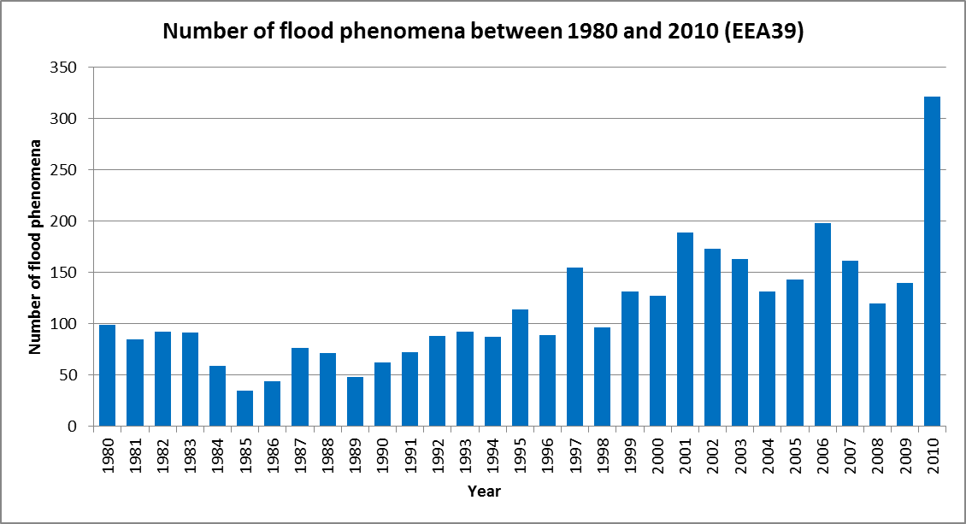

## Flood phenomena by country

If the number of derived significant flood phenomena is weighted with respect to country areas, Slovenia (54 flood phenomena per 10 000 km2 since 1980), Bulgaria (31 flood phenomena per 10 000 km2 since 1980), Luxembourg (31 flood phenomena per 10 000 km2 since 1980) and Poland (16 flood phenomena per 10 000 km2 since 1980) are the most flood affected countries (Map 1).

Finland, Sweden, Iceland and Latvia are less affected by significant floods considering their extent and number of past floods included in the database. In these countries, less than one significant flood phenomenon per 10 000 km2 has occurred since 1980.

Map : Flood phenomena per country (since 1980)

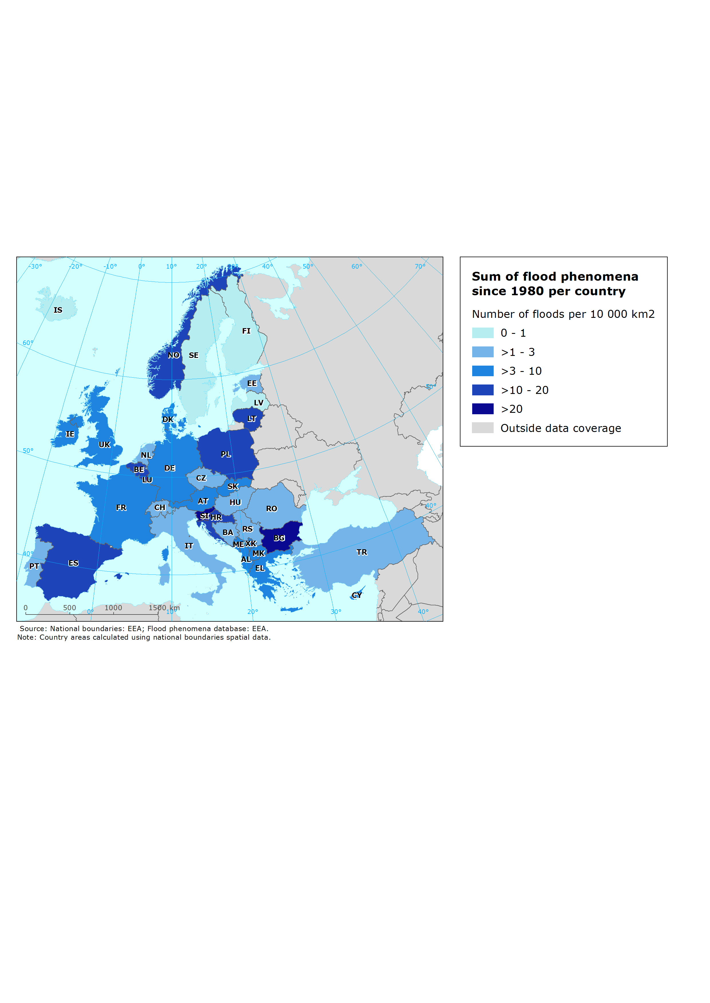

## Fatalities caused by floods

Since 1980, almost 5 000 people have died in Europe due to the floods. Out of 39 countries, fatalities caused by floods are reported by 27 countries. In Switzerland, Cyprus, Croatia, Hungary, Luxembourg, Finland, Sweden, Iceland, Latvia and the Netherlands floods have either caused no fatalities since 1980 or the data on fatalities are not available. The greatest absolute number of fatalities is significant for Turkey where more than 1 400 people have died due to floods since 1980 (more than half just during 36 flood phenomena which have occurred in 1990, 1991, 1992, 1995 and 1998).

The years 1997 (428 fatalities), 1998 (422 fatalities) and 1995 (368 fatalities) are the ones with the highest number of fatalities caused by floods in EEA member and cooperating countries (Figure 4).

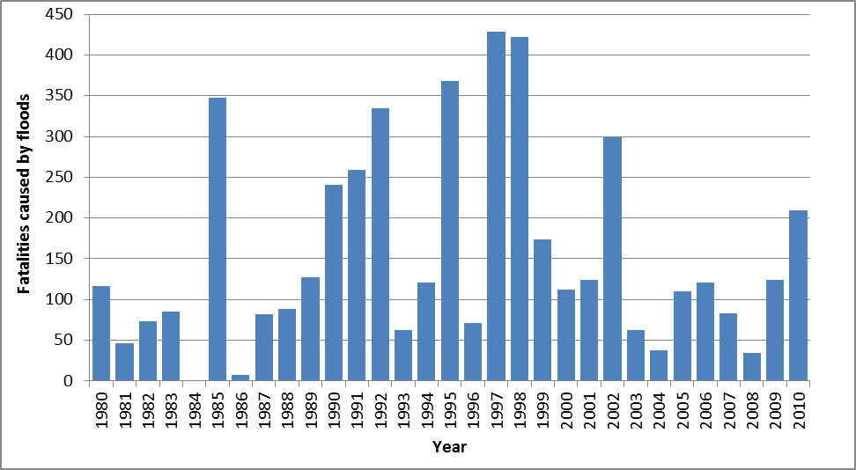

Figure : Fatalities caused by floods since 1980 in Europe.

If the fatalities numbers are weighted with respect to national total population figures (Map 2) the highest numbers of fatalities caused by floods is recorded for Bosnia and Herzegovina (38 fatalities per 1 million inhabitants) where just floods which occurred in 1989 caused more than 70 fatalities.

In Turkey, Romania, Spain, Portugal, Italy, the Czech Republic, Slovakia and Montenegro the number of fatalities per 1 million inhabitants caused by floods exceeds 10 fatalities per 1 million inhabitants.

Map : Fatalities caused by floods since 1980.

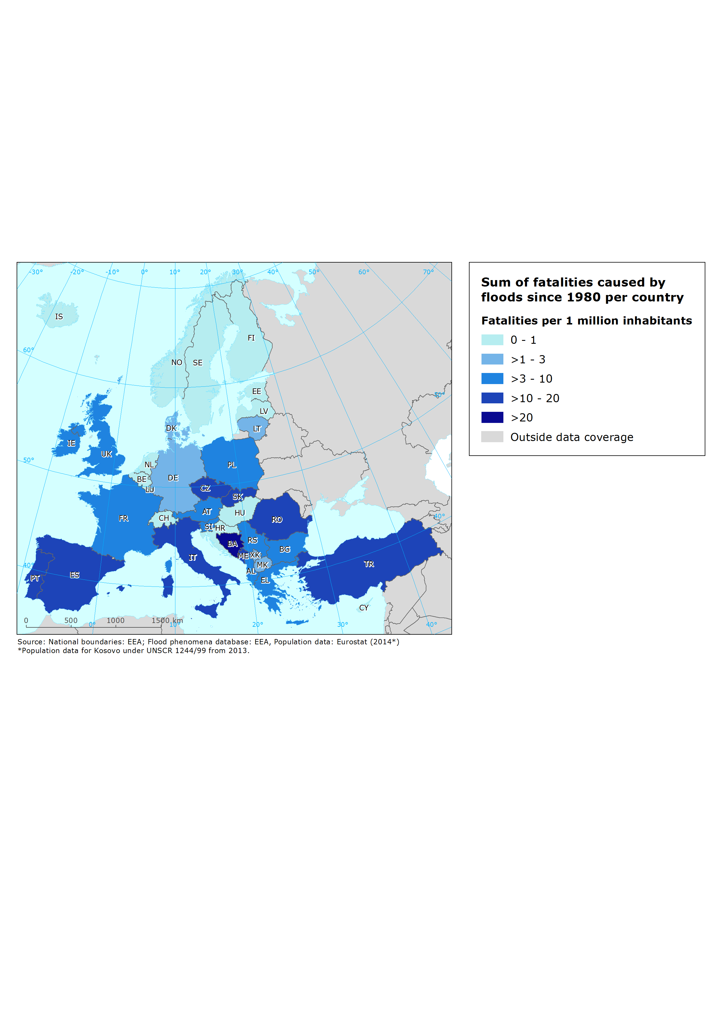

# Annex 1 Flood phenomena designation

Flood events as reported by countries in the PFRA were united into groups where each group presents a distinct hydrological phenomenon. Such units were distinguished by grouping the events with the same or overlapping time periods into a singular unit named flood phenomena.

Flood phenomena unit was designated by ETC/ICM using the following methodology:

1. All flood events with overlapping duration periods within one country were grouped into the same flood phenomena unit (red circle on the picture below).
2. Flood events for which the time period is not overlapping with any other flood events are treated as flood phenomena which consist of exactly one flood event (blue circle on the picture below.
3. Flood events with unknown start date are remaining singular events and are treated as flood phenomena which consist of not more than one flood event.
4. If a flood event (FE6 on the picture below) started and ended within the duration of another flood event (FE7 on the picture below), they were grouped into the same flood phenomena.
5. Flood events with known start date but unknown duration and end date were treated as flood events with a duration period equal to one day. If their time extent overlapped with other flood events they have been grouped into the same flood phenomena.

Aggregations to flood phenomena were possible just for the flood events with reported date of flood occurrence. It has been noticed and in some cases also emphasized by national authorities that even more aggregations from flood event to flood phenomena can be made. Such aggregations can be specified only by national authorities.[18] Flood phenomenon in many cases consists of more than one flood event. In such cases corresponding attributive data such as fatalities and damage have also been grouped / summed up. No data aggregations have been performed on EM-DAT and DFO flood data since flood duration periods within these databases are not overlapping[19].

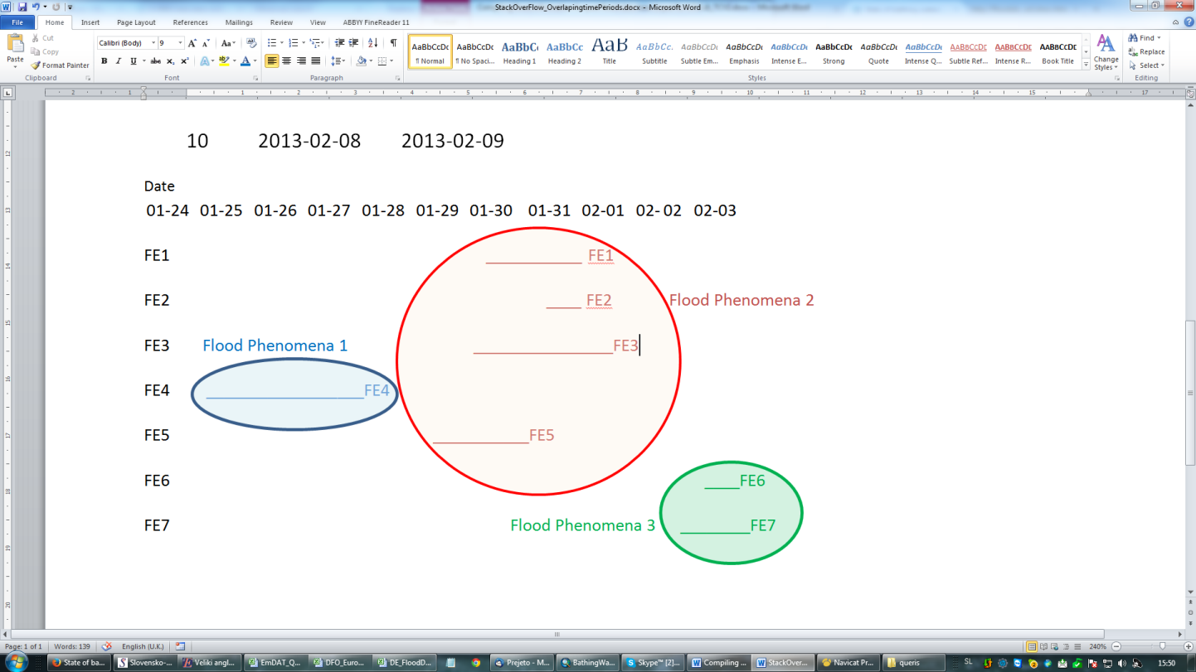

Figure : Flood phenomena aggregation scheme.

# Annex 2 Flood Severity assessment

Flood severity is the ETC/ICM assessment of flood phenomena magnitude. It considers the reported values on frequency, reported total damage (in € and categorical), number of flood events within one flood phenomena unit and severity classes as reported in *DFO* database. To each flood phenomenon, one of three severity categories (Very High, High, Moderate) was applied.

Flood phenomena severity criteria conditions used for severity assessment are listed in Table 6.

Table : Flood Severity Conditions.

|  |  |
| --- | --- |
| **Severity level** | **Conditions** |
| **Very High** | Number of reported flood events is bigger than nine **OR** |
| Frequency is assessed as “Very Rare” **OR** |
| Degree total damage class is reported as “High” or “Very High” **OR** |
| Severity class in DFO database is equal to 2* **OR** |
| Severity class in DFO database is equal to 1.5** **OR** |
| Reported fatalities are bigger than 0. |
| **High** | Flood phenomena severity was not assessed as “Very High” **AND** |
| Number of reported flood events is bigger than 0 but lower than 10 **OR** |
| Frequency is assessed as “Rare” **OR** |
| Degree total damage class is reported as “Medium” **OR** |
| Severity class in DFO database is equal to 1*** |
| **Moderate** | Flood phenomena which Severity level did not comply with “Very High” or “High” conditions, were assessed as “Moderate” |

*Extreme events with an estimated recurrence interval greater than 100 years.

**Estimated recurrence interval is greater than 20 years but shorter than 100 years and/or a local recurrence interval of at 10-20 years.

***1-2 decades-long reported interval since the last similar event and/or significant damage to structures or agriculture.

# Annex 3 Flood frequency - Hydrological magnitude of reported data

Hydrological magnitude of reported events is in the FD database reported either as **frequency** (“the statistical prediction of years between certain flood magnitude events” as written in FD reporting guidance) or/and recurrence interval (“the average number of years between floods of a certain size”). The data on “frequency” and “recurrence” were by Member States reported as numbers, ranges or text.

In order to harmonize frequency information, data have been grouped into three categories (**Frequent, Rare** and **Very Rare**) which reflect the hydrological magnitude of the reported floods (Table 7). Derived categories are stored in flood phenomena database (field “FrequencyCategory”).

Table : Flood frequency categorization (derived from frequency and recurrence descriptive categories)

|  |  |  |  |
| --- | --- | --- | --- |
| **Category** | **Frequent** | **Rare** | **Very Rare** |
| Range | 0-10 years | 11-50 years | >50 years |

Due to the fact flood phenomena in many cases consist of more than one flood event, numerous distinct flood event frequencies can be assigned to one flood phenomenon. In such cases “FrequencyCategory” was assessed by the following rules:

* If “FrequencyCategory” of at least one flood event within flood phenomenon was assessed as “Very Rare”, flood phenomenon frequency was assessed as “Very Rare”.
* If “FrequencyCategory” of at least one flood event within flood phenomenon was assessed as “Rare” and no flood event within flood phenomenon was assessed as “Very Rare”, flood phenomenon frequency was assessed as “Rare”.
* If “FrequencyCategory” of at least one flood event within flood phenomenon was assessed as “Frequent” and no flood event within flood phenomenon was assessed as “Very Rare” or “Rare”, flood phenomenon frequency was assessed as “Frequent”.

# Annex 4 Fatalities and reported damage update using secondary data

When data on fatalities (“Fatalities”) and reported damage (“Degree_TotalDamage”) have not been reported into FD database, it was updated with EM-DAT and DFOdatabases[20] when possible. Update has been performed by the following procedure:

* If data on fatalities or reported damage (€) is not available in FD and the flood phenomenon match[21] is found in EM-DAT, data from EM-DAT is kept.
* If data on fatalities or reported damage (€) is not available in FD or EM-DAT databases and the flood phenomenon match[22] is found in DFO database, data from DFO is kept.
* Derived tables (updated with secondary data) have been sent to national authorities for update and consultation. If national authorities have disagreed with the updated values, the updated value were either deleted from the database or updated with the new values provided by national authorities.

There are 28 flood phenomena in FD database which overlap with more than one flood reported in EM-DAT or DFO databases. In such cases, number of reported fatalities or damage was proportionally distributed between two or more flood phenomena according to flood phenomena duration (Table 8).

Table : Example of proportionally distributed damage values between two flood phenomena.

|  |  |  |  |
| --- | --- | --- | --- |
| **FD** | **Cc** | XX | XX |
| **FloodPhenomenaID** | XX-1997-07-07 | XX-1997-07-18 |
| **StartDate** | 5.7.1997 | 18.7.1997 |
| **EndDate** | 9.7.1997 | 19.7.1997 |
| **FP_Duration** | 4 | 1 |
| **Degree_TotalDamage** | / | / |
| **Updated damage value (EM-DAT)** | 110 827 920  (80% of 138 534 900) | 27 706 980  (20% of 138 534 900) |
| **EM-DAT** | **FloodPhenomenaID_EM** | XX-1997-07-08 | XX-1997-07-08 |
| **StartDate** | 8.7.1997 | 8.7.1997 |
| **EndDate** | 22.7.1997 | 22.7.1997 |
| **Damage** | 138534900 | 138534900 |

Primary data source in regard to flood phenomena data is kept in field “Source” while secondary sources which were used to update primary source missing data are listed in field “OtherSources”.

1. <http://www.eea.europa.eu/publications/mapping-the-impacts-of-natural>
2. <http://eur-lex.europa.eu/legal-content/EN/TXT/?uri=CELEX:32007L0060> (PFRA reporting; articles 4 & 5)
3. <http://cca.eionet.europa.eu/reports/EEA_JRC_ETC-CCA%20JTP>
4. <http://cca.eionet.europa.eu/reports/TP_4-2013>
5. <http://icm.eionet.europa.eu/ETC_Reports/HistoricFloodEvents_version_20140620>
6. The exercise is made for all 39 EEA member countries and cooperating countries (<http://www.eea.europa.eu/about-us/countries-and-eionet/intro>), however for Malta and Liechtenstein no flood related records were available in the global databases.
7. http://www.emdat.be/database
8. http://floodobservatory.colorado.edu/Archives/index.html
9. The PFRA master database (June 2013) have been used for these purposes.
10. Where information from the floods directive (FD) reporting was not available, a check of the EM-DAT database was made to complement the missing information where possible. For the remaining fields where no information was in the FD reporting, neither EM-DAT a check of DFO database was done. In the flood phenomena database it is made clear where the information included is coming from.
11. Deletion of EM-DAT and DFO flood records not corresponding with national flood data or already reported into FD database (but with different duration period) have been proposed by national authorities in some cases.
12. Due to the fact that flood phenomena database is composed of floods which have occured since 1980, flood events without date of occurence information could not be included into flood phenomena database.
13. Area data for flood phenomena which contain more than one flood event is in some cases most probably underestimated as only values for some events grouped into the phenomenon are available.
14. Number of fatalities applied to flood phenomena which contain more than one flood event is in some cases most probably underestimated as only values for some events grouped into the phenomenon are available.
15. Damage figures applied to flood phenomena which contain more than one flood event is in some cases most probably underestimated as only values for some events grouped into the phenomenon are available.
16. IPPC, 2012. Managing the Risks of Extreme Events and Disasters to Advance Climate Change Adaptation, [http.: https://www.ipcc.ch/pdf/special-reports/srex/SREX_Full_Report.pdf](http.:%20https://www.ipcc.ch/pdf/special-reports/srex/SREX_Full_Report.pdf)
17. More than 20 people lost their lives, approx. 3400 km2 of land have been inundated by the floods, total damage cost by floods have been assessed to more than 2 billion Euro.
18. During the country consultation some countries proposed additional flood event aggregations for the floods with not reported date of occurrence. Additional aggregations were performed in accordance with proposal.
19. More information regarding data compilation are provided in chapter 2.
20. Since reported damage is in EM-DAT and DFO database reported as USD ($), the values were converted into euros (€). The currency with the exchange rate (1 USD= 0.79 €) from 13-10-2014 was applied. Source of the currency exchange rate is European Central Bank.
21. Flood phenomena matches between EM-DAT and FD databases were identified with a search based on overlapped flood duration periods between analysed databases.
22. Flood phenomena matches between DFOand FD databases were identified with a search based on overlapped flood duration periods between analysed databases.