Water scarcity conditions in Europe
Last update 29/06/2022 – Frequency (every 2 years)

Summary
Water scarcity arises when the demand for water exceeds the volume of renewable freshwater available. It affected 16 % of the EU-27 territory and 26 % of its population nearly all year round in 2019. Although water abstraction declined by 15 % in the EU-27 between 2000-2019, no explicit downward trend is observed in water scarcity conditions. Water scarcity is an issue affecting areas all across the EU. Climate change exacerbates the natural fluctuations in seasonal water availability, resulting in increased frequency, intensity and impacts of drought events.

EU level

Figure 1.
Worst water scarcity conditions for European river basins in any quarter of 2019, as measured by using the water exploitation index plus (WEI+)

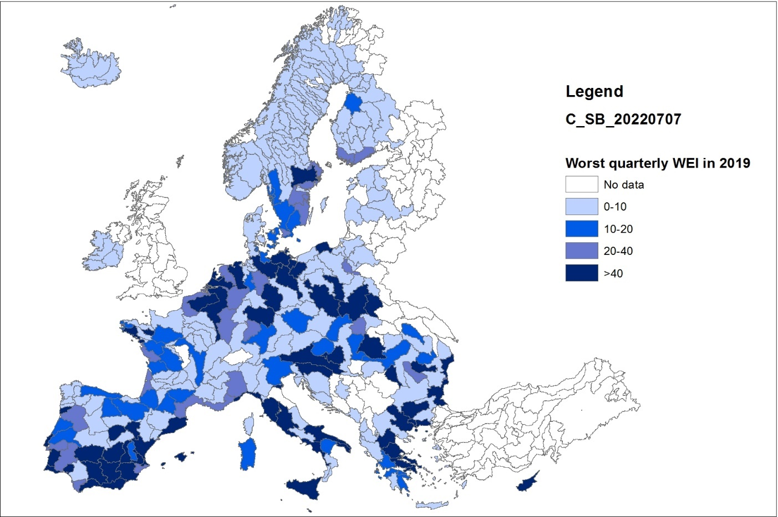

Notes:
- WEI+ illustrates the percentage of water consumption against renewable freshwater resources available for a given territory and period.
- This map gives an overview of the worst seasonal water scarcity conditions (maximum seasonal WEI+) in any quarter of 2019 across river basin in Europe. Seasonal WEI+ values are estimated as quarterly averages per river basin, as defined in the European Catchments and Rivers Network System (Ecrins).
- Annual quarters are: Q1 (January-March), Q2 (April-June), Q3 (July-September), Q4 (October-December)

Data sources:
- Waterbase — Water Quantity provided by the European Environment Agency (EEA, 2021).
- European Catchments and Rivers Network System (Ecrins) provided by the European Environment Agency (EEA, 2018).
- Waterbase — UWWTD: Urban Waste Water Treatment Directive — reported data provided by the Directorate-General for Environment (DG ENV) and the European Environment Agency (EEA, 2020).
- The European Pollutant Release and Transfer Register (E-PRTR), Member States reporting under Article 7 of Regulation (EC) No 166/2006 provided by the European Environment Agency (EEA, 2019).
- Water statistics (Eurostat) provided by the Statistical Office of the European Union (Eurostat, 2021b).
- Lisflood. Distributed Water Balance and Flood Simulation Model provided by the Joint Research Centre (JRC) (Burek et al., 2013).

Aggregate level assessment

Freshwater resources are essential for human health, nature, and the functioning of economies and societies. However, across Europe, these resources are threatened by multiple pressures. To address this, the Water Framework Directive requires Member States to promote the sustainable use of water resources (EU, 2000a). Monitoring the pressure on freshwater resources is important for assessing progress towards this objective and for identifying areas prone to water scarcity. This is also in line with the United Nations (UN) Sustainable Development Goal (SDG) 6.4.2, which aims at monitoring global water scarcity issues.

Water scarcity is determined primarily by (1) water demand, which largely depends on population and socio-economic activities; and (2) climatic conditions, which control water availability and the seasonality of supply. Assessing water scarcity conditions across Europe at river basin level from season to season is more informative, compared to aggregated annual estimates at European or even country level, which masks the extent or intensity of the problem for certain areas or seasons. The water exploitation index plus (WEI+) measures water consumption as a percentage of the renewable freshwater resources available for a defined territory and period: values above 20 % indicate that water resources are under stress; values above 40 % indicate that stress is severe and freshwater use is unsustainable (Raskin et al., 1997).
In general, water scarcity is more common in southern Europe, where more than half of the population lives permanently under water scarcity conditions almost all year round. Water abstractions for agriculture, public water supply and tourism are the most significant pressures on freshwater.
Water scarcity is not limited to southern Europe, but extends further to river basins in western, eastern and northern Europe. This is caused primarily by significant urbanisation, combined with high levels of abstraction for public water supply, energy and industry. During the last decade drought events are also becoming more frequent and severe in these areas having impact particularly seasonal water availability.

In 2019, 16% of the EU-27 territory and 26% of its population were affected by water scarcity conditions for at least three quarters of the year. Temporary water scarcity conditions, only for one quarter of the year, affected another 15% of the EU-27 territory and 23% of its population. Despite total water abstraction declined by 15 % in the EU-27 between 2000-2019, no explicit downward trend is observed for population and area affected by water scarcity conditions.

Climate change threatens to reduce further the availability of freshwater resources in parts of southern and western Europe and exacerbates the natural fluctuations in seasonal water availability. As a result, the frequency, intensity and impacts of drought events are increasing. Therefore, more effort is needed to ensure sustainable water use across Europe. and improvement of socio-economic and ecosystem resilience against water scarcity conditions.

Country level

Figure 2.
Worst seasonal water scarcity conditions for European countries in any quarter of 2019, as measured by using the water exploitation index plus (WEI+).

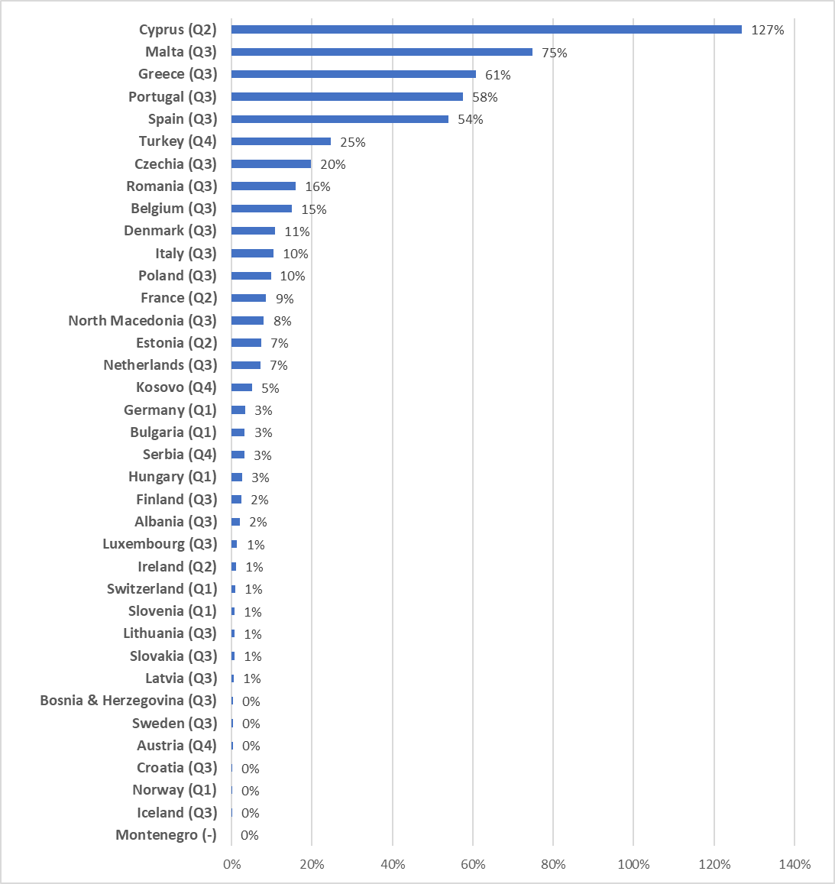

Notes:
- WEI+ illustrates the percentage of water consumption against renewable freshwater resources available for a given territory and period.
- This figure gives an overview of the worst seasonal water scarcity conditions (maximum seasonal WEI+) in any quarter of 2019 across countries in Europe. Seasonal WEI+ values are estimated as quarterly averages per country. Worst quarter of the year for water scarcity conditions is provided in brackets next to the name of the country.
- Annual quarters are: Q1 (January-March), Q2 (April-June), Q3 (July-September), Q4 (October-December)

Data sources:
- Waterbase — Water Quantity provided by the European Environment Agency (EEA, 2021).
- Water statistics provided by the Statistical Office of the European Union (Eurostat, 2021b).
- Aquastat water database provided by FAO(FAO, 2021) .
- OECD water database provided by the Organisation for Economic Co-operation and Development (OECD, 2021).

Disaggregate level assessment
In 2019, the countries that faced the most significant water scarcity conditions on the annual scale were Cyprus, and Malta (annual WEI+ > 20%; see further Country annual WEI+ results). Cyprus and Malta also showed significant water scarcity conditions on the seasonal scale, followed by Greece, Portugal, Spain and Turkey (seasonal WEI+ > 20%; see further Country seasonal WEI+ results) (Figure 2). In general, water scarcity conditions intensify between July and September in the majority of the EEA-38 countries. This is a combination of dry weather, reduced flows and increased abstractions for irrigated agriculture, tourism and other socio-economic activities during that period of the year.
Certain river basins and NUTS2 regions, which were significantly affected by seasonal water scarcity in 2019, are found in Belgium, Bulgaria, Cyprus, Denmark, Finland, France, Germany, Greece, Hungary, Italy, Malta, Poland, Portugal, Romania, Sweden, Spain and Turkey (seasonal WEI+ > 20%; see further NUTS2 seasonal WEI+ results and River basin seasonal WEI+ results).

Supporting information

EEA topics: FIXED from the EEA’s list (one mandatory, other two optional)

Subtopic tags: free text

Relevance: OPEN … (It is defined as ‘the degree to which the indicators meets current and potential needs of users. For the EEA, users are policy makers and the public. Jock suggests we have the public in mind. He also suggests we look at the template for indicators in SOER2005 Part B, for inspiration. It can be both environment and policy relevance).

Indicator definition
The WEI+ provides a measure of total water consumption as a percentage of the renewable freshwater resources available for a given territory and period.
The WEI+ is an advanced geo-referenced version of the WEI. It quantifies how much water is abstracted monthly or seasonally and how much water is returned before or after use to the environment via river basins. The difference between water abstraction and return is regarded as the amount of water used.

Rationale
Justification for indicator selection
The WEI+ is a water scarcity indicator that provides information on the level of pressure exerted by human activities on the natural water resources of a territory. This helps to identify the areas, which are prone to water stress problems (Feargemann, 2012). The WEI+ values on the country and annual scales are provided in line with the directions of UN SDG indicator 6.4.2 (“Level of water stress”), which is used to track progress towards target 6.4, addressing water scarcity and resource efficiency (UN, 2021) (however, ecological flows are not yet included in WEI+). Furthermore, computing and assessing the WEI+ at finer spatial scale (e.g. river basin districts) and finer temporal scale (e.g. seasonal), compared to the country-scale annual averages, helps to improve the monitoring and assessment of water scarcity issues, occurring regionally/locally and seasonally. Finally, computation and assessment of the WEI+ at the European level, would hide the large regional and local differences that exist across the continent. Therefore, it would be misleading. Instead, the computation and assessment of the proportional area and population being affected by water scarcity conditions (either seasonally or throughout an entire year) better capture the significance of water scarcity conditions on the continental scale.

Policy context and targets

Context description
The WEI is part of the set of water indicators published by several international organisations, such as the Food and Agricultural Organization of the United Nations (FAO), the Organisation for Economic Co-operation and Development (OECD), Eurostat and the Mediterranean Blue Plan. The WEI is also used to measure progress towards UN SDG target 6.4 at the global level (UN, 2021). Therefore, the WEI is an internationally accepted indicator for assessing the pressure of the economy on water resources, i.e. water scarcity.
The indicator and its underlying data may be used for assessments related to the decoupling of resource use from population and growth, which is one of the key objectives of the European Green Deal. In addition, it may support assessments on the improvement of socio-economic resilience against water scarcity, in line with the requirements of the EU Adaptation Strategy to climate change. Furthermore, the EU’s 8th EAP aims at ensuring the protection, conservation and enhancement of the EU’s natural capital. Monitoring the pressure of water consumption by different economic sectors at national, regional and local levels is necessary to achieve this.

Targets
There are no specific targets directly related to this indicator. However, the Water Framework Directive (Directive 2000/60/EC) (EU, 2000b) requires Member States to promote the sustainable use of water resources based on the long-term protection of available water resources, and to ensure a balance between abstraction and the recharge of groundwater, with the aim of achieving good groundwater status.
Regarding WEI+ thresholds, it is important that agreement is reached on how to delineate non-stressed and stressed areas. Raskin et al. (1997) suggested that a WEI value of more than 20 % should be used to indicate water scarcity, whereas a value of more than 40 % would indicate severe water scarcity. These thresholds are commonly used in scientific studies (Alcamo et al., 2000). Smakhtin et al. (2004) suggested that a 60 % reduction in annual total run-off would cause environmental water stress. The FAO uses a water abstraction value of above 25 % to indicate water stress and of above 75 % to indicate serious water scarcity (FAO, 2017). Since no formally agreed thresholds are available for assessing water stress conditions across Europe, in the current assessment, the 20 % WEI+ threshold proposed by Raskin at al. (1997) is considered to distinguish stressed from non-stressed areas, while a value of 40 % is used as the highest threshold for mapping purposes.

Institutional mandate: FIXED -> ROD - Other (any other legal act/agreement creating the reporting)

UN/EU SDGs: FIXED -> 17 goals from https://w3.unece.org/SDG/Home + possible second choice

DPSIR: FIXED -> Driving force – Pressure – State – Impact – Response + possible second choice

Typology: FIXED -> A (Descriptive indicators) - B (Performance indicators) – C (Efficiency indicators) - D (Policy effectiveness indicators) – E (Total welfare indicators) + possible second choice

Data sources and data providers: AUTOMATIC from data
Biogeographical regions provided by the Council of Europe (CoE), Directorate-General for Environment (DG ENV) (EEA, 2016).
The European Pollutant Release and Transfer Register (E-PRTR), Member States reporting under Article 7 of Regulation (EC) No 166/2006 provided by the European Environment Agency (EEA, 2019).
Waterbase — UWWTD: Urban Waste Water Treatment Directive — reported data provided by the Directorate-General for Environment (DG ENV) and the European Environment Agency (EEA, 2020).
European Catchments and Rivers Network System (Ecrins) provided by the European Environment Agency (EEA, 2018).
Urban morphological zones 2006 provided by the European Environment Agency (EEA, 2014).
Waterbase — Water Quantity provided by the European Environment Agency (EEA, 2021).
Water statistics (Eurostat) provided by the Statistical Office of the European Union (Eurostat, 2021b).
Eurostat statistics on population provided by the Statistical Office of the European Union (Eurostat, 2020b).
Lisflood. Distributed Water Balance and Flood Simulation Model provided by the Joint Research Centre (JRC) (Burek et al., 2013).
National Statistical offices (dataset URL is not available) provided by the Statistical Office of the European Union (Eurostat, 2021a).

Geographical coverage: AUTOMATIC from data

Time coverage: AUTOMATIC from data

Unit of measure: Unit of measure (Roberta will provide an initial list, to which people can add) – Magnitude – Relation (if any)

WEI+ values are given as percentages, i.e. water use as a percentage of renewable water resources. Absolute water volumes are presented as millions of cubic meters (million m³ or hm³).

Frequency of dissemination: from 1 to 6 years (shown as ‘yearly, etc.’)

Timeliness: AUTOMATIC from data (Length of time between data availability and the phenomenon described by the indicator)

Accuracy and uncertainties: OPEN (optional)

Geographical comparability: OPEN (extent to which data are comparable between geographical areas)

Comparability over time: OPEN (extent to which data are comparable over time)

Methodology: OPEN (summary description of the methodology applied to process the indicator, be it a simple calculation as a percentage or an equation or statistical methods)

Methodology for indicator calculation
The WEI+ is an advanced version of the WEI. It is geo-referenced and developed for use on a seasonal scale. It also takes into account water abstraction (gross) and return (net abstraction) to reflect water consumption.
In 2011, a technical working group, developed under the Water Framework Directive Common Implementation Strategy, proposed the implementation of a regional WEI+. This differed from the previous approach, as the WEI+ was able to depict more seasonal and regional aspects of water stress conditions across Europe (see EEA’s updated conceptual model of WEI+ computation). This proposal was approved by the Water Directors in 2012 as one of the awareness-raising indicators (Faergemann, H., 2012).
The regional WEI+ is calculated according to the following formula:
WEI+ = (abstractions - returns)/renewable freshwater resources.
Renewable freshwater resources are calculated as ‘ExIn + P - Eta ± ΔS’ for natural and semi-natural areas, and as ‘outflow + (abstraction - return) ± ΔS’ for densely populated areas.
Where:
ExIn = external inflow
P = precipitation
Eta = actual evapotranspiration
ΔS = change in storage (lakes and reservoirs)
Outflow = outflow to downstream/sea.
It is assumed that there are no pristine or semi-natural river basin districts or sub-basins in Europe. Therefore, the formula ‘outflow + (abstraction - return) ± ΔS’ is used to estimate renewable water resources.

Climate data and streamflow data have been integrated from the Joint Research Centre (JRC) Lisflood model (Burek et al., 2013). The cover Europe in a homogeneous way for the years 2000-2019 on a monthly scale.
Once the data series are complete, the flow linearisation calculation is implemented, followed by a water asset accounts calculation, which is done to fill the gaps in the data for the parameters requested for the estimation of renewable water resources. The computations are implemented at different scales independently, from sub-basin scale to river basin district scale.
Overall, annually reported data are available for water abstraction by source (surface water and groundwater) and water abstraction by sector with temporal and spatial gaps. Gap-filling methods are applied to obtain harmonised time series.
No sufficient data are available at the European scale on ‘return’. To fill gap in data on return, urban waste water treatment plant data, the European Pollutant Release and Transfer Register (E-PRTR) database, Eurostat population data, JRC data on the crop coefficient of water consumption and satellite-observed phenology data have been used as proxies to quantify the water demand and water use by different economic sectors. Eurostat tourism data (Eurostat, 2020a) and data on industry in production have been used to estimate the actual water abstraction and return on a monthly scale. Where available, Waterbase — Water Quantity database (EEA, 2021) and Eurostat data (Eurostat, 2020c) on water availability and water use have also been used at aggregated scales for further validation purposes.
Once water asset accounts have been implemented according to the United Nations System of Environmental- Economic Accounting for Water (UN, 2012), the necessary parameters for calculating water use and renewable freshwater resources are harvested.
Following this, bar and pie charts are produced, together with static and dynamic maps.

Methodology for gap filling
For each parameter of water abstraction, return and renewable freshwater resources, primarily data from the Waterbase — Water Quantity database have been used (EEA, 2021). Eurostat, OECD and Aquastat (FAO) databases have also been used to fill the gaps in the data sets. Furthermore, the statistical office websites (Eurostat, 2021a) of all European countries have each been visited several times to get the most up-to-date data from these national open sources. Despite this, some gaps still needed to be filled by applying certain statistical or geospatial methodologies (see EEA (undated), Table 1 — Reference data sources for gap filling and modulation coefficients).
Lisflood data from the JRC have been used to gap fill the streamflow data set (see EEA (undated), Table 1 — Reference data sources for gap filling and modulation coefficients). The spatial reference data for the WEI+ are the European Catchments and Rivers Network System (Ecrins) data (250-m vector resolution). Ecrins is a vector spatial data set, while Lisflood data are in 5-km raster format. To fill the gaps in the streamflow data, centroids of the Lisflood raster have been identified as fictitious (virtual) stations. The topological definition of the drainage network in Ecrins has been used to match the most relevant and nearest fictitious Lisflood stations with EEA-Eionet stations and the Ecrins river network. After this, the locations of stations between Eionet and Lisflood stations were compared and overlapping stations were selected for gap filling. For the remaining stations, the following criteria were adhered to: fictitious stations had to be located within the same catchment as the Eionet station and have the same main river segment; in addition, both stations had to show a strong correlation.
A substantial amount of gap filling has been performed on the data on water abstraction for irrigation. First, a mean factor between utilised agricultural areas and irrigated areas has been used to fill the gaps in the data on irrigated areas. Then, a multiannual mean factor of water density (m³/ha) in irrigated areas per country has been used to fill the gaps in the data on water abstraction for irrigation.
The gaps in the data on water abstraction for manufacturing and construction have been filled using Eurostat data on production in industry (Eurostat [sts_inpr_a]) and the E-PRTR database, with the methodologies in the best available techniques reference document (BREF) being used to convert the production level into the volume of water.

Uncertainties

Methodology uncertainty
Reported data on water abstraction and water use do not have sufficient spatial or temporal coverage. Therefore, estimates based on country coefficients are required to assess water use. First, water abstraction values are calculated and, second, these values are compared with the production level in industry and in relation to tourist movements to approximate actual water use for a given time resolution. This approach cannot be used to assess the variations (i.e. the resource efficiency) in water use within the time series.
Spatial data on lakes and reservoirs are incomplete. However, as reference volumes for reservoirs, lakes and groundwater aquifers are not available, the water balance can be quantified as only a relative change, and not the actual volume of water. This masks the actual volume of water stored in, and abstracted from, reservoirs. Thus, the impact of the residence time, between water storage and use, in reservoirs is unknown.
The sectoral use of water does not always reflect the relative importance of the sectors to the economy of a given country. It is, rather, an indicator that describes which sectors environmental measures should focus on in order to enhance the protection of the environment. A number of iterative computations based on identified proxies are applied to different data sets, i.e. urban waste water treatment plant data, E-PRTR data, Eurostat population data, JRC data on the crop coefficient of water consumption and satellite-observed phenology data have been used as proxies to quantify water demand and water use by different economic sectors. This creates a high level of uncertainty in the quantification of water return from economic sectors, thus also leading to uncertainty with regard to the ‘water use’ component.
To distribute population data across Europe, the Geostat 2011 grid data set from Eurostat (Eurostat, 2011) was used. Further aggregations were then performed in the spatial dimension to give the sub-basin and functional river basin district scales of Ecrins spatial reference data. The population within the time frame of 1 calendar year is regarded as stable. Variations are taken into account only for the annual scale. Deviations from officially reported data are expected because of the nature of the methodological steps followed.

Data set uncertainty
Data are very sparse on some particular parameters of the WEI+. For instance, current streamflow data reported by the EEA member countries to the WISE SoE — Water Quantity database (EEA, 2021) do not have sufficient temporal or spatial coverage to provide a strong enough basis for estimating renewable water resources for all of Europe. Such data are not available elsewhere at the European level either. Therefore, JRC Lisflood data are used intensively as surrogates (see EEA (undated), ‘Availability on streamflow data’).

Data on water abstraction by economic sector have better spatial and temporal coverage. However, the representativeness of data for some sectors is also poor, such as the data on water abstraction for mining. In addition to the WISE SoE — Water Quantity database, intensive efforts to compile data from open data sources such as Eurostat, OECD, Aquastat (FAO) and national statistical offices have also been made (see EEA (undated), ‘Share of surrogate data versus reported data on water abstraction by all economic sectors (total volume)’).

Quantifying water exchanges between the environment and the economy is, conceptually, very complex. A complete quantification of the water flows from the environment to the economy and, at a later stage, back to the environment, requires detailed data collection and processing, which have not been done at the European level. Thus, reported data have to be used in combination with modelling to obtain data that can be used to quantify such water exchanges, with the purpose of developing a good approximation of ‘ground truth’. However, the most challenging issue is related to water abstraction and water use data, as the water flow within the economy is quite difficult to monitor and assess given the current lack of data availability. Therefore, several interpolation, aggregation or disaggregation procedures have to be implemented at finer scales, with both reported and modelled data. The main consequences of data set uncertainty are the following:
- The water accounts and WEI+ results have been implemented in the EEA member and Western Balkan countries. However, regional data availability was an issue for some river basins (e.g. in Turkish river basins), which had to be removed from the assessment.
- Because of technical issues in estimating the variable outflow to the sea, the seasonal WEI+ calculation at NUTS2 level could not be performed for Netherlands and some of other NUTS regions from other countries. This has been made explicit without presenting the WEI results for such entities in the final WEI tab.

Rationale uncertainty
Because of the aggregation procedure used, slight differences exist between sub-basin and river basin district scales for total renewable water resources and water use.

References: AUTOMATIC via Zotero + manual addition
Alcamo, J., et al., 2000, World water in 2025 — Global modelling and scenario analysis for the World Commission on Water for the 21st century, Report No 2, Centre for Environmental Systems Research, University of Kassel, Germany (http://www.env-edu.gr/Documents/World%20Water%20in%202025.pdf) accessed 27 May 2021.
Burek, P., et al., 2013, Lisflood — Distributed water balance and flood simulation model: revised user manual 2013, Publications Office of the European Union, Luxembourg (https://op.europa.eu/en/publication-detail/-/publication/e3b3c713-c832-4614-8527-f3ab720192f8/language-en) accessed 27 May 2021.
EC, 2011, Communication from the Commission to the European Parliament, the Council, the European Economic and Social Committee and the Committee of the Regions — Roadmap to a resource efficient Europe (COM(2011) 571 final).
EEA, 2014, ‘Urban morphological zones 2006’, European Environment Agency (https://www.eea.europa.eu/data-and-maps/data/urban-morphological-zones-2006-1) accessed 28 May 2021.
EEA, 2016, ‘Biogeographical regions’, European Environment Agency (https://www.eea.europa.eu/data-and-maps/data/biogeographical-regions-europe-3) accessed 28 May 2021.
EEA, 2018, ‘European Catchments and Rivers Network System (Ecrins)’, European Environment Agency (https://www.eea.europa.eu/data-and-maps/data/european-catchments-and-rivers-network) accessed 28 May 2021.
EEA, 2019, ‘The European Pollutant Release and Transfer Register (E-PRTR), Member States reporting under Article 7 of Regulation (EC) No 166/2006’, European Environment Agency (https://www.eea.europa.eu/data-and-maps/data/member-states-reporting-art-7-under-the-european-pollutant-release-and-transfer-register-e-prtr-regulation-18) accessed 5 October 2020.
EEA, 2020, ‘Waterbase — UWWTD: Urban Waste Water Treatment Directive — reported data’, European Environment Agency (https://www.eea.europa.eu/data-and-maps/data/waterbase-uwwtd-urban-waste-water-treatment-directive-7) accessed 28 May 2021.
EEA, 2021, ‘Waterbase — water quantity’, European Environment Agency (https://www.eea.europa.eu/data-and-maps/data/waterbase-water-quantity-13) accessed 27 May 2021.
EEA, undated, ‘Conceptual model of the WEI+ computation’, European Environment Agency (https://www.eea.europa.eu/data-and-maps/indicators/use-of-freshwater-resources-3/resolveuid/b820b42dc3e8406a9bc9372ae3eee08b) accessed 27 May 2021.
EU, 2000a, Directive 2000/60/EC of the European Parliament and of the Council of 23 October 2000 establishing a framework for Community action in the field of water policy (OJ L 327, 22.12.2000, p. 1-73).
EU, 2000b, Directive 2000/60/EC of the European Parliament and of the Council of 23 October 2000 establishing a framework for community action in the field of water policy (OJ L 327, 22.12.2000, p. 1-73).
EU, 2013, Decision No 1386/2013/EU of the European Parliament and of the Council of 20 November 2013 on a general Union environment action programme to 2020 ‘Living well, within the limits of our planet’ (OJ L 354, 28.12.2013, p. 171-200).
Eurostat, 2011, ‘Geostat grid dataset-2011’, Population distribution (https://ec.europa.eu/eurostat/web/gisco/geodata/reference-data/population-distribution-demography/geostat) accessed 6 January 2021.
Eurostat, 2019, ‘Production in industry - monthly data’, Production in industry (https://ec.europa.eu/eurostat/databrowser/view/sts_inpr_m/default/table?lang=en) accessed 6 January 2021.
Eurostat, 2020a, ‘Nights spent at tourist accommodation establishments by NUTS 2 regions (tgs00111)’ (https://ec.europa.eu/eurostat/data/database?node_code=tin00175).
Eurostat, 2020b, ‘Population on 1 January by age and sex’, Eurostat (http://appsso.eurostat.ec.europa.eu/nui/show.do?dataset=demo_pjan&lang=en) accessed 28 May 2021.
Eurostat, 2020c, ‘Water abstraction by source and sector’, Data Explorer (http://appsso.eurostat.ec.europa.eu/nui/show.do?dataset=env_wat_abs) accessed 17 December 2020.
Eurostat, 2021a, ‘National statistical institutes’, Eurostat (https://ec.europa.eu/eurostat/web/links) accessed 27 May 2021.
Eurostat, 2021b, ‘Water’, Eurostat (https://ec.europa.eu/eurostat/web/environment/water) accessed 28 May 2021.
FAO, 2017, ‘Step-by-step monitoring methodology for indicator 6.4.2 level of water stress: freshwater withdrawal in percentage of available freshwater resources’, Food and Agriculture Organization of the United Nations (http://www.fao.org/elearning/course/SDG642/en/story_content/external_files/Step-by-step%20Methodology%20for%20indicator%206%204%202%20V20170719.pdf) accessed 27 May 2021.
FAO, 2021, ‘Aquastat water database’, Food and Agriculture Organization of the United Nations (http://www.fao.org/aquastat/statistics/query/index.html) accessed 6 January 2021.
Feargemann, H., 2012, ‘Update on water scarcity and droughts indicator development’, European Commission (https://circabc.europa.eu/ui/group/9ab5926d-bed4-4322-9aa7-9964bbe8312d/library/c676bfc6-e1c3-41df-8d31-38ad6341cbf9/details) accessed 15 December 2020.
Ivits, E., et al., 2013, ‘Ecosystem functional units characterized by satellite observed phenology and productivity gradients: A case study for Europe’, Ecological Indicators 27, pp. 17-28 (DOI: 10.1016/j.ecolind.2012.11.010).
OECD, 2021, ‘OECD water database’, Water database (https://www.eea.europa.eu/data-and-maps/data/external/oecd-water-database) accessed 6 January 2021.
Raskin, P., et al., 1997, Comprehensive assessment of the freshwater resources of the world — Water futures: assessment of long-range patterns and problems, Document prepared for the fifth session of the United Nations Commission on Sustainable Development, 1997, Stockholm Environmental Institute, Stockholm (https://www.sei.org/mediamanager/documents/Publications/SEI-Report-WaterFutures-AssessmentOfLongRangePatternsAndProblems-1997.pdf) accessed 27 May 2021.
Smakhtin, V., et al., 2004, Taking into account environmental water requirement in global scale water resources assessment, Research Report No 2, Comprehensive Assessment of Water Management in Agriculture, Colombo (https://core.ac.uk/download/pdf/6405183.pdf) accessed 27 May 2021.
UN, ed., 2012, System of environmental-economic accounting for water: SEEA-Water, United Nations, New York.
UN, 2021, ‘Indicator 6.4.2 “Level of water stress: freshwater withdrawal as a proportion of available freshwater resources”’ (https://www.sdg6monitoring.org/indicator-642/) accessed 27 May 2021.

Links to older versions: AUTOMATIC

Related products (Gallery of EEA products related to the indicator (data sets, figures, maps, tables etc. used in the indicator; other indicators of similar policy relevance)

Contact: info@eea.europa.eu (Antonio will provide contacts in COM, so that Roberta can inform them about the indicator authors)

At EEA-38 level, 17% of the territory and 38% of the population were affected by water scarcity conditions at least in one quarter of 2019.

