|  |  |
| --- | --- |
| **EEA/NSV/13/002 – ETC/ICM** |  |

**Public health and environmental protection in European water policies**

Version: 7.7

Date: 07.07.2016

ETC/ICM task, milestone: 1.5.2.b

Prepared by/compiled by: Anita Künitzer/Jeanette Völker (Helmholtz Centre for Environmental Research, UFZ)

with Lidija Globevnik (TC Vode), Hana Prchalova (Czech Environmental Information Agency, CENIA)

EEA project managers: Beate Werner, Caroline Whalley

**Public health and environmental protection in European water policies**

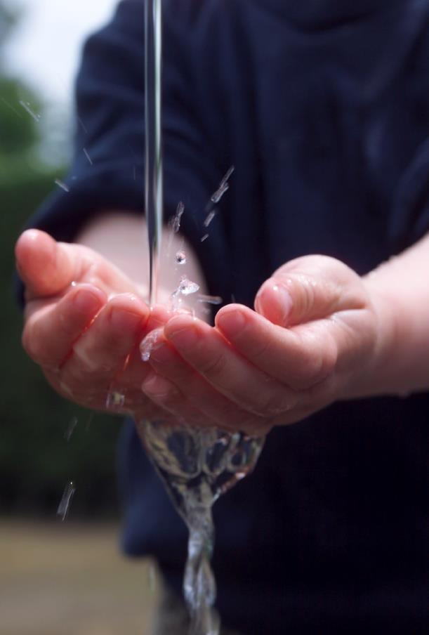



Contents

Acknowledgements 5

Acronyms and abbreviations 6

Executive summary 7

1 Overview of EU water-related legislation to protect human health and the aquatic environment 8

1.1 Introduction 8

1.1.1 Legislative context 8

1.1.2 Water management and the water cycle 8

1.1.3 Public interest 9

1.2 Scope and management tools of the directives 10

1.2.1 Urban Wastewater Treatment Directive 10

1.2.2 Bathing Water Directive 10

1.2.3 Drinking Water Directive 11

1.2.4 Water Framework Directive 12

1.3 Management measures 13

1.4 Relationships between the water industry directives and the WFD. 14

2 Protecting surface waters from nutrient and organic pollution 16

2.1 Introduction 16

2.2 Pressures and status of nutrient pollution 16

2.3 Impacts of nutrient pollution and eutrophication 19

2.3.1 Eutrophication in bathing waters 19

2.3.2 Nitrogen in drinking water 21

2.4 Policies and measures to reduce nutrient pollution 21

2.5 Biochemical oxygen demand: a key indicator of water quality 22

2.5.1 Background 22

2.5.2 Reduction of BOD in rivers due to urban wastewater treatment 22

2.6 Storm water overflow from combined sewers 24

2.7 Emerging issues 25

3 Protecting drinking water and bathing water from microbial pollution 27

3.1 Introduction 27

3.2 Causes of microbiological pollution 27

3.3 Monitoring of microbiological pollution: role of the directives 28

3.4 Microbiological pollution of bathing waters 29

4 Information to the public 32

4.1 Introduction 32

4.2 Reporting obligations 32

4.3 Information dissemination 32

5 Conclusions 34

5.1 Integrated water management 34

5.2 Water quality and impacts on the environment and human health 34

5.3 Information and public interest 35

5.4 Future challenges 35

References 37

Annex: Results reported under the three water industry directives 41

A1 Bathing Water Directive 42

A1.1 Introduction 42

A1.2 Bathing water quality 42

A1.3 Non-compliant and poor bathing water sites 44

A1.4 Country comparison 46

A1.5 Short-term pollution and abnormal situations 47

A1.6 Measures to improve bathing water quality 47

A1.7 Information dissemination 49

A2 Drinking Water Directive 51

A2.1 Introduction 51

A2.2 European results 54

A2.3 Country comparison 61

A2.4 Measures to improve drinking water quality 62

A2.5 Information dissemination 64

A3 Urban Waste Water Treatment Directive 66

A3.1 Legislation 66

A3.2 European results and trend in compliance 67

A3.3 Country comparison 70

A3.4 Measures to improve treatment 73

A3.5 Information dissemination 74

Acknowledgements

The European Environment Agency (EEA) and its European Topic Centre on Inland, Coastal and Marine Waters (ETC/ICM) prepared this report. The ETC/ICM is an international consortium brought together to support the EEA in its mission to deliver timely, targeted, relevant and reliable information to policy-makers and the public for the development and implementation of sound environmental policies in the European Union and other EEA member countries.

Caroline Whalley, Beate Werner and Stephane Isoard (European Environment Agency, EEA) and the task managers of the European Topic Centre on Inland, Coastal and Marine Waters (ETC/ICM), Jeanette Völker and Anita Künitzer, carried out the overall coordination of the report.

The authors are Lidija Globevnik, Gašper Šubelj and Luka Snoj from the Thematic Center for Water Research, Studies and Project Development, Ltd (TC Vode, Slovenia), Peter Kristensen from the EEA, Anita Künitzer and Jeanette Völker from the Helmholtz Centre for Environmental Research – UFZ, Germany, Hana Prchalova, Petra Ronen and Jiri Kvapil from the Czech Environmental Information Agency (CENIA, Czech Republic), and Ursula Schmedtje from the German Environment Agency.

Acronyms and abbreviations

BOD Biochemical oxygen demand

BWD Bathing Water Directive

CFU Colony-forming unit

CSO Combined storm overflow

DWD Drinking Water Directive

EAP Environment Action Programme

EC European Commission

EEA European Environment Agency

ETC/ICM European Topic Centre on Inland, Coastal and Marine Waters

EU-13 Member States of EU having joined since 2004 (2004: Cyprus, Czech Republic, Estonia, Hungary, Latvia, Lithuania, Malta, Poland, Slovakia, Slovenia; 2007: Bulgaria, Romania; 2013: Croatia)

EU-15 Member States of the EU before 2004 (Austria, Belgium, Denmark, Finland, France, Germany, Greece, Ireland, Italy, Luxembourg, Netherlands, Portugal, Spain, Sweden, United Kingdom)

EU-28 EU Member States at the time of publication (sum of EU-13 and EU-15)

GBP Great British Pound (sterling) - currency in UK

MSFD Marine Strategy Framework Directive

NH4 Ammonium

NiD Nitrates Directive

p.e. Population equivalents

UV ultraviolet

UWWTD Urban Waste Water Treatment Directive

UWWTP urban wastewater treatment plant

WFD Water Framework Directive

WHO World Health Organization

WISE Water Information System for Europe

WSP Water safety plan

Executive summary

Society depends on the satisfactory and sustainable management of water. Historically, the primary purpose for water treatment was to reduce the likelihood of disease being transmitted to humans through water. Subsequent measures to address environmental concerns have broadened our expectations of what water and wastewater treatment should deliver.

This report considers three pieces of EU water legislation targeted at particular sectors: the Bathing Water Directive (BWD, 1976, 2006), the Urban Wastewater Treatment Directive (UWWTD, 1991) and the Drinking Water Directive (DWD, 1998), together termed the “water industry directives”. Their objectives towards specific issues are considered in the context of the Water Framework Directive (WFD, 2000).

Consideration of the older legislation in the context of WFD is worthwhile as the European Commission considers a review of water legislation. Meanwhile, the European citizen’s initiative ‘Right2Water’ (<http://www.right2water.eu/>) highlighted the level of interest in water issues. This report looks at areas in common between the water industry directives and notes where integration under the WFD can identify synergies and allow for improved decision-making.

The report builds upon reports required under the sectoral legislation, summaries of which are provided in the annex. Common features towards public health, environmental quality and informing the public are identified and considered in the context of the WFD, which, as a framework directive conceived after much of the sectoral legislation was adopted, bridges over many objectives of the water industry directives.

As a general overview of the water industry directives, compliance of UWWTD tends to be high among the countries that were Member States before 2004 (EU-15). The picture is more mixed among the newer Member States (EU-13), where compliance is high or increasing. Compliance rates of BWD and DWD are high in all countries. Reporting under the WFD in the second cycle of river basin management planning is under way and results should become available over 2017-18. Results of the first river basin management plans of the WFD in 2009 showed nutrient inputs from wastewater treatment plants and agriculture as one of the most significant reasons for waterbodies failing to be in good status.

An integrated approach of water related directives may help us deal better with current and future challenges, for example using the WFD river basin management planning process to identify those stakeholders with relevant interests, and to implement effective decision-making that takes into account the differing issues, costs and benefits. Integration may need more detailed understanding of inter-related issues than that needed to meet more linear obligations under sectoral legislation, such as infrastructure improvement. Authorities and water managers need to identify related pressures and impacts to help identify root causes and thereby facilitate more effective implementation.

Continuing challenges remain in dealing with diffuse pollution, through for example: surface run-off from urban and agricultural land and overflow from combined sewers. Such diffuse sources are likely to become more significant over time as point sources are tackled. Moreover, emerging risks include micropollutants, microplastics and antimicrobial resistance, where potential risks for both the environment and human health have been identified but the significance is as yet unclear.

# Overview of EU water-related legislation to protect human health and the aquatic environment

1.1 Introduction

1.1.1 Legislative context

Water is an essential resource. Managing it to provide safe supplies is a fundamental requirement for human civilisation. Accordingly, ‘to safeguard the Union’s citizens from environment-related pressures and risks to health and wellbeing’ is an integral part of the EU’s environmental policy (EC, 2013). The Seventh Environment Action Programme (EAP) outlines that in its third objective (1386/2013/EU).

Over the years, the EU has adopted a suite of legislation that aims to protect and manage European waters. This started in 1976 with the first Bathing Water Directive, revised in 2006 (BWD, 2006/7/EC; EC, 2006), followed by the first Groundwater Directive in 1979 (80/68/EEC). In the 1990s, the Nitrates Directive (NiD, 91/676/EEC; EC, 1991a), the Urban Waste Water Treatment Directive (UWWTD, 91/271/EEC; EC, 1991b) and the Drinking Water Directive (DWD, 98/83/EC; EC, 1998) came into force. The UWWTD, BWD and DWD continued to focus on protecting human health, whereas the NiD targeted agriculture as the source of emission for protecting aquatic resources.

The Water Framework Directive (WFD, 2000/60/EC; EC, 2000) introduced a more holistic approach to ecosystem-based management in 2000. It focuses on the multiple relationships between the many different causes of pollution and their various impacts on water in a river basin. The WFD aims to ensure that human use of water is compatible with the environment’s own needs. The WFD uses the ‘good status’ standard to indicate if there is enough water of sufficient quality to support both ecosystems and human societies. The WFD, as a framework directive, provides a context for more targeted legislation, such as the revised Groundwater Directive (2006/118/EC). This established a system for setting groundwater quality standards and introducing measures to prevent or limit pollution of groundwater.

1.1.2 Water management and the water cycle

Looking at humans’ direct interaction with water, we could consider household and urban water management as a more or less distinct sub-cycle of the natural water cycle: drinking water is abstracted from the ground- or surface water, treated, and made available in households and businesses; and after use and treatment it is discharged again into the environment.

This human sub-cycle is, of course, part of the wider natural water cycle. Human uses and discharges strongly influence water ecosystems and their status and functionality. This has implications for both society and nature. Water can directly affect human health in two ways: if people drink the water or if they come into direct contact with it by swimming, and only where there is sufficient water of sufficient quality for the health of the ecosystem can we ensure human health as well.

The three directives, UWWTD, DWD and BWD are sometimes called ‘the water industry directives’. Each of them focuses on managing its respective part of the human water cycle. They provide a monitoring framework to document the quality of the water abstracted and used by humans, and discharged afterwards, and the quality of the water available for recreational purposes. Member States must report key parameters of water quality and management measures under these directives.

The water industry directives all aim to protect consumers and water users, including the environment, against harmful effects. Management measures are taken in different places as the compliance points for each of the Directives are different, but nevertheless there are complementarities between them, such as improving wastewater treatment under UWWTD and improved bathing water quality. The UWWTD ensures that all significant discharges of sewage from domestic and industrial sectors undergo treatment before release into surface water. The BWD and the DWD aim to improve bathing and drinking water; they require and facilitate water monitoring and management measures and make information easily and transparently available to the public (EC, 2012).

To help understand the (spatial) scopes of the three different directives, Figure 1.1 shows the points of compliance within a hydrological system in a schematic way. The UWWTD compliance point is at the outlet of the treatment plant, where European water quality standards need to be met. This point complies with the emission principle. Wastewater, probably with a high concentration of nutrients and/or pathogenic microorganisms, reaches a river or lake with a bathing area. This area must comply with the BWD. An abstraction point for raw water to be treated for the purpose of drinking complies with the WFD (Article 7), whereas compliance with DWD requirements is at the point where the consumer takes the water from the tap. This takes into account any water treatment and other water quality issues arising from transmission through any distribution and storage facilities.

Figure 1.1 Relative scopes of UWWTD, BWD, WFD (Article 7) and DWD.

1.1.3 Public interest

With their focus on the human part of the water cycle, and the quality of water for human consumption and use, the three water industry directives are also at the centre of public interest. The first successful European citizens’ initiative, the Right2Water initiative, called on the European Commission (EC) to ensure that all EU citizens enjoy the right to water and sanitation at affordable prices.

In response to the European citizens’ initiative, the EC identified a set of priorities and actions at EU or national level to address the concerns motivating this call for action. One focus is to improve information for citizens by further developing streamlined and more transparent data management and disseminating information about urban wastewater and drinking water. They also promote structured dialogue between stakeholders on transparency in the water sector, and aim to improve the transparency and accountability of water services providers by giving citizens access to comparable data on key economic and quality indicators.

1.2 Scope and management tools of the directives

1.2.1 Urban Wastewater Treatment Directive

The UWWTD regulates urban wastewater collection, treatment and discharge as well as treatment and discharge from the agriculture and food sectors. It requires the collection and treatment of wastewater in all agglomerations of more than 2 000 population equivalents (p.e.) (see Annex A 3.1), and more advanced treatment for agglomerations of more than 10 000 p.e. or in designated sensitive areas (for more information on the UWWTD, see Annex A3).

The main objectives of the directive are to increase the population connected to wastewater collection and urban wastewater treatment plants, and to expand more stringent wastewater treatment. To reach these objectives, the directive lays down four main principles: (a) planning, (b) regulation, (c) monitoring and (d) information and reporting. Water managers and responsible authorities need to develop and implement management strategies for each of these principles.

Besides designating sensitive areas and identifying the relevant hydraulic catchment areas, planning aspects include establishing a technical and financial programme for constructing sewage collection systems, if needed, and planning treatment that is more stringent than ‘secondary treatment’ in larger agglomerations.

The main regulatory tools are the authorisation and regulation of wastewater. In addition, the UWWTD requires measures to limit pollution by waters coming from storm water overflows, and technical requirements for the design, construction, operation and maintenance of plants that treat urban wastewater.

Monitoring programmes need to be in place and must correspond to the directive’s requirements. Member States must also ensure monitoring of both discharges from urban wastewater treatment plants and receiving waters (water bodies that receive discharges of wastewater). A well-established monitoring system ensures an informed assessment of the sewerage system and its treatment capacity.

Information and reporting are principal management tools. Member States need mechanisms to allow cooperation and exchange of information with each other (e.g. for benchmarking or if discharges of wastewater have an effect on water quality across a border). National reports and map viewers are also suitable and useful to present ratings and results transparently, both to the EC and to the general public.

1.2.2 Bathing Water Directive

The BWD safeguards public health and protects the aquatic environment in coastal and inland areas from pollution. To manage water quality, Member States monitor bathing water during the bathing season. They take samples of bathing water and analyse them to assess the concentrations of two bacteria, *Escherichia coli* and intestinal enterococci. This has to happen once a month during the bathing season, with a minimum of four samples per season collected at each bathing water site.

Throughout the bathing season, local or national governments publish monitoring results to inform the public about possible health risks when bathing. For all of their bathing water sites, countries also prepare bathing water profiles and ensure they are available to the public. These are descriptions of physical and hydrological conditions, covering a single site or contiguous sites. They also list potential impacts on water quality and potential threats to it. At the end of each bathing season, Member State authorities send their data to the EC and the EEA. Assessment results are then published in national reports, EU reports and interactive viewers, and the BWD data viewer.

A revised BWD (2006/7/EC) was due for implementation by Member States by December 2014. It is fully integrated within the body of measures protecting the quality of EU waters through the WFD, putting greater emphasis on the integrated management of bathing water. The effect is to encourage Member States to implement management measures to improve quality to at least ‘good’ or even ‘excellent’ (EEA, 2016).

Mitigation measures to reduce health risks may include construction of adequate wastewater treatment plants. Building sewage collection and treatment systems, ensuring compliance of emission concentrations and removing sediment are very important management actions to improve bathing water quality. Many cases of poor quality and non-compliance are linked to short-term pollution and cases of storm water overflow. Therefore, depending on water status, management measures might also include investigating the sewer network in the vicinity of the bathing water site, together with monitoring surface waters in the vicinity of the bathing water. Bathing water sites subject to such measures might be temporarily closed for part or all of the bathing season.

When extreme events or accidents occur (such as heavy rain, sewage spills, hazardous waste spills) Member States must impose temporary management measures to protect bathers’ health. In most cases, this means that local authorities must temporarily close bathing water locations or, at the very least, warn bathers where areas are affected.

The authorities can also close bathing water sites for other reasons, such as dangerous access to the bathing water, damaged infrastructure surrounding it, engineering works at or near the location, or a reduction in the water level of a reservoir. In some cases, the reason might be purely administrative or legal. If a bathing area is temporarily closed for unexpected or uncontrollable reasons, the quality of its water must still be monitored.

1.2.3 Drinking Water Directive

The DWD aims to ensure that water intended for human consumption is safe. It must be free of any microorganisms, parasites or substances that could potentially endanger human health. The directive applies to all water intended for human consumption apart from natural mineral waters and waters that are medicinal products.

The directive sets quality standards for drinking water at the tap (microbiological, chemical and indicator parameters) and obliges Member States to monitor drinking water quality regularly, to take remedial action (measures) if the monitoring reveals problems and to provide consumers with adequate and up-to-date information on their drinking water quality (see Annex A2). Tools for managing drinking water quality are focused on monitoring, measures and information to the public.

Depending on the monitoring strategy, the DWD obliges Member States to carry out a risk assessment for all drinking water quality parameters. This means that the directive permits exceptions to monitoring, either by reducing the frequency or by completely removing parameters from the monitoring programme. This is possible if (a) the values of the results obtained from sampling taken during a period of at least 2 successive years are constant and significantly better than the limits and (b) no factor is likely to cause a deterioration of the quality of the water.

Measures need to be implemented if the quality of drinking water needs further improvement. If the measures are related to treatment or the distribution network, the water supplier is responsible for ensuring high drinking water quality. If pollution comes from the catchment area, the supplier needs to coordinate with other institutions or stakeholders. Agriculture is the main cause of groundwater and surface water pollution, so water suppliers often contract with farmers to ensure the protection of water sources.

This can involve changes in management conditions, such as organic farming or other low-impact methods. Some Member States (e.g. Germany) allow water suppliers to pass on to water consumers the costs of compensating farmers for the changes in management practices. This is in the interest of efficiency, because it is much more costly to treat and clean the drinking water than to pay to reduce pollution at its origin (Kraemer et al., 2007).

Furthermore, the DWD requests that authorities make the results of drinking water quality tests available to the public. For this, a national triennial report needs to be published. Because of the diverse administrative structures in Member States and the multitude of water suppliers, few countries have a national centralised system for publishing drinking water quality on a level of water supply zones, like presented in Austria (http://www.trinkwasserinfo.at/trinkwasserdatenbank/). There is also no system at the European scale. National country reports based on the triennial reporting results are available at the respective Commission website.

Besides the directive’s obligations on management strategies, most Member States also follow the water safety planning (WSP) approach based on a guideline of the World Health Organization (WHO, 2004, 2011; EC, 2014).

The current DWD does not specifically note the WSP approach but the WHO recommends it to enable the management of drinking water quality in a holistic and systematic way that assesses and mitigates all risks from catchment to consumer. The approach requires water supply operators to carry out a comprehensive risk assessment for each treatment works and its connected supply system from source to tap, covering all hazards and hazardous events.

1.2.4 Water Framework Directive

The WFD establishes a legal framework to protect and restore clean water across Europe and ensure its long-term, sustainable use. The directive establishes an innovative approach for water management based on river basins, the natural geographical and hydrological units, and sets specific deadlines for Member States to achieve ambitious environmental objectives for aquatic ecosystems. Under the directive, Member States should have aimed to achieve good status in all bodies of surface water and groundwater by 2015. Article 10 details the directive’s “combined approach for point and diffuse sources” and refers to several related directives, including the BWD, DWD and UWWTD. The directive regards implementation of these other directives as a minimum requirement (EC 2008a, b).

River basin management plans were elaborated for extensive river basin districts rather than for individual water bodies. A programme of measures describes the actions that must be taken to bring water bodies into good status, for which the key measures are as follows, e.g. improving hydromorphology via restoration; removing or scaling back migratory obstacles and transverse structures such as weirs so as to restore river continuity; and sewage treatment plant optimization; implementation of good agricultural practice to reduce chemical inputs into water bodies. All such measures must be commensurate with (a) the nature and scope of the anthropogenic pressures involved; and (b) existing water usage modalities.

Inasmuch as water protection is a community undertaking, in order to meet the WFD objectives the EU member states will need to coordinate their river basin management plans and programmes of measures in a cross-border fashion. Moreover, involvement of the general public is a key instrument of the WFD. A consultation entailed announcement of timeline and work programme; the key water management issues for each river basin district; and the draft river basin management plans.

1.3 Management measures

The most significant reasons for failure of surface waters to achieve good ecological and/or good chemical status under the WFD are: hydro-morphological changes, such as building in riparian areas, canalisation and erection of barriers; diffuse water pollution from agricultural activities; discharge of urban wastewater. High inflow of nutrients or chemicals leads to eutrophication, oxygen depletion and accelerated loss of biodiversity, and could result in the loss of viable bathing water and good-quality raw water sources for the drinking water supply. Therefore, the UWWTD has an important link to public health. Furthermore, management under the UWWTD has a strong link with the WFD, for example by upgrading or constructing wastewater treatment plants to reach good ecological or chemical status. Therefore measures of the UWWTD are listed as ‘basic measures’ tackling the source of surface water pollution under the WFD, which clearly uses its measures to address the point source of pollution.

Bathing waters are one of the protected areas under the WFD, which means that Member States must achieve compliance with the standards and objectives for each protected area by 2015 (unless otherwise specified in the legislation). The BWD also complements the Marine Strategy Framework Directive (MSFD), in contributing to reaching good environmental status by 2020. All directives have clear links given that they consider monitoring stations, status assessment and causes of non-compliance. Measures under the WFD could also be adapted to improve bathing water quality in general and to reduce eutrophication on a larger scale. An example for the implementation of measures to protect and increase bathing water quality is given in Box 1‑2.

Drinking water is also a protected area under the WFD. Measures under the WFD related to drinking water mainly focus on reducing nutrient and pesticide pollution from agricultural activities in protected areas. These measures could also be implemented from the point of view of the DWD (catchment-related remedial actions). An example of an integrated management to ensure high drinking water quality is given in Box 1‑1.

Box 1‑1 Integrated management: the example from Lake Constance

Lake Constance is a natural lake that spans the borders of Germany, Switzerland and Austria. It is central Europe’s third-largest lake, approximately 570 km² in area and with an average depth of 90 m. Over 500 people per square kilometre live along the shoreline of the lake.

The International Commission for the Protection of Lake Constance, instituted in 1959, is responsible for the target-oriented implementation of measures. The Commission’s aims are to supply high-quality drinking water, protect the flora and fauna of the lake and catchment ecosystem, and maintain tourism. It needs to consider all these aims while complying with the DWD, BWD, UWWTD and WFD.

The main uses of the lake and its catchment area are drinking water, fisheries, tourism, agriculture, forestry, habitats for flora and fauna, transport and shipping. The main stressors on the lake are the inflow of highly polluted water from point and non-point sources.

Lake Constance provides high quality drinking water to the Northern lake catchment, reaching all the way up to the city of Stuttgart. The Lake Constance Water Supply Company (Bodensee Wasserversorgung), located on the Sipplinger mountain right above the lake, supplies 17 million m³ of drinking water per year to 320 municipalities with a total of approximately 4 million inhabitants. Water demand is also high due to tourism, with approximately 10 million overnight stays and about 27 million daily visitors. Tourism is among the most significant economic factor in the German part of the Lake Constance region (Hammerl and Gattenhoehner, 2003).

The central challenge in this region is to ensure the quality of drinking water. In the 1950s, Lake Constance was in a nutrient poor (“oligotrophic”) state. The phosphorus concentration increased to make the lake highly nutrient rich (“eutrophic”), because of an enormous inflow of untreated urban wastewater. This resulted in algal blooms, anoxic conditions in the deeper layers of the lake, and death of fish. The lake threatened to ‘tip over’. Thanks to international cooperation and investments totalling over EUR 5 billion in constructing and modernising sewage channels’ and 220 water treatment plants, the phosphorus level returned to < 10 mg/m³ in 2013 (Figure 1.1).

Figure 1.1 Total phosphorus concentration (annual mean) of Lake Constance.

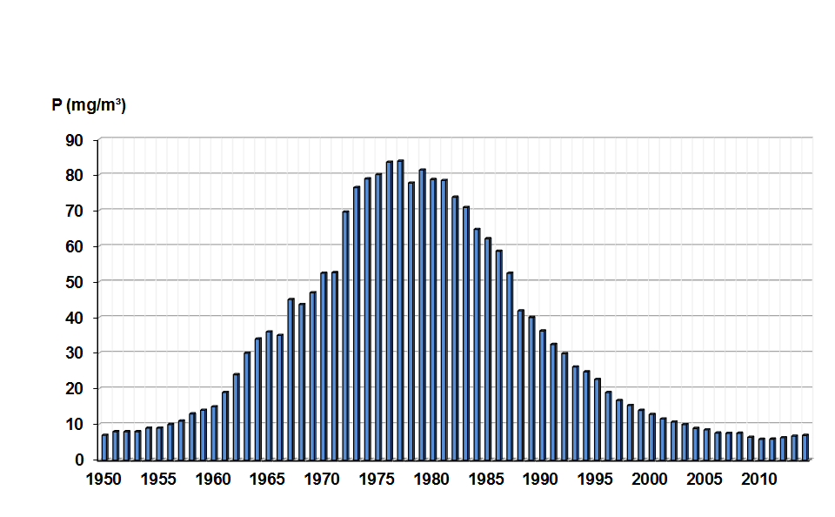

**Data source:** International Commission for the Protection of Lake Constance (2013).

Besides measures to build up wastewater treatment plants, there were, and still are, several measures within the catchment to reduce nutrient input from agriculture or to restore the lake’s banks. Furthermore, a drinking water protection area of 8.4 km² near the abstraction points was legally specified in 1987. Future challenges for the integrated management of Lake Constance will be the effects of climate change and micropollutants.

1.4 Relationships between the water industry directives and the WFD.

The main aim of European water policy is to ensure that sufficient good-quality water is available for people’s needs and for the environment.

The WFD promotes sustainable water use based on the long-term protection of water resources. In so doing, it contributes to the provision of sufficient supplies of good-quality bathing water and high-quality sources of drinking water intended for human consumption.

In the legislation, there is no direct link between drinking water quality and surface water or groundwater status under the WFD. The DWD considers the raw water from abstraction, through storage and treatment, to the drinking water distribution system and final delivery to the consumer at the tap. The river basin management plan under the WFD covers the water abstraction source, the water supply zone, its catchment and the wider environment within the area of the river basin, including bathing waters as well as point source pollution from domestic or industrial wastewater treatment plants.

Water from the environment supplies drinking water. Drinking water is treated to protect people from the risks presented by raw water. The elements that the DWD and WFD have in common are the raw water source and its catchment on a broader scale. The consequence of low quality raw water is more investment in treatment or water transfers. Both of these potentially result in higher energy use, more carbon emissions and higher prices for consumers.

Under the WFD regime, full implementation of basic measures is required, including compliance with the UWWTD. Going beyond the requirements of the UWWTD to improve wastewater treatment may be identified in river basin management plans as necessary for a waterbody to reach good status. Meanwhile, the improvements to a wastewater treatment plant undertaken to meet the UWWTD could feed into an overall improvement in status under the WFD.

Rather than aiming to meet a particular objective under a water industry directive in isolation, considering the synergies between each of the water industry directives and the WFD could lead to benefits such as more cost-effective measures, as well as improvement of the status and quality of waters.

Box 1‑2 Improvement in bathing water quality: Blackpool, north-west England

Tourism plays a major part in the economy along much of the Fylde coast of north-west England. This region, bounded by Fleetwood to the north and the Ribble estuary to the south, has four main population centres: Blackpool; Lytham St Annes; Southport; and Preston, located further inland. Blackpool is one of the country's most famous resorts and is visited by over 17 million people a year. The area had a long history of water quality problems, which had increasingly begun to threaten the local tourist industry.

A major programme of improvements was required. United Utilities have implemented a number of co-ordinated schemes to enhance sewerage infrastructures and increase wastewater treatment capability in order to address the quality of bathing water along this part of the coast. These included the provision of improved disinfection facilities and substantially increased storage for stormwater, together with the upgrading of treatment works and changes to outfall arrangements. Over the last 20 years, GBP 1 billion were spent improving the region's bathing water sites, with plans to invest a further GBP 250 million between 2015 and 2020.

In 1988, just six of the then 29 waters monitored in the region met bathing water guidelines. By 2014, all bathing water sites were of the necessary standard (source: United Utilities bathing water homepage: http://www.unitedutilities.com/Bathing-waters.aspx.).

# Protecting surface waters from nutrient and organic pollution

2.1 Introduction

From its inception, EU water policy has focused on pollution reduction of surface waters and groundwater. The Urban Wastewater Treatment Directive aims at protecting surface waters from pollution to minimise possible impacts on human health and to protect the environment. The Bathing Water Directive, with a primary focus on protecting human health, obliges Member States to achieve certain microbiological standards to avoid people getting infections. With its quality standards to protect human health, the Drinking Water Directive set standards for raw water quality as well as for the protected areas for drinking water supply. The Water Framework Directive serves as an umbrella, integrating the requirements of water related directives and stipulating integrated management of river basins.

For water industry directives, cross-cutting interests are predominantly around limiting pollutants entering water sources or watercourses. Excess nutrients, from wastewater treatment plants and agriculture, are addressed by the UWWTD and, indirectly, by the DWD. Organic pollution can be measured by the biochemical oxygen demand (BOD), which is a key determinant under the UWWTD.

Challenges to maintaining and improving water quality remain, for example diffuse pollution from agriculture as well as point source pollution from sewer overflows.

2.2 Pressures and status of nutrient pollution

Excess nutrients can cause eutrophication, a process characterised by increased plant growth, proliferation of algal blooms and an undesirable disturbance to the species composition and abundance of the organisms in the water (EEA, 2012).

In addition, eutrophication can lead to more serious problems, such as low levels of oxygen dissolved in the water. This happens when large amounts of algae die and decay. The process of decay uses up the oxygen in the water. Like the effects of high loads of organic matter in wastewater (high BOD, described in chapter 3), this can kill fish and other aquatic organisms. In rivers and lakes, eutrophication is mainly caused by high concentrations of phosphorus, whereas nitrogen enrichment is the main reason for eutrophication in coastal and marine waters (Chislock et al. 2013).

Nutrients in groundwater could also be a source of pollution for surface waters, if rivers or lakes are strongly influenced by groundwater, e.g. where groundwater levels are high particularly in the lowlands. Groundwater or surface water with high nitrate concentrations, can pose a risk to human health.

The main sources of nitrogen and phosphorus are point source emissions from UWWTPs and industry, and diffuse emissions from agriculture such as fertilisers and manure.

Figure 2.1 shows a decline in the nitrogen and phosphorus emissions from the domestic sector in 1990, 2000 and 2009.

Figure 2.1 Intensity of nitrogen and phosphorus emissions from the domestic sector.

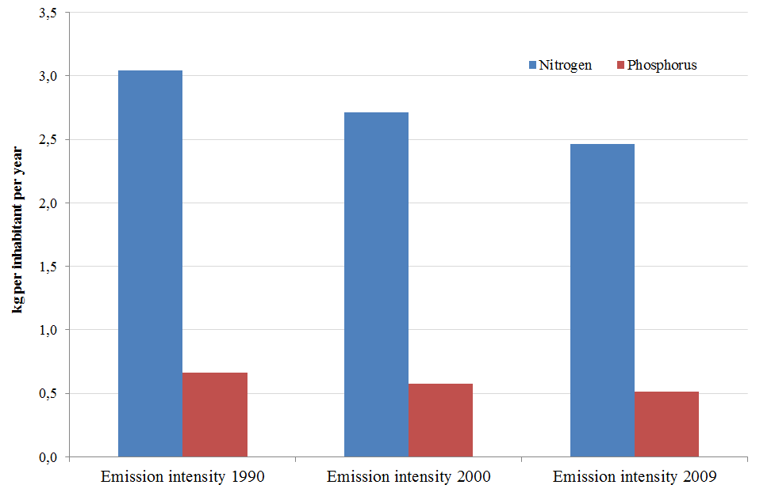

**Data source:** <http://www.eea.europa.eu/data-and-maps/indicators/emission-intensity-of-domestic-sector/assessment>. The nutrient emission intensity here is expressed in kilograms of nutrient discharged into the environment per inhabitant per year (kg/inhabitant x year).

Figure 2.2 shows a decline in the nutrient emission intensity of the manufacturing industry in Europe during 2004, 2007, 2010 and 2012. (Further information is available at <http://www.eea.europa.eu/data-and-maps/indicators/emission-intensity-of-manufacturing-industries-1/assessment>.) Note that interpretation of this graph may be biased due to the influence of the economic crisis in 2008.

Figure 2.2 Intensity of nutrient emissions from the manufacturing industry.

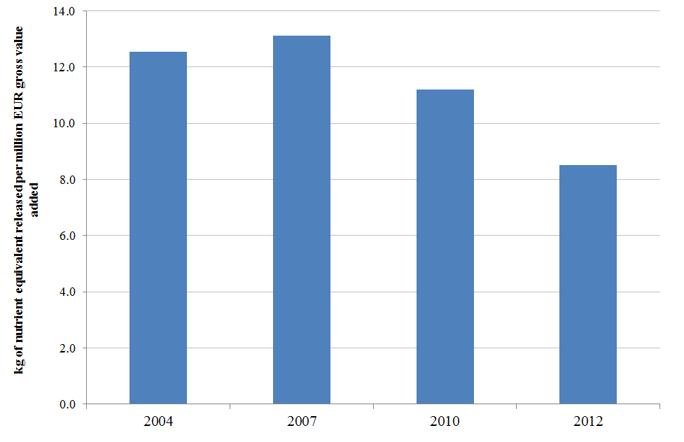

**Data source:** <http://www.eea.europa.eu/data-and-maps/indicators/emission-intensity-of-manufacturing-industries-1/assessment>. The nutrient emission intensity here is measured in kilograms of nutrient equivalent released per million euros gross value added.

Nutrient emission intensities showed downward trends in the domestic sector and the manufacturing industry during the assessed periods. Similarly, nitrogen (nitrate) and phosphorus (orthophosphate) concentrations in rivers declined (Figure 2.3).

Figure 2.3 Nutrient trends in European rivers.

|  |  |
| --- | --- |
| Nitrate | Phosphate |
|  |  |

**Source:** <http://www.eea.europa.eu/data-and-maps/indicators/freshwater-quality/freshwater-quality-assessment-published-may-2>

**1992-2012:** Austria, Belgium, Bulgaria, Germany, Denmark, Estonia, Finland, France, Ireland, Latvia, Liechtenstein, Lithuania, Luxembourg, Norway, Poland,  Slovakia, Slovenia, Sweden, Switzerland, United Kingdom  
**2000-2012:** Austria, Belgium, Bosnia-Herzegovina, Bulgaria, Croatia, Cyprus, Denmark, Estonia, Finland, France, Germany, Iceland, Ireland, Italy, Latvia, Liechtenstein, Lithuania, Luxembourg, Former Yugoslav Republic of Macedonia, Netherlands, Norway, Poland, Romania, Serbia, Slovakia, Slovenia, Sweden, Switzerland, United Kingdom

In European rivers, the average concentration of orthophosphate fell by more than half over the period 1992–2012. This can be attributed to measures taken under the UWWTD, in particular the removal of nutrients during wastewater treatment. In addition, the introduction of phosphate-free detergents has contributed considerably to the reduction of phosphate concentrations in surface waters.

During the past few decades, phosphate concentrations have also gradually reduced in many European lakes. Many outlets from wastewater treatment plants have been diverted away from lakes to rivers and this has led to significant phosphate reduction.

The assessments of the first river basin management plans under the WFD showed that diffuse pollution from agriculture constitutes a significant pressure for more than 40 % of Europe’s rivers and coastal waters, as well as for one third of Europe’s lakes and transitional waters (EEA, 2012).

Intensive use of mineral fertilisers and manure leads to high nutrient surpluses often causing diffuse nutrient pollution of surface waters, and groundwater. While phosphate is adsorbed to particles in the soil, limiting its release into water, nitrogen compounds, especially nitrate can dissolve in water and seep through the soil leaching into groundwater.

Figure 2.4 shows the nitrate concentration in Europe’s groundwater from 1992 to 2012. The shorter time series shows a similar pattern, with hardly any trend, although this larger selection of groundwater bodies shows a slightly higher average concentration level.

Natural nitrate levels in groundwater are generally very low (typically less than 10 mg/l NO3), although this depends on the oxygen concentration, since low oxygen availability favours nitrite over nitrate. Nitrate concentrations greater than natural levels are caused entirely by human activities, such as agriculture, industry, and domestic effluents.

Figure 2.4 Nitrate concentration in Europe’s groundwater.

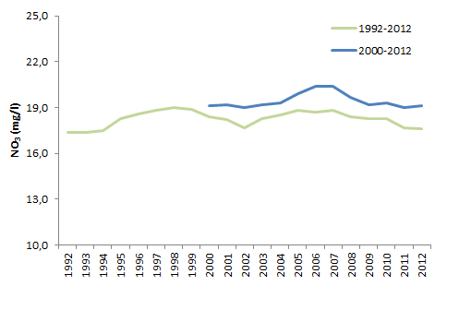

**Source:** <http://www.eea.europa.eu/data-and-maps/indicators/nutrients-in-freshwater/nutrients-in-freshwater-assessment-published-6>

**1992-2012:**  Austria, Belgium, Bulgaria, Denmark, Estonia, Finland, Germany, Ireland, Liechtenstein, Lithuania, Netherlands, Norway, Portugal, Slovakia, Slovenia.  
**2000-2012:** Austria, Belgium, Bulgaria, Cyprus, Czech Republic, Denmark, Estonia, Finland, France, Germany, Ireland, Italy, Liechtenstein, Lithuania, Luxembourg, Malta, Netherlands, Norway, Portugal, Serbia, Slovakia, Slovenia, Spain, Switzerland, United Kingdom.

2.3 Impacts of nutrient pollution and eutrophication

2.3.1 Eutrophication in bathing waters

Algae (i.e. phytoplankton) are most abundant in the summer. Their abundance is linked to the availability of nutrients in the water. Nutrient enrichment/eutrophication may therefore cause excessive growth of plankton algae (i.e. increase in phytoplankton biomass) which increases the concentration of chlorophyll a. This in turn may result in an increase in frequency and duration of phytoplankton blooms, which can pose hazards to human health in the case of toxic blue-green algae (EEA, 2012).

In marine and coastal waters, the chlorophyll a concentration is a proxy for the primary production and indicates the amount of phytoplankton. The higher the concentration, the higher the biomass of algae (Figure 2.5).

Figure 2.5 Chlorophyll a concentrations in European seas.

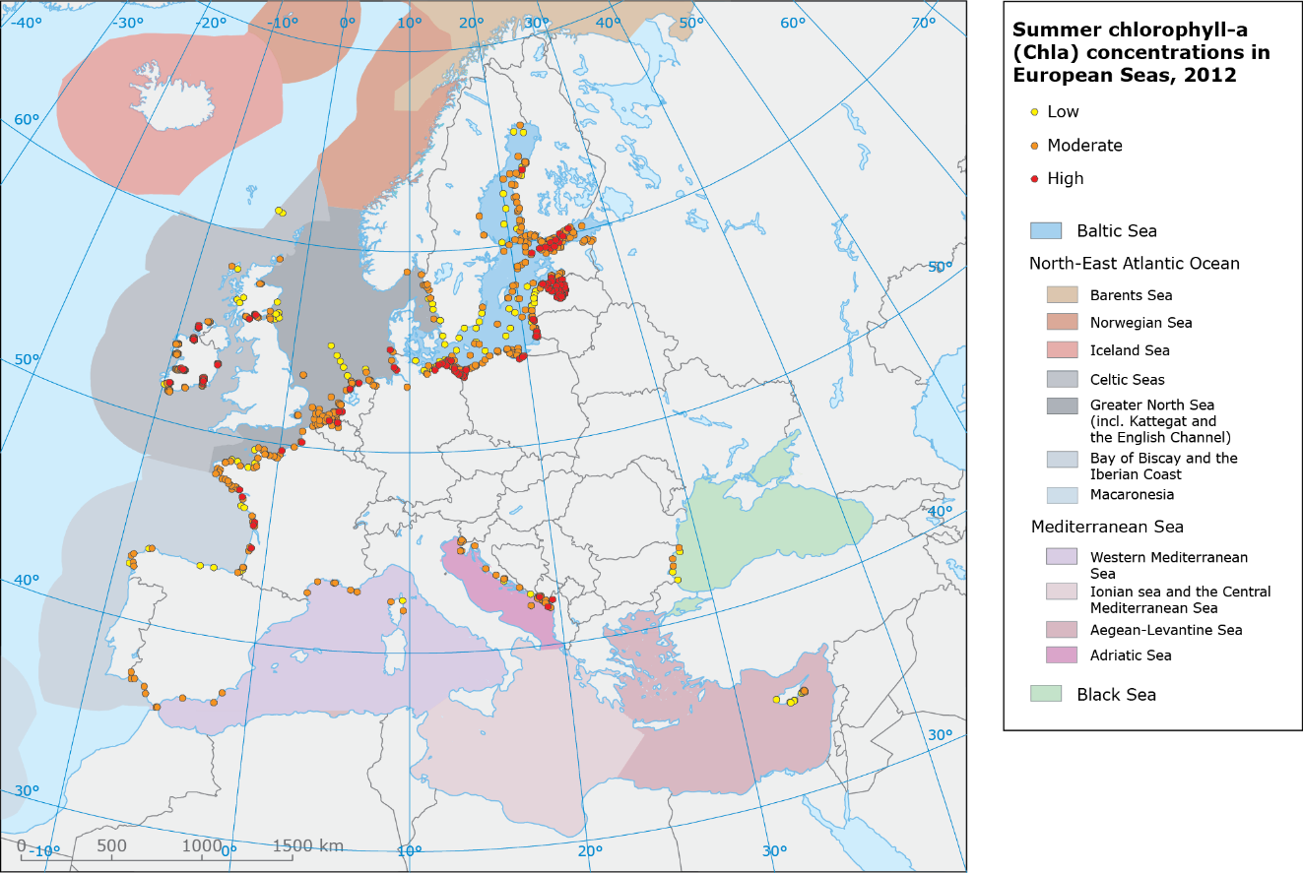

**Source:** http://www.eea.europa.eu/data-and-maps/figures/map-of-summer-chlorophyll-a-concentrations-observed-in-2.

Chlorophyll a concentrations are moderate or high in most European seas. According to reported data between 1985 and 2012 (http://www.eea.europa.eu/data-and-maps/data/waterbase-transitional-coastal-and-marine-waters-10) concentrations are decreasing in the Greater North Sea, Bay of Biscay and Adriatic Sea, but increasing in many parts of the Baltic Sea. The species that make up the pelagic food web and how it functions may change in ways that exacerbate the negative effects of excessive phytoplankton growth. Eutrophication in seas can also promote harmful algal blooms that may discolour the water, produce foam, kill off benthic fauna and make fish or shellfish poisonous to humans. Furthermore, excessive algal blooms in coastal waters (as well as in freshwater) could also affect tourism, with immense effects on the economy of the regions concerned.

Highly polluted lakes often have harmful blue-green algal blooms in summer. Optimal conditions for blue-green algae include intense radiation, high temperature, high levels of nutrients (phosphorus and nitrogen) and a lack of flow or turbulence. Blooms can endanger human health because of the proliferation of algal toxins. They can cause rashes, skin and eye irritation, allergic reactions and other effects.

Blue-green algae produce microcystin, which is a toxin. WHO sets standards of 1 μg/l for microcystin in drinking water (WHO, 2003a). If the level exceeds this value, additional treatment is necessary, or drinking water should be taken from a different source (see also Annex A3).

2.3.2 Nitrogen in drinking water

The DWD sets standards for drinking water of 50 mg/l of nitrate (NO3) and 0.5 mg/l of nitrite (NO2). This is due to the fact that nitrate can subsequently turn into nitrite in the human body. Nitrite oxidises the iron in the haemoglobin of the red blood cells thereby forming methaemoglobin, which lacks the oxygen-carrying ability of haemoglobin. This can create the condition known as methaemoglobinaemia (sometimes referred to as ‘blue baby syndrome’), in which blood cannot carry enough oxygen to the cells, so the veins and skin appear blue. The health concern is primarily if infants drink contaminated water (WRC, 2014).

In Europe, about 50 % of drinking water is taken from groundwater and about 30 % from surface water. Many waters in Europe are polluted with nutrients, and the levels of nitrate in groundwater have not decreased over decades. This might affect the supply of high-quality drinking water in the future, because the purification of highly contaminated raw water is becoming increasingly difficult and expensive. Increasing costs of water treatment could therefore also raise the price of drinking water for consumers.

2.4 Policies and measures to reduce nutrient pollution

The WFD is the key instrument for protecting water and setting quality objectives with respect to pressures such as pollution from diffuse sources (e.g. agriculture) or point sources. The UWWTD is one of the most important basic measures alongside the WFD and relates largely to point sources. Implementing the UWWTD has led to an increasing proportion of the EU’s population being connected to municipal treatment works via sewer networks. Furthermore, treatment levels have increased, moving from mechanical to biological treatment or to more stringent treatment (N and P removal). However, although there are national regulations that set standards for small waste water treatment plants (less than 2000 p.e.), neither the UWWTD nor any other European legislation directly addresses small-scale sanitation, which is inadequate in some locations. This poses a potential threat to water quality and public health particularly in rural areas (EEA, 2015).

Besides urban wastewater treatment, cost-effective measures to tackle diffuse agricultural pollution are also triggered through the WFD and its river basin management plans where water bodies are not in good status. The WFD covers the requirements for protected areas under the NiD, the BWD and the UWWTD, which include restrictions on water use, in particular for agriculture.

Box 2‑1 Good practice: two examples

1: Pollution of a reservoir in Hesse, Germany, was found to be caused by significant nutrient discharges from six small-scale UWWTPs on the two tributaries to the lake. The discharges caused blue-green algal blooms and repeated fish kills between the year 2000 and 2009. Subsequently bathing was banned in the summer months. This led to a reduction of income from tourism and so the local authorities and other concerned parties developed a common strategy to combat eutrophication of the lake. The following objectives were set: (a) halving the concentration of phosphorus in the discharges from all six waste water treatment plans, (b) merging two treatment plants and in addition diverting wastewater to another plant with higher treatment capacity, (c) reducing the percentage of water from external sources and (d) refurbishment of the sewer collection system. These measures have greatly improved the trophic condition in the lake. Since 2010, there have been no further algal blooms.

Blue-green algae bloom in a reservoir, Germany. Photo. J. Völker

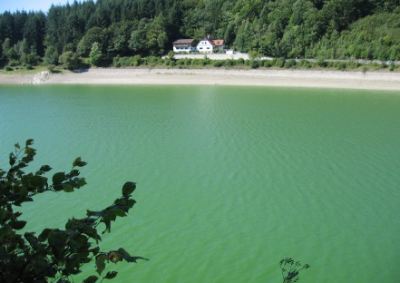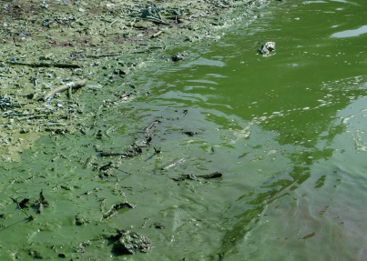

2: In the Federal State of Baden-Württemberg, Germany the “Protected Areas and Compensatory Regulation” (Schutzgebiets- und Ausgleichsverordnung - SchALVO) was adopted which aims to protect the raw drinking water from agricultural nutrient and pesticide contamination. The regulation restricts land use practices in the water protection areas according to different zones: zone I, ‘nitrate sanitation areas’; zone II, ‘nitrate problem areas’; and zone III, ‘normal areas’. The ‘water cent’ is an additional tax on the consumer price for drinking water to compensate farmers for implementing agri-environmental measures and potential losses in income (Umweltministerium BW, 2001).

2.5 Biochemical oxygen demand: a key indicator of water quality

2.5.1 Background

Biochemical oxygen demand is the amount of dissolved oxygen needed by aerobic organisms to break down organic material present in a water sample. It is a common indicator of organic biodegradable pollution and used to assess the effectiveness of wastewater treatment plants (Clair et al., 2003). Concentrations of BOD normally increase as a result of organic pollution caused by discharges from wastewater treatment plants, as well as industrial effluents and agricultural run-off. Severe organic pollution may lead to rapid de-oxygenation of river water, and can harm fish and aquatic invertebrates. BOD concentrations therefore provide an insight into the quality of water for aquatic life.

The most important sources of organic waste are from domestic wastewaters, from certain industries such as paper or food processing, and from agriculture in silage effluents and manure.

.

As outlined in Annex A3, the UWWTD regulates waste water discharges from domestic sources, certain industries such as paper or food processing, and from agriculture in silage effluents and manure The directive explicitly specifies which kind of treatment must be applied. Biological wastewater treatment (‘secondary treatment’) significantly reduces biodegradable pollution in wastewater and therefore has a direct influence on the surface water quality, in particular the organic carbon expressed as BOD.

2.5.2 Reduction of BOD in rivers due to urban wastewater treatment

Industrial and agricultural production increased in most European countries after the 1940s. Owing to a greater share of the population being connected to sewage collection and treatment systems the discharge of organic waste into surface water increased. Over the past 15 to 30 years, however, more and waste water treatment plants have introduced biological treatment (secondary treatment) and organic discharges have subsequently decreased throughout Europe.

In European rivers, biological oxygen demand (BOD) decreased by 1.6 mg/l between 1992 and 2012 (Figure 2.6).

Figure 2.6 Trend of 5-day BOD in European rivers.[1]

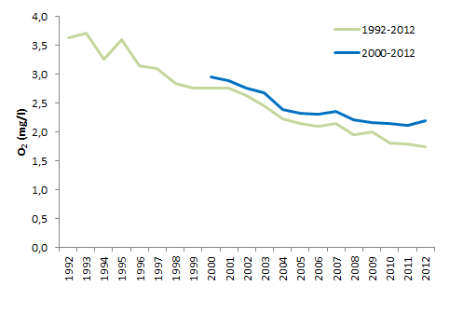

**Source:** <http://www.eea.europa.eu/data-and-maps/indicators/freshwater-quality/freshwater-quality-assessment-published-may-2> Figure 4.1 depicts two time series: the longer time series has fewer stations (539) and the shorter time series has more stations (1 235).

**1992-2012:**, Austria, Belgium, Bulgaria, Denmark, Estonia, Finland, France, Ireland, Latvia, Lithuania, Luxembourg,  former Yugoslav Republic of Macedonia, Slovakia, Slovenia, United Kingdom.  
**2000-2012:** Austria, Belgium, Bosnia-Herzegovina, Bulgaria, Croatia, Denmark, Estonia, Finland, France, Ireland, Italy, Latvia, Lithuania, Luxembourg, Former Yugoslav Republic of Macedonia, Poland, Romania, Slovakia, Slovenia, United Kingdom.

Figure 2.7 charts the changes of BOD concentration in rivers from 2000 to 2012 and the related percentages of the population connected to at least secondary treatment of municipal wastewater in 2010. There is a clear relation between BOD concentration in 2012 (red squares) and the percentage of inhabitants with secondary or more stringent treatment. However, Italy (94 % of inhabitants with adequate treatment), Belgium (73 %) and Poland (66 %) have BOD concentrations above 2 mg/l, which can be regarded as the cut-off point between slightly and moderately polluted rivers (e.g. LAWA 1998).

The largest decrease of BOD concentrations between 2000 and 2012 were in Macedonia, Luxembourg, Bulgaria and France. Concentrations fell by 54 %. Almost all countries with low concentrations of BOD (except Ireland, Latvia and Slovenia) have high proportions of the population (above 80 %) with at least secondary treatment. In all countries with high percentages of the population connected to at least some treatment, BOD concentrations in the river are low or water quality is gradually improving.

Figure 2.7 Changes of BOD concentrations in rivers between 2000 and 2012, and proportion of population with at least secondary treatment (2010).

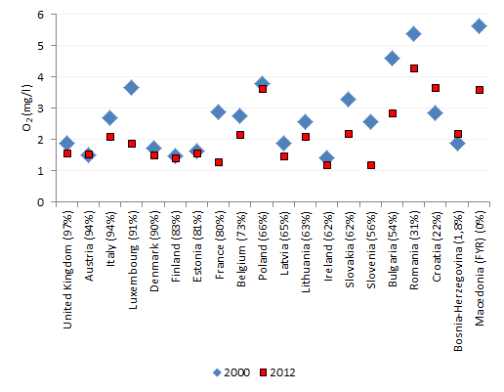

**Note:** Percentages in parentheses are inhabitants with secondary or more stringent treatment of urban wastewater (2010).

**Sources:** http://www.eea.europa.eu/data-and-maps/indicators/freshwater-quality/freshwater-quality-assessment-published-may-2; http://ec.europa.eu/eurostat/tgm/table.do?tab=table&init=1&language=en&pcode=ten00020&plugin=1

2.6 Storm water overflow from combined sewers

Combined sewers transport urban waste water as well as urban surface runoff in one pipe. Large amounts of rainfall in a short period can exceed the design capacity of the combined sewer leading to a combined sewer overflow (CSO). If the retention capacity of the sewers or the waste water treatment plant is insufficient, the excess water can cause flooding and untreated waste water is released.

Organic substances, hydrocarbons, chemicals, heavy metals, litter and pathogens (e.g. bacteria, viruses, parasites) in the released waste water can adversely affect water quality and aquatic life and impair bathing or the use of drinking water from nearby drinking water supply zones. CSOs lead to a multiple, diffuse and uncontrolled source of pathogens and pollutants in surface waters. It is one of the major threats for the quality of bathing waters (see chapter 3), and therefore for human health (Cools et al, 2016). Chemicals in CSOs may cause oxygen depletion, nutrient enrichment/eutrophication and toxic effects for aquatic organisms. These can result from pesticides, herbicides, fertilisers and other substances commonly applied to urbanised areas, farmlands and suburban gardens.

There are no EU-wide statistics on the actual number of CSOs at the agglomeration or at the national level. Ten EU Member States (Austria, Bulgaria, the Czech Republic, Finland, France, Germany, the Netherlands, Slovakia, Sweden and the United Kingdom) reported in 2010 under the WFD reporting that CSOs exerted a significant pressure on the ecological status of surface waters in their river basin districts.

As the implementation of the UWWTD is now quite advanced, it seems likely that efforts to improve ecological status under the WFD will bring more focus on the management of CSOs. By nature it will not be possible or economically feasible to design sewers to cope with all extreme events, but management measures can try to optimise the retention capacity of CSOs. Management solutions need to control the frequencies, volumes and pollutant loads to the receiving waters.

In the future, the impacts of storm water overflows could also be influenced by climate change, as changes in precipitation can influence the frequency and volume of discharges from CSOs. In the future, more intense rainfall events are expected particularly in Northern and Central Europe and these might cause more frequent overflows and with larger volumes. In addition, urban developments and increased sealing of surfaces could exacerbate the problem and result in even higher run-off and greater risk of storm water overflows (Moreira et al, 2016).

2.7 Emerging issues

In addition to nutrient and organic pollution there are a number of emerging issues some of which are as yet poorly understood in their potential impacts to public health and the integrity of aquatic ecosystems.

Emerging pollutants are typically chemicals present at low concentrations but which may have harmful effects on aquatic organisms or those that feed on them. They are not necessarily new chemicals. Emerging pollutants can be defined as pollutants that are currently not included in routine monitoring programmes at the European level and which may be candidates for future regulation, depending on research on their (eco)toxicity, potential health effects and public perception and on monitoring data regarding their occurrence in the various environmental compartments. Examples from the list of emerging substances are surfactants, flame retardants, pharmaceuticals and personal care products, gasoline additives and their degradation products, biocides, polar pesticides and their degradation products and various proven or suspected endocrine disrupting compounds (EDCs) (<http://www.norman-network.net/?q=node/19>). Such pollutants are not currently covered by EU legislation but the WFD provides a mechanism by which concentrations in the aquatic environment can be controlled.

Plastic in the environment is another emerging issue, especially the impacts of micro-plastics in the environment. Micro-plastics are pieces of plastic than have been scoured and degraded and are generally defined as being less than 5 mm in size. They have been recognised as a widespread contaminant in the marine environment (GESAMP, 2015) but their relevance is being increasingly discussed also for freshwaters. Research into the impacts from micro-plastics is under way. So far, European water legislation does not control the sources of micro-plastics, their pathways from land through wastewater treatment plants or from diffuse sources.

Antimicrobial resistance (AMR) is a phenomenon highly relevant for human health. It refers to the acquired resistance of a microorganism to an antimicrobial drug that was originally effective for treatment of infections caused by it. Resistant microorganisms are able to withstand attack by antimicrobial drugs (e.g. antibiotics), so that standard treatments become ineffective and infections persist, increasing the risk of spread to others (WHO 2015). This novel risk in the aquatic environment is at an early stage of research, but some recent work shows that increases in number of AMR bacteria could be associated with the proximity to wastewater treatment plants (Amos et al 2014, 2015).

# Protecting drinking water and bathing water from microbial pollution

3.1 Introduction

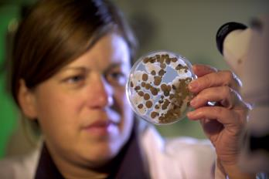Protection of human health from microbiological risks is a key aim of EU water legislation. Both the Drinking Water Directive and the Bathing Water Directive set microbiological standards to protect humans from possible infections resulting from water-based human or animal faeces. Where water status is impaired due to microbial pollution this can be reported as a main impact for failing to achieve good status of surface waters and groundwater.

3.2 Causes of microbiological pollution

Microbiological pollution caused by microorganismssuch as bacteria, viruses and protozoa. Micro-organisms can cause severe health problems when ingested including gastrointestinal diseases, cholera, typhoid and hepatitis. Possible risks are generally well under control and infections are rarely lethal in Europe. Water-based infections of humans can either by drinking polluted water or through body contact e.g. bathing in contaminated water.

Microbial pollution of natural waters can be assessed using certain faecal indicators, which indicate the presence of human or animal faeces in wastewater. The threat to human health comes from ingestion of coliphage viruses that infect the bacterium *Escherichia coli* (EPA, 2015). Therefore, we can assess health risks by monitoring indicative bacterial concentrations.

Such micro-organisms are typically found in sewage water, or washouts from fields for livestock grazing, manure-spreading and other farming activities. In addition, wildlife and domestic animals as well as humans bathing or sporting in surface waters can a source of microbial pollution. Furthermore, some naturally-occurring microorganisms can be harmful to human health (WHO, 2003b).

The most frequent causes of microbiological pollution reported under the BWD is pollution from sewage water as a result of sewer system failures or activation of sewer overflows , water draining from farms and farmland, and animals and birds on or near beaches (EEA, 2016).

Studies on the influence of effluents from wastewater treatment plants and combined sewer overflows upon the microbial quality of surface water usually show an increase of faecal contamination following storms (WHO 2003b). The impact might be especially large in small river catchments, where the concentrations of microorganisms downstream from sewer overflows may be hundred times greater after a storm than in dry weather. However, the actual impact of CSOs also depends on numerous environmental factors, therefore an assessment needs to be site specific.

The principal problems, combined with the specific characteristics of each bathing area, lead to a complex combination of pressures and impacts. For example, heavy rain may cause flooding of nearby pastures resulting in wash-out of significant microbiological pollution into the bathing area. In Germany, authorities reported that two bathing areas on Lake Constance had to be closed for this reason in 2014, while in other areas such events occur much more frequently e.g. in the Walloon Region where grazing of livestock on the meadows along the rivers was even prohibited to stop microbial pollution of the bathing sites. Other sources of microbiological pollution, e.g. public infrastructure, abandoned facilities or landfills near bathing water sites, may further complicate tracking the relevant source of pollution. An incidence at one bathing site in Portugal in 2013 was probably caused by a wastewater treatment plant not working properly (EEA 2015). But also bathers themselves when appearing in large numbers for extended periods can increase microbiological pollution of the water. In the Mediterranean this happens quite often throughout the bathing season (Saliba and Helmer 1990).

The BWD obliges the national authorities to monitor and report on bathing water quality. Regular monitoring and assessment has led to a better understanding of the causes of microbial water pollution. This has encouraged the development of targeted measures to reduce the microbial pollution in designated bathing sites. For example, Sweden has recently introduced a law that forbids all recreational ships and boats to discharge sewage into its territorial waters.

3.3 Monitoring of microbiological pollution: role of the directives

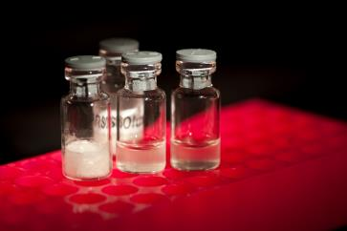The core principle is to identify faecal pollution sources and potential entry points into the aquatic environment, and to take action to reduce the presence of, or exposure to, hazards until they reach acceptable levels. Targeted measures can include emission reductions at municipal sewage discharge points, treatment works, combined sewer overflows and prosecution of illegal connections to combined sewers (WHO, 2003b).

The EU water industry directives prescribe monitoring of bacterial groups that are essential for assessing water quality for human use. Depending on the use of the water (bathing or drinking) different bacteria must be monitored.

DWD:

* *Clostridium perfringens*, including spores (if water originates from or is influenced by surface water)
* *Eschicheria coli*
* *Pseudomonas aeruginosa* (if water is offered for sale in bottles or containers)
* coliform bacteria.

BWD:

* *Escherichia coli*
* intestinal enterococci
* cyanobacteria.

The UWWTD does not require monitoring of specific bacteria, but instead prescribes monitoring of BOD, phosphorus and nitrogen. These indicate levels of nutrients that are able to support bacterial life (see also chapter 2 and Annex A3).

The European database on bathing water quality contains almost 1.1 million samples,  composing a time series of eight years (2008–2015). The data on bacterial concentrations covers bathing season which is generally from June to September.

Bathing sites are located in different categories of waters, each having their own geographical, physico-chemical and hydromorphological characteristics: coastal waters, lakes, rivers and transitional waters (typically estuaries and lagoons) (Table 3.1). Almost three-quarters of the designated bathing waters are on the coastlines of the sea; these are followed by lakes, which account for 21 % of all samples. The BWD defines quality classification limits depending on the surface water type. Therefore, unlike other water industry directives, the BWD provides data on microbiological pollution per water category but does not go as far as the WFD which stipulates the definition of surface water types within water categories.

Table 3‑1 BWD samples by water category.

|  |  |  |  |
| --- | --- | --- | --- |
| Type | BWD quality classification group | Number | Share of total (%) |
| Coastal | Coastal and transitional | 944 530 | 74 |
| Transitional | 18 274 | 1.5 |
| Lake | Inland | 272 340 | 21 |
| River | 42 983 | 3.5 |
| Total | | 1 278 127 | 100 |

On the other hand, the DWD provides data on the microbiological state of the water when it enters the distribution and supply system. According to the UWWTD, Member States have to provide monitoring data on the water discharged directly from the wastewater treatment plant, which is still polluted with microorganisms despite its treatment in the plant (Wakelin et al., 2008).

3.4 Microbiological pollution of bathing waters

According to the BWD, good bathing water quality is achieved if 95th percentile of all samples at the site in the most recent assessment period is lower than defined limits of intestinal enterococci and *E.coli*. Limits for coastal and transitional waters are 200 CFU/100ml of intestinal enterococci and 500 CFU/100ml for *E.coli*. For inland waters the limits are higher: 400 CFU/100ml for intestinal enterococci and 1 000 CFU/100ml for *E.coli*. For coastal and transitional waters, 2.2 % of all samples exceeded the limits, and likewise 2.2 % of all samples exceeded the limits for good bathing water quality in inland waters[2].

Figure 3.1 shows bacterial concentrations in European bathing waters. The data since 2008 shows no clear trend in bacterial concentrations, although in the 2015 bathing season a decrease in bacterial concentrations especially for *E. coli* can be noted.

The shorter-term time series (paler trend lines) cover a larger number of European bathing water sites and generally shows higher average bacterial concentrations. This indicates that bathing waters added to the monitoring programme more recently are of lower quality.

Figure 3.1 All-European trends in intestinal enterococci and *E. coli* concentrations in bathing waters.

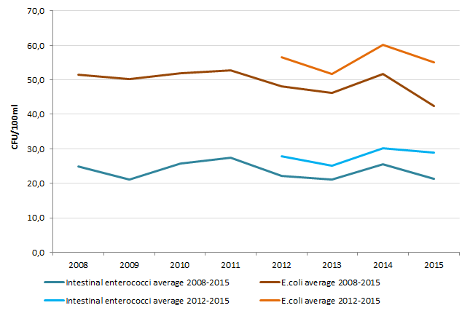

Figure 3.2 depicts bacterial concentrations per water category: coastal water, transitional water, lake and river. As expected, coastal bathing waters are of better quality than other water categories. They have fewer bacteria of both types owing to salt water providing harsher living conditions than freshwater. Coastal water bacterial concentrations are rather stable. *E coli* concentrations are around 49 CFU per 100 ml and intestinal enterococci concentrations around 27 CFU per 100 ml. The BWD classifies transitional waters according to the same standards. However, average bacterial concentrations are higher there than in coastal water, especially concentrations of *E. coli* (rising to 62 CFU per 100 ml in the 2015 season).

Bacterial concentrations in lake bathing waters were at their lowest in the 2013 season and rose again in 2014. *E. coli* reached 57 CFU per 100 ml and intestinal enterococci reached 30 CFU per 100 ml in the 2015 season.

Riverine bathing waters are the most polluted. They have exceptionally high concentrations of both *E. coli* (159 CFU per 100 ml) and intestinal enterococci (58 CFU per 100 ml) compared with other water categories, but with averages changing over the years.

Figure 3.2 Overall European trend in *E. coli* (left) and intestinal enterococci (right) concentrations by water categories (for bathing waters).

|  |  |
| --- | --- |
|  |  |

4 Information to the public

4.1 Introduction

As a resource essential for life it is important that the public has up-to date information on drinking and bathing water quality and about urban wastewater treatment. The European citizen initiative ‘Right2Water’ highlighted the level of interest in these issues. In response to this initiative, the European Commission committed itself to several actions to increase transparency with regard to water quality, supply and treatment (EC 2014).

4.2 Reporting obligations

Member States report to the European Commission on the implementation of each of the water industry directives in regular reporting cycles, although the reporting frequencies differ between directives. The BWD requires annual reporting of monitoring data and significant management measures implemented or planned. For the UWWTD, data on discharges from UWWTPs have to be reported within 6 months of data requests (typically biannually) and on implemented measures every 2 years. Under the DWD reports on the quality of water intended for human consumption have to be submitted every three years. All data are submitted in digital format into WISE, the Water Information System for Europe. These data bases are used by the EEA for assessments and thematic reports on the environment. The EC checks the compliance of the data reported by Member States against the standards and requirements set out in the directives.

Data reported under the BWD includes results on monitoring of bathing water as well as information about the duration of the bathing season, abnormal situations, short-term pollution incidents and on bathing water locations. UWWTD data includes information on the size of the agglomerations, UWWTPs, the type of treatment, emission loads of pollutants, discharge points and spatial data on sensitive areas. The triennial DWD reports consist of general information on the number of water supply zones, number of residents and water sources, and the volume of drinking water supplied. Furthermore, Member States report on drinking water quality, and give information on non-compliance and exceedances of standards. If water does not comply with the standards, Member States need to report remedial actions (measures) as well as timeframes for the implementation of the measures.

Under the WFD the river basin management plans and the programme of measures need to be reported every six years. The reported data includes e.g. information on significant pressures and impacts, the status of surface water and groundwater bodies, a dedicated programme of measures for those water bodies not yet in good status, justification of exemptions and information on coordination within the river basin district and public participation. Hence, the river basin management plans comprise a monitoring instrument for river basin managers, stakeholders and the European Commission.

Currently, the timetables for reporting are quite different,, but there are efforts under way to streamline reporting, e.g. reporting for the WFD and Floods Directive have already been aligned.

4.3 Information dissemination

Each of the water industry directives requires that the public be informed of the results. The BWD describes the requirements for dissemination of information in Article 12. The EEA produces an annual report that publishes the results of the bathing water assessments. Article 13 of the DWD covers information and reporting about water intended for human consumption. According to these articles, Member States have to ensure that the public has adequate and up-to-date information on the quality of bathing and drinking water. The UWWTD obliges the Member States to publish periodic reports about the disposal of wastewater and sludge under Article 16.

The interlinkage between the EU-level information and the national information platforms is important. EU-level information provides an overview at broader scale, enabling citizens and other stakeholders to compare the situation across the EU according to legislative reporting requirements. National information platforms can cater more directly to a Member State’s own needs and be updated more readily with the latest available information.

WISE is one of the main ways of making water information available to the public at the European level. It comprises a wide range of data and information collected by the EU institutions, and presents them through a set of map and data viewers.

The viewers are accessible through the EEA’s bathing water and UWWTD websites. They allow users to examine bathing water quality as well as UWWTD data across Europe. Users can check bathing water quality on an interactive map, download data for a selected country or region and make comparisons with previous years. They can examine various UWWTD data (agglomerations, discharge points, sensitive areas, treatment plants, etc.) on the UWWTD map viewer.

# Conclusions

5.1 Integrated water management

This report has considered the aims of the Bathing Water Directive, the Drinking Water Directive and the Urban Wastewater Treatment Directive in the context of the Water Framework Directive. The different water industry directives have specific roles in delivering their respective objectives. Rather than aiming to meet a particular objective under a water industry directive in isolation, consideration of the synergies between each of the water industry directives and the WFD can lead to benefits such as better integration of needs in the design of more cost effective measures in order to improve the status and quality of our waters. The WFD with river basin management plans provide a powerful framework for achieving integrated water management and stakeholder dialogue across all relevant sectors.

Water of good quality for human consumption and recreation is intrinsically linked with water that is good for the environment, and all are related to the same pressures and drivers; pollution from diffuse and point sources. For example, water from the environment supplies drinking water. Drinking water is treated to protect people from the risks posed by raw water. Common elements between the DWD and the WFD are the protection of the raw water source and its catchment. The consequence of lower raw water quality is a higher investment in treatment or water transfers, and higher water prices for the consumers. Considering sustainability on a broad scale, an improved understanding of the relationships and synergies between the DWD and the WFD would help integrated decision-making.

Under the WFD regime, full implementation of basic measures is required, including compliance with the UWWTD. Going beyond the requirements of the UWWTD to improve wastewater treatment may be identified in river basin management plans as a necessary measure for the water body to reach good status. Meanwhile, the improvements to a wastewater treatment plant undertaken to meet the UWWTD could feed into an overall improvement in status under the WFD. Focusing on the desired outcome and thinking more broadly than sector-specific solutions can enable improved information for decision-makers.

5.2 Water quality and impacts on the environment and human health

The main quality parameters of cross-cutting interest considered in this report are nutrient enrichment, organic pollution and microbiological contamination.

Increased nutrient inputs can present risks to surface and ground waters. Excess nutrients can lead to eutrophication in surface waters, a process characterised by increased plant growth, problematic algal blooms, loss of life in bottom water and an undesirable disturbance to the balance of organisms present in the water. Nutrients in groundwater could be a source of pollution for surface waters, if rivers or lakes are influenced by groundwater. If polluted groundwater is used for drinking, it could also pose a risk to human health, requiring additional, often energy-intensive treatment or mixing with less polluted raw water.

The main sources of nitrogen and phosphorus are point source emissions from urban wastewater treatment plants and industry, and diffuse emissions from agricultural production. The integrated management under the WFD provides more instruments for the reduction of these pollutants at source; it is the key instrument to set quality objectives for pressures, such as pollution, from these diffuse or point sources. Alongside the WFD, the UWWTD is one of the most important basic measures related to point sources. It has led to an increasing share of the EU's population being connected to urban wastewater treatment, and to overall increased water treatment levels. However, small-scale rural sanitation is not directly addressed by the UWWTD or any other European legislation, and its inadequacy in some locations poses a potential threat to water quality and public health.

Microbiological pollution of water intended for consumption or recreation is of primary interest for public health. Microbiological pollution originates mainly in both direct point sources (waste-water treatment discharges or even direct sewerage system discharges) and diffuse surface sources (especially manure run-off from livestock farming). The most frequent cause of microbiological pollution reported under the BWD is pollution from sewage as a result of system failures or overflows from sewerage works, water draining from farms and farmland, and animals and birds on or near beaches.

5.3 Information and public interest

With their focus on the human part of the water cycle, and the quality of water for human consumption and use, the three water industry directives are of significant public interest.

The BWD, in particular, considers the public interest obliging the responsible public authorities to provide information on each bathing water site to the public in an easily accessible format during the bathing season. The EEA publishes annual reports of European bathing water quality and provides information on the EEA website, including links to national websites.

While up-to-date bathing water information is available to the public at bathing sites, timely information on regional and local drinking water quality is frequently rather scarce.

For the UWWTD, the EC publishes regular implementation reports on improvements in waste water treatment. In addition, the information reported by the Member States can be found in the Water Information System for Europe on the EEA website and the water data centre (WISE, http://water.europa.eu/).

5.4 Future challenges

As measures to reduce point source pollution improve, the significance of diffuse inputs will increase. Such inputs are typically more difficult to address and manage.

Surface water bodies can be affected by intermittent discharges of untreated wastewater from storm overflows in combined sewer systems (combined storm overflow (CSO)). This will occur where there is no or insufficient storm water overflow retention capacity. Often, the nearby watercourse (usually the surface water) receives the wastewater and water quality is affected as a consequence.

CSOs represent a multiple, diffuse and uncontrolled source of pathogens and pollutants and are one of the major threats to good bathing water quality (see chapter 2), and consequently to human health.

The long-term effects of climate change may also influence the degree of environmental impacts caused by intermittent discharges. Higher intensity rainfall may result in some overflows operating more frequently and with greater spilled volumes.

Diffuse pollution from agriculture can affect raw water supplies for drinking water, for example leading to the need for increased treatment or dilution with less contaminated sources. It can also affect water quality, where surface runoff transports nutrients, harmful chemicals and microbiological contaminants from manure into watercourses.

Emerging issues for water quality, which represent potential but as yet poorly understood risks, include newly-identified micropollutants, microplastics and antimicrobial resistance. Improving understanding of these topics, particularly the risk they might present to public health and water quality, represent new challenges.

References

Amos, G.C.A., Hawkey, P.M., Gaze, W.H. and E. M. Wellington, 2014. Waste water effluent contributes to the dissemination of CTX-M-15 in the natural environment.; 69: 1785–1791 doi:10.1093/jac/dku079

Amos, G.C.A., Gozzard, E., Carter, c.e., Mead, A, Bowes, M.J., Hawkey, P.M., Zhang, L., Singer, A.C., Gaze, W.H. and E.M. Wellington, 2015. Validated predictive modelling of the environmental resistome The ISME Journal (2015), 1–10 & 2015 International Society for Microbial Ecology All rights reserved 1751-7362/15

Castiglioni, S., Bagnati, R., Fanelli, R., Pomati, F., Calamari, D. and Zuccato, E., 2006, ‘Removal of pharmaceuticals in sewage treatment plants in Italy’, *Environmental Science & Technology*, (40) 357–363.

Chislock, M. F., Doster, E., Zitomer, R. A. & Wilson, A. E., 2013. Eutrophication: Causes, Consequences, and Controls in Aquatic Ecosystems. Nature Education Knowledge 4(4):10

Cools, j., Cavaco, Y.K., Emonts, M. and E. Boelee, 2016. Assessment of impact of storm water overflows from combined and separate waste water collecting systems on water bodies (including the marine environment) in the 28 EU Member States. Final Report for Task 1.4. Specific Contract No. 070201/2014/SFRA/693725/ENV/C.2. <https://circabc.europa.eu/sd/a/8e7b4f1d-f1b7-4bf8-a54e-ac9795ebeb50/Task%204%20Health%20impact>

EC 2016. 'Eighth Report on the Implementation Status and the Programmes for Implementation (as required by Article 17) of Council Directive 91/271/EEC concerning urban waste water treatment'. http://eur-lex.europa.eu/legal-content/EN/TXT/?uri=CELEX:52016DC0105

EC, 1991a, Council Directive 91/676/EEC of 12 December 1991 concerning the protection of waters against pollution caused by nitrates from agricultural sources. http://eur-lex.europa.eu/LexUriServ/LexUriServ.do?uri=CELEX:31991L0676:EN:HTML

EC, 1991b, Council Directive 91/271/EEC of 21 May 1991 concerning urban waste-water treatment (http://eur-lex.europa.eu/legal-content/EN/TXT/?uri=CELEX:31991L0271) accessed 25 September 2015. http://eur-lex.europa.eu/LexUriServ/LexUriServ.do?uri=CONSLEG:1991L0271:20081211:EN:PDF

EC, 1998, Council Directive 98/83/EC of 3 November 1998 on the quality of water intended for human consumption (http://eur-lex.europa.eu/LexUriServ/LexUriServ.do?uri=OJ:L:1998:330:0032:0054:EN:PDF).

EC, 2000, Directive 2000/60/EC of the European Parliament and of the Council of 23 October 2000 establishing a framework for Community action in the field of water policy (http://eur-lex.europa.eu/resource.html?uri=cellar:5c835afb-2ec6–4577-bdf8–756d3d694eeb.0004.02/DOC_1&format=PDF).

EC, 2002–2013, ‘The Commission synthesis reports on the implementation of Council Directive concerning Urban Waste Water Treatment’ (http://ec.europa.eu/environment/water/water-urbanwaste/implementation/implementationreports_en.htm).

EC, 2006, Directive 2006/7/EC of the European Parliament and of the Council of 15 February 2006 concerning the management of bathing water quality and repealing Directive 76/160/EEC (http://eur-lex.europa.eu/LexUriServ/LexUriServ.do?uri=OJ:L:2006:064:0037:0051:EN:PDF) accessed 1 October 2014.

EC, 2008a. Water Notes on the Implementation of the Water Framework Directive. Water Note 2. Cleaning up Europe’s Waters. INdetifying and assessing surface water bodies at risk, Brussels. <http://ec.europa.eu/environment/water/participation/pdf/waternotes/water_note2_cleaning_up.pdf>

EC, 2008b. Water Notes on the Implementation of the Water Framework Directive. Water Note 9. Integrationg water policy: Linking all EU water legislation within a single framework. Brussels. http://ec.europa.eu/environment/water/participation/pdf/waternotes/water_note9_other_water_legislation.pdf

EC, 2012, Sustainable water ecosystems management in Europe — Bridging the knowledge of citizens, scientists and policy makers, Editor: C. Sassa, IWA Publishing, London.

EC, 2013, Decision 1386/2013/EU of the European Parliament and of the Council of 20 November 2013 on a General Union Environment Action Programme to 2020 ‘Living well, within the limits of our planet’ (http://eur-lex.europa.eu/legal-content/EN/TXT/PDF/?uri=CELEX:32013D1386&from=EN).

EC, 2014. 177 final COMMUNICATION FROM THE COMMISSION on the European Citizens' Initiative "Water and sanitation are a human right! Water is a public good, not a commodity. Brussels. http://ec.europa.eu/transparency/regdoc/rep/1/2014/EN/1-2014-177-EN-F1-1.Pdf

EC, 2015 ‘Technical assessment of the implementation of Council Directive concerning Urban Waste Water Treatment (91/271/EEC), Final version 25 March 2015 ’ <http://ec.europa.eu/environment/water/water-urbanwaste/implementation/implem_report_2016/8th%20Technical%20assessment%20of%20information%20on%20the%20implementation%20of%20Council%20Directive%2091-271-EEC.pdf>

EEA, 2012, *European waters — Assessment of status and pressures*, EEA Report No 8/2012, European Environment Agency. http://www.eea.europa.eu/publications/european-waters-assessment-2012

EEA, 2015, *European bathing water quality in 2014*, EEA Report No 1/2015, European Environment Agency (http://www.eea.europa.eu/publications/european-bathing-water-quality-in-2014).

EEA, 2016, *European bathing water quality in 2015*, EEA Report No 9/2016, European Environment Agency (http://www.eea.europa.eu/publications/european-bathing-water-quality-in-2015).

EPA, 2015, ‘Basic information about pathogens and indicators in drinking water’ (http://water.epa.gov/drink/contaminants/basicinformation/pathogens.cfm) accessed 8 September 2015.

Gadipelly, C., Pérez-González, A., Yadav, G. D., Ortiz, I., Ibáñez, R., Rathod, V. K. and Marathe, K. V., 2014, ‘Pharmaceutical industry wastewater: review of the technologies for water treatment and reuse’, *Industrial & Engineering Chemistry Research*, (53) 11571–11592 (doi: 10.1021/ie501210j).

GESAMP, 2015. “Sources, fate and effects of microplastics in the marine environment: a global assessment”(Kershaw, P. J., ed.). (IMO/FAO/UNESCO-IOC/ UNIDO/ WMO/ IAEA/UN/ UNEP/ UNDP Joint Group of Experts on the Scientific Aspects of Marine Environmental Protection). Rep. Stud. GESAMP No. 90, 96 p.

Hammerl, M. and Gattenhoehner, U., 2003, Lake Basin Management Initiative — Experience and lessons learned brief. Lake Constance/Bodensee. Paper presented at the Lake Basin Management Initiative Regional Workshop for Europe, Central Asia and the Americas in June 2003, Vermont, USA.

Holländer, R., Zenker, C., Pielen, B., Geyler, S. and Lautenschläger, S., 2008, ‘Trinkwasserpreise in Deutschland — Welche Faktoren begründen regionale Unterschiede?’, Report for Verband Kommunaler Unternehmen (VKU), Leipzig.

Hulsmann, A., Klaassens, E., Kros, H., Römkens, P. and de Vries, W., 2015, ‘Background document for stakeholder meeting on the evaluation of the Drinking Water Directive 98/83/EC — Tuesday, 26 May 2015, Brussels’ (http://www.safe2drink.eu/wp-content/uploads/2015/05/DWD-Stakeholder-meeting-May-2015-Background-document.pdf).

igkb (Internationale Gewässerschutzkommission für den Bodensee), 2013, ‘Faktenblatt “Phosphor im Bodensee” ’ (http://www.igkb.org/start/).

Kraemer, R. A., Pielen, B. and de Roo, C., 2007, ‘Regulation of water supply in Germany’, CESifo DICE Report, Vol. 5, No 2, 21–26.

LAWA (Länderarbeitsgemeinschaft Wasser) (1998). Beurteilung der Wasserbeschaffenheit von Fließgewässern in der Bundesrepublik Deutschland – Chemische Gewässergüteklassifikation. Länderarbeitsgemeinschaft Wasser, Berlin.

Moreira, G., Cools, J., Jurkiewicz, K., Damir, Y.K., and P. and T. Zamparutti, 2016. Assessment of impact of storm water overflows from combined waste water collecting systems on water bodies (including the marine environment) in the 28 EU Member States. Final report. Specific Contract No. 070201/2014/SFRA/693725/ENV/C.2 <https://circabc.europa.eu/sd/a/c57243c9-adeb-40ce-b9db-a2066b9692a4/Final%20Report>

Saliba, L. and Helmer, J.R., 1990, ‘Health risks associated with pollution of coastal bathing waters’, *World Health Statistics Quarterly*, (43) 177–187.

Umweltministerium BW, 2001: Verordnung des Umweltministeriums über Schutzbestimmungen und die Gewährung von Ausgleichsleistungen in Wasser- und Quellenschutzgebieten (Schutzgebiets- und Ausgleichs-Verordnung - SchALVO) vom 20. Februar 2001, letzte Änderung Dezember 2013. http://www.landesrecht-bw.de/jportal/?quelle=jlink&query=WasSchAusglV+BW&psml=bsbawueprod.psml&max=true

Wakelin, S. A., Colloff, M. J. and Kookanal, R. S. (2008), ‘Effect of wastewater treatment plant effluent on microbial function and community structure in the sediment of a freshwater stream with variable seasonal flow’, *Applied and Environmental Microbiology*, (74) 2659–2668 (http://www.ncbi.nlm.nih.gov/pmc/articles/PMC2394891/).

WHO, 2003a, ‘Cyanobacterial toxins — Microcystin-LR in drinking-water’, Background document for development of WHO Guidelines for Drinking-water Quality, World Health Organization, Geneva.

WHO, 2003b, *Guidelines for safe recreational water environments – Coastal and fresh waters*, World Health Organization, Geneva.

WHO, 2004, *Guidelines for drinking water quality, volume 1 — Recommendations*, World Health Organization, Geneva.

WHO, 2011, *Guidelines for drinking-water quality*, 4th Ed., World Health Organization, Geneva.

WRC – Water Research Center, 2014, ‘Nitrates and nitrites in drinking water and surfacewaters’ (http://www.water-research.net/index.php/nitrate).

Annex: Results reported under the three water industry directives

Since 2008 the EEA has assessed information under the BWD, since 2012 (for the seventh reporting cycle) it has assessed data under the UWWTD and in 2016 it can also document the information collected in the 2015 reporting cycle under the DWD.

The reporting cycles of the three water industry directives are different: the BWD reports every year, the UWWTD every second year and the DWD every third year. The commission together with EEA and consultancies developed assessments based on UWWTD and DWD water quality data in 2015 and 2016 and we can now present them together with the bathing water data from 2015. We also summarise the 2016 bathing water results in the context of the water industry directives; there is a more detailed stand-alone presentation on the occasion of the 40th anniversary of the BWD (EEA, 2016).

A1 Bathing Water Directive

A1.1 Introduction

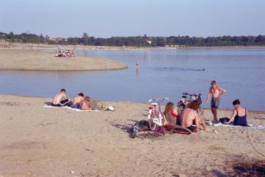The BWD safeguards public health and protects the aquatic environment in coastal and inland areas from pollution. To manage water quality, Member States monitor bathing water during the bathing season. They take samples of bathing water and analyse them to assess the concentrations of two bacteria, *E. coli* and intestinal enterococci. This has to happen once a month during the bathing season, with a minimum of four samples per season collected at each bathing water site.

Throughout the bathing season, local or national governments publish monitoring results to inform the public about possible health risks when bathing. For all of their bathing water sites, countries also prepare bathing water profiles and ensure they are available to the public. These are descriptions of physical and hydrological conditions, covering a single site or contiguous sites. They also list potential impacts on water quality and potential threats to it. At the end of each bathing season, Member State authorities send their data to the EC and the EEA. Assessment results are then published in national reports, EU reports and interactive viewers, and BWD data viewer.

The number of European bathing water sites varies from year to year, between 21 000 and 22 000. Two-thirds of them are coastal; the remainder are inland, in rivers and lakes. By the end of the 2015 bathing season, all monitored bathing water sites should have reached at least ‘sufficient’ quality. Therefore, those with poor quality will be have to have improvement measures or be closed to bathing.

A1.2 Bathing water quality

Bathing water in Europe continues to be of high quality. The share of bathing water sites meeting the minimum water quality standards (i.e. of at least ‘sufficient’ quality) increased from 92 % in 2010 to 96.1 % in 2015. The proportion assessed as excellent in 2015 reached 84.4 %, an increase of 9.7 percentage points from 2010. Fewer than 2 % of bathing water sites were assessed as being of poor quality (i.e. failing to meet the BWD’s minimum standards) in 2015.

For some sites, quality cannot be assessed because the required number of samples is not available. The number of such sites has significantly decreased over the years. In 2010, 6.5 % could not be assessed; by 2015 this proportion had fallen to 2.3 % of all bathing water sites.

Coastal bathing water sites in the EU

The majority of reported EU coastal bathing water locations are in France, Italy, and Spain. 97.1 % of all coastal waters in the EU achieved the minimum quality standards established by the EU directives.85.8 % of coastal bathing water sites were of excellent quality in 2015.

The proportion of coastal bathing water sites that achieved at least ‘sufficient’ quality (i.e. were compliant with mandatory values) increased from just under 80 % in 1990 to over 96 % in 2003. Since then, it has remained quite stable (Figure A1.1). Minor drop of “at least sufficient” bathing waters happened between 2009 and 2012 as an effect of implementing the revised BWD. The proportion of coastal bathing water sites of excellent quality (compliant with guide values) also increased from 1990 to 2000, before reaching a plateau. For the last five years, the trend has been positive again.

Very few coastal bathing water sites (1.6 %) were of poor quality and did not comply with mandatory values. This represents a slight decrease from 2014. It also represents a change in direction from the trend of the previous years, which saw the proportion of poor-quality sites increase between 2010 (1.1 %) and 2013 (1.9 %).

Figure A1.1 Percentage of EU coastal bathing water sites in each compliance category.

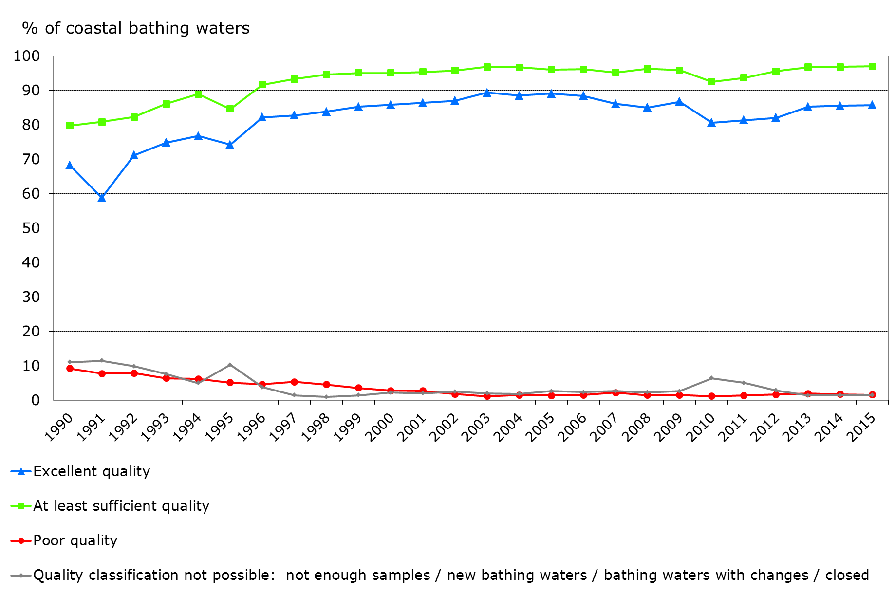

**Source:** EEA (2016).

Inland bathing water sites in the EU

In 2015, Member States monitored more than 6 000 bathing sites on rivers and lakes across Europe. The vast majority (80 %) of inland bathing water locations are on lakes. 93.8 % of inland bathing waters in the EU were of at least sufficient quality in 2015. In 2015, the percentage of inland sites with poor quality dropped to below 2 % for the first time since 1990.

The proportion of inland bathing water sites of excellent quality has been constantly growing (Figure A1.2). In 1995, fewer than 40 % of inland sites were excellent. In 1998, this proportion exceeded 60 %, and it remained more or less stable until 2011. The proportion of inland bathing water sites that achieved excellent quality (i.e. complied with the guide values) has increased significantly from 1995, reaching 81% in 2015.

Figure A1.2 Percentage of EU inland bathing water sites in each compliance category.



**Source:** EEA (2016).

A1.3 Non-compliant and poor bathing water sites

Bathing water sites that do not comply with monitoring provisions

The BWD contains a number of requirements related to bathing water management and monitoring. The basic monitoring requirements consist of taking a pre-season sample, a minimum of four samples per season and a minimum of one sample per month. These conditions must be met for all reported bathing water sites. Bathing water sites that do not meet the criteria are categorised as 'sampling frequency not satisfied. However, most Member States take more samples than required, to ensure that the results are reliable and minimise any potential risks. Sometimes Member States do not fulfil the monitoring requirements because the sampling starts too late, they do not take not enough samples or sampling is not possible as a result of abnormal situations such as floods or droughts.

In 2015, more than 400 bathing water locations in Europe had insufficient sampling frequencies. Nevertheless, their monitoring data that are available show that many of these non-compliant bathing water sites were of sufficient, good or even excellent quality.

Poor-quality bathing water sites

Many human activities result in water pollution. Pollution gets into the water from many sources and takes many forms. During the 20th century, increased population growth led to increased wastewater production from urban areas and industry, resulting in a marked increase in water pollution. Many years of investment in the sewerage system, combined with better wastewater treatment, have led to Europe’s bathing water being much cleaner today 30 years ago, when large quantities of untreated or partially treated urban and industrial wastewater were discharged into bathing water areas. Nevertheless, there are still some major sources that prevent the quality of some bathing water sites from improving. Faecal contamination is a cause of concern for public health — raw sewage and animal waste are full of bacteria and viruses. Swimming at contaminated beaches or bathing lakes can result in illness.

The major sources of pollution responsible for faecal bacteria in bathing water are:

* Sewage: bacteria from sewage can enter our waters as a result of system failures or overflows from sewerage works. Insufficiently treated wastewater of this sort finding its way into fresh waters and sea continues to be a pollution problem at some beaches.
* Farms and farmland: poorly stored slurry or manure from livestock can wash into streams, resulting in the pollution of downstream bathing water. Scattered houses with misconnected drains and poorly located or poorly maintained septic tanks can also cause pollution. Pollution from farmlands and from sewage increases during heavy rain, which washes more pollution into the rivers and seas and can cause sewerage systems to overflow.
* Animals and birds on or near beaches: bathing water can be affected by dog, bird and other animal faeces as it often contains high levels of bacteria. Crowded beaches with many swimmers may also result in poor quality, although it helps if people use the toilet and shower before swimming (EEA, 2016).

The highest rates of bathing water sites of poor quality in 2015, with over 3 % of sites were in the United Kingdom (31 sites, 4.9 %), Ireland (six sites, 4.4 %), the Netherlands (24 sites, 3.4 %) and Bulgaria (three sites, 3.2 %).

Member States are encouraged to report reasons for poor water quality at each of these bathing water sites. Ideally, along with reasons, they should report management measures to improve water quality.

Water policy integration

Efficient bathing water management often goes well with implementation of other water policies such as the UWWTD (adequate collection, treatment and discharge of urban wastewater and wastewater from certain industrial sectors) or the WFD (achieving good chemical and ecological water body status). Box A1.1 illustrates an example of how adequate implementation of one policy brought a positive result in implementing another policy and vice versa.

Box A1.1 Successful water policy integration: the case of Ardmore Beach (Ireland)

Ardmore Beach is a sandy beach on the south coast of Ireland near Ardmore village. During the bathing season, approximately 500 people per day visit the bathing water site. Surfing, body-boarding and kayaking are popular activities, as well as swimming. Besides recreational value, biodiversity on and near the beach is relatively high. Between the beach and the boat harbour, low tide gives access to numerous rock pools, which are home to a variety of plants and animals such as shrimps, crabs, small fish and anemones. There are areas of natural heritage conservation interest both east and west of Ardmore Beach. It includes good examples of coastal dry heather and vegetated sea cliffs (both listed in the Habitats Directive) and is of great ornithological importance. The Blackwater estuary, west of Ardmore Beach, is an internationally important wetland site because of the population of black-tailed godwit it supports.

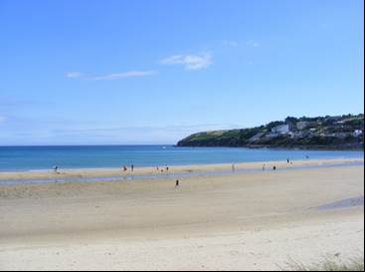

*Photo: © Paul Carroll. Bathing water at Ardmore beach*

The bathing water is sampled at least every 30 days. During the 2014 bathing season, southerly tidal and wind conditions interfered with the normal dispersion and dilution of screened sewage from the nearest wastewater treatment plant. As a consequence, bacterial levels in the bathing water rose. To mitigate these, measures were taken at the treatment plant, which included chlorinating the discharged waters during the bathing season. During operational testing, increased chlorine dosage levels were used to reduce the amount of faecal organisms in the bathing water. Samples taken after the application confirmed that bacterial levels were lower, allowing the bathing water advisory notice to be removed.

Screening and chlorination of sewage discharge during bathing season mitigated bacterial levels. The national authorities also plan to build a new treatment plant..

A1.4 Country comparison

There is a huge diversity of beaches within Europe, be it on the warm Mediterranean Sea or the colder Baltic Sea and North Atlantic Ocean. Lakes and rivers also have a great variety of bathing locations. The geographical coverage for the whole bathing water dataset is wide and relatively dense, with sampling points on marine, transitional and fresh waters throughout the continent.

Every country has its own specifics when implementing the BWD and managing bathing water. These depend on physical characteristics as well as economic, political and social constraints. Nevertheless, all Member States are putting an effort into improving the quality of bathing water and providing up-to-date information to the public about monitoring results, potential risks and other issues. Many of them face problems that affect bathing water quality. Such problems can result from natural phenomena such as floods and droughts, as well as human activities (e.g. pollution from sewage and water draining from farms and farmland).

All Member States had started implementing the revised BWD by 2012, some of them already in 2007. Albania and Switzerland, non-Member States, also report their data on bathing water quality to the EC and EEA.

The EEA bathing water viewer (http://www.eea.europa.eu/themes/water/interactive/bathing/state-of-bathing-waters) shows results in more detail. In 2015 Austria, Croatia, Cyprus, Germany, Greece, Italy, Luxembourg and Malta reported that at least 90 % of bathing water sites were of excellent quality. In spite of these good results, even these countries also had some poor quality sites. For example, there were 5 in Germany (0.2 %) and 95 in Italy (1.7%).

A1.5 Short-term pollution and abnormal situations

When the cause of pollution is clearly identifiable, it is normally expected to affect the bathing water quality for not more than approximately three days (EC, 2006). This can be reported as ‘short-term pollution’. The competent authorities should have established procedures to predict and deal with consequences of such events.

In 2015, 722 short-term pollution events were reported at 587 bathing water sites. This is a decrease compared to 739 (at 608 sites) in 2014. The countries that reported the largest numbers of short-term pollution events were Italy (156 sites, 2.9 % of e total in Italy), France (115, 3.4 % of all in France), and Spain (114, 5.2 %).

Short-term pollution is clearly distinguished from the general poor quality of some bathing water sites. If bathing water is classified as ‘poor’ for five consecutive years, bathing is banned permanently or permanent advice against bathing is introduced.

Abnormal situation is an event or combination of events impacting on bathing water quality at the location concerned and not expected to occur on average more than once every four year (EC, 2006). An example of such situation is central European flood which affected several bathing waters during 2016 bathing season. Extreme floods took place in central Europe in late May and early June 2013. The floods primarily affected regions along the Elbe and Danube rivers. The flooding affected bathing water sites in the region, as well as the monitoring and management of water quality. During the 2013 season, 313 abnormal situations caused by flooding were reported to affect European bathing water sites. At least 223 of them can be attributed to the central European floods. Monitoring could take place after the floods and adequate quality assessment samples were available for some affected bathing water sites.

A1.6 Measures to improve bathing water quality

The BWD requires large-scale measures to manage bathing water sites of persistently poor quality. It strongly encourages Member States to introduce management measures to improve quality to at least sufficient, or even good and excellent, status.

When unexpected or uncontrollable conditions occur (heavy rain, sewage spills, hazardous waste spills, floods, etc.), Member States must impose temporary management measures. Such measures can include informing the public, effective modelling and warning system, prohibiting bathing, and various measures to prevent, reduce or eliminate causes of pollution. They might temporarily close bathing water that requires such measures, for part or all of the bathing season.

To improve water quality and safeguard public health, Member States are also implementing long-term management measures. These include building adequate wastewater treatment plants, limiting pollution from agriculture, surveillance, early warning systems and other measures taken as part of river basin management planning under the WFD (see also Chapter 3).

Management measures are primarily implemented at those bathing water sites that have only sufficient or poor water quality. Such measures can include reducing sewer overflows, construction of wastewater treatment plant, reducing the pollution from farms and farmland and measures to restrict the number of animals (in case when bathing water is affected by large number of resting birds or dogs) (EEA, 2016).

Between 2014 and 2015, 125 bathing water sites changed status from poor to sufficient or better (Figure A1.3). However, in the same period, 76 sites changed their status from ‘sufficient quality’ or better to ‘poor quality’.

Box A1.2 Measures to reduce diffuse water pollution from agricultural and urban sources in the United Kingdom

Authorities in the United Kingdom are working with farmers and others to develop measures to reduce diffuse water pollution from agricultural and urban sources, and to provide information and advice to achieve the goals of the BWD and WFD. Different mechanisms are used in different parts of the United Kingdom:

**→** In England, the Environment Agency collects evidence of diffuse pollution from agriculture. The Rural Development Programme for England (RDPE) uses this to implement measures in the water bodies where they will deliver the greatest benefit. A key project in this programme is Catchment Sensitive Farming (CSF), which provides advice and capital grants to reduce diffuse pollution from agriculture.

**→** In Wales, the Flood and Water Management Act 2010 provides a framework for implementing sustainable drainage systems (SuDS) for new developments. The works planned by Schedule 3 of this act are under way in 2016. Besides, following consultation early in the year, voluntary standards and guidance for the construction of SuDS for new developments were published in December 2015. The Natural Resources Wales continues to undertake investigations to identify sources of contamination where they effect bathing water quality.

**→** The Scottish Environment Protection Agency is working with land managers, organising events and workshops to raise awareness and discuss actions. The Scotland Rural Development Programme 2014–2020 also offers funding to land managers towards the cost of certain measures to reduce diffuse pollution.

**→** In Northern Ireland, 12 000 farmers are participating in agri-environment schemes involving over 450 000 hectares of land. The Northern Ireland Rural Development Programme manages the projects. Countryside Management Scheme (NICMS) participants must prepare and implement a plan for managing farm nutrients and waste.

Figure A1.3 Improvements and deteriorations in bathing water quality.

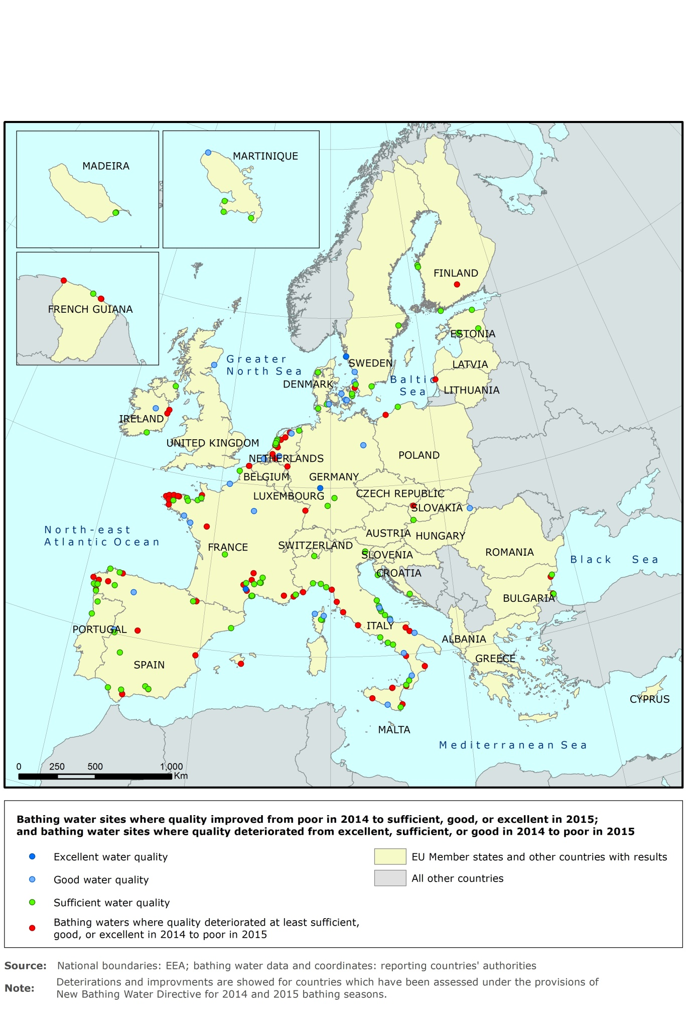

**Source:** EEA (2016).

A1.7 Information dissemination

For all of their bathing water sites, countries prepare descriptions of physical and hydrological conditions and ensure they are available to the public. Member States are obliged to encourage participation by the public concerned. They must provide information on how to participate and guidance on formulating suggestions, remarks or complaints. This particularly relates to setting up, reviewing and updating lists of bathing water sites. Competent authorities should take due account of any information obtained. Bathing water authorities must provide information that becomes available during the bathing season actively and promptly to the public concerned, in an easily accessible place near each bathing area. Short-term pollution should also be noted, along with its reasons and expected duration, as well as notes on similar events in previous bathing seasons. If permanent advice against bathing is introduced, the area must be removed from the list of bathing water sites. All this information is also reported to the EC and the EEA, so the reports can give a comprehensive European overview each year. The reports give adequate up-to-date information on how effectively the BWD is implemented.

Besides national reports, Member States also use the media, including the internet, to disseminate information about bathing waters. To provide comprehensive information to the public, all Member States have established national or local websites. Most of them have linked web pages for individual bathing sites. These web pages generally include a map search function and allow public access to the monitoring results, both in real time and for previous seasons, as well as additional descriptions of water quality, management measures and legislative backgrounds. Other ways of disseminating information about bathing water quality include press conferences before the bathing season, public information broadcasts on television and especially local radio, and printed leaflets for people who do not use digital media.

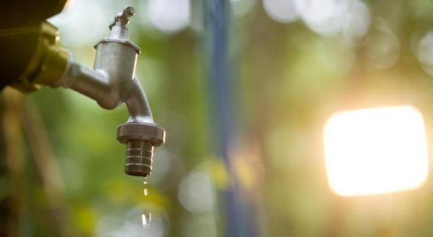A2 Drinking Water Directive

A2.1 Introduction

Legislation

The DWD aims to ensure that water intended for human consumption is safe. It must be free of any microorganisms, parasites or substances that could potentially endanger human health. The directive applies to all water intended for human consumption apart from natural mineral waters and waters that are medicinal products.

The directive came into force in 1998 and replaced Directive 80/778/EEC. 27 Member States of the EU have enacted it in their national legislation and have to comply with its requirements (Croatia do not yet have to comply with the DWD).

The directive:

* sets quality standards for drinking water at the tap (microbiological, chemical and organoleptic parameters) and the general obligation that drinking water must be wholesome and clean;
* obliges Member States to monitor drinking water quality regularly, to take remedial action if the monitoring reveals problems and to provide consumers with adequate and up-to-date information on the quality of their drinking water;
* allows Member States to exempt water supplies serving fewer than 50 persons or providing less than 10 m³ of drinking water per day on average, drinking water from tankers, drinking water in bottles or containers and water used in the food-processing industry, where the quality of water cannot affect the wholesomeness of the foodstuff in its finished form.

Drinking water quality parameters

The directive sets standards for the most common organisms and substances that can be found in drinking water. A total of 48 parameters must be monitored and tested regularly. In general, the basis for the standards is the WHO’s guidelines for drinking water and the opinion of the EC’s Scientific Advisory Committee.

Annex I of the directive divides the parameters into microbiological parameters, chemical parameters, indicator parameters and radioactivity.

The two *microbiological parameters* are E. coli and enterococci. Their parametric value is a substitute for zero. In other words, these organisms should be absent from drinking water to guarantee its quality.

The *indicator parameters* are not directly relevant to the quality of water. They indicate that something has changed in the source, the treatment or the distribution of the water. This needs to be investigated and may require urgent action. Most indicator parameters do not pose a direct threat to human health, but they might have an indirect impact through the appearance, taste or odour of the water, making it less acceptable to the consumer, or they might interfere with proper treatment. For example, organic matter may make disinfection inadequate.

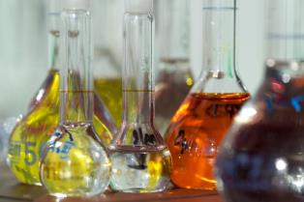The *chemical parameters*were selected for their potential impact on human health, and they do not closely match the list of priority substances under the WFD. Apart from accidents, chemicals are almost never present in drinking water in concentrations that cause acute health effects. They include trace elements, such as arsenic, nickel or lead, and other substances, such as cyanide, polycyclic aromatic hydrocarbons or nitrogen compounds (nitrate and nitrite). In particular, these parameters cause ‘blue baby syndrome’ (see Chapter 5). Furthermore, the impact of these chemicals depends on how they affect the human body. Mostly, the parametric values are based on lifelong exposure and an average intake of 2 l of drinking water per person per day. There is a distinction between threshold and non-threshold substances:

* Threshold chemicals have no impact on human health when concentrations are below the threshold. In cases of non-compliance, the impact depends on the amount of exceedance, the duration of exposure and the safety factor that has been used in setting the parametric value. This differs for each parameter, based not only on health impacts but also on technological capability and ability to analyse substances in the water.
* Non-threshold chemicals, such as pesticides, have no threshold below which there is no potential effect on human health. Dealing with them uses a risk approach that mostly accepts one additional death through drinking water among 1 million people; this is stricter than the value that the WHO currently uses (1 in 100 000 people). If we know the level of non-compliance and the duration, we can then try to estimate the potential impact on human health in a particular Member State or water supply zone (Hulsmann et al., 2015).

Member States may, for a limited time, deviate from the chemical quality standards specified in Annex I of the directive. This process is called ‘derogation’. A derogation can be granted if it does not constitute a potential danger to human health and if there is no other reasonable means of maintaining the supply of water intended for human consumption in the area concerned.

Drinking water quality must be checked at typical locations. They must represent the water source, treatment plant, storage facilities, distribution network, points at which water is delivered to the consumer and points of use. Therefore, where to sample the water depends on the parameter and the potential risk. For instance, excess lead mostly comes from domestic pipe systems and is not a problem in waterworks, so it is all the more important to sample water for lead at the tap, after it has gone through the distribution network.

Water supply zones and dependency on environmental pressures

Assessing drinking water quality is based on the spatial scale of a water supply zone. A water supply zone is ‘a geographically defined area within which water intended for human consumption comes from one or more sources and within which water quality may be considered as being approximately uniform’ (Annex II, DWD). This means that a water supply zone could be a waterworks that collects and processes raw water from two drinking water reservoirs; or it could also be an elevated tank that supplies a district with drinking water.

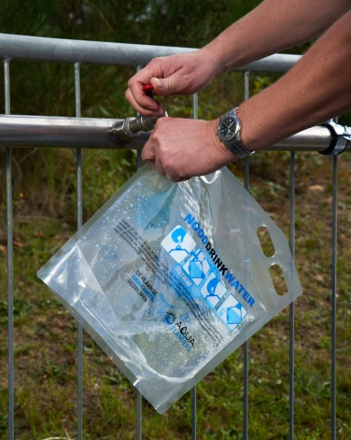The directive makes a distinction between large and small water supply zones. Large water supply zones supply more than 1 000 m³ of drinking water per day, on average, or serve more than 5 000 persons. Small water supply zones are subdivided into three further categories: category 1 supplies 10–100 m³ per day; category 2 supplies 100–400 m³ per day; and category 3 supplies 400–1 000 m³ per day.

The level of treatment required in a particular water supply zone depends on the quality of water it receives from its sources. Water efficiency measures are worth exploring if there are shortages of raw water or if polluted sources require costly treatment. The option to transfer water from another basin with abundant resources would need to be assessed with the financial and environmental costs of transfer against the costs of treatment and possibility to reduce pollution at source (for costs of transport see also e.g. Kraemer et al., 2007; Holländer et al., 2008). Measures to reduce demand and clean up pollution should be exploited before considering the need to transfer water between basins. The DWD itself does not request any information about the quality of raw water, its source (in terms of transfers from other water bodies) or the intensity of treatment necessary (see also Chapter 3). Integrated approaches to evaluate the most appropriate solution taking source water quality into account be implemented in an integrated way under the WFD.

Information to the public

Large and small supply zones have the same minimum water quality requirements. However, monitoring requirements differ. Reporting to the EC is mandatory for large water supply zones. Member States are also obliged to report the water quality of small water supply zones if data are available.

Every three years, Member States must digitally report drinking water quality to the EC. They are also obliged to publish a national report to the public. Table A2.1 lists links to the national drinking water quality reports or information about the reporting period 2011–2013. Furthermore, national country reports show drinking water quality in the reporting period 2011–2013 in a nutshell (map viewer on dwd.etcicm.cenia.cz). All reported data are available in the WISE databases.

Table A2.1 Links to national drinking water reports and information for 2011–2013

| Member State | Report location |
| --- | --- |
| Austria | http://bmg.gv.at/home/Schwerpunkte/VerbraucherInnengesundheit/Lebensmittel/Trinkwasser/ |
| Belgium | http://www.leefmilieu.brussels/themas/water |
| Bulgaria | http://eea.government.bg/bg/output/soe-report/index.html |
| Cyprus | http://www.moh.gov.cy/moh/mphs/phs.nsf/DMLwater2_archive_gr?OpenForm&Start=1&Count=1000&Expand=1&Seq=1 |
| Czech Republic | http://www.szu.cz/tema/zivotni-prostredi/pitna-voda |
| Denmark | http://cdr.eionet.europa.eu/dk/eu/dwd/envvnnugw/National%20report%20on%20drinking%20water%202011–2013.pdf/manage_document |
| Estonia | http://cdr.eionet.europa.eu/ee/eu/dwd/refvlizg/ |
| Finland | http://cdr.eionet.europa.eu/fi/eu/dwd/envvlix7g/ |
| France | http://www.sante.gouv.fr/IMG/pdf/Rapport_qualite_eau_du_robinet_2012_DGS.pdf |
| Germany | http://www.umweltbundesamt.de/themen/wasser/trinkwasser/trinkwasserqualitaet |
| Greece | www.moh.gov.gr |
| Hungary | http://oki.antsz.hu/files/dokumentumtar/Ivovizminoseg2011.pdf |
| Ireland | www.epa.ie |
| Italy | http://www.cheacquabeviamo.it/main.htm |
| Latvia | http://cdr.eionet.europa.eu/lv/eu/dwd/envvpbw_w/ |
| Lithuania | http://vmvt.lt/maisto-sauga/kontrole/valstybine-maisto-kontrole/geriamojo-vandens-kontrole |
| Luxembourg | http://www.eau.public.lu/publications/index.html |
| Malta | http://cdr.eionet.europa.eu/mt/eu/dwd/envvowj9q/index_html?&page=3 |
| Netherlands | https://www.rijksoverheid.nl/documenten/rapporten/2014/12/08/de-kwaliteit-van-het-drinkwater-in-nederland-in-2013 |
| Poland | http://www.gis.gov.pl/?lang=pl&go=content&id=30 |
| Portugal | http://www.ersar.pt/website/ViewContent.aspx?SubFolderPath=%5cRoot%5cContents%5cSitio%5cMenuPrincipal%5cDocumentacao%5cPublicacoesIRAR&Section=MenuPrincipal&FolderPath=%5cRoot%5cContents%5cSitio%5cMenuPrincipal%5cDocumentacao&BookTypeID=3&BookCategoryID=1 |
| Romania | https://www.insp.gov.ro/cnmrmc/images/rapoarte/Raport-sintetic-2013.pdf |
| Slovakia | http://www.uvzsr.sk/index.php?option=com_content&view=category&layout=blog&id=156&Itemid=65 |
| Slovenia | http://www.mpv.si/porocila |
| Spain | http://www.msssi.gob.es/profesionales/saludPublica/saludAmbLaboral/calidadAguas/publicaciones.htm |
| Sweden | www.livsmedelsverket.se |
| United Kingdom | http://www.dwi.gov.uk/ |

A2.2 European results

General information

According to the drinking water quality data of reporting period 2011 to 2013 in the EU, the volume of water supplied divided by number of resident population is about 220 l. This is much more than the mean water consumption per person and day, because drinking water supply for industry or other uses than human consumption is included. The water consumption varies between Member States; for example it is about 81 l in Slovakia, 150 l or less in Denmark and Hungary, and more than 200 l in Austria, Bulgaria, Cyprus, Finland, France, Greece, Ireland, Italy, Luxembourg, Portugal, Romania, Slovakia, Sweden and the United Kingdom. The high consumption level also includes water for agriculture and/or industry in many cases. This water comes from various sources, mainly groundwater or surface water (e.g. drinking water reservoir). Overall, the main source in EU’s countries is groundwater, which provides some 50 % of the total (Figure A2.1). Figure A2.2 shows the percentages of water sources in EU Member States (before Croatia’s accession).

Figure A2.1 Sources of drinking water in the EU, 2011–2013.

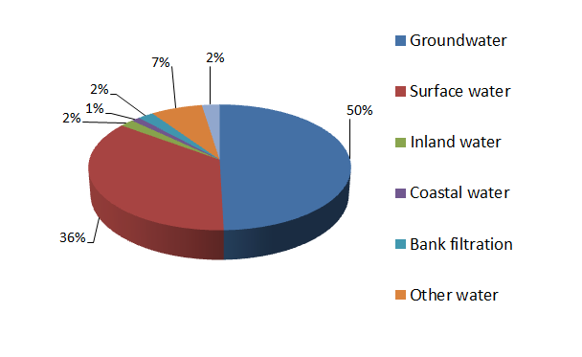

Figure A2.2 Sources of drinking water, 2011–2013.

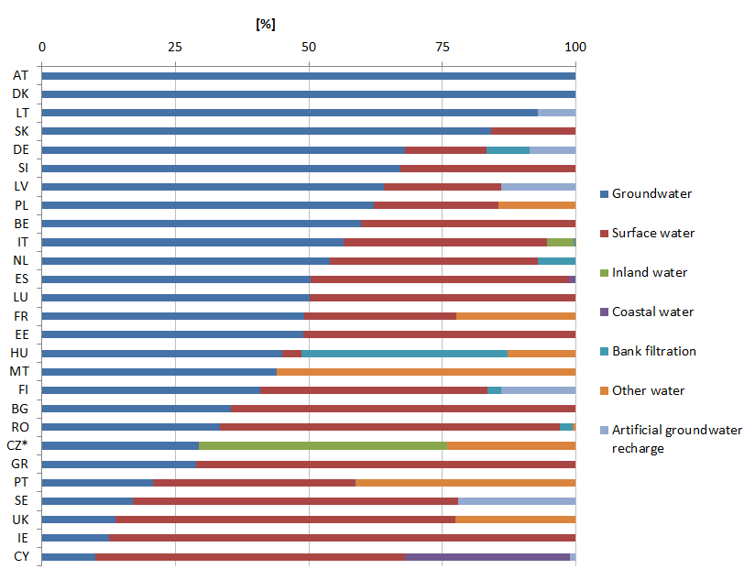

*In the Czech Republic, inland water is synonymous with surface water.

Figure A2.3 shows the percentage of resident population in large water supply zones (> 1 000 m³ per day and/or supplying more than 5 000 people). Some countries also reported the resident population of small water supply zones for in 2011–2013. If we add those, the total proportions of residents supplied are 100 % in Bulgaria, France, Hungary, Malta, Portugal and Slovakia; 96 % in Belgium; 95 % in Cyprus; 93 % in Spain; 90 % in Slovenia; 85 % in Ireland; and 66 % in Romania.

Figure A2.3 Population with access to large water supply zones, 2011–2013.



Drinking water quality

To assess drinking water quality in water supply zones, Member States carried out a huge number of analyses in the reporting period 2011–2013: microbiological parameters (4.1 million analyses), chemical parameters (7.1 million analyses) and indicator parameters (17.5 million analyses).

For each parameter, information on compliance was available. Percentage of compliance reflects the ratio between the number of analyses and the number of exceedances. Compliance with the Directive means that more than 99 % of all analyses meet the given standard. Exceeding indicator parameters does not necessarily mean non-compliance with the directive, for the reasons mentioned in section A 3.1, but only if there is no direct threat to human health.

Figure A2.4 shows the percentage of compliance for the parameter groups: microbiological, chemical and indicator parameters. The results show high compliance rates for microbiological and chemical parameters. Indicator parameters reached almost 99 % compliance in the reporting years 2011–2013. The indicator parameters covered exclude colour, odour, taste and turbidity, which do not have numerical values.

Figure A2.4 Percentage of compliance for microbiology, chemicals and indicator parameters in the EU.

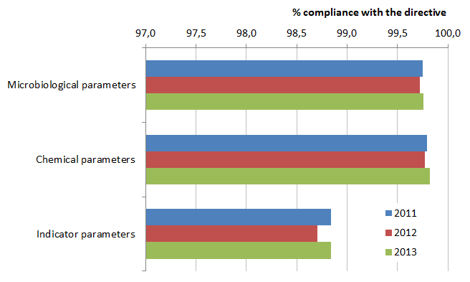

Figure A2.5 shows information on compliance for the chemical parameters in the EU.

Figure A2.5 Compliance rates for the chemical parameters in the EU, 2011–2013.

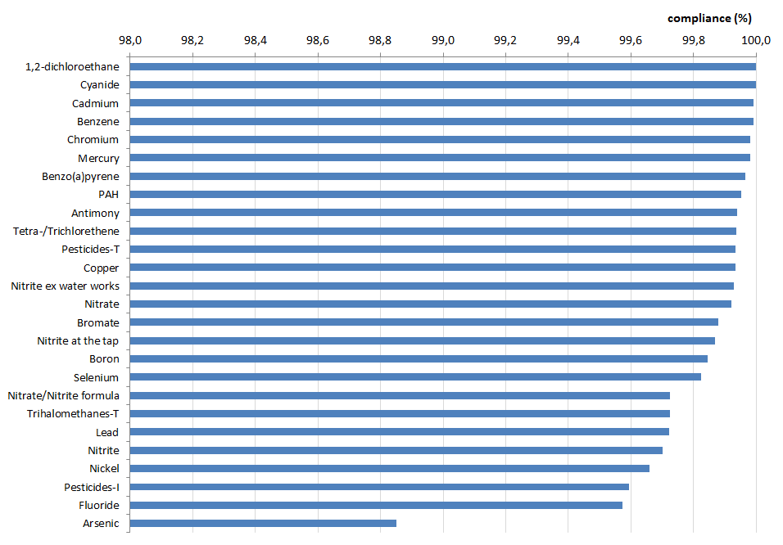

At 98.83 %, arsenic shows the lowest compliance rate. This is mainly caused by geological background concentrations in the catchment areas.

Figure A2.6 shows information on exceedances for indicator parameters. The figure just gives an overview of the exceedances. It does not reflect non-compliance with the directive, because a number of indicator parameters do not have a numerical value, such as colour, taste, odour or turbidity.

The most frequent exceedances in the indicator parameter group are for total organic carbon, iron, sulphate and manganese.

Figure A2.6 Compliance rates for the indicator parameters in the EU, 2011–2013, excluding colour, taste, odour and turbidity.

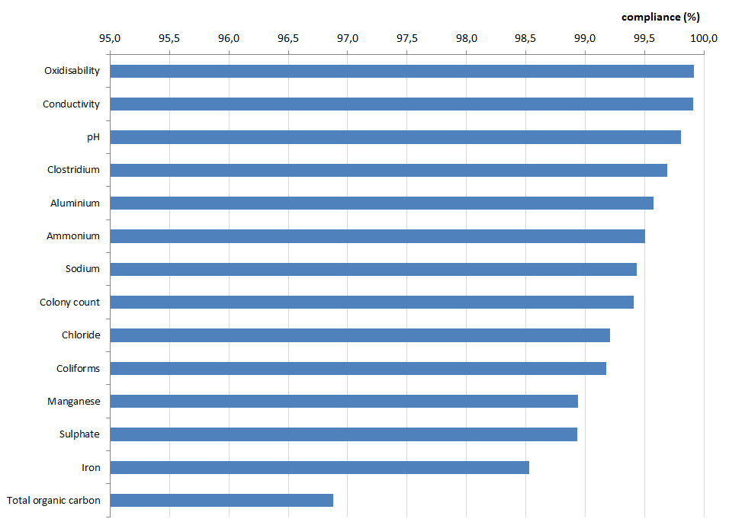

Box A2.1 reflects the importance of pesticides as a potential risk for drinking water quality.

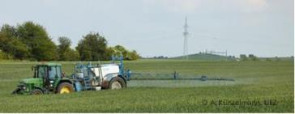Box A2.1 Pesticides in drinking water

Pesticides can be ‘contaminants of concern’ for aquifer recharge, and mainly reach aquifers from agricultural run-off.

Much effort has been put into standards for pesticide levels in drinking water. The standards use an indicator approach and do not really reflect acceptable concentrations for health. The DWD sets a concentration limit of 0.1 μg/l for individual pesticides, and the sum of the pesticides must not exceed 0.5 μg/l. Because pesticides are present on a regular basis and in low concentrations, exposure to these chemicals is generally chronic. The health risk is difficult to assess, because data on acceptable doses for chronic exposure are scarce and the low concentrations involved are difficult to monitor.

Member States monitor a huge number of national specific pesticides and metabolites in drinking water. However, the EC and Member States agreed a short list of 13 pesticides for which the Member States reported monitoring frequency and non-compliance in 2011–2013. The short list is a harmonised approach and makes reporting comparable, but does not show the full picture of all pesticides and all relevant metabolites in a country.

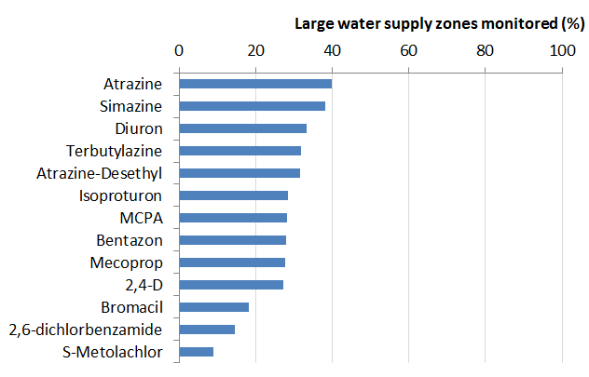The following figure shows the percentage of large water supply zones in the EU, where monitoring of the listed pesticides have been carried out in the reporting period 2011–2013.

Admitting that monitoring is low, compliance rates are consistently high. The compliance rate is more than 99.9 % for pesticides in total, but 99.6 % for individual pesticides (see Figure A2.5). These include the region-specific substances and all relevant metabolites.

Protecting raw water is particularly important. Critical groundwater bodies need special attention from specific measures for drinking water. That cannot be the task of the water suppliers alone. Rather, various stakeholders need to cooperate closely to plan and implement measures in the catchment area. To protect drinking water against pollution from the catchment area, there must be a well-integrated link between the DWD and the other water-related directives, such as the WFD and the BWD.

Causes of non-compliance

The reporting obligations mean that, if a water supply zone does not comply, Member States need to report causes and remedial actions. The number of causes depends on the number of non-compliant analyses.

Failures suspected of being caused by contamination of the source water are defined as ‘catchment related’. These causes include discharges from wastewater treatment plants or stormwater overflow (see also Chapters 3 and 6), agricultural activities (use of fertiliser and pesticides) and industrial activities. Treatment-related causes are mainly associated with the treatment processes at the plant, such as chemical dosing regimens, coagulation and clarification procedures, filter operation or disinfection. Within the distribution network, causes of contamination could be flow reversals and pressure changes, changes in the flushing or scouring regime, or leakages. Failures associated with the domestic distribution network can be identified only at the consumer’s tap. Non-compliances with the standards for copper, lead and nickel at the consumer’s tap may be associated with the consumer’s pipes and fittings.

Figure A2.7 shows the main parameters that exceeded the parametric value and that had causes reported. During the reporting period 2011–2013, most of the reported causes of exceedances were for coliform bacteria. A number of causes were also reported for iron, microbiological parameters other than coliform bacteria, total organic carbon, ammonium and manganese. Most of these are indicator parameters that pose no direct threat to human health.

Figure A2.7 Number of analyses with reported causes of exceedances for the parameters of the DWD in the EU, 2011–2013.

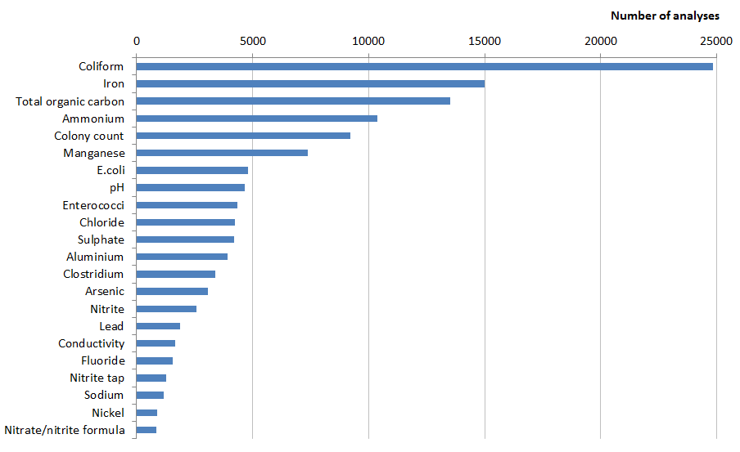

Figure A2.8 shows the different causes for the most reported parameters. Causes of exceedances due to biological parameters (coliform bacteria, colony count, *E. coli*, enterococci, clostridium) and iron cannot be exactly specified, exceedances of ammonium, manganese, pH, chloride, sulphate, arsenic and nitrite are mainly related to the catchment. Total organic carbon and aluminium mainly come from treatment, whereas lead is clearly associated with problems in domestic distribution networks. (So is nickel, which is not shown in the figure.)

The problem of nitrite and the nitrate/nitrite formula is widely discussed. The figure shows a rather small number of reported causes. They are obviously related to the catchment and are less prone to sudden impacts within the source area. Pre-selection and combination of higher-quality raw waters usually mitigate them.

Figure A2.8 Causes of non-compliance for the most reported parameters of the DWD in the EU, 2011–2013.

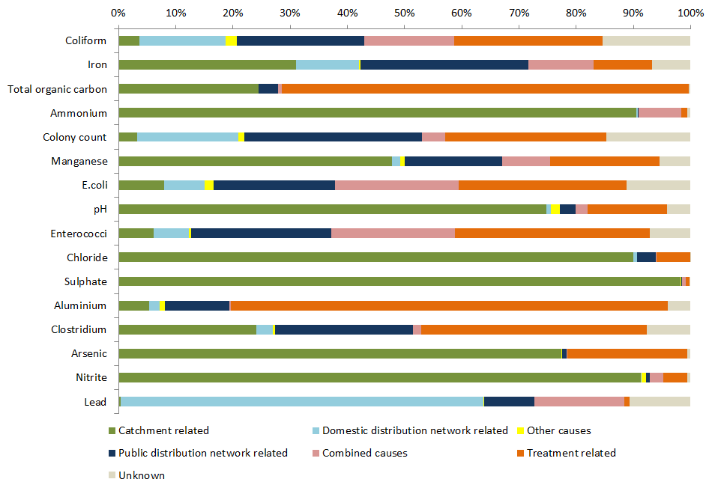

A2.3 Country comparison

Table A2.2 presents compliance of parameter groups for each EU Member State (before Croatia’s accession). The percentages are the mean compliance rate for each parameter group in 2011–2013.

Table A2.2 Compliance rates in 2011–2013 (%)

| Member State | Microbiological parameters | Chemical parameters | Indicator parameters* |
| --- | --- | --- | --- |
| Austria | 99.84 | 99.9 | 99.6 |
| Belgium | 99.75 | 99.9 | 99.1 |
| Bulgaria | 99.25 | 99.5 | 99.3 |
| Cyprus | 99.01 | 99.9 | 96.3 |
| Czech Republic | 99.91 | 99.9 | 99.2 |
| Denmark | 99.80 | 99.8 | 98.6 |
| Estonia | 99.99 | 99.8 | 99.1 |
| Finland | 100.00 | 99.9 | 99.6 |
| France | 99.84 | 99.8 | 99.4 |
| Germany | 99.88 | 99.9 | 99.7 |
| Greece | 99.64 | 99.9 | 99.5 |
| Hungary | 99.71 | 98.6 | 97.1 |
| Ireland | 99.97 | 99.5 | 99.3 |
| Italy | 99.20 | 99.6 | 99.6 |
| Latvia | 99.92 | 100.0 | 98.7 |
| Lithuania | 100.00 | 99.3 | 99.0 |
| Luxembourg | 99.77 | 100.0 | 99.5 |
| Malta | 100.00 | 99.9 | 90.1 |
| Netherlands | 99.97 | 100.0 | 100.0 |
| Poland | 100.00 | 100.0 | 99.8 |
| Portugal | 99.57 | 99.9 | 99.3 |
| Romania | 99.69 | 99.7 | 99.2 |
| Slovakia | 99.52 | 100.0 | 99.4 |
| Slovenia | 99.25 | 100.0 | 98.7 |
| Spain | 99.62 | 99.8 | 99.4 |
| Sweden | 99.94 | 100.0 | 99.1 |
| United Kingdom | 99.98 | 99.9 | 99.9 |
|  |  |  |  |
|  | 99–100 % rate of compliance |  |  |
|  | 98–% rate of compliance |  |  |
|  | < 98 % rate of compliance |  |  |

*Except odour, taste, colour and turbidity.

For the microbiological parameters, all Member States reported between 99 % and 100 % compliance. For the chemical parameters, 26 Member States reported compliance of between 99 % and 100 %, and only Hungary reported between 98 % and 100 % compliance.

For the indicator parameters, three Member States had compliance rates between 98 % and 100 %, three had compliance rates of less than 98 % and 21 had compliance rates of 99 % to 100 %. Malta reported a mean compliance rate of less than 98 % because of very low compliance rates for chloride.

A2.4 Measures to improve drinking water quality

Where the quality of drinking water needs further improvement, the action to take depends on the parameter and the cause.

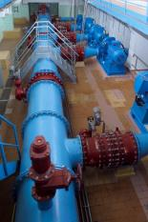Some parameters, such as nitrate or pesticides, relate to human activity in the catchment area. In these cases, measures need to be taken to improve site-specific source protection over a long time. For example, authorities could improve wastewater treatment plants or restrict the use of fertiliser and pesticides within the zone of contribution. They also need to liaise with the teams implementing the river basin management plan under the WFD. Short-term remedial actions could be additional treatment or changing the source of raw water; however, that might require longer water transfers.

For treatment-related parameters, remedial actions include changes in chemical dosing regime, coagulation, clarification procedures, filter operation (backwashing arrangements) or disinfection. Remedial actions related to distribution networks are, inter alia, flushing/scouring the mains or replacing/refurbishing corroded/leaking pipes.

If loss of drinking water quality is linked to the use of materials such as lead, copper and nickel, problems are often related to the domestic distribution network and in-house installation. The only ways to solve them are conditioning the water and informing the public about the proper use of materials and actions they can take to avoid too high levels of those substances in their drinking water.

Figure A2.9 shows the percentages of different kinds of remedial actions for three parameters that cause non-compliance or had a higher number of exceedances in 2011–2013: coliform bacteria, lead and total organic carbon.

Figure A2.9 Remedial actions for selected water quality parameters in the EU, 2011–2013.

|  |  |  |
| --- | --- | --- |
| Coliform bacteria | Arsenic | Lead |
|  |  |  |
| (C, catchment; D, domestic distribution network; E, emergency; P, public distribution network; T, treatment) | | |
|  | | |

Remedial actions for coliform bacteria contamination mainly affect the public distribution network or treatment. Remedial actions to minimise high concentrations of arsenic in drinking water are related to treatment (46 %) or catchment (29 %). For concentrations of lead exceeding the standards, 67 % of all reported remedial actions were replacing or disconnecting lead pipes in the domestic distribution network.

To summarise, specific drinking water quality parameters or groups of parameters cause problems at different points of extraction: water source, treatment, distribution and end of pipe — the consumer. That makes it difficult to develop transparent and useful monitoring, to identify the causes of non-compliance and to implement measures to maintain a healthy supply of drinking water in the EU.

A2.5 Information dissemination

Whereas up-to-date information about bathing water is available to the public at the bathing sites, through the media, in reports and through data viewers, data on drinking water are frequently not up to date and can be difficult to understand. Most Member States do not use comprehensive maps or other published public reports, except a yearly report on national drinking water quality. This makes it difficult to provide the public with updated EU-wide information on drinking water policy and quality on a regular basis. In addition, countries monitor, process and report data in different ways across the EU. That makes it difficult to compare the performance of different Member States and their compliance with the directive. A revision of the directive is now in progress. It is updating the monitoring requirements and methods of analysing drinking water quality parameters (Annexes II and III; DWD). Furthermore, the digital reporting is planned to be further revised and harmonised, based on the lessons learned from the reporting exercise for 2011–2013.

A3 Urban Waste Water Treatment Directive

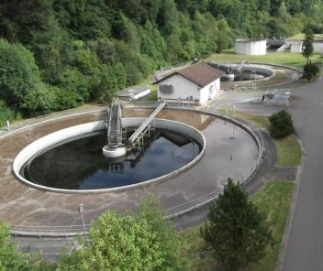A3.1 Legislation

The UWWTD is one of the core elements of EU water policy. Adopted in 1991, it regulates discharges of municipal wastewater from cities, towns and larger villages (called agglomerations) and explicitly specifies what kind of treatment must be applied.

Every second year, Member States report their national data on compliance with the UWWTD to the European Commission. The EEA, consultants and the Commission take different parts in checking these data for good quality and subsequent analysis for compliance with the UWWTD. The data and results are visible within a map viewer (<http://www.eea.europa.eu/data-and-maps/uwwtd/interactive-maps/urban-waste-water-treatment-maps-1>) while the EC publishes a report summarising compliance (EC 2016).

The directive requires the following:

* **Article 3:** All European agglomerations with a size of more than 2 000 population equivalents (p.e.) are equipped with collecting and treatment systems for their wastewaters. The UWWTD uses the term ‘population equivalent’ (p.e.) to measure the size of agglomerations. It is calculated on the basis that the average five-day BOD per person is 60 g of oxygen a day.
* **Article 4:** Urban wastewater from agglomerations above 2000 p.e., which enters collecting systems, needs to be subjected to secondary treatment. Wastewater treatment should significantly reduce biodegradable pollution, mainly BOD and chemical oxygen demand, in wastewater.
* **Article 5:** “Sensitive areas” are those areas suffering from the enrichment of water by nutrients, especially compounds of nitrogen and/or phosphorus, resulting in eutrophication. They and their catchments require more stringent treatment to eliminate nutrients before the wastewater is discharged for agglomerations of more than 10 000 p.e.

Compliance with the requirements of the UWWTD is assessed at the national level as well as at the level of the individual agglomeration. An agglomeration is considered to be in compliance with the UWWTD if it collects all the wastewater it generated and sends it to treatment plants, and all the plants serving the agglomeration comply with the required treatment (treatment type and discharge wastewater concentrations or percentage reduction). However, the EC allows a certain margin of flexibility to Member States when assessing compliance with Article 3 (2 % of the generated load or 2 000 p.e.), Article 4 and Article 5 (1 % of the collected load or 2 000 p.e.).

A3.2 European results and trend in compliance

European results

The eighth report on implementation of the UWWTD (EC, 2016) assessed the situation in about 19 000 towns and cities (agglomerations) of more than 2 000 inhabitants (generating pollution corresponding to a population of 495 million) during 2011 or 2012 (EC, 2015).

Almost 15 000 towns and cities, or 86 % of the pollution load, are in the 15 Member States that joined the EU before 2004 (EU-15). The remainder are in the 13 Member States that joined the EU in 2004, 2007 and 2014 (EU-13). The compliance assessment was carried out for 25 Member States. Data from Italy and Poland were of insufficient quality to include, while for Croatia no compliance obligation was applicable as of 2012.

Figure A3.1 presents the status of the implementation of the UWWTD across the EU for the reference year (2011 or 2012). It shows the share of the total generated load that requires compliance with the UWWTD (darker bars) and the share of the load for which compliance has been achieved (paler bars), both in relation to the total generated load.

Summarising the results, we can conclude that the obligations for collecting sewage (Article 3) were met for 94.9 % of the total generated load. This corresponds to 479 million p.e. and 98.3 % of the load that had to be collected (only 96.4 % of the total generated load had to be collected).

Article 4 deals with biological (or ‘secondary’) treatment. These obligations were met for 464 million p.e. and 92.0 % of the load that had to be treated (93.5 % of the total generated load required biological treatment).

Article 5 requires more stringent treatment in sensitive areas with agglomerations over 10 000 p.e. These obligations were met for 285 million p.e. and 88.1 % of the load that needed more stringent treatment (57.5 % of the total generated load was identified as needing this level of treatment).

Compliance rates in the EU-15 are, in general, very high. They are lower in the EU-13, especially in sensitive areas (Article 5). Results for the EU-28 overall, however, are still very high because the EU-13 contributed relatively little pollution (14 %).

Figure A3.1 Average compliance rates in relation to the total generated load.

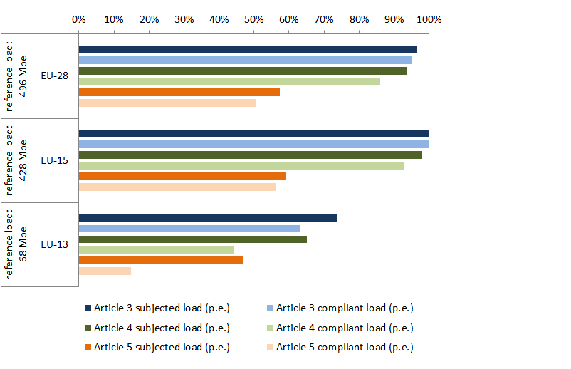

**Note:** darker bars indicate load that should be collected and/or treated; paler bars indicate load for which the collection or treatment provided complies with the provisions in the directive. Data exclude Poland, Italy and Croatia.

Article 3: wastewater collection from agglomerations of more than 2 000 p.e.

Article 4: wastewater with biological treatment.

Article 5: wastewater with more stringent treatment in sensitive areas.

Mpe: million p.e.

**Source:** EC (2015a).

Trends in compliance

The EC publishes regular implementation reports. Comparing the compliance rates in them, a positive pattern appears: compliance increases over time (Table A3.1).

Table A3.1 European compliance rates for Articles 3, 4 and 5

|  |  |  |  |  |
| --- | --- | --- | --- | --- |
| Report | Reference year | Compliance rate (%) | | |
| Collection | Biological treatment | Advanced treatment |
| 2 | 1998 | – | – | 9 |
| 3 | 2000/2001 | 83 | 69 | 14 |
| 4 | 2001/2002 | – | 79 | 84 |
| 5 | 2005/2006 | 99 | 86 | 85 |
| 6 | 2007/2008 | 93 | 78 | 75 |
| 7 | 2009/2010 | 94 | 82 | 77 |
| 8 | 2011/2012 | 98 | 92 | 88 |

**Note:** Nine EU Member States (Bulgaria, Czech Republic, Greece, Ireland, Italy, Malta, Poland, Spain, United Kingdom) are missing from the presentation of the fifth report. The sixth report does not include a dataset for the United Kingdom and the eighth report does not include data for Italy and Poland.

**Source**: EC 2002-2013

UWWTP indicator: proportion of inhabitants connected to UWWTPs during last 20 years

The percentage of the population connected to primary, secondary and more stringent wastewater treatment in southern, south-eastern and eastern Europe has increased over the last 10 years. The latest proportions of the population connected to wastewater treatment in the southern countries are comparable to those in the central and northern countries, whereas those in eastern and south-eastern Europe are still relatively low.. The percentage of more stringent, also called tertiary treatment is far lower in the southern than in the northern countries. This is also the case in central Europe, where the overall treatment level is fairly high. In eastern and south-eastern Europe, the total number of the population connected to wastewater treatment has increased over the last two years, but the proportion of untreated wastewater is still relatively high. In the non-EU western Balkan countries, an increasing proportion of wastewater is treated, but still most of it is not (Figure A3.2).

Figure A3.2 Changes in wastewater treatment in regions of Europe between 1990 and 2012.

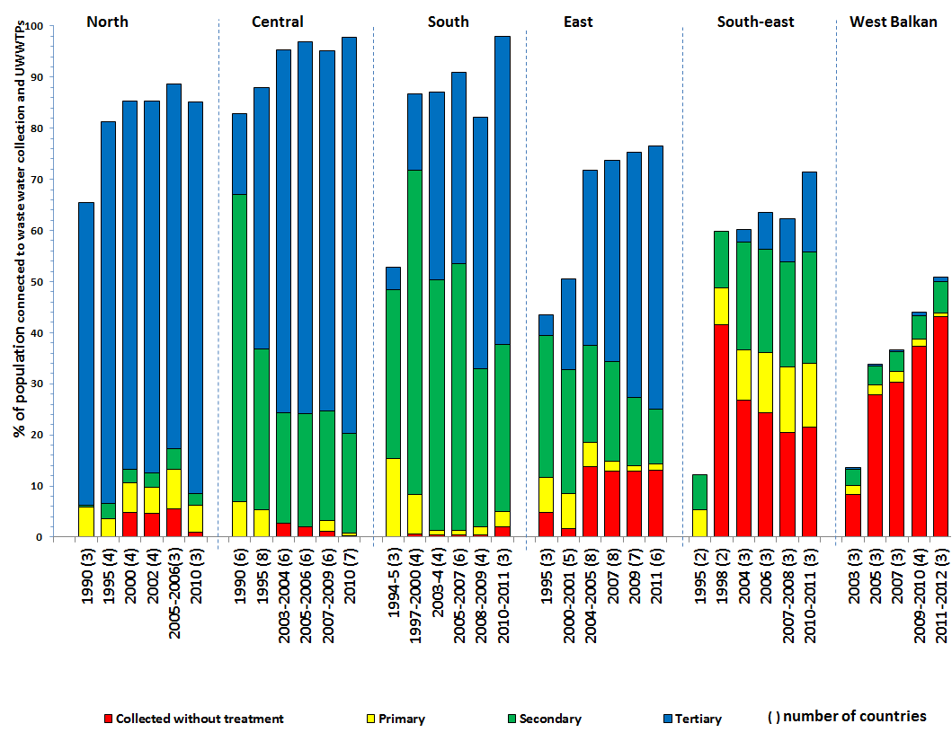

**Note:** North: Finland, Iceland, Norway, Sweden. Central: Austria, Denmark, England and Wales, Scotland, Germany, Ireland, Luxembourg, Netherlands, Switzerland. South: Cyprus, France, Greece, Malta, Portugal, Spain. East: Czech Republic, Estonia, Hungary, Latvia, Lithuania, Poland, Slovakia, Slovenia. South-east: Bulgaria, Romania, Turkey. West Balkan: Albania, Bosnia and Herzegovina, Macedonia (FYR), Serbia.

Only countries with data from (almost) all periods included (number of countries in parentheses).

The chart is based on the Eurostat data set, which includes information on all wastewater treatment plants reported, regardless of the size of agglomeration they serve. Thus the number may differ (in some countries) from the numbers of wastewater treatment plants reported under the UWWTD, which reports only those serving agglomerations of more than 2 000 p.e.

**Source:** EEA, Urban Waste Water Treatment Indicator (CSI 024, last update 2015), http://www.eea.europa.eu/data-and-maps/indicators/urban-waste-water-treatment/urban-waste-water-treatment-assessment-3.

A3.3 Country comparison

For more stringent treatment (removal of nutrients in sensitive areas), the overall compliance rate was 88 %. However, EU-13 Member States showed delays in implementing more stringent treatment. They treated only 32 % of wastewaters appropriately. On the positive side, 11 countries reached 90–100 % compliance.

The maps in Figure A3.3 show compliance rates for collecting systems (Article 3), secondary treatment (Article 4) and more stringent treatment (Article 5) in Member States as a percentage of the load subject to compliance (reference years 2011–2012).

For Article 3 (collecting systems), 20 EU Member States are completely compliant: they collect 100 % of the wastewater load. Belgium has a compliance rate of 98 %, Estonia 94 % and Romania 99 %. Only two EU Member States collect less than 60 % of the load that should be collected (Bulgaria 12 % and Slovenia 57 %).

For Article 4 (secondary treatment), 16 EU Member States reach a level of compliance between 90 % and 100 %. Five (Cyprus, the Czech Republic, France, Portugal and Spain) have a compliance rate between 60 % and 90 %. Romania’s is 48 %. Low compliance rates can be seen in Bulgaria (11 %) and Slovenia (14 %). Malta shows no compliance with Article 4.

More stringent treatment of wastewaters, also known as tertiary treatment, complements secondary treatment when needed. It mostly aims to eliminate nutrients to combat eutrophication. An additional benefit is increasing the removal rates of hazardous substances. More advanced treatment includes sand filtration, ozonation and ultraviolet (UV) treatment, which are well-known treatment technologies for drinking water. Several treatment plants have installed these measures to reduce bacteriological pollution that might affect human health (e.g. for drinking water zones or bathing waters) and at the same time to further reduce emissions of hazardous substances. Other more stringent treatment technologies are chlorination and membrane technologies. All of the above are widely discussed as ways of reducing the micropollutants (emerging contaminants, including pharmaceuticals, personal care products and industrial chemicals) entering the aquatic environment.

Compliance with Article 5 (more stringent treatment) is between 90 % and 100 % in 10 EU Member States. Five Member States (Belgium, Estonia, Hungary, Portugal and Sweden) show compliance rates of 60 % to 90 %. On the other hand, 10 Member States are still below 50 % compliance; of these, Latvia and Malta have 0 % compliance with Article 5 and Bulgaria and Ireland show 1 % compliance. However, many countries increased their level of compliance in recent years.

Figure A3.3 Share of generated load compliant with Articles 3, 4 and 5 in the EU-28.

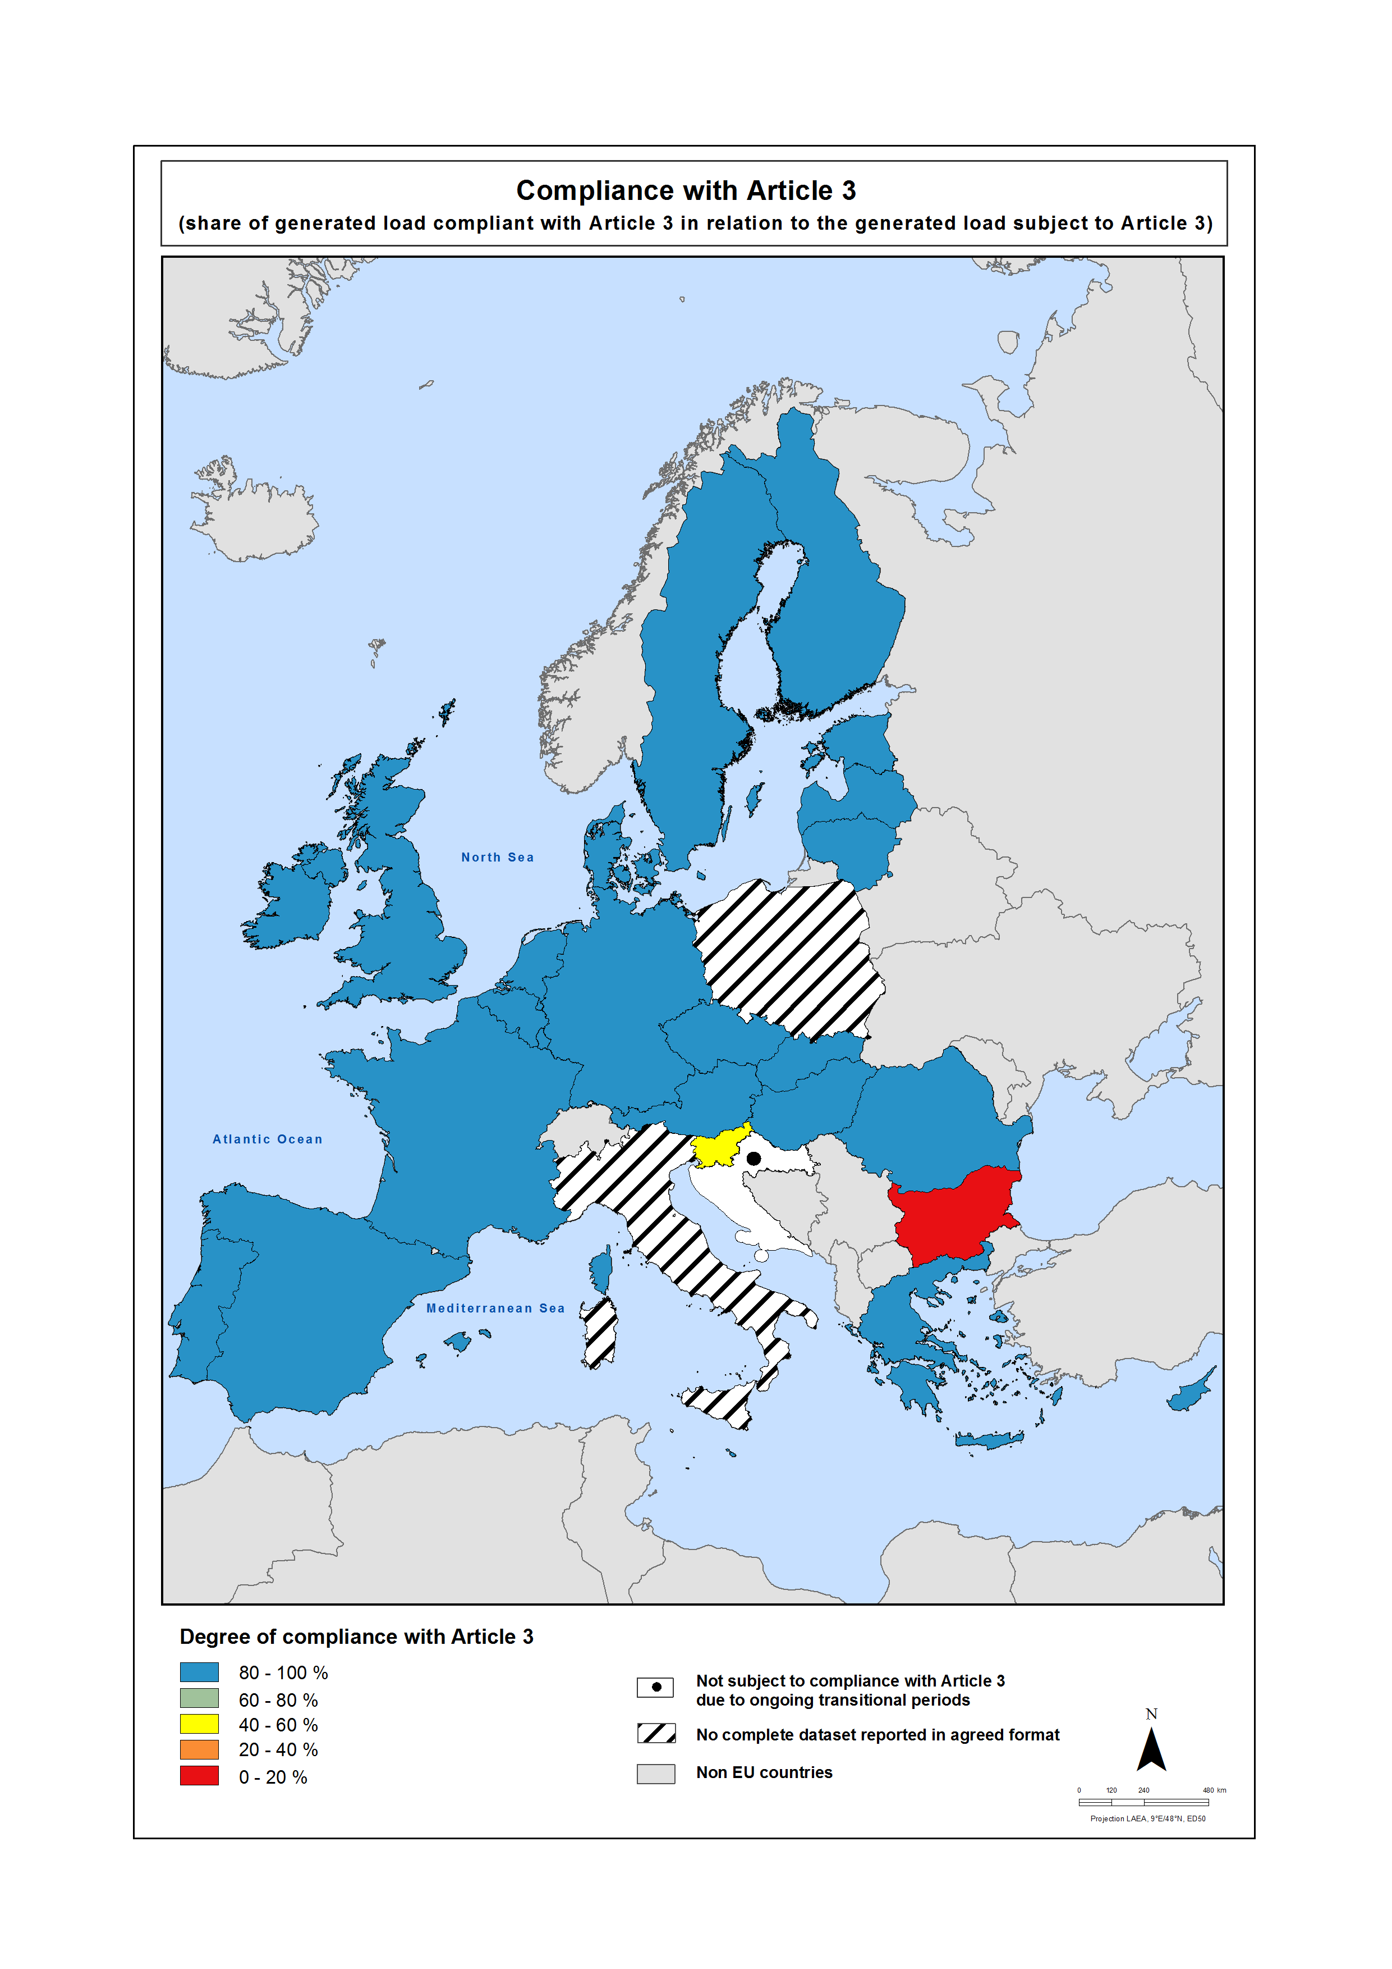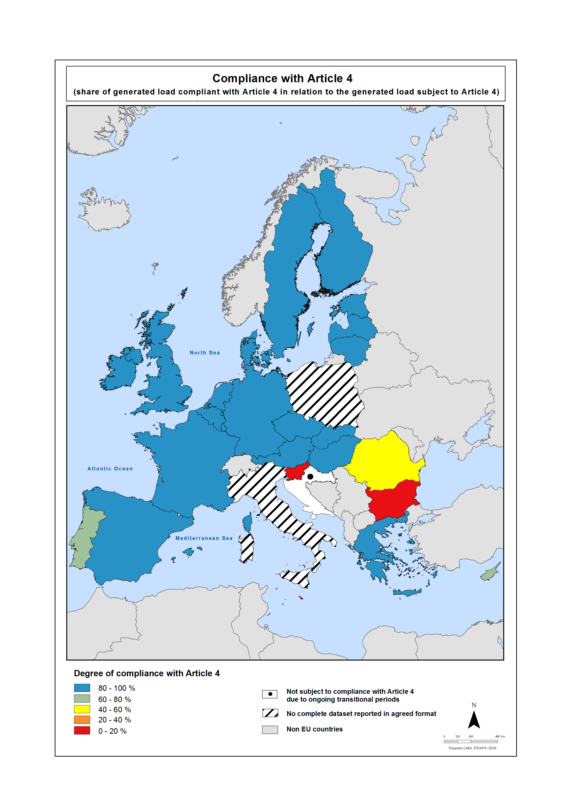

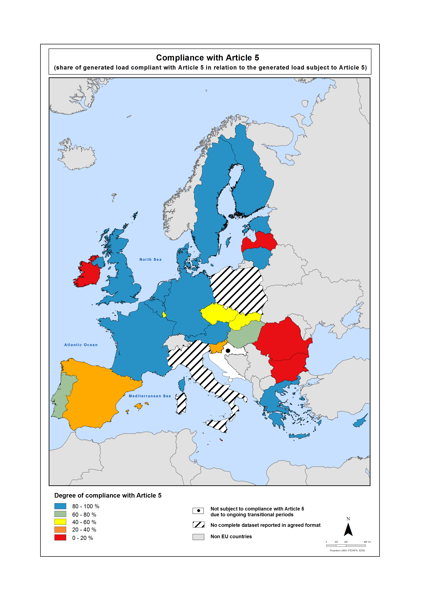

**Source:** EC (2016).

A3.4 Measures to improve treatment

The UWWTD sets minimum requirements for wastewater treatment in agglomerations of more than 2 000 p.e. However, other drivers (e.g. the WFD, other water directives, water utilities benchmarking, Wastewater discharge licence based on more stringent limits than set in the Directive, wastewater reuse) encourage ‘better treatment’ (i.e. more efficient, more stringent or addressing hazardous substances).

Optimisation of the performance of wastewater management systems improves the cost-effectiveness of wastewater treatment. Practical solutions include measures based on advanced knowledge of microbial systems (sequential batch reactors, biological filters, membrane bioreactors) and/or using integrated plant-wide control systems. However there can also be a need to increase the proportion of wastewater receiving treatment. Introducing measures to control the discharge of untreated wastewater from CSOs; maintaining the hydraulic capacity of existing infrastructure; providing suitable retention facilities or introducing decision support systems; are ways to improve quality of final discharge.

Several Member States have achieved the maximum level of compliance with Articles 3, 4 and/or 5 in recent years. However, not content with that, they are regularly improving wastewater treatment by advancing it further, improving the maintenance and technical equipment of UWWTPs, etc.

Agglomerations of more than 10 000 p.e. in sensitive areas must remove nutrients. Figure A3.4 shows that nutrient removal is quite common in agglomerations smaller than 10 000 p.e. in Austria, Finland and the United Kingdom.

Figure A3.4 More stringent treatment.

|  |  |
| --- | --- |
| Austria (2010) | Finland (2009) |
|  |  |
| United Kingdom (2010) |  |
|  |  |

**Source:** EEA, DISCOMap, UrbanWasteWater, http://discomap.eea.europa.eu/Services.aspx?agsID=14&fID=5549.

Other measures that go beyond the requirements of the UWWTD are establishing appropriate wastewater collection and treatment in agglomerations smaller than 2 000 p.e. This is particularly the case if they are located in protected areas, or if the discharge affects the status of water bodies.

The hygiene standards for bathing water, and the more stringent limits related to wastewater reuse, encourage additional treatment methods such as disinfection, chlorination and ozonisation. The Urban Waste Water Treatment Maps (http://www.eea.europa.eu/data-and-maps/uwwtd/interactive-maps/urban-waste-water-treatment-maps-1) provide an overview of their use across the EU, in the layer ‘types of additional polishing treatment steps’. A total of 25 807 treatment plants were reported under the UWWTD in 2013. Of them, 778 use UV disinfection, 41 use ozonation and almost 4 000 use chlorination to remove or eliminate pathogens.

Newly identified, potential pollutants can be termed ‘emerging contaminants’. This group now includes certain pharmaceuticals and personal care products. Studies from numerous European wastewater treatment plants have found such emerging contaminants in the treated wastewater. Technologies such as flocculation, ozonation, advanced oxidation, membrane filtration (activated carbon adsorption) and photocatalysis could help remove trace amounts of contaminants from wastewater effluents (Gadipelly et al., 2014; Castiglioni et al., 2006). Increasingly, countries go beyond the requirements of the UWWTD in their efforts to improve water quality under the WFD.

A3.5 Information dissemination

Every two years, the relevant authorities publish situation reports on the disposal of urban wastewater and sludge in their areas. The principal aim of these reports is to inform the public regularly of the situation, on a given date, regarding wastewater collection and treatment. They also show how the situation has developed since at least the two previous years.

At regular intervals, the EC also draws up implementation reports on the situation of wastewater treatment and the progress of implementing the UWWTD in the EU. Since 2007, reporting under Article 15 of the UWWTD has followed a new standardised approach. The EC, the EEA and Member States developed it jointly and set it up in line with reporting principles under the Water Information System for Europe (WISE).

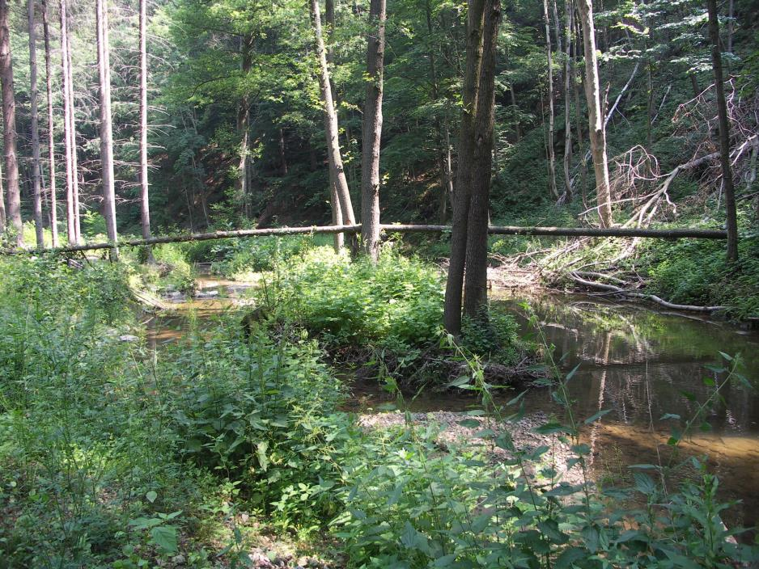

1. BOD can be measured over 5 days, or less commonly, over 7 days: in figure 2.6, BOD7 data have been recalculated into BOD5 data.
2. Note that national authorities can report samples as having been taken in short-term pollution periods, and yearly assessments exclude them if replacement samples are provided. This review of sample statistics, however, uses all samples for its calculations. It includes those taken during short-term pollution events because these are typical examples of microbiological pollution.