OCP/EEA/NSS/18/002 – ETC/ICM | 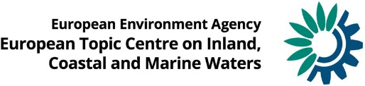

Bathing water management in Europe:
Successes and challenges

Authors:
Lidija Globevnik, Luka Snoj, Gašper Šubelj, Mustafa Aydin, Rob St. John

Place and date:
Copenhagen, May 2020

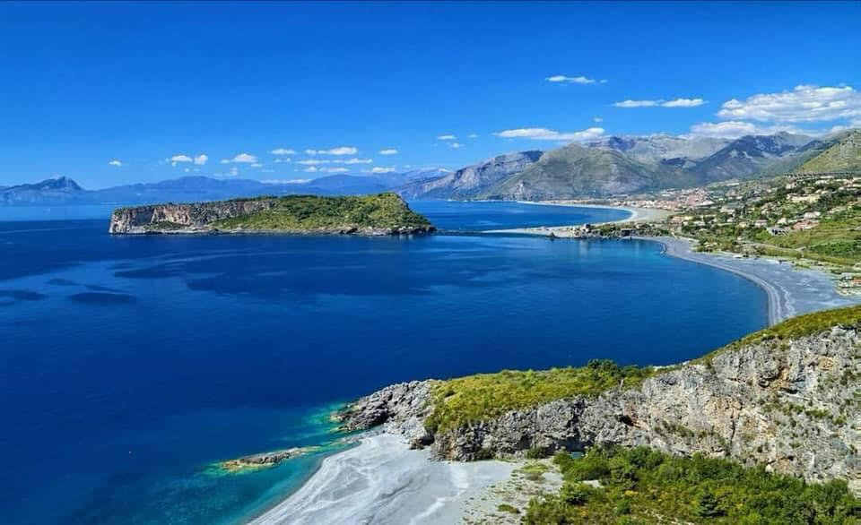
Photo: San Nicola Arcella. Italy ©Comune di San Nicola Arcela (Cs)

Contents
Abbreviations 3
Executive summary 4
1. Foreword and objectives of the report 7
2. Why care for bathing waters? 8
3. How do we care for bathing waters? 10
3.1. Control of bathing health risks through legislation 10
3.2. Integrated bathing water management 12
3.3. From polluted to excellent bathing waters 15
3.4. Now we can swim in some of our cities again 18
4. Addressing the challenges to bathing waters 21
4.1. Bacteria: an invisible health risk 21
4.1.1. How has it been managed? 22
4.2. Extreme weather and other events: unpredicted impacts on water quality 25
4.2.1. How has it been managed? 25
4.3. Algae in water: eutrophication as a health risk 28
4.3.1. How has it been managed? 29
4.4. Cyanobacteria and other hazards 30
4.4.1. How it has been managed? 31
4.5. Wild bathing in Europe – a challenge for water management 33
5. Bathing in the future 35
5.1. Climate change impacts 35
5.1.1. Rise in seawater level 35
5.1.2. River flows and floods 36
5.1.3. Rise in air and water temperature 38
5.1.4. Droughts and water shortage 39
5.2. Plastic litter in bathing waters: an emerging issue 40
5.3. Transboundary cooperation 42
6. Conclusions 45
7. References 49

Abbreviations
BWD Bathing Water Directive
CSO Combined Sewer Overflow
DWD Drinking Water Directive
EC European Commission
EEA European Environment Agency
ETC/ICM European Topic Centre on Inland, Coastal and Marine Waters
HMWB Heavily Modified Water Body
MSFD Marine Strategy Framework Directive
NBS Nature-Based Solutions
NiD Nitrates Directive
UWWTD Urban Waste Water Treatment Directive
SUP Single-Use Plastics Directive
TCI Tourism Climate Index
WHO World Health Organisation
WFD Water Framework Directive
WWTP Waste Water Treatment Plant

Executive summary
Swimming is consistently among the top public outdoor recreational activities in Europe and has numerous positive effects on human health and psychology. Bathing sites are often very attractive tourist destinations. The need to protect and improve bathing water quality in both marine and freshwater environments is thus a key issue for policy makers and environmental managers.
For decades, European countries have shared a common vision to sustain good quality bathing waters. Efforts to achieve this target have been prompted and supported by the Bathing Water Directive, introduced in 1976. The Bathing Water Directive (BWD) was revised in 2006. The update was based on up-to-date scientific evidence on the most reliable indicator parameters for predicting microbiological health risk for designated European bathing waters. In addition, the updated BWD simplified its management and surveillance methods.
The bathing season in Europe usually lasts from May to September. During that time, local and national authorities take bathing water samples and analyse them for the types of bacteria which indicate pollution from sewage or livestock (e.g. Escherichia coli and intestinal enterococci). Based on the levels of bacteria detected, bathing water quality is then classified as ‘excellent’, ‘good’, ‘sufficient’ or ‘poor’.
All European Member States make great efforts to improve the quality of existing bathing waters, to provide up-to-date information on their state to the public, and to make bathing feasible in urbanised and formerly heavily polluted surface waters. Significant investments in urban waste water treatment plants, improvements in sewage networks and other measures have contributed to a reduction in ‘poor’ bathing water quality in more than 3000 large cities in Europe. Safe bathing is now possible in many European capitals – including Amsterdam, Berlin, Budapest, Copenhagen, London, Riga and Vienna, – a feat that would have been unimaginable in the 1970s.
Thanks to successful environmental policy and management guided by the BWD, the percentage of European bathing waters achieving at least ‘sufficient’ quality (the minimum quality standards set by BWD) increased from just 74% in 1991 to over 95% in 2003, and has remained quite stable since then. The percentage of bathing waters at the highest water quality (classified as ‘excellent’) has increased from 53% in 1991 to 85% in 2019. Thanks to common European action, more than eight out of ten of Europe’s monitored bathing waters now have ‘excellent’ water quality.

Whilst bathing water quality in Europe is increasing, and bathing is today possible even in some heavily urbanised areas, there is still a need for integrated and adaptive management to mitigate both existing and emerging pressures.

The major bathing water management challenges in Europe are:

Faecal bacteria
A common cause of ‘poor’ water bathing water quality is the presence of faecal bacteria, which can pose significant public health risks. Major sources of bacteria include sewage, inefficient waste water treatment plants, animal waste (e.g. birds and dogs at beaches) and water draining from farms and farmland. Significant investments in sewage systems and treatment plants have helped reduce faecal bacteria levels in European bathing waters in recent decades.

Storm water overflows

Sewerage systems in cities are not always able to drain all storm water, and after periods of heavy rain, bathing water quality can decrease significantly due to overflows. The number of such pollution events has increased in recent years. Sewage overflows across Europe are increasingly being managed using new measures such as the construction of storage tanks and the creation of nature-based retention basins that serve also as urban green areas. Modelling and warning systems can be put in place to advice bathers against bathing during short-term pollution events.

Nutrient and chemical pollution
Nutrient and chemical pollution due to agricultural run-off and insufficient waste water treatment can cause a number of environmental impacts on bathing waters, potentially making them unsafe for public use. Nutrient pollution can cause excessive algae growth and eutrophic blooms of toxic cyanobacteria. Other substances such as heavy metals can enter bathing waters from both natural and anthropogenic sources and be deposited on their coasts and banks. These can originate from either diffuse (non-point) sources, such as runoff from land, or point sources such as industrial outfall or natural springs containing high concentrations of mercury.

The positive impacts of the wide-ranging and collaborative measures that have been supported by the BWD since 1976 represent a major positive step for environmental policy and management in Europe. However, the task is not accomplished yet. Whilst environmental managers continue to deal with the key issues above, emerging challenges such as climate change and plastic pollution are increasing the complexity of bathing water management.

Climate change
Projected climate changes in Europe over the coming decades will bring challenges for bathing water management and the recreation activities and tourism industries that rely on clean bathing waters. The impacts of ongoing climate change on aquatic ecosystems will vary geographically across Europe (EEA, 2017b). Many coastal bathing water resorts and infrastructure will be threatened by rising sea levels and more varied and volatile storms. Increased river flows may damage bathing sites, destroy bathing water infrastructure and shift and deposit debris. In some regions, drought and freshwater scarcity may cause bathing sites to disappear, or to be affected by issues such as eutrophication. Due to temperature rises, the bathing season will be prolonged into spring and autumn in some areas. Climate change will shift conditions suitable for bathing northwards, meaning that more bathing water sites are expected to be identified and monitored across Europe in the future.

Plastic pollution
A clean coastline is vital for beach tourism. Marine litter is aesthetically the most unappealing pollutant to swimmers, and dirty bathing sites are unattractive for visitors. Litter, particularly plastic litter, is accumulating in our seas and along our coasts and poses threats both to marine biodiversity and bathers (EEA, 2015b). Plastic litter damages fisheries and tourism, kills and injures a wide range of marine life, has the capacity to transport potentially harmful chemicals and invasive species and can represent a threat to human health (Thompson, et al., 2009).
Beach and sea floor litter at bathing water sites might cause injuries, and when fractured into micro pieces in water can be accidentally ingested by swimmers. Accumulation of such ‘microlitter’ in the human body may cause health effects. The extent of such health effects is still unknown, and a precautionary approach is necessary.

It is clear that bathing water legislation has helped improve the microbiological quality of Europe’s bathing waters. However, the task is not accomplished yet. Achieving the vision of ‘excellent’ bathing water quality across Europe is closely linked with how we address emerging future challenges such as climate change and plastic pollution.
Besides emerging challenges, there will be unexpected risks that may require management, such as the COVID-19 virus and pandemic. There are currently no viral indicators as parameters in the BWD. The EEA has published the ‘European bathing water quality in 2019 Briefing’, in which it provided information on risks in Europe for the 2020 bathing season with regard to COVID-19 and links to key guidance documents. Members of the public are advised to always follow the guidance and instructions at the bathing sites, from their local and national authorities in order to prevent the spread of the virus.
This report summarises how 40 years of European environmental policy and management has significantly improved bathing water quality across Europe. We outline the key challenges for bathing water management in Europe, and describe how these are addressed by governments implementing the BWD through the specific management measures, strategies and practices. In addition, we point out that the improvement of bathing water quality can serve as inspiration and best practices in environmental management. Further, we discuss how bathing water protection and restoration does not necessarily take place only at popular coastal resorts. On the contrary, improving bathing water quality is feasible and desirable for the rivers and lakes within the towns and cities that many of us live in. Through the report we highlight the value and importance of bathing waters in Europe and identify challenges for future bathing water management.

- Foreword and objectives of the report
Outdoor bathing is consistently among the top public recreational activities in Europe. It is also one of the most accessible ones – at least in the places with good access to clean seas, rivers or lakes. Every summer, millions of Europeans visit seas, rivers and lakes for exercise and recreation. Making sure that these bathing waters attain high enough quality to make these activities safe is thus a key priority for environmental policy and management.
In Europe, as in many other parts of the world, the water quality of coastal waters, rivers and lakes generally degraded from the 19th century onwards, largely owing to growing towns and industries discharging untreated wastewater. Through the 20th century, the increased use of pesticides and fertilisers on agricultural land added chemicals to this pollution ‘cocktail’, and recent evidence (EEA, 2017b) shows that climate change is further degrading water quality in Europe. Excessive nutrient pollution coupled with climate warming is causing eutrophication and even harmful algal blooms. In other words, European water quality in both freshwater and coastal ecosystems is affected by multiple pressures, some of which can interact to intensify their individual effects. Moreover, many river banks, lake shores and coastlines have been structurally modified for flood protection, navigation, tourism, land transportation and construction. Such modifications can also deteriorate water quality, limit self-purification and increase pollution risks.
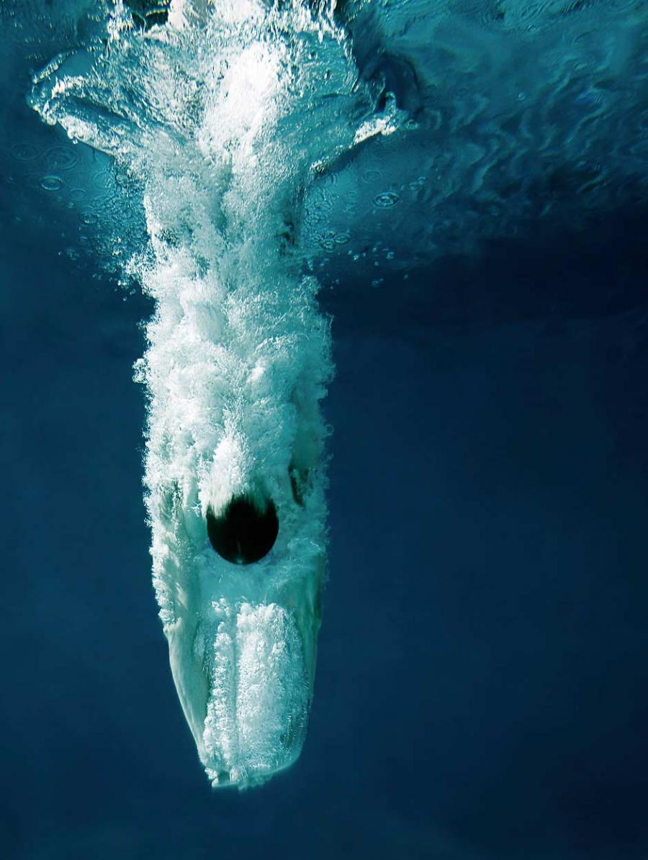
Photo: ©Boby (Flickr, 2008; Creative Commons licences)
Since the 1970s, the European Union has introduced numerous environmental policies to improve the health and status of Europe’s waters. One key policy is the Bathing Water Directive (or BWD as it is often known) – originally introduced in 1976 and updated in 2006 – which aims to safeguard public health and recreation through the provision of clean bathing waters. European countries have subsequently made significant water quality improvements at several bathing sites, as well as identifying new sites, and prohibiting bathing at those that did not achieve adequate water quality guidelines.
This report will show how four decades of European water policy and management guided by the Bathing Water Directive has significantly improved bathing conditions across the continent. This represents a significant ‘good news’ story in an era of environmental declines and reported disconnections between people and nature, especially in urban areas. This report gives an overview of how specific water management measures, strategies and practices have been implemented in different places in response to local challenges. These serve as ‘good practice’ examples for management in the future. However, maintaining good bathing water conditions in the future will depend on adaptive management of emerging pressures such as climate change and plastic pollution. The report outlines the nature of these pressures, and their impacts, and highlights the management strategies that might mitigate their effects. The objectives of this report are thus twofold: first, to celebrate the value and importance of bathing waters in the lives of millions of European people; and second, to outline how we might protect and restore bathing sites for decades to come.

- Why care for bathing waters?
Few things are as enjoyable as going for a swim on a hot day. Submerging into crystal clear water is something we do for leisure, sport, personal hygiene and health. Europe has a great diversity of beautiful beaches and bathing areas. Each year millions of Europeans spend their afternoons, weekends and holidays at the beach chilling and cooling off by the water (EEA, 2018).
Bathing has a long and rich history in Europe. Although the myths of the ancient civilisations of eastern Mediterranean show an inclination of Europeans towards water and swimming, from the medieval period to the 19th century the majority of Western Europeans did not swim. The population relearned to swim in schools, spas and barracks during the Enlightenment and mass-participation swimming only took off in the 19th century. In that period, the development of the railways gave millions of city residents access to seaside resorts, and a specific act on baths and washhouses enabled English municipalities to build in-ground, heated pools in deprived urban areas. From then, the popularity of bathing grew, and today millions swim for fitness and leisure in pools, and take waterside holidays throughout the year (Chaline, 2018).
Bathing can have numerous positive effects on physical human health and psychology. It can improve cardiac and vessel functions, blood circulation, lung capacity and oxygen intake (Koopman, 2019). Swimming can also help with the mental tensions and anxieties caused by everyday stress (Kjendlie, et al., 2010). Stretching and moving in water has been shown to put low stress on the joints, muscles and bones, but is very effective in providing an adequate workout through resistance. There is also less chance of injury for people who are at risk of falls, which makes aquatic exercise ideal for the elderly. Chronic fatigue syndrome and some fertility issues can be assisted by bathing in colder temperatures. Alternatively, warm water bathing can increase levels of serotonin – the chemical produced by the brain associated with happiness and well-being (Koopman, 2019). Swimming is consistently rated among the top public recreational activities in Europe. It is the physical activity recommended in more than 80% of appropriate medical cases (Petrescu, et al., 2014). It is also one of the most studied sports within the Sport Sciences research community (Kjendlie, et al., 2010) and is, at least in countries with abundant surface waters and suitable bathing water quality, one of the most accessible recreational outdoor activities.
Since bathing water quality has a big impact on the public health, it is very important that bathing waters are clean and safe to swim in, and that any potential hazards to the health of bathers are minimised as far as possible.
Photo: ©Roberto (Flickr, 2011)

- How do we care for bathing waters?

Control of bathing health risks through legislation
When bathing takes place outdoors, the need to protect and improve water quality is an issue both for human and environmental health. In other words, healthy aquatic ecosystems benefit both human and non-human lives. Bathing waters are thus sites where European environmental and public health policies overlap and support one another. It is for this reason that the concept of bathing water quality has been addressed in research, policy and legislation. From a global perspective, the term ‘bathing water’ is predominantly used in Europe and it is indeed here that the need to protect bathing environments was originally identified in the 1970s, and developed in subsequent decades. The World Health Organisation’s (WHO) activity that aims to foster safe bathing environments on a global scale is based on this European legacy, and the EU's Bathing Water Directive is based on the same concept.
Figure 1: Potential pollution sources in bathing waters
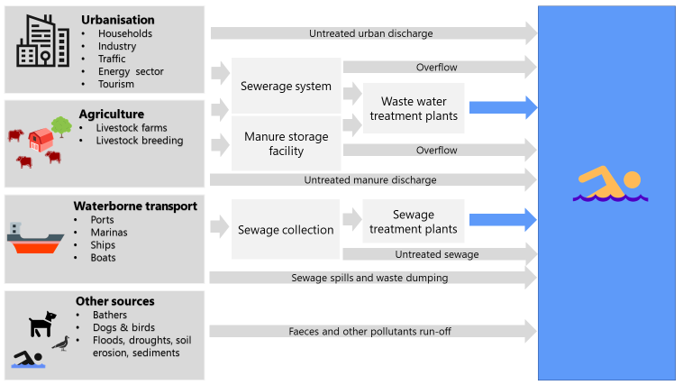

Before the EU Bathing Water Directive was originally adopted in 1976, large quantities of mostly uncontrolled, untreated or partially-treated wastewater were discharged into many of Europe’s surface waters. As a result, these waters became heavily polluted. Dirty beaches and resulting concerns regarding the health of swimmers and growing environmental awareness consequently paved the way to the BWD’s adoption. European Member States were obliged to take all necessary measures to ensure that the quality of their bathing water conformed to water quality guidelines within ten years. These guidelines included 19 microbiological (i.e. several bacteria and viruses) and physico-chemical (i.e. pH, colour, presence of oils, concentration of dissolved oxygen etc.) parameters. Other substances regarded as indications of pollution, and potentially dangerous to public health were also included. The Bathing Water Directive is one of the great success stories of EU environmental policy, and the overall quality of bathing water across Europe has steadily improved since its adoption.
The initial Bathing Water Directive reflected the state of European populations, scientific knowledge and policy experience of the early 1970s. Patterns of bathing water use have changed since then, as has the state of scientific and technical knowledge. As a result, a revised version of the Bathing Water Directive (2006) came into force in 2006, addressing all surface water sites where a large number of people are expected to bathe during the season suitable for bathing. This designation does not include swimming pools, confined waters subject to treatment, or artificially created confined waters separated from surface water and groundwater. All EU Member States are subject to this legislation, whilst an additional two (Albania and Switzerland) are part of the European bathing water monitoring network. The revised BWD uses the latest scientific evidence in implementing the most reliable indicator parameters for predicting microbiological health risk for designated bathing waters, and simplifies its management and surveillance methods. The resulting information is presented to the public in a variety of interactive and accessible ways, allowing people to find clean bathing waters, and to receive timely notifications of water quality deteriorations and health risks.
However, with the BWD now fully implemented throughout the EU, it is important to continuously assess its results. It is not merely a case of assessing water quality across Europe, but also about encouraging various stakeholders – such as national politicians, environmental managers, tourism managers, bathing water managers – to integrally implement the Directive. How do we deal with an (albeit small) number of ‘poor’ quality bathing waters that are still attractive for swimming? How do we relate bathing water management with wider environmental issues? How do we make bathing safe in urbanised and once heavily polluted environments? And how do we work towards improving the quality of already ‘sufficient’ bathing sites so that they achieve ‘good’ or ‘excellent’ classification status? These are the questions addressed through the concept of integrated bathing water management discussed in this report.
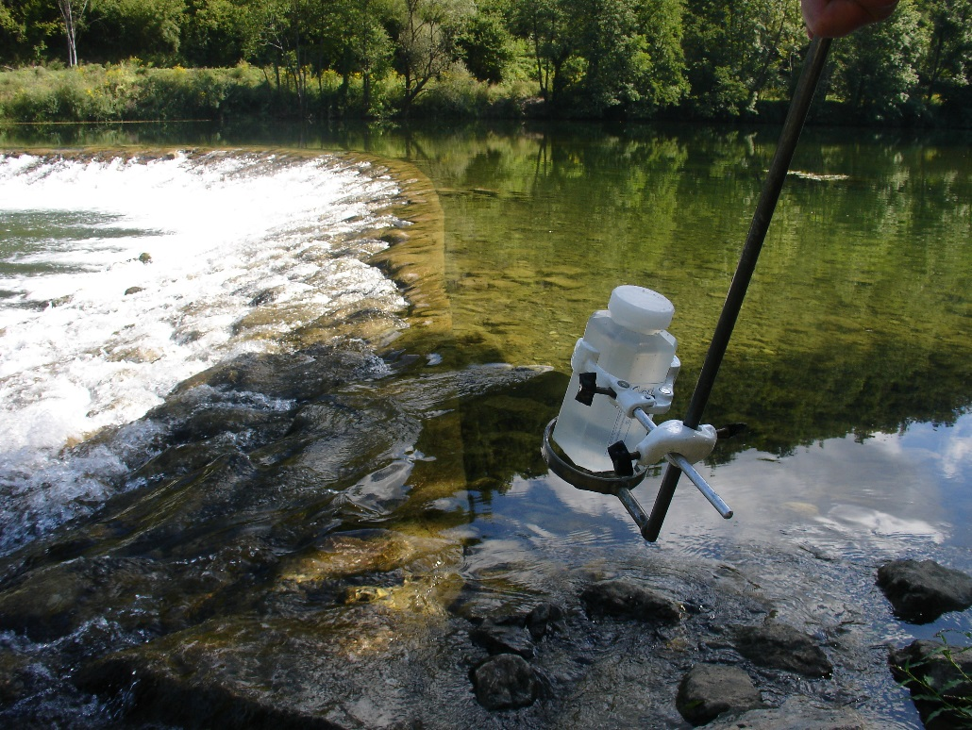
Photo: Taking a bathing water sample ©Mateja Poje

Integrated bathing water management
Integrated bathing water management involves finding synergies between different parties and interest groups through collaboration to encourage effective bathing water management. Under this approach, bathing water designation should not follow a traditional top-down approach where a higher authority (e.g. the EU) delegates tasks to participants at lower levels (e.g. a local community). Public consultation and engagement with local communities is vital, and plays an important role when dealing with the challenges associated with bathing water management. Every European Member State tackles its own specific issues when managing bathing waters and implementing the BWD. These specifics depend mostly on physical, administrative, and socio-economical constraints (EEA, 2016b). Nevertheless, all Member States make great efforts, not only to improve the quality of existing bathing waters and provide up-to-date information to the public, but also to make bathing feasible in urbanised and formerly heavily polluted surface waters.
Clean water in freshwater ecosystems is not only beneficial for bathing: it also benefits drinking water provision and the wider health of the ecosystem. Efforts to improve bathing water quality therefore need to be closely coordinated with the suite of legislation designed to protect and manage European waters. These include the legislation on urban waste water treatment, drinking water, management of nitrates in farming that affect water sources, protection of marine environments and ultimately the Water Framework Directive (2000). These so-called ‘water industry directives’ focus on protecting human health, whilst at the same time regulating farming and economic practices as to reduce and prevent water pollution. Various elements of these policies focus on managing specific parts of the water cycle. Between them, there is a European monitoring and reporting network to document the quality of the water abstracted and used by humans², discharged afterwards¹, and the quality of the water available for recreational purposes (EEA, 2016b). Efficient bathing water quality management therefore dovetails with the implementation of other European water policies. The Urban Waste Water Treatment Directive (UWWTD) regulates the collection, treatment and discharge of urban waste water, whereas the WFD regulates a holistic approach to maintaining good water status in general. Box 1 illustrates an example of how the implementation of UWWTD and WFD brought positive results in implementing the BWD at the Lacuisine bathing water on the Semois River in Belgium (Box 1).
An important aspect of European bathing water legislation is the involvement of all stakeholders around a water body, including the public. European legislation has thus also integrated the practices of the Blue Flag programme, started in 1985 by a non-governmental organisation. The programme seeks to implement various environmental, educational, safety, and accessibility criteria at bathing waters (EEA, 2016b). While the majority of Blue Flags have been awarded to coastal bathing sites, the number of blue flags on inland bathing waters, including in cities, is increasing.

Box 1: Successful water policy synergy: the case of Lacuisine (Belgium)
For many years, the Walloon Region in Belgium permanently prohibited bathing at the Lacuisine bathing water on the Semois River due to ‘poor’ bathing water quality. Such prohibition of (or advice against) bathing is prescribed by the BWD to protect human health and to encourage management of the underlying issues that affect environmental quality.
Between 2012 to 2016, numerous measures were undertaken in order to improve the quality of bathing water at Lacuisine. These included improved urban drainage, the construction of a wastewater treatment plant and a collector built in the upstream protection zone, the establishment of pasture bank fences in upstream area, and controlling storm water overflows on the bathing area. These measures were designed and implemented in the framework of the holistic approach provided by the WFD. Together, they worked to substantially improve the quality of water at Lacuisine.
After six years of water quality management, Lacuisine was re-opened for bathing in 2018.

Successful integration of bathing and urban waste water treatment legislation had also a positive effect on water quality at Ardmore Beach in Ireland (Box 2).

Box 2: Water policy integration: the case of Ardmore Beach (Ireland)
Ardmore Beach is a sandy beach on the south coast of Ireland near Ardmore village. It is visited by hundreds of bathers, surfers and kayakers during the bathing season. The biodiversity of the beach and its surroundings is relatively high. Between the beach and harbour, low tide provides access to rock pools which are home to numerous species of shrimps, crabs, fish, and anemones. Natural heritage areas situated in the vicinity of the beach include vegetated sea cliffs and coastal dry heather which are home to many bird species, and the Blackwater estuary, an internationally important wetland site.
During 2014, high tides and strong winds interfered with the normal dispersion and dilution of screened sewage from the nearest waste water treatment plant, causing bathing water to be classified as ‘poor’. In order to improve bathing water quality, water discharged from the treatment plant has been additionally treated during the bathing season. Bacterial levels were significantly reduced. Bathers, surfers and kayakers returned to the beach, as soon as the advisory notice was removed. For the past two years, bathing water at Ardmore beach has been of ‘excellent’ quality.
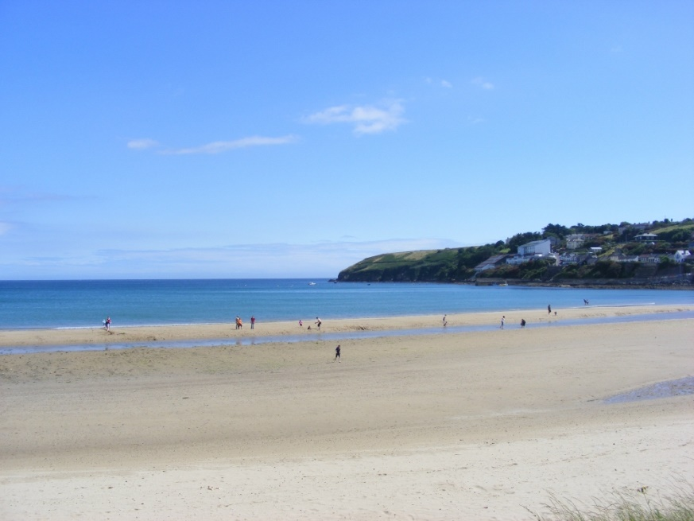
Photo: ©Paul Carroll

The bathing season in Europe usually lasts from May to September. During that time, local and national authorities take bathing water samples and analyse them for types of bacteria which indicate pollution from sewage or livestock (e.g. Escherichia coli and intestinal enterococci). Based on detected levels of bacteria, bathing water quality is then classified as ‘excellent’, ‘good’, ‘sufficient’ or ‘poor’. Polluted water can have negative impacts on human health – such as diarrhoea or stomach problems – if swallowed (EEA, 2018). According to the BWD, if bathing water quality has been ‘poor’ for five consecutive years, bathing must be permanently prohibited, or permanent advice against bathing must be put in place.

The next section will show how the quality of European bathing waters has improved in recent decades.

From polluted to excellent bathing waters
Over almost 30 years there has been an increase in the number of European bathing waters that are monitored and managed under the BWD. The increase was especially dramatic between 1990 and 1991: the number of bathing water sites monitored by seven EU Member States in 1990 was 7 539, while just a year later, there were five more Member States and the number of bathing waters increased to 15 075. Since 2004, bathing water quality has been monitored at more than 20 000 locations; in 2019 there were 22 295 official bathing waters in Europe (Figure 2).

Figure 2: Total number of bathing waters in Europe since 1990
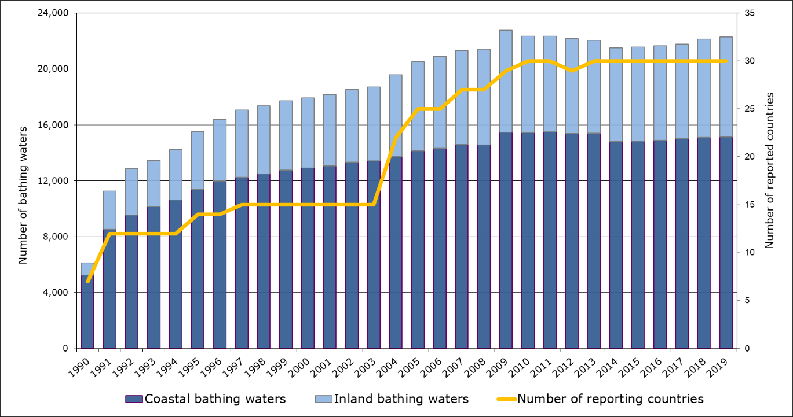
Source: WISE bathing water quality database (data from annual reports by EU Member States).

In recent decades, European countries have not only begun to manage higher number of bathing waters, but have also significantly improved their water quality. Great efforts have been made at numerous bathing sites to reduce and eliminate pollution, and ensure safe bathing at thousands of bathing waters across Europe. As a result, the percentage of bathing waters achieving at least ‘sufficient’ quality (the minimum quality standards set by the BWD) increased from just 74% in 1991 to over 95% in 2003, and has remained quite stable since then. The percent of bathing waters at the highest water quality (classified as ‘excellent’) increased from 53% in 1991 to 85% in 2019. In other words, more than eight out of ten of Europe’s monitored bathing waters now have ‘excellent’ water quality (Figure 3).

Significant investments in urban waste water treatment plants, improvements in sewage networks and other measures have contributed to a reduction in poor bathing water quality across Europe in recent decades. In 1991, 9% of bathing waters were classified as ‘poor’, whereas in 2019 this was the case for only 1.4% of bathing waters.

Figure 3: Bathing water quality in Europe since 1991
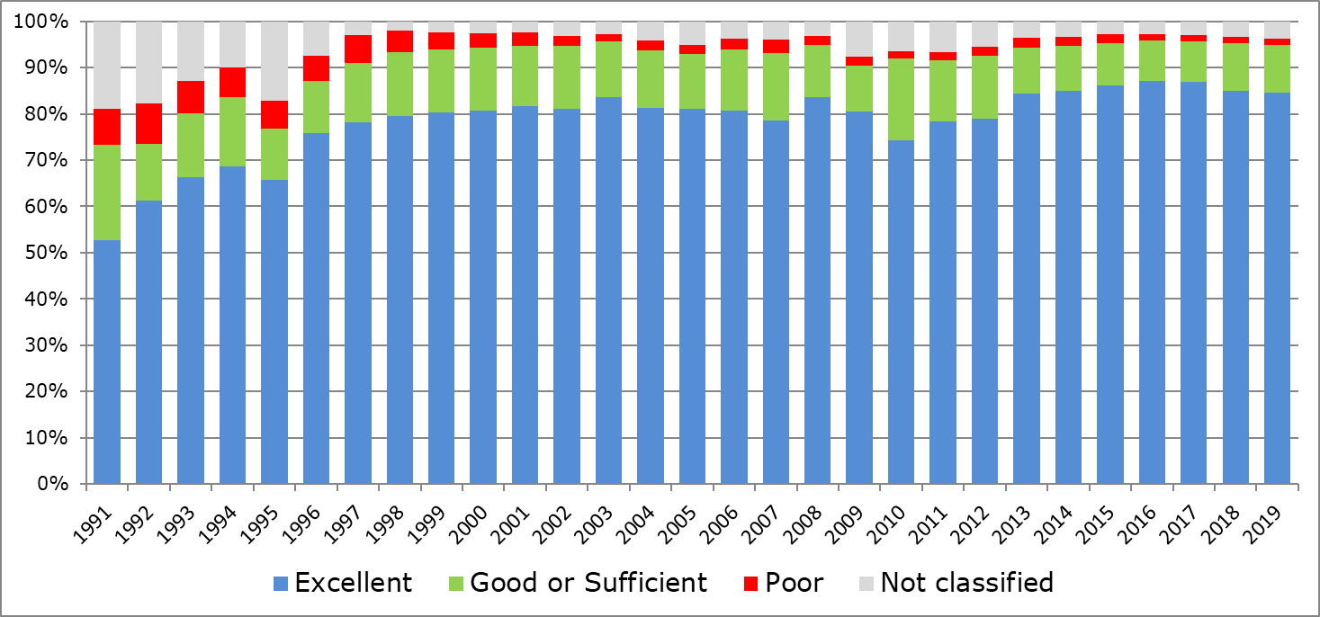
Source: WISE bathing water quality database (data from annual reports by EU Member States).

It is encouraging to see that more and more European bathing water sites have reached the minimum (‘sufficient’) water quality standard. It is even more reassuring to note that European countries are putting great efforts to ensure that more and more bathing waters are classified in the highest ‘excellent’ quality standard. Whilst most European countries began to improve the quality of bathing waters decades ago, Albania has undergone this process more recently, as explained in Box 3 below.
Box 3: Albania as coastal tourist destination
In 2015, almost 40% of bathing waters (31 bathing sites) in Albania were classified as ‘poor’. A great majority of these bathing water sites were situated on the coastline of Durres, one of the main tourist and country’s second largest city (EEA, 2016a). The national authorities have paid significant attention to the water sector in the Durres area in recent years. The World Bank also supported investments in the Durres water supply network, and the construction of water transmission pipeline to link villages to the city’s water supply system and reduce losses in the water distribution network. In addition, the local sewage network and its transfer capacity from the tourist beach area to the wastewater treatment plant were also enhanced (World Bank, 2014). In the recent years, five wastewater treatment plants providing treatment for almost half a million residents have been constructed in Albania (EEA, 2018).
These measures gradually contributed to better bathing and overall water quality in Albania. In 2019, only 7 bathing water sites (or 5.9%) were classified as ‘poor’ which is a significant reduction since 2015 when 31 bathing water sites (almost 40%) were assessed as ‘poor’. Improvement of bathing water quality offers great potential for coastal tourism. The tourism industry in Albania contributes more than 8% of the country’s GDP. Improving bathing water quality by ensuring clean and safe bathing waters is paving the way for Albania to become an established and well recognised tourist destination.
Map 1: Bathing water quality in Albania in 2015 (left) and 2019 (right).
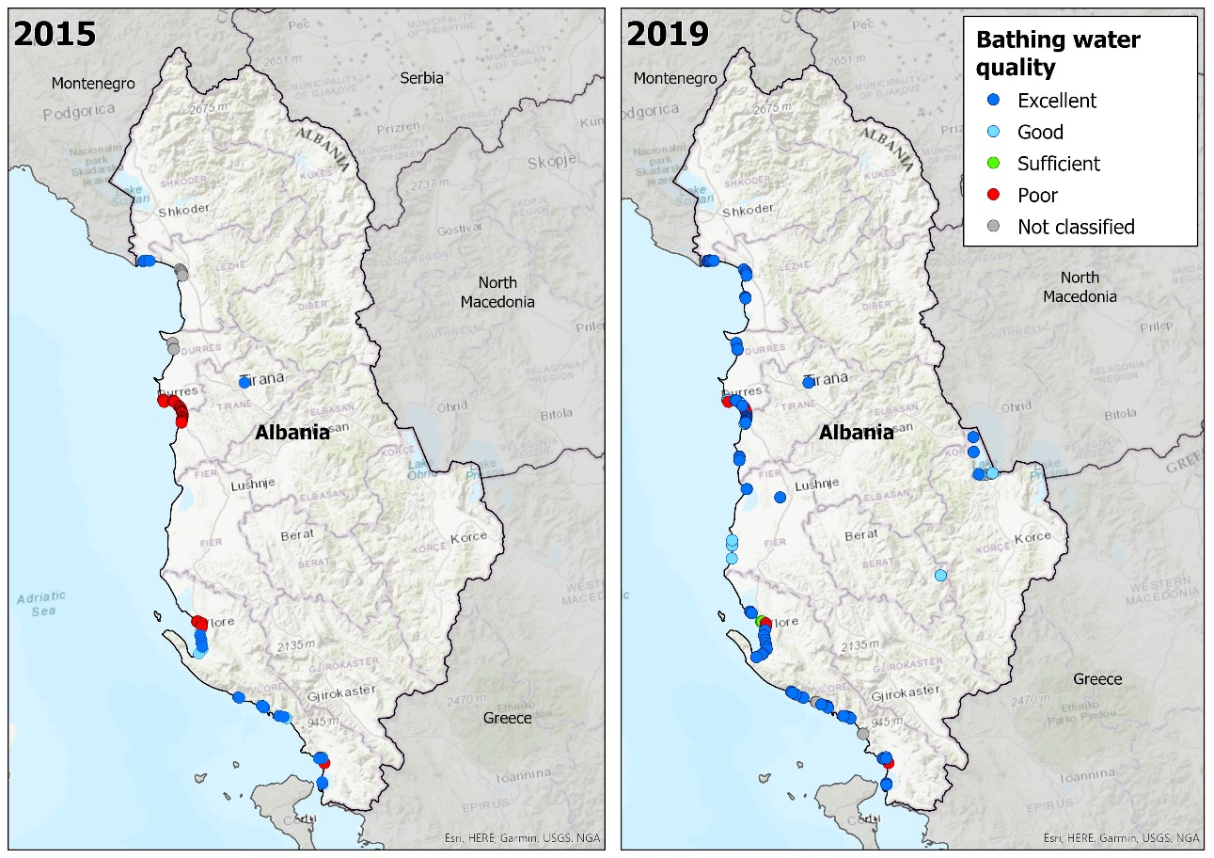
Source: National boundaries: EEA; bathing water data and coordinates: reporting countries' authorities.

Clean bathing waters are not only essential for safe recreation, but also for the environment and economy. EU water policy has been successful in helping to protect and improve bathing waters in recent decades. What is the next step? One answer is revitalising bathing waters in cities, where the complexity of urban activities and pressures makes ensuring clean and safe bathing a significant challenge.

Now we can swim in some of our cities again
Since the Industrial Revolution began in the 18th century, the geographical distribution of human populations across Europe has changed significantly. In that time, Europe has become one of the most densely populated regions in the world, where almost 75% of the population lives in urban areas (Koceva, et al., 2016). The gradual increase in the proportion of people living in urban areas has come at a cost to European rivers and lakes over the last century. Many freshwaters were heavily degraded and polluted during this urbanisation process (EEA, 2016). As a result, traditional uses of rivers – such as bathing – disappeared. Large loads of wastewater flowing directly to the rivers and lakes made bathing impossible at such places without jeopardising human health.
In recent years, great progress has been made in improving water quality in European urban rivers and lakes. This is mainly due to construction of sewers and new waste water treatment plants, alongside upgrades to existing ones. Cumulative restoration measures – such as reopening covered rivers and improving water quality to bathing standards – contribute to how both local citizens and visitors experience urban rivers and lakes.
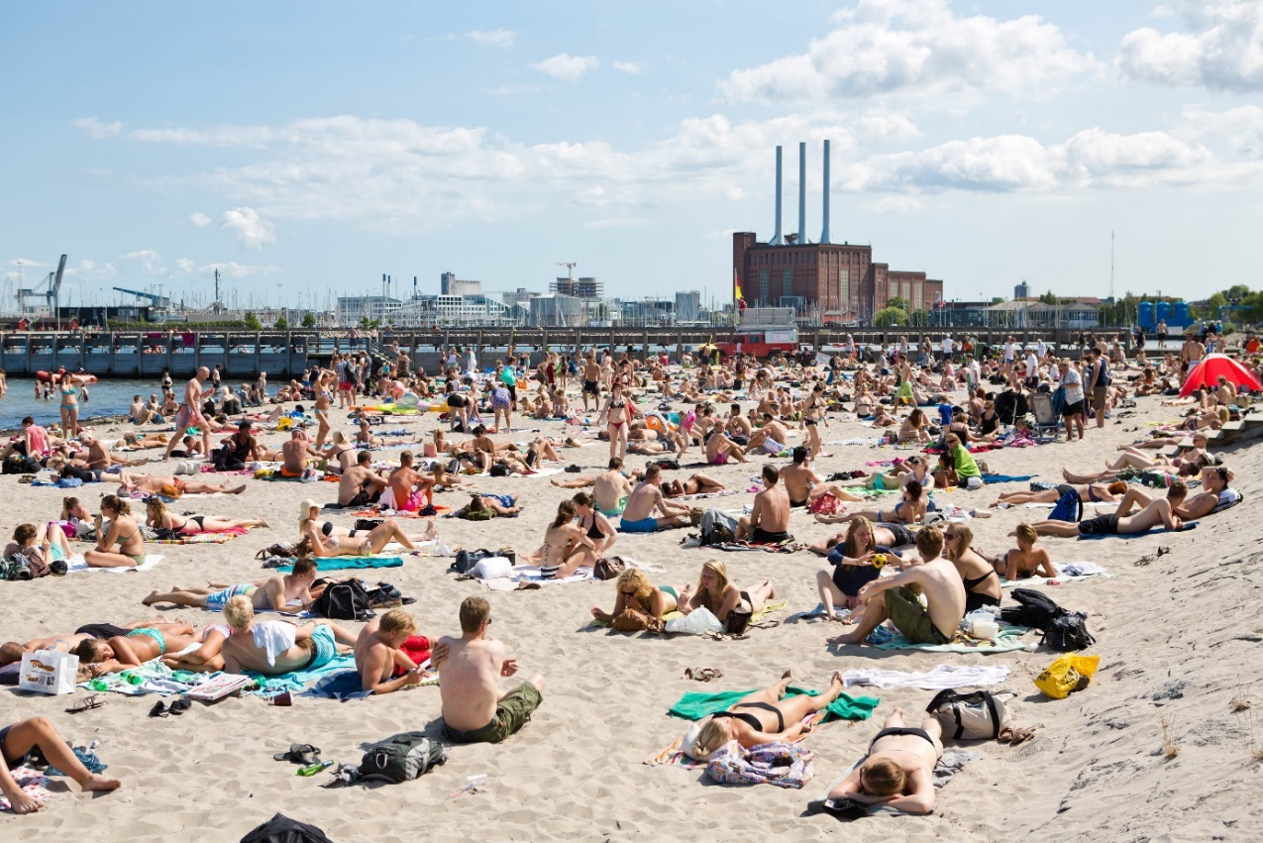
Photo: Public bathing at the harbour in Copenhagen, Denmark © Ursula Bach, Municipality of Copenhagen
Restoring urban lakes and rivers which flow through big cities to the point where their water quality meets the bathing water standards is becoming more and more realistic and feasible. In recent years there has been a significant increase in the number of safe bathing waters situated in big cities. In the last decade the number of urban bathing sites has increased substantially. About 75% of these bathing waters are coastal and thus situated in cities by the sea: with many on the Mediterranean Sea in cities of Nice (150 bathing waters), Pesaro (almost 90 bathing waters) and Toulon (70 bathing waters). The cities with the highest number of inland urban bathing waters are Amsterdam (38), Stockholm (36), Berlin (33), Lugano (28), Geneva (25), Rotterdam (23) and Vienna (23).
Today, safe bathing is possible even in some European capitals; people can bath on the banks of the River Danube in Vienna and Budapest, on the River Spree in Berlin, numerous places in Amsterdam, on the River Daugava in Riga, at Copenhagen Harbour (Box 4) and many others.
Whilst bathing water quality in the Europe is increasing, and bathing is today possible even in some heavily urbanised areas, there is the still a need for integrated and adaptive management to mitigate both existing and emerging pressures, as outlined in the following chapter.

Box 5: Management of large bathing waters in Barcelona (Spain)

Barcelona has a population of 1.6 million inhabitants, with 1.5 million more in the wider metropolitan area. The seafront of the city has been transformed, and it is today a key tourist site, with over 10 km of beaches, visited by over three million tourists each year. Due to its high population density and hilly terrain, Barcelona’s bathing waters are exposed to sewer systems overflows. These overflows cause episodes of short-term water contamination which may affect the quality of bathing waters. As is common in Mediterranean climates, heavy rain events are often concentrated in very few days with high intensities.
Up to the early 1990s, Barcelona faced flooding problems and overflows, causing environmental pollution. In 2006, an ambitious plan was proposed, with improved environmental and public wellbeing objectives: to reduce the combined sewage outflows so that the number of hours that the bathing waters are not allowed for bathing is reduced.
Information systems have been developed for both internal coordination and general public information. The public can access bathing information (bathing water quality predictions, weather forecast, presence of jellyfish etc.) using electronic panels at the beach and on public web pages. A coordination protocol is activated by the detention of an overflow, which can be triggered by tele-controlled sensors, camera images or direct observations at the beach. The protocol describes different responsibilities so that the responsible agent can diagnose the outflow and take correction measures for the immediate resolution of the problem.
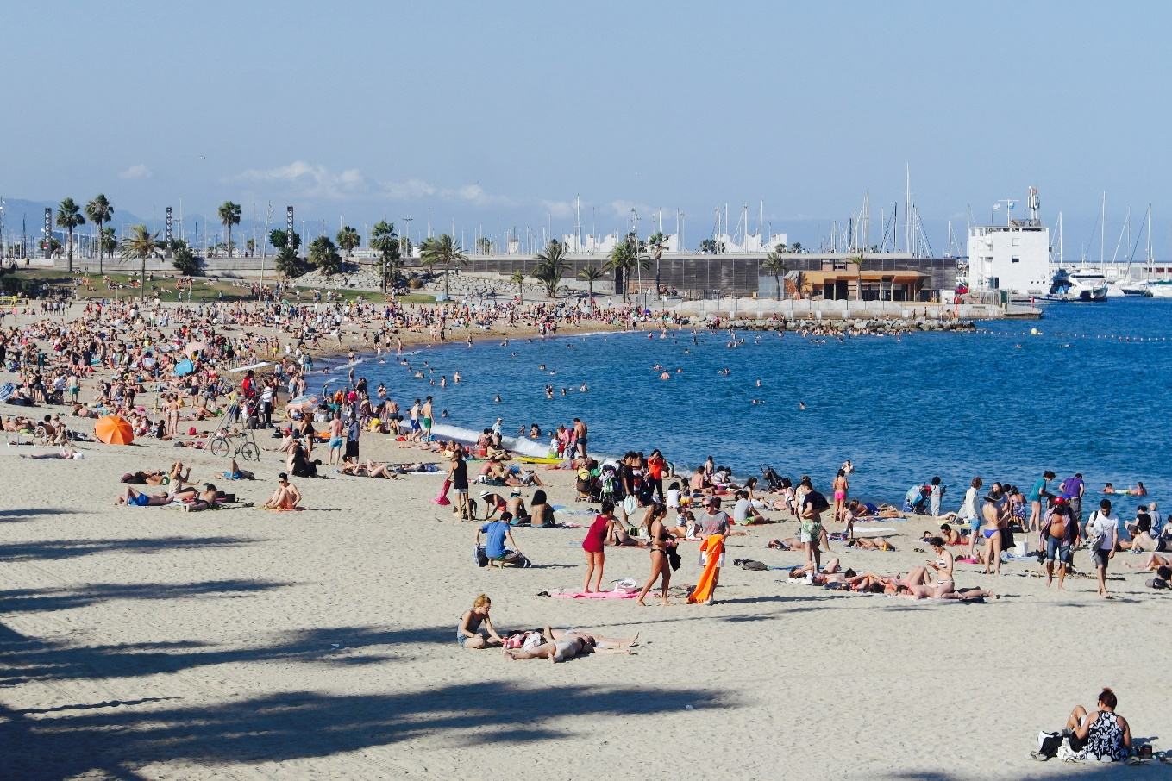
Photo: ©Nikolaï Posner

- Addressing the challenges to bathing waters

Bacteria: an invisible health risk
The major sources of faecal bacteria pollution come from sewage, insufficient waste water treatment plants, animals (e.g. birds and dogs at beaches) and water draining from farms and farmland. The presence of faecal bacteria can lead to poor bathing water quality, presenting a threat to bathers’ health. Pollution from sewage is often the result of storm water overflows of sewage, agricultural run-off, or from poorly maintained cesspits and septic tanks. Badly connected plumbing – where for example water from toilets directly enters surface waters – constitutes another potential source of microbiological pollution (EEA, 2018).
Figure 4: Threats to bathers' health
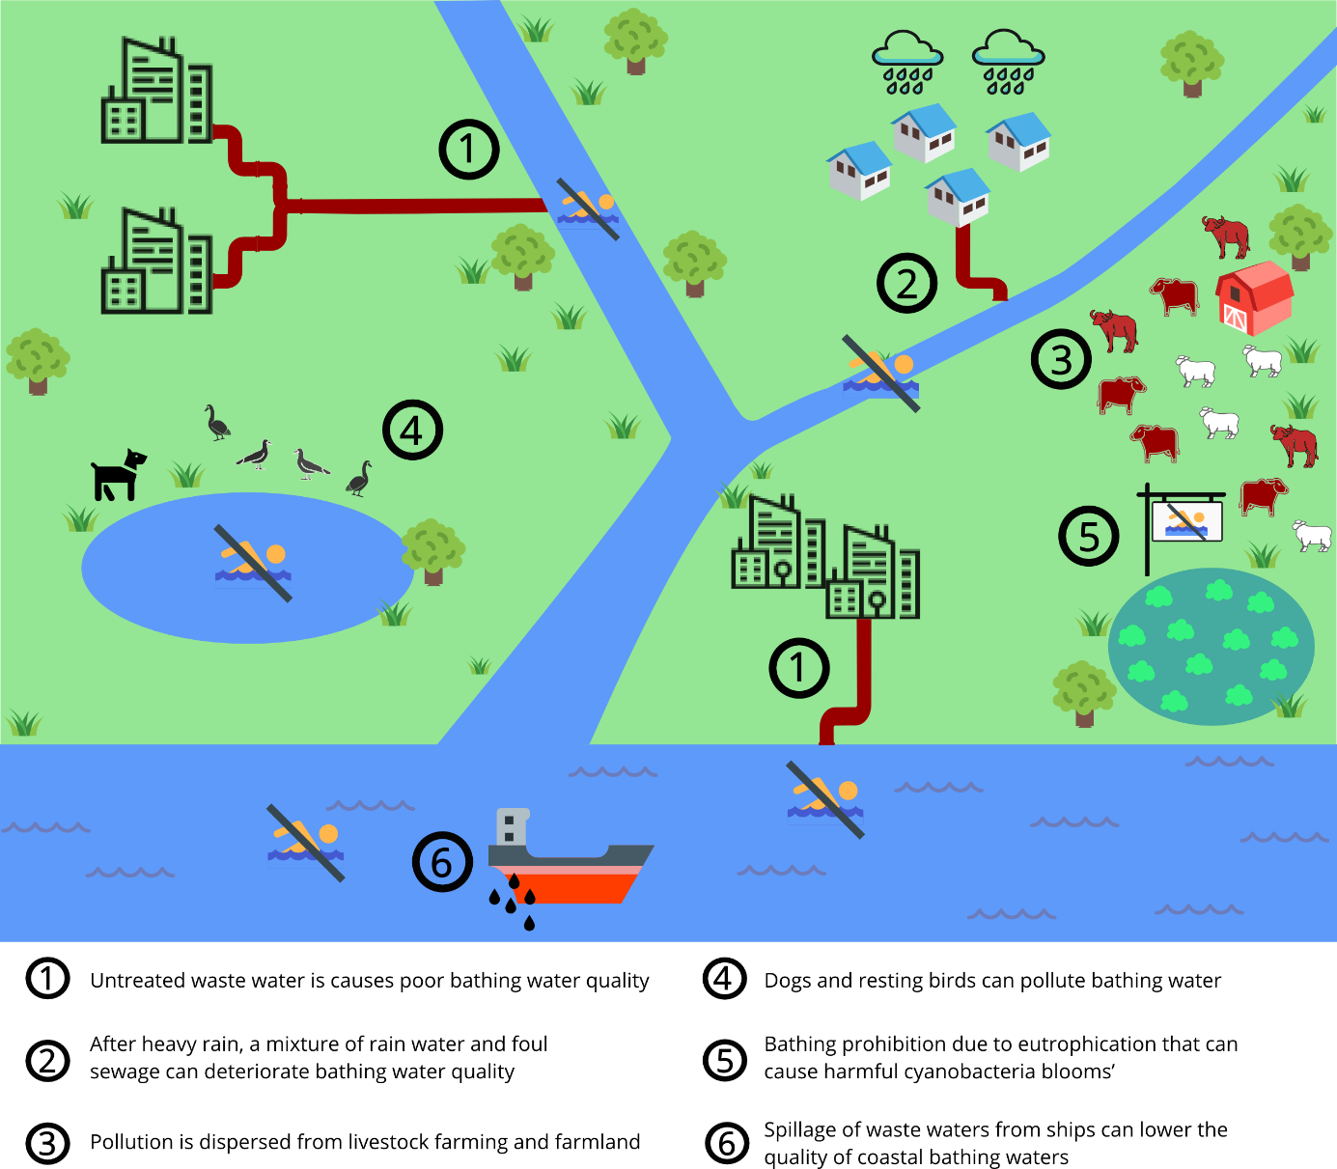
In mid-1970s, large quantities of uncontrolled, untreated or partially-treated wastewater were discharged into many European waters. Back then, many of today’s ‘excellent’ bathing waters were heavily polluted and unsafe for recreational use. Swimming at bathing sites with ‘poor’ water quality can result in intestinal illness. If faecal bacteria (e.g. Escherichia coli) enters the human body through contaminated water, it can cause diarrhoea and other illnesses of the intestinal tract.
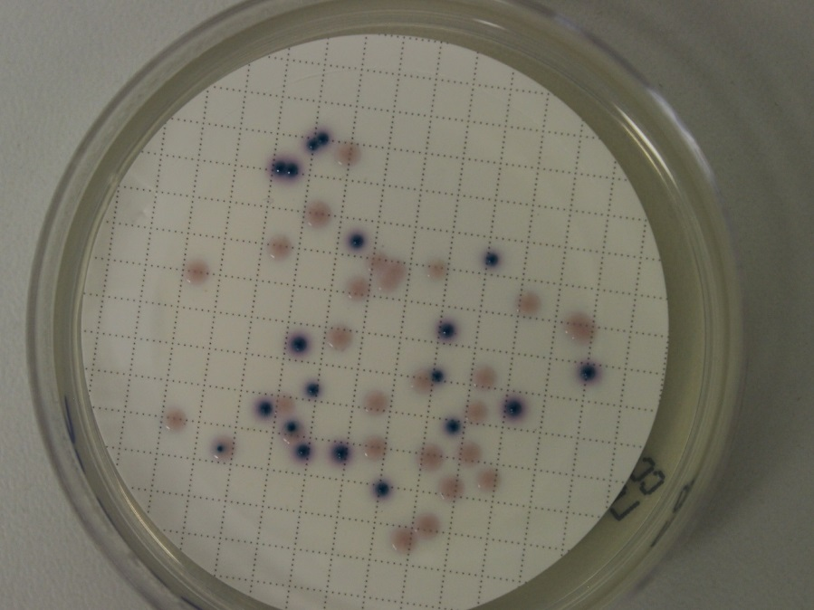
Photo: Escherichia coli in bathing water sample ©Mateja Poje

How has it been managed?
Large investments in sewage systems and treatment plants have caused Europe's bathing water to be much cleaner than in years past in terms of bacterial pollution (EEA, 2019a). Today, almost all significant discharges of sewage from households and industry undergo collection and treatment before they are released into rivers and lakes. Additional treatment methods such as disinfection, chlorination and ozonisation are also being implemented across Europe in order to ensure high hygiene standards for bathing waters (EEA, 2016b).
If microbiological pollution causes ‘poor’ bathing water quality, the sources and extent of pollution have to be assessed in the first place (e.g. foul sewage pipe, pollution from manure). If the causes of poor water quality are not known, special studies to explore the sources might be needed. The implementation of Urban Waste Water Directive has successfully led to reduced pollution and improved water quality at numerous bathing water sites of low quality. The assessment confirms that the UWWTD has proved very effective overall when fully implemented and has improved water quality throughout the European Union. Though implementing the Directive has been expensive, its benefits clearly outweigh its costs (EEA, 2019b). In order to find and eliminate pollution sources, inventories of bathing waters affected by water draining from farms and farmland and from scattered houses with misconnected drains are established. If bathing waters are affected by large number of animals (Box 6), it may be necessary to restrict their access (e.g. fence) or change the location of the bathing water site. Bathing water sites classified as 'poor' have to be closed throughout the following bathing season and must have measures in place to reduce pollution and eliminate hazards to the health of bathers.

Figure 5: Management measures to reduce pollution and improve bathing water quality
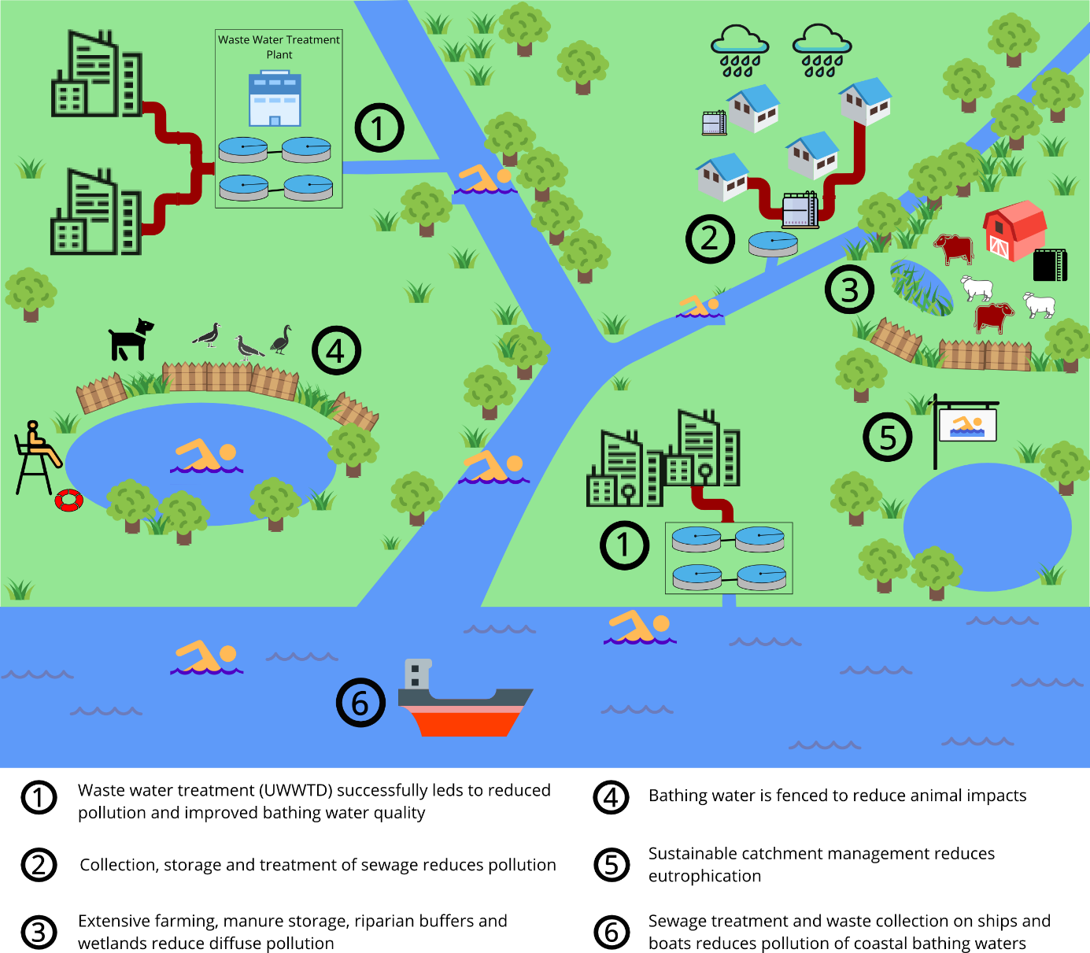

Box 6: Birds impacting the quality of bathing water (Czechia)
Brušperk is a water tank built for flood protection in the 1960s in the vicinity of Ostrava, Czechia. It is nowadays used mainly for bathing and fishing. Between 2012 and 2015, the quality of this bathing water was impaired largely due to presence of large quantities of water birds fed by the beach visitors, as well as pollution from the farm located near the tank. In the 2012 season, bathing was temporarily prohibited due to microbial pollution caused by the presence of large quantities of water birds, which were overfed at the shore by bathing water visitors. After intervention from local authorities, the feed was cleaned from the banks of the reservoir and moved to the surrounding water bodies – people were kindly requested to feed the birds at different location which is not used by bathers. The microbiological quality of the bathing water is now ‘excellent’.
Box 7: Uncontrolled sewage at the Arturówek bathing water (Poland)
The Arturówek bathing water is located in Poland, on the northern part of Łódź at the edge of Łagiewnicki Forest. It holds three reservoirs, with two adapted for bathing purposes and hiring of water recreation equipment. The Arturówek ponds are an important place of recreation for inhabitants of Łódź, as well as one of the major tourist sites during the holiday period.
There were several uncontrolled sewage discharges in the river catchment upstream of these reservoirs. Since the sewage was washed down by the rainwater and snowmelt to the Bzura river and reservoirs, the quality of this bathing water was heavily impacted.
Since all previous attempts to improve water quality of the ponds (such as the removal of bottom sediments) only improved the situation temporarily, a systemic approach was taken within the ‘Ecohydrological rehabilitation EU LIFE’ project. Technical measures implemented under this project (e.g. desludging its bottom to remove nutrients, or implementation of a novel wastewater treatment technology of sequential biofiltration to reduce the load of organic pollution from sewage) improved the water quality and overall attractiveness of the Arturówek site. This demonstrates the application of the eco-hydrological methods to sustainable water management in urban areas, involving both the public and decision makers. Finally, it establishes the basis for the rehabilitation of key water systems in Łódź under the Water Framework Directive.
In 2018, the Arturówek ponds were finally reopened for bathing after eight years. Even though a BWD water quality classification is not yet possible, the monitoring results are already now showing a gradual improvement of bathing water quality.
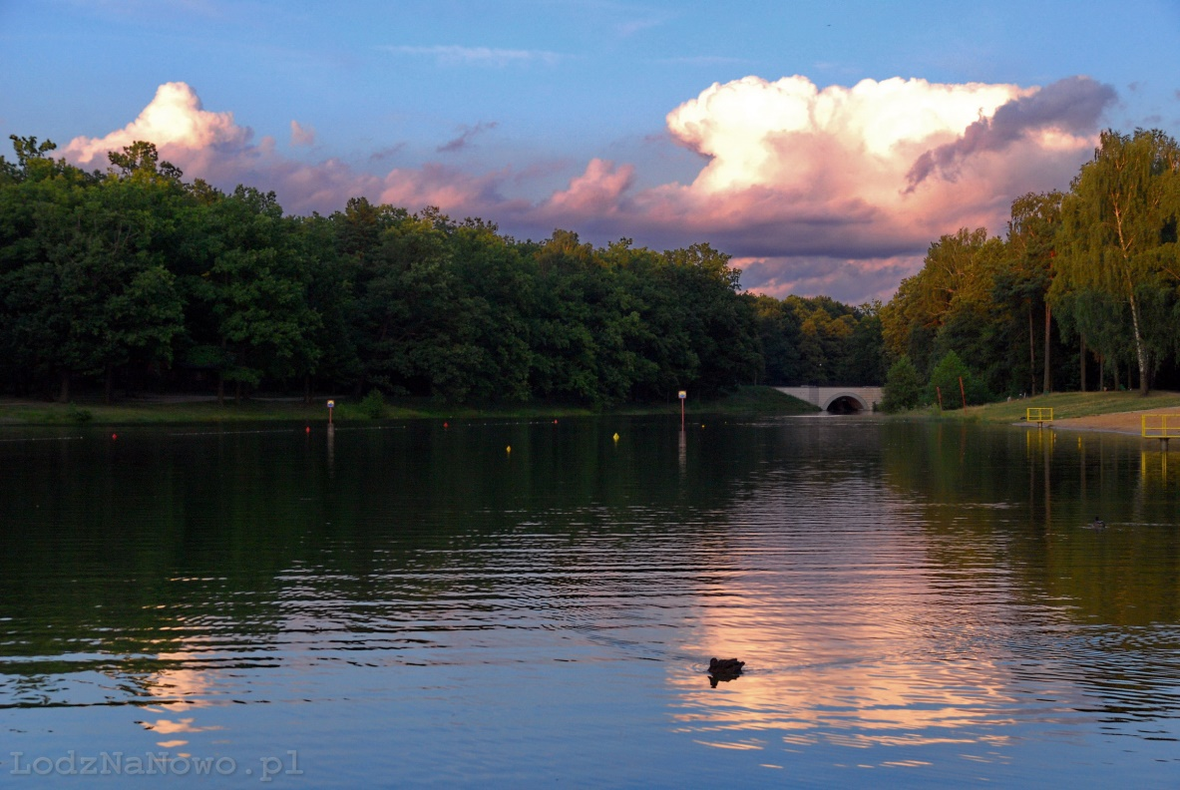
Photo: ©Mariusz Kucharczyk

Extreme weather and other events: unpredicted impacts on water quality
The causes of short-term pollution events are usually weather events such as excessive precipitation and subsequent surface runoff, as well as waste water overflow, when a mixture of surface water and foul sewage is discharged to the environment via combined sewer flows (CSO) (EEA, 2018). Concrete pipes, sewers and particularly paved surfaces make it difficult for storm water to be absorbed where it falls (EEA, 2015c). It is also evident that concrete systems in cities are not always able to drain all storm water through the sewage systems and therefore they might be the real cause of urban flooding. For this reason, they need to be addressed with integrative urban management including forecasting pollution in correlation with other factors, managing pollution when it is detected, and assessing the overall risk of such events.
Such pollution events are often of short duration – potentially up to 72 hours but often significantly shorter – and have clearly identifiable causes. After heavy rain, a mixture of surface water and sewage is sometimes discharged into bathing waters or their vicinity, impacting water quality by introducing bacteria and viruses that can affect human health. In a small number of cases, short-term pollution events occur also due to technical errors such as malfunction of sewerage systems or wastewater treatment plants, or the spillage of waste waters from ships.
In the last four years, more than 3 000 short-term pollution events have been reported throughout Europe. The number of reported events is increasing – this may also be an indication of more frequently applied management approaches resulting in a larger number of events reported (EEA, 2017c). Although short-term pollution events occur in bathing waters of all kinds of quality, they much more frequently impact bathing waters of ‘poor’ and ‘sufficient’ quality.
On the other hand, some inland bathing sites may lack water due to droughts caused by low runoff or even water abstractions for hydropower generation, cooling and irrigation. Water quality may deteriorate in parallel due to weak dilution of pollutants. High summer temperatures or construction works on bathing sites may worsen the situation.

How has it been managed?
Sewage overflows across Europe are being managed under the UWWTD using different measures such as the installation of equipment for monitoring spills to the environment, construction of storage tunnels and tanks to reduce the storm overflows as well as formation of nature-based retention basins. Green areas in cities can function as storm-water retention basins and mitigate the load on conventional sewage systems. Such solutions are not only less expensive than traditional ‘concrete’ infrastructure but also provide a wide array of co-benefits for local economies and social communities (EEA, 2015c). Such measures can also prevent flooding as well as minimising adverse impacts to the environment and bathers’ health.
Box 8: Managing storm overflow pollution in Blackpool (The United Kingdom)
There are three bathing waters situated on Fylde coastline around Blackpool, Lancashire, flanked by the urban fringe along the coastline, with agricultural land dominating further inland. Most surface water in the catchment is diverted away from the bathing waters. In the 1990s these bathing waters were of ‘poor’ quality mainly due to insufficient sewage infrastructure.
The £500 million coastal clean-up project »Sea Change« was launched in 1994 by the UK Environment Agency in conjunction with the water service company to improve bathing water quality in North West England, particularly along the Fylde Coast. Under this programme, the company made improvements in the Blackpool area by constructing a tunnel to provide storage for storm discharges and transferring flows from four coastal pumping stations serving the Blackpool area to a new sewage treatment works at Fleetwood. In addition, large storage tanks were also built to reduce the storm overflows. Due to these measures, water quality at Blackpool improved gradually, reaching ‘good’ and even ‘excellent’ quality.
As part of the improvement programme from 2015 to 2020, the storm overflows from Chorley, Blackburn and Preston sewage treatment works will be improved to protect bathing water quality. Further work to reduce the number of storm discharges will improve bathing water quality on the Fylde coast in Lancashire.
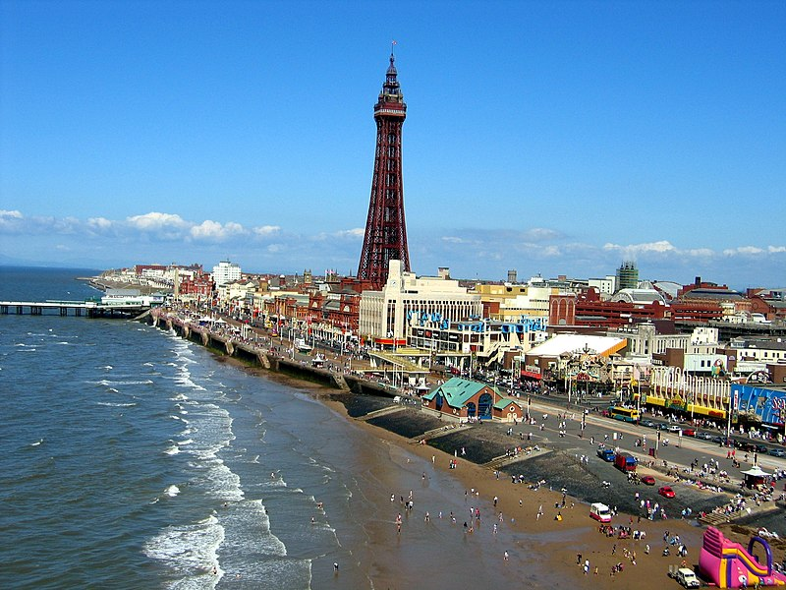
Photo: ©Zergo512 (Wikipedia, 2019)

Modelling and warning systems are put in place to advice bathers against entering the water after short-term pollution events at bathing waters affected by heavy rains and storm water overflows (Box 9). This is in addition to measures to reduce pollution at source (Box 8) and at rainwater storage basins (EEA, 2018).

Box 9: Early warning system for short-term pollution at the Lake Baldeney (Germany)
Along the intensely industrialised Ruhr valley in northern Germany, the River Ruhr became increasingly polluted through the 20th century. Over time, using the river for recreational purposes became a serious health hazard, and bathing was banned due to chemical and microbiological risks between 1971 and 2015 (Strathmann, et al., 2016). Water quality was additionally deteriorated due to coal and steel mining.
With implementation of all levels of waste water treatments in 2005 in Essen, the site gradually improved water quality. Decades after it was closed for swimming, people can safely bathe in Lake Baldeney again. The development of an early warning system for short-term pollution was an important step in managing this site. Short-term pollution events can happen in running waters after a heavy rainfall event, and for the approval as an official bathing area it was essential to have an early warning system for the swimmers, allowing authorities to swiftly prohibit bathing at the site if needed. The early warning system (Strathmann, et al., 2016) is based on measured precipitation data. It is activated if the rainfall exceeds certain precipitation threshold between the evaluation date and two days before. In such case, a web application issues an automatic bathing warning and bathing is temporarily prohibited at the site. The early warning system is now operating and it has a high level of reliability to protect swimmers from illness.
Essen has proven to be an environmentally innovative city, especially in the face of a challenging industrial history. Important success factors in making bathing at Lake Baldeney possible again include the strong participation of the local population and the scientific evaluation of the costs and the benefits of the operation of such a bathing area (IWW, 2017).
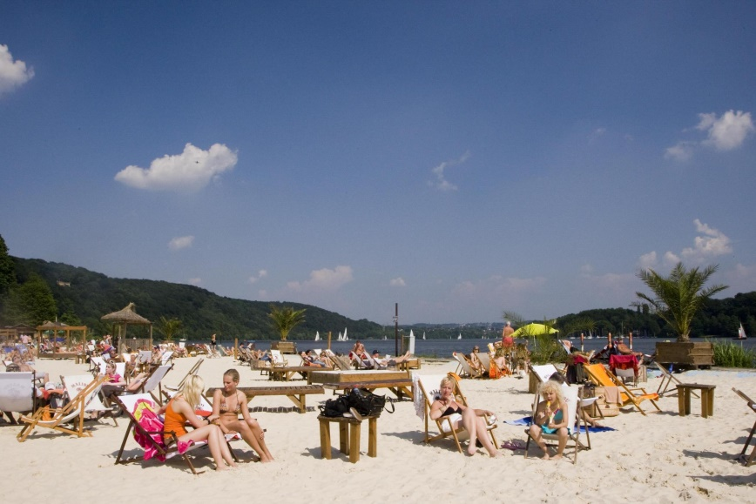
photo: ©Seaside Beach Baldeney Facebook

Algae in water: eutrophication as a health risk
The rapid increase in industrial and agricultural production as well as household consumption in Europe during the 20th century has resulted in greater volumes of nutrient-rich wastewater reaching aquatic ecosystems. The nutrient over-enrichment (mostly from inputs of nitrogen and phosphorus) of seas, lakes, rivers and streams from land-based sources, marine activities and atmospheric deposition can result in a series of negative ecological effects known as eutrophication (EEA, 2019b). As a consequence, aquatic ecosystems are impacted because a considerable amount of oxygen is being consumed by algae while growing and then decomposing (Nemery, 2019). This can lead to water bodies with low levels of dissolved oxygen – known as hypoxia – where many freshwater organisms struggle to survive.
Phosphorus is the main nutrient which causes eutrophication in rivers and lakes, whereas nitrate is the key substance in salt waters. Increased nutrient concentrations can alter aquatic ecosystems to such an extent that they become unsuitable for consumption and bathing.
The main sources of nitrogen pollution are surpluses of mineral fertilisers and manure which are washed out of agricultural soil to groundwater, rivers and seas by the rain. Most phosphorus pollution comes from households and industry. If appropriate mitigation measures are not in place, higher concentration of nutrients can be measured at bathing waters situated downstream of pollution sources, potentially leading to problems with public and environmental health. The consequences of such eutrophication can also include blooms of blue-green algae, which reduce water clarity and quality. Decomposing algae can also cause depletion of oxygen and induce fish kills (CSIRO, 2019).
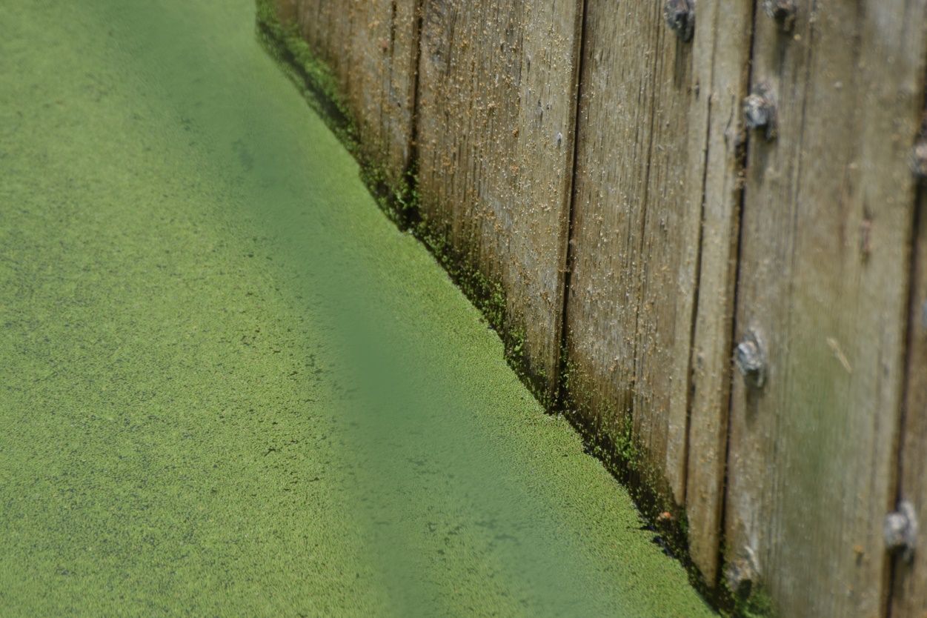
Photo: Algae blooms can pose a public health risk in bathing waters ©Dana L. Brown

How has it been managed?
The implementation of the UWWTD – which includes collection and treatment of wastewater in the EU – has resulted in reduced releases of nutrients to fresh and coastal bathing waters, diminishing public health risks in some regions of Europe (EEA, 2010; EEA 2012). As a result, bathing waters all over Europe are now much cleaner than they were 30 years ago. Nevertheless, agriculture continues to be a major source of nutrient pollution, particularly from fertiliser run-off. For example, the Baltic Sea is known to be one of the most eutrophic seas in the world, mainly due to high loads of nitrogen and phosphorus originating from agriculture, entering the sea from river systems (EEA and JRC 2013).

Box 11: Cultural eutrophication of Lake Varese (Italy)
Lake Varese is a small lake of glacial origin in Lombardy, in the north of Italy. Since the 1960s, the lake has suffered water quality deteriorations as the result of intense – and often toxic – algae blooms caused by high phosphorous loads. These have caused fish kills and restricted water use. Lake Varese constitutes the first case in Italy where in-lake methods are used to counteract the problems caused by excessive nutrient enrichment in a relative large system. Since the 1990s, the lake has been the subject of a cooperative research program supported by the European Commission, the Italian Ministry of the Environment, the Lombardy Region, and the Varese Province. In 1992, the Regional Water Clean-up Plan was formed, with the objectives to protect aquatic biota, achieve good ecological status and safeguard water uses, including drinking water supply, bathing (three bathing sites are situated on the lake), fishing and irrigation.
Direct interventions had a key role in accelerating the restoration process in the lake, and in controlling the effects on the phosphorous releases from sediments. Major in-lake eutrophication control methods included nutrient inactivation, lake level drawdown, covering bottom sediments, sediment removal (dredging), harvesting, and other measures. As a result, a great amount of total phosphorous, total nitrogen and ammonia were removed from the lake in 2000 and 2001. Lake transparency is now close to the final objective – 5 metres – of the Regional Water Clean-Up Plan. Algal density has decreased by a factor of four and the frequency of algal blooms has decreased by half.
After decades of neglect due to a lack of beaches, pollution from industrial effluent and eutrophication, Lake Varese has regained its sparkle. In 2018, three bathing waters were operating on the lake; two of them being of ‘excellent’ quality and one being ‘poor’ due to of insufficiently treated waste water.
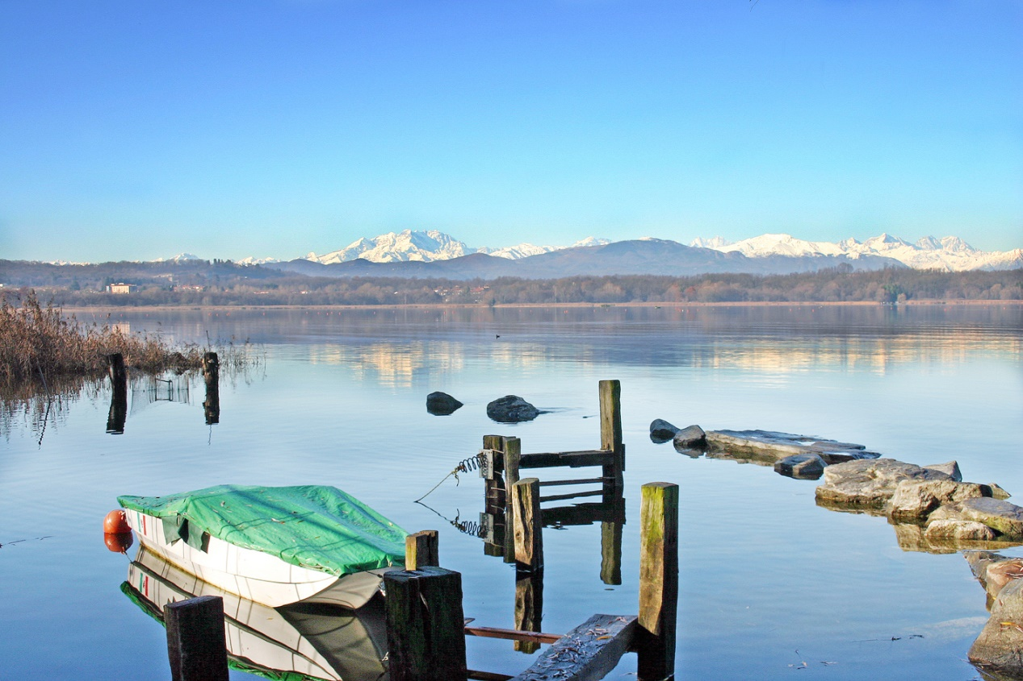
Photo: ©Maxalari (Flickr, 2003; Creative Commons licences)

Cyanobacteria and other hazards
Cyanobacteria – also known as blue-green algae – can be harmful if swallowed and can cause skin rashes. Proliferations of cyanobacteria can occur when environmental conditions are favourable, such as when there are high levels of nutrients in water, there is a high stability of the water column, and when temperatures and light are favourable and conditions are calm and windless (EEA, 2018). Human activities can accelerate this process through activities such as inadequate sewage treatment, agricultural runoff, and runoff from roads (WHO, 2003).
Cyanobacteria blooms are most pronounced during the summer months, which coincides with the bathing season in Europe, and the highest demand for recreational water. Mass blooms of cyanobacteria can affect the amenity value of recreational waters due to reduced transparency, discoloured water and scum formation. Furthermore, bloom degradation can be accompanied by an unpleasant smell (WHO, 2003). Information available from European countries indicates issues with cyanobacteria blooms in Central European inland bathing waters in Czechia, Germany and Poland, but also in other countries. Although cyanobacteria are not subject to quantitative monitoring prescribed by the BWD, the blooms frequently create the need for temporary advice against, or prohibition of, bathing. Each year, hundreds of bathing water sites are affected by cyanobacteria blooms that decrease water quality and can affect the health of bathers (EEA, 2018). Bathing in water affected by cyanobacteria can result in headaches, nausea, diarrhoea, pneumonia, vomiting, fever and other health issues.
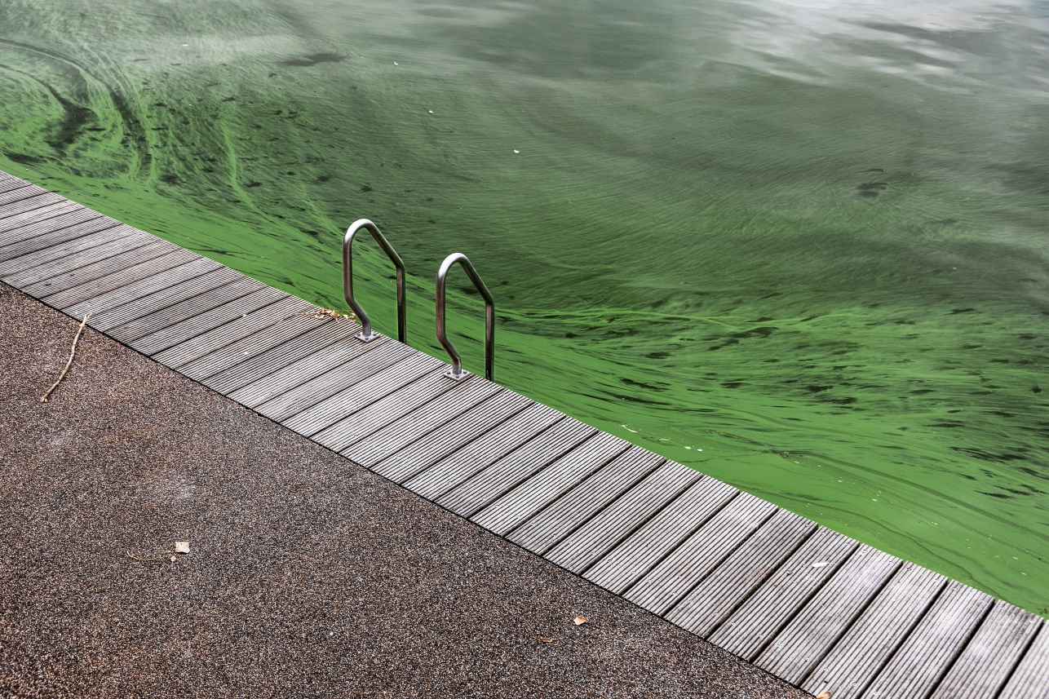
Photo: Cyanobacteria blooms on a bathing water ©Wouter Rietberg
Other hazards, such as chemical pollution, heavy metals, and mercury, can enter bathing waters or be deposited on their coasts from both natural and anthropogenic sources. These can be either diffuse (non-point) sources, such as runoff from land, or point sources such as natural springs with high concentrations of mercury or industrial outfall. Likelihood, extent, and frequency of exposure are vital when assessing the risk of such hazards. Many such contaminants tend to settle at the bottom of water bodies where they accumulate in sediments. If the sediments remain undisturbed, the risk is relatively low. If the sediment is disturbed or bathers are in direct contact with the sediment, the concern is higher.

How it has been managed?
Algal blooms result from a complex interaction between biological, chemical, meteorological and especially hydrographic conditions, of which only few can be controlled. In order to minimise health risks due to cyanobacteria blooms, phosphorus concentrations should be kept below a ‘carrying capacity’ threshold. In particular, nutrient inputs from agricultural runoff may in many cases be reduced by decreasing the application of agricultural fertilisers, or protecting the shoreline from erosion by planting trees and vegetation along the shoreline in order to create ‘buffer strips’ for pollutants.

When minimising the health risks of chemical pollution, it is very important to understand the industry and other human activities in the catchment area and near vicinity of the bathing water, and whether direct or indirect discharges of pollutants are made to the bathing water. Different measures can be applied when reducing the risk of such hazards. In Lake Mälaren in Sweden, 95% of mercury in the sediment was successfully isolated by covering the polluted lake bed with artificial bottom sediment (Box 12).

European overseas bathing waters might be impacted by major weather or environmental events such as cyclones or the massive beaching of algae (Box 13). It is difficult to reduce such hazards. Such events should be closely monitored so that bathing can be prohibited if necessary for public health.

Box 12: Releases of mercury and pollution with heavy metals (Sweden)
Lake Mälaren located west of Stockholm is the third largest lake in Sweden. With an area of 1 140 km² and extending about 120 km across Sweden, it is the country’s third largest lake. There are 19 bathing sites on its shore. Until recently, mercury spread into Lake Mälaren in the municipality of Nykvarn.

Between 1946 and 1966, a paper mill released fiber residues containing mercury into the Turingeån River and Lake Turingen with its outflow to Lake Mälaren. Although the use of mercury was banned in 1966, secondary releases continued, which resulted in high levels of mercury in water and fish tissues. When remediation management started in 1998, there was almost 400 kg of mercury in the river and lake bottom. In the first stage of the remediation project the mouth of the Turingeån River and an overgrown bay alongside the mouth of the river were dredged. The dredged materials were placed in the inner part of the bay and covered with a sheet and a sealing layer of sand. In the second stage 80- percent of the bottom of Lake Turingen was covered with an artificial bottom sediment to prevent the further leakage of mercury. In addition, 20% of the area outside the mouth of the river was dredged as well and capped with a strong, woven geotextile, fine sand and crushed rock. Water barriers were also built to control the exchange of water between lakes. As a result, about 95% of mercury was isolated. The mercury levels is steadily declining. The remediation could be also applied to cases when sediments are contaminated with other heavy metals or organic contaminants.

Box 13: Bathing waters in overseas territories with specific hazards There are around 250 bathing waters monitored each year that are situated in European overseas territories. All these are French bathing waters and are located in the Caribbean Islands, French Guiana, Mayotte, and Reunion.
These bathing waters are often impacted by major weather or environmental events such as cyclones accompanied by heavy rains, or the massive beaching of Sargassum algae, a phenomenon that appeared in 2014 and seems to be lasting. These phenomena do not necessarily affect the bathing water quality but can impact the management of the water quality control. During the 2018 bathing season, two bathing waters were affected by the Irma cyclone and its consequences, while the Caribbean coastline faced the phenomenon of Sargassum algae bloom. The accumulation of these algae can have significant consequences on the environment and economy and can pose serious risk to bather’s health. Sargassum algae bloom impacted four bathing waters during 2018 bathing season. National authorities prohibited bathing during the event and did not performed sampling due to difficult access to the sites.
Map 2: Bathing waters in the Guadalupe Island
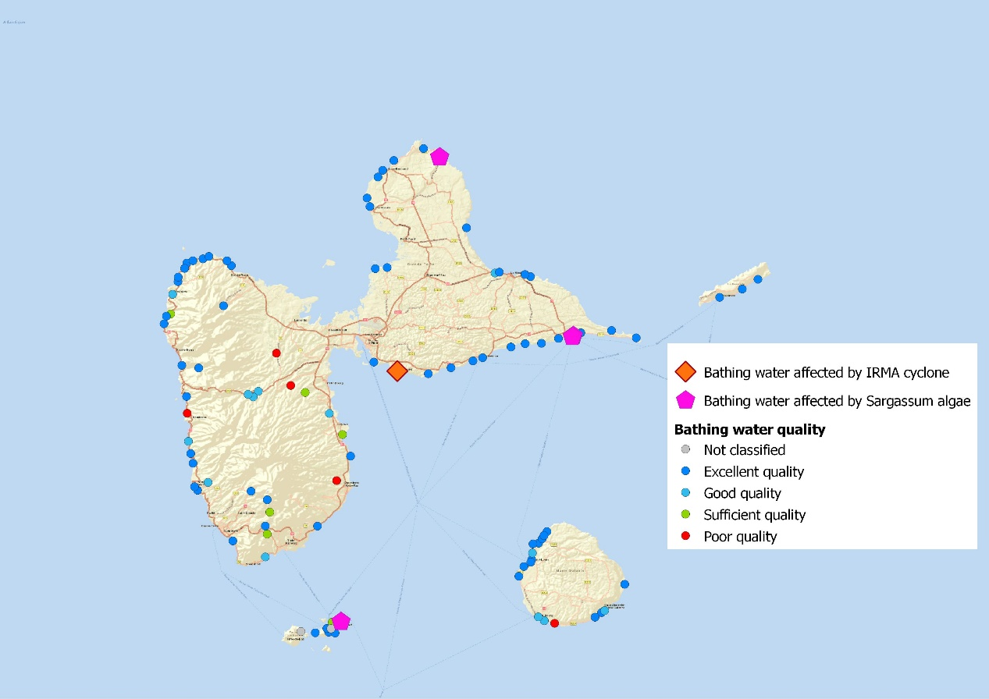

Wild bathing in Europe – a challenge for water management
Swimming in natural waters has grown in popularity across Europe in recent years. As a result, the official number of bathing sites identified under the BWD does not cover all the rivers, lakes and seas that adventurous bathers may use. EU legislation, as implemented in national laws, describes main conditions for a bathing site to be designated as official: such as the large number of bathers visiting the bathing site and/or any infrastructure and facilities provided at the bathing site. Because not all potential bathing sites meet these conditions, there are many more bathing sites in use than monitored under the BWD.
Given that unofficial bathing sites are less strictly monitored for potential health risks (if at all) and thus no management is done, their water quality (and thus bathing safety) may remain unknown. For such waters, the implementation of other directives supporting good environmental status is even more important. Sites where bathing is officially prohibited due to ‘poor’ water quality might still be visited by bathers. At such sites, information boards offering advice against bathing and explanations of possible health risks are required. Bathing prohibition information is also communicated through the press, social media and local websites. Monitoring as set by BWD must continue to support ecological restoration measures if implemented.
In Europe, there are many attractive natural waters with ‘excellent’ water quality that are not suitable for bathing due to their ecological vulnerability. Lake ecosystems in alpine and karstic areas, for example, are very sensitive, not only to pollution but also to physical disturbances. Bathing in high mountain lakes can also cause a process of re-suspension of sediment which is accumulated in the lake (Toro, et al., 2006). Swimming in such sites should be controlled. Environmental and potential human health problems might be presented at such sites in innovative ways to help raise visitor awareness and engagement into their protection. The case-study of a small alpine lake of Dvojno jezero in Slovenia (Box 14) demonstrates such issues around wild bathing in ecologically vulnerable environments.
Box 14: Bathing in ecologically sensitive environments (Slovenia)
The so-called ‘Double Lake’ (Dvojno jezero) situated in the Triglav national park in Slovenia is highly sensitive ecosystem impacted by anthropogenic introduction of lake char fish, waste water drainage from nearby mountain had and summer bathing. As is common in other high mountain lakes in Europe, the Double Lake originally did not contain fish (Leskošek, and Brancelj, 2009). The introduction of the fish and and waste water have caused growth of algae (Erhatič, 2010). When people bathe in the lake, they introduce materials into its delicate environment: sun creams, skin excretions, microplastics from bathing costumes, and even food leftovers. As a result, water quality deteriorated in the lake (Leskošek, et al., 2009), posing risks to bathers’ health. In addition the physical activity of swimming can also damage aquatic plants and stir up sediments.
The Triglav National Park and partners have prepared a project called ‘VrH Julijcev’, which aims to restore the ecosystem of the Double Lake. Its restoration measures include the extraction of non-native fish species, removal of organic material, and improved treatment of hut waste water (Paladin, 2018). An information and communication campaign has already started. In order to raise awareness, visitors to the lake and Triglav national park are being informed about the fragility of the lake environment and the adverse consequences caused by bathing activities.
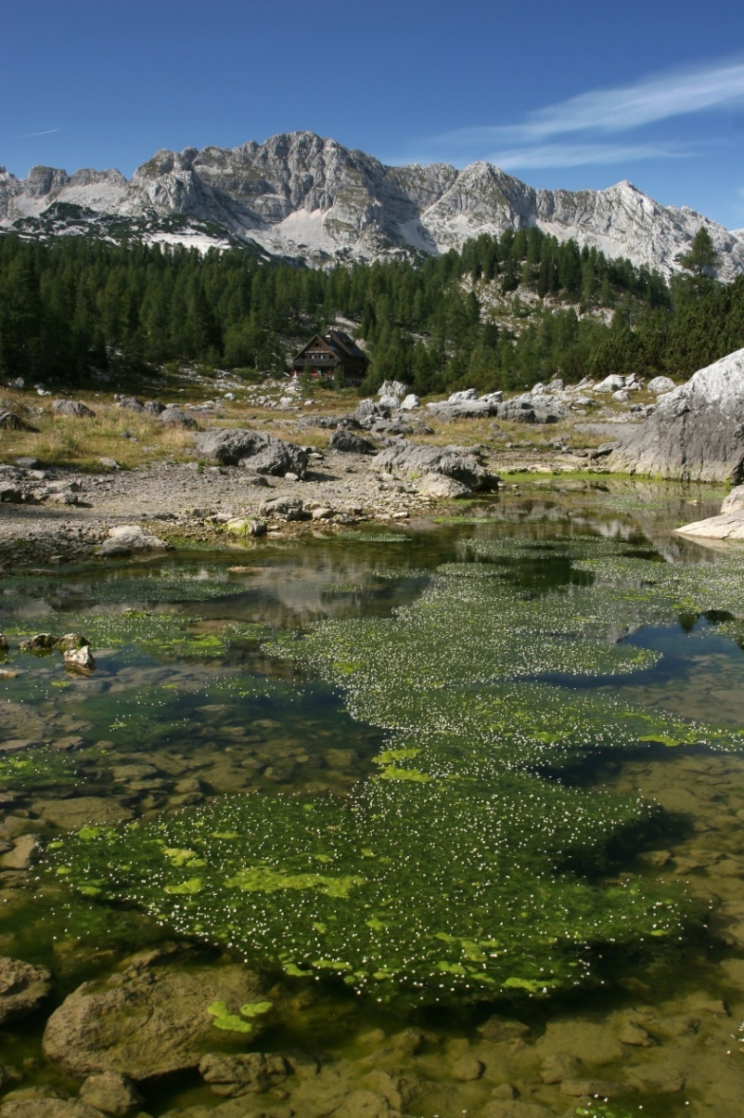

Photo: ©Davorin Tome

- Bathing in the future

Climate change impacts
Climate change has substantially impacted European landscapes already, and will continue for many decades to come. Land and sea temperatures are increasing, precipitation patterns are changing, wet regions in Europe are becoming even wetter, dry regions drier, and sea levels are rising. Extreme events such as heat waves, heavy rain and droughts are increasing in frequency as well as intensity in many regions across Europe (EEA, 2017b). Projected short and long term climate changes will bring challenges for bathing water management. Due to climate change, the risk of flooding and strong storms generating very high waves are expected to increase, potentially causing damage to infrastructure, beaches and settlements (Borja, et al., 2020).
Most of the studies assessing the likely impacts of climate change on beach tourism in Europe use the tourism climate index (TCI). The TCI assesses the climatic elements that are most relevant to the quality of the tourism experience, such as maximum and mean daily temperature, humidity, precipitation, sunshine and wind, in order to assess human comfort for general outdoor activities (Amelung, and Moreno, 2009; Nicholls, and Amelung, 2015). Over the 21st century, climate change is projected to shift a ‘favourable’ climate northwards. As a result, Southern Europe’s suitability for bathing tourism will most likely decrease in the summer but increase in spring and autumn. Since climate conditions at the Atlantic and northern European coasts will most likely improve, competition between bathing destinations in Europe may increase.
It is likely that a projected increased number of heat waves and rising air temperatures will encourage more people to seek refreshment in bathing waters during hot summer months. In many regions, the bathing season could be prolonged into spring and autumn. Higher demand for bathing is likely to force national authorities to expand their bathing water network, identify and monitor new bathing waters and ensure that supporting infrastructure is in place (e.g. parking lots, toilets, showers).
This section presents some of the consequences of climate change as well as their impacts on the management of bathing waters in the years to come.

Rise in seawater level
Global sea level has risen by almost 20 cm in the past hundred years. Sea levels have increased at most locations along the European coastline, and it is expected that in the future, sea level rise will most likely occur at a higher rate than in the last century (EEA, 2017b). Even if greenhouse gas concentrations were stabilised right now, sea levels would continue to rise for many centuries (IPCC, 2013). The potential impacts of sea level rise also include flooding and coastal erosion, which present a risk to life, property, tourism and recreation. Many coastal bathing water resorts and infrastructure will be threatened by elevated sea level and occasional flooding. Popular Mediterranean bathing destinations such as Spain, France, Italy, Croatia and Greece are among most vulnerable destinations threatened by sea level rise.
Photo: How will future generations be able to use and enjoy European bathing waters? ©Katarina Zore

River flows and floods
Floods are a natural phenomenon that have shaped floodplains for millennia. Atmospheric warming and associated hydrological changes have significant implications for changed river flows and regional flooding (EEA, 2017a). As a result, in recent decades river flows in Europe have increased in winter and decreased in summer. These changes cannot be attributed only to climate change but also other factors such as river engineering (EEA, 2017b). Evidence also indicates that the number of severe floods in Europe has increased in recent decades (EEA, 2016c). During flooding events, river velocities are higher than at normal flows, water transparency is reduced, and pollution levels are often higher (EEA, 2017a). In Europe, economic losses from flooding have increased significantly (Barredo, 2009). For the end of the 21st century, the greatest increase in river floods with recurrence period of 100 years (probability of flooding is 1%) is projected for the British Isles, north-west and south-east France, northern Italy and some regions in south-east Spain and the Balkans (EEA, 2017a). Minor increases are also projected for central Europe where more than 200 bathing waters were affected by so called ‘Central European floods’ during 2013 bathing season (Box 15).
Increased river flows can damage bathing water infrastructure and delay different kind of debris at the bathing water area. Bathing waters affected by flooding during bathing season have to implement specific measures such as temporary bathing prohibition, debris and sediment removal. Only when bathing is considered as safe again can the temporary advice against bathing can be removed, and the bathing water can resume operation. Traditional flood risk reduction measures (e.g. dikes and dams) are costly, have negative impacts on environment and may in some cases even increase flood risk. In recent years, there has been increased interest in the use of so-called ‘nature-based’ solutions (NBSs). NBSs are actions to protect, sustainably manage and restore ecosystems in order to simultaneously provide human well-being (e.g. protection from flooding) as well as biodiversity benefits (IUCN, 2016). These can be achieved by re-establishing natural flood plains along parts of a river with the objective of reducing flood height (EEA, 2017a). One of the key attractions of such nature-based solutions is their multifunctionality. Besides their economic (e.g. reducing flood risk) and environmental (e.g. conserving biodiversity) benefits they can also provide valuable recreational and social services if they are also managed as bathing waters. Such infrastructure has the potential to offer win-win solutions by tackling several linked environmental problems and providing great number of benefits, within an economically feasible framework.

Box 15: Bathing waters affected by Central European floods
The so called ‘Central European floods’ which took place in the Central Europe in late May and June 2013 particularly affected regions along Elbe and Danube rivers, including southern and eastern German states, the western part of Czechia and Austria. Between 30 May and 1 June, these regions received up to 250 mm rainfall, which is for some regions one-fifth of the annual average.
Major flooding affected about 200 bathing waters in Germany, Austria, Hungary and Czechia. Due to the flooding and its consequences, bathing water monitoring and management were interrupted. Appropriate information was provided to the public regarding the temporary suspension of monitoring information for affected bathing waters in these cases. Monitoring could resume and adequate quality assessment samples were available for some affected bathing waters after the floods (EEA, 2014).
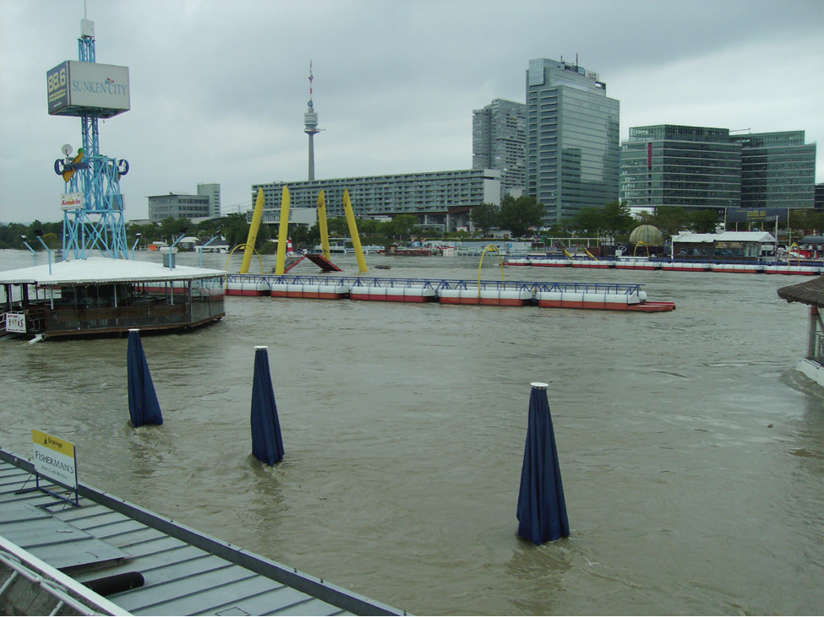
Photo: ©Wolfgang Zoufal

Rise in air and water temperature
Average air temperatures in Europe are projected to increase between 1–4.5 °C by the end of the 21st century, which is more that the projected global increase due to climate change. The strongest warming is projected for north-eastern Europe and Scandinavia in winter, and southern Europe in summer. The sea surface temperature is also projected to increase, although more slowly than air temperature (EEA, 2017b).
As a result of the projected rise in sea surface temperature, increases in harmful algal blooms (see section 4.4) have been projected for the North Sea and the Baltic Sea (Glibert, et al., 2014). Elevated marine water temperatures also accelerate the growth rate of certain pathogens, such as Vibrio species that can cause food-borne outbreaks from infected seafood. On rare occasions, ingestion may lead to severe necrotic ulcers, septicaemia and even death if individuals are being exposed during bathing in contaminated marine environments (EEA, 2017b).
Over the last century, water temperatures in major European rivers have increased by 1–3 °C and are projected to increase further alongside projected increases in air temperature (EEA, 2017b). Mean river temperature of major European rivers is projected to increase by 1.6–2.1 °C during the 21st century (van Vliet, et al., 2013). Bathing will thus become possible in numerous European rivers which are today unsuitable for bathing due to low temperatures. Due to rise in temperature, the conditions for bathing will be more favourable to increase bathing both temporally to spring and autumn, and spatially northwards, the latter especially after 2050. Some Mediterranean destinations may become too hot in the summer, leading to decrease of summer tourism in the summer months. Nevertheless, the Mediterranean will most likely remain by far the most popular bathing destination (Perrels, et al., 2015).

Droughts and water shortage
Most river monitoring stations in Europe show a decreasing trend in summer low flows over the second half of the 20th century (Stahl, et al., 2010). The severity and frequency of droughts has increased in parts of Europe and will continue to increase. Studies project large increases in droughts in most of Europe over the 21st century, except for northern regions. Unusually, low river flow, which may result from prolonged meteorological drought, also impacts water quality by reducing the ability of a river to dilute pollution (EEA, 2017b). Inland bathing waters in the Mediterranean region (in particular the Iberian Peninsula, France, Italy and Albania) and parts of central (Hungary) and south-eastern Europe are amongst the most vulnerable. In these regions, bathing water managers will have to compete with other water users such as agriculture and industry in order to ensure adequate bathing water quantity and quality during such events.
The Ružín in Slovakia is a bathing site located close to a hydropower plant (see Box 16). The quality of water strongly depends on hydropower operation as does the management of the bathing site.

Box 16: Temporary interruption of bathing waters due to lack of water (Slovakia)
Ružín in Slovakia is a bathing water with excellent water quality that was closed for two consecutive seasons in 2011 and 2012. The closure to bathing was due to nearby construction works. Ružín is a reservoir for a pumped-storage hydropower plant. In 2011 and 2012, construction works at the plant, coupled with a lack of precipitation in the spring, led to a water level decrease as large as 6.5 m, rendering the location unsafe for bathing. This prompted the authorities to close Ružín as a bathing water. Since 2015, the bathing water operates again and is of ‘excellent’ quality (EEA, 2015a).
In Czechia, Lhotka, Šeberák and Popovice are other examples of ‘excellent’ quality bathing waters that were closed in 2014 due to lack of water in reservoirs. In all of the above mentioned cases the reason was removal of bottom sediments (EEA, 2015a).
In the future, bathing water managers will have to compete with other water users such as agriculture and industry in order to ensure adequate bathing water quantity during the bathing season.

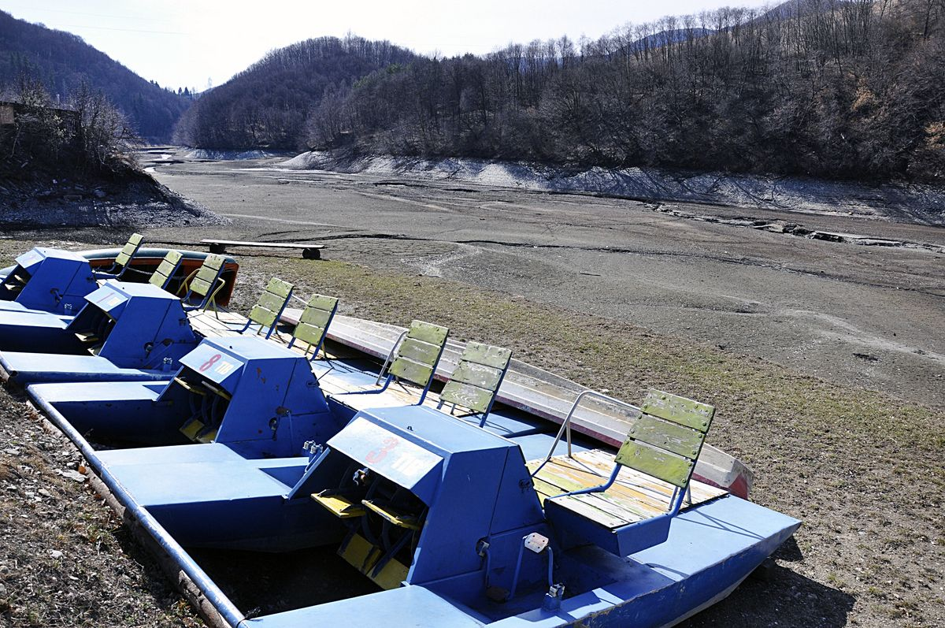
Photo: © Novy čas

Plastic litter in bathing waters: an emerging issue
Plastics have become the standard material of the modern economy, combining unique functional properties with low production costs. Global production of plastic has grown at approximately 9% per year from around 1.5 million tons in 1950 to 348 million tonnes per year (PlasticsEurope, 2019). Marine litter is the result of mismanaged plastic waste and a linear economy in which products are often thrown away after one use. Approximately 10 million tonnes of litter end up in the world’s seas and oceans every year.
Plastics – especially cigarette butts and packaging waste such as beverage bottles and single-use bags – are by far the main type of debris found at the beaches. The list goes on: damaged fishing nets, ropes, sanitary towels, balloons, tampons, cotton buds sticks, condoms, disposable lighters amongst many others. Beach and sea floor litter can cause injuries: a study in Australia reflects that 21.6% of beach users received injuries from beach litter at ‘clean’ beaches (defined using the ‘clean coast’ index - approximately 1.69 kg of litter per beach), illustrating that even ‘clean’ beaches pose a threat (Campbell, et al., 2016).
Beach litter at bathing water sites can then fracture into micro pieces in the water where it can be accidentally ingested by swimmers. Accumulation of such ‘microlitter’ – particularly microplastics – in the human body may might cause serious health effects. The extent of such health effects is still unknown, and a precautionary approach is necessary.
Marine animals can become entangled in beach, sea floor and floating litter items. Entanglement can cause fatal effects for animals; compromising their ability to capture and digest food, sense hunger, escape from predators, and reproduce, as well as decreasing body condition and locomotion (Thompson, et al., 2014). Entanglement is not the only negative issue; animals can also mistake marine litter for food. More than 40% of species of whales, dolphins and porpoises, all species of marine turtles, and around 36% of sea birds species are reported to have ingested marine litter.
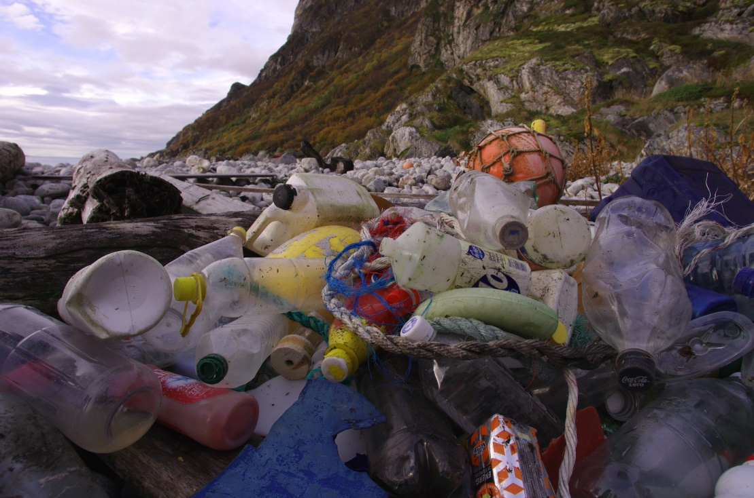
Photo: Plastic pollution on a beach ©Bo Eide
In addition to its environmental and health impacts, marine litter also has socio-economic costs, mostly affecting coastal communities. On average, 700 items of litter are found on each 100 m stretch of European beach, and without action and clean-up activities, marine litter will continue to accumulate. In order to boost the appeal of their bathing sites to tourists, many communities and businesses must clean up the beaches before the start of the summer season (EEA, 2016c). In the United Kingdom, municipalities spend approximately € 18 million per year on beach clean-ups. The teoretical estimated cost of keeping all 34 million km of global coastlines clean is; USD 69 billion (EUR 50 billion) per year (UN Environment, 2017), and this figure will continue to increase if we do not stop littering.

There are several EU policies associated with the management of marine litter. The Marine Strategy Framework Directive (2008) requires EU Member States to ensure that, by 2020, "properties and quantities of marine litter do not cause harm to the coastal and marine environment". The Single-Use Plastics Directive (2019) introduces a set of ambitious measures such as a ban on selected single-use products made of plastic (including cutlery, plates, straws, cups), measures to reduce consumption of food containers and beverage cups made of plastic, and specific marking and labelling of certain products (EU, 2019).

We should work together as a European and international community in order to tackle the growing marine litter problem. The European Environment Agency has developed Marine LitterWatch to strengthen Europe's knowledge base and thus provide support to European policy making. The information on six years of beach litter collection efforts with Marine LitterWatch can be found at: http://www.eea.europa.eu/themes/coast_sea/marine-litterwatch.

Transboundary cooperation
Water bodies – particularly seas and oceans – are often transboundary in their nature. This means that pressures such as pollution can be spread to the whole water body or neighbouring water bodies. This includes spreading from freshwater streams to lakes and vice versa, and from freshwaters to marine water bodies. As a result, the transboundary management principle has been embedded to the EU directives (Box 17), as well as to the international conventions that have been brought in to provide a framework for international standards on pollution, monitoring and assessment, conservation and protection; and cooperation in implementing such standards. For example, the OSPAR Convention (1992) sets the framework for the North-East Atlantic and Barcelona Convention (last amended in 1995) for the Mediterranean. Freshwater resources are subject of transboundary agreements such as the Danube River Protection Convention (1994), the largest body or river basin management expertise in Europe (ICPDR, 2019). With the main objectives of the latter including ensuring sustainable water management, the Convention offers the political framework for implementing transboundary projects that affect water quality and therefore bathing.

How can management of bathing waters be embedded in such transboundary cooperation? First, there is the catchment–based approach, introduced by the EU’s Water Framework Directive (WFD), that treats waters and land bodies within a river catchment as a single system, administered by different parties: land owners, government and agencies, public, non-governmental organisations and so on. The approach also introduces the standard that river catchments in Europe should be managed as a single entity, even across national borders. The effect of land-based pollution sources to aquatic environments should be treated at their source, as they can have a long line of effects throughout the catchment and onward out to the sea. The Baltic and the Adriatic Sea are examples of semi-enclosed seas with higher vulnerability to pollution from freshwater streams.

Box 17: Cross border cooperation on the River Kolpa (Slovenia and Croatia)

The River Kolpa runs on the border along Slovenia and Croatia for 100 km of its course. There are nine bathing waters identified on the Slovenian side of the Kolpa – six are of excellent water quality and three of good quality. The Slovenian and Croatian water authorities successfully cooperate in the management of the river and its catchment area according to the principles of the Water Framework and Floods Directives. The work is coordinated through a bilateral commission. For example, in 2000, a Kolpa water management plan was prepared. Six years ago, a Slovenian–Croatian cross border project (Frisco1) started to reduce flood risk with non–structural measures. Both countries are also cooperating in the management of pollution sources and heavy rain runoff to support good ecological status and prevent future deterioration of bathing water quality.

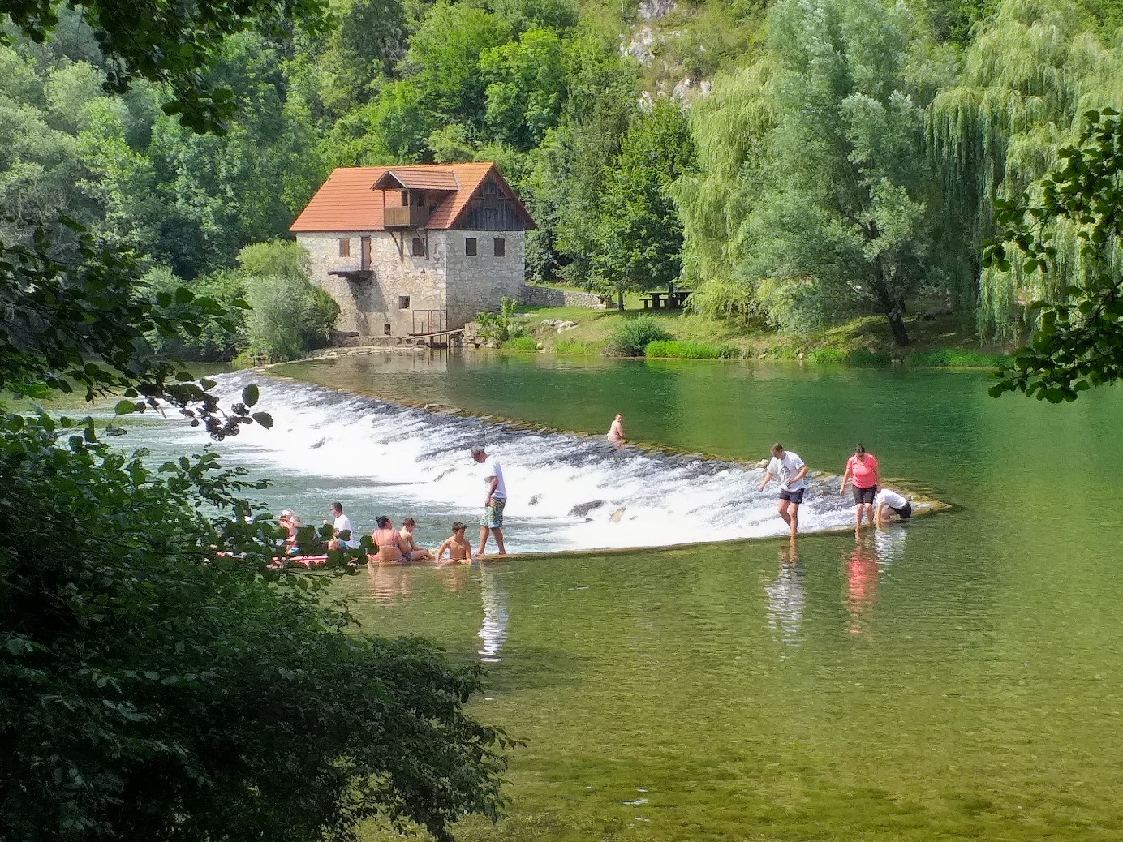
Photo: ©Mateja Poje

In addition to catchment–based approaches, good practices of bathing water quality supervision (including monitoring) and measure-taking are already shared and discussed between EU Member States, within an expert framework set by the BWD. For example, the EU SWIM project, launched during the bathing season of 2019, has facilitated cross border benefits, as both schools (in Ireland and the UK, respectively) participating in weather data collecting programme can link their results, sharing knowledge on interconnected environmental factors that affect bathing water quality, and reaching as far as developing bathing water quality prediction models(EPA Catchment Unit, 2019). Nevertheless, good practices of management for critical bathing waters with long-term low bathing water quality should be shared and discussed further. There is still space to improve a number of ‘poor’ quality bathing waters throughout European Member States, mostly in inland areas. In the future, common pollution prediction models and wider early-warning systems can be developed, as they are based on mathematical models and be relatively easily expanded to different environments, provided that the experts from these cooperate in a common effort.

- Conclusions
Clean bathing waters are vital for both public and environmental health. Bathing sites on seas, lakes and rivers are valuable spaces for people to exercise, relax and engage with nature. Clean bathing waters are thus important tourist attractions, often bringing jobs and money to local areas. Improving water quality at bathing waters through conservation and restoration often benefits the wider aquatic ecosystem by improving biodiversity habitats.

Seas, lakes and rivers are often the destination of the excesses of human activities – whether sewage, storm water overflows, plastics or chemicals – making their management complex and multi-faceted, particularly given climate change predictions for coming decades. In Europe, the Bathing Water Directive has been effective in helping to reverse decades of the degradation of the continent’s bathing waters. However, if bathing water management in Europe is to continue to have successful impacts, it needs to address emerging challenges using innovative and cooperative management approaches.

Five key issues for bathing water management in Europe

This report has outlined five main groups of issues affecting bathing water quality, each with its specific drivers and pressures, but sometimes addressed with the same (or similar) legislative or technical approach.

1. Microbiological pollution is the most obvious risk to human health. Even after decades of pollution management, elevated bacteria levels still affect at least 15% of European bathing waters that cannot reach ‘excellent’ quality classification according to the BWD, although they may be of acceptable (i.e. ‘sufficient’) quality for bathing. This pollution comes primarily from waste-water and sewage outflows, agricultural manure, or technical malfunctions in water infrastructure.

2. Extreme events – typically storms or low water levels – are gradually becoming more common causes of bathing water pollution in Europe as the result of climate change. In effect, they are similar to microbiological pollution in that they involve spillages from combined sewage outflows. Such spillages and overflows can contain a wide range of contaminants that reduce bathing water quality. Such events are increasingly well-reported, which may also be due to more strict management in the past decade.

3. Eutrophication of bathing waters – particularly common in lakes – results in a direct threat to bathers’ health. Excessive algae growth and decomposition can also create hypoxic conditions and poor water quality. Eutrophication is mainly caused by the run-off of nitrogen fertilisers and manure from agriculture, but it can also originate from household waste.

4. Cyanobacteria blooms are also a result of eutrophication, although result from a complex set of reasons working in synergy, and are of particular toxic risk to human health. They are most often reported from Central European lakes at the height of the summer season. Cyanobacteria blooms often have significant negative effects on aquatic life. Case studies show that management approaches should be well-studied and planned in advance, as some approaches can in turn cause further harm to ecological conditions of the aquatic environment.

5. Wild bathing is increasingly common across Europe, as adventurous swimmers look for new waters to swim in. Such ‘wild bathing’ has the potential to deepen engagement between people and the environment, but also raises new issues for water managers. At some unmonitored sites, water quality may not be high enough for safe bathing, whilst at others, the activities of swimmers might disrupt sensitive ecosystems. Adaptive management approaches with public communication at their core are necessary to support safe ‘wild bathing’ in the future.

Successful water policy and management guided by the BWD

The multiple pressures acting on seas, rivers and lakes mean that water quality at many European bathing sites made swimming unsafe. At many sites – especially those in urban areas – bathing would have been unimaginable, indeed in 1991, more than a quarter of all identified EU bathing waters could not be declared of ‘sufficient’ quality for bathing.

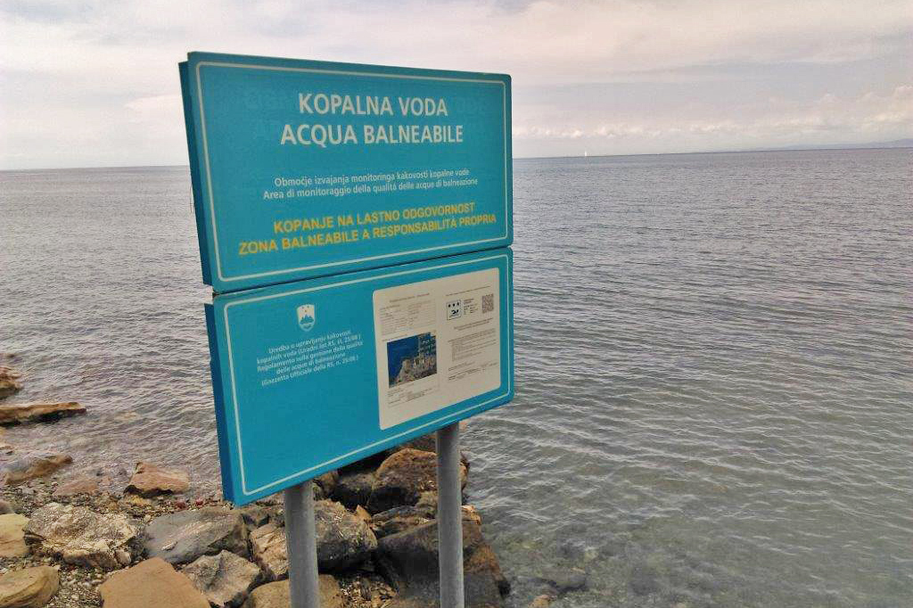
Photo: Informing public on a bathing water site ©Mateja Poje

European legislation on bathing water management has developed over past decades, centred around the Bathing Water Directive, which aims to address dynamic conditions and implement updated knowledge and technologies. The main focus of the BWD lies in the integrated management of bathing waters through interconnected water industry directives and measures that address the causes (such as reducing pollution) of different pressures as well as mitigating short- and long-term consequences (such as early warning systems).
This management approach has public participation at its core. As a direct result of these policies, water quality has improved significantly in Europe over the past two decades. In the past decade, more than 95% of European bathing waters have been of ‘sufficient’ quality for bathing, with the majority of these being classified as ‘excellent’. As a result, bathing is now possible in centres of many previously polluted European cities. Through a review of management approaches, this report has shown how the countries of the EU have made large improvements at a number of bathing sites, opened new ones, and prohibited bathing at the ones that did not achieve adequate water quality status. Consequently, the general condition of bathing waters in the EU is getting better from year to year. The case studies listed throughout the report highlight the specific management approaches that resulted in bathing water quality improvement. However, the small proportion of European bathing waters that are consistently of a quality too low for safe bathing shows that there will be an on-going need for sound management of bathing water quality.

Continuous efforts in applying existing management approaches alongside new innovative solutions that tackle emerging issues are necessary if the European bathing water policy and management is to remain a significant success story.

Innovative approaches to European water management
Over the decades, the array of approaches taken to improve bathing water quality has included various technical, information-sharing, educational, and innovative solutions, based on legislative requirements. For example, microbiological pollution issues seem to be best solved by involving various stakeholders (most notably the public that has an interest in using bathing waters. This process involves seeking both systemic and specific causes and addressing them with long-term policy, so that there would be as little need for coping with the consequences as possible.

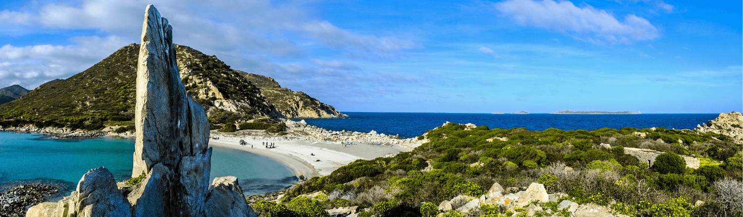
Photo: Punta Molentis, Sardinia ©Giunta Regionale Sardegna

It is, however, more difficult to predict the causes of extreme events resulting in acute short-term pollution events. Again, integrated and modern approaches should explore causes and address consequences of extreme events. Green areas in cities can function as storm-water retention basins and mitigate the load on conventional sewage systems. Such solutions are not only less expensive than traditional ‘concrete' infrastructure, but also provide a wide array of co-benefits for local economies, social communities as well as local economies (EEA, 2015a).

As it would be challenging to completely halt the causes of eutrophication, in-lake methods have proven to be effective. These include eutrophication control methods such as nutrient inactivation, lake level drawdown, covering bottom sediments, sediment removal (dredging), and harvesting.

Emerging issues for bathing water management in Europe

The final chapter of this report surveyed the challenges ahead for bathing water management in Europe. Most notably, there will be climatic changes in the future that will substantially affect bathing and its management. Higher demand for bathing will press national authorities to expand their bathing water networks, identify and monitor new bathing waters and ensure that supporting infrastructure is in place. Rises in sea water levels, altered and extreme river flows and floods, as well as rising air and water temperatures are likely to significantly affect bathing and its management in Europe. However, substantial regional differences are expected in all these processes. Among the issues already present, floods and short-term pollution events are likely to increase, making water managers compete with other water users such as agriculture and industry in order to ensure adequate bathing water quantity and quality during such events.

But these changing conditions are not only likely to accentuate current issues, they are also likely to introduce new issues, such as accelerating the growth rate of new pathogens that were not problematic until now. Management under these new conditions will need to be informed, responsive and agile, and based on available data and well-understood technologies, in order to avoid harm from unforeseen side effects.

An emerging problem in Europe is marine litter, which can be found even in wild bathing destinations. Litter, plastics in particular, is accumulating in our seas and coasts. Plastic pollution threatens the health of marine species and humans. In addition to its environmental impacts, marine litter creates a major economic loss for the coastal economies.

A good example of unexpected risks is the COVID-19 virus and pandemic. The fast spread of the virus around the world was an unexpected development, which also affected bathing in Europe. The European Union must continue to work for a resilient, sustainable and healthy bathing practice, to overcome emerging risks. And the European Union should continuously implement the hygiene measures at the bathing sites, such as social distancing and hand cleaning.

There are more than 21 000 bathing waters in the EU, covering diverse environments, landscapes and cultures, and subject to a variety of issues and policies. However, the overall quality of bathing waters and their management has been supported by decades of strong European bathing water policy. The Bathing Water Directive has achieved a high share of ‘good’ and ‘excellent’ quality bathing waters, which comprise 92.5% of the EU’s bathing water inventory. As this ‘deep dive’ into the issues surrounding bathing water management in Europe has outlined, the BWD has created a strong framework for managing and mitigating emerging challenges in the years to come.

- References
Amelung, B. and Moreno, A., 2009, 'Impacts of climate change in tourism in Europe', JRC Scientific and Technical Reports EUR 24114 (ftp://s-jrcsvqpx101p.jrc.es/pub/EURdoc/JRC55392.pdf) accessed November 20, 2015.
Barredo, J. I., 2009, 'Normalised flood losses in Europe: 1970-2006', Natural Hazards and Earth System Sciences 9, pp. 97–104.
Borja, A., White, M. P., Berdalet, E., Bock, N., Eatock, C., Kristensen, P., Leonard, A., Lloret, J., Pahl, S., Parga, M., Prieto, J. V., Wuijts, S. and Fleming, L. E., 2020, 'Moving Toward an Agenda on Ocean Health and Human Health in Europe', Frontiers in Marine Science 7, pp. 37.
Campbell, M. L., Slavin, C., Grage, A. and Kinslow, A., 2016, 'Human health impacts from litter on beaches and associated perceptions: A case study of ‘clean’ Tasmanian beaches', Ocean & Coastal Management 126, pp. 22–30.
Chaline, E., 2018, 'How Europe Learnt to Swim', History Today (https://www.historytoday.com/miscellanies/how-europe-learnt-swim) accessed April 21, 2020.
CSIRO, 2019, 'What are blue-green algae?', CSIRO (https://www.csiro.au/en/Research/Environment/Water/Blue-green-algae/What-are-blue-green-algae) accessed April 21, 2020.
EEA, 2010, 'Freshwater quality', in: The European environment — state and outlook 2010, European Environment Agency.
EEA, 2012, European bathing water quality in 2011, EEA Report, 3/2012, European Environment Agency.
EEA, 2014, European bathing water quality in 2013, EEA Report, 1/2014, European Environment Agency.
EEA, 2015a, European bathing water quality in 2014, EEA Report, 1/2015, European Environment Agency.
EEA, 2015b, 'European citizens to help tackle marine litter', European Environment Agency (https://www.eea.europa.eu/themes/water/europes-seas-and-coasts/assessments/marine-litterwatch/at-a-glance/european-citizens-to-help-tackle) accessed March 14, 2020.
EEA, 2015c, Exploring nature-based solutions: the role of green infrastructure in mitigating the impacts of weather — and climate change — related natural hazards, EEA Technical Report, 12/2015, European Environment Agency.
EEA, 2016a, European bathing water quality in 2015, EEA Report, 32/2016, European Environment Agency.
EEA, 2016b, European water policies and human health, EEA Report, 32/2016, European Environment Agency.
EEA, 2016c, Flood risks and environmental vulnerability — exploring the synergies between floodplain restoration, water policies and thematic policies, EEA Report, 1/2016, European Environment Agency.
EEA, 2016, Rivers and lakes in European cities, EEA Report, 26/2016, European Environment Agency.
EEA, 2017a, Climate change adaptation and disaster risk reduction in Europe: enhancing coherence of the knowledge base, policies and practices, EEA Report, 15/2017, European Environment Agency.
EEA, 2017b, Climate change, impacts and vulnerability in Europe 2016 — an indicator-based report, EEA Report, 1/2017, European Environment Agency.
EEA, 2017c, European bathing water quality in 2016, EEA Report, 5/2017, European Environment Agency.
EEA, 2018, European bathing water quality in 2017, EEA Report, 2/2018, European Environment Agency.
EEA, 2019a, European bathing water quality in 2018, EEA Report, 3/2019, European Environment Agency.
EEA, 2019b, Nutrient enrichment and eutrophication in Europe’s seas: moving towards a healthy marine environment., EEA Report, 14/2019, European Environment Agency.
EEA and JRC, 2013, Environment and human health, EEA Report, 5/2013, European Environment Agency.
EPA Catchment Unit, 2019, 'EU SWIM Project launches during the 2019 Bathing Water Season', Catchments (https://www.catchments.ie/eu-swim-project-launches-during-the-2019-bathing-water-season/) accessed April 21, 2019.
Erhatič, B., 2010, 'Dvojno jezero', Enciklopedija naravne in kulturne dediščine na Slovenskem (http://www.dedi.si/dediscina/19-dvojno-jezero) accessed July 11, 2020.
EU, 1975, Council Directive 75/440/EEC of 16 June 1975 concerning the quality required of surface water intended for the abstraction of drinking water in the Member States, OJ L 194, 25.7.1975, p. 26–31.
EU, 1980a, Council Directive 80/68/EEC of 17 December 1979 on the protection of groundwater against pollution caused by certain dangerous substances, OJ L 20, 26.1.1980, p. 43–48.
EU, 1980b, Council Directive 80/778/EEC of 15 July 1980 relating to the quality of water intended for human consumption, OJ L 229, 30.8.1980, p. 11–29.
EU, 1991a, Council Directive 91/271/EEC of 21 May 1991 concerning urban waste water treatment, OJ L 135, 30.5.1991, p. 40-52.
EU, 1991b, Council Directive 91/676/EEC of 12 December 1991 concerning the protection of waters against pollution caused by nitrates from agricultural sources, OJ L 375, 31.12.1991, p. 1-8.
EU, 1998, Council Directive 98/83/EC of 3 November 1998 on the quality of water intended for human consumption
EU, 2000, Directive 2000/60/EC of the European Parliament and of the Council of 23 October 2000 establishing a framework for Community action in the field of water policy, OJ L 327, 22.12.2000, p. 1-73.
EU, 2006, Directive 2006/7/EC of the European Parliament and of the Council of 15 February 2006 concerning the management of bathing water quality and repealing Directive 76/160/EEC, OJ L 64, 4.3.2006, p. 37-51.
EU, 2008, Directive 2008/56/EC of the European Parliament and of the Council of 17 June 2008 establishing a framework for community action in the field of marine environmental policy (Marine Strategy Framework Directive), OJ L 164, 25.6.2008, p. 19–40.
EU, 2019, Directive (EU) 2019/904 of the European Parliament and of the Council of 5 June 2019 on the reduction of the impact of certain plastic products on the environment, OJ L 155, 12.6.2019, p. 1–19.
Glibert, P. M., Icarus Allen, J., Artioli, Y., Beusen, A., Bouwman, L., Harle, J., Holmes, R. and Holt, J., 2014, 'Vulnerability of coastal ecosystems to changes in harmful algal bloom distribution in response to climate change: projections based on model analysis', Global Change Biology 20(12), pp. 3845–3858.
ICPDR, 2019, 'ICPDR - International Commission for the Protection of the Danube River', (https://www.icpdr.org/main/) accessed May 14, 2019.
IPCC, 2013, Climate change 2013: the physical science basis. Working Group I contribution to the Fifth Assessment Report of the Intergovernmental Panel on Climate Change, Stocker, T. F., Qin, D., Plattner, G.-K., et al. (eds)., Cambridge University Press, Cambridge.
IUCN, 2016, 'Nature-based Solutions', IUCN (https://www.iucn.org/commissions/commission-ecosystem-management/our-work/nature-based-solutions) accessed December 18, 2019.
IWW, 2017, 'It is possible again to swim in the river Ruhr', IWW Water Centre (https://iww-online.de/en/it-is-possible-again-to-swim-in-the-river-ruhr/) accessed November 27, 2019.
Kjendlie, P.-L., International Symposium on Biomechanics and Medicine in Swimming and Norges Idrettshøgskole, eds., 2010, Biomechanics and medicine in swimming XI: proceedings of the XIth International Symposium for Biomechanics and Medicine in Swimming, Oslo, 16th - 19th June, 2010, Oslo.
Koceva, M. M., Brandmüller, T., Lupu, I., Önnerfors, Å., Corselli-Nordblad, L., Coyette, C., Johansson, A., Strandell, H., Wolff, P. and Europäische Kommission, eds., 2016, Urban Europe: statistics on cities, towns and suburbs, 2016 edition., Publications Office of the European Union, Luxembourg.
Koopman, D., 2019, '10 Scientifically Proven Health Benefits of Taking a Bath', Lifehack (https://www.lifehack.org/381960/10-scientifically-proven-health-benefits-taking-bath) accessed April 22, 2020.
Leskošek, T. and Brancelj, A., 2009, 'Posledice naselitve rib v Dvojno jezero', Gore in ljudje (https://www.gore-ljudje.net/novosti/48758/) accessed October 7, 2019.
Nemery, J., 2019, 'Phosphorus and eutrophication', Encyclopédie de l’environnement (https://www.encyclopedie-environnement.org/en/water/phosphorus-and-eutrophication/) accessed July 18, 2019.
Nicholls, S. and Amelung, B., 2015, 'Implications of climate change for rural tourism in the Nordic region', Scandinavian Journal of Hospitality and Tourism 15(1–2), pp. 48–72.
Paladin, J., 2018, 'Gorska jezera niso za kopanje', Gorenjski Glas (http://www.gorenjskiglas.si/article/20180908/C/180909836/1036/1003/gorska-jezera-niso-za-kopanje) accessed July 15, 2019.
Perrels, A., Kortschak, D., Heyndrickx, C., Prettenthaler, F., Ciari, F., Bösch, P., Kiviluoma, J., Azevedo, M., Ekholm, T., Crawford-Brown, D. and Thompson, A., 2015, Opportunities for tool-assisted decision support: the cases for energy, transport and tourism, D2.4,
Petrescu, S., Piţigoi, G. and Păunescu, M., 2014, 'The Effects of Practicing Swimming on the Psychological Tone in Adulthood', Procedia - Social and Behavioral Sciences 159, pp. 74–77.
PlasticsEurope, 2019, 'Plastics – the Facts 2018', (https://www.plasticseurope.org/application/files/6315/4510/9658/Plastics_the_facts_2018_AF_web.pdf) accessed September 10, 2019.
Stahl, K., Hisdal, H., Hannaford, J., Tallaksen, L. M., van Lanen, H. A. J., Sauquet, E., Demuth, S., Fendekova, M. and Jódar, J., 2010, 'Streamflow trends in Europe: evidence from a dataset of near-natural catchments', Hydrology and Earth System Sciences 14(12), pp. 2367–2382.
Strathmann, M., Horstkott, M., Koch, C., Gayer, U. and Wingender, J., 2016, 'The River Ruhr – an urban river under particular interest for recreational use and as a raw water source for drinking water: The collaborative research project ‘Safe Ruhr’ – microbiological aspects', International Journal of Hygiene and Environmental Health 219(7), pp. 643–661.
Thompson, R. C., Gall, S. C., Secretariat of the Convention on Biological Diversity, United Nations Environment Programme, Global Environment Facility and Scientific and Technical Advisory Panel, 2014, 'Impacts of marine debris on biodiversity: current status and potential solutions', CBD Technical Series 67 (http://www.deslibris.ca/ID/242832) accessed May 14, 2020.
Toro, M., Granados, I., Robles, S. and Montes del Olmo, C., 2006, 'High mountain lakes of the Central Range (Iberian Peninsula): Regional limnology & environmental changes', Limnetica 25, pp. 217–252.
UN Environment, 2017, Marine Litter Socio Economic Study, nited Nations Environment Programme, Nairobi, Kenya.
van Vliet, M. T. H., Franssen, W. H. P., Yearsley, J. R., Ludwig, F., Haddeland, I., Lettenmaier, D. P. and Kabat, P., 2013, 'Global river discharge and water temperature under climate change', Global Environmental Change 23(2), pp. 450–464.
WHO, ed., 2003, Guidelines for safe recreational water environments, World Health Organization, Geneva, Switzerland.
World Bank, 2014, 'World Bank supports doubling Water Availability in Durres region', World Bank (https://www.worldbank.org/en/news/press-release/2014/01/16/world-bank-supports-doubling-water-availability-in-durres-region) accessed March 30, 2016.

Directive on surface water quality for drinking water abstraction (1975), followed by the first Groundwater Directive (1980), and the first Drinking Water Directive (1980b). In the early 1990s, the Nitrates Directive (1991) and the Urban Waste Water Treatment Directive (1991a) came into force.
Urban Waste Water Treatment Directive, 91/271/EEC (1991a)
Drinking Water Directive, 98/83/EC (1998)
Nitrates Directive, 91/676/EEC (1991b)
Marine Strategy Framework Directive, 2008/56/EC OF (2008)
Bathing Water Directive, 2006/7/EC (2006)
Beside EU Member States, data have been reported also by three non-EU countries: Albania (from 2013), Montenegro (2010-2011) and Switzerland (from 2009).
Urban areas reported under UWWTD as »Big cities« and urban areas (agglomerations) as identified by JRC in riparian zones spatial data.

