Landing page

Country profiles on water resources and water scarcity
This section presents key data related to sustainable management of water resources in Europe. Country profiles are available for each EU Member State, EEA Member and Cooperating countries (Eionet).
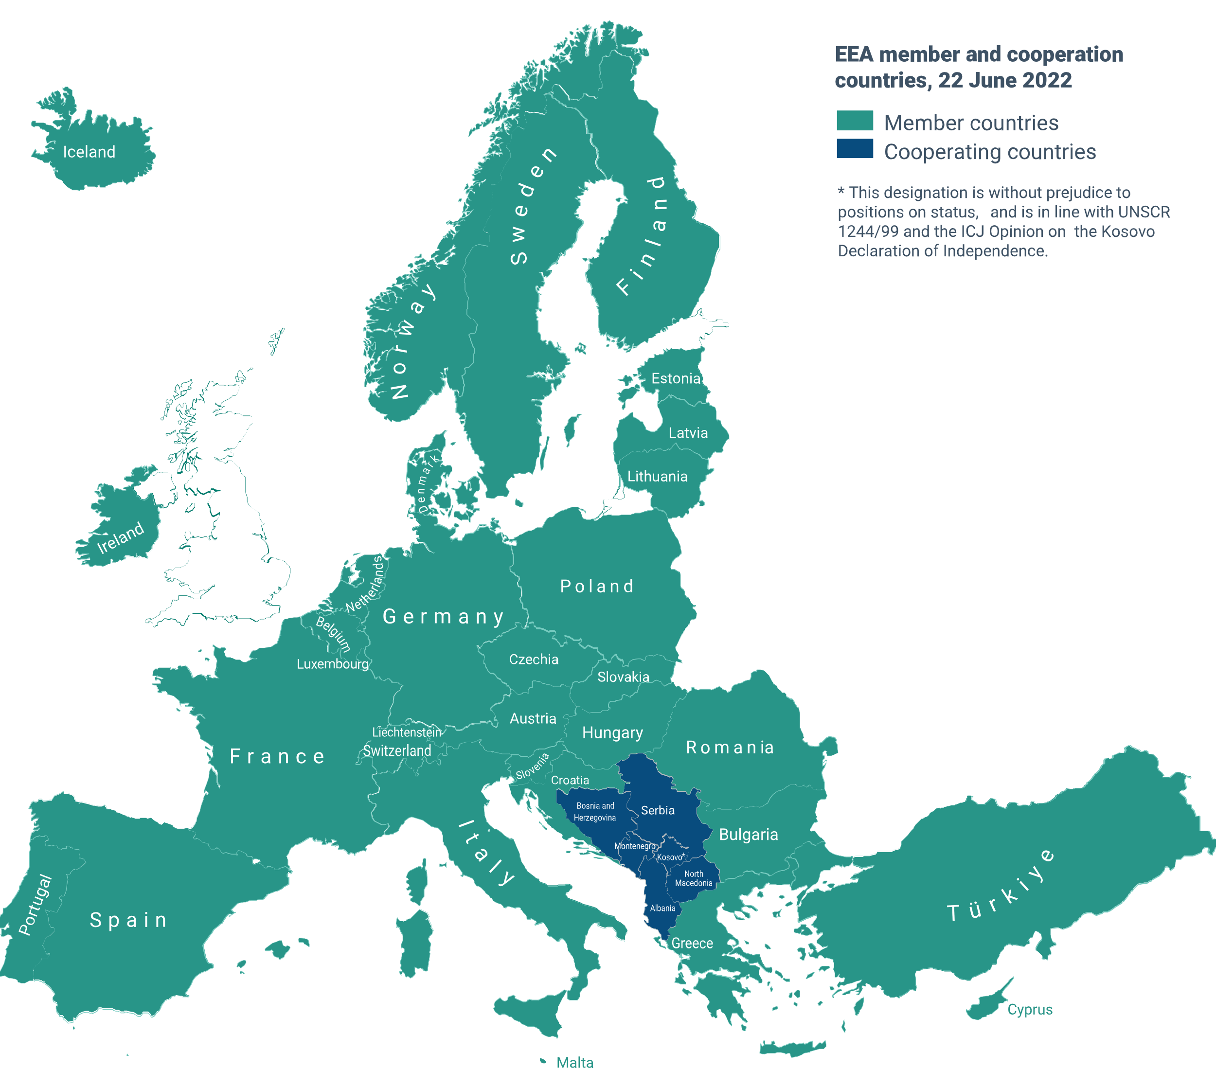
[Note: Image has been added for illustrative purposes; the landing page design is subject to change, but all Eionet countries should be visible on the final landing page]
Purpose of the WISE country profile on water resources

The objective of the EU Water Framework Directive is to promote sustainable water use based on long-term protection of available water resources, to prevent further deterioration and to protect and improve the status of aquatic ecosystems and, in terms of their water needs, terrestrial ecosystems and wetlands directly dependent on aquatic ecosystems, and to enhance the protection and improvement of the aquatic environment.
Consistent with the overall objective of the Water Framework Directive, the Country Profile is intended to provide the public with access to robust and reliable information on water resources, address the key characteristics of water resources at the country level, and promote the exchange of data and information on water resources among EIONET member countries.
Further reading

The website of the European Commission
Water resources of Europe
Water scarcity conditions in Europe (Water exploitation index plus)
Water abstraction by economic sector
Water resources across Europe — confronting water stress: an updated assessment. EEA Report No 12/2021.
Water and agriculture: towards sustainable solutions. EEA Report No 17/2020.
Glossary

fresh surface water: water which flows over, or is stored on, the ground surface. It includes artificial reservoirs, lakes, rivers and streams, glaciers, snow and ice.

groundwater: water which collects in the pores or fractions or cavities of underground geological formations (known as aquifers).

renewable freshwater resources: The average annual amount of precipitation less evapotranspiration that ends up as run-off to rivers and recharge to aquifers (internal flow), and the average amount of inflow of surface waters and groundwater from neighbouring countries minus the outflow of surface water and groundwater into neighbouring countries and into the sea.

water abstraction: The amount of water that is removed from any source, either permanently or temporarily, in a given period of time for final consumption and production activities. Water used for hydroelectric power generation is also considered to be water abstraction. Total water abstraction can be broken down according to the type of source, such as water resources and other sources, and the type of use.

water use: The total volume of water intake by a socio-economic activity (e.g. water intake for household needs, including drinking water, irrigation of crops, cooling at industrial and energy production plants). Water use includes both consumptive and non-consumptive activities. Consumptive activities result in evaporation and transpiration of water or its integration into products. Non-consumptive activities use water and then return it to surface water and groundwater but with potential changes to its physico-chemical properties. Water use may incorporate excess water intake ('water waste'), which does not serve the needs of the activity.

water consumption: The part of water used that is not returned to groundwater or surface water because it is incorporated into products (e.g. food and beverages) or consumed by households (e.g. drinking water) or livestock. It is calculated as the difference between total water use and total supply to other sectors + returns to surface water and groundwater. Thus, it may include transpiration of water from crops, the losses due to evaporation during distribution and the apparent losses due to unauthorised tapping and malfunctioning meters. The term is equivalent to 'consumptive water use'

water scarcity: Water scarcity defines a mid-term water stress condition (e.g. seasonal, annual or multi-annual) occurring when the water demand for human needs frequently exceeds the sustainable supply capacity of the natural system in river basins. Water scarcity is the consequence of anthropogenic impacts on the availability of water resources. Water scarcity can be measured as the ratio between renewable freshwater resources and water abstraction or water use. The occurrence of droughts in river basins exacerbates the impacts of water scarcity on both ecosystem and socio-economic conditions (as regards resilience, maintenance and restoration/development).

Country profile (pilot)

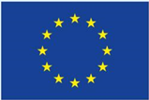  European Union | Water consumed in [TV0.1] xxxx as a percentage of  renewable fresh surface water and groundwater  between April and September [TV0.2] 2000-2019 average)  No water scarcity  Water scarcity  Severe water scarcity  [TV0.3]

Panel 1

Development of renewable fresh surface water and groundwater
Rainfall, melted snow and inflow of fresh surface water and groundwater from neighbouring countries increase volume of fresh surface water and groundwater in a country, whereas a part of the freshwater evaporates from open water surfaces and the soil or transpires from crops and other vegetation. The balance of these processes leads to the annual renewal of the fresh surface water and groundwater in a country.  Between [TV1.1] 2000 and [TV1.2] 2021, the volume of the renewable fresh surface water and groundwater in [TV1.3] Xxxxx was estimated at [TV1.4] 100,754 million m³ on average. The lowest volume was observed in [TV1.5] 2011 ([TV1.6] 55,572 million m3) and the highest in [TV1.7] 2000 ([TV1.8] 183,837 million m3).  The average volume of renewable fresh surface water and groundwater during [TV1.9] 2016-2021 was [TV1.10] lower / higher / the same compared to [TV1.11] 2000-2005.  Taking into account the population of [TV1.3] the EU-27, the average volume of renewable fresh surface water and groundwater is [TV1.12] below / above / the same as the long-term EU average between [TV1.1] 2000 and [TV1.2] 2021.  It is noted that climatic, landscape and geological characteristics may cause significant differences in the regional or local availability of fresh surface water and groundwater, compared to the country average. | FIGURE 1.1 Annual volume of renewable fresh surface water and groundwater between [TV1.1] 2000 and [TV1.2] 2021 in [TV1.3] Xxxxx (in million m³).  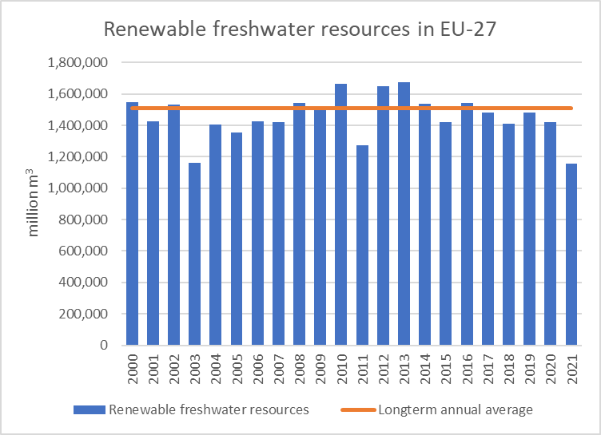  FIGURE 1.2 Average volume of renewable fresh surface water and groundwater per person in [TV1.3] tXxxxx compared to the EU-27 ([TV1.1] 2000 - [TV1.2] 2021 average; in m³ per person).  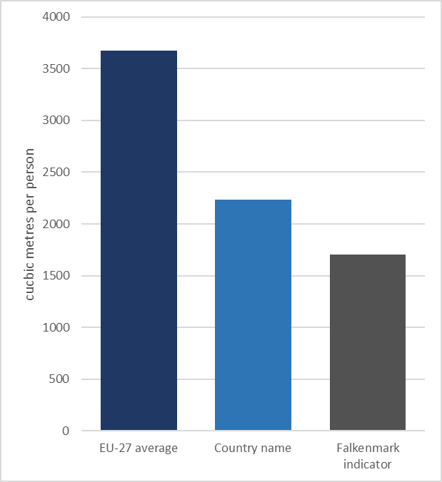

Panel 2
Development of abstraction from fresh surface water and groundwater
Society and economy depend largely on the abstraction of fresh surface water and groundwater from the environment to meet their needs.  Between [TV2.1] 2000 and [TV2.2] 2019, the total abstraction of fresh surface water and groundwater in [TV2.3] the EU-27 [TV2.4] remained the same / decreased from [TV2.4.1] 235,167 to [TV2.4.2] 176,515 million m³ / increased from 36,455 to 30,359 million m³ /  - The abstraction of fresh surface water [TV2.5] remained the same / decreased from [TV2.5.1] 192,281 to [TV2.5.2] 133,095 million m³ / increased from 30,456 to 24,028 million m³.  - The abstraction of fresh groundwater [TV2.6] remained the same / decreased from 5,989 to 6,331 million m³ / increased from [TV2.6.1] 42,885 to [TV2.6.2] 43,420 million m³. | FIGURE 2.1 Volume of fresh surface water and groundwater abstracted (in million m³).  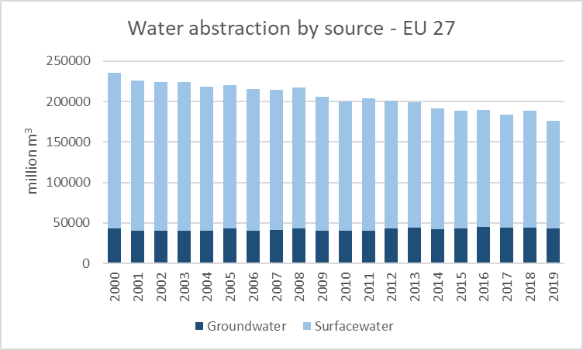

Panel 3
Development of abstraction from fresh surface water and groundwater by each economic sector
Decreasing the abstraction of fresh surface water and groundwater from the environment can help to reduce the risk of water scarcity. It also helps to be better prepared against droughts and their potential consequences on society and economy.  Between [TV3.1] 2000 and [TV3.2] 2019, the total abstraction of fresh surface water and groundwater in [TV3.3] Xxxxx [TV3.4] decreased / increased / remained the same.  The abstraction of fresh surface water and groundwater decreased in [TV3.5] agriculture, electricity cooling, manufacturing, public water supply and increased in [TV3.6] : .  [If the value of 2000 and/or the value of 2020 are 0, then write at the bottom:]  Insufficient data are available for [TV3.7] construction, manufacturing cooling, mining and quarrying. | FIGURE 3.1 Volume of fresh surface water and groundwater abstracted by each economic sector (in million m³).  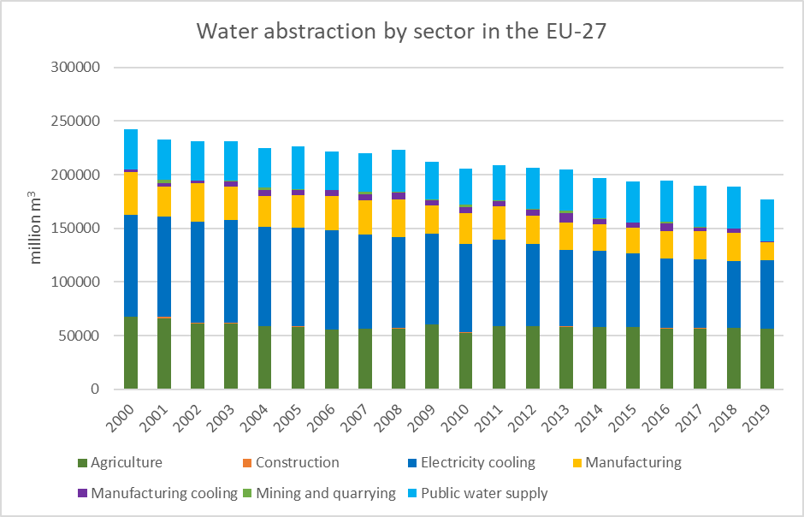

Panel 4
Development of leakages and other water losses
Decreasing the leakages and other water losses (e.g. evaporation and transpiration) during water transport may help to reduce the water abstracted from the environment, improve the conveyance efficiency and lower the costs for water treatment and supply.  Between [TV4.1] 2000 and [TV4.2] 2021, leakages and other water losses during water transport in [TV4.3] the EU-27 [TV4.4] decreased / increased / remained the same. | FIGURE 4.1 Leakages and other water losses during water transport in the EU-27 (in million m³).  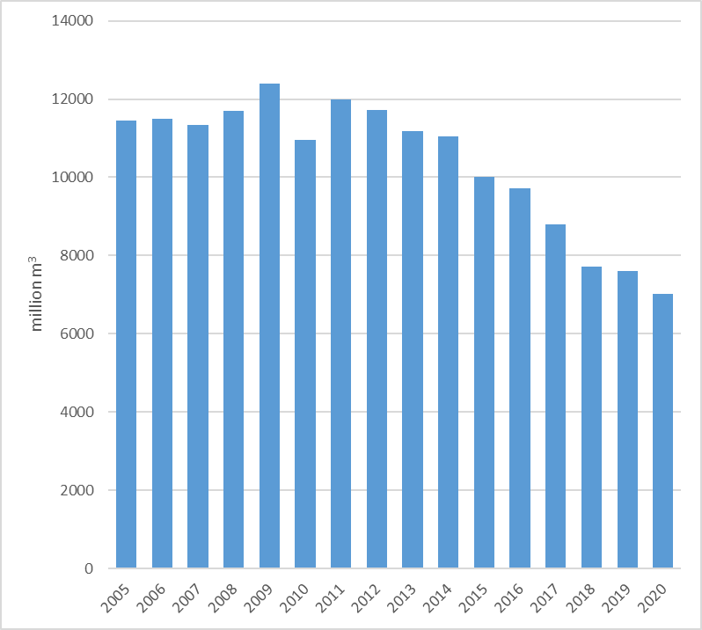

Panel 5
Development of water scarcity
The annual level of water scarcity [TV5.1] decreased / increased /remained the same in [TV5.2] Xxxxx between [TV5.3] 2000 and [TV5.4] 2019, based on the water consumed in the country, as a percentage of the annual volume of renewable fresh surface water and groundwater.  Furthermore, the level of water scarcity of year 2000 was exceeded [TV5.5] xx times in [TV5.6] xx years.  [TV5.7] Xxxxx has not been exposed to water scarcity condition between [TV5.8] 2000 and [TV5.8] 2019 . | FIGURE 5.1  Water consumed in the country, as a percentage (%) of the annual volume of renewable fresh surface water and groundwater.  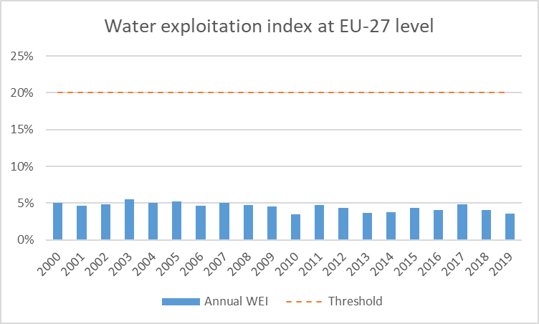

Panel 6
Supply of reclaimed water, desalinated water or other non-freshwater resources
Increasing the supply of reclaimed water from urban waste water or desalinated water or other non-freshwater resources (e.g. brackish surface water and groundwater) may relieve the pressure on fresh surface water and groundwater, reduce water scarcity, and diversify the sources of water supply in the case of droughts.  In [TV6.1] Xxxxx:  - [TV6.2] water is reclaimed from urban waste water / water is not reclaimed from urban waste water  - [TV6.3] desalination takes place / desalination does not take place  - [TV6.4] other non-freshwater resources are used / other non-freshwater resources are not used  - [TV6.5] data is not available | FIGURE 6.1 Volume of reclaimed water, desalinated water or other non-freshwater resources supplied (in million m³).  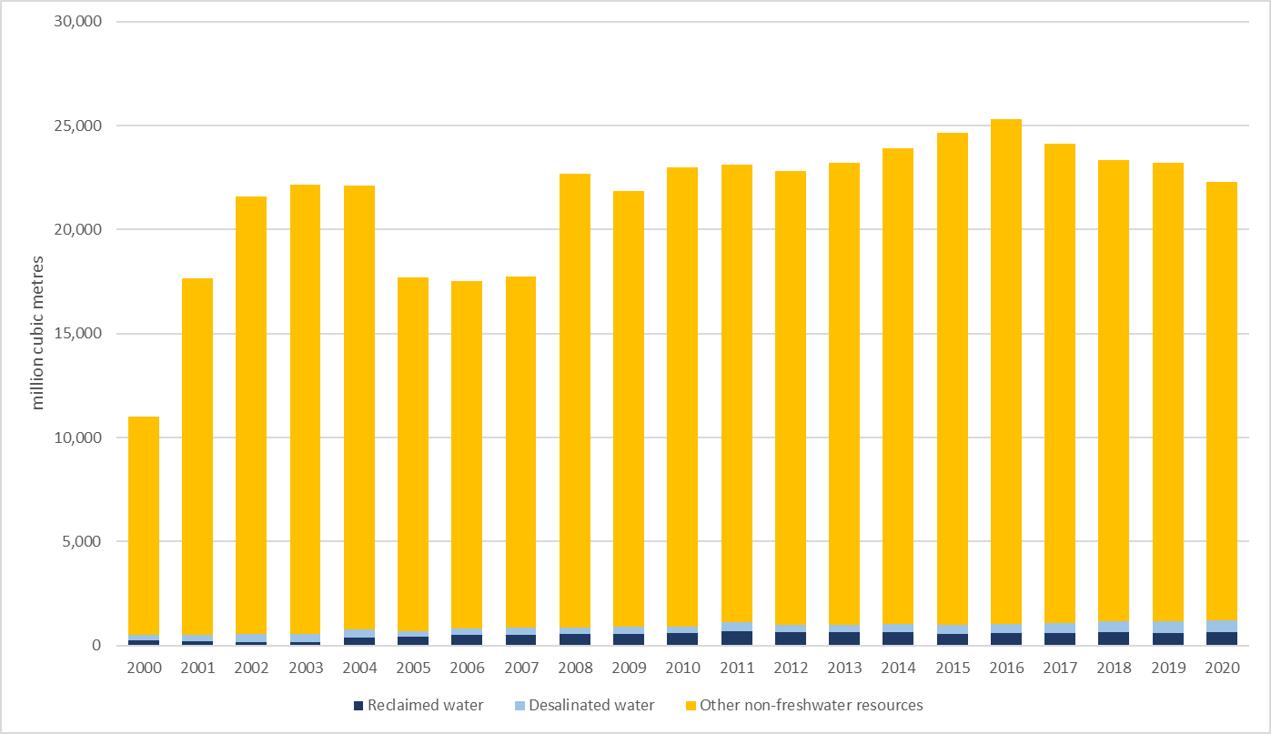

Panel 7
Is water price adequate to maintain the water supply system?
Article 9 of the Water Framework Directive requires that EU Member States apply water-pricing policies, providing adequate incentives for efficient water use and, thus, contributing to the achievement of the Directive’s environmental objectives. Furthermore, water-pricing is a key instrument to arrive at an adequate contribution from the various water use sectors (disaggregated into at least households, agriculture and industry) to the recovery of the costs of the various water services. | MAP 7.1 Percentage of financial cost recovery at river basin district level [TV7.1] Xxxxx in the 2nd RBMPs (2009-2015).  Households Agriculture Industry  [NOTE: A map viewer will display three categories of service prices and their financial cost recovery rates at RBD level i.e.  - Households which is consisting of overall water supply for drinking water and/or sanitation services  - Agriculture which includes also water supply for irrigation  - Industry covers water use in industrial production and energy generation as well.  The above map just illustrates financial cost recovery rate of water supply services for households by randomly assigned threshold values]  MAP 7.2 Average price of water supply and sanitation services in main cities of [TV7.1] Xxxxx.  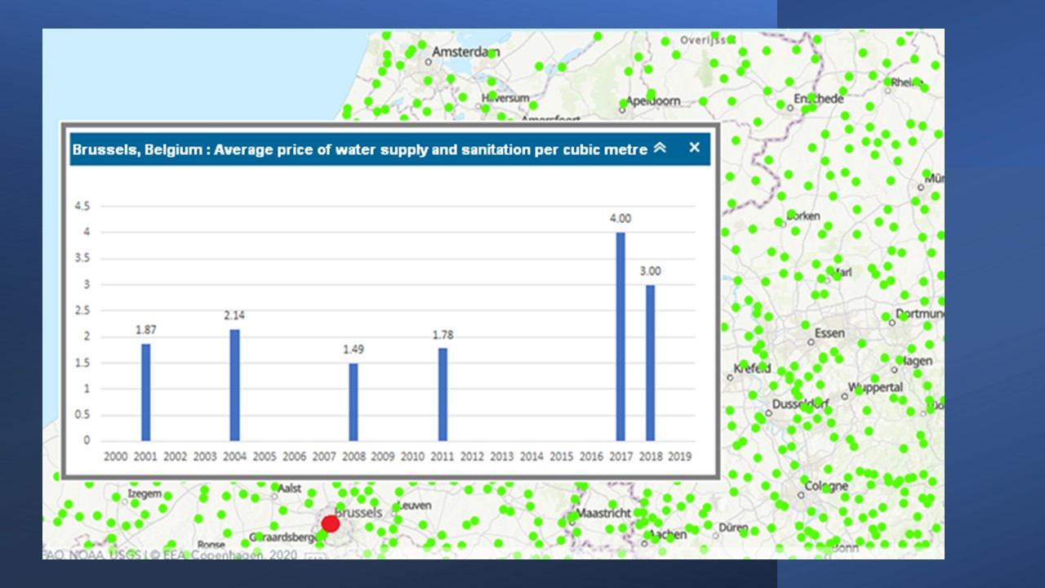  Example from Brussels (Xxxxx)

Generic section

Country remarks

DG ENV / EEA remarks

Other remarks/clarifications/definitions

The water consumed in the country, expressed as a percentage (%) of the annual volume of renewable fresh surface water and groundwater is an indicator for measuring water scarcity, which is known as Water Exploitation Index plus (WEI+). For further read see: “Water scarcity conditions in Europe (Water exploitation index plus)”.
However, it is noted that potential health risks and environmental impacts must be safely managed and tackled, taking into account EU and national legislation.

